Baseline Professional Learning Handout
M152 Reasoning and Proof through Congruence

Baseline Professional Learning Handout 1
Selected Common Core High School Standards for Mathematics 1
Progressions Geometry Excerpt 4
M152 Content and Practice Expectations 5
M152 Content and Practice Expectations and Indicators 6
Let’s Investigate 8
Identifying Rotations Task 8
Origami Equilateral Triangle Task 8
Let’s do some math! Round 1 9
Task 1: Brand Logo 9
Learning Principles 10
Task 1: Brand Logo Student Work 11
Let’s do some math! Round 2 12
Task 2: Mathematics in Art 12
Task 2: Mathematics in Art Student Work 14
Criteria for Success 15
References 15

Selected Common Core High School Standards for Mathematics

High School Geometry- Congruence
Experiment with transformations in the plane
- Know precise definitions of angle, circle, perpendicular line, parallel line, and line segment, based on the undefined notions of point, line, distance along a line, and distance around a circular arc.
- Represent transformations in the plane using, e.g., transparencies and geometry software; describe transformations as functions that take points in the plane as inputs and give other points as outputs. Compare transformations that preserve distance and angle to those that do not (e.g., translation versus horizontal stretch).
- Given a rectangle, parallelogram, trapezoid, or regular polygon, describe the rotations and reflections that carry it onto itself.
- Develop definitions of rotations, reflections, and translations in terms of angles, circles, perpendicular lines, parallel lines, and line segments.
- Given a geometric figure and a rotation, reflection, or translation, draw the transformed figure using, e.g., graph paper, tracing paper, or geometry software. Specify a sequence of transformations that will carry a given figure onto another.

Understand congruence in terms of rigid motions
- Use geometric descriptions of rigid motions to transform figures and to predict the effect of a given rigid motion on a given figure; given two figures, use the definition of congruence in terms of rigid motions to decide if they are congruent.
- Use the definition of congruence in terms of rigid motions to show that two triangles are congruent if and only if corresponding pairs of sides and corresponding pairs of angles are congruent.
- Explain how the criteria for triangle congruence (ASA, SAS, and SSS) follow from the definition of congruence in terms of rigid motions.

Prove geometric theorems
- Prove theorems about lines and angles. Theorems include: vertical angles are congruent; when a transversal crosses parallel lines, alternate interior angles are congruent and corresponding angles are congruent; points on a perpendicular bisector of a line segment are exactly those equidistant from the segment’s endpoints.
- Prove theorems about triangles. Theorems include: measures of interior angles of a triangle sum to 180°; base angles of isosceles triangles are congruent; the segment joining midpoints of two sides of a triangle is parallel to the third side and half the length; the medians of a triangle meet at a point.
- Prove theorems about parallelograms. Theorems include: opposite sides are congruent, opposite angles are congruent, the diagonals of a parallelogram bisect each other, and conversely, rectangles are parallelograms with congruent diagonals.

Make geometric constructions
- Make formal geometric constructions with a variety of tools and methods (compass and straightedge, string, reflective devices, paper folding, dynamic geometric software, etc.). Copying a segment; copying an angle; bisecting a segment; bisecting an angle; constructing perpendicular lines, including the perpendicular bisector of a line segment; and constructing a line parallel to a given line through a point not on the line.
- Construct an equilateral triangle, a square, and a regular hexagon inscribed in a circle.

High School Geometry- Circles
Understand and apply theorems about circles
- Prove that all circles are similar.
- Identify and describe relationships among inscribed angles, radii, and chords. Include the relationship between central, inscribed, and circumscribed angles; inscribed angles on a diameter are right angles; the radius of a circle is perpendicular to the tangent where the radius intersects the circle.
- Construct the inscribed and circumscribed circles of a triangle, and prove properties of angles for a quadrilateral inscribed in a circle.

Find arc lengths and areas of sectors of circles
- Derive using similarity the fact that the length of the arc intercepted by an angle is proportional to the radius, and define the radian measure of the angle as the constant of proportionality; derive the formula for the area of a sector.

Progressions Geometry Excerpt
Understand congruence in terms of rigid motions Two figures are defined to be congruent if there is a sequence of rigid motions carrying one onto the other.^{G-CO.6} It is important to be wary of circularity when using this definition to establish congruence. For example, you cannot assume that if two triangles have corresponding sides of equal length and corresponding angles of equal measure then they are congruent; this is something that must be proved using the definition of congruent, as shown in the margin.^{G-CO.7}  Notice that the argument in the margin does not in fact use  every equality of corresponding sides and angles. It only uses  |$BC$|= |$QR$|, m$<ACB=$m$<PRQ$, and |$CA$| = |$RP$| (along with  the fact that rigid motions preserve all of these equalities). These equalities are indicated with matching hash marks in the figures. Thus, this argument it amounts to a proof of the SAS criterion for congruence. A variation of this argument can also be used to prove the ASA criterion. In that case one would drop the assumption that |$AC$| = |$PR$| (the double hash marks) and add the assumption that m$<ABC=$m$<PQR$. Then one would argue at the conclusion that $P$ coincides with the reflection $R\left(T\left(A\right)\right)$ because line $QP$coincides with the reflection of line $QR\left(T\left(A\right)\right)$, and therefore its intersection with line $RP$ must coincide with the reflection of $R\left(T\left(A\right)\right)$. The proof of the SSS congruence criterion^{G-CO.8} is a little more involved. | 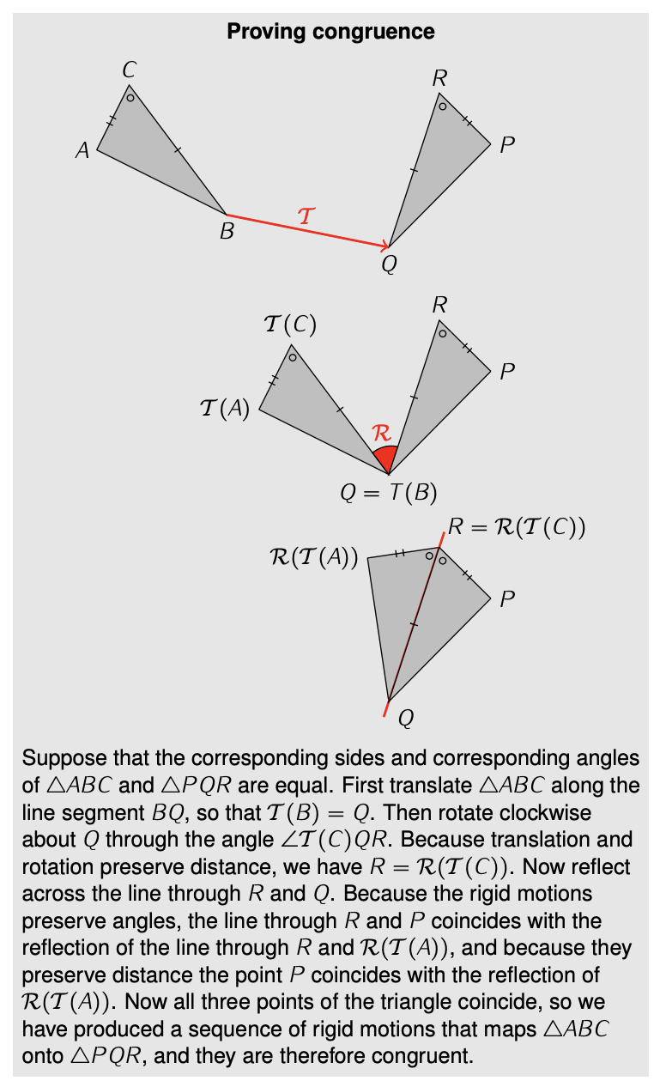

M152 Content and Practice Expectations
152.a | Use definitions of rotations, reflections, and translations in terms of angles, circles, perpendicular lines, parallel lines, and line segments.
152.b | Given a geometric figure and a rotation, reflection, or translation, draw the transformed figure using graph paper, tracing paper, geometry software, etc.
152.c | Specify a sequence of transformations that will carry a given figure onto another.
152.d | Given two figures, use the definition of congruence in terms of rigid motions to decide if they are congruent.
152.e | Use the definition of congruence in terms of rigid motions to show that two triangles are congruent if and only if corresponding pairs of sides and corresponding pairs of angles are congruent.
152.f | Explain how the criteria for triangle congruence (ASA, SAS, and SSS) follow from the definition of congruence in terms of rigid motions.
152.g | Prove theorems about lines and angles.
152.h | Prove theorems about triangles.
152.i | Prove theorems about parallelograms.
152.j | Make formal geometric constructions with a variety of tools and methods (compass and straightedge, string, reflective devices, paper folding, dynamic geometric software, etc.).

M152 Content and Practice Expectations and Indicators
Content and Practice Expectations | Indicators  Choose an artifact where you…
152.a: Use definitions of rotations, reflections, and translations in terms of angles, circles, perpendicular lines, parallel lines, and line segments. | i. explain what a rotation, reflection, or translation is using appropriate terms: angle, circle, perpendicular line, parallel line, or line segment.
152.b: Given a geometric figure and a rotation, reflection, or translation, draw the transformed figure using tools such as graph paper, tracing paper, or geometry software. | i. create a rotated, reflected, and/or translated figure using graph paper, tracing paper, or geometry software.
 | ii. explain how you rotated, reflected, and/or translated a figure.
152.c: Specify a sequence of transformations that will carry a given figure onto another. | i. describe a sequence of transformations that would carry a figure onto another figure.
152.d: Given two figures, use the definition of congruence in terms of rigid motions to decide if they are congruent. | i. write an argument or explanation for why two figures are congruent, using similarity transformations in your reasoning.
 | ii. write an argument or explanation for why two figures are not congruent, using similarity transformations in your reasoning.
152.e: Use the definition of congruence in terms of rigid motions to show that two triangles are congruent if and only if corresponding pairs of sides and corresponding pairs of angles are congruent. | i. demonstrate using an example that if two triangles are congruent, then corresponding angles and corresponding sides are also congruent.
 | ii. explain why, in general, if two triangles are congruent, then corresponding angles and corresponding sides are also congruent.
 | iii. demonstrate using an example that if two triangles have corresponding angles and corresponding sides that are congruent, then the two triangles are also congruent.
 | iv. explain why, in general, if two triangles have corresponding angles and corresponding sides that are congruent, then the two triangles are also congruent.
152.f: Explain how the criteria for triangle congruence (ASA, SAS, and SSS) follow from the definition of congruence in terms of rigid motions. | i. demonstrate using an example that if two triangles meet one of the triangle congruence criteria (ASA, SAS, or SSS), then they are congruent according to the definition of congruence in terms of rigid motions.
 | ii. explain why, in general, if two triangles meet one of the triangle congruence criteria (ASA, SAS, or SSS), then they are congruent according to the definition of congruence in terms of rigid motions.
152.g: Prove theorems about lines and angles. | i. find a missing length or angle measurement in a diagram containing lines and angles and explain how you determined your answer.
152.g: Prove theorems about lines and angles. | ii. read a proof of a statement about lines and angles (a specific case or in general) and summarize or explain it in your own words.
152.g: Prove theorems about lines and angles. | iii. write a proof of a statement about lines and angles (a specific case or in general), using rigid transformations or the concept of congruence in your reasoning.
152.h: Prove theorems about triangles. | i. find a missing length or angle measurement in a triangle and explain how you determined your answer.
152.h: Prove theorems about triangles. | ii. read a proof of a statement about a triangle or triangles in general and summarize or explain it in other words.
152.h: Prove theorems about triangles. | iii. write a proof of a statement about a triangle or triangles in general, using rigid transformations or the concept of congruence in your reasoning.
152.i: Prove theorems about parallelograms. | i. find a missing length or angle measurement in a parallelogram and explain how you determined your answer.
152.i: Prove theorems about parallelograms. | ii. read a proof of a statement about a parallelogram or parallelograms in general and summarize or explain it in your own words.
152.i: Prove theorems about parallelograms. | iii. write a proof of a statement about a parallelogram or parallelograms in general, using rigid transformations or the concept of congruence in your reasoning.
152.j: Make formal geometric constructions with a variety of tools and methods (compass and straightedge, string, reflective devices, paper folding, dynamic geometric software, etc.). | i. construct a geometric figure using compass and straightedge, dynamic geometric software, or other tools.
 | ii. explain how you constructed a geometric figure.

Let’s Investigate

Identifying Rotations Task
Below is triangle ABC and a rotated image triangle DEF.
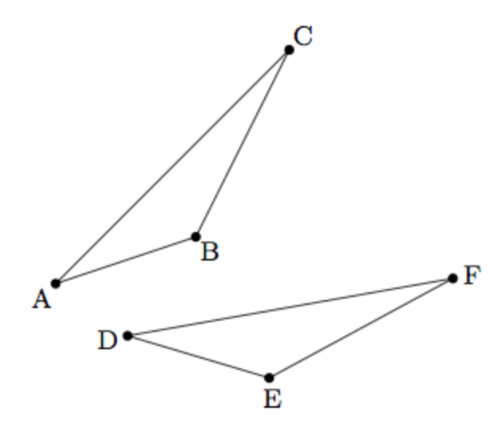
- Explain how to identify the center of rotation.

- Once you have found the center, how do you find the angle of rotation?

Source: Illustrative Mathematics

Origami Equilateral Triangle Task

Jessica is working to construct an equilateral triangle with origami paper and uses the following steps.

- First she folds the paper in half and then unfolds it, leaving the crease along the dotted line:

- Next Jessica folds two corners over to the center crease as shown in the picture below:


Explain why the two purple triangles meet in a point as the picture suggests and why the large white triangle is an equilateral triangle.

Source: Illustrative Mathematics

Let’s do some math! Round 1

Task 1: Brand Logo
Students are given a problem like this:

In the field of marketing, it is crucial to create a brand that stands out from the rest! Think about your favorite brand logos. What about those logos make them memorable?

One of the ways that companies capture their audience is through symmetry. Symmetrical patterns are said to give the human brain a sense of familiarity and order, making it easier to remember products. Take a moment to explore the article Why Do We Get So Much Pleasure From Symmetry? from the website howstuffworks to learn more.

- Name a brand that comes to mind for you initially. Explain any symmetry you see represented in the brand’s logo.
- Select two company logos with symmetry, one with line symmetry and one with rotational.
  - Make an argument for which logo is more aesthetically pleasing in terms of the type of symmetry.
  - Work to give detailed explanations wherever possible. For example, for the logo with rotational symmetry, identify and explain the degree of the rotation.
- Let’s explore a company logo that took a different approach by not using symmetry in its design.
  - Find and select a logo you like that fits this description. What is something about this logo you appreciate?
  - Redesign the logo so it is visually appealing and has rotational symmetry.
  - Explain your chosen degree of rotation for your new logo. What is the degree or rotation you decided to use? In what ways does this honor what you appreciate about the logo or company?

Sample Learning Experience
Launch this lesson with a “Which one doesn’t belong?” warm up activity. Create a four-image comparison of
logos that are a mix of symmetrical and non-symmetrical. Give students silent thinking time to create an
argument around their choice. Have them share out in groups or to the whole class. Consider using Four Corners to have students share their arguments with others who selected the same choice before sharing
with the whole class.

Questions that can be posed during share out:
- Which logos have line symmetry?
- Which logos have rotational symmetry? What do you think is the degree of rotation? What did you pay attention to in the logo to land on that response?
- What other logos come to mind? Which of these have symmetry? How can you tell?

Give students time to research logos as they work to respond to Question 2. Invite them to research logos in order to identify two logos: one with line symmetry and another with rotational. Monitor their progress and select student work that illustrates understanding of symmetry. Have students share out and explain identified symmetry for each logo selected. Encourage them to ask questions to each other. Consider using the following questions:

- What is clear to you from this explanation?
- What is something you want to hear more about?
- What additional questions surface for you?

Following the share out, give students an opportunity to further develop, modify, or revise their work.

Give students time to research logos as they work on Question 3 of the task. Invite them to identify a logo that does not utilize symmetry in its design. Give students time to begin exploration independently, then invite them to work in pairs to engage in the design process by selecting one of their logos to work together to make it more aesthetically pleasing. Give students the option to utilize tools and web-based applications, like tracing paper, Desmos, GeoGebra, Canva, or Photoshop as they redesign the logo of their choice. Consider concluding this exploration by having students participate in a gallery walk to showcase their designs.

Learning Principles
Engage with cognitively demanding tasks in heterogeneous settings (LP 1). Students should be given opportunities to grapple with multistep, non-routine tasks that promote mathematical rigor. These experiences should be differentiated so that all students engage in appropriate challenges—for example, through tasks with multiple entry points and solution pathways. These experiences should continue to integrate knowledge and skills developed in grades 6-8 at the level of sophistication of high school mathematics.

Engage in social activities (LP 2). Students should have opportunities to work independently and to communicate with one another about mathematics by engaging in collective and collaborative learning activities. Explaining and having opportunities to revise one’s thinking has excellent value in solidifying one’s knowledge.

Build conceptual understanding through reasoning (LP 3). Students should be given the opportunity to reason, justify, and problem solve with critical thinking, reading, writing, speaking, and listening. Through reasoning and work with multiple representations, students learn why procedures work and build a conceptual understanding of key mathematical ideas.

Have agency in their learning (LP 4). Students should be able to choose tasks and learning experiences that align with their interests and aspirations. All students have rich and varied experiences and home lives. Learning mathematics should bring students’ identities and interests to the fore and build on the strengths that they bring to the learning space.

View mathematics as a human endeavor across centuries (LP 5). Students should understand that mathematical ideas emanated over time from civilizations around the world and have opportunities to explore these contributions to mathematics. Students should develop an appreciation of mathematics as a human endeavor: one in which they feel a sense of belonging, where they see themselves as mathematicians, and one that offers opportunities to broaden their ideas about what mathematics is, how it is used, and who it is for.

See mathematics as relevant (LP 6). Students should engage with mathematics in ways that authentically involve real-world situations. Problem-solving contexts should allow students to perceive mathematics as a tool for addressing the questions that arise in everyday life, as well as the ways it can model our world and address global economic, social, and environmental challenges. Students should also engage with mathematics in ways that connect to academic disciplines and future careers by doing the mathematics used by artists, designers, engineers, and other professionals.

Employ technology as a tool for problem-solving and understanding (LP 7). Research indicates that technology is a powerful tool for learning deeper mathematics by improving calculation efficiency and enabling more sophisticated analysis. Students should learn to use technology, with emphasis put on widely used tools and software, such as calculators and spreadsheets, to make sense of models. Technology use should not be limited to supporting “doing mathematics,” but should also be used as a tool for displaying and communicating results to appropriate audiences.

Task 1: Brand Logo Student Work

Example 1:

Insert image of student work here

Example 2:

Insert image of student work here

Example 3:

Insert image of student work here

Let’s do some math! Round 2

Task 2: Mathematics in Art
Students are given a problem like this:

Part 1: Mathematics in Art
Artists like Kiayani “Kay” Douglas use mathematics as they design their artwork. In this task you will have the opportunity to learn more about Ms. Douglas and her art, as well as time and space to create your own artwork using some of the mathematical ideas she shares with us, and specifically tessellations.

Watch this interview with Ms. Douglas about her Portraits Collection and the use of tessellations: https://bit.ly/3Rh7tJM.
- What intrigued you about what Ms. Douglas shared? What questions did it surface for you?
- What might you want to learn or explore further in preparation to create your own artwork?
- What insights from Ms. Douglas’ video do you want to incorporate into your artwork?

Part 2: Create Your Own Artwork

In the video, we learned how Ms. Douglas designed the tessellations present in her portrait collection by working with a square. We also learned that working with tessellates and other tools, like ink and colored pencils, can be used to create images on that piece, much like Ms. Douglas’ outline of Africa and the power fist.

For this task you will explore and design a tessellating piece for your final work of art.
- Select a polygon to base your template (tessellating piece) on: a square or other polygon (triangle, rectangle, or hexagon).
- Explore ways to modify the polygon to create a piece that tessellates.
- Iterate your piece to create a sample tessellation using your template. What transformations are in play? What images can you see surfacing? What might you draw on it to create the image you want to share?
- Repeat Steps 1-3 until you find the shape you will use as the template of the tessellating piece in your artwork.

Create your work of art. Consider how you will use color, space, and other elements to design artwork that
you're proud of. Upon completing your artwork, write or record a statement addressing the following
questions:
- Tell us a little about yourself. What is something you learned about yourself in doing this work?
- Tell us about your art piece. What inspired this work? How would you describe the composition and elements of this piece? How would you describe what we’re looking at?
- Tell us about your tessellating piece. How did you construct the template? How did you design it to take on the image(s) it currently holds? What transformations are evident in your template?
- Tell us about the tessellation. How does your tessellating piece fill the space? How did you use this space? How would you describe the transformations present in your tessellation?

Sample Learning Experience

Part 1: Mathematics in Art
Begin by inviting students to share what they know about how mathematics may surface in art. Listen for students sharing elements such as shapes, symmetry, perspective, patterns, and proportion. Use these elements to set the stage for listening to Kiayani “Kay” Douglas’ video. Share the video. Facilitate a discussion and have students reflect on what they heard.

Highlight the use of transformations to form the background for the shared artwork. Encourage students to
visit Ms. Douglas’ website, https://www.iamkaydouglas.com/, to explore and look at the images she highlighted more closely.

Move the conversation towards coming to a shared understanding of what a tessellation is and establish comfort with identifying the tessellating piece. Encourage students to identify and share where tessellations might be found in everyday life, e.g., tile work on floors and walls, some wallpaper patterns, and rugs.

Part 2: Create Your Own Artwork

Give students individual work time to develop a template for the tessellating piece. You may opt to use pattern blocks as a precursor to deepen an understanding of how polygons work to tessellate a plane. For example, we can tile using one polygon—tessellating piece—or we may use multiple pieces to tile a plane. Pattern blocks can make that visible. This exploration can lead to a list of polygons that students may want to consider as the basis of their tessellation.

Provide students multiple copies of various polygons they can use to explore different options, as illustrated here: Math Engaged; Tessellations. As students work, encourage them to explore the impact of translating, reflecting, and rotating cut-outs on overall tessellation (Steps 2 and 3). Encourage students to work in pairs as they create their template to share and discuss their progress with each other. Make dynamic geometric applications, like Desmos and Geogebra, available for students to use to create their template and tessellation.

Monitor and select student work to share with the class. Ask selected students to share how they have approached the task of creating the template for the tessellating piece. Consider asking:

- How did you go from the original polygon to the shape we see now?
- What transformations did you use?
- How would you describe what you see happening as you tessellate your piece? What transformations do you see in play?

Encourage students to engage with and make sense of each other’s designs, using these questions:

- What do you appreciate about this approach?
- What questions does this approach surface for you?
- What can you take from this approach to apply to your own work?

Provide opportunity for students to return to their work to revise, modify, and finalize their template.

Once they have finalized their template, consider having students display their template under a document camera or overhead, so that classmates can share what they might “see” in the template, e.g., a flower, a ship, a car, an animal, etc. This may help students with adding details to their template to create their artwork.

Provide the opportunity for students to return to their work to revise, modify, and finalize the design of their template.

Provide additional time for students to complete their artwork and determine a way to tell their story. You
may opt to host a gallery walk when all pieces are complete and invite community members to attend.

Task 2: Mathematics in Art Student Work

Example 1:

Insert image of student work here

Example 2:

Insert image of student work here

Example 3:

Insert image of student work here

Criteria for Success

Conference and Provide Revision Support | Accept with Revision | Accept
The student’s artifact shows an emerging understanding of the expectations of the indicator(s). After conferencing and additional instruction/learning, the student may provide a revised or different artifact as evidence of the indicator(s). | The student’s artifact is approaching a full understanding of the expectations of the indicator(s). The artifact may contain execution errors that should be corrected in revision. The student may revise the selected artifact or submit a different artifact. | The student’s artifact demonstrates evidence that they have met the expectations of the indicator(s).

References

Math Engaged. “Tessellations.” Math Engaged, Math Engaged, http://mathengaged.org/resources/activities/art-projects/tessellations/. Accessed 22 August 2023.

