Example 1: Everything Is All Right!

What do you know to be true about the triangle shown below? Explain your thinking with mathematical or written justification.
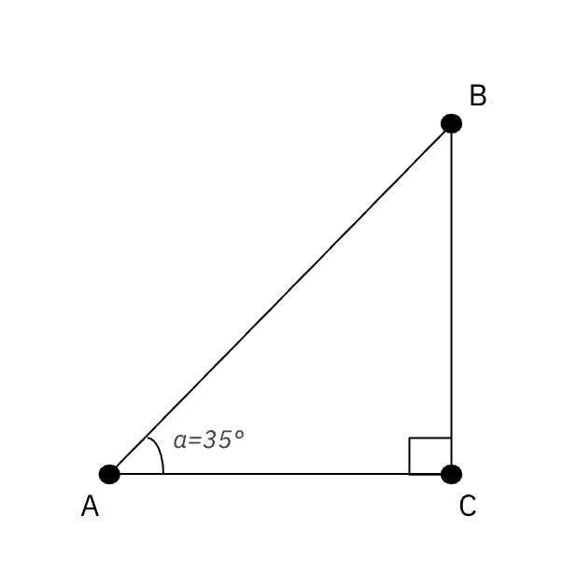

In this task, we will explore ratios of sides of right triangles to expand ways we can work with right triangles.

- Use measurement tools or dynamic geometry software such as GeoGebra or Desmos to construct a right triangle, with a right angle at B and a 35° angle at A. What do you notice? Create a sketch of your triangle below, noting any unique features or components.

- Here is some terminology used to describe the relationship between the sides of a right triangle and the reference angle, which in this case is angle A.
- Side $\underline{AB}$is the hypotenuse of this right triangle,
- Side $\underline{BC}$is the side opposite angle A, and
- Side $\underline{AC}$is the side adjacent to angle A.
Take a moment to study the image from earlier. What makes sense to you about how each side is referred to?

- Measure the three sides of the triangle and record the lengths in the table.
Side
Length

- Find each of the ratios listed in the table.

Ratio | $\frac{length of leg opposite angle A}{length of leg adjacent to angle A}$ | $\frac{length of leg opposite angle A}{length of the hypotenuse}$ | $\frac{length of leg adjacent angle A}{length of the hypotenuse}$
Measurement

Given what you explored today, respond to the following prompts.

- If you were to compare the side measurements you found with those of your classmates, how do you think those measurements will compare? Are there any relationships between the side lengths you anticipate will still hold? Why does that make sense?

- If you were to compare the ratios you found with those of your classmates, how do you think those ratios would compare? Why does that make sense?

- Do you think the relationships you’ve noticed hold true for any right triangle? Construct additional right triangles to demonstrate your conjecture.

Example 2: Too Tall to Measure

When we measure objects, we can often use a measuring tape, ruler or other tool. But what if the object we need to know the height of is much taller than we are? Choose a tall object to determine the height of -- one that is too tall to measure with a tape measure or ruler.

Using a measurement app on a smartphone, measure the height of the object three times.

- Why do you think you should do the measurement three times instead of just once?

- Record your measurements in the data table below.
Which object did you choose? | Measurement Trial 1 | Measurement Trial 2 | Measurement Trial 3

- Now, determine another way to measure the height of the object. Describe the new process you used and the height you determined.

- Choose two additional objects and repeat the process. Record three trials using the measurement app. Then use the other process and record that height as well.
Which object did you choose? | Measurement Trial 1 | Measurement Trial 2 | Measurement Trial 3 | Height Determined Another Way

- Based on your research, how well do you think the measurement app works?

