Baseline Professional Learning Handout
M103 Modeling with Functions of Quadratic Type

Baseline Professional Learning Handout 1
Functions Progression Excerpt 5
M103 Content and Practice Expectations 5
M103 Content and Practice Expectations and Indicators 6
Let’s Investigate 8
Skeleton Tower Task 8
Profit of a Company Task 9
Let’s do some math! Round 1 10
Task 1: Rocket Launch 10
Learning Principles 13
Task 1: Rocket Launch Student Work 14
Let’s do some math! Round 2 15
Task 2: Height of a Ball 15
Task 2: Height of a Ball Student Work 17
Criteria for Success 18
References 18
Selected Common Core High School Standards for Mathematics

High School - Algebra
Write expressions in equivalent forms to solve problems
- Choose and produce an equivalent form of an expression to reveal and explain properties of the quantity represented by the expression.★
  - Factor a quadratic expression to reveal the zeros of the function it defines.
  - Complete the square in a quadratic expression to reveal the maximum or minimum value of the function it defines.

Create equations that describe numbers or relationships ★
- Create equations in two or more variables to represent relationships between quantities; graph equations on coordinate axes with labels and scales.

Solve equations and inequalities in one variable
- Solve quadratic equations in one variable.
  - Use the method of completing the square to transform any quadratic equation in x into an equation of the form ${(x-p)}^{2}=q$ that has the same solutions. Derive the quadratic formula from this form.
  - Solve quadratic equations by inspection (e.g., for $x^{2}=49$), taking square roots, completing the square, the quadratic formula and factoring, as appropriate to the initial form of the equation. Recognize when the quadratic formula gives complex solutions and write them as $a±bi$ for real numbers a and b.

High School - Functions
Interpret functions that arise in applications in terms of the context
- For a function that models a relationship between two quantities, interpret key features of graphs and tables in terms of the quantities, and sketch graphs showing key features given a verbal description of the relationship. Key features include: intercepts; intervals where the function is increasing, decreasing, positive, or negative; relative maximums and minimums; symmetries; end behavior; and periodicity.★

- Relate the domain of a function to its graph and, where applicable, to the quantitative relationship it describes. For example, if the function h(n) gives the number of person-hours it takes to assemble n engines in a factory, then the positive integers would be an appropriate domain for the function.★

- Calculate and interpret the average rate of change of a function (presented symbolically or as a table) over a specified interval. Estimate the rate of change from a graph.★

Analyze functions using different representations
- Graph functions expressed symbolically and show key features of the graph, by hand in simple cases and using technology for more complicated cases.★
a. Graph linear and quadratic functions and show intercepts, maxima, and minima.

- Write a function defined by an expression in different but equivalent forms to reveal and explain different properties of the function.
  - Use the process of factoring and completing the square in a quadratic function to show zeros, extreme values, and symmetry of the graph, and interpret these in terms of a context.

- Compare properties of two functions each represented in a different way (algebraically, graphically, numerically in tables, or by verbal descriptions). For example, given a graph of one quadratic function and an algebraic expression for another, say which has the larger maximum.

Build a function that models a relationship between two quantities
- Write a function that describes a relationship between two quantities.★
  - Determine an explicit expression, a recursive process, or steps for calculation from a context.
  - Combine standard function types using arithmetic operations. For example, build a function that models the temperature of a cooling body by adding a constant function to a decaying exponential, and relate these functions to the model.

High School - Modeling
Modeling links classroom mathematics and statistics to everyday life, work, and decision-making. Modeling is the process of choosing and using appropriate mathematics and statistics to analyze empirical situations, to understand them better, and to improve decisions. Quantities and their relationships in physical, economic, public policy, social, and everyday situations can be modeled using mathematical and statistical methods. When making mathematical models, technology is valuable for varying assumptions, exploring consequences, and comparing predictions with data.

A model can be very simple, such as writing total cost as a product of unit price and number bought, or using a geometric shape to describe a physical object like a coin. Even such simple models involve making choices. It is up to us whether to model a coin as a three-dimensional cylinder, or whether a two-dimensional disk works well enough for our purposes. Other situations—modeling a delivery route, a production schedule, or a comparison of loan amortizations—need more elaborate models that use other tools from the mathematical sciences. Real-world situations are not organized and labeled for analysis; formulating tractable models, representing such models, and analyzing them is appropriately a creative process. Like every such process, this depends on acquired expertise as well as creativity. Some examples of such situations might include:
- Estimating how much water and food is needed for emergency relief in a devastated city of 3 million people, and how it might be distributed.
- Planning a table tennis tournament for 7 players at a club with 4 tables, where each player plays against each other player.
- Designing the layout of the stalls in a school fair so as to raise as much money as possible.
- Analyzing stopping distance for a car.
- Modeling savings account balance, bacterial colony growth, or investment growth.
- Engaging in critical path analysis, e.g., applied to turnaround of an aircraft at an airport.
- Analyzing risk in situations such as extreme sports, pandemics, and terrorism.
- Relating population statistics to individual predictions.

In situations like these, the models devised depend on a number of factors: How precise an answer do we want or need? What aspects of the situation do we most need to understand, control, or optimize? What resources of time and tools do we have? The range of models that we can create and analyze is also constrained by the limitations of our mathematical, statistical, and technical skills, and our ability to recognize significant variables and relationships among them. Diagrams of various kinds, spreadsheets and other technology, and algebra are powerful tools for understanding and solving problems drawn from different types of real-world situations. One of the insights provided by mathematical modeling is that essentially the same mathematical or statistical structure can sometimes model seemingly different situations. Models can also shed light on the mathematical structures themselves, for example, as when a model of bacterial growth makes more vivid the explosive growth of the exponential function.

The basic modeling cycle is summarized in the diagram. It involves (1) identifying variables in the situation and selecting those that represent essential features, (2) formulating a model by creating and selecting geometric, graphical, tabular, algebraic, or statistical representations that describe relationships between the variables, (3) analyzing and performing operations on these relationships to draw conclusions, (4) interpreting the results of the mathematics in terms of the original situation, (5) validating the conclusions by comparing them with the situation, and then either improving the model or, if it is acceptable, (6) reporting on the conclusions and the reasoning behind them. Choices, assumptions, and approximations are present throughout this cycle.

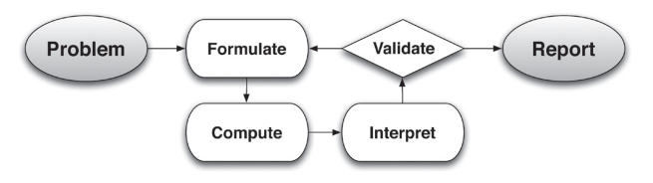

In descriptive modeling, a model simply describes the phenomena or summarizes them in a compact form. Graphs of observations are a familiar descriptive model— for example, graphs of global temperature and atmospheric CO2 over time.

Analytic modeling seeks to explain data on the basis of deeper theoretical ideas, albeit with parameters that are empirically based; for example, exponential growth of bacterial colonies (until cut-off mechanisms such as pollution or starvation intervene) follows from a constant reproduction rate. Functions are an important tool for analyzing such problems. Graphing utilities, spreadsheets, computer algebra systems, and dynamic geometry software are powerful tools that can be used to model purely mathematical phenomena (e.g., the behavior of polynomials) as well as physical phenomena. Modeling Standards Modeling is best interpreted not as a collection of isolated topics but rather in relation to other standards. Making mathematical models is a Standard for Mathematical Practice, and specific modeling standards appear throughout the high school standards indicated by a star symbol (★).

High School - Statistics and Probability
- Represent data on two quantitative variables on a scatter plot, and describe how the variables are related.
- Fit a function to the data; use functions fitted to data to solve problems in the context of the data. Use given functions or choose a function suggested by the context. Emphasize linear, quadratic, and exponential models.

Functions Progression Excerpt
Functions and Modeling In modeling situations, knowledge of the context and statistics are sometimes used together to find a function defined by an algebraic expression that best fits an observed relationship between quantities. (Here “best” is assessed informally, see the Modeling Progression and high school Statistics and Probability Progression for further discussion and examples.) Then the algebraic expressions can be used to interpolate (i.e., approximate or predict function values between and among the collected data
values) and to extrapolate (i.e., to approximate or predict function values beyond the collected data values). One must always ask whether such approximations are reasonable in the context.

In school mathematics, functional relationships are often given by algebraic expressions. For example, f(n) = n² for n ≥ 1 gives the n^{th} square number. But in many modeling situations, such as the temperature at Boston’s Logan Airport as a function of time, algebraic expressions may not be suitable. (Common Core Writing Team, 2003, p. 3)

M103 Content and Practice Expectations
103.a | Engage in the modeling cycle.
103.b | Interpret quadratic functions that arise in applications in terms of the context.
103.c | Analyze quadratic functions using different representations.
103.d | Build quadratic functions that model relationships between two quantities.
103.e | Construct and compare linear and quadratic models, solve problems, and draw conclusions.
103.f | Interpret expressions for quadratic functions in terms of the situation they model.
103.g | Summarize, represent, and interpret data on two quantitative variables for linear and quadratic model fits.
103.h | Understand the relevance of modeling with quadratic functions.
103.i | Use a quadratic function model to determine values of interest in a real-world problem.

M103 Content and Practice Expectations and Indicators
Content and Practice Expectations | Indicators  Choose an artifact where you…
103.a: Engage in the modeling cycle (performance assessment). | i. engage with the full modeling cycle (problem, formulate, compute, interpret, validate, revise as necessary, report).
103.b: Interpret quadratic functions that arise in applications in terms of the context. | i. select two different data points that illustrate something interesting or important about the context you are modeling and describe what these points tell you about the topic.
 | ii. use a model to compute output values and then interpret the values in the problem’s context.
 | iii. describe the domain of the quadratic function, including anything noticed about values that are not part of the domain or why the shape of the model might change for particular values of the domain.
 | iv. describe the contextual meaning of the average rate of change between two points for a quadratic function.
103.c: Analyze quadratic functions using different representations. | i. create a quadratic graph to show a particular context and describe important values that help understand something about the problem you are exploring.
 | ii. explain how the parameters of a quadratic model relate to its graph.
103.d: Build quadratic functions that model relationships between two quantities. | i. identify the variables of interest in a given situation or data set that are interesting and that demonstrate a quadratic relationship.
 | ii. build a function that models the quadratic relationship between two quantities in a situation.
103.e: Construct and compare linear and quadratic models and solve problems. | i. distinguish between situations that can be modeled with linear functions and those that can be modeled with quadratic functions, based on the quantities involved or through analysis of the rate of change.
 | ii. provide insight into why some relationships are linear and others are quadratic, or explain why, in terms of a situation being modeled, a quadratic function is a better model than a linear function.
103.f: Interpret expressions for quadratic functions in terms of the situation they model. | i. describe the meaning of the parameters for a quadratic function in terms of the context.
103.g: Summarize, represent, and interpret data on two quantitative variables for linear and quadratic model fits. | i. choose a particular representation of your data to communicate something important to a particular person or audience and explain why you made that choice. In this badge, students are encouraged to investigate patterns of association in bivariate data, which includes informal description of the fit of the curve and addresses the usefulness of the model for the particular context.
103.h: Understand the relevance of modeling with quadratic functions. | i. recognize something that surprised you or that you learned about the topic through quadratic modeling of data. Share what surprised you or what you learned.
 | ii. highlight something you are most proud of in your learning about quadratic modeling.
 | iii. explain how modeling can be used to answer important questions.
103.i: Use a quadratic function model to determine values of interest in a real-world problem. | i. determine one or more output values for specific inputs to the function.

Let’s Investigate

Skeleton Tower Task
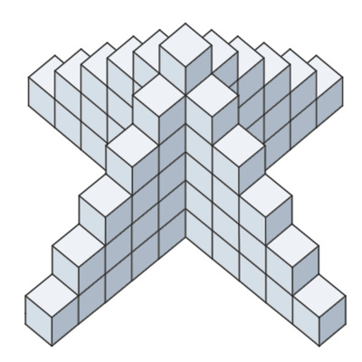
- How many cubes are needed to build this tower?

- How many cubes are needed to build a tower like this, but 12 cubes high? Justify your reasoning.

- How would you calculate the number of cubes needed for a tower n cubes high?

Source: Illustrative Mathematics

Profit of a Company Task

The proﬁt that a company makes selling an item (in thousands of dollars) depends on the price of the item (in dollars). If p is the price of the item, then three equivalent forms for the proﬁt are:

Standard form: $-2p^{2}+24p-54$
Factored form: $-2(p-3)(p-9)$
Vertex form: $-{(p-6)}^{2}+18$

Which form is most useful for ﬁnding

- The prices that give a proﬁt of zero dollars?

- The proﬁt when the price is zero?

- The price that gives the maximum proﬁt?

Source: Illustrative Mathematics

Let’s do some math! Round 1

Task 1: Rocket Launch

Students are given a problem like this to work on in groups:

Part 1: Making sense of rocket launches

- Watch this video of Grasshopper 744m Test| Single Camera (Hexacopter).
- Reflect: What questions does this clip bring to mind?
- Sketch a diagram that illustrates the rocket’s flight. Use the diagram you developed to sketch a graph.
- Read the article “Why SpaceX wants to land a rocket on a platform in the ocean” by Joseph Stromberg.
- What questions do the article and the video answer? What new questions does this surface for you?

Part 2: Modeling with Quadratics

After some trials, SpaceX learned to control the flight of reusable rockets used to launch spaceships into space.

- Watch and gather data from SpaceX’ April 2022 launch of Ax-1 [watch from about 3:26 to 3:36] to create a model for the flight of the Phase 1 rocket used in that mission.
- Prepare to share your findings.
- What new questions surface for you?

Sample Learning Experience

Part 1: Making sense of rocket launches

Begin by inviting students to share what they know about space exploration. Listen for stories where students express curiosity about launching objects into space: how are things launched, do these objects ever come back, and what happens to objects once they are launched into space? Use these themes to set up SpaceX’s work with reusable rockets. Share the video of Grasshopper’s 744m Test (1:36) from their early efforts in the development of these rockets.

Monitor students as they work to sketch the rocket’s flight. Select student responses to highlight. Some possible approaches may take the following forms:

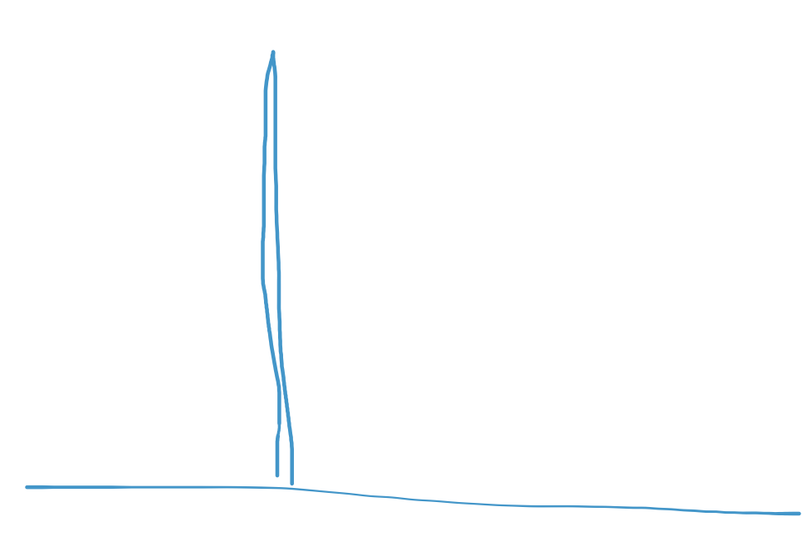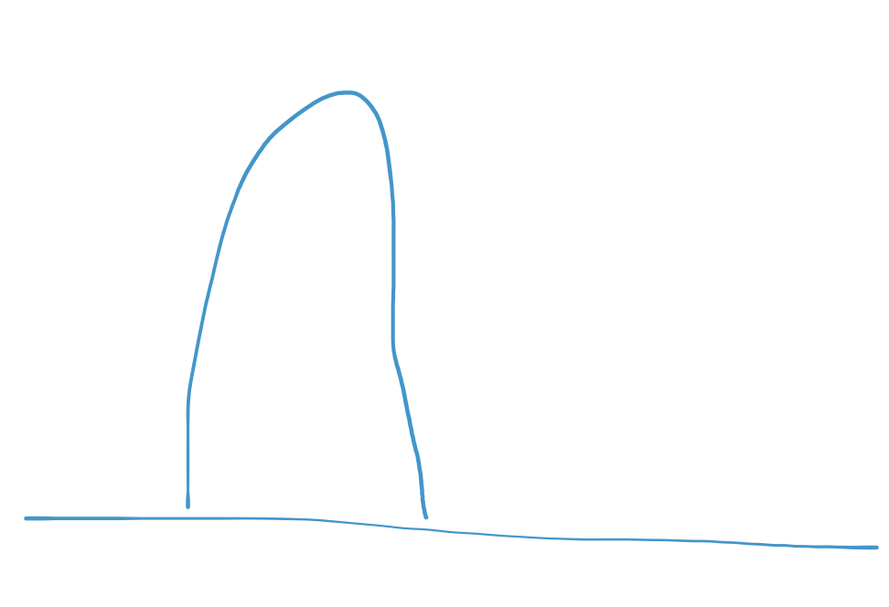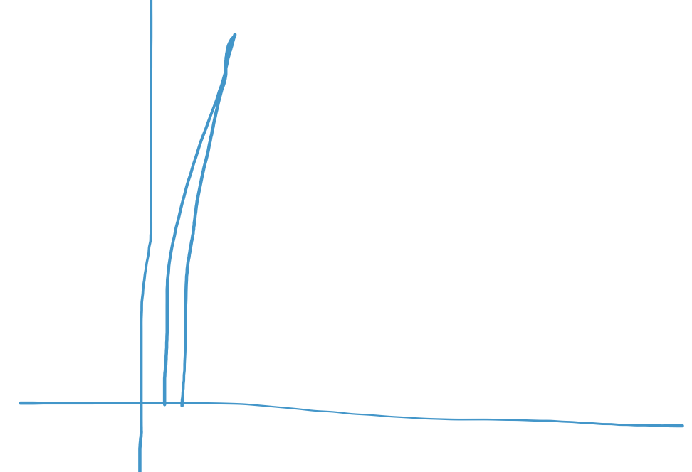

As students share their sketches with classmates, invite them to make sense of each other’s sketches. Consider the following questions:

- What are some things you appreciate about this sketch?
- What questions does this sketch surface for you?
- Do you think the sketch is reasonable? Why or why not?
- What do your horizontal and vertical axes represent?
- What can you take from this approach to apply to your own work?
- What are some quantities we could track and work to represent in mathematical ways? What questions could we answer with that information?

As you bring the discussion of Part 1 to a close, give students time to make note of new insights they have gained into rocket flights. Consider amplifying ideas around what quantities they want to track and ask how they might measure or get that information.

Part 2: Modeling with Quadratics

Share with students, “Since SpaceX’s efforts in 2013 with the Grasshopper rocket, they have made tremendous progress.”

Use thoughts students shared in discussion of Part 1 to set the stage for viewing the video of the April 8, 2022, Ax-1 Mission. This video tracks the time, speed (km/hr.), and altitude for both the Phase 1 and Phase 2 rockets. Encourage students to focus on the Phase 1 rocket.

Give students a few minutes of individual work time before encouraging them to work in a small group. Students should have access to spreadsheets and graphing software or calculators. As they join their small groups, ask students to take time to share and make sense of each other’s approach. As students share progress made within their small groups, select a couple of strategies to share with the whole class. The focus of this whole group discussion is to provide space for students to make sense of various approaches and gain insights into their own thinking. The goal is not to discuss a model just yet.

Consider using the following prompts to facilitate the conversation:

- What makes sense about this approach?
- What questions does this approach surface for you?
- Do you think the approach (or model) is reasonable? Why or why not?
- What can you take from this approach to apply to your own work?

Some possible graphs students may develop:

Speed (km/s) vs. time Altitude (m) vs. time
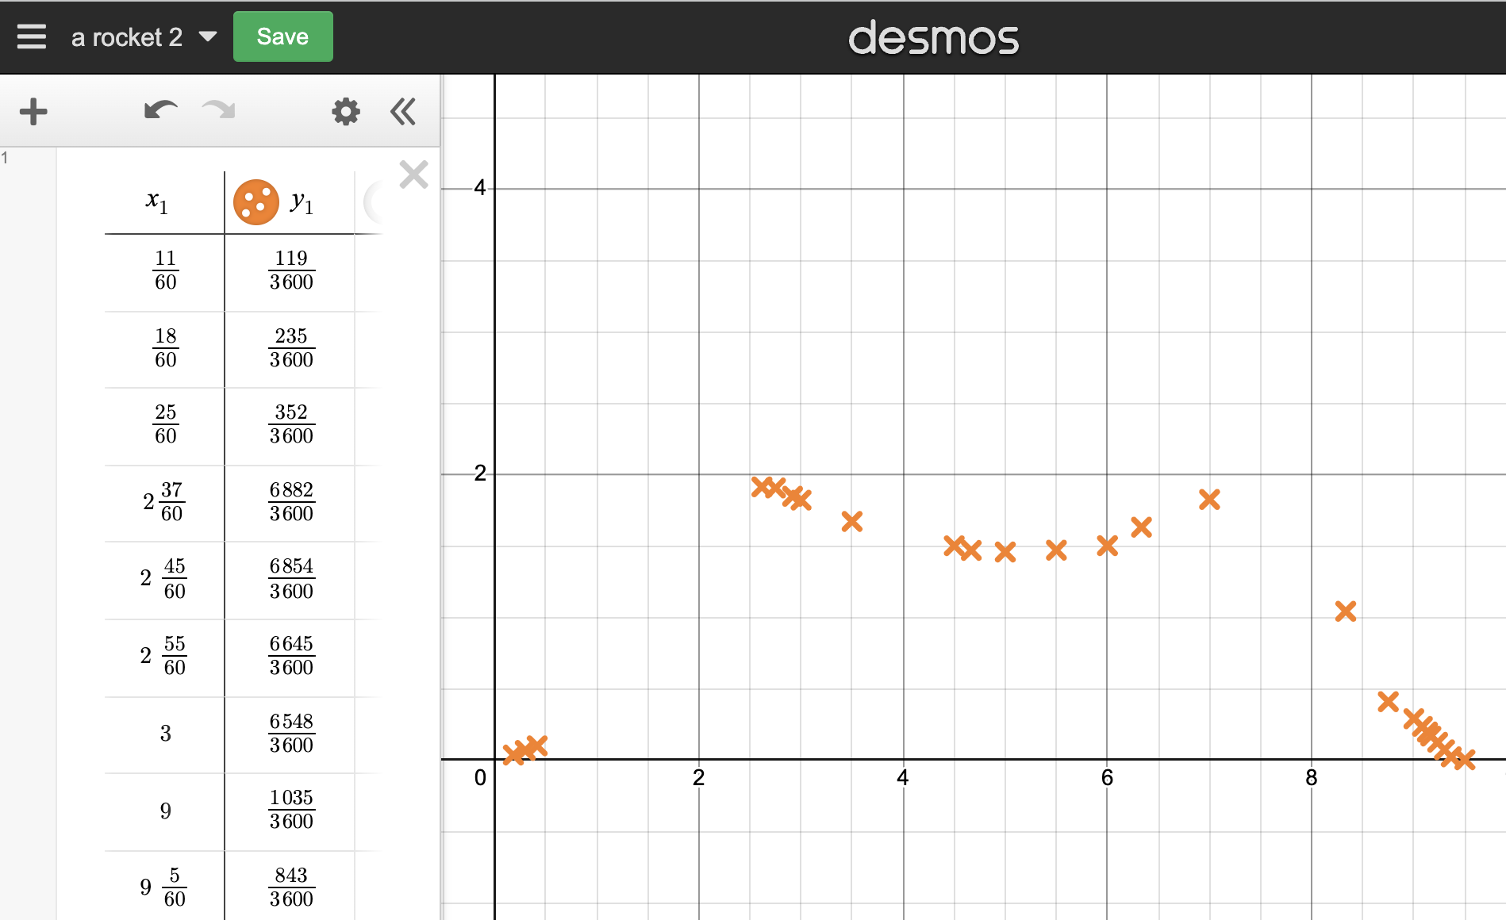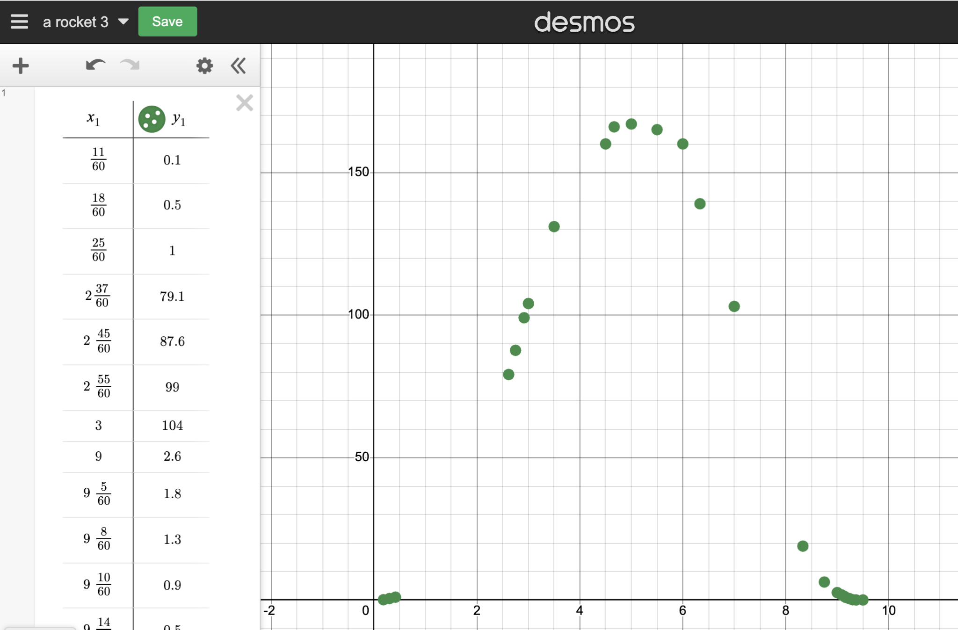

Give students additional time to use insights gained from sharing to revise and further develop their models. The image below illustrates a manual fit (purple) quadratic and one from a regression analysis. As student groups work, monitor and note different approaches they take to find a quadratic model they feel best fits the data gathered. Select varied approaches to share with the whole class.

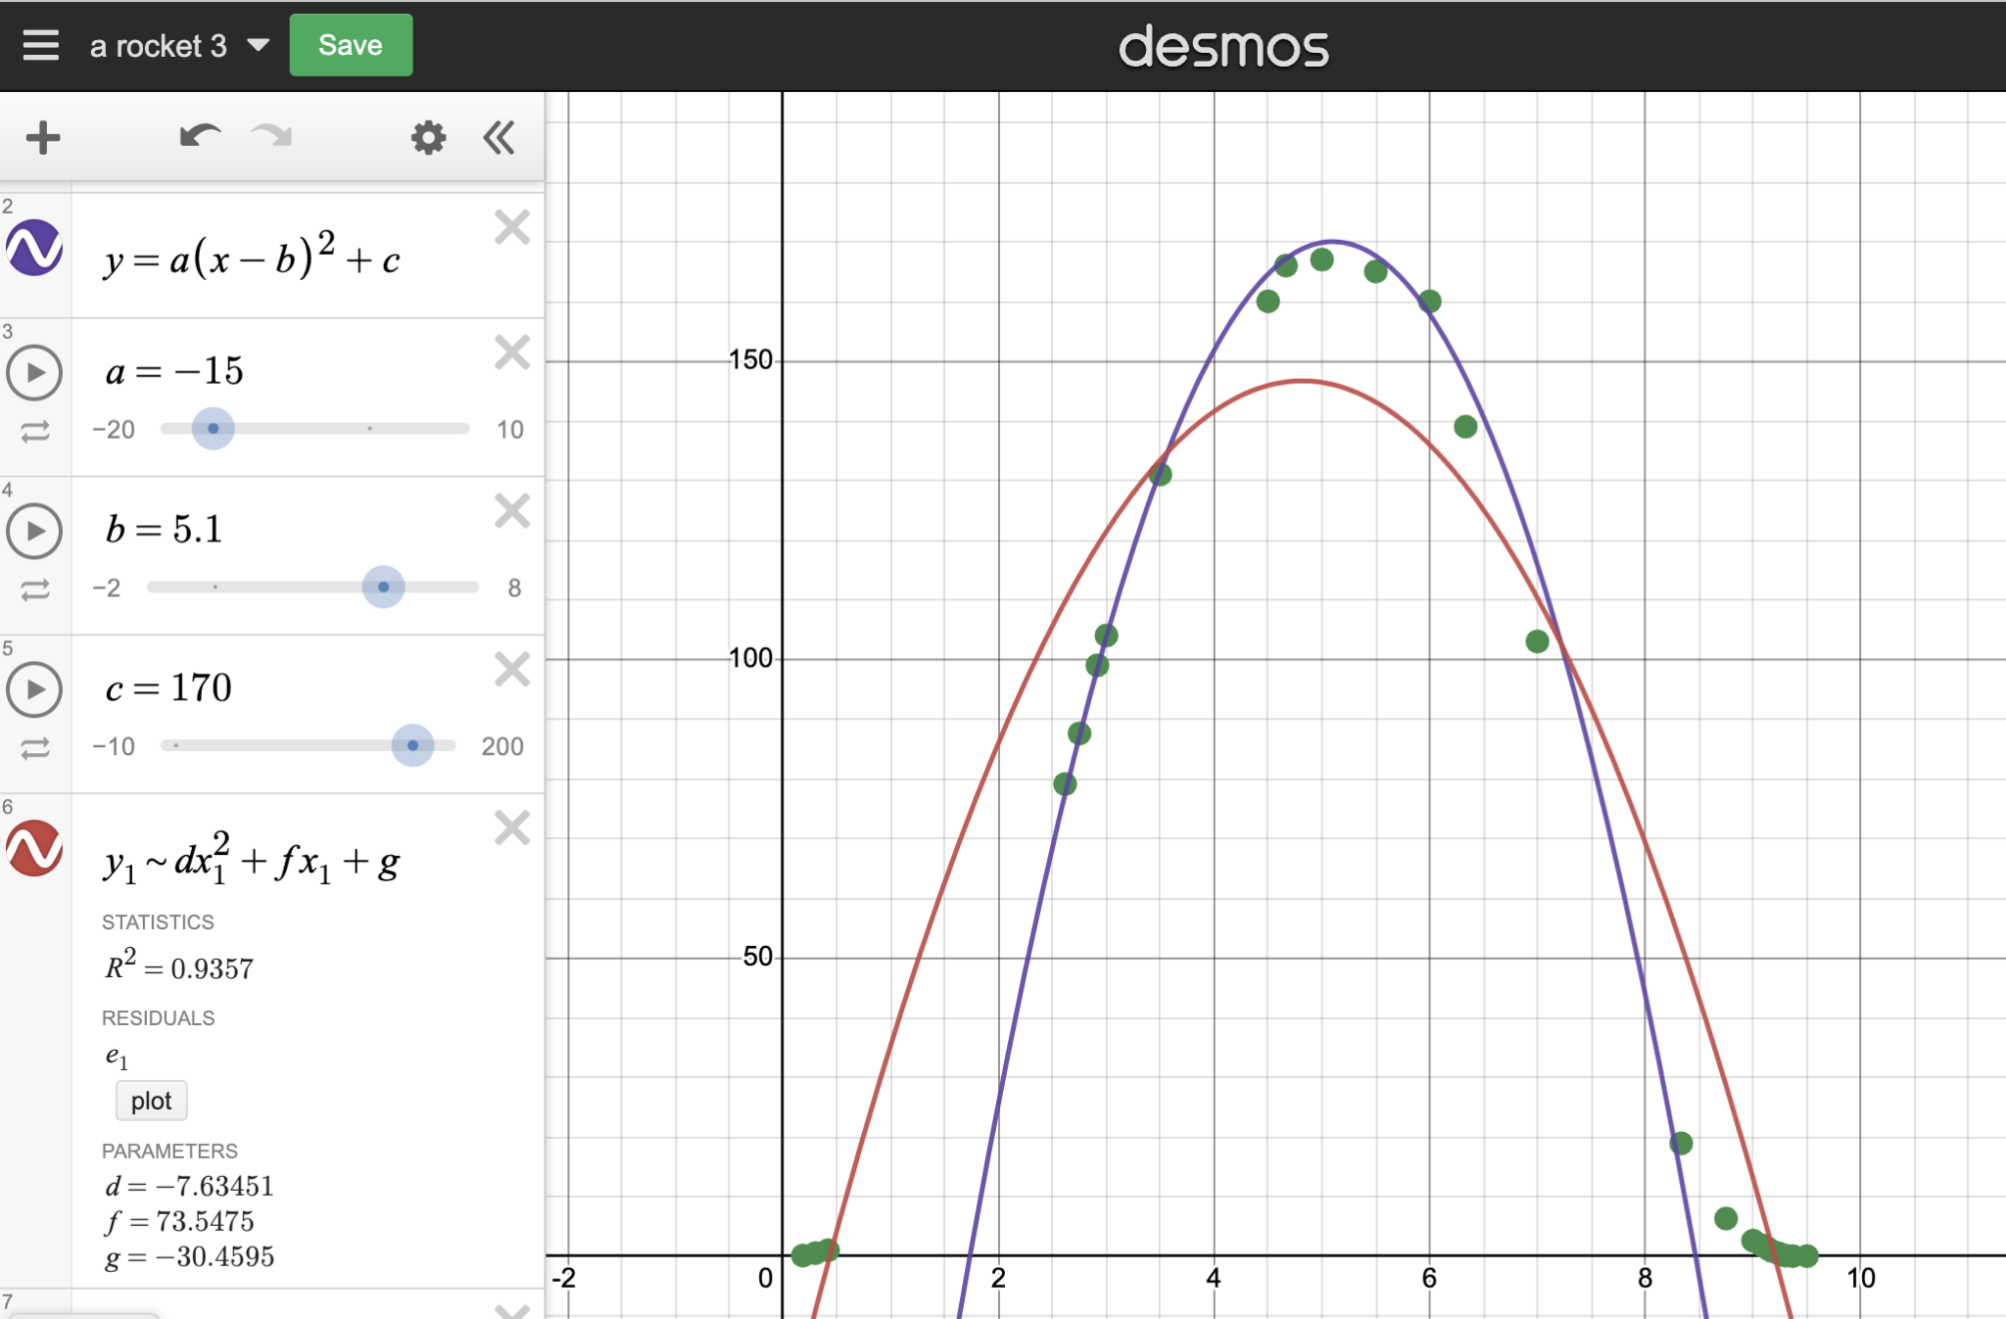

Consider using the following prompts to facilitate the conversation:

- What’s promising about this approach?
- What questions does this approach surface for you?
- Do you think the model is reasonable? Why or why not?
- What can you take from this approach to apply to your own work?

Amplify aspects of the conversation that:

- attempt to explain the quadratic nature of this relationship.
- contextualize the key features of the graph.
- lead to the equation of this quadratic function.

Allow students the opportunity to return to their work to revise, as necessary.

Have students work in pairs to complete the task. Allow them the option of using chart paper, Google Slides, or other creative outlets to showcase their work.

Learning Principles
Engage with cognitively demanding tasks in heterogeneous settings (LP 1). Students should be given opportunities to grapple with multistep, non-routine tasks that promote mathematical rigor. These experiences should be differentiated so that all students engage in appropriate challenges—for example, through tasks with multiple entry points and solution pathways. These experiences should continue to integrate knowledge and skills developed in grades 6-8 at the level of sophistication of high school mathematics.

Engage in social activities (LP 2). Students should have opportunities to work independently and to communicate with one another about mathematics by engaging in collective and collaborative learning activities. Explaining and having opportunities to revise one’s thinking has excellent value in solidifying one’s knowledge.

Build conceptual understanding through reasoning (LP 3). Students should be given the opportunity to reason, justify, and problem solve with critical thinking, reading, writing, speaking, and listening. Through reasoning and work with multiple representations, students learn why procedures work and build a conceptual understanding of key mathematical ideas.

Have agency in their learning (LP 4). Students should be able to choose tasks and learning experiences that align with their interests and aspirations. All students have rich and varied experiences and home lives. Learning mathematics should bring students’ identities and interests to the fore and build on the strengths that they bring to the learning space.

View mathematics as a human endeavor across centuries (LP 5). Students should understand that mathematical ideas emanated over time from civilizations around the world and have opportunities to explore these contributions to mathematics. Students should develop an appreciation of mathematics as a human endeavor: one in which they feel a sense of belonging, where they see themselves as mathematicians, and one that offers opportunities to broaden their ideas about what mathematics is, how it is used, and who it is for.

See mathematics as relevant (LP 6). Students should engage with mathematics in ways that authentically involve real-world situations. Problem-solving contexts should allow students to perceive mathematics as a tool for addressing the questions that arise in everyday life, as well as the ways it can model our world and address global economic, social, and environmental challenges. Students should also engage with mathematics in ways that connect to academic disciplines and future careers by doing the mathematics used by artists, designers, engineers, and other professionals.

Employ technology as a tool for problem-solving and understanding (LP 7). Research indicates that technology is a powerful tool for learning deeper mathematics by improving calculation efficiency and enabling more sophisticated analysis. Students should learn to use technology, with emphasis put on widely used tools and software, such as calculators and spreadsheets, to make sense of models. Technology use should not be limited to supporting “doing mathematics,” but should also be used as a tool for displaying and communicating results to appropriate audiences.

Task 1: Rocket Launch Student Work

Example 1:

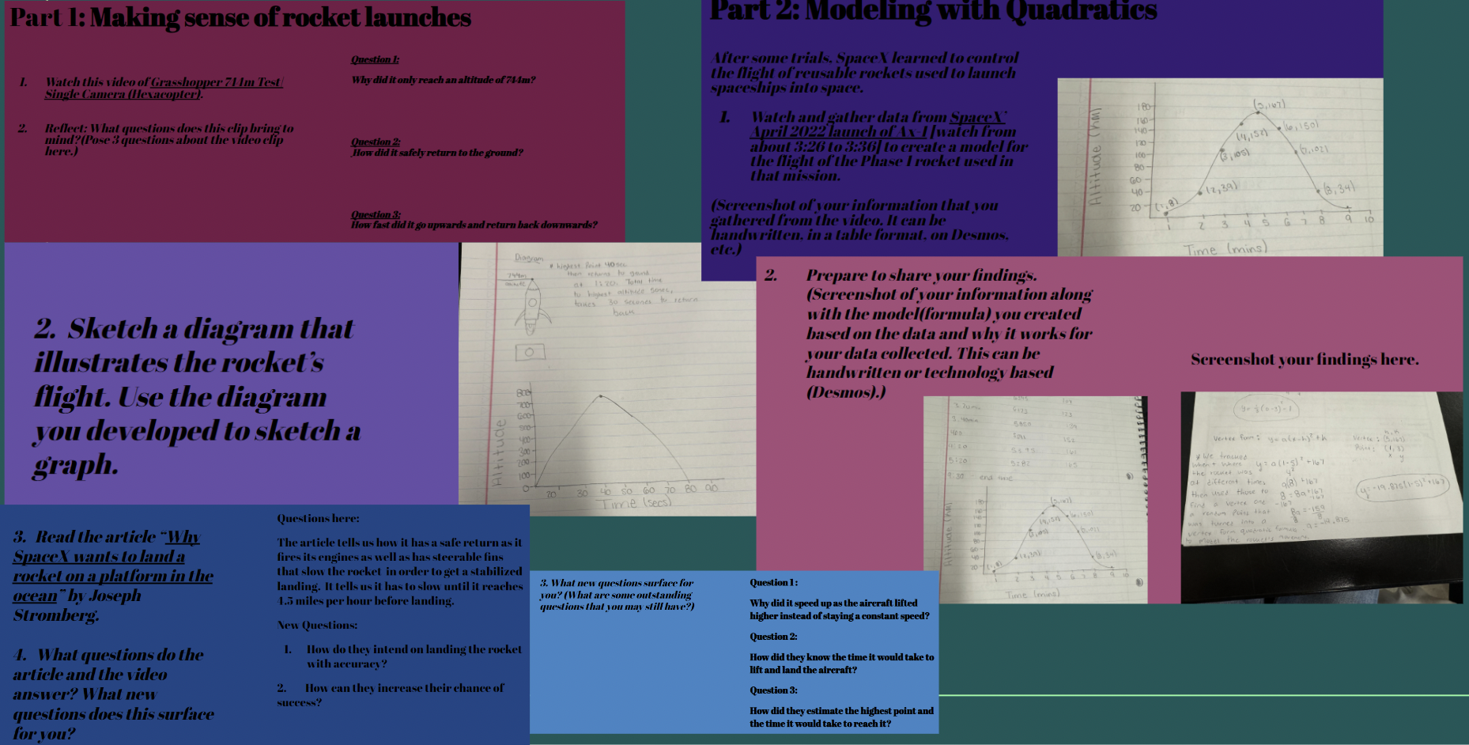

Example 2:

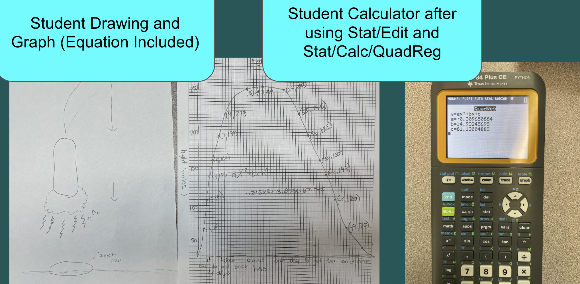

Example 3:

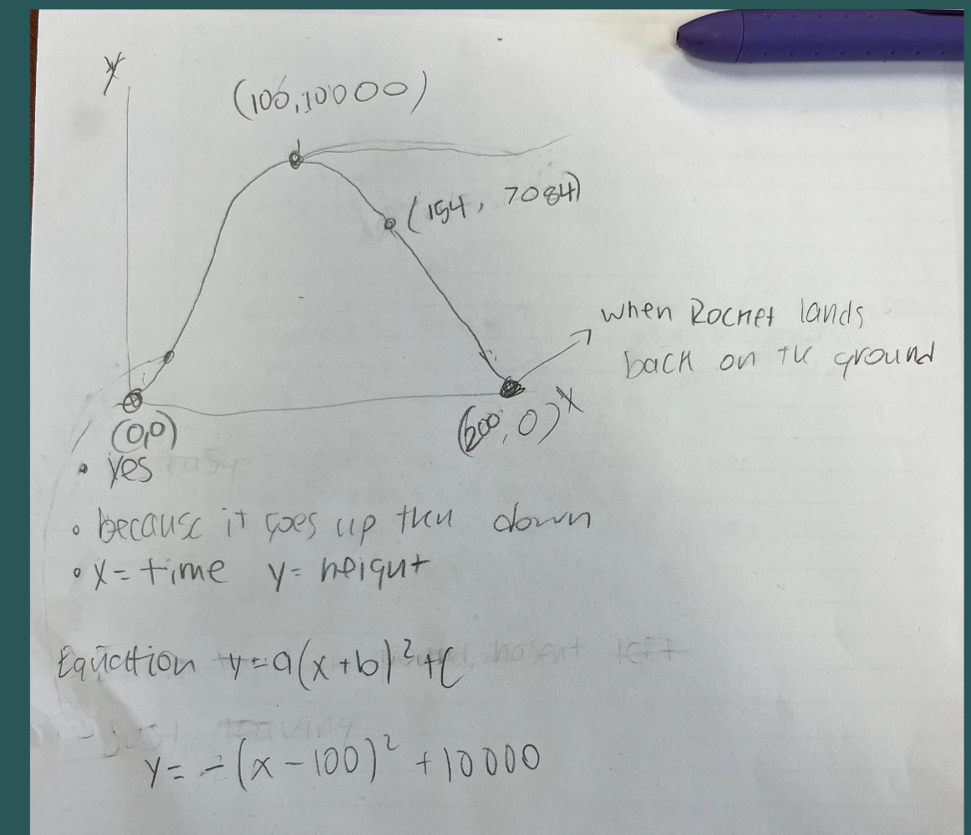

Let’s do some math! Round 2

Task 2: Height of a Ball

Students are given a problem like this to work on in groups:

Work with your group to develop a model that describes the height of a ball thrown at a given time during the throw. Have one person in the group throw a ball while another records a video of the event. Make sure that the video includes the entire path of the ball from the throw to when it hits the ground. Prepare your findings to share with the class.

Sample Learning Experience
Students could be given the largely unstructured task above, along with the tools needed to carry it out: a ball, recording technology, and tools to make mathematical models, like spreadsheets and access to graphing software. Consider bringing the class together at strategic points to facilitate progress toward the goal of developing a mathematical model.

In these instances, monitor, select, and sequence groups to report on their efforts.

The following questions can be used to facilitate discussion early in the process:

- Watch a selected group’s video. Ask students to describe what they notice while watching the video. Listen for descriptions of key elements, such as the height of the ball upon release, the highest point the ball reached, and when and where the ball landed.
- Ask students, “How might we represent this mathematically?”
As students share, make note of ideas that surface. When they use hand signals or share descriptions that allude to the graph of a quadratic function, encourage students to sketch what that might look like.
- Once a sketch of a graph is offered, ask students, “What quantities are captured here?” in order to develop insights into what quantities they will work on to define and then gather data.
- Use the list of what students noticed in #1 above to frame the next phase of investigation. For example, you may build from a statement like “The ball hits a high point before coming back down” to ask, “How high was the ball above the ground at its highest point?” Invite students to discuss and brainstorm the following question: “What makes finding this difficult and how can you persevere?”
- Ask students to reflect on the question “What can you take from this discussion to apply to your own work?” before continuing with their investigation.

When ready, give time for groups to share their models with the class. Here are some questions to facilitate this discussion:
- What do you appreciate about this approach?
- What questions does this approach surface for you?
- Do you think the model is reasonable? Why or why not?
- What can you take from this approach to apply to your own work?

Following the discussion, students are given an opportunity to reflect on and revise their work.

Task 2: Height of a Ball Student Work

Example 1:

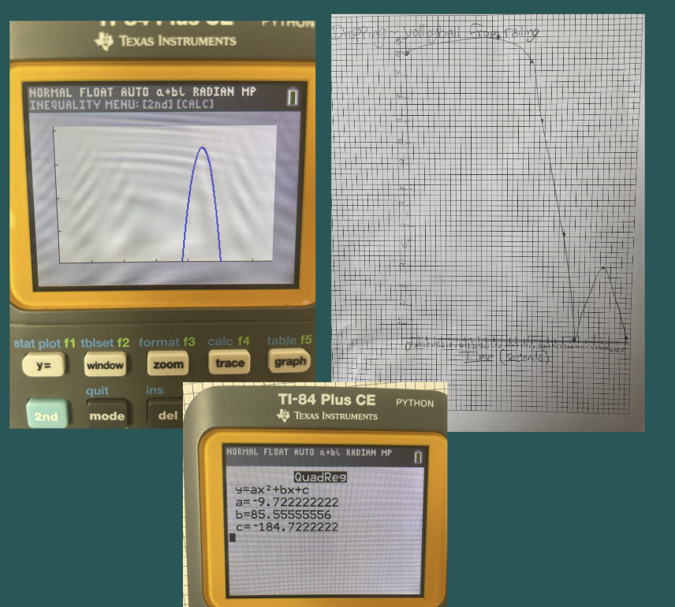

Example 2:

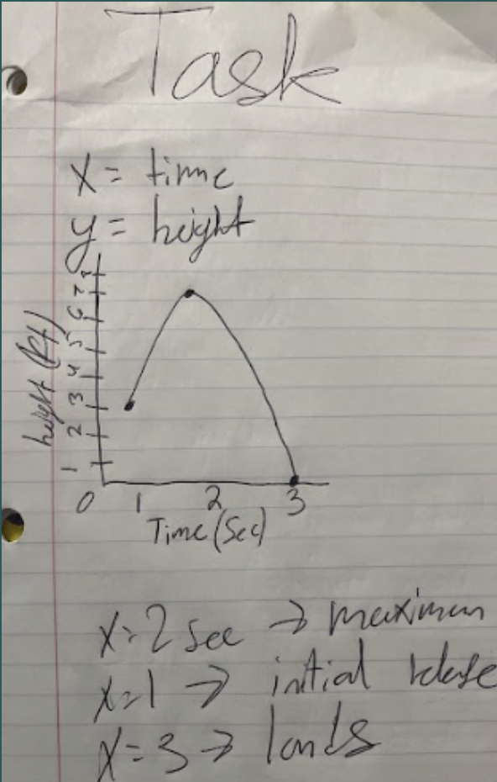

Example 3:
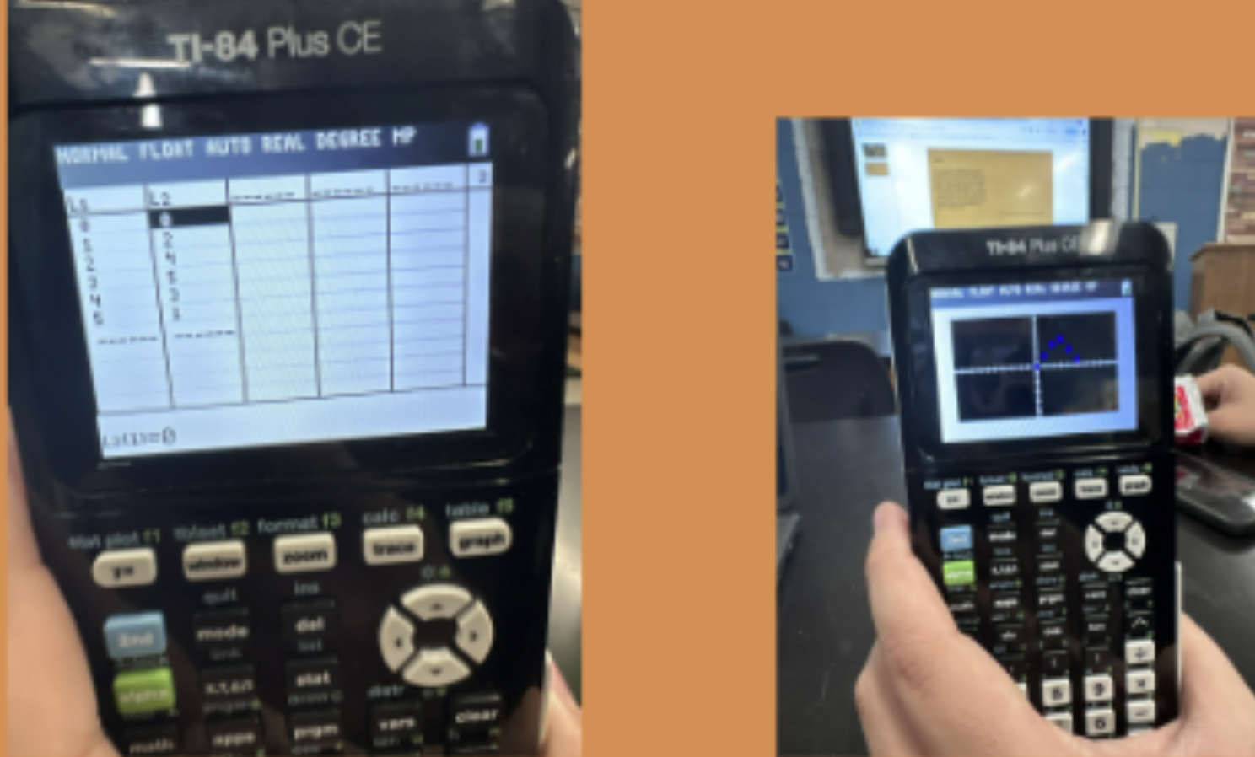

Criteria for Success

Conference and Provide Revision Support | Accept with Revision | Accept
The student’s artifact shows an emerging understanding of the expectations of the indicator(s). After conferencing and additional instruction/learning, the student may provide a revised or different artifact as evidence of the indicator(s). | The student’s artifact is approaching a full understanding of the expectations of the indicator(s). The artifact may contain execution errors that should be corrected in revision. The student may revise the selected artifact or submit a different artifact. | The student’s artifact demonstrates evidence that they have met the expectations of the indicator(s).

References

Common Core Standards Writing Team. (2013, March 1). Progressions for the Common Core State Standards in Mathematics (draft). Grade 8, High School, Functions. Tucson, AZ: Institute for Mathematics and Education, University of Arizona.

Illustrative Mathematics. (2016, May 4). Profit of a Company. Illustrative Mathematics. https://tasks.illustrativemathematics.org/content-standards/tasks/434

Illustrative Mathematics. (2016, May 4). Skeleton Tower. Illustrative Mathematics. https://tasks.illustrativemathematics.org/content-standards/tasks/75

Illustrative Mathematics. (2016, May 4). Thunder and Lightning Task. Illustrative Mathematics Grade 7. http://tasks.illustrativemathematics.org/content-standards/7/RP/A/tasks/1597

