Design Notes

M102B Performance Task
Breaking Even with Side Hustle Businesses
Modeling with Linear Functions and Equations
Teacher Version
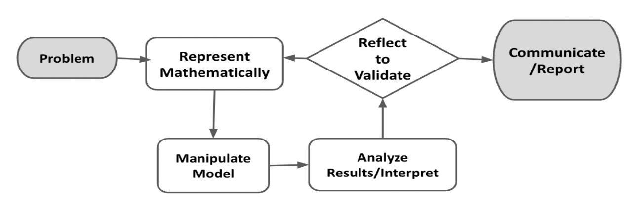
In this task, students will determine and create an appropriate way to report the findings they visualize and analyze using linear functions. They will choose one of two side hustle businesses to determine variables, write a linear equation, and represent it graphically. This performance task is structured to guide students through the process of simultaneously engaging in each component of the modeling cycle and developing a presentation to share their findings. Students will be recording information as they go through different sections. This can either be captured in an online word processing document or on paper if working by hand. Student-teacher consultations have been built in to scaffold the process. Consider using those structured check-in points as places where select student(s) share their approach/findings with the class to support the collective learning of the class. This learning experience centers around the CCSSM modeling cycle as illustrated below.

Source: Diagram of Modeling Process. From “Progressions for the Common Core State Standards for Mathematics”

Connections to Learning Principles
Students will:
- have agency in their learning as they choose a side hustle business that they either know well or have seen through their interaction with the world (LP2, LP4, LP6);
- develop and deliver a presentation that includes evidence from their findings to persuade their peers that their side hustle is a good investment (LP2, LP3, LP6);
- collect authentic data based on their location as they identify important factors necessary to write a linear equation and represent it graphically. There is an added level of rigor for students due to the multiple pathways that can be used to model their function (LP1, LP3, LP4, LP6); and
- use algebraic thinking and models to understand, then make real-life decisions (LP3, LP5, LP6).
The following pages provide teacher versions of this task with guidance, suggestions, and comments in red. Students choose from one of three options, so sample student responses are in blue italics, while responses for Option A, B, and C will be pink, green, and orange, respectively.
Student Task

The Modeling Cycle
You are looking to make some extra cash, and you decide to invest in a side hustle business. Side hustle businesses are a wonderful way to make money outside of school hours. Explore the two side hustle options below and choose one that is a best fit for you. Once you choose an option, you will need to complete the following:
- Create two different equations to model the cost and profit of your side hustle.
- Graph these equations to determine the “break-even point.”
  - The “break-even” point is where the total expenses (cost) and total revenue (profit) are equal.
- Present your findings to the class. (Remember this is a business and you must put your best foot forward.)
Mathematical models are used to make sense of ideas and phenomena in our world. As illustrated in the image below, the modeling cycle is a process of collecting data about an idea or problem, creating models of that data, analyzing the story told by those models, and reporting the results to the appropriate audience. In this task, you will be engaging with the mathematical modeling cycle to analyze the difference between an individual and a group knowing the correct answer to a particular question.

Your process and final products from this task will be shared with the greater class as a pitch for the side hustle. There will be time for them to probe and ask clarifying questions. Be prepared to answer them, including what you have not yet resolved. Their job is to decide whether your business is a wise investment.

Source: Diagram of Modeling Process. From “Progressions for the Common Core State Standards for Mathematics”

Breaking Even with Side Hustle Businesses

Launch
There are several ways that students can make money outside of school hours. Important factors to consider when thinking about a business are the expenses involved as well as how much revenue could be earned. Not all side hustles, or business ventures, are the same.
QUESTION 1
 | What are some ways that students can make money?
Answers will vary. Possible student responses:
- Retail/Cashier Positions:
  - Cashier at a grocery store, retail shop, or fast-food restaurant.
  - Stocking shelves and assisting customers.
- Pet Care:
  - Dog walking or pet sitting for neighbors or local pet owners.
  - Working at a local animal shelter.
- Babysitting:
  - Caring for younger children in the neighborhood.
- Lawn Care and Gardening:
  - Mowing lawns, raking leaves, weeding, and gardening for neighbors.
- Bakery/Café Assistant:
  - Working at a local bakery or café with tasks like cleaning, taking orders, or serving food.
- Camp Counselor:
  - Assisting at summer camps or local community centers.
- Household Chores:
  - Offering services for tasks like cleaning, organizing, or basic home maintenance for neighbors.
- Online Freelancing:
  - Depending on skills, tasks like graphic design, content writing, or social media management can be done online.
- Farmers' Market Vendor:
  - Assisting at a farmers' market booth, selling produce or products.
- Technology Assistance:
  - Helping older individuals with tech-related tasks like setting up devices or troubleshooting.
- Lifeguard:
  - If the student is a strong swimmer and certified, they could work as a lifeguard at a pool or beach.
- Sports Referee/Scorekeeper:
  - Officiating or keeping score at youth sports events.
- Artisan Crafts:
  - Creating and selling handmade crafts or artwork at local markets.
- Car Wash Attendant:
  - Working at a local car wash, cleaning, and detailing vehicles.
- Fitness/Yoga Assistant:
  - Assisting at fitness classes or yoga studios.
- Streamer
  - YouTube or Twitch
- After sharing or discussing the Launch statement with students, consider giving students a few minutes of individual think time to generate responses to Q1.
- Consider offering students various ways to share their thoughts with the class: pair-share, chart, or other spaces. You can even complete Q1 as a class.
- Remind them that these are possible jobs for high school students, not jobs they themselves must do.

Problem, Formulate, and Represent Mathematically
In the Problem, Formulate, and Represent Mathematically sections, you will determine weekly cost factors, availability, and weekly revenue for your side hustle. This will allow you to formulate your weekly profit, which will be the difference between your cost and revenue. The Problem, Formulate, and Represent Mathematically Checklist can be used to ensure you have the necessary components before moving on to the remaining parts of the task.
ACTION 1
 | You were just gifted $500 to kick start your side hustle (except in Option A). Consider this “seed money.” Seed money is money given to a business in its initial stages which you do not have to pay back. You must consider this a cost of the side hustle regardless of which one you choose. Each side hustle also has factors and constraints that will impact your business. These are things that you need to keep in mind as you start earning, so you can break even and then start making a profit.  Use the slope-intercept equation to help create your equations, y = mx + b, where:  y = total cost  m = slope, (e.g., hourly rate)  x = the variable (e.g., time, items, lawns)  b = the y-intercept  Choose one of the two side hustle jobs listed in the pages below. Each side hustle has specific considerations to think about as you start your business.

Option A - Rideshare Driver  No seed money needed.  Choose to drive for either UberX with a compact car or UberXL with an SUV in your existing, gas-powered car. You must drive during after-school hours or weekends.  Vehicle: Honda Accord
  Use the following resources to research your side hustle and plan accordingly!
  How Much Do Ubers Drivers Make?
  Ride Share Guy
  Uber Pay Schedule
- Determine weekly expenses (will vary week by week based on the price of gas and the vehicle you select):
  - Gas (use the mega formula below to help with this)
  - Weekly full car insurance coverage (Find the monthly car insurance and divide that by 4.3) ($240.80 per month, $56 per week)
- Determine weekly income:
  - Hourly rate ($15 per hour)
  - $40 in tips per week
- Using your availability, plan out your work week in the calendar template located after the options.

Considerations:
- For your location, what is the average number of rides you can complete per hour?
- How many hours are you available to drive?
- Where are you going to Uber?
- What is your car’s average miles per gallon (MPG) gas rating?

Calculating Weekly Gas Cost Mega Formula (for Rideshare Driver path ONLY)
______16________  (Total Hours Worked) | × | 30 miles per hour | = | ________480_________  (Total Weekly Miles Driven)

______480_______  (Total Miles Driven) | ÷ | ___26_MPG__  (MPG gas rating) | = | ______18.46 gal______  (Total Gas Used)

____18.46 gal ____  (Total Gas Used) | × | ____$2.75 _____  (gas rate $/gal) | = | ______$50.77 _______  (Total Gas Expenses)

Option B - Landscape Designer  $500 in seed money available.  You provide landscaping services in the form of mowing lawns for 10 families. You must schedule your services during after-school hours or weekends.
  Use the following resources to research your side hustle and plan accordingly!
  Home Depot
  Lowes
  Amazon
- Determine weekly expenses and start-up cost:
  - Lawnmower $369
  - Gas and oil container $35
  - Engine oil $9
  - Gas Will vary but, lawnmower holds 5 gallons.
  - Weekly maintenance budget (in case something ever goes wrong you have money set aside)
- Determine weekly income:
  - Hourly rate Students have a lot of freedom to choose how much they should charge.
- Plan out your work week in the calendar template below using your availability.

Considerations:
- The weather
- You can only spend $500 to start your business.
- The average human can mow 1 average-sized lawn per hour.
- How often families need their lawns to be mowed.
- You cannot mow lawns during school hours.

What do you need to consider when scheduling your hours? Complete the calendar to plan your week.

Calendar
Sunday
Monday | Drive from 3pm-6pm (3 hours)
Tuesday
Wednesday | Drive from 3pm-6pm (3 hours)
Thursday
Friday | Drive from 3pm-6pm (3 hours)
Saturday | Drive from 10am-5pm (7 hours)

Help students consider factors for scheduling such as prior commitments, availability, etc.

What are your weekly costs, revenue, and profit? Clearly show the values you used to determine the total expenses, revenue, and profit in the table below.

Weekly Expenses | Weekly Revenue | Weekly Profit
Insurance $240.80/4.3 = $56  Gas = $50.77  Total weekly expenses = $106.77 | Rides $15/hr • 16 hr = $240  Tips = $40  Total weekly income = $280 | $280 - $106.77 = $173.23

Support students in defining each term, if necessary. They should understand that they would need to subtract their weekly expenses from their weekly revenue to determine their weekly profit.

Problem, Formulate, and Represent Mathematically Checklist
Requirement | Teacher Notes
Determine availability, expenses (consider all factors), and weekly revenue. | (Teachers, please add your notes here.)
Determine weekly profit. | (Teachers, please add your notes here.)
(Teachers, please add your notes here.)

Manipulate Model
In the Manipulate Model section, you will create different representations to help you analyze your profit. The Manipulate Model Checklist can be used to ensure you have the necessary components before moving on to the remaining parts of the task.
How can you represent your weekly expenses, revenue, and profit? Write three different equations to model your data using y = mx + b. Then, interpret each variable (m, x, and b) for each equation, including units.
Equation #1 Equation #2 Equation #3
Variable | Expenses  y = 106.77 | Revenue  y = 15x + 40 | Profit  y = 15x - 66.77
y | Total expenses in dollars | Total revenue in dollars | Total profit in dollars
m | 0 (all expenses are fixed) | 15 (income per hour) | 15 (income per hour)
x | None | Total hours worked | Total hours worked
b | 106.77 (weekly cost of gas and insurance) | 40 (estimated weekly tips) | 66.77 (weekly net expenses)

If necessary, support students in deciding about considering a tip in Option A. They may consider it a constant (i.e., average for the week), although the calculation for it may be more complicated. The point of the task is to keep the focus on the linear relationship between hours worked and revenue.

Graph your generated line for profit in Desmos. Use your graph to determine the point where you will break even (i.e., how many hours you should drive or how many lawns should you mow?). Include your graph to support your response.
What is your identified break-even point?
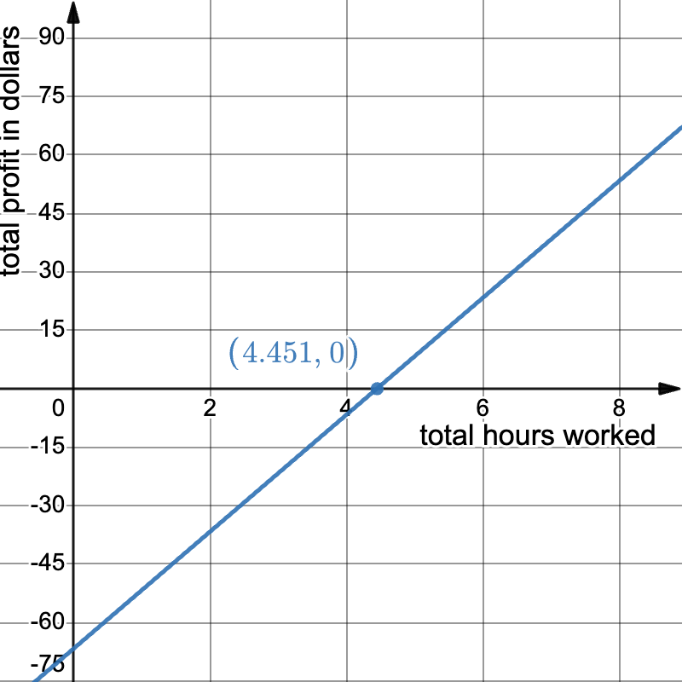
Answers will vary. Possible student responses:

Sample student graph for Option A
- Option A: We will break even after working 4.451 hours. That is the point where the profit is zero dollars. After that, all hours worked will result in added profit.

- Option B: Landscape/lawn care (use the $500 as the break-even point)
  - y is the total amount in $ and x is the number of lawns mowed
  - Cost Equation: $y= 413+(gas price)x$
413 (total $ for equipment), x is the number of gallons
Students should determine the price of gas locally and calculate the total to eliminate the variable in the cost equation.
  - Income Equation: $y= 40x$ where x is now the number of lawns mowed.
  - Based on the model, the student would need to mow around 13-15 lawns in a week to determine the break-even point.

- Encourage the use of precise mathematical vocabulary.
- Have students use the units they chose in their explanation.
- Challenge them to share their findings with a classmate that may have chosen the same option.
- Students can use $y=500$ as the horizontal line they need to pass to break even.

Manipulate Model Checklist
Requirement | Teacher Notes
Write equations accurately representing revenue and expenses using the y = mx + b format. | (Teachers, please add your notes here.)
Each equation’s variables are accurately interpreted, using correct units. | (Teachers, please add your notes here.)
The Desmos profit line is accurately graphed and used to determine and identify a break-even point. | (Teachers, please add your notes here.)
The model is interpreted to identify costs, how income is generated, and how profit might be maximized weekly. | (Teachers, please add your notes here.)
(Teachers, please add your notes here.)

Reflect and Report
In the Reflect and Report sections, you will reflect on and provide valuable feedback about the task you chose and completed. You will also use what you learned about that particular side hustle business to create a persuasive presentation in which you try to convince your classmates that your side hustle is a profitable investment! The Reflect and Report Checklist can be used to ensure you have completed all the necessary components of this final part of the task.

Reflect
Which side hustle did you undertake? What surprised you as you completed this task?
Answers will vary. Possible student responses:
- Option A
  - It is possible to make money driving people.
  - Uber‘s cut is 25% per ride, which is a lot for doing nothing!
- Option B
  - Lawnmowers are expensive, but the push ones are not too bad.
  - I wonder if I can start this in my neighborhood.
- Encourage students to answer in detail, providing specific examples and precise wording when possible.
- Remind students to keep it simple and use two variables.
- Remind student they are to convince their classmates that their option is the best, using facts and numbers to support their choice.
- Converse with students to help them.

What was the most challenging part of this task?
Answers will vary. Possible student responses:
- Option A:
  - Figuring out which car I was going to use.
  - Calculating all the cost of gas and insurance.
  - Deciding when and where I am going to drive.
  - Creating all the equations.
- Option B:
  - Choosing a lawn mower.
  - Creating all the equations.
  - Deciding when I am going to work.
- Encourage students to answer in detail, providing specific examples and precise wording when possible.

What was the most fun part of this task?
- Option A
  - Choosing a car to drive.
  - Making money.
  - Flexibility in creating my own work schedule.
  - Seeing math related in the real world.

- Option B
  - Making money.
  - Researching lawnmower and comparing companies, styles, and models.
  - Exploring the unique features of lawnmowers.
  - Taking into account environmental considerations.
- Encourage students to answer in detail, providing specific examples and precise wording when possible.

Report
ACTION 2
Convince your classmates to invest or not invest in your side hustle (Shark Tank style). Use your findings—your data on cost and income. Be sure to be persuasive, as there is investment money at stake!

Considerations:
- How does your break-even point differ from those who chose the other side hustle option?
- After looking at your data, will you stick with your chosen side hustle business, or choose another?
Presentations will differ as students might have found different data using a variety of sources. However, all student presentations should include the following:
- Important factors from their data collection and analysis.
- How students calculated weekly profit based on their weekly expenses and weekly revenue.
- The break-even point for their side hustle business.
- Reasons to invest or not invest in their side hustle business.
The teacher should look for the following as students prepare for their presentation:
- That it is mathematically sound.
- That all sections of the task are complete and correct, especially the break-even point calculation.
- Students are planning to defend their decisions based on evidence.
As students present, the teacher should encourage students in the audience to think of questions/constructive comments to ask the presenting group. Students can use loose leaf paper to capture these notes and comments. Remind students of the option to present using different modalities (i.e., in person, pre-record, etc.).
This time also provides teachers an opportunity to orchestrate discourse in connections between tasks. Ask students to consider any additional costs and expenses that were not considered in presentations (i.e., maintenance on equipment, speeding tickets, etc.).

Reflect and Report Checklist
Requirement | Teacher Notes
Provide specific, detailed feedback on the side hustle business that was researched during this task. | (Teachers, please add your notes here.)
Presentation includes accurate, pivotal factors from the related data collection and analysis that include weekly profit calculations based on expenses and revenue and the break-even point for the business. | (Teachers, please add your notes here.)
Presentation is persuasive, articulate, and demonstrates entrepreneurial creativity alongside mathematical precision and a business mindset. | (Teachers, please add your notes here.)
Presentation is convincing to the audience with compelling evidence for investing or not investing in that side hustle business. | (Teachers, please add your notes here.)
(Teachers, please add your notes here.)

Extension
Keep thinking about your side hustle business—the best entrepreneurs are always seeking ways to improve…or to move on to new things! Challenge yourself and awaken your entrepreneurial genius by considering and responding to these reflective questions:
- Did you make the wrong choice? Is there another side hustle that you think will be better? Prove it!
- Consider unexpected additional factors and how that would impact on your profit and other additional decision making.
- Rideshare driver-
  - My Uber driving rating.
  - The number of rides I can make.
  - Where I am going to drive.
  - What if my car breaks down?
  - Vehicle accessories (chargers, gum, mint, snacks, water)
  - Keeping the car clean.
  - TAXES
- Landscape/lawn care
  - Do I need to clean up after finishing the lawn work? I would need a shovel, garbage bags, garbage bin, etc.
  - Should I also invest in a weedwhacker and/or lawn edgers?
  - Weather
  - Seasonal demand
  - Equipment breakdown
  - Competition
  - Unhappy customer
  - TAXES

References

Amazon. (n.d.). Amazon. Amazon. Retrieved October 22, 2023, from https://www.amazon.com/
Campbell, H. (n.d.). The destination for drivers. The Rideshare Guy. Retrieved October 22, 2023, from https://therideshareguy.com/
The Home Depot. (n.d.). Top Savings for You. The Home Depot. Retrieved October 22, 2023, from https://www.homedepot.com/
Lowes. (n.d.). Online Closeout Event. Lowes. Retrieved October 22, 2023, from https://www.lowes.com/
Nike. (n.d.). Nike SNKRS Release. Nike. Retrieved October 22, 2023, from https://www.nike.com/launch
Nike. (n.d.). Sneakers: Just Dropped. GOAT. Retrieved October 22, 2023, from https://www.goat.com/en-ca
The Rideshare Guy. (2022). How Much Do Uber Drivers Make? YouTube. https://www.youtube.com/watch?v=zgf1y3sl7As
StockX. (n.d.). StockX AJ Satin Bred Women's. StockX. Retrieved October 22, 2023, from https://stockx.com/
Uber. (n.d.). Most Drivers Work for Lowest Paying Uber. Uber PNG. Retrieved October 22, 2023, from https://drive.google.com/file/d/1CW9fFuXGP9ZimtQDO9-X8Brc8UVjDPxB/view

