Baseline Professional Learning Handout
M113 Modeling with Probability

Baseline Professional Learning Handout 1
Statistics and Probability Progression Excerpt 5
M113 Content and Practice Expectations 6
M113 Content and Practice Expectations and Indicators 7
Let’s Investigate 8
Rain and LightningTask 8
Rolling Dice Task 9
Let’s do some math! Round 1 10
Task 1: Titanic 10
Learning Principles 12
Task 1: Titanic Student Work 13
Let’s do some math! Round 2 16
Task 2: Random Walk Prompt 16
Task 2: Random Walk Student Work 18
Criteria for Success 21
References 21
Selected Common Core High School Standards for Mathematics

Statistics and Probability
Understand and evaluate random processes underlying statistical experiments.
- Understand statistics as a process for making inferences about population parameters based on a random sample from that population.
- Decide if a specified model is consistent with results from a given data-generating process, e.g., using simulation. For example, a model says a spinning coin falls heads up with probability 0.5. Would a result of 5 tails in a row cause you to question the model?

Understand independence and conditional probability and use them to interpret data.
- Describe events as subsets of a sample space (the set of outcomes) using characteristics (or categories) of the outcomes, or as unions, intersections, or complements of other events (“or,” “and,” “not”).
- Understand that two events A and B are independent if the probability of A and B occurring together is the product of their probabilities, and use this characterization to determine if they are independent.
- Understand the conditional probability of A given B as P(A and B)/P(B), and interpret independence of A and B as saying that the conditional probability of A given B is the same as the probability of A, and the conditional probability of B given A is the same as the probability of B.
- Construct and interpret two-way frequency tables of data when two categories are associated with each object being classified. Use the two-way table as a sample space to decide if events are independent and to approximate conditional probabilities. For example, collect data from a random sample of students in your school on their favorite subject among math, science, and English. Estimate the probability that a randomly selected student from your school will favor science given that the student is in tenth grade. Do the same for other subjects and compare the results.
- Recognize and explain the concepts of conditional probability and independence in everyday language and everyday situations. For example, compare the chance of having lung cancer if you are a smoker with the chance of being a smoker if you have lung cancer.

Use the rules of probability to compute probabilities of compound events in a uniform probability model.
- Find the conditional probability of A given B as the fraction of B’s outcomes that also belong to A, and interpret the answer in terms of the model.
- Apply the Addition Rule, P(A or B) = P(A) + P(B) – P(A and B), and interpret the answer in terms of the model.

Investigate chance processes and develop, use, and evaluate probability models.

- Understand that the probability of a chance event is a number between 0 and 1 that expresses the likelihood of the event occurring. Larger numbers indicate greater likelihood. A probability near 0 indicates an unlikely event, a probability around 1/2 indicates an event that is neither unlikely nor likely, and a probability near 1 indicates a likely event.
- Approximate the probability of a chance event by collecting data on the chance process that produces it and observing its long-run relative frequency, and predict the approximate relative frequency given the probability. For example, when rolling a number cube 600 times, predict that a 3 or 6 would be rolled roughly 200 times, but probably not exactly 200 times.
- Develop a probability model and use it to find probabilities of events. Compare probabilities from a model to observed frequencies; if the agreement is not good, explain possible sources of the discrepancy.
  - Develop a uniform probability model by assigning equal probability to all outcomes, and use the model to determine probabilities of events. For example, if a student is selected at random from a class, find the probability that Jane will be selected and the probability that a girl will be selected.
  - Develop a probability model (which may not be uniform) by observing frequencies in data generated from a chance process. For example, find the approximate probability that a spinning penny will land heads up or that a tossed paper cup will land open-end down. Do the outcomes for the spinning penny appear to be equally likely based on the observed frequencies?
- Find probabilities of compound events using organized lists, tables, tree diagrams, and simulation.
  - Understand that, just as with simple events, the probability of a compound event is the fraction of outcomes in the sample space for which the compound event occurs.
  - Represent sample spaces for compound events using methods such as organized lists, tables and tree diagrams. For an event described in everyday language (e.g., “rolling double sixes”), identify the outcomes in the sample space which compose the event.
  - Design and use a simulation to generate frequencies for compound events. For example, use random digits as a simulation tool to approximate the answer to the question: If 40% of donors have type A blood, what is the probability that it will take at least 4 donors to find one with type A blood?

Modeling
Modeling links classroom mathematics and statistics to everyday life, work, and decision-making. Modeling is the process of choosing and using appropriate mathematics and statistics to analyze empirical situations, to understand them better, and to improve decisions. Quantities and their relationships in physical, economic, public policy, social, and everyday situations can be modeled using mathematical and statistical methods. When making mathematical models, technology is valuable for varying assumptions, exploring consequences, and comparing predictions with data.

A model can be very simple, such as writing total cost as a product of unit price and number bought, or using a geometric shape to describe a physical object like a coin. Even such simple models involve making choices. It is up to us whether to model a coin as a three-dimensional cylinder, or whether a two-dimensional disk works well enough for our purposes. Other situations—modeling a delivery route, a production schedule, or a comparison of loan amortizations—need more elaborate models that use other tools from the mathematical sciences. Real-world situations are not organized and labeled for analysis; formulating tractable models, representing such models, and analyzing them is appropriately a creative process. Like every such process, this depends on acquired expertise as well as creativity. Some examples of such situations might include:
- Estimating how much water and food is needed for emergency relief in a devastated city of 3 million people, and how it might be distributed.
- Planning a table tennis tournament for 7 players at a club with 4 tables, where each player plays against each other player.
- Designing the layout of the stalls in a school fair so as to raise as much money as possible.
- Analyzing stopping distance for a car.
- Modeling savings account balance, bacterial colony growth, or investment growth.
- Engaging in critical path analysis, e.g., applied to turnaround of an aircraft at an airport.
- Analyzing risk in situations such as extreme sports, pandemics, and terrorism.
- Relating population statistics to individual predictions.

In situations like these, the models devised depend on a number of factors: How precise an answer do we want or need? What aspects of the situation do we most need to understand, control, or optimize? What resources of time and tools do we have? The range of models that we can create and analyze is also constrained by the limitations of our mathematical, statistical, and technical skills, and our ability to recognize significant variables and relationships among them. Diagrams of various kinds, spreadsheets and other technology, and algebra are powerful tools for understanding and solving problems drawn from different types of real-world situations. One of the insights provided by mathematical modeling is that essentially the same mathematical or statistical structure can sometimes model seemingly different situations. Models can also shed light on the mathematical structures themselves, for example, as when a model of bacterial growth makes more vivid the explosive growth of the exponential function.

The basic modeling cycle is summarized in the diagram. It involves (1) identifying variables in the situation and selecting those that represent essential features, (2) formulating a model by creating and selecting geometric, graphical, tabular, algebraic, or statistical representations that describe relationships between the variables, (3) analyzing and performing operations on these relationships to draw conclusions, (4) interpreting the results of the mathematics in terms of the original situation, (5) validating the conclusions by comparing them with the situation, and then either improving the model or, if it is acceptable, (6) reporting on the conclusions and the reasoning behind them. Choices, assumptions, and approximations are present throughout this cycle.

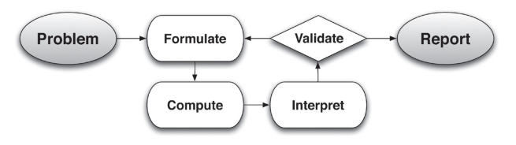

In descriptive modeling, a model simply describes the phenomena or summarizes them in a compact form. Graphs of observations are a familiar descriptive model— for example, graphs of global temperature and atmospheric CO2 over time.

Analytic modeling seeks to explain data on the basis of deeper theoretical ideas, albeit with parameters that are empirically based; for example, exponential growth of bacterial colonies (until cut-off mechanisms such as pollution or starvation intervene) follows from a constant reproduction rate. Functions are an important tool for analyzing such problems. Graphing utilities, spreadsheets, computer algebra systems, and dynamic geometry software are powerful tools that can be used to model purely mathematical phenomena (e.g., the behavior of polynomials) as well as physical phenomena. Modeling Standards Modeling is best interpreted not as a collection of isolated topics but rather in relation to other standards. Making mathematical models is a Standard for Mathematical Practice, and specific modeling standards appear throughout the high school standards indicated by a star symbol (★).

Statistics and Probability Progression Excerpt

Chance processes and probability models In Grade 7, students build their understanding of probability on a relative frequency view of the subject, examining the proportion of “successes” in a chance process—one involving repeated observations of random outcomes of a given event, such as a series of coin tosses. “What is my chance of getting the correct answer to the next multiple choice question?” is not a probability question in the relative frequency sense. “What is my chance of getting the correct answer to the next multiple choice question if I make a random guess among the four choices?” is a probability question because the student could set up an experiment of multiple trials to approximate the relative frequency of the outcome. And two students doing the same experiment will get nearly the same approximation. These important points are often overlooked in discussions of probability for this grade.

Students begin by relating probability to the long-run (more than five or ten trials) relative frequency of a chance event, using coins, number cubes, cards, spinners, bead bags, and so on. Hands-on activities with students collecting the data on probability experiments are critically important, but once the connection between observed relative frequency and theoretical probability is clear, they can move to simulating probability experiments via technology (graphing calculators or computers). It must be understood that the connection between relative frequency and probability goes two ways. If you know the structure of the generating mechanism (e.g., a bag with known numbers of red and white chips), you can anticipate the relative frequencies of a series of random selections (with replacement) from the bag. If you do not know the structure (e.g., the bag has unknown numbers of red and white chips), you can approximate it by making a series of random selections and recording the relative frequencies. This simple idea, obvious to the experienced, is essential and not obvious at all to the novice. The first type of situation, in which the structure is known, leads to “probability”; the second, in which the structure is unknown, leads to “statistics.”

A probability model provides a probability for each possible nonoverlapping outcome for a chance process so that the total probability over all such outcomes is unity. The collection of all possible individual outcomes is known as the sample space for the model. For example, the sample space for the toss of two coins (fair or not)
is often written as {TT, HT, TH, HH}. The probabilities of the model can be either theoretical (based on the structure of the process and its outcomes) or empirical (based on observed data generated by the process). In the toss of two balanced coins, the four outcomes of the sample space are given equal theoretical probabilities of ¼ because of the symmetry of the process—because the coins are balanced, an outcome of heads is just as likely as an outcome of tails. Randomly selecting a name from a list of ten students also leads to equally likely outcomes with probability 0.10 that a given student’s name will be selected. If there are exactly four seventh graders on the list, the chance of selecting a seventh grader’s name is 0.40. On the other hand, the probability of a tossed thumbtack landing point up is not necessarily ½ just because there are two possible outcomes; these outcomes may not be equally likely and an empirical answer must be found by tossing the tack and collecting data. (Common Core State Standards Writing Team, 2011)

M113 Content and Practice Expectations
113.a | Engage in the modeling cycle.
113.b | Understand and evaluate random processes underlying statistical experiments.
113.c | Use a model to determine the probability of an event.
113.d | Use the rules of probability to compute probabilities of compound events.
113.e | Understand independence and conditional probability and use them for modeling.
113.f | Use probability to make decisions.

M113 Content and Practice Expectations and Indicators

Content and Practice Expectations | Indicators  Choose an artifact where you…
113.a: Engage in the modeling cycle. | i. engage with the full modeling cycle (problem, formulate, compute, interpret, validate, revise as necessary, report).
113.b: Understand and evaluate random processes underlying statistical experiments. | i. describe or use an experiment or simulation to generate frequencies for compound events.
 | ii. decide if a specified model is consistent with results from a given data-generating process, e.g., using simulation.
 | iii. make an inference about a population based on a random sample.
113.c: Use a model to determine the probability of an event. | i. determine the probability of an event by reasoning about the number of possible outcomes.
113.c: Use a model to determine the probability of an event. | ii. compare two different events in terms of their probabilities.
113.d: Use the rules of probability to compute probabilities of compound events. | i. determine the probability of the intersection or union of multiple events.
113.e: Understand independence and conditional probability and use them for modeling. | i. describe events as subsets of a sample space (the set of outcomes) using characteristics (or categories) of the outcomes, or as unions, intersections, or complements of other events ("or," "and," "not")
 | ii. explain or show why two events can be considered independent or dependent.
 | iii. determine a conditional probability.
113.f: Use probability to make decisions. | i. use probability to make a recommendation.

Let’s Investigate

Rain and Lightning Task
- Today there is a 55% chance of rain, a 20% chance of lightning, and a 15% chance of lightning and rain together. Are the two events “rain today” and ”lightning today” independent events? Justify your answer.

- Now suppose that today there is a 60% chance of rain, a 15% chance of lightning, and a 20% chance of lightning if it’s raining. What is the chance of both rain and lightning today?

- Now suppose that today there is a 55% chance of rain, a 20% chance of lightning, and a 15% chance of lightning and rain. What is the chance that we will have rain or lightning today?

- Now suppose that today there is a 50% chance of rain, a 60% chance of rain or lightning, and a 15% chance of rain and lightning. What is the chance that we will have lightning today?

Source: Illustrative Mathematics

Rolling Dice Task

Roll two dice 10 times. After each roll, note whether any sixes were observed and record your results in the table below.

Roll | Any Sixes? (Y/N)
1
2
3
4
5
6
7
8
9
10

- What fraction of the 10 rolls resulted in at least one six?

- Combine your results with those of your classmates. What fraction of all the rolls in the class resulted in at least one six?

- Make a list of all the different possible outcomes that might be observed when two dice are rolled. (Hint: There are 36 different possible outcomes.)

- What fraction of the 36 possible outcomes result in at least one six?

- Suppose you and your classmates were able to roll the two dice many thousands of times. What fraction of the time would you expect to roll at least one six?

Source: Illustrative Mathematics

Let’s do some math! Round 1

Task 1: Titanic

Students are given a task like this:

Part 1: The Titanic

On April 15, 1912, the Titanic struck an iceberg and rapidly sank with only 710 of her 2,204 passengers and crew surviving. Some believe that the rescue procedures favored the wealthier first class passengers. Others believe that the survival rates can be explained by the ”women and children first” policy. Data on survival of passengers are summarized in the table below. Investigate what might and might not be concluded from the given data.

 | Survived | Did not survive | Total
Children in first class | 4 | 1 | 5
Women in first class | 139 | 4 | 143
Men in first class | 58 | 118 | 176
Children in second class | 22 | 0 | 22
Women in second class | 83 | 12 | 95
Men in second class | 13 | 154 | 167
Children in third class | 30 | 50 | 80
Women in third class | 91 | 88 | 179
Men in third class | 60 | 390 | 450
Total passengers | 500 | 817 | 1317

The Statistics of the Disaster

The Titanic 3, (Illustrative Mathematics, 2016)

Part 2: Extending the learning

- What additional questions surface for you as a result of the work above?
- What are your thoughts and feelings regarding what you have learned about travel in 1912?
- Are there any current events you believe to have similar disparities as those seen in the survival rates of the Titanic? Work to formulate a plan for gathering data about this event and conduct an investigation to see what might or might not be concluded from that data.
- Based on your analysis, what conclusions have you reached? What would you like to see happen?

Sample Learning Experience

Part 1: The Titanic
Launch this task by displaying the following information about the Titanic and passenger survival data. Give students time to study, and pose the questions: What do you notice? What do you wonder?

On April 15, 1912, the Titanic struck an iceberg and rapidly sank with only 710 of her 2,204 passengers and crew surviving. Data on survival of passengers are summarized in the table below.

 | Survived | Did not survive | Total
First class passengers | 201 | 123 | 324
Second class passengers | 118 | 166 | 284
Third class passengers | 181 | 528 | 709
Total passengers | 500 | 817 | 1317

After some quiet time, give students an opportunity to share their ideas with a partner. As students share, listen for observations and questions that get at how class and survival rate might be related. Capture ideas that surface on a visible surface, like chart paper or white board. Leverage this part of the conversation to then transition to the prompt presented. Refer to student generated observations and questions as applicable.

As students work, notice various ways students make sense of the information and formulate a plan for responding to the prompt. Select some students or partner pairs to share their thinking with the class. Consider using questions below to facilitate discussion:

- What’s promising about this approach?
- What questions does this approach surface for you?
- What can you take from this approach to apply to your own work?

Following the discussion, give students an opportunity to reflect on and revise their work. Use questions students generate to further engage students with this data, as well as to amplify the mathematics in play.

Part 2: Extending the learning
Give students time to work individually or with a small group to identify current events they’d like to investigate in this manner. Monitor and select student voices to share their preliminary progress, focusing the discussions on the formulation of their plans. Consider using the questions below to facilitate discussion:

- What’s promising about this approach?
- What questions does this approach surface for you?
- What can you take from this approach to apply to your own work?

Following the discussion, give students an opportunity to reflect on and revise their work.

Give additional time for students to conduct their investigation and present their findings to the class or other audience they feel is appropriate.

Learning Principles
Engage with cognitively demanding tasks in heterogeneous settings (LP 1). Students should be given opportunities to grapple with multistep, non-routine tasks that promote mathematical rigor. These experiences should be differentiated so that all students engage in appropriate challenges—for example, through tasks with multiple entry points and solution pathways. These experiences should continue to integrate knowledge and skills developed in grades 6-8 at the level of sophistication of high school mathematics.

Engage in social activities (LP 2). Students should have opportunities to work independently and to communicate with one another about mathematics by engaging in collective and collaborative learning activities. Explaining and having opportunities to revise one’s thinking has excellent value in solidifying one’s knowledge.

Build conceptual understanding through reasoning (LP 3). Students should be given the opportunity to reason, justify, and problem solve with critical thinking, reading, writing, speaking, and listening. Through reasoning and work with multiple representations, students learn why procedures work and build a conceptual understanding of key mathematical ideas.

Have agency in their learning (LP 4). Students should be able to choose tasks and learning experiences that align with their interests and aspirations. All students have rich and varied experiences and home lives. Learning mathematics should bring students’ identities and interests to the fore and build on the strengths that they bring to the learning space.

View mathematics as a human endeavor across centuries (LP 5). Students should understand that mathematical ideas emanated over time from civilizations around the world and have opportunities to explore these contributions to mathematics. Students should develop an appreciation of mathematics as a human endeavor: one in which they feel a sense of belonging, where they see themselves as mathematicians, and one that offers opportunities to broaden their ideas about what mathematics is, how it is used, and who it is for.

See mathematics as relevant (LP 6). Students should engage with mathematics in ways that authentically involve real-world situations. Problem-solving contexts should allow students to perceive mathematics as a tool for addressing the questions that arise in everyday life, as well as the ways it can model our world and address global economic, social, and environmental challenges. Students should also engage with mathematics in ways that connect to academic disciplines and future careers by doing the mathematics used by artists, designers, engineers, and other professionals.

Employ technology as a tool for problem-solving and understanding (LP 7). Research indicates that technology is a powerful tool for learning deeper mathematics by improving calculation efficiency and enabling more sophisticated analysis. Students should learn to use technology, with emphasis put on widely used tools and software, such as calculators and spreadsheets, to make sense of models. Technology use should not be limited to supporting “doing mathematics,” but should also be used as a tool for displaying and communicating results to appropriate audiences.

Task 1: Titanic Student Work
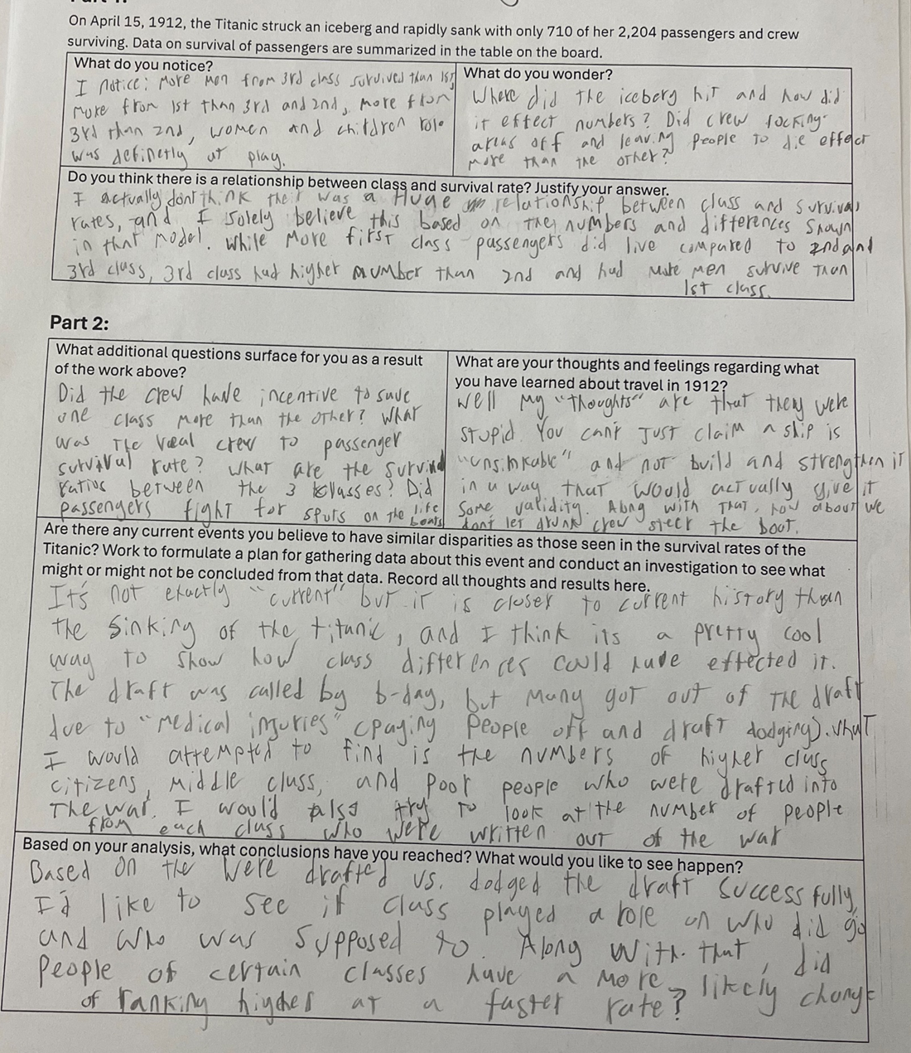
Example 1:

Insert image of student work here

Example 2:

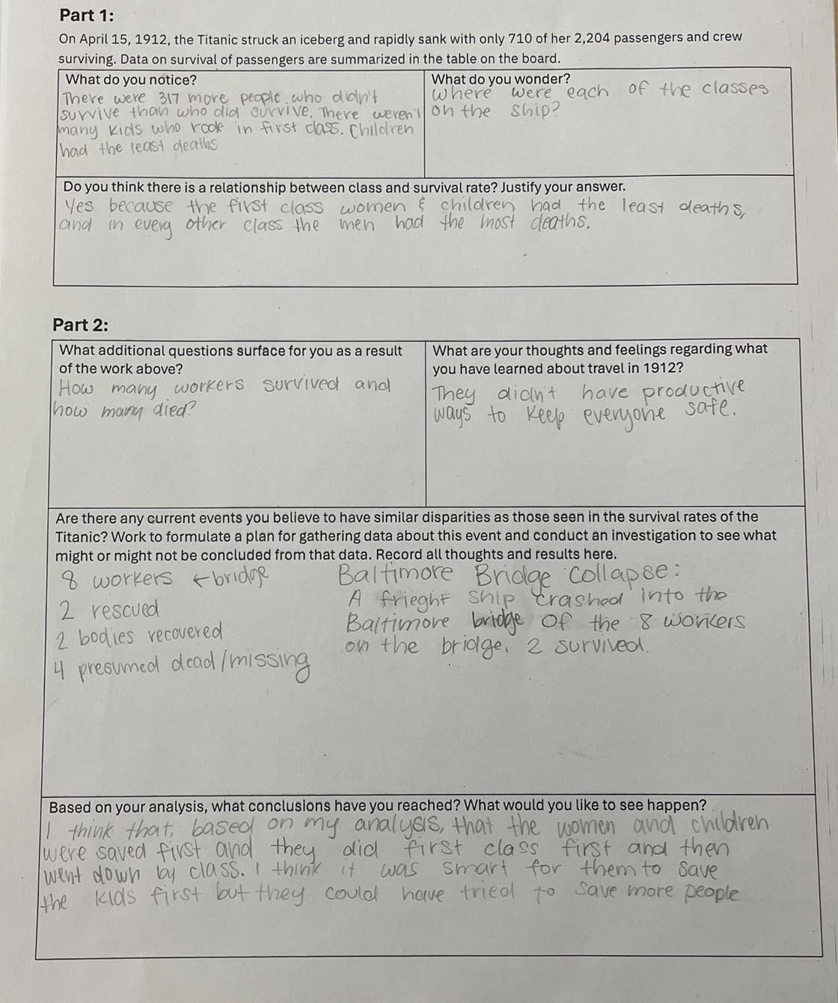

Example 3:
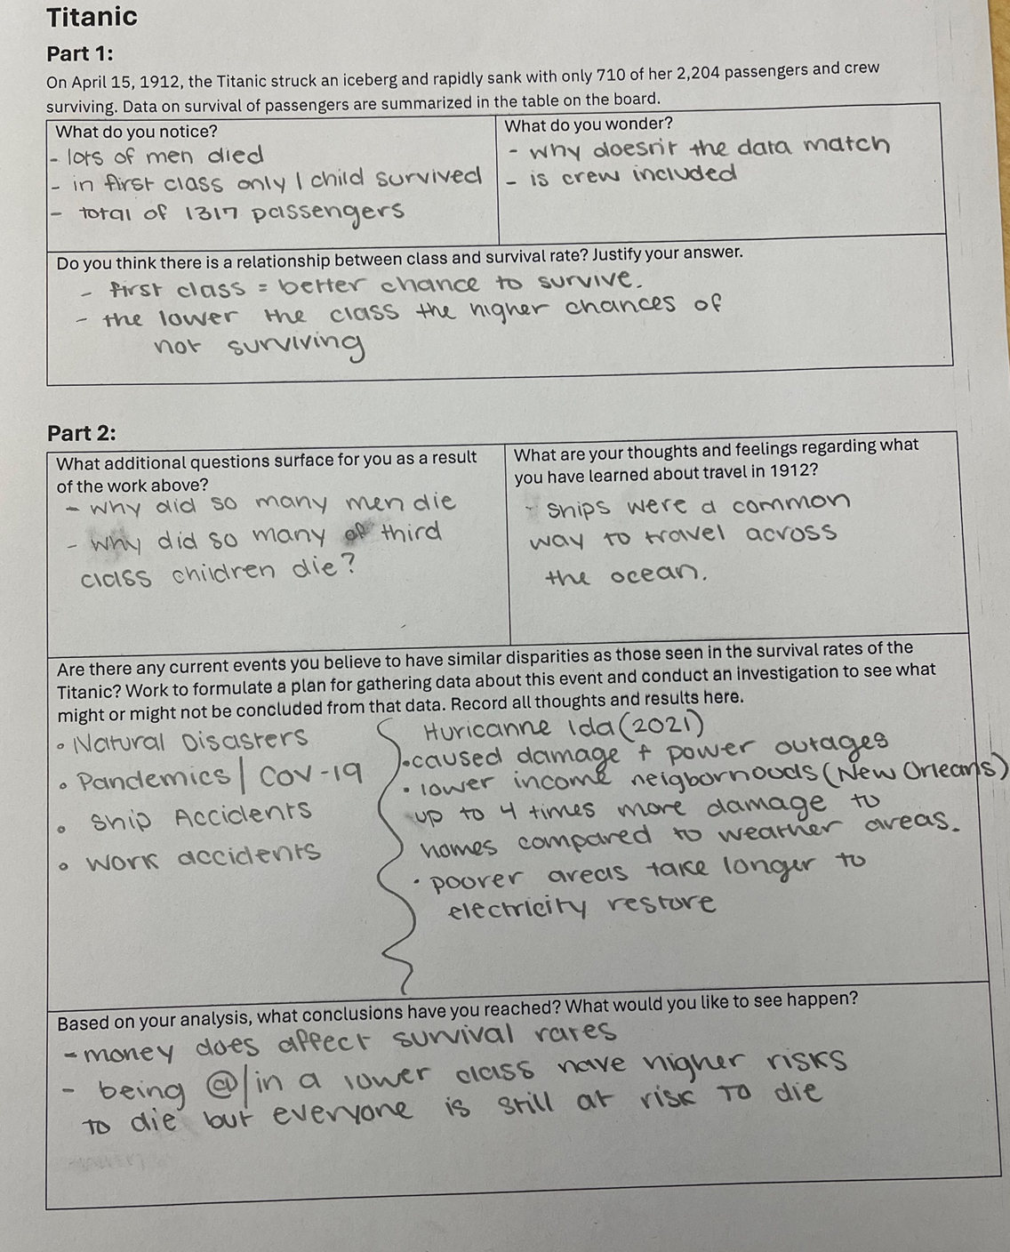

Let’s do some math! Round 2

Task 2: Random Walk Prompt
Students are given a task like this:

In this task you will explore the connection between random walks and internet searches.

Part 1: Random Walks
Let’s begin by exploring how random walks work. Consider the following map with four points of interest.
2
3
4
1
- If someone starts at one of the points and randomly decides where to go next, what do you anticipate will happen? Make at least three predictions.
- Design and carry out a simulation to test one of your predictions. Determine ways to quantify how often someone can end up at one of the points.
- What did you learn from designing a simulation to test your predictions?
- What do you anticipate the random walk phenomenon has to do with internet searches?

Part 2: Internet Searches
Watch this short video The Internet: How Search Works (Code.org., 2017)
- What connections do you see between the work on Part 1: Random Walks and internet searches?
- Let’s examine how internet pages are ranked by building on what you’ve learned about random walks. To simplify things, let’s consider an internet with four pages that have links to each other as illustrated in the diagram below.
  - What do you notice about the relationships between the pages? How do you anticipate the pages will rank?
Page 4
Page 3
Page 1
Page 2
- Design and carry out a simulation to test your prediction. Based on the simulation, how do the pages rank? Does this surprise you?
  - What is the relative frequency of visits to each page? What do these percentages mean?
- In the video, we hear Akshaya explain how “spammers try to game the search algorithm.” How might you modify the map above to illustrate how this works? Design a simulation as before and prepare to share your results.
- Based on your current understanding, what might explain why people have different experiences when they search the internet? What are your thoughts on this?
(adapted from Dr. Claudio Gómez-Gonzáles, Carleton College)

Task 2: Random Walk Student Work

Example 1:

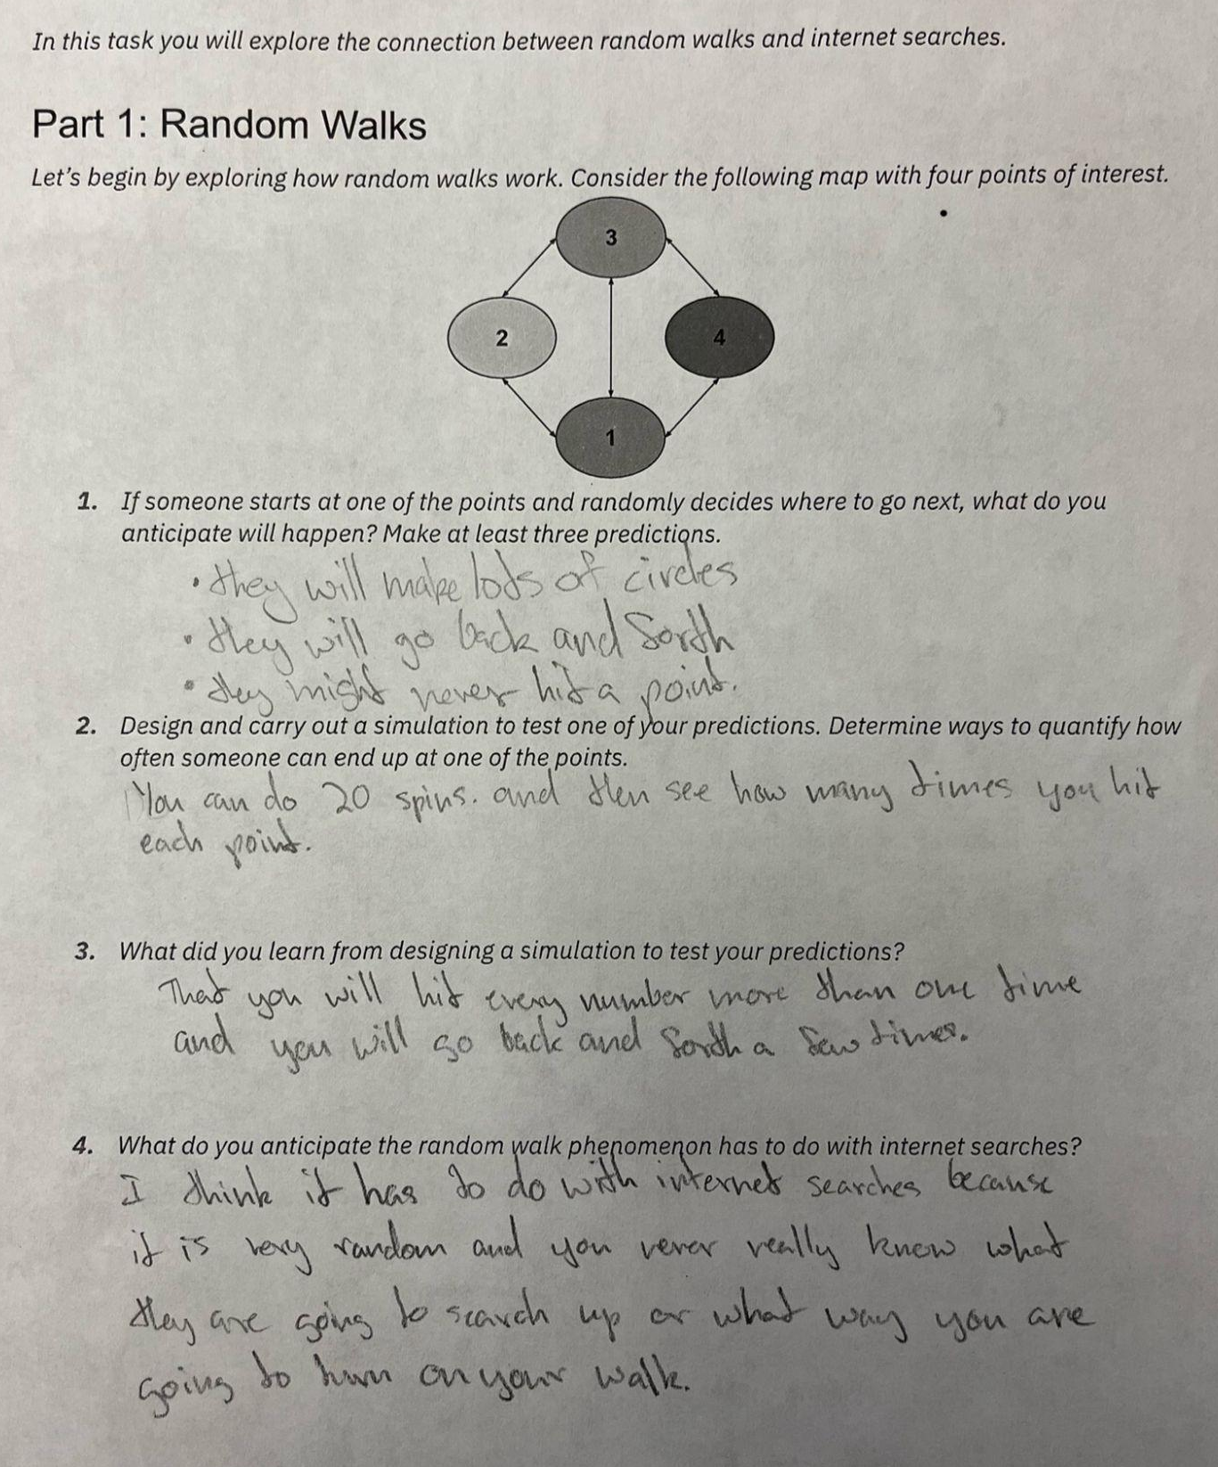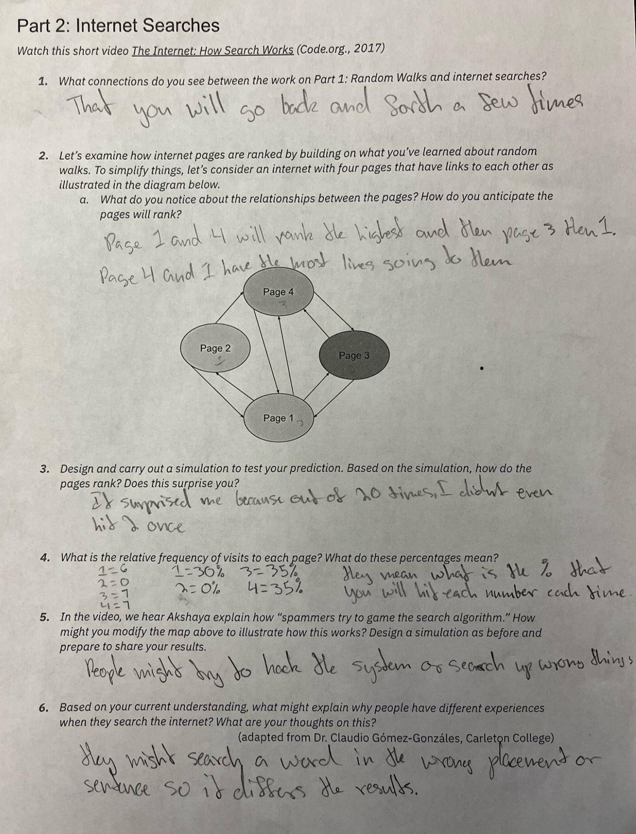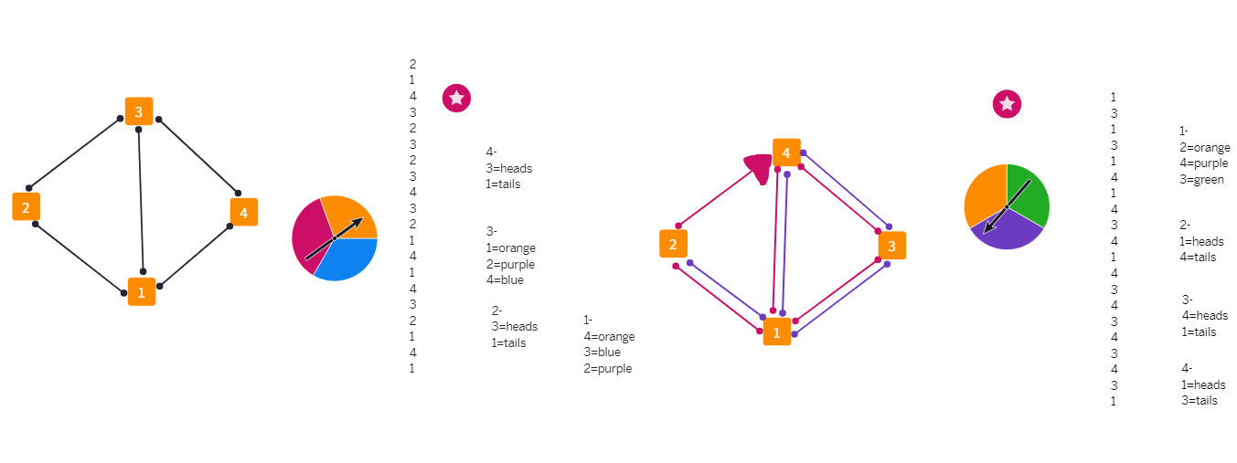

Example 2:

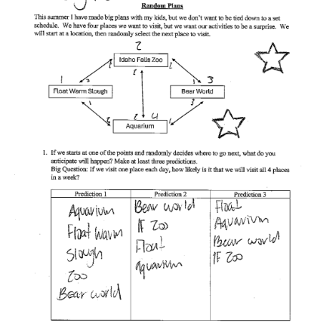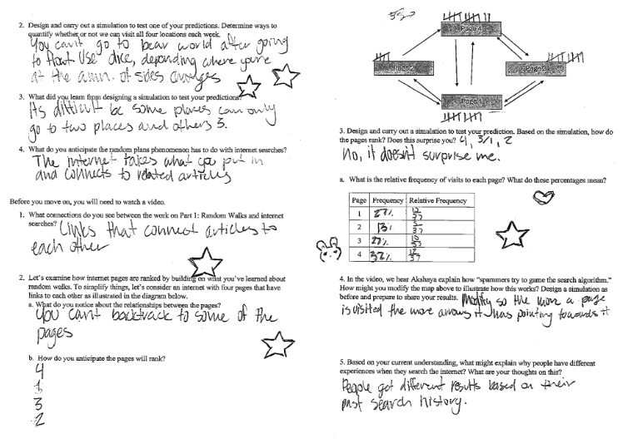
Example 3:
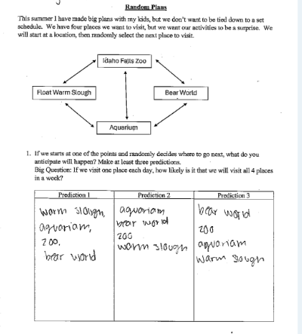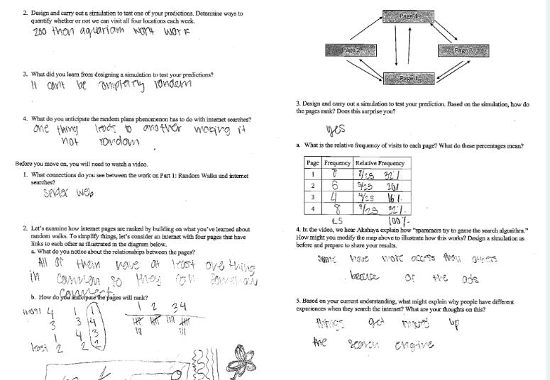

Criteria for Success

Conference and Provide Revision Support | Accept with Revision | Accept
The student’s artifact shows an emerging understanding of the expectations of the indicator(s). After conferencing and additional instruction/learning, the student may provide a revised or different artifact as evidence of the indicator(s). | The student’s artifact is approaching a full understanding of the expectations of the indicator(s). The artifact may contain execution errors that should be corrected in revision. The student may revise the selected artifact or submit a different artifact. | The student’s artifact demonstrates evidence that they have met the expectations of the indicator(s).

References
Common Core State Standards Writing Team. (2011, December 26). 6-8 Statistics and Probability. Progressions for the Common Core State Standards in Mathematics (draft). https://achievethecore.org/content/upload/Draft%206%E2%80%938%20Progression%20on%20Statistics%20and%20Probability.pdf

Illustrative Mathematics. (2016, May 4). Rain and Lightning. Illustrative Mathematics. http://tasks.illustrativemathematics.org/content-standards/HSS/CP/A/2/tasks/1112

Illustrative Mathematics. (2016, May 4). Rolling Dice. Illustrative Mathematics. http://tasks.illustrativemathematics.org/content-standards/7/SP/C/7/tasks/1216

