M151 Performance Task
Designing a Zoo Enclosure
Orangutan Version

The Modeling Cycle
Designing a zoo requires creating a space that meets the needs of the animals as well as the needs of the visitors. For example, a space must be created that replicates the key features of an animal’s natural habitat while simultaneously ensuring the safety of visitors and giving visitors the ability to observe the animals in that space. In this task, you will design an enclosure for an animal and produce a scale drawing of the enclosure you’ve designed.
Mathematical models are used to make sense of ideas and phenomena in our world. As illustrated in the image below, the modeling cycle is a process of identifying a problem, creating models, analyzing the story told by those models, and reporting the results to the appropriate audience. In this task, you will be engaging with the mathematical modeling cycle to design an animal enclosure for a zoo given several real-world constraints.
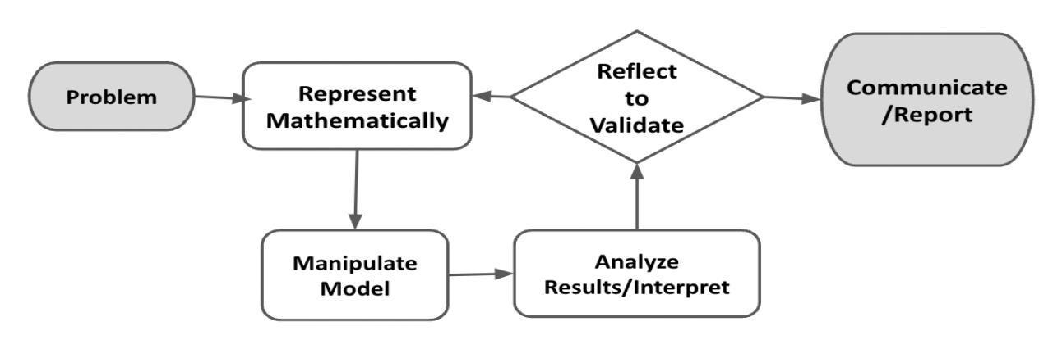
Figure 1. Diagram of Modeling Process. From “Progressions for the Common Core State Standards for Mathematics” [Draft manuscript], by Common Core Standards Writing Team, 2019, p. 6 (http://mathematicalmusings.org/wp-content/uploads/2022/05/modeling_02082019.pdf).

Designing a Zoo Enclosure
Launch
You are a zoo architect, and you and your team have been commissioned to design some of the zoo enclosures for the new San Diego Zoo satellite location. This is a huge project, and several animals need homes!
In this task, you will explore zoo enclosures and design your own while taking into account important design guidelines to ensure the animal will be healthy and the enclosure will stay within the spatial constraints and budget. You will use graph paper or Google Draw to model what you think is the best enclosure for your chosen animal and report on the enclosure’s specifications. Have fun!

QUESTION 1
 | What are some of the things you need to consider when designing your enclosure? Brainstorm with your group.

QUESTION 2
How do architects use math and geometry to design enclosures, buildings, and other structures?

Designing a Zoo Enclosure - Orangutan Version
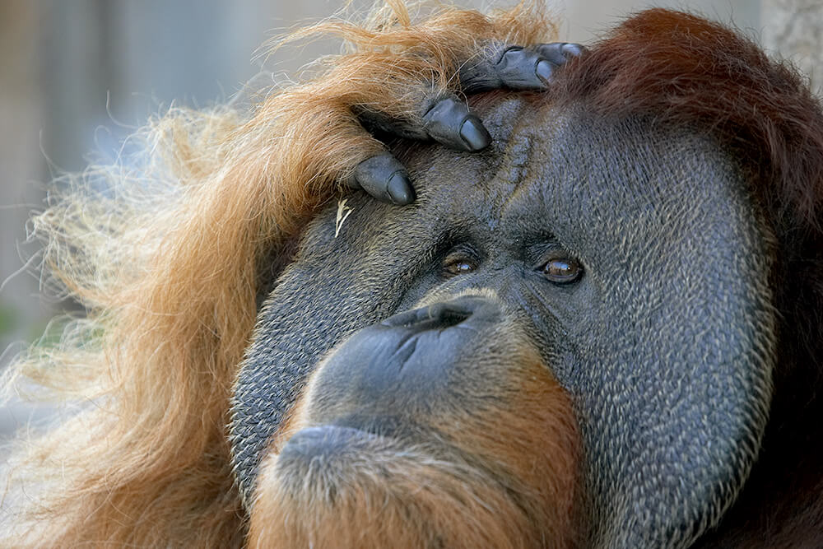
Orangutan Background Details
Orangutans are clever animals who live most of their lives in trees. In the San Diego Zoo, Ken Allen was a Bronean orangutan who escaped multiple times during his long life there by unscrewing bolts, reaching around to unlatch locks, and climbing over walls. So your design has to account for some orangutans’ wiley escape tactics!
Your Task: There are two types of animals the San Diego Zoo needs to build enclosures for: orangutans and elephants. You have chosen to design enclosures for orangutans. In this task, you will create a scale drawing of an enclosure for the animal you selected.

In Part 1, the Formulate and Represent Mathematically sections, you will develop a scaled drawing of an enclosure to meet the constraints for designing a space for orangutans. The Formulate and Represent Mathematically (Part 1) Checklist can be used to ensure you have the necessary components before moving on to the remaining parts of the task.

Formulate (Part 1)
ACTION 1
Determine the outer perimeter boundary walls for your enclosure. Consider drafting a sketch of what this might look like before creating a scaled drawing.
What are boundary walls?
These are walls that separate the animal from the rest of the zoo and the visitors.
These are walls that establish the total amount of living space the animal has.
These are walls that are secured into the ground.

Note: You are welcome to use additional paper or digital forms to document your work. Be sure to include all of your work in your final submission.

Represent Mathematically (Part 1)
ACTION 2
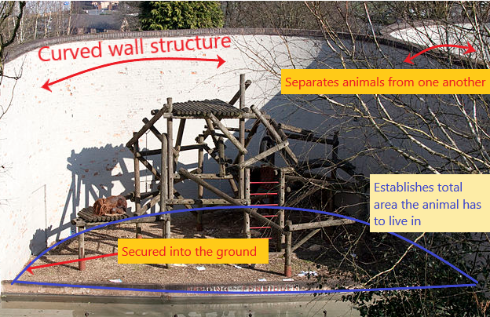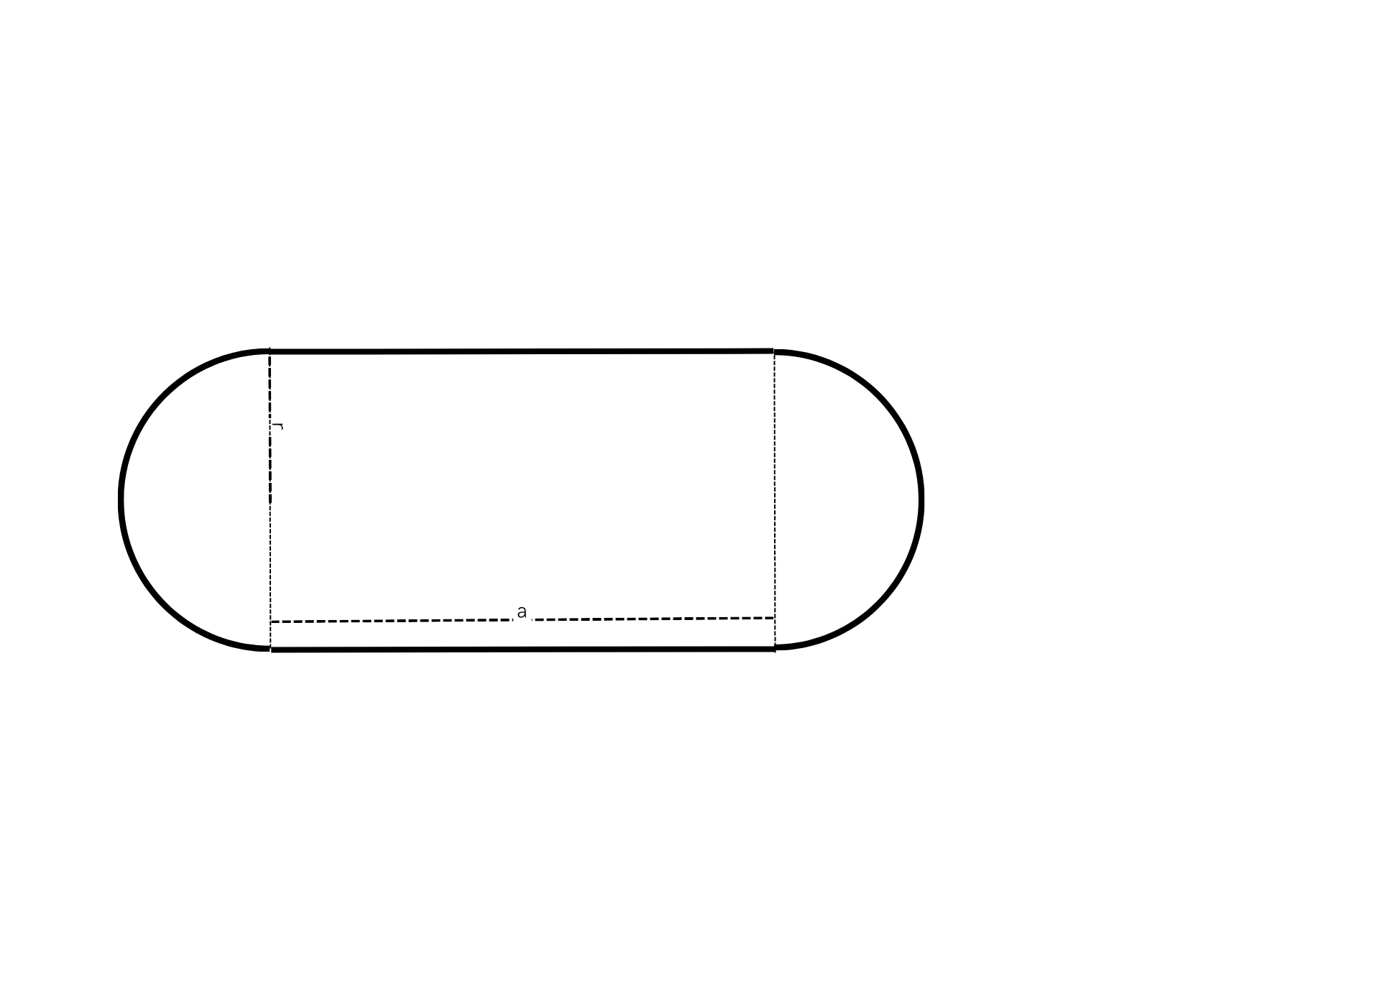
Design Constraints
We are going to model after the Chester Zoo in the UK and give the orangutans at least 3200 but no more than 4500 square meters of space (budget constraints). Assume a flat, level ground for the build.

Perimeter boundary walls need to avoid 90-degree angles with all other perimeter boundary walls to lower the chance of escape. As you draw your perimeter boundary, avoid creating right angles. Consider using ellipses, circles, and composite shapes which are two or more shapes together (like the shape of a track or pill, which is a rectangle and two semicircles). Internal boundaries can be any angle—just the perimeter boundary walls need to have NO 90-degree angles.
Use a piece of graph paper or Google Draw to create a two-dimensional scale drawing of the boundary of your enclosure.
- Include:
  - a key that shows the scale for your drawing; and
  - calculations showing that the area is within the guidelines (3200-4500 m²).
- When you finish Part 1 of your design, use the checklist below to ensure you have all the requirements.

Formulate and Represent Mathematically (Part 1) Checklist
Requirement | Fulfilled?
I have drawn perimeter boundary walls that are curved and avoid right angles. | ▢
I have included a key showing the scale. | ▢
I have included calculations to show that the design is between 3200-4500 square meters of area. | ▢
Teacher Consultation: | ______________

Formulate (Part 2)
ACTION 3
Design the units within the enclosure. There must be at least four separate units within the enclosure because females and the young orangutans need to be separated from adult males. Discuss or provide a draft of your design that meets this need.

Note: You are welcome to use additional paper or digital forms to document your work. Be sure to include all of your work in your final submission.

Represent Mathematically (Part 2)
ACTION 4
With these design constraints in mind, add to your graph paper or Google drawing and create at least four units in the enclosure boundaries. Include calculations showing that each unit area is within the guidelines above.

Additional Design Constraints

Each adult male needs to be completely isolated from any other adult male, and they should never interact. There will be two adult male orangutans. Each male adult should have at least 700 square meters of outdoor space. Label each of these spaces “Single Male Unit.”
Females and young need at least 1000 square meters for their group (they all live together). Label that unit “Females and Young Unit.”
There needs to be an indoor space. The indoor space needs to have an area of 400-450 square meters. This is where orangutans can avoid bad weather and get relief from the sun and human visitors coming to see them. Add at least one indoor space within the boundary and label it “Indoor Unit” on your drawing.
When you finish Part 2 of your design, use the checklist below to ensure you have all the requirements.

Formulate and Represent Mathematically (Part 2) Checklist
Requirement | Fulfilled?
I have at least four separate units within the perimeter boundary, and each unit has a label. | ▢
I have planned for each of the two Single Male Units to have an area of at least 700 square meters, and calculations of the areas are included. | ▢
I have planned the outdoor Females and Young Unit to have a total area of at least 1000 square meters, and calculations of the area are included. | ▢
I have planned the indoor unit to have a total area of 400-450 square meters, and calculations of the area are included.
Teacher Consultation: | ______________

Formulate (Part 3)
ACTION 5
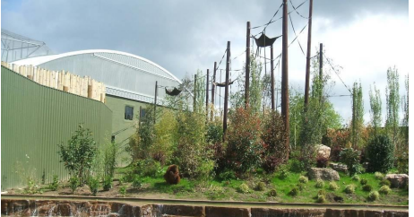
Consider adding environmental elements such as trees, rocks, water sources, climbing structures, or anything else you think of that would provide a good environment for orangutans.
As you add these features, consider how the exhibit enhances the visitor experience.

Represent Mathematically (Part 3)
ACTION 6
Imagine what those environmental elements and features would look like from above as your sketch is two-dimensional.
Add these elements to your blueprint design.
When you finish Part 3 of your design, use the checklist below to ensure you have all the requirements.

Formulate and Represent Mathematically (Part 3) Checklist
Requirement | Fulfilled?
I have intentionally added and placed environmental elements to enhance the animal experience depicted on the scale drawing. | ▢
I have intentionally added and placed environmental elements to enhance the visitor experience. | ▢
Teacher Consultation: | ______________

Validate and Report
ACTION 7
Create a presentation of your design for the orangutan enclosure for the zoo’s board of directors for approval (using a slideshow, poster, video, and/or report). Use your blueprint and supporting computations to show the estimated space needed in your presentation.
Make sure to address:
- mathematical evidence that orangutans will have at least 3200 square meters but no more than 4500 square meters of living-space area;
- appropriate-sized indoor unit that has between 400-450 square meters of area (back up your claim with mathematical evidence);
- any potential design concerns you have with your model (e.g., escape potential, birth and new offspring accommodations);
- ways in which you have enhanced the environment with water features, ropes, plants, etc., for the animals; and
- ways in which you have enhanced the environment for the visitors (visibility, safety, etc.).

Validate and Report Checklist
Requirement | Fulfilled?
I have provided a rationale showing that required constraints have been met and that additional features enhance both the animal and visitor experience. | ▢
I have clearly communicated the results in a way that is appropriate for the intended audience. | ▢
Teacher Consultation: | ______________

