M103 Performance Task
Take Me Out to the Ball Game

The Modeling Cycle
Sometimes at sporting events, parades, or other fun events, you might see t-shirts flying high into the air. Spectators throw their arms up in the air, hoping to be one of the lucky people to catch one of these flying prizes. So how far and how high can those t-shirt cannons actually shoot the balled-up shirts? Let’s find out!

Mathematical models are used to make sense of ideas and phenomena in our world. As illustrated in the image below, the modeling cycle is a process of collecting data about an idea or problem, creating models of that data, analyzing the story told by those models, and reporting the results to the appropriate audience. In this task, you will be engaging with the mathematical modeling cycle to analyze the trajectories of flying t-shirts to understand how to create a path for an object traveling in a parabolic direction.

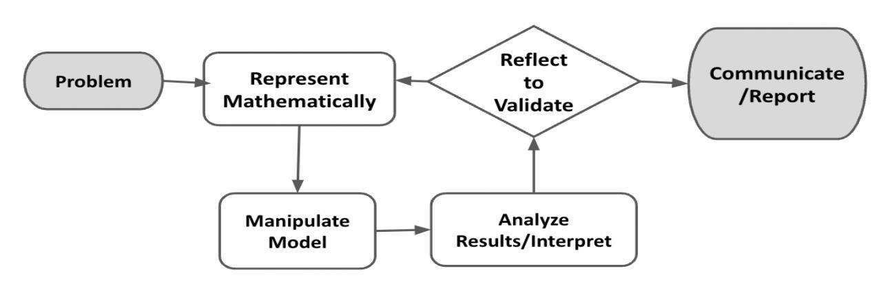
Figure 1. Diagram of Modeling Process. From “Progressions for the Common Core State Standards for Mathematics” [Draft manuscript], by Common Core Standards Writing Team, 2019, p. 6 (http://mathematicalmusings.org/wp-content/uploads/2022/05/modeling_02082019.pdf).

Take Me Out to the Ball Game
Launch
 | Watch this short video clip about the t-shirt launcher the New York Mets use at their baseball games. What do you notice and wonder about this clip?

Watch the launch one more time. What are some data or measurements that were included in the video? Why do you think the creator decided to include those measurements?

Introduction: Projectiles
A projectile is something that is projected (which means launched into the air), and the only force acting on it is gravity. Examples of projectiles are footballs being thrown, a pencil falling off a desk, or water coming out of a hose at an angle, to name a few. The image below presents visuals of some of these projectile paths, the shape of which is often mathematically called a parabola, or a parabolic path.

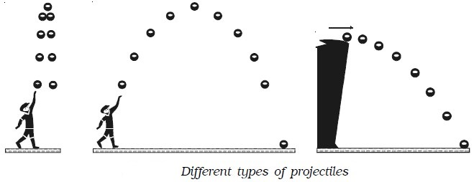
Image 1. Credit: from Engineers Field website.

Your Task: Imagine you had a job in which it was important to be able to precisely define the path of an object, such as a video game programmer or a scientist at NASA. In this task, you will explore how to create a mathematical model for the parabolic path of an object and consider ways to refine the mathematical model to make it more precise.

In the Problem Formulation sections, you will revisit the video clip of the t-shirt launcher and generate some specific measurements associated with each launch. The Problem Formulation Checklist can be used to ensure you have the necessary components before moving on to the remaining parts of the task.

Problem Formulation
Examine the three launches shown in the video clip Science Behind the Mets T-Shirt Cannon for each of the time intervals shown below. Record your responses in a Google document or on a sheet of paper.

Launch 1 (video clip from 1:38-1:50)
- What is the approximate height from which the t-shirt is launched? How did you estimate this height?
- How far from the initial launch point does the t-shirt land?
- Do you have any other information about the location of the t-shirt between its initial launch and its landing on the ground? If so, describe it in detail.

Launch 2 (video clip from 1:50-2:03)
- What is the approximate height from which the t-shirt is launched? How did you estimate this height?
- How far from the initial launch point does the t-shirt land?
- Do you have any other information about the location of the t-shirt between its initial launch and its landing on the ground? If so, describe it in detail.

Launch 3 (video clip from 2:03-2:20)
- What is the approximate height from which the t-shirt is launched? How did you estimate this height?
- What other information do you have about this launch?

Problem and Formulate Checklist
Requirement | Fulfilled?
I have made a reasonable estimate of the height for the initial launch for each video clip. | ▢
I have provided additional information, such as distance from initial launch or maximum vertical height. | ▢
Teacher Consultation: | ______________

In the Represent Mathematically and Compute sections, you will use some of your measurement data to generate one or more equations to represent the path of a t-shirt. The Represent Mathematically & Compute Checklist can be used to ensure you have the necessary components before moving on to the remaining parts of the task.

Represent Mathematically
Based on your information from the previous section, write the coordinates of two points that would be on the graph of the t-shirt’s path for each launch. The coordinates will represent the horizontal distance of the t-shirt from its launch point and the height of the t-shirt in the air.

Launch | Point 1 Coordinates | Point 2 Coordinates
Launch 1
(center field)
Launch 2
(left field)
Launch 3
(upper deck)

ACTION
 | Open the Desmos Calculator to begin to generate an equation for one of the launches. Choose the launch for which you think you have the best estimate for two of the points on the t-shirt’s path.  Which launch are you graphing?  - Select the + sign and then choose table.  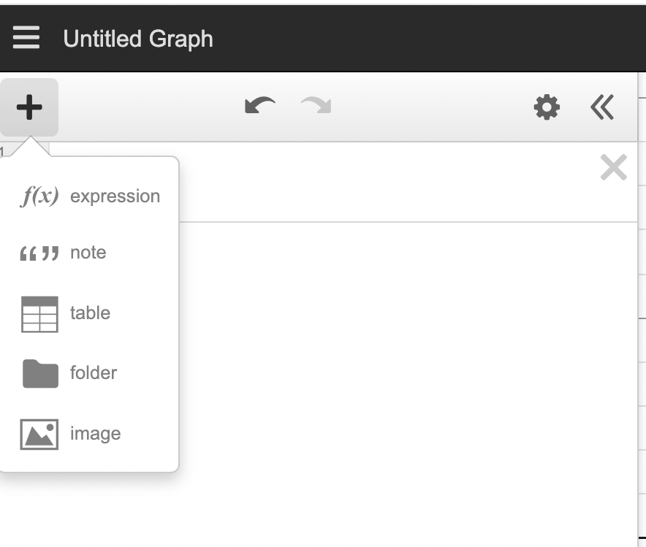  - Enter the x and y values for two points associated with the launch. Enter a third point if you have one.  - Create a generic form of a quadratic equation by typing y₁ ~ ax₁² + bx₁ + c in a new cell  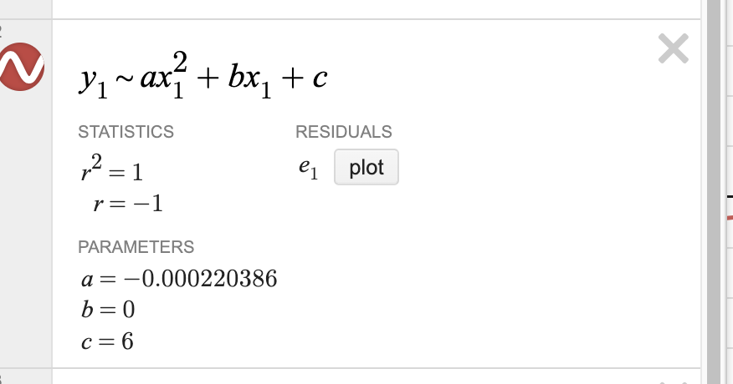  ________________________

Using the values of a, b, and c given, what equation does Desmos give for the current points you have plotted?

Do you think that the regression graph created in Desmos accurately depicts the path of the t-shirt launch? Why or why not?

Compute
What are the coordinates of two additional points on the graph that you currently have created in Desmos?

What do these points mean, if anything, in the context of the problem?

Represent Mathematically and Compute Checklist
Requirement | Fulfilled?
I have completed the Launch Coordinates table with at least one set of realistic coordinates for each t-shirt launch’s projected points on a graph. | ▢
I have generated an equation and a related regression graph in Desmos. | ▢
I have evaluated the Desmos regression graph for accuracy against the actual t-shirt launch path, and have identified other graph points and explained them within the context of the problem. | ▢
Teacher Consultation: | ______________

In the Analyze and Interpret section, you will identify a potential additional t-shirt launch path point and evaluate its influence on your Desmos graph. The Analyze and Interpret Checklist can be used to ensure you have the necessary components before moving on to the remaining parts of the task.

Analyze and Interpret
Watch the Science Behind the Mets T-Shirt Cannon video again starting from 1:25. You can slow down and pause the video as much as needed.
Use the video to estimate at least one additional point that is on the path of the t-shirt for the launch you currently have graphed in Desmos. What are the coordinates of this point?

How did you estimate this point?

Add this point to your table in Desmos. How does this additional point change the graph and the equation?

Analyze and Interpret Checklist
Requirement | Fulfilled?
I have estimated an additional t-shirt launch path point, identified the coordinates, and explained the estimation mathematically. | ▢
I have added the estimated coordinates to the original Desmos table, and identified/described any resulting changes to the Desmos graph. | ▢
Teacher Consultation: | ______________

In the Reflect to Validate and Report sections, you will analyze, evaluate, and refine your graph, and you will create an informational product to guide others in examining similar parabolic paths traveled by objects. The Reflect to Validate and Report Checklist can be used to ensure you have the necessary components before moving on to the remaining parts of the task.

Validate and Report
Watch the video again from 1:25. Are there methods you could use to improve the accuracy of your current graph? If so, explain what they are. If not, explain why you don't think so.

It’s fun to think about the paths created by t-shirts launched from a cannon. The stakes are pretty low if you’re hoping to get it into the upper deck but only manage to shoot it into the middle section. However, there are other scenarios in the world where the stakes are a bit higher. For people designing “jumps” in video games, they will need greater precision about how players take off and land. Scientists mapping out the paths of rocket ships or other projectiles from take off to landing need even greater precision.
Create an informational video, pamphlet, or other output to explain how somebody might plan the path of an object that travels in a parabolic direction. Include specific examples from your work here to help your viewers or readers understand why each step you are giving them matters.

Reflect to Validate and Report Checklist
Requirement | Fulfilled?
I have created an informational product that comprehensively and accurately provides guidance on how to illustrate parabolic travel by objects. | ▢
I have developed guidance in the product that is mathematically sound, and the product includes illustrative examples from the study of t-shirt cannon launch paths. | ▢
Teacher Consultation: | ______________

YouTuber Mark Rober built the world’s largest t-shirt cannon. Watch this 16-minute video to see how t-shirt cannons work.

