Baseline Professional Learning Handout
M203 Polynomial and Rational Expressions, Functions, and Equations

Baseline Professional Learning Handout 1
Selected Common Core High School Standards for Mathematics 2
Progressions Excerpt 3
M203 Content and Practice Expectations 4
M203 Content and Practice Expectations and Indicators 5
Let’s Investigate 6
Trina’s Triangles Task 6
Egyptian Fractions II Task 7
Let’s do some math! Round 1 8
Task 1: Planetary Motion Prompt 8
Learning Principles 12
Task 1: Planetary Motion Student Work 13
Let’s do some math! Round 2 14
Task 2: Polynomial Graphs Prompt 14
Task 2: Polynomial Graphs Student Work 16
Criteria for Success 17
Selected Common Core High School Standards for Mathematics

High School - Algebra
Interpret the structure of expressions.
- Interpret expressions that represent a quantity in terms of its context.★
- Interpret parts of an expression, such as terms, factors, and coefficients.
  - Interpret complicated expressions by viewing one or more of their parts as a single entity. For example, interpret P(1+r)^{n} as the product of P and a factor not depending on P.
- Use the structure of an expression to identify ways to rewrite it. For example, see x⁴ – y⁴ as (x²)² – (y²)², thus recognizing it as a difference of squares that can be factored as (x² – y²)(x² + y²).

Perform arithmetic operations on polynomials.
- Understand that polynomials form a system analogous to the integers, namely, they are closed under the operations of addition, subtraction, and multiplication; add, subtract, and multiply polynomials.

Understand the relationship between zeros and factors of polynomials.
- Know and apply the Remainder Theorem: For a polynomial p(x) and a number a, the remainder on division by x – a is p(a), so p(a) = 0 if and only if (x – a) is a factor of p(x).
- Identify zeros of polynomials when suitable factorizations are available, and use the zeros to construct a rough graph of the function defined by the polynomial.

Use polynomial identities to solve problems.
- Prove polynomial identities and use them to describe numerical relationships. For example, the polynomial identity (x² + y²)² = (x² – y²)² + (2xy)² can be used to generate Pythagorean triples.

Rewrite rational expressions.
- Rewrite simple rational expressions in different forms; write a(x)/b(x) in the form q(x) + r(x)/b(x), where a(x), b(x), q(x), and r(x) are polynomials with the degree of r(x) less than the degree of b(x), using inspection, long division, or, for the more complicated examples, a computer algebra system.

Interpret functions that arise in applications in terms of the context.
- For a function that models a relationship between two quantities, interpret key features of graphs and tables in terms of the quantities, and sketch graphs showing key features given a verbal description of the relationship. Key features include: intercepts; intervals where the function is increasing, decreasing, positive, or negative; relative maximums and minimums; symmetries; end behavior; and periodicity.★
- Relate the domain of a function to its graph and, where applicable, to the quantitative relationship it describes. For example, if the function h(n) gives the number of person-hours it takes to assemble n engines in a factory, then the positive integers would be an appropriate domain for the function.★
- Calculate and interpret the average rate of change of a function (presented symbolically or as a table) over a specified interval. Estimate the rate of change from a graph.★

Algebra Progression Excerpt
Arithmetic with Polynomials and Rational Expressions
At first algebraic expressions are simply numbers in which one or more letters are used to stand for a number which is either unspecified or unknown. Students learn to use the properties of operations to write expressions
in different but equivalent forms. At some point they see equivalent expressions, particularly polynomial and rational expressions, as naming some underlying thing. There are at least two ways this can go. If the function concept is developed before or concurrently with the study of polynomials, then a polynomial can be identified with the function it defines. In this way x² − 2x − 3, (x − 1)(x − 3), and (x − 1)² − 4 are all the same polynomial because they all define the same function. Another approach is to think of polynomials as elements of a formal number system, in which you introduce the “number” x and see what numbers you can write down with it. In this approach, x² − 2x − 3, (x − 1)(x − 3), and (x − 1)² − 4 are all the same polynomial because the properties of
operations allow each to be transformed into the others. Each approach has its advantages and disadvantages; the former approach is more common. Whichever is chosen and whether or not the choice is explicitly stated, a curricular implementation should nonetheless be constructed to be consistent with the choice that has been made. Either way, polynomials and rational expressions come to form a system in which they can be added, subtracted, multiplied and divided. Polynomials are analogous to the integers; rational expressions are analogous to the rational numbers.

Polynomials form a rich ground for mathematical explorations that reveal relationships in the system of integers. For example, students can explore the sequence of squares

1, 4, 9, 16, 25, 36, …

and notice that the differences between them—3, 5, 7, 9, 11—are consecutive odd integers. This mystery is explained by the polynomial identity

(n + 1)² − n² = 2n + 1.

A more complex identity

(x² + y²)² = (x² − y²)² + (2xy)².

allows students to generate Pythagorean triples. For example, taking x = 2 and y = 1 in this identity yields 5² = 3² + 2².

M203 Content and Practice Expectations
203.a | Interpret the structure of polynomial and rational expressions.
203.b | Reason about and perform operations on polynomials.
203.c | Understand the relationship between the zeros and factors of polynomials.
203.d | Use polynomial identities to solve problems.
203.e | Rewrite rational expressions.
203.f | Interpret polynomial and rational functions that arise in applications in terms of the context.

M203 Content and Practice Expectations and Indicators
Content and Practice Expectations | Indicators  Choose an artifact where you…
203.a: Interpret the structure of polynomial and rational expressions. | i. interpret how parts of an expression, such as terms, factors, and coefficients relate to a real-world situation.
 | ii. interpret complicated expressions by viewing one or more of their parts as a single entity.
 | iii. use the structure of an expression to identify ways to rewrite it.
203.b: Reason about and perform operations on polynomials. | i. demonstrate understanding that polynomials are closed under the operations addition, subtraction, and multiplication.
203.b: Reason about and perform operations on polynomials. | ii. add, subtract, and multiply polynomials.
203.c: Understand the relationship between the zeros and factors of polynomials. | i. identify zeros of polynomials when suitable factorizations are available.
 | ii. use the zeros to construct a rough graph of a function defined by a polynomial.
203.d: Use polynomial identities to solve problems. | i. prove polynomial identities and use them to describe a numerical relationship.
203.e: Rewrite rational expressions. | i. rewrite simple rational expressions in different forms.
203.f: Interpret polynomial and rational functions that arise in applications in terms of the context. | i. interpret key features of graphs and tables in terms of the quantities for a function that models a relationship between two quantities.
 | ii. sketch graphs showing key features given a verbal description of the relationship between quantities.
 | iii. calculate and interpret the average rate of change of a polynomial or rational function over a specified interval.
 | iv. relate the domain of a function to its graph, and where applicable, to the quantitative relationship it describes.

Let’s Investigate

Trina’s Triangles Task
Alice was having a conversation with her friend Trina, who had a discovery to share:

“Pick any two integers. Look at the sum of their squares, the difference of their squares, and twice the product of the two integers you chose. Those three numbers are the sides of a right triangle.”
Trina had tried this several times and found that it worked for every pair of integers she tried. However, she admitted that she wasn't sure whether this "trick" always works, or if there might be cases in which the trick doesn't work.
- Investigate Trina's conjecture for several pairs of integers. Does her trick appear to work in all cases, or only in some cases?

- If Trina's conjecture is true, then give a precise statement of the conjecture, using variables to represent the two chosen integers, and prove it. If the conjecture is not true, modify it so that it is a true statement, and prove the new statement.

- Use Trina's trick to find an example of a right triangle in which all of the sides have integer length, all three sides are longer than 100 units, and the three side lengths do not have any common factors.

Source: Illustrative Mathematics

Egyptian Fractions II Task

Ancient Egyptians used unit fractions, such as $\frac{1}{2}$ and $\frac{1}{3}$, to represent all other fractions. For example, they might express the number $\frac{3}{4}$ as $\frac{1}{2}$ + $\frac{1}{3}$. The Egyptians did not use a given unit fraction more than once so they would not have written $\frac{3}{4}$ = $\frac{1}{4}$ + $\frac{1}{4}$ + $\frac{1}{4}$.

- How might the Egyptians have expressed the number $\frac{2}{7}$? What about $\frac{5}{13}$?

- We will see how we can use identities between rational expressions to help in our understanding of Egyptian fractions. Verify the following identity for any x > 0:

$\frac{1}{x}=\frac{1}{x+1}+\frac{1}{x(x+1)}$

- Show that each unit fraction $\frac{1}{n}$, with n ≥ 2, can be written as a sum of two or more different unit fractions.

- Describe a procedure for writing any positive rational number, say, $\frac{p}{q}$ with p,q > 0, as an Egyptian fraction.

Source: Illustrative Mathematics

Let’s do some math! Round 1

Task 1: Planetary Motion

Students are given a task like this:

Part 1: Make Sense

In the early 1600s, Johannes Kepler (1571–1630) studied the motions of the planets to find a good mathematical model for them. In 1619, he published his third law of planetary motion, which says how the orbital periods of the planets are related to their distances from the sun. In Kepler’s time, Uranus and Neptune had not been discovered, but in the table below are data for all 8 planets:

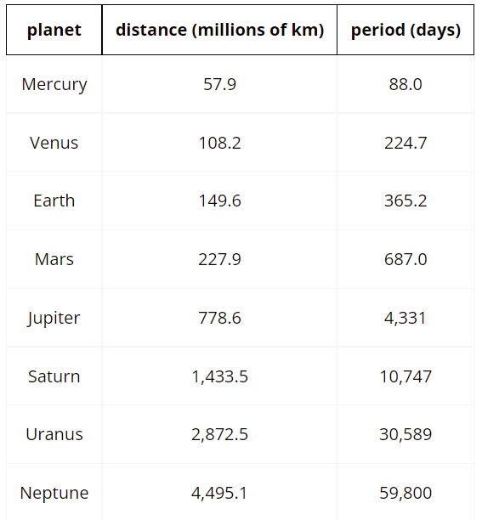

- What sort of function do you anticipate will fit this data? How did you arrive at that conclusion?

Part 2: Graphing

- Plot the distance (
- $x$) and period ($y$) of each planet, and find a polynomial model that fits the data as well as possible. You may have to experiment with both the degree of your polynomial function and the number of terms.
- Make another plot that uses the square root of each distance instead, and find a polynomial model that fits those points as well as possible.
- Which model do you think is best?
  - Jupiter has a lot of moons. Look up the periods and distances of some of them, and use that data to make a polynomial model of the relationship between period and distance for Jupiter’s moons.
  - Use your model to predict the period of another one of Jupiter’s moons using the radius of its orbit.
  - How good was the prediction? What are some possible sources of error?

Part 3: Analyze

Kepler’s Third Law of Planetary Motion states: “The square of the orbital period of a planet is proportional to the cube of the semi-major axis of its orbit”.
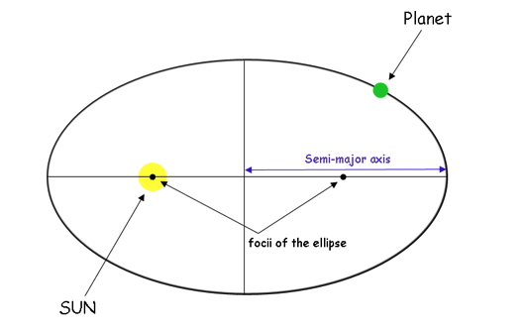
Keplers laws
- What does Kepler’s Third Law look like in terms of an algebraic equation? What do variables in that equation mean?
- How can you use the information given in the table to determine the value of the constant?
- Does the same constant hold for every planet?
- How might this information be helpful in determining what polynomial function models this relationship?

Part 4: Refine and Reflect

Jupiter has a lot of moons. Here are the periods and distances of the Galilean moons, which were discovered in 1610:
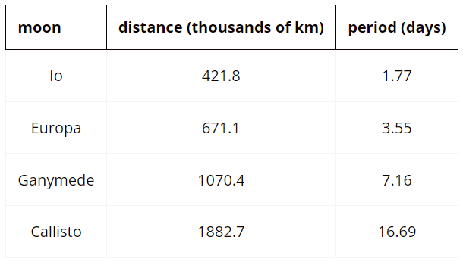
Note: Distance refers to the average distance from the center of Jupiter to each moon.

- Use the data to make a polynomial model of the relationship between a moon’s orbital period and its distance from Jupiter’s center.
- Another moon of Jupiter, number LXXI, was discovered in 2018. Its distance from Jupiter is 11,483 thousand km. According to your model, what should its period be?
- The actual period of the moon (LXXI) is 252.0 days. How close was the prediction? What are some possible sources of error?
- What is something you learned about the work of developing functions that model real-world phenomena?

Sample Learning Experience

Part 1: Make Sense

Launch this experience by inviting students to consider why studying the motions of the planets might be important. Consider using these questions:
- What might the motion of the planets tell us?
- What factors do you think influence the motion of the planets?

To deepen understanding on why studying planet motion is important, consider having students explore one or more of these resources:
Video: How the Movement of Other Planets Affects Earth — Yes, Really
Article: Planet Movements Impact Earth

Ask students:
- What is something that you learned that was new?
- What surprised you?

After discussing, present students the prompt and table above. Invite students to make sense of the table given:
- What do you think the term “period” means here?
- What do you notice about the distance and period? Is there any relationship between the two?
- What type of association is represented in the table (linear, quadratic, power, etc.)?

After discussing, let students know that we are working with this information to find a polynomial function that best fits the data. Give students time to consider what sort of function might fit this data and why, then ask them to share thoughts with their classmates, in pairs or small groups. Make note of students’ ideas in a public space to refer to as the opportunity surfaces.

Part 2: Graphing

Ensure students have access to graphing technology, or share a link to the Desmos graph Planetary Distance and Period. As students work on this part, monitor and select students to share their approaches with the class.

Questions that can be posed to student pairs as they work:
- What kind of growth is happening in the table? How do you know?
- What happened to your best fit equation as the degree changed?
- How would you explain the relationship between the period and distance of the moons?

Consider using questions like this to facilitate discussion:
- What’s promising about this approach?
- What questions does this approach surface for you?
- What can you take from this approach to apply to your own work?

Provide time for students to revise and refine their work.

Part 3: Analyze

Invite students to share their models for the relationship between the orbital period and distance, and for the relationship between the orbital period and the square root of the distance.

Share with students the statement of Kepler’s third law, which is: “The square of the orbital period of a planet is proportional to the cube of the semi-major axis of its orbit.” This means that the square of the orbital period is the product of some constant and the cube of the distance. This can be expressed as p²=n・d³. This can be rearranged into something of the form p= k(d^{1/2})³ which is the relationship they have been investigating. Once Kepler saw this relationship, he could divide the square of any planet’s period by the cube of its distance in order to find out the proportionality constant.

The goal of this part of the journey is for students to explore these ideas for themselves and verify that all planets have the same proportionality constant. You may also invite students to compare what happens with Jupiter’s moons—do they have the same proportionality constant as the planets? Newton’s laws of gravity later explained why this relationship between distance and period is true. Give students to explore these ideas by conducting additional research.

Monitor and select students to share their approach as they work on these prompts. After some quiet time to think, encourage students to work with a partner or in small groups. Consider using the following questions to facilitate the discussion:
- What’s promising about this approach?
- What questions does this approach surface for you?
- What can you take from this approach to apply to your own work?

Provide time for students to revise and refine their work.

Part 4: Refine and Reflect

Give selected pairs of students time to share responses and invite classmates to respond or pose questions.

Provide time for students to revise their work. While they work, select additional pairs to share how they used the structure and relationship between the equations to determine which sets of equations have the same answer. Give students additional time to revise their work.

Learning Principles
Engage with cognitively demanding tasks in heterogeneous settings (LP 1). Students should be given opportunities to grapple with multistep, non-routine tasks that promote mathematical rigor. These experiences should be differentiated so that all students engage in appropriate challenges—for example, through tasks with multiple entry points and solution pathways. These experiences should continue to integrate knowledge and skills developed in grades 6-8 at the level of sophistication of high school mathematics.

Engage in social activities (LP 2). Students should have opportunities to work independently and to communicate with one another about mathematics by engaging in collective and collaborative learning activities. Explaining and having opportunities to revise one’s thinking has excellent value in solidifying one’s knowledge.

Build conceptual understanding through reasoning (LP 3). Students should be given the opportunity to reason, justify, and problem solve with critical thinking, reading, writing, speaking, and listening. Through reasoning and work with multiple representations, students learn why procedures work and build a conceptual understanding of key mathematical ideas.

Have agency in their learning (LP 4). Students should be able to choose tasks and learning experiences that align with their interests and aspirations. All students have rich and varied experiences and home lives. Learning mathematics should bring students’ identities and interests to the fore and build on the strengths that they bring to the learning space.

View mathematics as a human endeavor across centuries (LP 5). Students should understand that mathematical ideas emanated over time from civilizations around the world and have opportunities to explore these contributions to mathematics. Students should develop an appreciation of mathematics as a human endeavor: one in which they feel a sense of belonging, where they see themselves as mathematicians, and one that offers opportunities to broaden their ideas about what mathematics is, how it is used, and who it is for.

See mathematics as relevant (LP 6). Students should engage with mathematics in ways that authentically involve real-world situations. Problem-solving contexts should allow students to perceive mathematics as a tool for addressing the questions that arise in everyday life, as well as the ways it can model our world and address global economic, social, and environmental challenges. Students should also engage with mathematics in ways that connect to academic disciplines and future careers by doing the mathematics used by artists, designers, engineers, and other professionals.

Employ technology as a tool for problem-solving and understanding (LP 7). Research indicates that technology is a powerful tool for learning deeper mathematics by improving calculation efficiency and enabling more sophisticated analysis. Students should learn to use technology, with emphasis put on widely used tools and software, such as calculators and spreadsheets, to make sense of models. Technology use should not be limited to supporting “doing mathematics,” but should also be used as a tool for displaying and communicating results to appropriate audiences.

Task 1: Planetary Motion Student Work

Example 1:

Insert image of student work here

Example 2:

Insert image of student work here

Example 3:

Insert image of student work here

Let’s do some math! Round 2

Task 2: Polynomial Graphs Prompt
Students are given a task like this:

You have been given a polynomial graph with three equivalent equations. Analyze and make connections from the information in the questions below.

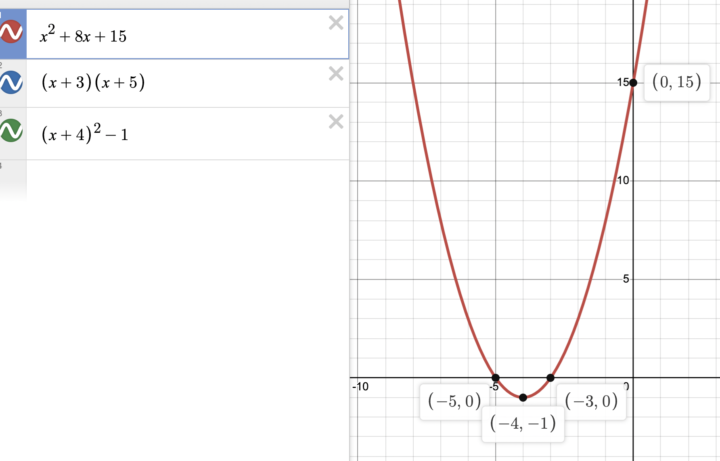

- Complete the chart below using the given graph and equations

Write in each equation according to its form. | Explain the features of the equation connecting the graph to this form. | When would using this form of the equation be most useful?
Standard Form

Vertex Form

Factored

- Now, you have been given the graph of a polynomial function, but the equations are missing.
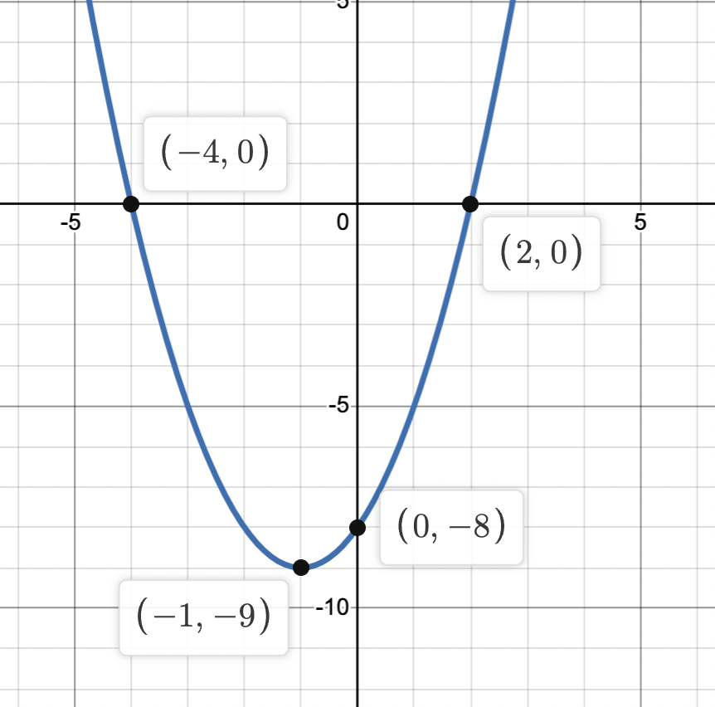

  - Write an equation for the factored form. What do the values for x represent in this equation? Defend your thinking using mathematical and/or written justifications.

  - Explain the process for developing the vertex form of the function. What does the value for x represent in this equation?

  - Sketch the graph for your own polynomial equation using Desmos, linked here.
  - From the graph, write the three equivalent equations that would produce this graph.
  - Defend your thinking using mathematical and/or written justifications.
  - Summarize the importance of three forms of a polynomial function.

Sample Learning Experience

Provide time for students to consider the question posed and independently develop a response. Have students write their response including their justification. Have partner pairs share their written justification and critique each other’s response, allowing for students to defend their response. Provide time for students to revise their written justifications using the information gained during their partner-sharing time. While observing student discussions, identify varying solution methods to be presented during the whole group sharing. Have selected students present their responses—consider using a document camera for students to show actual work—and explain their justification.

As discussion takes place, invite classmates to join the discussion. Ask:

- What about this reasoning makes sense?
- Is there anything you disagree with?
- What questions surface for you?

Provide time for students to revise their work.

Task 2: Polynomial Graphs Student Work

Example 1:

Insert image of student work here

Example 2:

Insert image of student work here

Example 3:

Insert image of student work here

Criteria for Success

Conference and Provide Revision Support | Accept with Revision | Accept
The student’s artifact shows an emerging understanding of the expectations of the indicator(s). After conferencing and additional instruction/learning, the student may provide a revised or different artifact as evidence of the indicator(s). | The student’s artifact is approaching a full understanding of the expectations of the indicator(s). The artifact may contain execution errors that should be corrected in revision. The student may revise the selected artifact or submit a different artifact. | The student’s artifact demonstrates evidence that they have met the expectations of the indicator(s).

