Baseline Professional Learning Handout
M100 Quantitative Reasoning

Baseline Professional Learning Handout 1
Quantity Progression Excerpt 6
M100 Content and Practice Expectations 7
M100 Content and Practice Expectations and Indicators 8
Let’s Investigate 10
Thunder and Lightning Task 10
Traffic Jam Task 10
Let’s do some math! Round 1 11
Task 1: Baking Pans 11
Learning Principles 12
Task 1: Baking Pans Student Work 13
Let’s do some math! Round 2 15
Task 2: Public Service Announcement 15
Task 2: Public Service Announcement Student Work 17
Criteria for Success 20
References 20
Selected Common Core Standards for Mathematics

Quantities
Reason quantitatively and use units to solve problems.
- Use units as a way to understand problems and to guide the solution of multi-step problems; choose and interpret units consistently in formulas; choose and interpret the scale and the origin in graphs and data displays.
- Define appropriate quantities for the purpose of descriptive modeling.
- Choose a level of accuracy appropriate to limitations on measurement when reporting quantities.

Ratios and Proportional Relationships
Understand ratio concepts and use ratio reasoning to solve problems.
- Understand the concept of a ratio and use ratio language to describe a ratio relationship between two quantities. For example, “The ratio of wings to beaks in the bird house at the zoo was 2:1, because for every 2 wings there was 1 beak.” “For every vote candidate A received, candidate C received nearly three votes.”
- Understand the concept of a unit rate a/b associated with a ratio a:b with b ≠ 0, and use rate language in the context of a ratio relationship. For example, “This recipe has a ratio of 3 cups of flour to 4 cups of sugar, so there is 3/4 cup of flour for each cup of sugar.” “We paid $75 for 15 hamburgers, which is a rate of $5 per hamburger.”1
- Use ratio and rate reasoning to solve real-world and mathematical problems, e.g., by reasoning about tables of equivalent ratios, tape diagrams, double number line diagrams, or equations.
- Make tables of equivalent ratios relating quantities with whole number measurements, find missing values in the tables, and plot the pairs of values on the coordinate plane. Use tables to compare ratios.
- Solve unit rate problems including those involving unit pricing and constant speed. For example, if it took 7 hours to mow 4 lawns, then at that rate, how many lawns could be mowed in 35 hours? At what rate were lawns being mowed?
- Find a percent of a quantity as a rate per 100 (e.g 30% of a quantity means 30/100 times the quantity); solve problems involving finding the whole, given a part and the percent.
- Use ratio reasoning to convert measurement units; manipulate and transform units appropriately when multiplying or dividing quantities.

Analyze proportional relationships and use them to solve real-world and mathematical problems.
- Compute unit rates associated with ratios of fractions, including ratios of lengths, areas and other quantities measured in like or different units. For example, if a person walks 1/2 mile in each 1/4 hour, compute the unit rate as the complex fraction 1/2/1/4 miles per hour, equivalently 2 miles per hour.
- Recognize and represent proportional relationships between quantities.
- Decide whether two quantities are in a proportional relationship, e.g., by testing for equivalent ratios in a table or graphing on a coordinate plane and observing whether the graph is a straight line through the origin.
- Identify the constant of proportionality (unit rate) in tables, graphs, equations, diagrams, and verbal descriptions of proportional relationships.
- Represent proportional relationships by equations. For example, if total cost t is proportional to the number n of items purchased at a constant price p, the relationship between the total cost and the number of items can be expressed as t = pn.
- Explain what a point (x, y) on the graph of a proportional relationship means in terms of the situation, with special attention to the points (0, 0) and (1, r) where r is the unit rate.
3. Use proportional relationships to solve multistep ratio and percent problems. Examples: simple interest, tax, markups and markdowns, gratuities and commissions, fees, percent increase and decrease, percent error.

Statistics and Probability
Summarize and describe distributions.
- Display numerical data in plots on a number line, including dot plots, histograms, and box plots.
- Summarize numerical data sets in relation to their context, such as by:
- Reporting the number of observations.
- Describing the nature of the attribute under investigation, including how it was measured and its units of measurement.
- Giving quantitative measures of center (median and/or mean) and variability (interquartile range and/or mean absolute deviation), as well as describing any overall pattern and any striking deviations from the overall pattern with reference to the context in which the data were gathered.
- Relating the choice of measures of center and variability to the shape of the data distribution and the context in which the data were gathered.

Expressions and Equations
Solve real-life and mathematical problems using numerical and algebraic expressions and equations.
- Solve multi-step real-life and mathematical problems posed with positive and negative rational numbers in any form (whole numbers, fractions, and decimals), using tools strategically. Apply properties of operations to calculate with numbers in any form; convert between forms as appropriate; and assess the reasonableness of answers using mental computation and estimation strategies. For example: If a woman making $25 an hour gets a 10% raise, she will make an additional 1/10 of her salary an hour, or $2.50, for a new salary of $27.50. If you want to place a towel bar 9 3/4 inches long in the center of a door that is 27 1/2 inches wide, you will need to place the bar about 9 inches from each edge; this estimate can be used as a check on the exact computation.
- Use variables to represent quantities in a real-world or mathematical problem, and construct simple equations and inequalities to solve problems by reasoning about the quantities.
- Solve word problems leading to equations of the form px + q = r and p(x + q) = r, where p, q, and r are specific rational numbers. Solve equations of these forms fluently. Compare an algebraic solution to an arithmetic solution, identifying the sequence of the operations used in each approach. For example, the perimeter of a rectangle is 54 cm. Its length is 6 cm. What is its width?
- Solve word problems leading to inequalities of the form px + q > r or px + q < r, where p, q, and r are specific rational numbers. Graph the solution set of the inequality and interpret it in the context of the problem. For example: As a salesperson, you are paid $50 per week plus $3 per sale. This week you want your pay to be at least $100. Write an inequality for the number of sales you need to make, and describe the solutions.

Geometry
Graph points on the coordinate plane to solve real-world and mathematical problems.
- Use a pair of perpendicular number lines, called axes, to define a coordinate system, with the intersection of the lines (the origin) arranged to coincide with the 0 on each line and a given point in the plane located by using an ordered pair of numbers, called its coordinates. Understand that the first number indicates how far to travel from the origin in the direction of one axis, and the second number indicates how far to travel in the direction of the second axis, with the convention that the names of the two axes and the coordinates correspond (e.g., x-axis and x-coordinate, y-axis and y-coordinate).
- Represent real world and mathematical problems by graphing points in the first quadrant of the coordinate plane, and interpret coordinate values of points in the context of the situation.

Solve real-world and mathematical problems involving area, surface area, and volume.
- Find the area of right triangles, other triangles, special quadrilaterals, and polygons by composing into rectangles or decomposing into triangles and other shapes; apply these techniques in the context of solving real-world and mathematical problems.
- Find the volume of a right rectangular prism with fractional edge lengths by packing it with unit cubes of the appropriate unit fraction edge lengths, and show that the volume is the same as would be found by multiplying the edge lengths of the prism. Apply the formulas V = l w h and V = b h to find volumes of right rectangular prisms with fractional edge lengths in the context of solving real-world and mathematical problems.
- Draw polygons in the coordinate plane given coordinates for the vertices; use coordinates to find the length of a side joining points with the same first coordinate or the same second coordinate. Apply these techniques in the context of solving real-world and mathematical problems.
- Represent three-dimensional figures using nets made up of rectangles and triangles, and use the nets to find the surface area of these figures. Apply these techniques in the context of solving real-world and mathematical problems.

Solve problems involving scale drawings of geometric figures, including computing actual lengths and areas from a scale drawing and reproducing a scale drawing at a different scale.
- Computations with rational numbers extend the rules for manipulating fractions to complex fractions.
- Draw (freehand, with ruler and protractor, and with technology) geometric shapes with given conditions. Focus on constructing triangles from three measures of angles or sides, noticing when the conditions determine a unique triangle, more than one triangle, or no triangle.
- Describe the two-dimensional figures that result from slicing three dimensional figures, as in plane sections of right rectangular prisms and right rectangular pyramids.

Solve real-life and mathematical problems involving angle measure, area, surface area, and volume.
- Know the formulas for the area and circumference of a circle and use them to solve problems; give an informal derivation of the relationship between the circumference and area of a circle.
- Use facts about supplementary, complementary, vertical, and adjacent angles in a multi-step problem to write and solve simple equations for an unknown angle in a figure.
- Solve real-world and mathematical problems involving area, volume and surface area of two- and three-dimensional objects composed of triangles, quadrilaterals, polygons, cubes, and right prisms.

Measurement and Data
Solve problems involving measurement and conversion of measurements from a larger unit to a smaller unit.
- Know relative sizes of measurement units within one system of units including km, m, cm; kg, g; lb, oz.; l, ml; hr, min, sec. Within a single system of measurement, express measurements in a larger unit in terms of a smaller unit. Record measurement equivalents in a two column table. For example, know that 1 ft is 12 times as long as 1 in. Express the length of a 4 ft snake as 48 in. Generate a conversion table for feet and inches listing the number pairs (1, 12), (2, 24), (3, 36), ...
- Use the four operations to solve word problems involving distances, intervals of time, liquid volumes, masses of objects, and money, including problems involving simple fractions or decimals, and problems that require expressing measurements given in a larger unit in terms of a smaller unit. Represent measurement quantities using diagrams such as number line diagrams that feature a measurement scale.
- Apply the area and perimeter formulas for rectangles in real world and mathematical problems. For example, find the width of a rectangular room given the area of the flooring and the length, by viewing the area formula as a multiplication equation with an unknown factor.

Convert like measurement units within a given measurement system.
- Convert among different-sized standard measurement units within a given measurement system (e.g., convert 5 cm to 0.05 m), and use these conversions in solving multi-step, real world problems.

Geometric measurement: understand concepts of volume and relate volume to multiplication and to addition.
- Recognize volume as an attribute of solid figures and understand concepts of volume measurement.
  - A cube with side length 1 unit, called a “unit cube,” is said to have “one cubic unit” of volume, and can be used to measure volume.
  - A solid figure which can be packed without gaps or overlaps using n unit cubes is said to have a volume of n cubic units.
- Measure volumes by counting unit cubes, using cubic cm, cubic in, cubic ft, and improvised units.
- Relate volume to the operations of multiplication and addition and solve real world and mathematical problems involving volume.
  - Find the volume of a right rectangular prism with whole-number side lengths by packing it with unit cubes, and show that the volume is the same as would be found by multiplying the edge lengths, equivalently by multiplying the height by the area of the base. Represent threefold whole-number products as volumes, e.g., to represent the associative property of multiplication.
  - Apply the formulas V = l × w × h and V = b × h for rectangular prisms to find volumes of right rectangular prisms with whole number edge lengths in the context of solving real world and mathematical problems.
  - Recognize volume as additive. Find volumes of solid figures composed of two non-overlapping right rectangular prisms by adding the volumes of the non-overlapping parts, applying this technique to solve real world problems.

Quantity Progression Excerpt

Quantities Units are central to applied mathematics and everyday life. Units are prominent in a wide variety of situations involving, for example, acceleration, currency and currency conversions, people-hours, energy and power, concentration and density, social science rates (e.g., number of deaths per 100,000), and other everyday rates (e.g., points per game).

Using and interpreting units Reasoning quantitatively includes knowing when and how to convert units in computations, such as when adding and subtracting quantities that measure the same attribute but are expressed in different units and other computations with measurements in different units or converting units for derived quantities such as density and speed. Reasoning quantitatively can also include analyzing the units in a calculation to reveal the units of the answer. This can help to reveal a mistake if, for example, the answer comes out to be a distance when it should be a speed (MP.2). In applications, formulas are often used, and errors can occur in the use of the formulas if units are not attended to carefully. The formula d = vt notwithstanding, a car driving at 25 mph for 3 minutes does not cover a distance of 25 ⨉ 3 miles. Conversely, if the student does attend carefully to units, the result can be a deeper understanding of a formula or a situation.N-Q.1 Students should specify units when defining variables and attend to units when writing
expressions and equations (MP.6).

A good quantitative understanding of the situation at hand helps a student make sound choices for the scale and origin of a graph or a display. In a map of arable land area, for example, there is no sense in having a scale that extends to negative values; in a graph showing the concentration of atmospheric carbon dioxide over the past 2000 years, the choice of origin in the vertical scale is an important editorial decision. These considerations apply to graphs, data tables, scatter plots, and other visual displays of numerical data. It should go without saying that graphs and displays must be properly labeled, or else they are meaningless (MP.6).

M100 Content and Practice Expectations
100.a | Identify quantities of interest for modeling purposes.
100.b | Reason with units in problems, formulas, and data displays to solve problems.
100.c | Interpret simple numeric and algebraic expressions that arise in applications in terms of the context.
100.d | Interpret equations, tables, and graphs that arise in applications involving proportional relationships.
100.e | Interpret data displays, such as line plots, histograms, and box plots in terms of the context.
100.f | Solve real-world problems involving distances, intervals of time, liquid volume, mass, money, and other situations where operations with fractions and decimals are appropriate.
100.g | Solve real-world problems involving area and perimeter of polygons, as well as surface area and volume of prisms and pyramids.
100.h | Solve real-world problems involving quantities in a proportional relationship, including scale drawings.
100.i | Choose a level of accuracy appropriate to limitations on measurement when reporting quantities.

M100 Content and Practice Expectations and Indicators

Content and Practice Expectations | Indicators  Choose an artifact where you…
100.a: Identify quantities of interest for modeling purposes. | i. make sense of a situation and choose key quantities. Explore the relationship between those quantities to answer a question of interest.
100.b: Reason with units in problems, formulas, and data displays to solve problems. | i. determine an appropriate scale for a graph or data display.
 | ii. manipulate units as part of the problem solving process.
 | iii. explain how the units (including derived units, where appropriate) represented in a solution relate to the problem context, formula, and/or data display.
100.c: Interpret simple numeric and algebraic expressions that arise in applications in terms of the context. | i. select two different expressions that illustrate something interesting or important about the context you are modeling and describe what these expressions tell you about the context.
 | ii. describe the contextual meaning of a number or variable of interest in an expression.
100.d: Interpret equations, tables, and graphs that arise in applications involving proportional relationships. | i. select two different representations (equations, tables, or graphs) that illustrate something interesting or important about a proportional relationship you are modeling and describe what these representations tell you about the context.
 | ii. describe the contextual meaning of a number, variable, or coordinates in an equation, table, or graph of interest.
100.e: Interpret data displays, such as line plots, histograms, and box plots in terms of the context. | i. select two different data displays that illustrate something interesting or important about a real-world situation and describe what these representations tell you about the context.
 | ii. describe the contextual meaning of a key component of a data display (e.g., describe the meaning of one bar on a histogram).
100.f: Solve real-world problems involving distances, intervals of time, liquid volume, mass, money, and other situations where operations with fractions and decimals are appropriate. | i. write a numeric or algebraic expression to model a situation.
 | ii. use a numeric or algebraic expression model to compute values and then interpret the values in the context of the problem.
100.g: Solve real-world problems involving area and perimeter of polygons, as well as surface area and volume of prisms and pyramids. | i. create an equation, table, or graph to model a context involving area and perimeter of polygons and/or surface area and volume of prisms and pyramids.
 | ii. use an equation, table, or graph to solve a problem.
 | iii. interpret the values of the solution in terms of the context.
100.h: Solve real-world problems involving quantities in a proportional relationship, including scale drawings. | i. create an equation, table, or graph to model a proportional relationship.
 | ii. use an equation, table, or graph to solve the problem.
 | iii. interpret the quantities of the solution in terms of the context.
100.i: Choose a level of accuracy appropriate to limitations on measurement when reporting quantities. | i. explain the level of accuracy chosen when answering a contextual question.

Let’s Investigate

Thunder and Lightning Task

Alyssa sees a lightning bolt in the sky and counts four seconds until she hears the thunder.

- There are 5280 feet in a mile and about 3.28 feet in a meter. Given that sound travels about 343 meters per second, is the lightning strike within one mile of Alyssa?

- What is the speed of sound in miles per hour?

Source: Illustrative Mathematics

Traffic Jam Task

Last Sunday an accident caused a traffic jam 12 miles long on a straight stretch of a two lane freeway. How many vehicles do you think were in the traffic jam? Explain your thinking and show all calculations.

Source: Illustrative Mathematics

Let’s do some math! Round 1

Task 1: Baking Pans

Students are given a task like this:

Ayhan came across his great grandmother’s recipe for lemon cake. He mixed all the ingredients together in his 3 quart mixing bowl and noticed the batter almost filled up the bowl.

Now he has to determine which baking pan to use. He has a set of pans that include the following:
- A loaf pan that measures 8.5 inches by 4.5 inches by 2.5 inches
- A square pan that measures 8 inches by 8 inches by 2 inches
- An oblong pan that measures 13 inches by 9 inches by 1.75 inches
Which pan should he use?

Sample Learning Experience

Launch this prompt by asking students to share what they know about baking. Chart ideas that surface so that students can reference later. Allow students to search baking tips as needed.

Give students some quiet work time to consider their approach and response. Monitor students as they work. Look for students who make simplifying assumptions, as well as students who use expressions and equations to reason about this prompt. Look for students who recognize baking pans should not be filled to the brim, since the batter will spill over in the baking process. Select students with varied approaches to share their thinking with the class.

The following questions can be used to engage students in each other’s work:
- What’s promising about this approach?
- What questions does this approach surface for you?
- Do you think the model is reasonable? Why or why not?

Be sure to make visible any simplifying assumptions students make, as well as any insights offered about baking that come from student experience and research. Prompt students to explain the meaning of the numbers and any other relevant quantities used in their model.

Once different approaches have been shared, students could be given an opportunity to revise their work.

Learning Principles
Engage with cognitively demanding tasks in heterogeneous settings (LP 1). Students should be given opportunities to grapple with multistep, non-routine tasks that promote mathematical rigor. These experiences should be differentiated so that all students engage in appropriate challenges—for example, through tasks with multiple entry points and solution pathways. These experiences should continue to integrate knowledge and skills developed in grades 6-8 at the level of sophistication of high school mathematics.

Engage in social activities (LP 2). Students should have opportunities to work independently and to communicate with one another about mathematics by engaging in collective and collaborative learning activities. Explaining and having opportunities to revise one’s thinking has excellent value in solidifying one’s knowledge.

Build conceptual understanding through reasoning (LP 3). Students should be given the opportunity to reason, justify, and problem solve with critical thinking, reading, writing, speaking, and listening. Through reasoning and work with multiple representations, students learn why procedures work and build a conceptual understanding of key mathematical ideas.

Have agency in their learning (LP 4). Students should be able to choose tasks and learning experiences that align with their interests and aspirations. All students have rich and varied experiences and home lives. Learning mathematics should bring students’ identities and interests to the fore and build on the strengths that they bring to the learning space.

View mathematics as a human endeavor across centuries (LP 5). Students should understand that mathematical ideas emanated over time from civilizations around the world and have opportunities to explore these contributions to mathematics. Students should develop an appreciation of mathematics as a human endeavor: one in which they feel a sense of belonging, where they see themselves as mathematicians, and one that offers opportunities to broaden their ideas about what mathematics is, how it is used, and who it is for.

See mathematics as relevant (LP 6). Students should engage with mathematics in ways that authentically involve real-world situations. Problem-solving contexts should allow students to perceive mathematics as a tool for addressing the questions that arise in everyday life, as well as the ways it can model our world and address global economic, social, and environmental challenges. Students should also engage with mathematics in ways that connect to academic disciplines and future careers by doing the mathematics used by artists, designers, engineers, and other professionals.

Employ technology as a tool for problem-solving and understanding (LP 7). Research indicates that technology is a powerful tool for learning deeper mathematics by improving calculation efficiency and enabling more sophisticated analysis. Students should learn to use technology, with emphasis put on widely used tools and software, such as calculators and spreadsheets, to make sense of models. Technology use should not be limited to supporting “doing mathematics,” but should also be used as a tool for displaying and communicating results to appropriate audiences.

Slide Deck for sharing student work

Task 1: Baking Pans Student Work

Example 1:
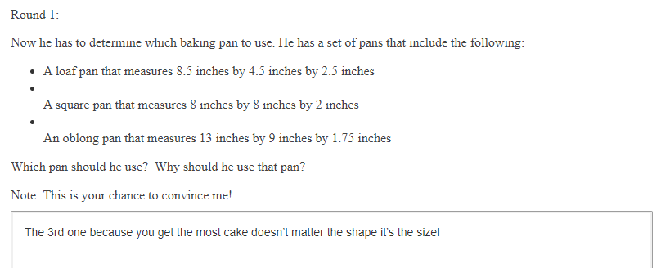

Example 2:
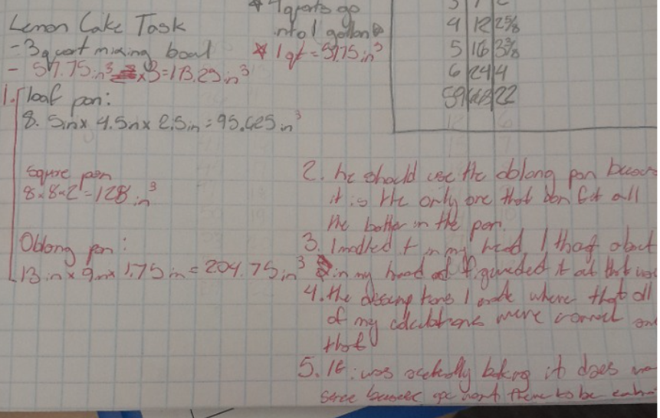

Example 3:

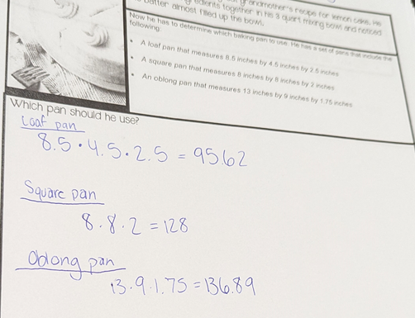

Let’s do some math! Round 2

Task 2: Public Service Announcement
Students are given a task like this:

The United States Environmental Protection Agency (EPA) “estimates that more food reaches landfills and incinerators than any other single material in our everyday trash, constituting 24 percent of the amount landfilled and 22 percent of the amount combusted with energy recovery.” [source: Regional Resources to Reduce and Divert Wasted Food Across the United States | US EPA ]

A study completed by The Drawdown Review: Climate Solutions for a New Decade shared “composting organic waste versus landfilling can reduce more than 50% of carbon dioxide-equivalent greenhouse gas emissions, for a total of 2.1 gigatons between now (2020) and 2050 if climate change is curbed to a 2 degree Celsius rise in the average global temperature.” [source: The ComPOSTer: How much can composting help in solving the climate challenge? [UPDATED] ]

Your task is to develop a public service announcement (PSA) in the form of an infographic or advertisement (suitable for radio, social media, or television) to inform your community about ways they can help minimize the amount of food and organic waste that goes into landfills.

Your PSA should include information that informs your community about:
- waste trends in your local area
- the long-term impact of current trends
- ways to change current trends for positive impact

Your PSA should:
- identify relevant quantities
- use appropriate graphical displays of these quantities

Sample Learning Experience
Students can be introduced to this topic in a variety of ways. One way to raise awareness and create space for students to make sense of waste management is to engage students with Student Achievement Partners’ Modeling Task: Super Fill. Build on this activity by inviting students to use what they now understand about landfills to explore additional considerations. Articles by the US Environmental Protection Agency, linked below, are a good place to start.

Another option is to begin by giving students time to explore resources. A sample list is provided in Part 1 of Additional Resources. Structure this time so that students have time to read and summarize findings. This can be done individually or in pairs. Encourage students to identify questions that surface as they read through the materials. Invite students to share findings and questions with the class, and make a public record of questions that surface.

Encourage students to reflect on the preliminary presentations and make note of how they want to move forward on this task. Some questions to consider are as follows:
- What resonates with you?
- What questions pique your interest and drive you to learn more?
- What information will be helpful as you prepare to make your PSA?
- What questions will help focus your PSA so that community members take your advice?

Give students time to conduct further research to answer some of their questions. Encourage students to explore infographics and other materials that have been developed to inform the public. Select and facilitate a discussion inviting students to make sense of the quantities of interests used in existing materials, examples of which can be found under Part 2 of Additional Resources below. Some questions to pose are as follows:
- What does the quantity_____ represent in this material?
- Why do you think the author/creator chose to highlight that quantity?
- How does that quantity relate to what you already know about this topic?
- Where do you think they got these figures?
- Where/how might you look for information relevant to our context?
- What have you learned from studying existing materials that you want to apply to your work?

Give students time to conduct further research to answer some of their questions. As students develop their PSA, provide opportunities for students to share progress with classmates. Consider the following questions to facilitate discussion:
- What’s promising about the planned PSA?
- What questions surface for you?
- Do you think the model is reasonable? Why or why not?
- What can you take from this approach to apply to your own work?

Give students time to conduct further research and revise their PSA. As students finalize their PSA, share products with classmates and at your site. Explore ways to partner with local businesses and radio and television stations in order to broadcast student work. Leverage social media outlets and electronic applications that your site has available.

Additional Resources
Part 1: Making sense of waste management
- Wasted Food Programs and Resources Across the United States | US EPA
- National Overview: Facts and Figures on Materials, Wastes and Recycling | US EPA
- The ComPOSTer: How much can composting help in solving the climate challenge? [UPDATED]
Part 2: Making sense of infographics
- Food Waste — Information is Beautiful
- Consumers | USDA
Part 3: Making sense of composting efforts
- Composting efforts gain traction across the United States - The Washington Post
- Beginner's Guide to Composting | One Small Step | NowThis
- Composting for Beginners | The Dirt | Better Homes & Gardens
- 6 Different Ways To Compost, No Matter Where You Live
- Why is composting so hard in the United States? | Greenbiz

Task 2: Public Service Announcement Student Work

Example 1:

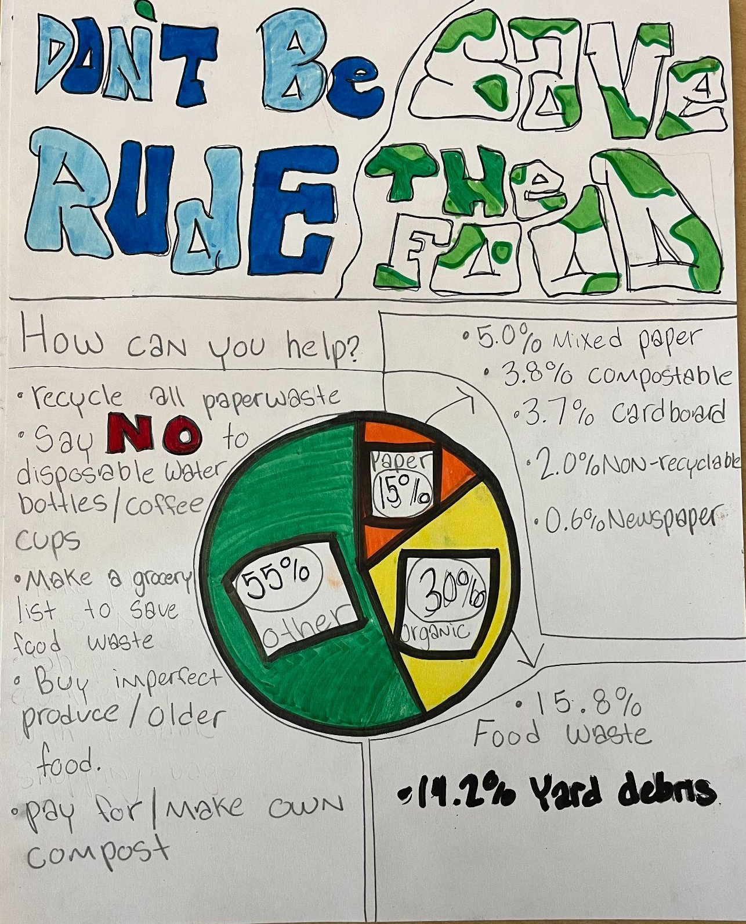

Example 2:

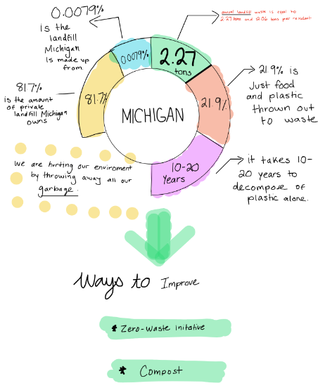

Example 3:

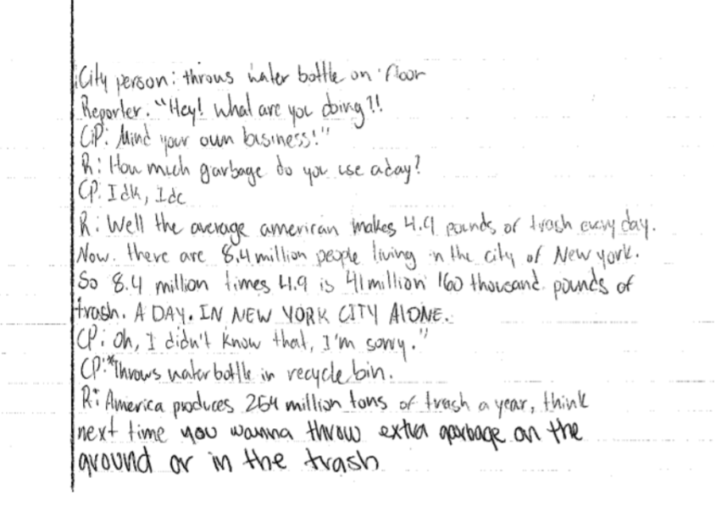

Criteria for Success

Conference and Provide Revision Support | Accept with Revision | Accept
The student’s artifact shows an emerging understanding of the expectations of the indicator(s). After conferencing and additional instruction/learning, the student may provide a revised or different artifact as evidence of the indicator(s). | The student’s artifact is approaching a full understanding of the expectations of the indicator(s). The artifact may contain execution errors that should be corrected in revision. The student may revise the selected artifact or submit a different artifact. | The student’s artifact demonstrates evidence that they have met the expectations of the indicator(s).

References
Common Core Standards Writing Team. (2016, August 17). Progressions for the Common Core State Standards in Mathematics (draft). High School, Quantity. Tucson, AZ: Institute for Mathematics and Education, University of Arizona.

Illustrative Mathematics. (2016, May 4). Thunder and Lightning Task. Illustrative Mathematics Grade 7. http://tasks.illustrativemathematics.org/content-standards/7/RP/A/tasks/1597

