M112B Performance Task
Let’s Get Weird, Let’s Get Real

The Modeling Cycle
Do you think your hand size predicts your math grade? Is there a relationship between the width of your earlobe and your shoe size? Have you measured how fast you can run or how high your friends can jump? How long can your teachers hold their breath, and does it depend on the numerical day of the week they were born? This task is divided into two parts. First, you will collect data on two seemingly unrelated variables and determine if there is a correlation. Then you will explore possible relationships between two variables for a topic of your choice.

Mathematical models are used to make sense of ideas and phenomena in our world. As illustrated in the following diagram, the modeling cycle is a process of collecting data about an idea or problem, creating models of that data, analyzing the story told by those models, and reporting the results to the appropriate audience.

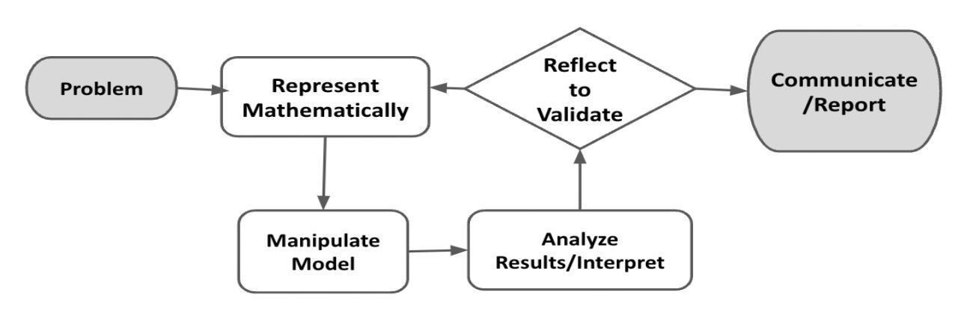

In this task, you will be engaging with this mathematical modeling cycle to collect and analyze data, evaluate findings, and identify trends in two variables. You will use the models and your takeaways from this task to create a presentation, informational video, poster, or another creative product to communicate your hypothesis and findings. You will also interpret your findings and explain how your data and model can be used to benefit others.

PART 1: Random Relationships
Launch
There are different types of data that you can collect in the world. The most common types are categorical data and numeric data. Categorical data are descriptive or qualitative. Examples of categorical data include name, hair color, brand of sneaker, type of shampoo, school subject, favorite sport, and travel method to school, to name a few. In contrast, numerical data are quantitative — values that can be measured and placed into a logical order. Examples of numerical data can include height, birth month, age, number of pets owned, shoe size, birth order compared to siblings, average temperature on your birthday, SAT Math score, and how quickly you can run a mile, among others.
QUESTION 1
 | Think about these different types of data and any others that come to mind. Brainstorm some information that you are curious to learn about your classmates.

QUESTION 2
Now identify two numeric variables that are seemingly unrelated. You can choose variables from your list above or something new that came to mind.

In the Problem and Formulate sections, you will analyze the data you collected to determine the possible relationship; then you will evaluate this relationship to identify a model of best fit and create a related equation. Specifically, consider linear, quadratic, and exponential functions as possible models for the relationship. The Problem Formulation Checklist can be used to ensure you have the necessary components before moving on to the remaining parts of the task.

Problem
Let’s get weird. Can we find relationships by looking at two seemingly unrelated variables? Survey your classmates to gather information on the two variables that you chose.

QUESTION 3
What two variables did you choose to collect data on? How do you know your variables are random and seemingly unrelated?

ACTION 1
Conduct a survey to collect data from your classmates on the two variables that you chose.

QUESTION 4
Graph the data. Describe the shape of the data. Do you see a relationship between the two variables of data? Why or why not?

Formulate
QUESTION 5
Using Desmos, determine a model of best fit for this data. Would any other model possibly fit? If no model fits this data, explain why not.

QUESTION 6
Do you believe this model is a good fit for the data that you have collected? Why or why not? How strong is the correlation for the model that you chose?

Problem Formulation Checklist
Requirement | Fulfilled?
I selected two seemingly unrelated variables. | ▢
I accurately plotted the data points for these two variables and clearly described the shape of the graph. | ▢
Where possible, I identified a model and created an equation for relating the two variables. If not possible, I gave a thorough explanation as to why a model does not fit. | ▢
Teacher Consultation: | _____________

PART 2: Real World Relationships
Launch
Keisha has noticed that the number of views on her TikTok videos are not surpassing 500. She wonders if there is a relationship between the length of her videos (which can be long) and the number of views. She identifies her problem as: TikTok video views are stuck between 400 and 500. She brainstorms possible variables that could be contributing to this: length of video, video content, age of content creator, and number of followers. What variables may be correlated? What questions can Keisha pose for this problem?

Similar to Keisha, you may have your own questions. Are high school students spending too much time on social media? How do sleep patterns impact your test scores? How can I improve my batting average? In the second part of this task, you and your classmates will act as researchers and statisticians to answer a question of interest. This task will give you an opportunity to explore possible relationships between two seemingly related numerical variables for a topic of your choice. This can be education, gaming, social media, sports, or anything else you are interested in!
In the Problem and Formulate sections, you will analyze data to determine the possible relationship; then you will evaluate this relationship to identify a model of best fit and create a related equation. Specifically, consider linear, quadratic, and exponential functions as possible models for the relationship. The Problem Formulation Checklist can be used to ensure you have the necessary components before moving on to the remaining parts of the task.

Problem

QUESTION 7
Brainstorm a question that you have or that maybe you have heard your classmates or teachers discuss. Create a hypothesis that clearly states the two numeric variables for the question that you want to investigate. For example, a hypothesis can be that taller baseball players have a higher batting average because they have a longer reach. In this example, your two numeric variables would be the height of the baseball player and that player’s batting average.

What is your hypothesis? Why do you think these variables are related?

QUESTION 8
What is your plan for data collection — would you like to collect data on yourself? Would you like to collect data from your classmates or from a publicly available source? Cite your sources if you decide to use publicly available data.

ACTION 2
Conduct a survey to collect data from your classmates on the two variables that you chose.

Formulate
QUESTION 9
Graph the data and describe the relationship. Identify a model of best fit for this data. Would any other model possibly fit? Why or why not?

QUESTION 10
Do you believe this model is a good fit for the data that you have collected? Why or why not? How strong is the correlation for the model that you chose?

Problem Formulation Checklist
Requirement | Fulfilled?
I formed a hypothesis concerning the relationship between two variables. | ▢
I accurately plotted the data points for two variables and clearly described the shape of the graph. | ▢
I identified a model and created an equation for relating the two variables of choice. | ▢
Teacher Consultation: | ____________

In the Compute and Interpret & Analyze sections, you will use your equation to make predictions about future populations, evaluate your predictions against other factors, and consider the importance of and relationship among these variables in these kinds of analyses. The Compute, Interpret, & Analyze Checklist can be used to ensure you have the necessary components before moving on to the remaining parts of the task.

Compute
ACTION 3
Use your model (graph and/or equation) to predict information for future data. Predict information for at least five additional data points using the equation and model you created.

Interpret & Analyze
QUESTION 11
How accurate do you think this prediction will be? Give a rationale for your explanation.

Compute, Interpret, & Analyze Checklist
Requirement | Fulfilled?
I used the equation to make predictions for future data points. | ▢
I provided thoughtful, valid reasons for why the model will or will not be good at predicting future data points. | ▢
Teacher Consultation: | ______________

In the Validate, Reflect, and Report sections, you will identify ways to research and improve the accuracy and effectiveness of your equation; you will also create a product that appropriately demonstrates your conclusions. The Validate, Reflect, & Report Checklist can be used to ensure you have the necessary components before moving completing the task.

Validate & Reflect
QUESTION 12
Returning to your hypothesis, do the data you collected and the model (graph and/or equation) you created support your hypothesis? Why or why not?

QUESTION 13
If you were to do this again, what would you change? Would you choose a different variable? Would you change your data collection method? Why or why not?

Report
ACTION 4
Create a presentation, informational video, poster, or some other method to communicate succinctly what hypothesis you tested and what your findings were.

QUESTION 14
Based on your model and findings, how can the data you collected and the model you created be used to benefit others?

Validate, Reflect, & Report Checklist
Requirement | Fulfilled?
I created a clear, comprehensive summary that connects all the variables studied and provides some possible actions to consider in tackling the chosen challenge. | ▢
I provided a valid reason for needing to share the data, model, and findings. | ▢
Teacher Consultation: | ______________

