Baseline Professional Learning Handout
M111 Modeling with Data: One-Variable Measurement Data

Baseline Professional Learning Handout 1
Selected Common Core Standards for Mathematics 2
Progressions Excerpt 5
M111 Content and Practice Expectations 6
M111 Content and Practice Expectations and Indicators 7
Let’s Investigate 9
Speed Trap Task 9
Do You Fit in this Car? Task 10
Let’s do some math! Round 1 11
Task 1: Community Insights Prompt 11
Learning Principles 13
Task 1: Community Insights Student Work 14
Let’s do some math! Round 2 17
Task 2: Student Voice Prompt 17
Task 2: Student Voice Student Work 20
Criteria for Success 23
Selected Common Core Standards for Mathematics

Statistics and Probability
Summarize, represent, and interpret data on a single count or measurement variable.
- Represent data with plots on the real number line (dot plots, histograms, and box plots).
- Use statistics appropriate to the shape of the data distribution to compare center (median, mean) and spread (interquartile range, standard deviation) of two or more different data sets.
- Interpret differences in shape, center, and spread in the context of the data sets, accounting for possible effects of extreme data points (outliers).
- Use the mean and standard deviation of a data set to fit it to a normal distribution and to estimate population percentages. Recognize that there are data sets for which such a procedure is not appropriate. Use calculators, spreadsheets, and tables to estimate areas under the normal curve.

Develop understanding of statistical variability.
- Recognize a statistical question as one that anticipates variability in the data related to the question and accounts for it in the answers. For example, “How old am I?” is not a statistical question, but “How old are the students in my school?” is a statistical question because one anticipates variability in students’ ages.
- Understand that a set of data collected to answer a statistical question has a distribution which can be described by its center, spread, and overall shape.
- Recognize that a measure of center for a numerical data set summarizes all of its values with a single number, while a measure of variation describes how its values vary with a single number.

Summarize and describe distributions.
- Display numerical data in plots on a number line, including dot plots, histograms, and box plots.
- Summarize numerical data sets in relation to their context, such as by:
- Reporting the number of observations.
- Describing the nature of the attribute under investigation, including how it was measured and its units of measurement.
- Giving quantitative measures of center (median and/or mean) and variability (interquartile range and/or mean absolute deviation), as well as describing any overall pattern and any striking deviations from the overall pattern with reference to the context in which the data were gathered.
- Relating the choice of measures of center and variability to the shape of the data distribution and the context in which the data were gathered.

Draw informal comparative inferences about two populations.
- Informally assess the degree of visual overlap of two numerical data distributions with similar variabilities, measuring the difference between the centers by expressing it as a multiple of a measure of variability. For example, the mean height of players on the basketball team is 10 cm greater than the mean height of players on the soccer team, about twice the variability (mean absolute deviation) on either team; on a dot plot, the separation between the two distributions of heights is noticeable.
- Use measures of center and measures of variability for numerical data from random samples to draw informal comparative inferences about two populations. For example, decide whether the words in a chapter of a seventh-grade science book are generally longer than the words in a chapter of a fourth-grade science book.
Modeling
Modeling links classroom mathematics and statistics to everyday life, work, and decision-making. Modeling is the process of choosing and using appropriate mathematics and statistics to analyze empirical situations, to understand them better, and to improve decisions. Quantities and their relationships in physical, economic, public policy, social, and everyday situations can be modeled using mathematical and statistical methods. When making mathematical models, technology is valuable for varying assumptions, exploring consequences, and comparing predictions with data.

A model can be very simple, such as writing total cost as a product of unit price and number bought, or using a geometric shape to describe a physical object like a coin. Even such simple models involve making choices. It is up to us whether to model a coin as a three-dimensional cylinder, or whether a two-dimensional disk works well enough for our purposes. Other situations—modeling a delivery route, a production schedule, or a comparison of loan amortizations—need more elaborate models that use other tools from the mathematical sciences. Real-world situations are not organized and labeled for analysis; formulating tractable models, representing such models, and analyzing them is appropriately a creative process. Like every such process, this depends on acquired expertise as well as creativity. Some examples of such situations might include:
- Estimating how much water and food is needed for emergency relief in a devastated city of 3 million people, and how it might be distributed.
- Planning a table tennis tournament for 7 players at a club with 4 tables, where each player plays against each other player.
- Designing the layout of the stalls in a school fair so as to raise as much money as possible.
- Analyzing stopping distance for a car.
- Modeling savings account balance, bacterial colony growth, or investment growth.
- Engaging in critical path analysis, e.g., applied to turnaround of an aircraft at an airport.
- Analyzing risk in situations such as extreme sports, pandemics, and terrorism.
- Relating population statistics to individual predictions.

In situations like these, the models devised depend on a number of factors: How precise an answer do we want or need? What aspects of the situation do we most need to understand, control, or optimize? What resources of time and tools do we have? The range of models that we can create and analyze is also constrained by the limitations of our mathematical, statistical, and technical skills, and our ability to recognize significant variables and relationships among them. Diagrams of various kinds, spreadsheets and other technology, and algebra are powerful tools for understanding and solving problems drawn from different types of real-world situations. One of the insights provided by mathematical modeling is that essentially the same mathematical or statistical structure can sometimes model seemingly different situations. Models can also shed light on the mathematical structures themselves, for example, as when a model of bacterial growth makes more vivid the explosive growth of the exponential function.

The basic modeling cycle is summarized in the diagram. It involves (1) identifying variables in the situation and selecting those that represent essential features, (2) formulating a model by creating and selecting geometric, graphical, tabular, algebraic, or statistical representations that describe relationships between the variables, (3) analyzing and performing operations on these relationships to draw conclusions, (4) interpreting the results of the mathematics in terms of the original situation, (5) validating the conclusions by comparing them with the situation, and then either improving the model or, if it is acceptable, (6) reporting on the conclusions and the reasoning behind them. Choices, assumptions, and approximations are present throughout this cycle.

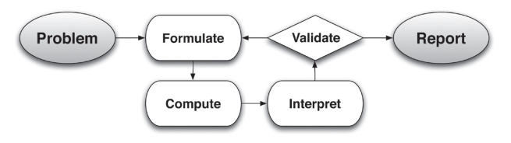

In descriptive modeling, a model simply describes the phenomena or summarizes them in a compact form. Graphs of observations are a familiar descriptive model— for example, graphs of global temperature and atmospheric CO2 over time.

Analytic modeling seeks to explain data on the basis of deeper theoretical ideas, albeit with parameters that are empirically based; for example, exponential growth of bacterial colonies (until cut-off mechanisms such as pollution or starvation intervene) follows from a constant reproduction rate. Functions are an important tool for analyzing such problems. Graphing utilities, spreadsheets, computer algebra systems, and dynamic geometry software are powerful tools that can be used to model purely mathematical phenomena (e.g., the behavior of polynomials) as well as physical phenomena. Modeling Standards Modeling is best interpreted not as a collection of isolated topics but rather in relation to other standards. Making mathematical models is a Standard for Mathematical Practice, and specific modeling standards appear throughout the high school standards indicated by a star symbol (★).

Statistics and Probability Progression Excerpt

Summarize, represent, and interpret data on a single count or measurement variable Students build on the understanding of key ideas for describing distributions—shape, center, and spread—described in the Grades 6-8 Statistics and Probability Progression. This enhanced understanding allows them to give more precise answers to deeper questions, often involving comparisons of data sets. Students use shape and the question(s) to be answered to decide on the median or mean as the more appropriate measure of center and to justify their choice through statistical reasoning. They also add a key measure of variation to their toolkits.

In connection with the mean as a measure of center, the standard deviation is introduced as a measure of variation. The standard deviation is based on the squared deviations from the mean, but involves much the same principle as the mean absolute deviation (MAD) that students learned about in Grades 6-8. Students should see that the standard deviation is the appropriate measure of spread for data distributions that are approximately normal in shape, as the standard deviation then has a clear interpretation related to relative frequency. (Common Core Writing Team, 2012, p.3)

M111 Content and Practice Expectations
111.a | Engage in the modeling cycle.
111.b | Develop statistical questions in the course of modeling with one-variable measurement data.
111.c | Interpret differences in shape, center, and spread in the context of data sets, accounting for the possible effects of extreme data points (outliers).
111.d | Use measures of center and variability to describe one-variable measurement data.
111.e | Generate a random sample in the course of modeling with one-variable measurement data.
111.f | Use statistics appropriate to the shape of the data distribution to compare center (median, mean) and spread (interquartile range, standard deviation) of two or more different data sets.
111.g | Estimate population percentages by using a normal curve to approximate a data distribution.

M111 Content and Practice Expectations and Indicators

Content and Practice Expectations | Indicators  Choose an artifact where you…
111.a: Engage in the modeling cycle. | i. engage with the full modeling cycle (problem, formulate, compute, interpret, validate, revise as necessary, report).
111.b: Develop statistical questions in the course of modeling with one-variable measurement data. | i. develop a statistical question to investigate.
 | ii. explain or justify why your question is statistical.
111.c: Interpret differences in shape, center, and spread in the context of data sets, accounting for the possible effects of extreme data points (outliers). | i. determine and construct an appropriate graphical representation of collected data, such as box plot, line plot, histogram, or other data display.
 | ii. describe the shape, center, and spread of a data set.
 | iii. interpret the real-world meaning of the shape, center, and spread of a data set.
 | iv. identify and explain the effect of an outlier on the shape, center, and spread of a data set.
111.d: Use measures of center and variability to describe one-variable measurement data. | i. find the mean or median of a set of data and explain its meaning.
 | ii. find the interquartile range, standard deviation, or mean absolute deviation of a set of data and explain its meaning within the context of the data.
111.e: Generate a random sample in the course of modeling with one-variable measurement data. | i. describe a process for generating a random sample to investigate a statistical question.
 | ii. explain why a proposed process generates a random sample that is appropriate for the statistical question being investigated.
111.f: Use statistics appropriate to the shape of the data distribution to compare center (median, mean) and spread (interquartile range, standard deviation) of two or more different data sets. | i. construct a box plot, line plot, histogram, or other data display for each of two related data sets.
 | ii. find measures of center (mean or median) and variability (standard deviation, interquartile range, or mean absolute deviation) for two data sets.
 | iii. compare two data sets in terms of their center and variability.
 | iv. explain the choice of measures of center and variability used to compare the two populations.
111.g: Estimate population percentages by using a normal curve to approximate a data distribution. | i. explain why a normal distribution is an appropriate approximation for a data set.
 | ii. find an estimated population percentage by using a normal curve to approximate a data distribution.
 | iii. explain the meaning of an estimated population percentage.

Let’s Investigate

Speed Trap Task
A statistically-minded state trooper wondered if the speed distributions are similar for cars traveling northbound and for cars traveling southbound on an isolated stretch of interstate highway. He uses a radar gun to measure the speed of all northbound cars and all southbound cars passing a particular location during a fifteen minute period. Here are his results:

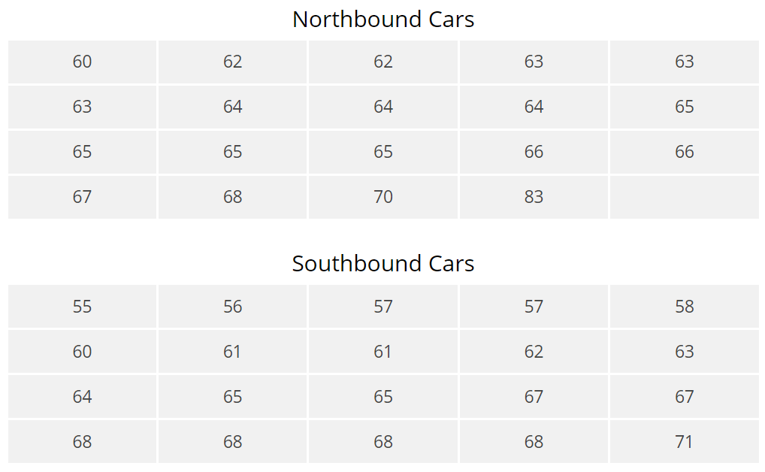

Draw box plots of these two data sets, and then use the plots and appropriate numerical summaries of the data to write a few sentences comparing the speeds of northbound cars and southbound cars at this location during the fifteen minute time period.

Source: Illustrative Mathematics

Do You Fit in this Car? Task

Automobile manufacturers have to design the driver’s seat area so that both tall and short adults can sit comfortably, reach all the controls and pedals, and see through the windshield. Suppose a new car is designed so that these conditions are met for people from 58 inches to 76 inches tall.

The heights of adult men in the United States are approximately normally distributed with a mean of 70 inches and a standard deviation of 3 inches. Heights of adult women are approximately normally distributed with a mean of 64.5 inches and a standard deviation of 2.5 inches. What percentage of men in the United States is this car not designed to accommodate? What percentage of women in the United States is this car not designed to accommodate?

Source: Illustrative Mathematics

Let’s do some math! Round 1

Task 1: Community Insights
Students are given a problem like this:

Data can be used to gain insights about communities and help us understand issues.

Framing Questions
What are some questions you have about your community that could be answered by collecting data?
- Why are these questions/issues important?
- Why should we care about this question/issue?
- Who else might care about these questions/issues?
- Why might it be important to them?

For this task you will prepare a presentation in any form (slideshow, report, song, artwork) delivering a message you want to share on a topic of your choice, supported by the evidence you collect.

(Adapted from Julia Aguirre)
Sample Learning Experience
Invite students to write down questions they have about their community, such as:

- How many cars does the typical family in my neighborhood own?
- How many children are there in a typical family in my neighborhood?
- How many doors does the typical house/apartment have in my neighborhood?

As students write down ideas, circulate and look for trends. Give students time to connect with a partner and share what they generated. Select students to share ideas about their thinking with the class and revisit frequently the set of framing questions to help students connect data collection to understanding issues in communities. Offer students opportunities to go through iterative cycles of defining their topic and survey questions to use to gather data.

Students will collect data from their classmates and create a data display using technology (Desmos, applets, graphing calculator) and use summary statistics to describe what “typical” values are for the data they gathered.

Once students summarize their collected data, they will consider questions about generalizability of their data. These questions can be:
- Will all neighborhoods in your city have the same or similar data distributions? What do you expect to be the same? Different?
- Will all towns in your state have the same or similar data distributions? What do you expect to be the same? Different?
- Synthesis: What is the largest population that you could generalize to using your data? What about your data allows you to generalize to this new, larger population?

Students will then choose a nearby community, gather data from that community, and create a data display for data from the neighborhood and from a nearby community, using technology (Desmos, applets, graphing calculator). Once data sets are created for both communities, have students consider the following:
- How do the data distributions of both communities compare? [emphasis on writing answers in the context of the question of interest]
- Synthesis: Based on the differences you observed between the two communities, explain a method to gather data for your state that would be representative of the entire state.

Following the discussion, students are given an opportunity to reflect on and revise their work. Finally, one or more reasonable models are revealed explicitly, and students have an opportunity to reflect on the reasonable models and revise their work.

Learning Principles
Engage with cognitively demanding tasks in heterogeneous settings (LP 1). Students should be given opportunities to grapple with multistep, non-routine tasks that promote mathematical rigor. These experiences should be differentiated so that all students engage in appropriate challenges—for example, through tasks with multiple entry points and solution pathways. These experiences should continue to integrate knowledge and skills developed in grades 6-8 at the level of sophistication of high school mathematics.

Engage in social activities (LP 2). Students should have opportunities to work independently and to communicate with one another about mathematics by engaging in collective and collaborative learning activities. Explaining and having opportunities to revise one’s thinking has excellent value in solidifying one’s knowledge.

Build conceptual understanding through reasoning (LP 3). Students should be given the opportunity to reason, justify, and problem solve with critical thinking, reading, writing, speaking, and listening. Through reasoning and work with multiple representations, students learn why procedures work and build a conceptual understanding of key mathematical ideas.

Have agency in their learning (LP 4). Students should be able to choose tasks and learning experiences that align with their interests and aspirations. All students have rich and varied experiences and home lives. Learning mathematics should bring students’ identities and interests to the fore and build on the strengths that they bring to the learning space.

View mathematics as a human endeavor across centuries (LP 5). Students should understand that mathematical ideas emanated over time from civilizations around the world and have opportunities to explore these contributions to mathematics. Students should develop an appreciation of mathematics as a human endeavor: one in which they feel a sense of belonging, where they see themselves as mathematicians, and one that offers opportunities to broaden their ideas about what mathematics is, how it is used, and who it is for.

See mathematics as relevant (LP 6). Students should engage with mathematics in ways that authentically involve real-world situations. Problem-solving contexts should allow students to perceive mathematics as a tool for addressing the questions that arise in everyday life, as well as the ways it can model our world and address global economic, social, and environmental challenges. Students should also engage with mathematics in ways that connect to academic disciplines and future careers by doing the mathematics used by artists, designers, engineers, and other professionals.

Employ technology as a tool for problem-solving and understanding (LP 7). Research indicates that technology is a powerful tool for learning deeper mathematics by improving calculation efficiency and enabling more sophisticated analysis. Students should learn to use technology, with emphasis put on widely used tools and software, such as calculators and spreadsheets, to make sense of models. Technology use should not be limited to supporting “doing mathematics,” but should also be used as a tool for displaying and communicating results to appropriate audiences.

Task 1: Community Insights Student Work

Example 1:
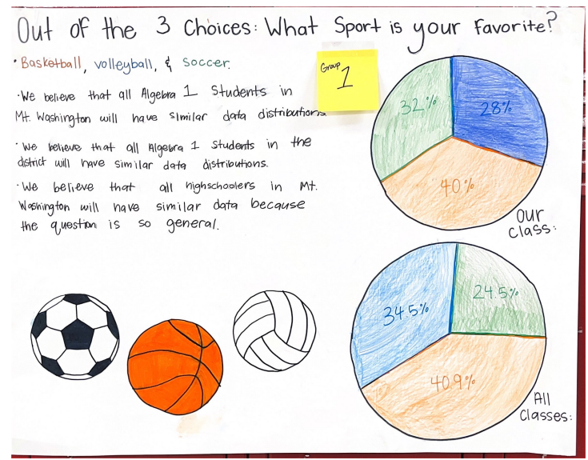

Example 2:

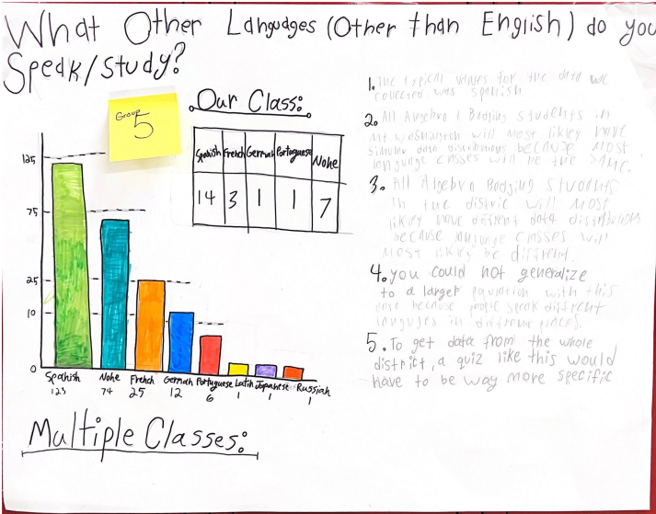

Example 3:

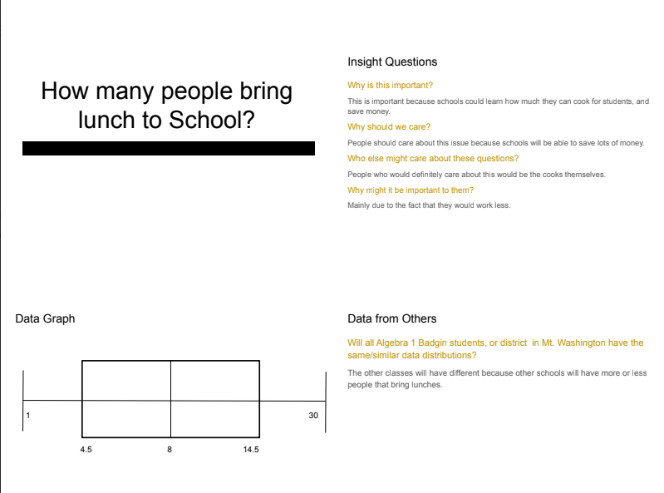

Let’s do some math! Round 2

Task 2: Student Voice
Students are given a problem like this:

Part 1: Making sense of student voice

Do you feel like you are given space to use your voice throughout the school day? How often? Do you wish you could talk more? Or less? Think about how you would answer the following questions:

- How often do you get to talk in each of your classes? How would you quantify/track this?
- Who do you listen to? How much?
- How much do students talk throughout a typical school day?

Part 2: Using our voice

For this task, you will have an opportunity to learn more about the student experience at your school. Your job is to prepare a presentation, in any form, that represents your answer to the question “What do you wish more teachers knew about the opportunities that students are given throughout the school day to use their voice?”

For this work, you will need to determine the following:
- What data will help you tell the story? How would you quantify this?
- What statistical questions will you pose to get the data you need?
- What data displays are appropriate for your data?
- Who is the audience for this data?
- What form of a presentation (video, slideshow, report, poem, song, etc.) will work best for this purpose?

Your presentation should include your response to “What do you wish more teachers knew from these data about the student experience?” supported by the evidence you collected.

Sample Learning Experience
In this experience, students will gather data to quantify the student experience within the context of how students use their voice across their classes. This creates space for students to recognize patterns and mathematically analyze these patterns to shed light on the question “What do you wish more teachers knew about the opportunities that students are given throughout the school day to use their voice?”

In preparation for Part 2 of this task, instructors must take into account their local context. They can select 2-3 courses that most students are currently enrolled in, such as English language arts or math and/or science, and plan for building consensus on the statistical questions they will use to collect data in those classes. As part of representing the data, students will make life-sized number lines. Based on the number of courses for which data will be generated, instructors should determine the number of life-sized number lines that will be needed so that each course has its own data display. The length of the class period should be used to determine the range and scale of numbers represented on each number line.

Part 1: Making sense of student voice
Use the questions posed to elicit student thinking about this topic and to design a collective approach to gathering data that helps the class see trends in how student voice is heard across the school day. Give students quiet time to reflect and respond to the questions posed. Then invite students to share with group mates to recognize similarities and differences in how they think about this topic.

As students share with team mates, monitor and select students to share their ideas. Record ideas that surface. The ideas generated through this share out will be used to design Part 2. Work to identify the question(s) and type of data students will gather in previously selected courses (English language arts, math and/or science). For example, the class may choose to count the number of times students are given a chance to talk during class in each of those classes, or students may work to count the total number of minutes students have an opportunity to talk during class in each of the classes.

As students work to agree on the data they want to collect, give time to reflect, using the following questions:
- What might we learn from this data?
- What might be the limitations?
- How might we collect this data?
- How might we record this data? What would that look like?

Before the end of the session, establish a date by which students will bring in their data.

Part 2: Using our voice
Before class begins, create the number lines along one side of the classroom using painter’s tape on the floor or along the wall. During the learning experience, students can use sticky notes to show where they would place their data point along each number line to reflect the number of minutes they spend talking during each of the courses represented.

Once all students have represented their data on each of the number lines, do some informal analyses. Based on the distribution they see, ask students: What story does this data tell? Give students quiet time to think and formulate their responses. Then give students time to share with a partner. Monitor and select a couple of students to share their story with the class.

Invite students to choose a data display they would like to use to tell their story. Each student will construct a data display (digital or on paper) to represent the data collected during their activity. Once they are finished, have students find one other person with a different display type than their own and swap for analysis. As students discuss with their peers, monitor and select a few students to share key ideas that surfaced from their discussion. Listen for insights students gained about how students used features of their displays to tell the story they envisioned. Consider documenting noteworthy insights in a public space for future reference.

Have students study their peer’s display and analyze using multiple interpretation questions. All answers vary depending on the data collected. For example, if students represented the story, “Most students talk about 7 minutes in a class,” here are some sample questions to ask:

- Where in this display do we see that “most students talk about 7 minutes in a class”?
- What additional information can you glean from this display?
- What additional questions does this data surface for you?

Extension: Consider having students divide into two or more groups and choose their own question to explore and create a data set using a display choice they had not used before. For example, if they used a dot plot in the activity, they can then use a box plot for the choice question.

Give space for students to reflect on their work:
- What story does the data tell?
- How does the display you choose work to tell the story?
- What was challenging about gathering this data?
- If you could do this again, what would you do differently? Why?

Following the discussion, students are given an opportunity to reflect on and revise their work. Finally, one or more reasonable models are revealed explicitly, and students have an opportunity to reflect on the reasonable models and revise their work.

Task 2: Student Voice Student Work

Example 1:

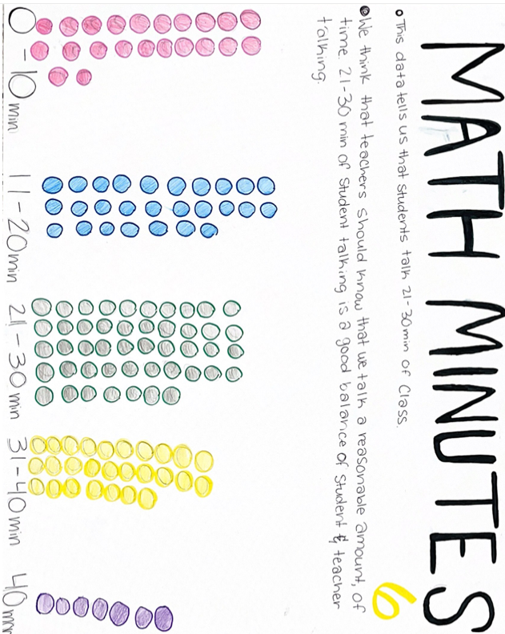

Example 2:

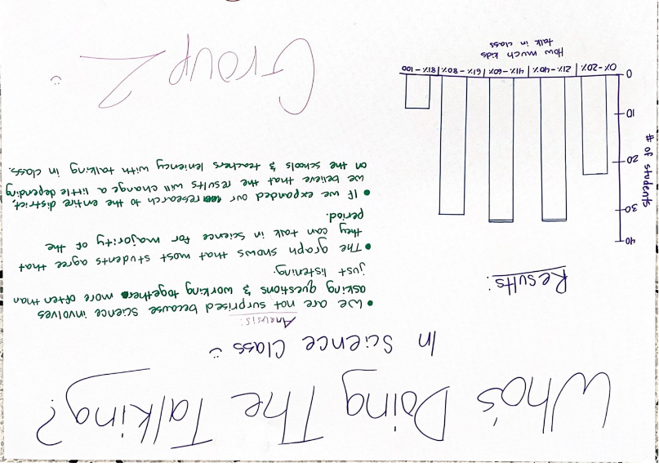

Example 3:

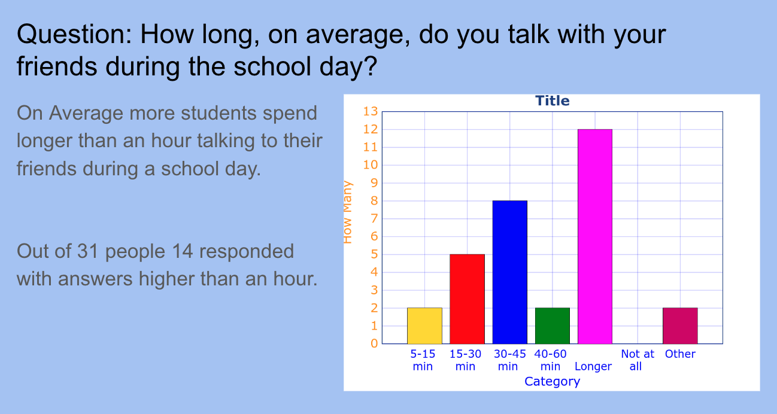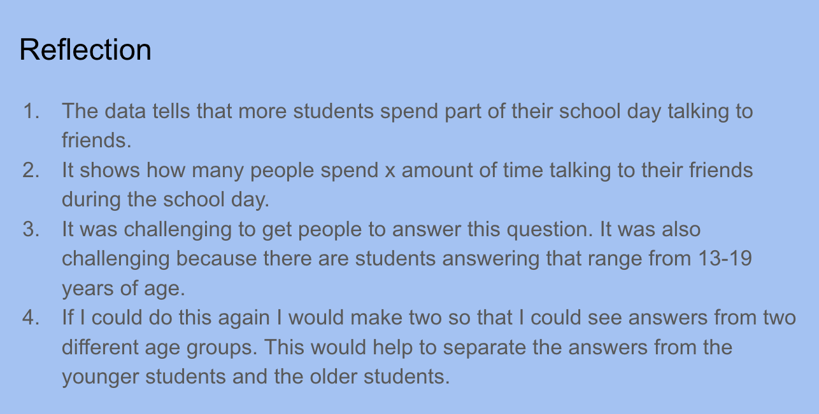

Criteria for Success

Conference and Provide Revision Support | Accept with Revision | Accept
The student’s artifact shows an emerging understanding of the expectations of the indicator(s). After conferencing and additional instruction/learning, the student may provide a revised or different artifact as evidence of the indicator(s). | The student’s artifact is approaching a full understanding of the expectations of the indicator(s). The artifact may contain execution errors that should be corrected in revision. The student may revise the selected artifact or submit a different artifact. | The student’s artifact demonstrates evidence that they have met the expectations of the indicator(s).

References

Common Core Standards Writing Team. (2012, April 21). High School Statistics and Probability. Progressions for the Common Core State Standards in Math (draft). https://achievethecore.org/content/upload/Draft%20High%20School%20Progression%20on%20Statistics%20and%20Probability.pdf

Illustrative Mathematics. (2016, May 4). Do You Fit in This Car? Illustrative Mathematics High School Statistics and Probability. http://tasks.illustrativemathematics.org/content-standards/HSS/ID/A/4/tasks/1020

Illustrative Mathematics. (2016, May 4). Speed Trap. Illustrative Mathematics High School Statistics and Probability. http://tasks.illustrativemathematics.org/content-standards/HSS/ID/A/2/tasks/1027

