M102B Performance Task
Breaking Even with Side Hustle Businesses

The Modeling Cycle
You are looking to make some extra cash, and you decide to invest in a side hustle business. Side hustle businesses are a wonderful way to make money outside of school hours. Explore the two side hustle options below and choose one that is a best fit for you. Once you choose an option, you will need to complete the following:
- Create two different equations to model the cost and profit of your side hustle.
- Graph these equations to determine the “break-even point.”
  - The “break-even” point is where the total expenses (cost) and total revenue (profit) are equal.
- Present your findings to the class. (Remember this is a business and you must put your best foot forward.)
Mathematical models are used to make sense of ideas and phenomena in our world. As illustrated in the image below, the modeling cycle is a process of collecting data about an idea or problem, creating models of that data, analyzing the story told by those models, and reporting the results to the appropriate audience. In this task, you will be engaging with the mathematical modeling cycle to analyze the difference between an individual and a group knowing the correct answer to a particular question.
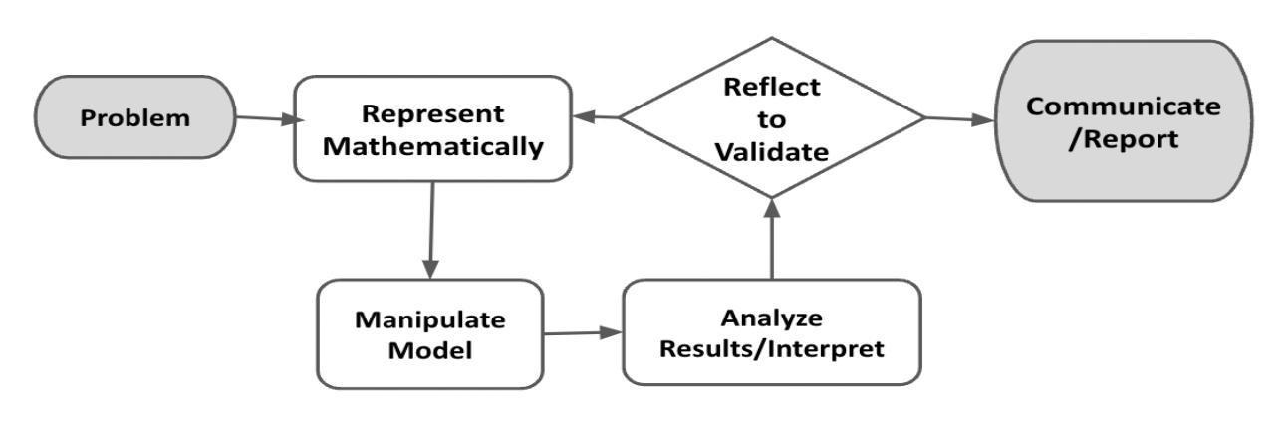
Your process and final products from this task will be shared with the greater class as a pitch for the side hustle. There will be time for them to probe and ask clarifying questions. Be prepared to answer them, including what you have not yet resolved. Their job is to decide whether your business is a wise investment.

Source: Diagram of Modeling Process. From “Progressions for the Common Core State Standards for Mathematics”
Breaking Even with Side Hustle Businesses

Launch
There are several ways that students can make money outside of school hours. Important factors to consider when thinking about a business are the expenses involved as well as how much revenue could be earned. Not all side hustles, or business ventures, are the same.
 | What are some ways that students can make money?

Problem, Formulate, and Represent Mathematically
In the Problem, Formulate, and Represent Mathematically sections, you will determine weekly cost factors, availability, and weekly revenue for your side hustle. This will allow you to formulate your weekly profit, which will be the difference between your costs and revenue. The Problem, Formulate, and Represent Mathematically Checklist can be used to ensure you have the necessary components before moving on to the remaining parts of the task.
ACTION 1
 | You were just gifted $500 to kick start your side hustle (except in Option A). Consider this “seed money.” Seed money is money given to a business in its initial stages which you do not have to pay back. You must consider this a cost of the side hustle regardless of which one you choose. Each side hustle also has factors and constraints that will impact your business. These are things that you need to keep in mind as you start earning, so you can break even and then start making a profit.  Use the slope-intercept equation to help create your equations, y = mx + b, where:  y = total cost  m = slope, (e.g., hourly rate)  x = the variable (e.g., time, items, lawns)  b = the y-intercept  Choose one of the two side hustle businesses listed in the pages below. Each side hustle has specific considerations to think about as you start your business.

Option A - Rideshare Driver  No seed money needed.  Choose to drive for either UberX with a compact car or UberXL with an SUV in your existing, gas-powered car. You must drive during after-school hours or weekends.  Vehicle: __________________________
  Use the following resources to research your side hustle and plan accordingly!
  How Much Do Ubers Drivers Make?
  Ride Share Guy
  Uber Pay Schedule
- Determine weekly expenses (will vary week by week based on the price of gas and the vehicle you select):
  - Gas (use the mega formula below to help with this)
  - Weekly full car insurance coverage (find the monthly car insurance and divide that by 4.3)
- Determine weekly income:
  - Hourly rate
  - $40 in tips per week
- Using your availability, plan out your work week in the calendar template located after the options.

Considerations:
- For your location, what is the average number of rides you can complete per hour?
- How many hours are you available to drive?
- Where are you going to Uber?
- What is your car’s average miles per gallon (MPG) gas rating?

Calculating Weekly Gas Cost Mega Formula (for Rideshare Driver path ONLY)
_________________  (Total Hours Worked) | × | 30 miles per hour | = | _____________________  (Total Weekly Miles Driven)

_________________  (Total Miles Driven) | ÷ | _________________  (MPG gas rating) | = | _____________________  (Total Gas Used)

_________________  (Total Gas Used) | × | _________________  (gas rate $/gal) | = | _____________________  (Total Gas Expenses)

Option B - Landscape Designer
Use the following resources to research your side hustle and plan accordingly!
Home Depot
Lowes
Amazon
$500 in seed money available.
You provide landscaping services in the form of mowing lawns for 10 families. You must schedule your services during after-school hours or weekends.

- Determine weekly expenses and start-up cost:
  - Lawnmower
  - Gas and oil container
  - Engine oil
  - Gas
  - Weekly maintenance budget (in case something ever goes wrong you have money set aside)
- Determine weekly income:
  - Hourly rate
- Plan out your work week in the calendar template below using your availability.

Considerations:
- The weather
- You can only spend $500 to start your business.
- The average human can mow 1 average-sized lawn per hour.
- How often families need their lawns to be mowed.
- You cannot mow lawns during school hours.

What do you need to consider when scheduling your hours? Complete the calendar to plan your week.

Calendar
Sunday
Monday
Tuesday
Wednesday
Thursday
Friday
Saturday

What are your weekly costs, revenue, and profit? Clearly show the values you used to determine the total expenses, revenue, and profit in the table below.

Weekly Expenses | Weekly Revenue | Weekly Profit

Problem, Formulate, and Represent Mathematically Checklist
Requirement | Fulfilled?
Determine availability, expenses (consider all factors), and weekly revenue. | ▢
Determine weekly profit. | ▢
Teacher Consultation: | ____________

Manipulate Model
In the Manipulate Model section, you will create different representations to help you analyze your profit. The Manipulate Model Checklist can be used to ensure you have the necessary components before moving on to the remaining parts of the task.
How can you represent your weekly expenses, revenue, and profit? Write three different equations to model your data using y = mx + b. Then, interpret each variable (m, x, and b) for each equation, including units.

Equation #1 Equation #2 Equation #3
Variable | Expenses  y = _______________ | Revenue  y = _______________ | Profit  y = _______________
y | Total expenses in dollars | Total revenue in dollars | Total profit in dollars
m
x
b

Graph your generated line for profit in Desmos. Use your graph to determine the point where you will break even (i.e., how many hours you should drive or how many lawns should you mow?). Include your graph to support your response.
What is your identified break-even point? Explain your reasoning.

Manipulate Model Checklist
Requirement | Fulfilled?
Write equations accurately representing revenue and expenses using the y = mx + b format. | ▢
Each equation’s variables are accurately interpreted, using correct units. | ▢
The Desmos profit line is accurately graphed and used to determine and identify a break-even point. | ▢
The model is interpreted to identify costs, how income is generated, and how profit might be maximized weekly. | ▢
Teacher Consultation: | ______________

Reflect and Report
In the Reflect and Report sections, you will reflect on and provide valuable feedback about the task you chose and completed. You will also use what you learned about that particular side hustle business to create a persuasive presentation in which you try to convince your classmates that your side hustle is a profitable investment! The Reflect and Report Checklist can be used to ensure you have completed all the necessary components of this final part of the task.
Reflect
Which side hustle did you undertake? What surprised you as you completed this task?

What was the most challenging part of this task?

What was the most fun part of this task?

Report
ACTION 2
Convince your classmates to invest or not invest in your side hustle (Shark Tank style). Use your findings—your data on cost and income. Be sure to be persuasive, as there is investment money at stake!

Considerations:
- How does your break-even point differ from those who chose the other side hustle option?
- After looking at your data, will you stick with your chosen side hustle business, or choose another?

Reflect and Report Checklist
Requirement | Fulfilled?
Provide specific, detailed feedback on the side hustle business that was researched during this task. | ▢
Presentation includes accurate, pivotal factors from the related data collection and analysis that include weekly profit calculations based on expenses and revenue and the break-even point for the business. | ▢
Presentation is persuasive, articulate, and demonstrates entrepreneurial creativity alongside mathematical precision and a business mindset. | ▢
Presentation is convincing to the audience with compelling evidence for investing or not investing in that side hustle business. | ▢
Teacher Consultation: | ______________
Extension
Keep thinking about your side hustle business—the best entrepreneurs are always seeking ways to improve…or to move on to new things! Challenge yourself and awaken your entrepreneurial genius by responding to the following reflective questions.
- Did you make the wrong choice? Is there another side hustle business that you think will be better? Prove it!
- Consider unexpected additional factors and how they would impact on your profit and other additional decision making.

