M112 Performance Task
The Price of Technology—Then and Now
Modeling with Data: Two-Variable Measurement Data
Teacher Version

Design Notes
In this task, students will take on the role of an economist to examine historical and current data on the price of technology and advise on issues that affect how much people are spending and buying. Students will identify how the cost of different technological devices has changed over the years and try to determine how those changes affect peoples’ lives.
Student-teacher consultations have been built in to scaffold the process. Consider using those structured check-in points as places where select student(s) share their approach/findings with the class to support the collective learning of the class. This learning experience centers around the CCSSM modeling cycle as illustrated below:
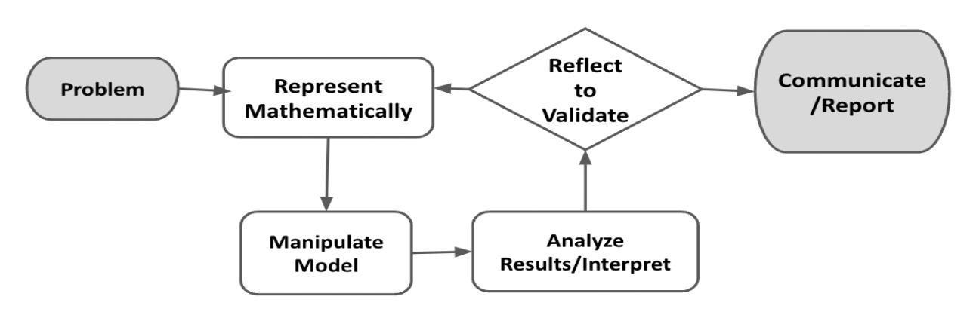
Figure 1. Diagram of Modeling Process. From “Progressions for the Common Core State Standards for Mathematics” [Draft manuscript], by Common Core Standards Writing Team, 2019, p. 6 (http://mathematicalmusings.org/wp-content/uploads/2022/05/modeling_02082019.pdf).

Connections to Learning Principles
Students will:
- analyze the implications of changing technology costs on human access (LP1);
- decide the best medium for sharing their learning with a wider audience (LP4); and
- explore the changing cost of technology and analyze through the lens of an economist (LP6).

The following pages provide teacher versions of this task with guidance, suggestions, and comments in red and sample student responses in blue italics.
Student Task

The Modeling Cycle
Did you ever wonder what cell phones, televisions, or computers looked like when they first came out? Or how much they cost back then, compared to today? In this task, you will ask these kinds of questions, taking on the role of an economist. Economists often use current and historical data to examine, understand, and advise on issues that affect how much people are spending and buying. As an economist, in this task, you will examine how the cost of different technological devices has changed over the years and try to determine how those changes affect peoples’ lives.
Mathematical models are used to make sense of ideas and phenomena in our world. As illustrated in the image below, the modeling cycle is a process of collecting data about an idea or problem, creating models of that data, analyzing the story told by those models, and reporting the results to the appropriate audience. In this task, you will be engaging with this mathematical modeling cycle to analyze data, evaluate findings, and identify trends in the changing cost of technology over time.
Figure 1. Diagram of Modeling Process. From “Progressions for the Common Core State Standards for Mathematics” [Draft manuscript], by Common Core Standards Writing Team, 2019, p. 6 (http://mathematicalmusings.org/wp-content/uploads/2022/05/modeling_02082019.pdf).

The Price of Technology—Then and Now
Launch
The first cell phone came out in 1973. It weighed 2.4 pounds, and you could only talk on it for 30 minutes—then you had to charge it for 10 hours! In contrast, today’s typical cell phones weigh under half a pound and can hold a charge for many hours.

 | Why do you think that cell phones have changed so much over time?
Answers will vary. Possible student responses:
- People probably complained about how heavy they were.
- Companies always want to make things better so that more people will want to buy them.
- Technology has improved and we’ve been able to make things much smaller.
 | The purpose of this question is to get students thinking about the evolution of products over time. Today’s students are likely familiar with the newest and latest technologies being released by companies annually and this question helps them understand just how much these technologies change from their first release to the present day.

If you had to guess, how much do you think cell phones cost to purchase back in 1973? Did they cost more or less than today? Why do you think that?
Answers will vary. Possible student responses:
- $3
- $50
- $500
- $10,000
This question is intended to prompt students’ thinking about whether technology has gotten cheaper or more expensive over time. They will explore this trend in greater depth throughout the task, so the question gives them space to simply make a guess up front.

Problem
You have been asked to create a public service announcement that informs the public about trends you recognize in the changing prices of technology over time. These trends will help consumers make better money-management and purchasing decisions. These trends will also help identify areas where certain groups of people might not have equal access to technology.
Use the internet to research whether the cost of certain technologies (e.g., cell phones, televisions, personal computers, video game consoles) are increasing or decreasing over time. Record a few notes based on your research and be sure to cite any sources you use to locate the information.
In the Formulate and Represent Mathematically section, you will collect and analyze data on the changing purchase price of an item of your choice. The Formulate and Represent Mathematically Checklist can be used to ensure you have the necessary components before moving on to the remaining parts of the task.

Formulate and Represent Mathematically
QUESTION 3
Choose whether to explore cell phone (smartphone) costs or personal computer costs over time.
- Using one of the datasets your teacher will provide, create an appropriate mathematical model (table, graph, and/or equations) to display the data you collected.
- Describe trends you see in the data.
Access the datasets here. Explain to students that these datasets reflect a more compact timeframe. A more thorough analysis of cost trends over time would require taking into account the changing value of money and inflation, so studying trends in a smaller time frame can give a general sense of trends without fully unpacking the changing value of a dollar. An extension is provided later in the task for students who may be interested in understanding these impacts in greater depth.

Formulate and Represent Mathematically Checklist
Requirement | Teacher Notes
Data collection has been completed and compiled to include in the report. | (Teachers, please add your notes here.)
Appropriate visuals (table, graph, and/or equation) have been created. | (Teachers, please add your notes here.)
Description of trends in the data is aligned with visible data patterns and supported by selected visuals. | (Teachers, please add your notes here.)
(Teachers, please add your notes here.)

In the Manipulate Model/Compute, Interpret, Reflect, and Report sections, you will use the models you created to interpret and forecast trends, inform your analysis and results, and present your findings. The Manipulate Model/Compute, Interpret, Reflect, and Report Checklist can be used to ensure you have the necessary components before finalizing your work on this task.

Manipulate Model/Compute
QUESTION 4
Use your mathematical model to determine the cost of this item when it first came out. Use the following dates for this purpose: Cell phone → 1973; and personal computer → 1971.
Conduct additional research to learn about the retail price when the item first came out. How does the number your model predicted compare to the actual historical price?

QUESTION 5
Use your mathematical model to predict the cost of this item in the near future.
If using an equation, what did you use for the input? What does the output mean in terms of the context?

Interpret
QUESTION 6
Do the quantities generated by your mathematical model make sense in terms of the trends you noticed in the data? Describe how the quantities you arrived at compare to the shape of your graph and/or the trends you see in the table.

QUESTION 7
Is the price people paid when the product first came out comparable to what people are paying now? Why or why not? What are some factors that contribute to costs of any item going up or going down?

ACTION 1
 | Decide how to integrate this information with your findings so far to make your public service announcement. Provide a summary or outline on how you might integrate this information into your public service announcement.

Reflect
QUESTION 8
What do you expect to happen in the future? Will the trends you notice continue? What evidence do you have to support your prediction?
What additional information or data would you need to validate your claim?

QUESTION 9
What do you think is the impact of changing prices on the number of people who buy these items?

ACTION 2
Decide how to integrate this information with your findings so far to make your public service announcement. Provide a summary or outline on how you might integrate this information into your public service announcement.

Students do not need to answer every question in the above sections. These are provided as a means to support students in mentally walking through and thinking about the different parts of this task.

Report
ACTION 3
Create a pamphlet, presentation, informational video, or another method to communicate succinctly what your data tell you about the changing cost in the tech tool you selected.
Consider speaking to the impact of changing prices on people’s lifestyles, the number of people who use these items, and who has access to these items.

Manipulate Model/Compute, Interpret, Reflect, and Report Checklist
Requirement | Teacher Notes
The communication includes at least two data displays (e.g., table, graph, and/or equation) that inform the audience about trends in the changing costs of the selected item. | (Teachers, please add your notes here.)
The communication effectively integrates information from the task and any additional research to inform the audience about the impact and relevance of changing prices of the selected item. | (Teachers, please add your notes here.)
(Teachers, please add your notes here.)

Extension
In conducting some of your research, you may have come across an article that mentioned an adjusted price for today or adjusted to account for inflation. Inflation has an impact on the buying power of money—basically, how much you can get for a certain amount of money. For this extension, explore the concept of inflation and buying power further. Your task is to explain the role inflation has played in the cost of the item you explored.
Here are some recommended places to begin your research:
- CPI Home | U.S. Bureau of Labor Statistics
- Purchasing power and constant dollars | U.S. Bureau of Labor Statistics
- Chart of the Day . . . or Century? | American Enterprise Institute - AEI

