M212B Performance Task
Predictive Modeling - UFOs

Predictive Modeling - UFOs
Teacher version

Design Notes
In this task, students will take on the role of a data scientist to examine a dataset of reported UFO sightings collected by an online survey. Students will explore the data, try different unsupervised methods to find patterns in the data, and analyze their findings by proposing explanations for the patterns and thinking about what new data they would like to collect.
Student-teacher consultations have been built in to scaffold the process. Consider using those structured check-in points as places where select students share their approach/findings with the class to support the collective learning of the class. This learning experience centers around the CCSSM modeling cycle as illustrated below:
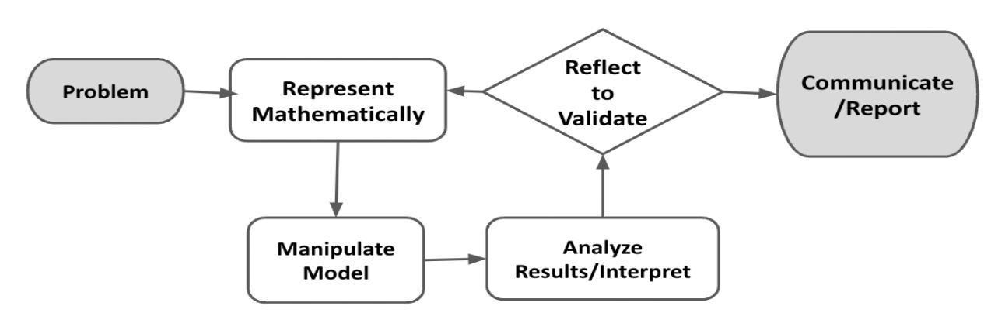
Figure 1. Diagram of Modeling Process. From “Progressions for the Common Core State Standards for Mathematics” [Draft manuscript], by Common Core Standards Writing Team, 2019, p. 6 (http://mathematicalmusings.org/wp-content/uploads/2022/05/modeling_02082019.pdf).

Connections to Learning Principles
Students will:
- analyze a messy, real-world dataset about UFOs using unsupervised methods (LP1);
- explore a facet of an interesting societal question - are we alone in the universe? - through the lens of a data scientist (LP6); and
- use technology to enable a sophisticated analysis of the given variables (LP7).

The following pages provide teacher versions of this task with guidance, suggestions, and comments in red and sample student responses in blue italics.

Note: Sample code generating the example student outputs are included in this file.

The Modeling Cycle
Since the beginning of recorded human history, people have reported seeing flying objects unlike any familiar animals or aircraft. Popularly known as Unidentified Flying Objects, UFOs could be secret military or civilian technology, a trick of the light, an outright fabrication…or perhaps evidence that alien life has arrived at Earth. In this task, you will take on the role of a data scientist to investigate a dataset with multiple variables describing UFO sightings over the past 100 years. As a data scientist, you will conduct an exploratory analysis of the data, look for emergent patterns in the data, and interpret what story about UFOs the data may be hiding.
Mathematical models are used to make sense of ideas and phenomena in our world. As illustrated in the image below, the modeling cycle is a process of collecting data about an idea or problem, creating models of that data, analyzing the story told by those models, and reporting the results to the appropriate audience. In this task, you will be engaging with this mathematical modeling cycle to identify patterns in how, where, and when people report seeing UFOs.
Figure 1. Diagram of Modeling Process. From “Progressions for the Common Core State Standards for Mathematics” [Draft manuscript], by Common Core Standards Writing Team, 2019, p. 6 (http://mathematicalmusings.org/wp-content/uploads/2022/05/modeling_02082019.pdf).

Introduction: What makes a UFO sighting, anyways?
By definition, an Unidentified Flying Object (UFO) must be in the air, and we must not have enough information to definitely identify it as a known aircraft, animal, or natural phenomena. This includes all sorts of mundane occurrences: if someone throws a tomato past your head and you don’t get a clear look at it, that tomato would be a UFO. In popular usage, a UFO is generally an object seen in the sky that looks or moves like a piloted vessel. Most sightings are of far away objects, but people have also reported seeing alien spacecraft up close, perhaps even being taken on board!
Read some of the text descriptions of sightings in the UFO dataset, then answer the questions below.

QUESTION 1
 | Imagine receiving a UFO report with a grainy photo of a faraway circular object. The reporter says they saw the object hovering in the sky for 30 seconds before it disappeared behind a cloud, and swears the photo is conclusive proof that we are not alone in the universe. Brainstorm as many possible explanations for this sighting as you can. Which explanations might you think are more likely than others, and why?
  Some possibilities:
  - It’s a real alien spacecraft
  - It’s a normal man-made aircraft. The circular shape and the fact that it did not accelerate, but rather vanished behind a cloud, means it could be a high-altitude weather balloon
  - It’s a secret man-made aircraft, such as a spy balloon
  - It was an animal with an unusual cross section hovering in the air
  - It was a particularly round cloud
  - The reporter hallucinated the object
  - The reporter heard the story second hand and is reporting it themselves
  - The reporter made up the sighting entirely
  - Someone sent in a bad survey response on purpose, perhaps as a prank
  Of these options, it seems most likely the reporter misidentified some other object - in order, probably a balloon, then a round cloud, then an animal of some sort. Answering this survey didn’t lead to press or book deals, so the reporter didn’t have a reason to lie or prank the survey. And it probably isn’t a secret man-made aircraft or alien ship, if only because presumably these objects are rare.
  The purpose of this question is to get students thinking creatively about possible explanations for an observation, especially a human-reported observation that can’t be verified. This would be a great opportunity to emphasize the base rate part of Bayes’ Rule: even if the evidence fits a rare possibility (alien ship sighting), it is often more likely to be a misidentification of a more common possibility.

QUESTION 2
What features or evidence from a UFO sighting would make you more inclined to believe that it was an artificial aircraft of some sort? What features or evidence would convince you more that it was an alien aircraft?

Video evidence, especially corroborated from independent sources, greatly reduces the chance of a hoax or false memory.
Other detection methods - radar, or even a close-by flight - can rule out animals or clouds.
The credibility of the reporter: do they have a history of wild claims of UFO sightings? Do they have anything to gain or lose from reporting a sighting?

To show it’s an alien spacecraft specifically, we would like to see some kind of capability that is beyond current human technology. This could be maneuverability or acceleration that can’t be achieved by current military aircraft, or perhaps a shape or unknown propulsion system that doesn’t seem like it should be able to stay in the air, or even weapons or tractor beams.

Statements of disbelief from heads of state of major military countries, or panic at high levels of government, would also suggest that the UFO is not just a secret military project.
The purpose of this question is for students to think about how they could be convinced that something interesting is happening. In general, data scientists are skeptical of data generated by surveying people - and rightly so. Indeed, almost every dataset is imperfect in some way. But that does not mean we need to give up: sometimes gathering the right kind of additional data is a good next step.

Initial Data Exploration
QUESTION 3
Plot separate distributions of responses to three variables from the UFO dataset. You might consider histograms, violin plots, or box plots. What do you notice about the distribution of these data?

Answers may vary, but here is one possible example of the three variables:
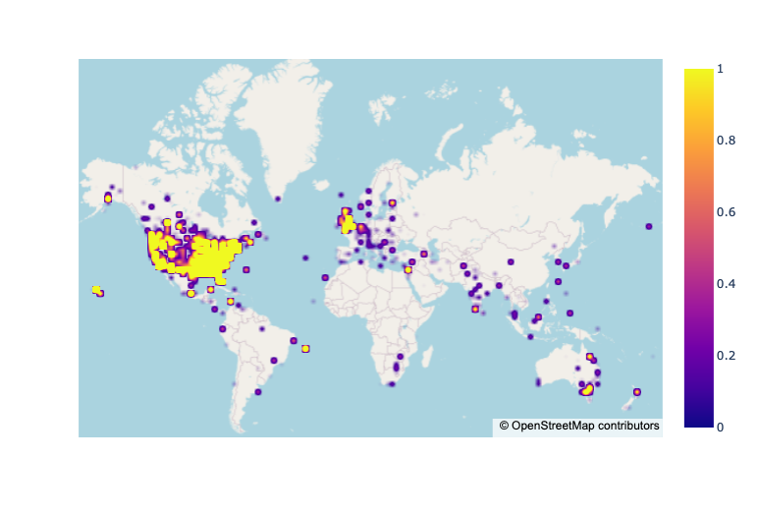
This map visualizes the location information given in the data. We can see the vast majority of responses come from English speaking locations, especially the United States and England, with additional responses from Australia and Europe. There are a few exceptions scattered around the rest of the globe, though they seem less like outliers and more of an artifact of how the data were gathered (presumably an online English survey).
The purpose of this question is to reinforce concepts of visualizing data from M211 as well as take part in a necessary step before conducting a formal analysis of the dataset. Examining the variables is of particular importance when the dataset could be biased or contain incorrect responses, which could skew our models considerably.

Planning your analysis
This UFO dataset contains several variables, which may or may not be related to each other. We also lack ground truth data; since these are self-reported UFO sightings, we don’t know for sure what each respondent actually saw or even if their report is accurate.

Of course, that doesn’t mean we are helpless. Researchers work with imperfect datasets all the time. We will begin by brainstorming some hypotheses that you think this dataset could help you answer.

QUESTION 4
Brainstorm two testable hypotheses that you could analyze with this dataset. For each hypothesis, include:
- Your hypothesis written in plain English
- How the data might show your hypothesis is false
- What you think could be interesting if your hypothesis is true

For example,
Hypothesis: Certain UFO shapes are more commonly seen than others.
Evidence of falsity: The reported proportions for each UFO shape are similar (i.e., all ~10%).
Potential interesting findings: If there are one or two shapes that are much more common, and those shapes happen to be the same shapes we see on popular media (generally ovals or circles), that could show the media affect our perception and attention in the wider world to the point of causing people to see aliens where they might not exist.

Answers will vary based on student interest. Some possibilities:
- Sightings since cell phones became ubiquitous will be longer in duration.
- Sightings will be more common in countries with higher GDP per capita.
- Sightings will be more common during the day than the night.
- Sightings will be more common on the weekend.
This question asks students to turn general ideas of “wouldn’t it be cool to analyze this idea?” into specific hypotheses that can be (partially) answered through statistical analysis. The hypothesis should be falsifiable, and the potential findings should show genuine thought. However, it is inherently difficult to study UFOs and this dataset likely includes gross errors; expect that the quality of “evidence” to be low and its connection to the potential findings to be loose but plausible.

QUESTION 5
Choose one of your hypothesis from the previous question and explain how you would test the dataset to see if your hypothesis is false. This is likely to be a statistical test of some kind. However, if you have a very interesting question that doesn’t seem to fit neatly into a statistical test on this dataset, you may propose a different analysis or visualization along with how you will use the data to support or refute your hypothesis.

Because this dataset is relatively messy, you may not be able to prove your hypothesis true or false. That is fine, as long as your analysis can partly support or refute your hypothesis.

For example,
Hypothesis: Certain UFO shapes are more commonly seen than others.
Test: χ2 goodness of fit test on UFO shape proportions against the uniform distribution. Our hypothesis is supported if the test shows that the distribution of shape proportions is significantly different from uniform.

Or another example,
Hypothesis: People are mistaking man-made objects for UFOs.
Test: Create a heatmap of sightings based on the geolocated data and compare it to an online map of major world airports. Even better, compare it against an online map of the average number of man-made objects in the sky, if such a map exists. Our hypothesis is supported if our UFO heatmap shows sightings are significantly concentrated around major airports or places where many man-made objects are in the sky.

Answers will vary based on the student’s hypotheses. Some examples are included in the question text for students to read themselves.
The purpose of this question is for students to turn the “evidence of falsity” from the previous question into a statistical test or visualization. While an actual test will provide more precise evidence, visualizations may also be interesting and can help answer questions that are not neatly answered by a test the students have learned. However, for any imprecise tests, the student should say what they are expecting to see for a positive or negative result before they run their test or create their visualization rather than constructing post-hoc justifications.

Initial Data Exploration and Planning Your Analysis Checklist
Requirement | Teacher Notes: For each Requirement, what are some specific things that came up in that part of the task?
I plotted separate distributions of responses to three variables from the UFO dataset described what I noticed about the distribution of those variables. | (Teachers, please add your notes here.)
I proposed two testable hypotheses for the dataset and reported on evidence of falsity and potential interesting findings. | (Teachers, please add your notes here.)
I chose one of my hypotheses and tested the data to either support or refute that hypothesis. | (Teachers, please add your notes here.)
General Teacher Notes: | (Teachers, please add your notes here.)

Open Modeling Challenge
QUESTION 6
Attempt to support or refute your hypothesis using your suggested analysis from the previous section. Make sure to include a table, graph, or some other visualization that would help a reader interpret your results.

Answers will vary based on the student’s preferred method.

Using “Certain UFO shapes are more commonly seen than others” as our hypothesis:
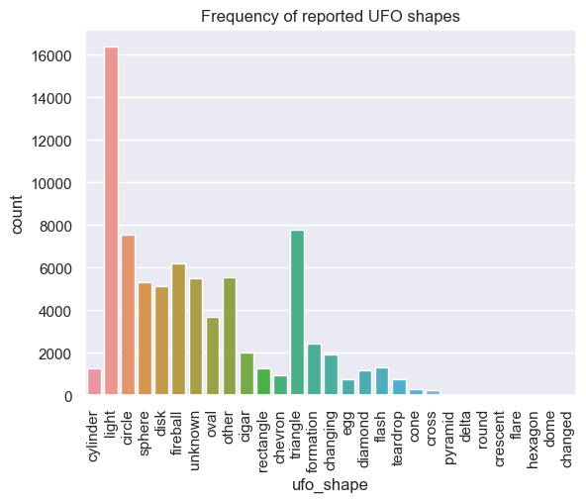
This visualization is pretty suggestive that some shapes are more common than others (and particularly UFOs are commonly seen as “light”). To know for sure, we can run a chi square test with expected equal proportions of each shape. We get:

chi_square statistic:137864.1885882323
p: 0.0

The p value is so small it rounds to 0, so we reject the null hypothesis.
The purpose of this question is for students to actually implement their plan of analysis and show appropriate usage of statistics or visualizations to support or refute a claim. Even in cases where there is a well-defined statistical test, a supporting visualization can help illustrate what is going on and guard against some kinds of errors. Strong students may include some measure of effect size to help interpret their answers.

Evaluation and interpretation
QUESTION 7
Explain whether or not your analysis supported or refuted your hypothesis. If you feel the result was ambiguous or inconclusive, explain why and what you could have done differently to get a more conclusive result. Explain your reasoning as if you were giving a presentation to a government official who only knows a little statistics.

Answers will vary based on the student’s preferred method.

For the hypothesis “Certain UFO shapes are more commonly seen than others,” both the visualization and statistical test support our hypothesis.

However, our analysis does bring up the question of what our result would have been if we had restricted our dataset to common shapes before doing our analysis. Part of the reason we are seeing such a strong effect is that some people reported unusual shapes like “domed,” situations that are not truly shapes like “light” or “changed”, or may have chosen a different name when they meant the same shape such as “pyramid” instead of “triangle.” Even a single person doing this would greatly skew the results of our analysis, which treats all reported shapes as equally valid.
The purpose of this question is for students to interpret their results. In particular, they should be able to speak to the strengths and weaknesses of their analysis to help the reader understand how it fits into their argument. This will often say more about the dataset and how it was collected or recorded than it does about the statistical test they used.

Correlation and Causation
QUESTION 8
One of the marks of a principled approach to scientific analysis is to consider counterarguments. For your analyses, present at least one counterargument to your findings and what you would need to do to evaluate the counterargument.

For example, let’s say we discovered that the proportion of UFO shapes are not significantly different from the uniform distribution. In other words, in this dataset each shape is reported a similar amount of the time. A counterargument to this finding could be that in fact some shapes are more common, but the dataset is polluted by random and false reports because it was drawn from online surveys with minimal verification. To check whether this is true, we could do a similar analysis but only on sightings with a “description” field containing more than 5 words and written in relatively coherent English, because random reporters would likely not take the time to fully describe what they saw.

Answers will vary based on the student’s preferred method.

In the sample analyses above, we already hinted at some problems with our conclusion that some UFO shapes are significantly more common than others. For example, singular respondents responding with unusual shapes can greatly influence the results of the test we ran. One way to deal with this is to take the list of shapes, without counts, and ask a third party to filter or collapse the shapes. An observer might decide that “round” and “circle” are similar enough to be considered the same, for example, or that “changed” and “light” are not shapes. It is important this be done by someone who has not seen the underlying data to avoid bias when choosing how the shapes should be classified.
The purpose of this question is for students to understand that there are almost no perfect statistical arguments when the subject matter involves experimental data. The statistical test may have assumptions that are not met, or the data may be messy or incorrect for some reason. Students should think about what they can do with the existing data or by collecting new data to uncover information closer to the truth. This may not necessarily strengthen their argument - it may in fact weaken it!

Reflection
QUESTION 9
Congratulations on completing an open-ended data modeling task!
- Say you were on a mission to figure out once and for all whether UFO sightings are glimpses of top-secret military aircraft or even alien spaceships, rather than people misinterpreting a cloud or normal aircraft for a UFO or even making up reports. Did your analysis help you decide whether people are truly seeing something “secret?”
- If you could access more data than the dataset provides, what other existing data would you like to include in your analysis to help you find patterns or even figure out what people are really seeing? Why do you think this new data could help you?

Answers will vary widely. In general, however, this dataset is not precise enough to determine whether we have any evidence people are seeing something they “shouldn’t”, i.e. secret aircraft or alien ships. Since we did not think our clustering approach was very promising, we definitely cannot conclude that we have evidence for this hypothesis.

We might have more evidence if we had included the shape data. A cluster of sightings of a particular specific shape might be evidence that there is a new aircraft people are sighting…or it might mean that a new movie about aliens came out with that shape of ship and it’s on people’s minds.

What other data would we want to know if people are seeing real air- or spacecraft? Video data would be great but could be a lot of work to analyze. Something easier might be radio wave or other professionally collected airspace detection data, labeled with locations of unidentified objects. If we see a correlation between human-reported sightings based on timestamp and location with these detection incidents, we could have more confidence people are seeing something real.

The purpose of this question is for students to think about the next step after their analysis. In the real world, data scientists will usually have unanswered questions once they are “done.” If the questions are important enough, it is always an option to search for more data or even collect more data themselves.

Open Modeling Challenge Checklist
Requirement | Teacher Notes: For each Requirement, what are some specific things that came up in that part of the task?
I included a visualization to help support or refute my analysis. | (Teachers, please add your notes here.)
I explained my reasoning as if I were giving a presentation to a government official who only knows a little statistics. | (Teachers, please add your notes here.)
I presented a counterargument to my findings as well as what I would need to do to evaluate the counterargument. | (Teachers, please add your notes here.)
I suggested additional data I would like to include in my analysis to help find patterns or figure out what people are really seeing. | (Teachers, please add your notes here.)
General Teacher Notes: | (Teachers, please add your notes here.)

