Baseline Professional Learning Handout
M155 Right Triangle Trigonometry

Baseline Professional Learning Handout 1
High School, Geometry Progression Excerpt 2
M155 Content and Practice Expectations 3
M155 Content and Practice Expectations and Indicators 3
Let’s Investigate 4
Ask the Pilot Task 4
Sine and Cosine of Complementary Angles Task 5
Let’s do some math! Round 1 6
Task 1: Right Triangles 6
Learning Principles 9
Task 1: Right Triangles Student Work 10
Let’s do some math! Round 2 11
Task 2: Measurement Apps 11
Task 2: Measurement Apps Student Work 13
Criteria for Success 14
Selected Common Core High School Standards for Mathematics

High School - Geometry
Similarity, Right Triangles, and Trigonometry

Define trigonometric ratios and solve problems involving right triangles
- Understand that by similarity, side ratios in right triangles are properties of the angles in the triangle, leading to definitions of trigonometric ratios for acute angles.
- Explain and use the relationship between the sine and cosine of complementary angles.
- Use trigonometric ratios and the Pythagorean Theorem to solve right triangles in applied problems. ★

High School, Geometry Progression Excerpt
Define trigonometric ratios and solve problems involving right triangles Because all right triangles have a common angle, the right angle, the AA criterion becomes, in the case of right triangles, an “A criterion”; that is, two right triangles are similar if they have an acute angle in common. This observation is the key to defining a
trigonometric ratio for a single acute angle.^{G-SRT.6}

M155 Content and Practice Expectations
155.a | Use similarity to explain the meaning of trigonometric ratios.
155.b | Explain and use the relationship between the sine and cosine of complementary angles.
155.c | Use trigonometric ratios to solve right triangles in applied problems.

M155 Content and Practice Expectations and Indicators
Content and Practice Expectations | Indicators  Choose an artifact where you…
155.a: Use similarity to explain the meaning of trigonometric ratios. | i. measure side lengths and angles of multiple triangles and describe patterns you see
 | ii. explain why trigonometric ratios remain the same for different-sized right triangles
155.b: Explain and use the relationship between the sine and cosine of complementary angles. | i. illustrate the relationship between the sine and cosine of complementary angles
 | ii. use the relationship between the sine and cosine of complementary angles to solve problems
155.c: Use trigonometric ratios to solve right triangles in applied problems. | i. use trigonometric ratios to find unknown side lengths in problems
 | ii. use trigonometric ratios to find unknown angles in problems

Let’s Investigate

Ask the Pilot Task
In the July 2013 issue of United Airlines' Hemisphere Magazine the following article appeared:
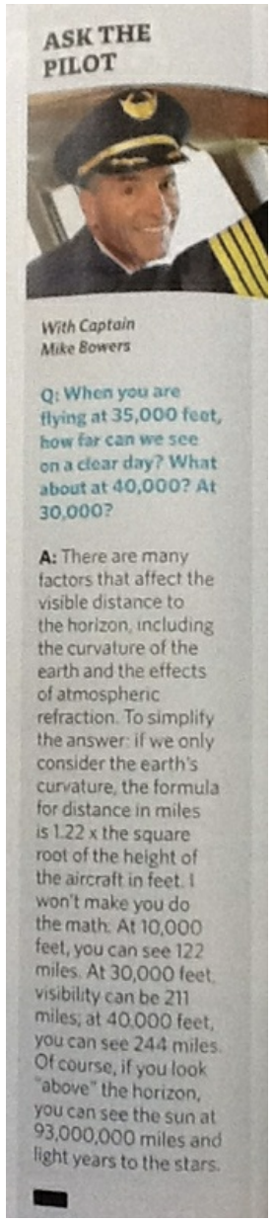
- Write down an equation that describes Captain Bowers' method.
- Create your own mathematical model to find the distance to the horizon from a plane.
- Compare the two models. What simplifying assumptions did Captain Bowers make to create his model? Are these assumptions justified?

Source: Illustrative Mathematics

Sine and Cosine of Complementary Angles Task

- Suppose $0<a<90$∘ is the measure of an acute angle. Draw a picture and explain why$sin a = cos \left(90-a\right)$

- Are there any angle measures $0<a<90$ for which $sin a=cos a$. Explain.

Source: Illustrative Mathematics

Let’s do some math! Round 1

Task 1: Right Triangles

Students are given a problem like this:
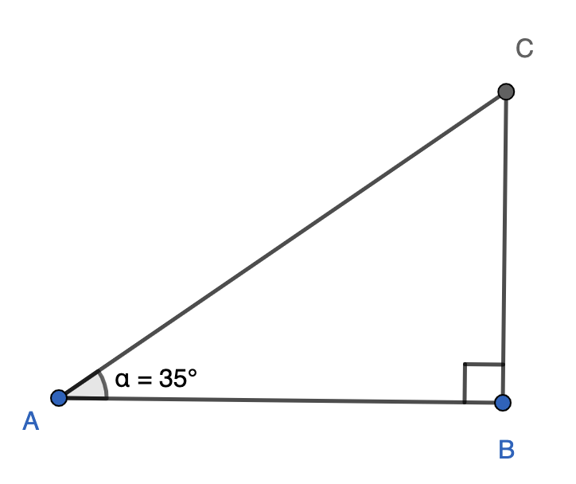
Right triangles have surfaced in previous work: slope, finding areas of complex shapes, and indirect measurement. In this task we will explore ratios of sides of right triangles in order to expand ways we can work with right triangles.
- Use measurement tools or dynamic geometry software such as GeoGebra or Desmos to construct a right triangle 𝐴𝐵𝐶, with a right angle at B and a 35° angle at A.

- Here is some terminology used to describe the relationship between the sides of a right triangle and the reference angle, which in this case is angle A.
  - Side 𝐴𝐶 is the hypotenuse of this right triangle,
  - Side 𝐵𝐶 is the side opposite angle A, and
  - Side 𝐴𝐵 is the side adjacent to angle A.
Take a moment to study the image provided. What makes sense to you about how each side is referred to?
- Measure the three sides of the triangle and record the lengths in a table. Please use the terminology offered above to communicate measures.
- Find each of the ratios listed below.
  - $\frac{length of leg opposite angle A}{length of leg adjacent to angle A}$
  - $\frac{length of leg opposite angle A}{length of the hypotenuse}$
  - $\frac{length of leg adjacent angle A}{length of the hypotenuse}$
- If you were to compare the measurements you found with that of your classmates, how do you think those measurements will compare? Are there any relationships between the side lengths you anticipate will still hold? Why does that make sense?
- If you were to compare the ratios you found with that of your classmates, how do you think those ratios would compare? Why does that make sense?
- Do you think the relationships you’ve noticed hold true for any right triangle? Construct additional right triangles to demonstrate your conjecture.
Adapted from Interactive Math Program Year 1 Shadows Unit
Sample Learning Experience
Begin by giving students quiet time to make sense of the information given and process the task they have to complete. Provide them with physical tools, such as graphing paper, transparencies or patty paper, ruler and protractor, and/or access to dynamic geometry software such as GeoGebra or Desmos.
After some individual time, encourage students to discuss progress with a partner or small group. Encourage students to make their thinking visible.
Initially, focus a conversation on how students went about constructing their triangles. Consider using some of the following questions to facilitate the discussion:
- What strategies led to success in your effort to construct a right triangle with the given conditions?
- What new insights do you have about the work of constructing right triangles?
- If students used dynamic software to complete construction, select students with varied approaches to this work. Look for students who used construction tools to ensure they had 90-and 35-degree angles, as well as students who may have not controlled for that. Begin the conversation by asking students “what happens if we drag some of these points?”
  - Invite students to attempt to drag points to recognize what elements of their triangle remain constant and which don’t.
  - Follow up with additional questions to invite students to reflect on their construction approach- for example, some approaches make it so that either or both of the 90° and 35° angles remain constant.
The image on the left illustrates a student’s approach using GeoGebra. The image on the right illustrates a student’s approach using Desmos.
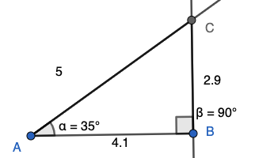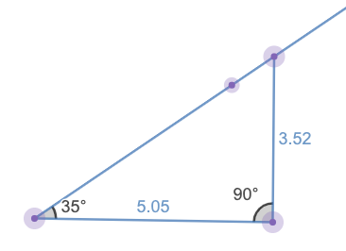

Give students time to revise their constructions as needed before proceeding to the next stage of the investigation. As students enter the next stage of the investigation, do hold space for students to have some independent work time before they collaborate with classmates.
For the second prompt, consider using the Math Language Routine 1: Stronger and Clearer Each Time (MLR 1) to give students an opportunity to learn from each other. The prompt in focus for this iteration of MLR 1 is: When given a right triangle and an angle to focus on, how can you tell which leg of the triangle is the leg opposite of the angle? …leg adjacent to the angle? …hypotenuse? A possible way to consolidate this conversation is to use Math Language Routine 2: Collect and Display or create an anchor poster using student language.
For the last prompts, consider creating a poster where students can contribute their data, similar to the table below, as classmates continue to work through the rest of the prompts.
Student | $\frac{length of leg opposite A}{length of leg adjacent A}$ | $\frac{length of leg opposite A}{length of hypotenuse}$ | $\frac{length of leg adjacent A}{length of hypotenuse}$

As students develop responses for questions 5 and 6, monitor for, select, and share student work that embodies different approaches and levels of formality for discussion. Note and select various levels of formality students are comfortable with as they share their work with each other. Look for students who use arguments grounded in the idea of similarity, as well as students who utilize technology to generate multiple examples, as illustrated in the GeoGebra screenshot below .
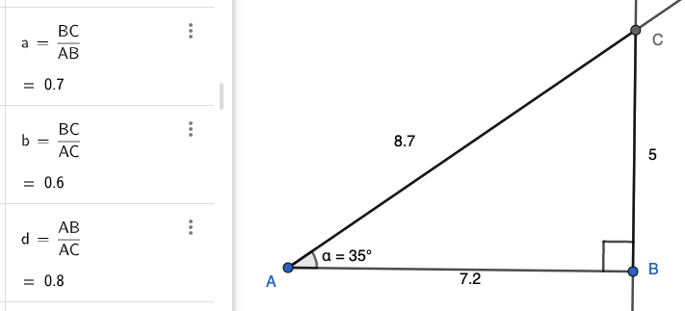
As students share their reasoning with other, consider the following questions:
- What are some things you appreciate about this explanation?
- What questions does this explanation surface for you?
- What can you take from this explanation to apply to your own work?

To engage students in a discussion of Question 7, consider selecting students who constructed additional right triangles with different reference angles, as well as those who approached this by focusing on m<C, 55°, angle.

Following the sharing and discussion, give students an opportunity to revise their work and share with each other again. Focus this second discussion on changes or adjustments that they have made based on their peers’ work.

Learning Principles
Engage with cognitively demanding tasks in heterogeneous settings (LP 1). Students should be given opportunities to grapple with multistep, non-routine tasks that promote mathematical rigor. These experiences should be differentiated so that all students engage in appropriate challenges—for example, through tasks with multiple entry points and solution pathways. These experiences should continue to integrate knowledge and skills developed in grades 6-8 at the level of sophistication of high school mathematics.

Engage in social activities (LP 2). Students should have opportunities to work independently and to communicate with one another about mathematics by engaging in collective and collaborative learning activities. Explaining and having opportunities to revise one’s thinking has excellent value in solidifying one’s knowledge.

Build conceptual understanding through reasoning (LP 3). Students should be given the opportunity to reason, justify, and problem solve with critical thinking, reading, writing, speaking, and listening. Through reasoning and work with multiple representations, students learn why procedures work and build a conceptual understanding of key mathematical ideas.

Have agency in their learning (LP 4). Students should be able to choose tasks and learning experiences that align with their interests and aspirations. All students have rich and varied experiences and home lives. Learning mathematics should bring students’ identities and interests to the fore and build on the strengths that they bring to the learning space.

View mathematics as a human endeavor across centuries (LP 5). Students should understand that mathematical ideas emanated over time from civilizations around the world and have opportunities to explore these contributions to mathematics. Students should develop an appreciation of mathematics as a human endeavor: one in which they feel a sense of belonging, where they see themselves as mathematicians, and one that offers opportunities to broaden their ideas about what mathematics is, how it is used, and who it is for.

See mathematics as relevant (LP 6). Students should engage with mathematics in ways that authentically involve real-world situations. Problem-solving contexts should allow students to perceive mathematics as a tool for addressing the questions that arise in everyday life, as well as the ways it can model our world and address global economic, social, and environmental challenges. Students should also engage with mathematics in ways that connect to academic disciplines and future careers by doing the mathematics used by artists, designers, engineers, and other professionals.

Employ technology as a tool for problem-solving and understanding (LP 7). Research indicates that technology is a powerful tool for learning deeper mathematics by improving calculation efficiency and enabling more sophisticated analysis. Students should learn to use technology, with emphasis put on widely used tools and software, such as calculators and spreadsheets, to make sense of models. Technology use should not be limited to supporting “doing mathematics,” but should also be used as a tool for displaying and communicating results to appropriate audiences.

Task 1: Right Triangles Student Work

Example 1:

Insert image of student work here

Example 2:

Insert image of student work here

Example 3:

Insert image of student work here

Let’s do some math! Round 2

Task 2: Measurement Apps
Students are given a problem like this:

Our phones offer tools that we can use to measure things without the use of traditional tools, like measuring tape or yard sticks. Today, you will determine the accuracy of such tools. You will need some classmates to work with, a cell phone, and access to a measuring app. This short article, 10 Best Measurement Apps for Android and iPhone, by Beebom offers some options.

Your task:
- Select an object to use for this task, consider a flagpole, bell tower, or basketball basket.
- Use a smartphone’s measurement tool to measure the height of the object from at least three different positions.
  - How do the measurements compare? If there is a difference in the heights, what do you think accounts for the differences you see?
- Determine the height of that object using more traditional techniques or research. How do the measures you got from using the phone compare to the numbers you got from indirect measurement using traditional tools or from your research?
- Select other objects to go through this process.
- Based on your findings, how would you describe the accuracy of the smartphone’s measurement app?
- Conduct some additional research to determine how these phone apps work, what recommendations do you have for changes or improvements?

Prepare to report your findings.

Sample Learning Experience
Based on what you know about your students, you may choose to launch this task by asking students who has used a measurement app on their phone? Following this question, invite a student or two who has used such tools to demonstrate how it works. Alternatively, you can launch this task by showing this short video clip- “Did you know your Smartphone could do THIS!?” by @Mrwhosethe boshShorts. Share with students that their task is to determine the accuracy of their smartphone measuring tool.
As students work on the first two prompts of this task, monitor and select students or student groups to share their preliminary approach to this task with the whole group. Look for groups who are deliberate about the horizontal positions they are using, as well as students who take into account their ability to frame the object (lighting, camera’s ability to capture the object and key points for measurement.
Images below illustrate some of the measurements students might make with their smartphone measuring apps:
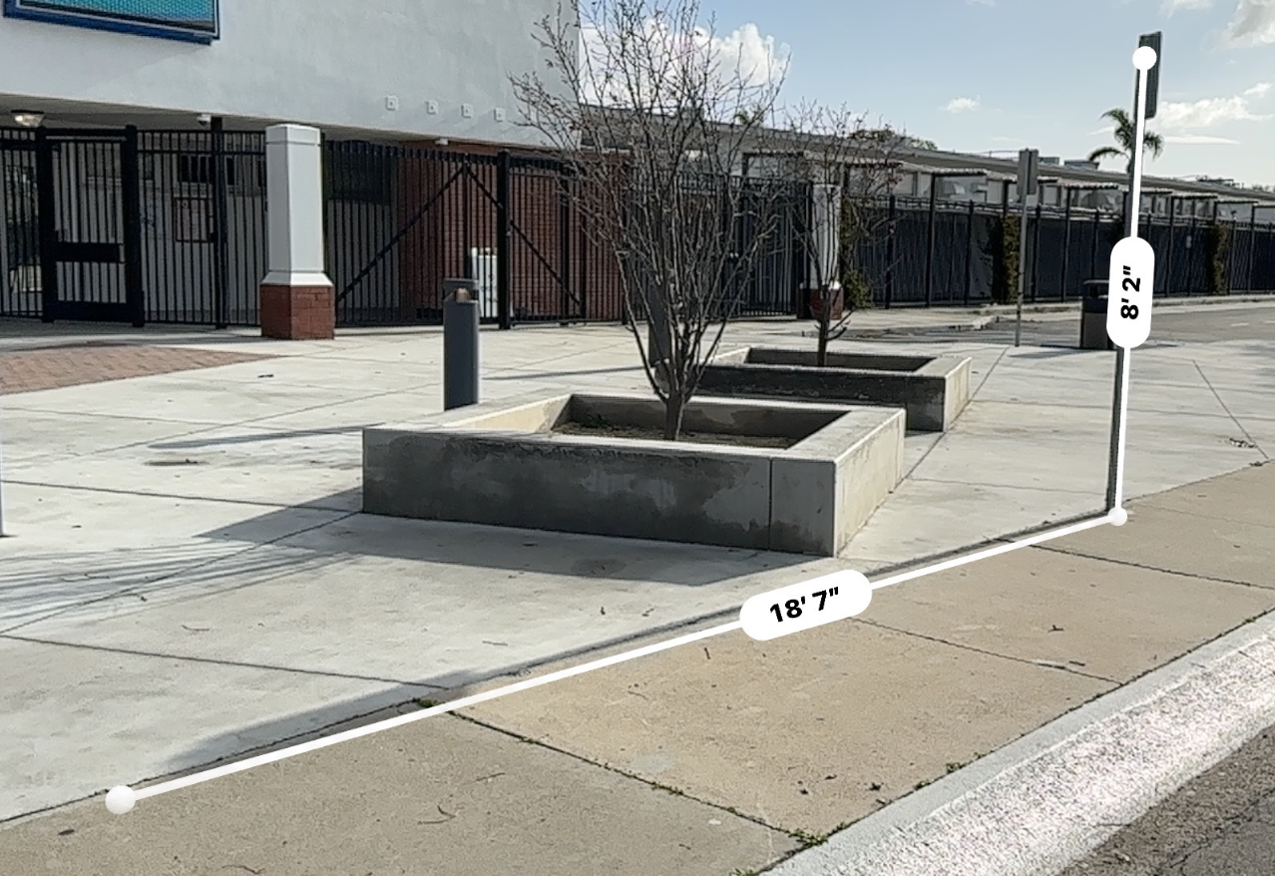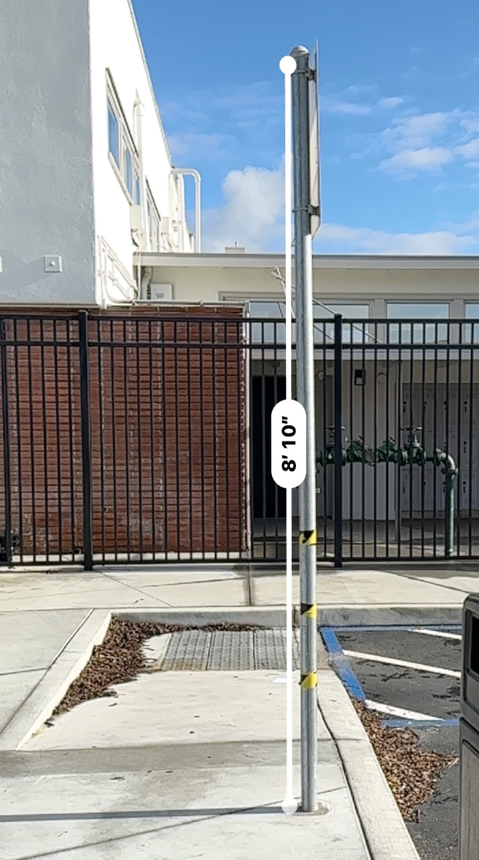
As students work, consider some of these questions to learn more about their approach:
- How did you decide where to stand? How did you decide what other positions to try?
- What have you noticed about how this app works? What impact do you think that has on what and how you measure things?
As students share their approach with classmates, invite them to make sense of each other’s work. Consider the following questions:
- What are some things you appreciate about this approach?
- What questions does this approach surface for you?
- What can you take from this explanation to apply to your own work?

Following the sharing and discussion, give students an opportunity to revise their work or build upon their work to share with each other again. Focus this second discussion on changes or adjustments they have made based on their peers’ work.

As students return to work on the remaining prompts, monitor and select students who use similar triangles and/or trigonometry as forms of indirect measurement, as well as other mathematically promising approaches. Ensure tools for measuring angle of elevation are readily available for use or to be assembled.

As they share their approach with classmates, invite students to make sense of each other’s work. Consider the following questions:

- What are some things you appreciate about this approach?
- What questions does this approach surface for you?
- What can you take from this explanation to apply to your own work?

Following the sharing and discussion, give students an opportunity to revise their work or build upon their work to share with each other again.

Encourage students to consider sharing their findings and suggestions for improvements with app developers. Invite students who hear back from developers to share the impact of their work with the class.

Task 2: Measurement Apps Student Work

Example 1:

Insert image of student work here

Example 2:

Insert image of student work here

Example 3:

Insert image of student work here

Criteria for Success

Conference and Provide Revision Support | Accept with Revision | Accept
The student’s artifact shows an emerging understanding of the expectations of the indicator(s). After conferencing and additional instruction/learning, the student may provide a revised or different artifact as evidence of the indicator(s). | The student’s artifact is approaching a full understanding of the expectations of the indicator(s). The artifact may contain execution errors that should be corrected in revision. The student may revise the selected artifact or submit a different artifact. | The student’s artifact demonstrates evidence that they have met the expectations of the indicator(s).

