Baseline Professional Learning Handout
M153 Reasoning and Proof through Similarity

Baseline Professional Learning Handout 1
Selected Common Core High School Standards for Mathematics 1
Progressions Geometry Excerpt 3
M153 Content and Practice Expectations 4
M153 Content and Practice Expectations and Indicators 5
Let’s Investigate 7
Bank Shot Task 7
Dilating a Line Task 8
Let’s do some math! Round 1 9
Task 1: Similar Triangles 9
Learning Principles 12
Task 1: Similar Triangles Student Work 13
Let’s do some math! Round 2 14
Task 2: Similar Circles 14
Task 2: Similar Circles Student Work 17
Criteria for Success 18
References 18

Selected Common Core High School Standards for Mathematics

High School Geometry- Similarity, Right Triangles, and Trigonometry
Understand similarity in terms of similarity transformations
- Verify experimentally the properties of dilations given by a center and a scale factor:
  - A dilation takes a line not passing through the center of the dilation to a parallel line, and leaves a line passing through the center unchanged.
  - The dilation of a line segment is longer or shorter in the ratio given by the scale factor.
- Given two figures, use the definition of similarity in terms of similarity transformations to decide if they are similar; explain using similarity transformations the meaning of similarity for triangles as the equality of all corresponding pairs of angles and the proportionality of all corresponding pairs of sides.
- Use the properties of similarity transformations to establish the AA criterion for two triangles to be similar.

Prove theorems involving similarity
- Prove theorems about triangles. Theorems include: a line parallel to one side of a triangle divides the other two proportionally, and conversely; the Pythagorean Theorem proved using triangle similarity.
- Use congruence and similarity criteria for triangles to solve problems and to prove relationships in geometric figures.

Define trigonometric ratios and solve problems involving right triangles
- Understand that by similarity, side ratios in right triangles are properties of the angles in the triangle, leading to definitions of trigonometric ratios for acute angles.
- Explain and use the relationship between the sine and cosine of complementary angles.
- Use trigonometric ratios and the Pythagorean Theorem to solve right triangles in applied problems.★

High School Geometry- Circles
Understand and apply theorems about circles
- Prove that all circles are similar.
- Identify and describe relationships among inscribed angles, radii, and chords. Include the relationship between central, inscribed, and circumscribed angles; inscribed angles on a diameter are right angles; the radius of a circle is perpendicular to the tangent where the radius intersects the circle.
- Construct the inscribed and circumscribed circles of a triangle, and prove properties of angles for a quadrilateral inscribed in a circle.

Find arc lengths and areas of sectors of circles
- Derive using similarity the fact that the length of the arc intercepted by an angle is proportional to the radius, and define the radian measure of the angle as the constant of proportionality; derive the formula for the area of a sector.

Progressions Geometry Excerpt
Understand similarity in terms of similarity transformations  The traditional notion of similarity applies only to polygons. Two such figures are said to be similar if corresponding angles are congruent and corresponding lengths are related by a constant scale factor. If similarity is defined in terms of transformations, then this understanding is a consequence of the definition rather than being a definition itself.^{G-SRT.2}  For example, using the fact that a dilation takes a line to a parallel line, and facts about transversals of pairs of parallel lines, students can show that a dilation preserves angles, that is, the image of an angle is congruent to the angle itself (see image).  They also observe that under dilation the length of any line segment—not only segments with an endpoint at the center—is scaled by the scale factor of the dilation.^{G-SRT.1b} A complete proof of this fact is beyond the scope of a high school geometry course, but a proof in specific cases is suitable for an investigation by STEM-intending students. The simplest case is where the scale factor is 2, which can be proven by a congruence argument. (Common Core Standards Writing Team, 2022. p.229) | 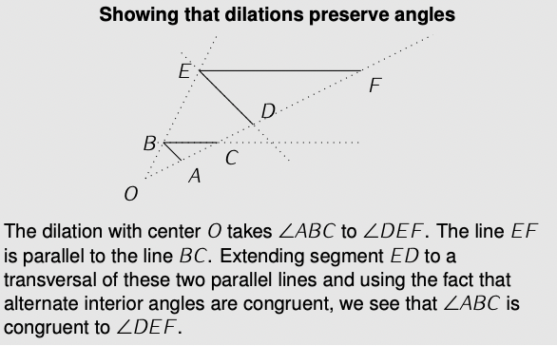

M153 Content and Practice Expectations
153.a | Given a geometric figure and a dilation, draw the transformed figure using tools such as graph paper, tracing paper, or geometry software.
153.b | Specify a sequence of transformations that will carry a given figure onto a similar figure.
153.c | Verify experimentally the properties of dilations given by a center and a scale factor.
153.d | Given two figures, use the definition of similarity in terms of similarity transformations to decide if they are similar.
153.e | Explain using similarity transformations the meaning of similarity for triangles as the equality of all corresponding pairs of angles and the proportionality of all corresponding pairs of sides.
153.f | Use the properties of similarity transformations to establish the AA criterion for two triangles to be similar.
153.g | Use similarity to prove theorems about triangles.
153.h | Use similarity criteria for triangles to solve problems and to prove relationships in geometric figures.

M153 Content and Practice Expectations and Indicators
Content and Practice Expectations | Indicators  Choose an artifact where you…
153.a: Given a geometric figure and a dilation, draw the transformed figure using, e.g., graph paper, tracing paper, or geometry software. | i. create a dilated figure using graph paper, tracing paper, or geometry software.
 | ii. explain how you dilated a figure.
153.b: Specify a sequence of transformations that will carry a given figure onto a similar figure. | i. describe a sequence of transformations that would carry a figure onto a similar figure.
153.c: Verify experimentally the properties of dilations given by a center and a scale factor. | i. create a dilated figure using graph paper, tracing paper, or geometry software and describe the effect of dilations on line segments.
 | ii. create a dilated figure using graph paper, tracing paper, or geometry software and describe the effect of dilations on angles.
153.d: Given two figures, use the definition of similarity in terms of similarity transformations to decide if they are similar. | i. write an argument or explanation why two figures are similar, using similarity transformations in your reasoning.
 | ii. write an argument or explanation why two figures are not similar, using similarity transformations in your reasoning.
 | iii. use the definition of dilation within your argument.
153.e: Explain using similarity transformations the meaning of similarity for triangles as the equality of all corresponding pairs of angles and the proportionality of all corresponding pairs of sides. | i. demonstrate using similarity transformations an example that similar figures have corresponding angles that are equal in measure.
 | ii. explain why, in general, similar figures have corresponding angles that are equal in measure using similarity transformations in your reasoning.
 | iii. demonstrate using an example that similar figures have corresponding sides that are proportional.
 | iv. explain why, in general, similar figures have corresponding sides that are proportional using similarity transformations in your reasoning.
153.f: Use the properties of similarity transformations to establish the AA criterion for two triangles to be similar. | i. demonstrate using an example that if two figures have two corresponding angles that are equal in measure, then they are similar.
 | ii. explain why, in general, two figures that have two corresponding angles that are equal in measure are similar, using similarity transformations in your reasoning.
153.g: Use similarity to prove theorems about triangles. | i. read a proof of a statement about a triangle or triangles in general and summarize or explain it in your own words.
153.g: Use similarity to prove theorems about triangles. | ii. write a proof of a statement about a triangle or triangles in general using similarity transformations or similarity criteria in your reasoning.
153.h: Use similarity criteria for triangles to solve problems and to prove relationships in geometric figures. | i. find an unknown length measurement in a triangle and explain how you determined your answer using similarity transformations or similarity criteria in your reasoning.
 | ii. find an unknown angle measurement in a triangle and explain how you determined your answer using similarity transformations or similarity criteria in your reasoning.

Let’s Investigate

Bank Shot Task
Pablo is practicing bank shots on a standard 4 ft.-by-8 ft. pool table that has a wall on each side, a pocket in each corner, and a pocket at the midpoint of each eight-foot side.

Pablo places the cue ball one foot away from the south wall of the table and one foot away from the west wall, as shown in the diagram below. He wants to bank the cue ball off of the east wall and into the pocket at the midpoint of the north wall.
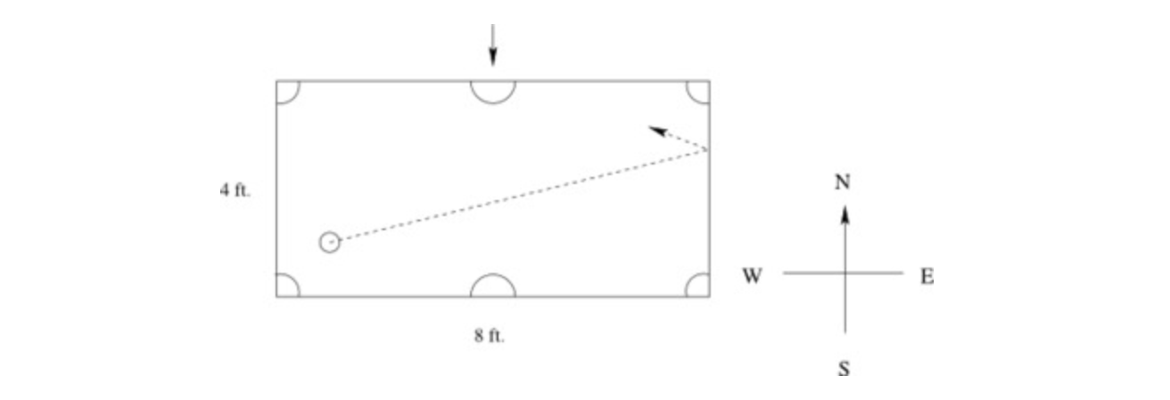
- At what point should the cue ball hit the east wall?

- After Pablo practices banking the cue ball off of the east wall, he tries placing the eight-ball two feet from the east wall, as shown in the diagram below, so that if he shoots the cue ball exactly as he did before, the cue ball will strike the eight-ball directly and sink the eight-ball into the north pocket. How far from the north wall should Pablo place the eight-ball?

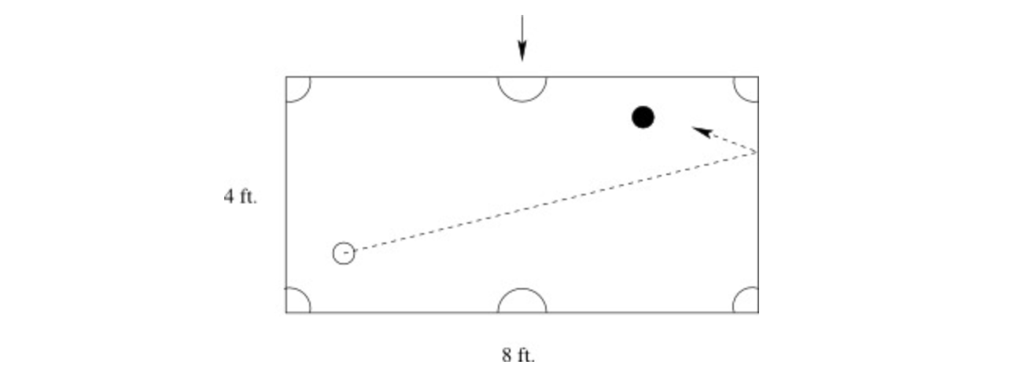

Source: Illustrative Mathematics

Dilating a Line Task

Suppose we apply a dilation by a factor of 2, centered at the point P, to the figure below.
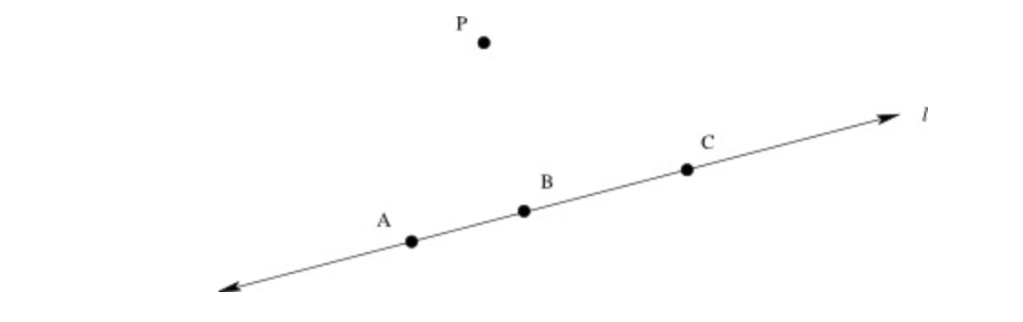
- In the picture, locate the images A', B', and C' of the points A, B, and C under this dilation.
- Based on your picture in part (a), what do you think happens to the line l when we perform the dilation?
- Based on your picture in part (a), what appears to be the relationship between the distance A'B' and the distance AB? How about the distances B'C' and BC?
- Can you prove your observations in part (c)?
Source: Illustrative Mathematics

Let’s do some math! Round 1

Task 1: Similar Triangles
Students are given a problem like this:

In the two triangles pictured below, $m\left(<A\right)=m\left(<D\right)$ and $m\left(<B\right)=m\left(<E\right)$:
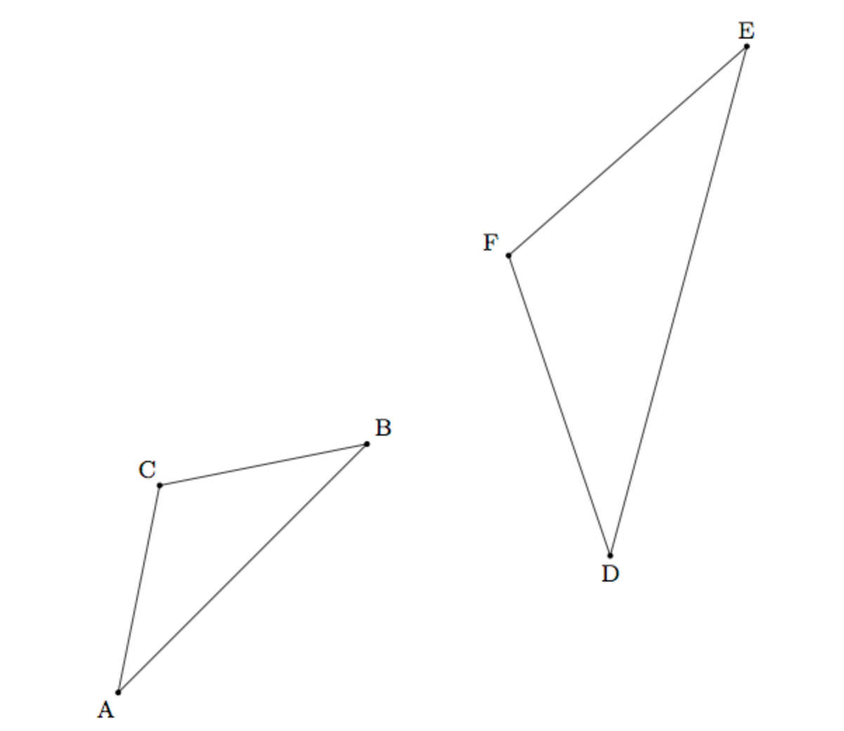
Using a sequence of translations, rotations, reflections, and/or dilations, show that △ABC is similar to △DEF.
(Illustrative Math Task Similar Triangles, 2016)

Sample Learning Experience
Begin by giving students quiet time to make sense of the information given and process the task they have to complete. Provide them with physical tools, such as transparencies or patty paper, or digital geometry software to experiment with different transformations.

After some individual time, encourage students to discuss progress with a partner or small group. Encourage students to make their thinking visible. Initially, focus a conversation on how students interpreted and used the given information. Consider pulling the class together to discuss and share students’ labels and use of tools to build shared understanding of the known information about the triangles. Monitor and select student work that aids in the conversation. Note some may mark up their paper whereas others may use their transparency or tracing paper to arrive at the conclusion that the given corresponding angles are congruent.

Monitor for, select, and share student work that embodies different approaches and levels of formality for discussion. Listen for the various ways students name the sequence of transformations. Note and select various levels of formality students are comfortable with as they share their work with each other. For example:

Sample Student Response 1
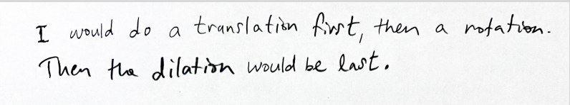

Sample Student Response 2
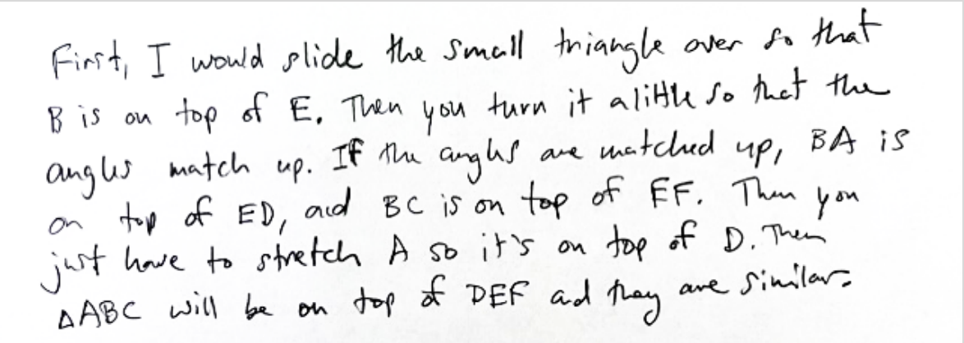
Sample Student Response 3
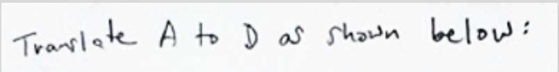
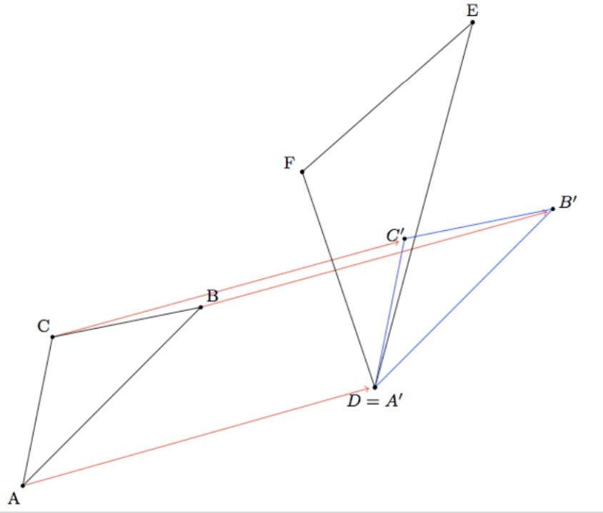
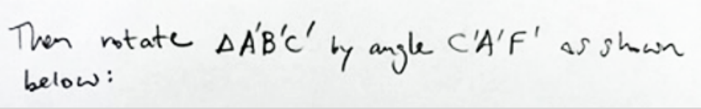
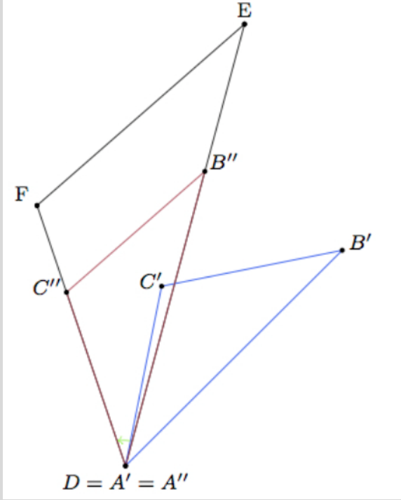
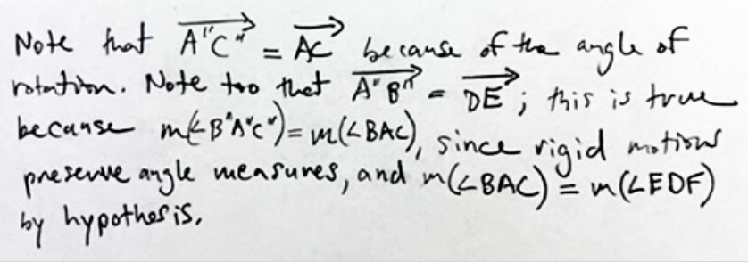
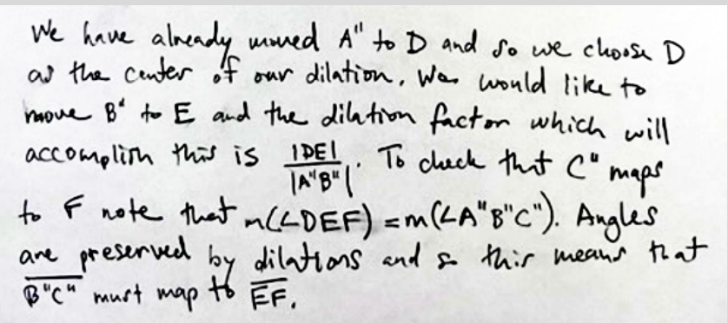

As students share their sketches and reasoning with classmates, invite them to make sense of each
other’s sketches. Consider the following questions:

- What are some things you appreciate about this explanation?
- What questions does this explanation surface for you?
- What can you take from this explanation to apply to your own work?

Following the sharing and discussion, give students an opportunity to revise their work and share with
each other again. Focus this second discussion on changes or adjustments that they have made based
on their peers’ work.

Learning Principles
Engage with cognitively demanding tasks in heterogeneous settings (LP 1). Students should be given opportunities to grapple with multistep, non-routine tasks that promote mathematical rigor. These experiences should be differentiated so that all students engage in appropriate challenges—for example, through tasks with multiple entry points and solution pathways. These experiences should continue to integrate knowledge and skills developed in grades 6-8 at the level of sophistication of high school mathematics.

Engage in social activities (LP 2). Students should have opportunities to work independently and to communicate with one another about mathematics by engaging in collective and collaborative learning activities. Explaining and having opportunities to revise one’s thinking has excellent value in solidifying one’s knowledge.

Build conceptual understanding through reasoning (LP 3). Students should be given the opportunity to reason, justify, and problem solve with critical thinking, reading, writing, speaking, and listening. Through reasoning and work with multiple representations, students learn why procedures work and build a conceptual understanding of key mathematical ideas.

Have agency in their learning (LP 4). Students should be able to choose tasks and learning experiences that align with their interests and aspirations. All students have rich and varied experiences and home lives. Learning mathematics should bring students’ identities and interests to the fore and build on the strengths that they bring to the learning space.

View mathematics as a human endeavor across centuries (LP 5). Students should understand that mathematical ideas emanated over time from civilizations around the world and have opportunities to explore these contributions to mathematics. Students should develop an appreciation of mathematics as a human endeavor: one in which they feel a sense of belonging, where they see themselves as mathematicians, and one that offers opportunities to broaden their ideas about what mathematics is, how it is used, and who it is for.

See mathematics as relevant (LP 6). Students should engage with mathematics in ways that authentically involve real-world situations. Problem-solving contexts should allow students to perceive mathematics as a tool for addressing the questions that arise in everyday life, as well as the ways it can model our world and address global economic, social, and environmental challenges. Students should also engage with mathematics in ways that connect to academic disciplines and future careers by doing the mathematics used by artists, designers, engineers, and other professionals.

Employ technology as a tool for problem-solving and understanding (LP 7). Research indicates that technology is a powerful tool for learning deeper mathematics by improving calculation efficiency and enabling more sophisticated analysis. Students should learn to use technology, with emphasis put on widely used tools and software, such as calculators and spreadsheets, to make sense of models. Technology use should not be limited to supporting “doing mathematics,” but should also be used as a tool for displaying and communicating results to appropriate audiences.

Task 1: Similar Triangles Student Work

Example 1:

Insert image of student work here

Example 2:

Insert image of student work here

Example 3:

Insert image of student work here

Let’s do some math! Round 2

Task 2: Similar Circles
Students are given a problem like this:

The picture below depicts a dilation between Circle x and Circle y. A dilation is defined as, “A transformation that moves each point along the ray through the point emanating from a fixed center, and multiplies distances from the center by a common scale factor” (Mathematics Glossary CCSS).
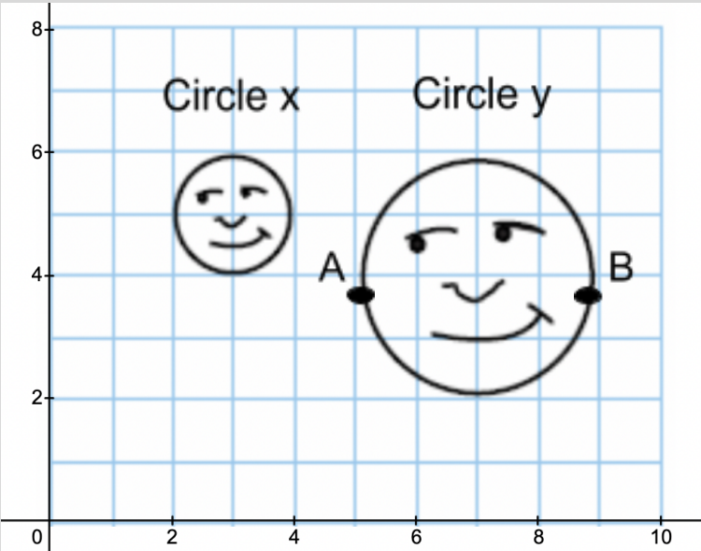
- Given the position of the images, is Circle y a dilation from inside, on, or outside Circle x?

- Determine the scale factor of the dilation to produce Circle y.

- Use Geogebra to recreate the image online. Then, find the center of dilation from Circle x to Circle y.

- Given a scale factor of 4, what is the set of coordinates of the image of points A and B? What was the center of the dilation that resulted in those coordinates? Would a different center of dilation result in the same coordinates you found? Why or why not?

- Given a scale factor of 1/4, explain how Circle y would change. Under what conditions would this happen?

- Revisit the definition of a dilation: “A transformation that moves each point along the ray through the point emanating from a fixed center and multiplies distances from the center by a common scale factor.” How did you use parts of the definition to respond to the questions above?

Sample Learning Experience

Introduce the lesson by displaying the given image. Ask students: “What do you notice? What do you wonder?” Chart student responses close to the image, in a place that is visible to the whole class. Encourage them to elaborate in order to make ways they are attending to structure visible to themselves and their classmates.

Introduce the definition provided and ask students to make connections between the definition and what they shared on what they noticed. Ask: “What connections do you see between what you noticed and this definition?” Give students a minute of quiet time to think, then share with a partner before eliciting responses from the whole group. Chart student connections close the previous collection of student-generated ideas.

If the concept of dilations is new to students, consider using excerpts from Illustrative Mathematics Grade 8 Unit 2 Lesson 2 as a way to introduce it before engaging in this task.

Give students time to engage in Question 1 individually, followed by partner or small group work. Monitor and select varied approaches to this prompt to share for whole class discussion.
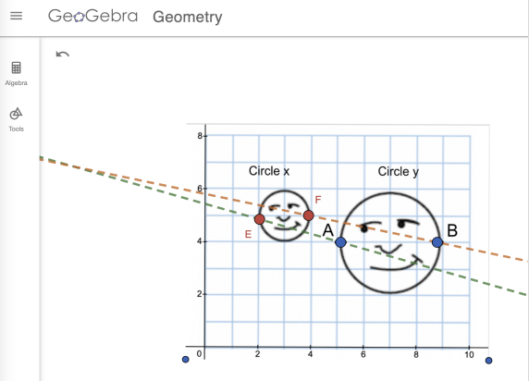
As students share their approach with classmates, invite them to make sense of each other’s work. Consider the following questions:
- What are some things you appreciate about this approach?
- What questions does this approach surface for you?
- What can you take from this explanation to apply to your own work?

Following the sharing and discussion, give students an opportunity to revise their work or build upon their work to share with each other again. Focus this second discussion on changes or adjustments they have made based on their peers’ work.

As students return and work on Questions 2 and 3, monitor and select varied approaches to these prompts for whole class discussion.
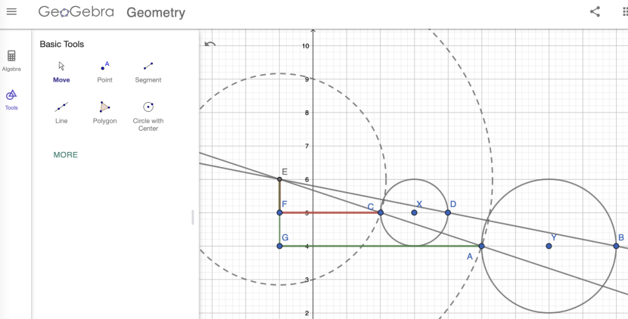
As they share their approach with classmates, invite students to make sense of each other’s work. Consider the following questions:
- What are some things you appreciate about this approach?
- What questions does this approach surface for you?
- What can you take from this explanation to apply to your own work?

Following the sharing and discussion, give students an opportunity to revise their work or build upon their work to share with each other again.

As students return and work on Questions 4 and 5, monitor and select varied approaches to these prompts for whole class discussion. Focus this discussion on the role the center of dilation plays in determining where dilated images live on the plane.

Following the sharing and discussion, give students an opportunity to revise their work or build upon their work to share with each other again.

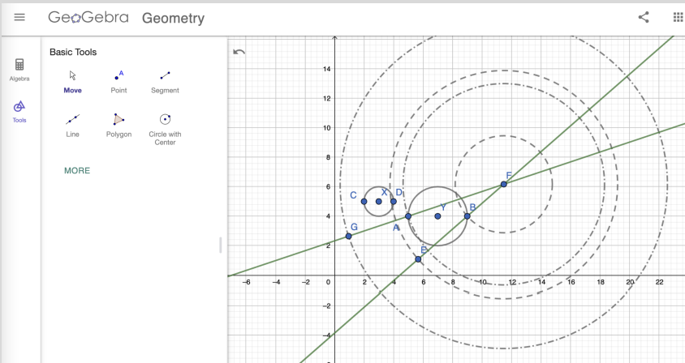

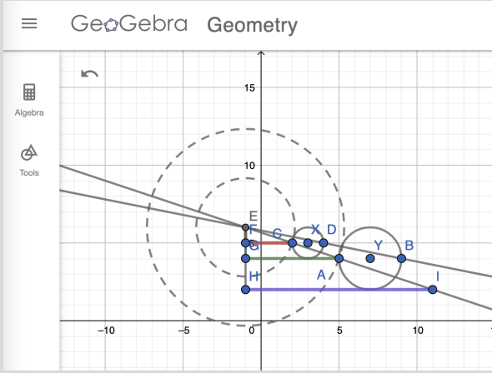

For Question 6, consider using the math language routine, Stronger and Clearer to give students a structure
with which to synthesize their learning. Begin by posing the prompt and giving students time to write their
preliminary response individually. Then give students three to four minutes to share their response with a
peer. Then give students a moment to write a note to themselves based on what they heard from their
classmate. Give students another opportunity to pair up with a different classmate and share responses
again. Finally, give students time to revise their preliminary response.

Task 2: Similar Circles Student Work

Example 1:

Insert image of student work here

Example 2:

Insert image of student work here

Example 3:

Insert image of student work here

Criteria for Success

Conference and Provide Revision Support | Accept with Revision | Accept
The student’s artifact shows an emerging understanding of the expectations of the indicator(s). After conferencing and additional instruction/learning, the student may provide a revised or different artifact as evidence of the indicator(s). | The student’s artifact is approaching a full understanding of the expectations of the indicator(s). The artifact may contain execution errors that should be corrected in revision. The student may revise the selected artifact or submit a different artifact. | The student’s artifact demonstrates evidence that they have met the expectations of the indicator(s).

References
Common Core Standards Writing Team. (2022). Progressions for the Common Core State Standards for Mathematics (February 28, 2023). Tucson, AZ: Institute for Mathematics and Education, University of Arizona.

Illustrative Mathematics. “Bank Shot.” Illustrative Mathematics High School Geometry, Illustrative Mathematics, 4 May 2016, http://tasks.illustrativemathematics.org/content-standards/HSG/SRT/B/5/tasks/651.

Illustrative Mathematics. “Circular Grid.” Illustrative Mathematics Grade 8 Unit 2 Lesson 2, Kendall Hunt, 2019, https://im.kendallhunt.com/MS/teachers/3/2/2/index.html.

Illustrative Mathematics. “Dilating a Line.” Illustrative Mathematics High School Geometry, Illustrative Mathematics, 4 May 2016, http://tasks.illustrativemathematics.org/content-standards/HSG/SRT/A/1/tasks/602.

Illustrative Mathematics. “Similar Triangles.” Illustrative Mathematics High School Geometry, Illustrative Mathematics, 4 May 2016, http://tasks.illustrativemathematics.org/content-standards/HSG/SRT/A/3/tasks/1422.

