Baseline Professional Learning Handout
M151: Modeling with Geometry

Baseline Professional Learning Handout 1
Selected Common Core High School Standards for Mathematics 2
Progressions Excerpt 2
M151 Content and Practice Expectations 3
M151 Content and Practice Expectations and Indicators 4
Let’s Investigate 6
Roses for Rosa Task 6
Ready to Run Task 7
Let’s do some math! Round 1 8
Task 1: Roses for Rosa Task 8
Learning Principles 9
Task 1: Roses for Rosa Student Work 10
Let’s do some math! Round 2 13
Task 2: Design a Controller Prompt 14
Task 2: Design a Controller Student Work 16
Criteria for Success 19
References 19

Selected Common Core High School Standards for Mathematics

Apply geometric concepts in modeling situations
- Use geometric shapes, their measures, and their properties to describe objects (e.g., modeling a tree trunk or a human torso as a cylinder).★
- Apply concepts of density based on area and volume in modeling situations (e.g., persons per square mile, BTUs per cubic foot).★
- Apply geometric methods to solve design problems (e.g., designing an object or structure to satisfy physical constraints or minimize cost; working with typographic grid systems based on ratios).★

Explain volume formulas and use them to solve problems
- Give an informal argument for the formulas for the circumference of a circle, area of a circle, volume of a cylinder, pyramid, and cone. Use dissection arguments, Cavalieri's principle, and informal limit arguments.
- Use volume formulas for cylinders, pyramids, cones, and spheres to solve problems.★

Visualize relationships between two-dimensional and three-dimensional objects
- Identify the shapes of two-dimensional cross-sections of three-dimensional objects, and identify three-dimensional objects generated by rotations of two-dimensional objects.

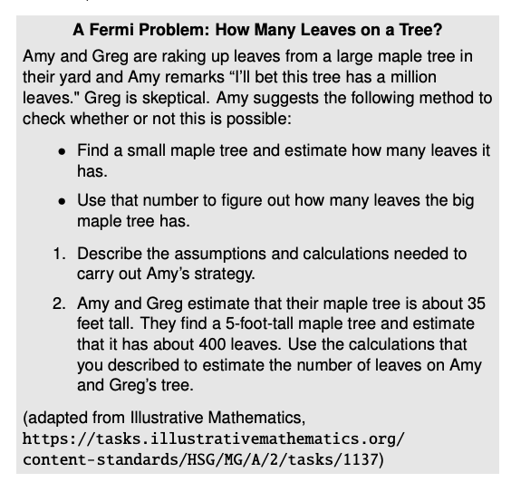
Progressions Excerpt
Any mathematical object that represents a situation from outside mathematics and can be used to solve a problem about that situation is a mathematical model. Modeling often involves making simplifying assumptions that ignore some features of the situation being modeled. If a population grows by approximately the same percentage each year, sometimes a bit above, sometimes a bit below, students might choose to fit an exponential function to the data and use it to make predictions. In geometry, in order to study how the illuminated percentage of the moon’s surface varies during a month, students might represent the moon as a rotating sphere, half black and half white. G.MG.1

Geometric modeling can be used in Fermi problems, problems which ask for rough estimates of quantities. Such problems often involved estimates of densities, as in the example in the margin. G.MG.2

Of all the subjects students learn in geometry, trigonometry may have the greatest application in college and career. Students in high school should see authentic applications of trigonometry to many different contexts (see next page). G.SRT.8

M151 Content and Practice Expectations
151.a | Engage in the modeling cycle.
151.b | Use geometric shapes, their measures, and their properties to describe objects.
151.c | Apply concepts of density based on area and volume in modeling situations.
151.d | Apply geometric methods to solve design problems.
151.e | Give an informal argument for the formulas for the circumference of a circle, area of a circle, volume of a cylinder, pyramid, and cone.
151.f | Use volume formulas for cylinders, pyramids, cones, and spheres to solve problems.
151.g | Solve real-world problems involving area, volume, and surface area of two- and three-dimensional objects composed of triangles, quadrilaterals, polygons, cubes, and right prisms.
151.h | Use the Pythagorean Theorem to solve right triangles in applied problems.

M151 Content and Practice Expectations and Indicators
Content and Practice Expectations | Indicators  Choose an artifact where you…
151.a: Engage in the modeling cycle (performance assessment). | i. engage with the full modeling cycle (problem, formulate, compute, interpret, validate, revise as necessary, report).
151.b: Use geometric shapes, their measures, and their properties to describe objects. | i. represent a context, situation, or object from outside mathematics as a mathematical object
 | ii. explain how the mathematical object(s) represent the real-life context, situation, or object
 | iii. use properties of the mathematical object to determine quantities of interest and interpret those values within the context
151. c: Apply concepts of density based on area and volume in modeling situations. | i. represent a context or situation using concepts of density based on area and/or volume
 | ii. provide insight into why the concept of density is applicable to the context or situation
 | iii. use model to compute values of interest and interpret the values in the context of the problem
151. d: Apply geometric methods to solve design problems. | i. design an object or structure to satisfy physical constraints or features of a real life context
151. d: Apply geometric methods to solve design problems. | ii. apply prior knowledge and understandings to solve the problem
151.e: Give an informal argument for the formulas for the circumference of a circle, area of a circle, volume of a cylinder, pyramid, and cone. | i. look for and make use of structure in a way that the approach lends itself to a dissection, transformation, or limit argument
 | ii. look for and express regularity in repeated reasoning in a way that the approach lends itself to a dissection, transformation, or limit argument
 | iii. give an informal justification using a dissection argument, transformation of layers, or informal limit argument
151.f: Use volume formulas for cylinders, pyramids, cones, and spheres to solve problems. | i. solve real-life and mathematical problems using volume formulas for cylinders, pyramids, cones, and spheres.
151.g: Solve real-world problems involving area, volume, and surface area of two- and three-dimensional objects composed of triangles, quadrilaterals, polygons, cubes, and right prisms. | i. analyze the context of the problem to understand the situation and choose an appropriate approach
 | ii. solve real-life problems using area, volume, and surface area of two- and/or three-dimensional objects composed of triangles, quadrilaterals, polygons, cubes, and/or right prisms
151.h: Use the Pythagorean Theorem to solve right triangles in applied problems. | i. formulate a model that describes relationships between quantities appropriate for use of the Pythagorean Theorem
 | ii. solve applied problems using the Pythagorean Theorem

Let’s Investigate
Roses for Rosa
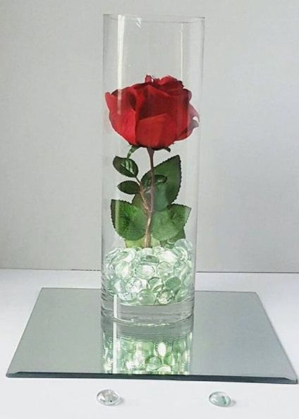
Rosa and her family are planning for her Quinceañera. Each of the 15 tables at Rosa’s reception will have a centerpiece—a cylindrical glass vase filled one-third of the way with glass marbles holding a rose in place.

- The glass vases are 10 inches tall with a 4 inch diameter.
- Rosa can choose between marbles that are 12mm or 16mm in diameter.
- The 12mm marbles cost $11.99 for 340 pieces.
- The 16mm marbles cost $11.99 for 140 pieces.
- Rosa spent $110 on the vases.
- The florist is not charging Rosa for the 15 extra roses for the centerpieces.

- If Rosa chooses 12mm marbles, how many bags will she need? How many bags will she need if she chooses 16mm marbles?
- Rosa’s budget for the centerpieces is $250. Will she be able to stay within her budget?
- The marble company also sells 8mm marbles (1100 pieces for $11.99). Would you recommend Rosa buy these marbles instead?
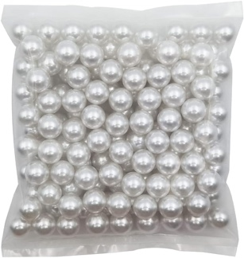
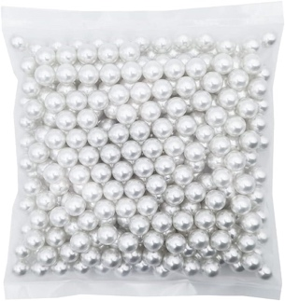

12 mm marbles 16 mm marbles
340 pieces 140 pieces
$11.99 $11.99

Source: Adapted from Illustrative Mathematics

Ready to Run Task

Setting up the learning experience:
In an open space, have students walk so that there is an inner loop or rectangle and an outer loop or rectangle. The goal of the opening is to get students to think about how the perimeter of an inside path is different from the perimeter of an outside path. Give students the tools to quantify the relationships they are exploring (measurement tools, possibly yarn if using non-rectangular walking paths).

Transition to the idea of an outdoor track:
[Find an image of a track or take students to a track if one is available and weather is good.]

What do students think about the perimeter of the different lanes of a track? Is one lane longer than the others? If so, which is the longest? Which is the shortest?

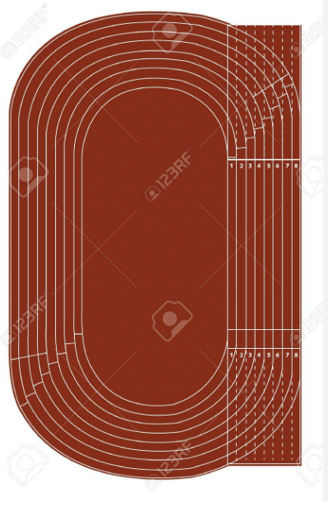

Core Task:
Create a scale model or drawing of an outdoor track. Tell what scale factor you selected to create your scale model or drawing. Label a few places on the model or drawing with both real world dimensions and scale dimensions.

- What shapes do you see that make up the track?
- What information do you need to have to create a scale model?
- How will you decide what scale factor to use?
- Based on your learning, why are the runners’ starting lines at different points but the finishing lines are all at the same point?
- Add start and finish lines to your scale drawing.
- Are there any parts of your model or drawing that you think are more or less accurate? Reflect on why those parts were more challenging to create.

Source: Adapted from Illustrative Mathematics

Let’s do some math! Round 1

Task 1: Roses for Rosa
Rosa and her family are planning for her Quinceañera. Each of the 15 tables at Rosa’s reception will have a centerpiece—a cylindrical glass vase filled one-third of the way with glass marbles holding a rose in place.

- The glass vases are 10 inches tall with a 4 inch diameter.
- Rosa can choose between marbles that are 12mm or 16mm in diameter.
- The 12mm marbles cost $11.99 for 340 pieces.
- The 16mm marbles cost $11.99 for 140 pieces.
- Rosa spent $110 on the vases.
- The florist is not charging Rosa for the 15 extra roses for the centerpieces.

- If Rosa chooses 12mm marbles, how many bags will she need? How many bags will she need if she chooses 16mm marbles?
- Rosa’s budget for the centerpieces is $250. Will she be able to stay within her budget?
- The marble company also sells 8mm marbles (1100 pieces for $11.99). Would you recommend Rosa buy these marbles instead?

12 mm marbles 16 mm marbles
340 pieces 140 pieces
$11.99 $11.99

Learning Principles
Engage with cognitively demanding tasks in heterogeneous settings (LP 1). Students should be given opportunities to grapple with multistep, non-routine tasks that promote mathematical rigor. These experiences should be differentiated so that all students engage in appropriate challenges—for example, through tasks with multiple entry points and solution pathways. These experiences should continue to integrate knowledge and skills developed in grades 6-8 at the level of sophistication of high school mathematics.

Engage in social activities (LP 2). Students should have opportunities to work independently and to communicate with one another about mathematics by engaging in collective and collaborative learning activities. Explaining and having opportunities to revise one’s thinking has excellent value in solidifying one’s knowledge.

Build conceptual understanding through reasoning (LP 3). Students should be given the opportunity to reason, justify, and problem solve with critical thinking, reading, writing, speaking, and listening. Through reasoning and work with multiple representations, students learn why procedures work and build a conceptual understanding of key mathematical ideas.

Have agency in their learning (LP 4). Students should be able to choose tasks and learning experiences that align with their interests and aspirations. All students have rich and varied experiences and home lives. Learning mathematics should bring students’ identities and interests to the fore and build on the strengths that they bring to the learning space.

View mathematics as a human endeavor across centuries (LP 5). Students should understand that mathematical ideas emanated over time from civilizations around the world and have opportunities to explore these contributions to mathematics. Students should develop an appreciation of mathematics as a human endeavor: one in which they feel a sense of belonging, where they see themselves as mathematicians, and one that offers opportunities to broaden their ideas about what mathematics is, how it is used, and who it is for.

See mathematics as relevant (LP 6). Students should engage with mathematics in ways that authentically involve real-world situations. Problem-solving contexts should allow students to perceive mathematics as a tool for addressing the questions that arise in everyday life, as well as the ways it can model our world and address global economic, social, and environmental challenges. Students should also engage with mathematics in ways that connect to academic disciplines and future careers by doing the mathematics used by artists, designers, engineers, and other professionals.

Employ technology as a tool for problem-solving and understanding (LP 7). Research indicates that technology is a powerful tool for learning deeper mathematics by improving calculation efficiency and enabling more sophisticated analysis. Students should learn to use technology, with emphasis put on widely used tools and software, such as calculators and spreadsheets, to make sense of models. Technology use should not be limited to supporting “doing mathematics,” but should also be used as a tool for displaying and communicating results to appropriate audiences.

Task 1: A Walk in the Park Student Work
Example 1:

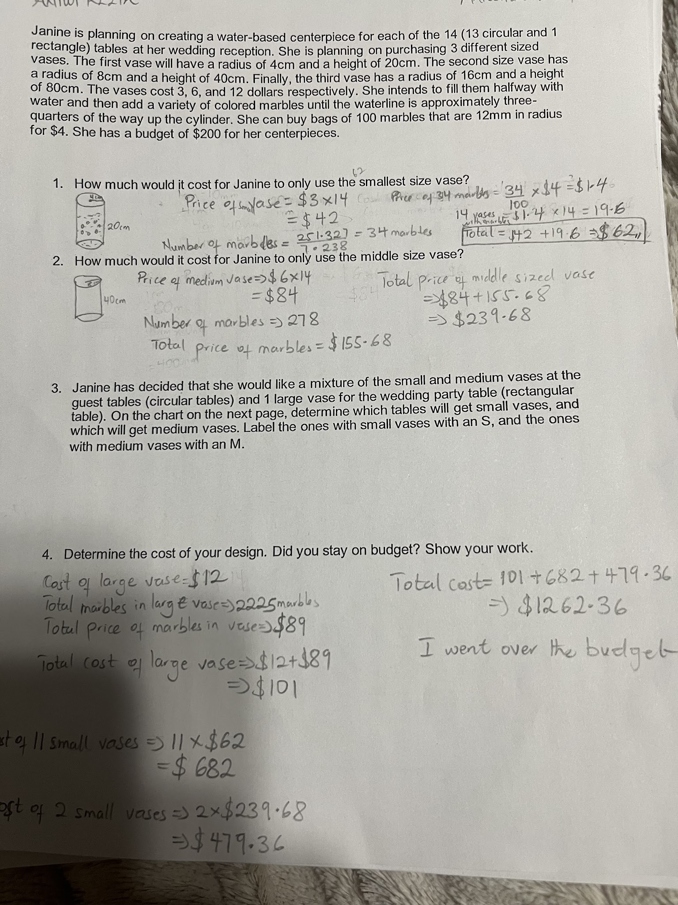

Example 2:

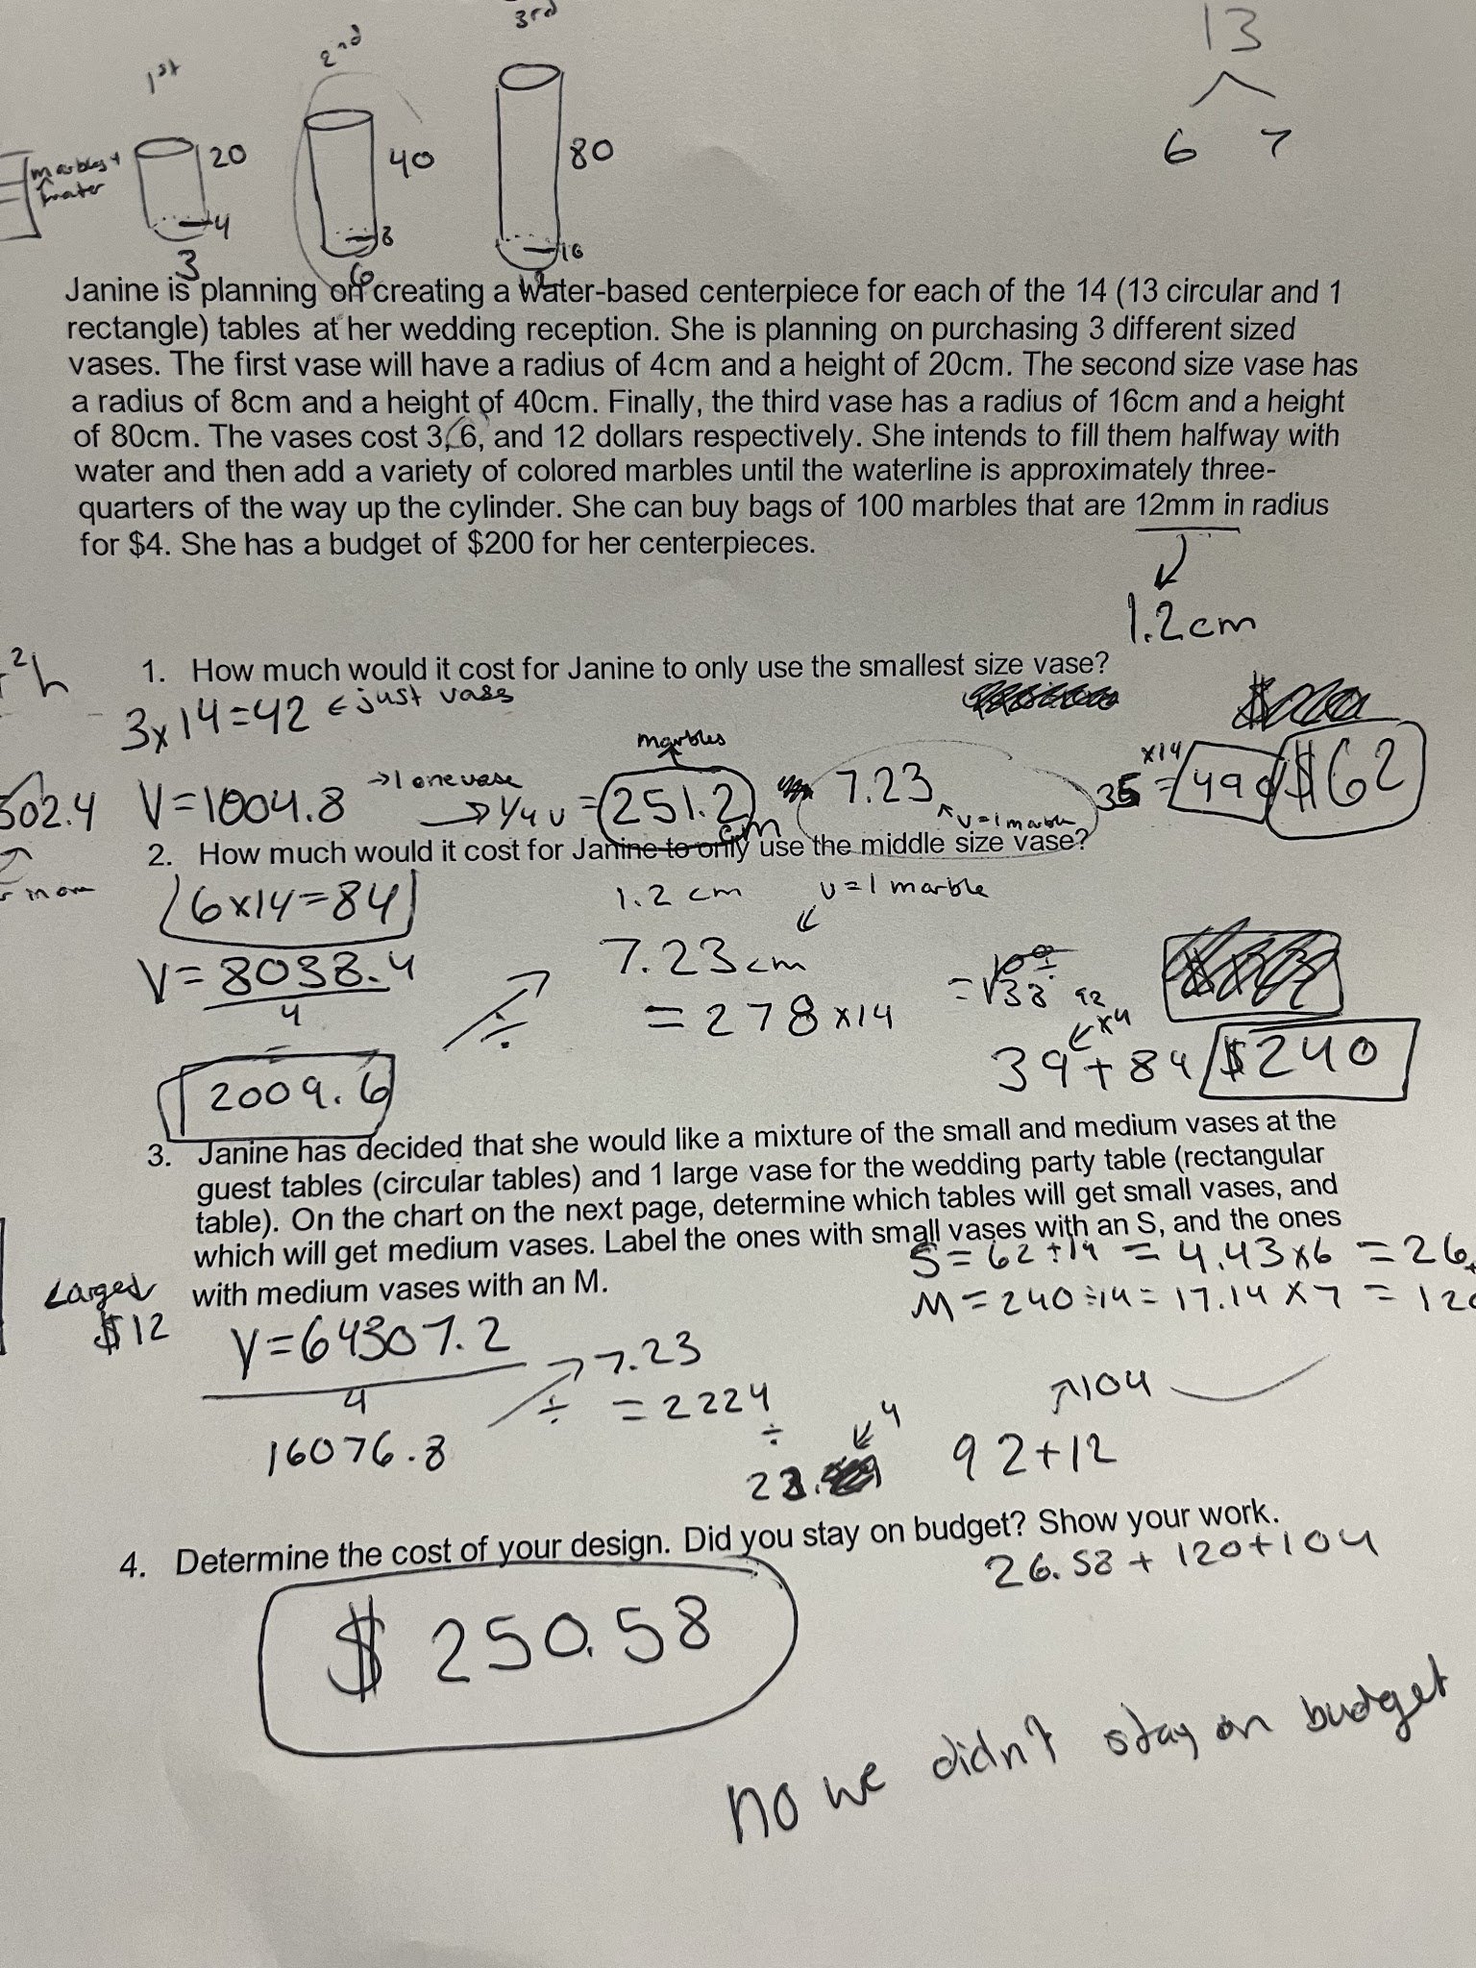

Example 3:

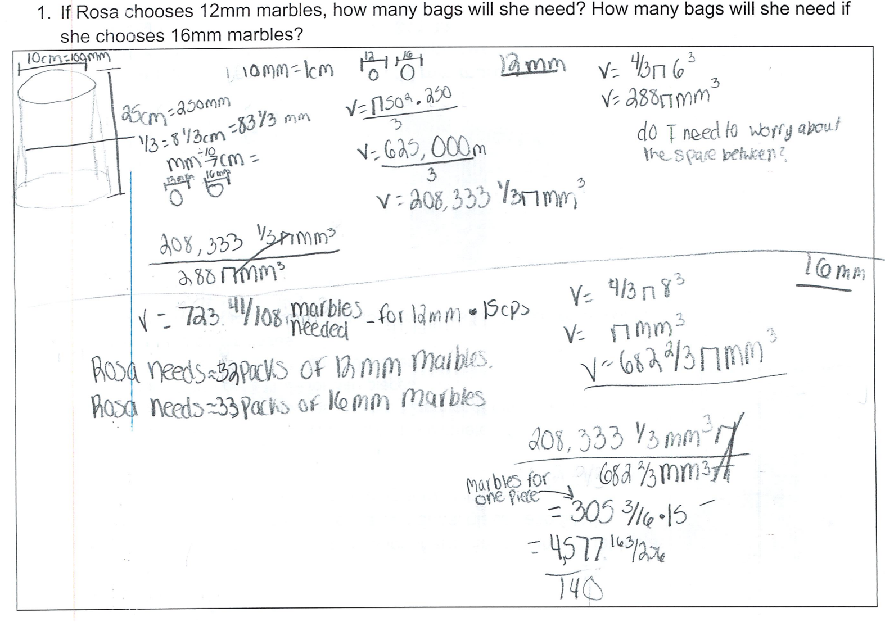

Let’s do some math! Round 2

Task 2: Design a Controller Prompt
Part 1: Design a Controller
You are a small business owner, and you will create a new controller design for your favorite gaming system. You plan to sell your controller on an online store to reach a greater market.
- Sketch a design of the controller. Consider the shapes you’ll use in your redesign: a prism, cone, pyramid, or some combination of these shapes [or any three-dimensional geometric figure you can describe.]
- Determine the dimensions. How much material will this design need?
- Explore how companies are approaching eco-friendly products. What did you learn? Why might this be important?
- What do you want to aspire to as you reflect on the design of your product? Invite students to revisit and redesign their item.
Part 2: Design a Package
Your job is to design an eco-friendly package for shipping the controller you designed.
- Explore how other products are currently packaged. How eco-friendly are the current designs? How can the current designed by improved upon? What elements in your analysis would make the packaging more eco-friendly?
- Design an eco-friendly way to package the controller you imagined in Part 1. Make note of packaging shape and dimensions.
- Draft a presentation that illustrates the design of the controller and packaging.
Within your presentation
  - prove the controller fits
  - share how your design is more eco-friendly than what is currently used
  - share the benefits and drawbacks of packaging items like your design compared to the ones we see in stores
Sample Learning Experience
Invite students to share hobbies and interests they have outside of school. In this task students have the opportunity to explore some of the decisions a small business owner and designer has to make. Part 1 of this task offers an opportunity for students to explore and design a new controller. Students may use a collection of materials, card stock, pre-designed cardboard cylinders, and paper as well as computer-aided design software to develop their controller design. Give students opportunities to research and brainstorm product designs, with at least one cycle of feedback.
Some resources for students to explore are as follows:
- Ecofriendly Shipping Supplies
- What Does Eco-Friendly Actually Mean?
- What Does Eco-Friendly Mean?
- Xbox One’s Production Cost Revealed
- 24 Eco Friendly Packaging Examples that Benefit your Brand
- 18 Creative Sustainable Packaging Design Examples
Some questions to facilitate feedback discussion are as follows:
- What do you appreciate about this approach?
- What questions does this approach surface for you?
- Do you think this design is reasonable? Why or why not?
- What can you take from this approach to apply to your own work?
If not brought up by students, consider inviting students to think about the ramifications of mass producing a design. Give students an opportunity to redesign their product based on insights gained from feedback sessions.
Part 2 of this task offers students an opportunity to explore current packaging practices and reflect on eco-friendly alternatives.
Offer students the opportunity to work in pairs or small groups to complete the task. Give the option of using chart paper, google slides or other creative outlets to showcase their work. Give students the opportunity to return to their work to revise, as necessary.

Task 2: Design a Controller Student Work
Example 1:

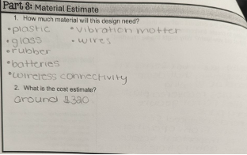
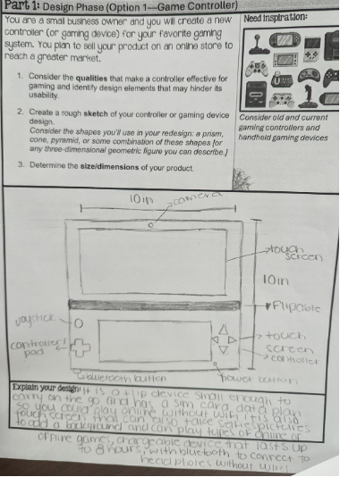

Example 2:

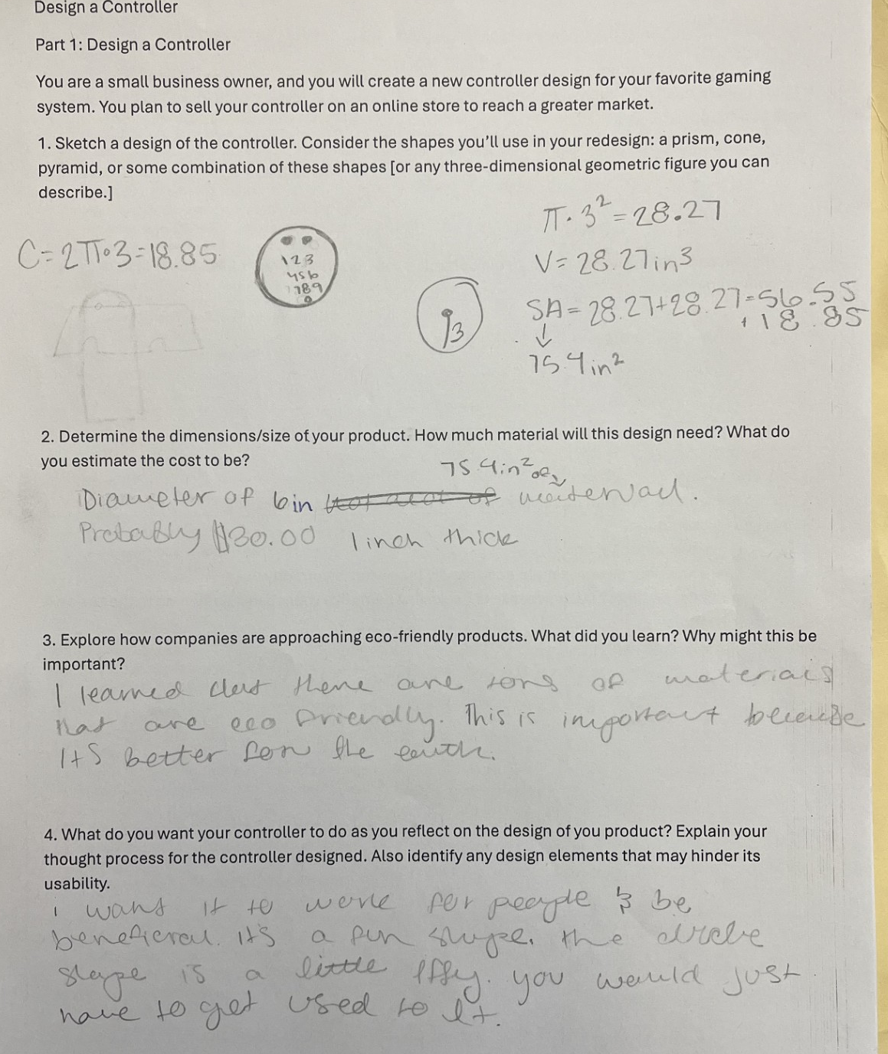

Example 3:

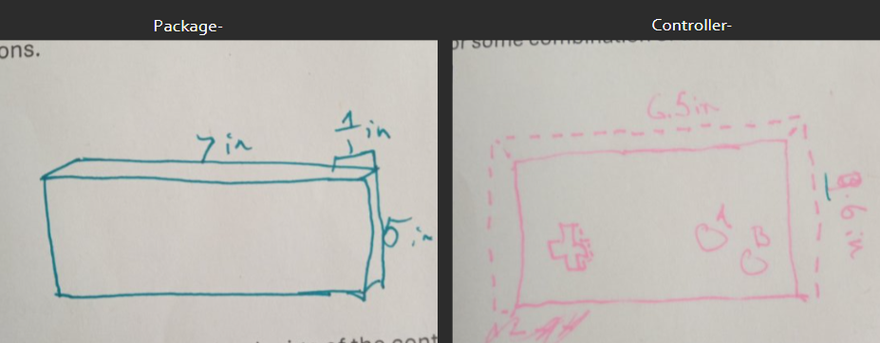

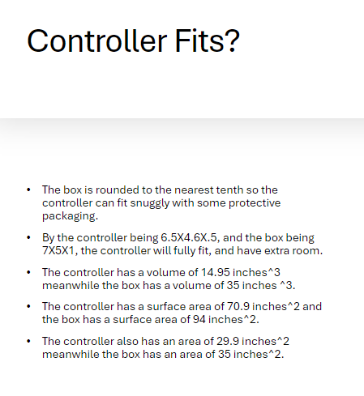

Criteria for Success

Conference and Provide Revision Support | Accept with Revision | Accept
The student’s artifact shows an emerging understanding of the expectations of the indicator(s). After conferencing and additional instruction/learning, the student may provide a revised or different artifact as evidence of the indicator(s). | The student’s artifact is approaching a full understanding of the expectations of the indicator(s). The artifact may contain execution errors that should be corrected in revision. The student may revise the selected artifact or submit a different artifact. | The student’s artifact demonstrates evidence that they have met the expectations of the indicator(s).

References

Illustrative Mathematics. “Centerpiece.” Illustrative Mathematics, Illustrative Mathematics, 4 May 2016, http://tasks.illustrativemathematics.org/content-standards/HSG/GMD/A/3/tasks/514.

Illustrative Mathematics. “Running Around a Track I.” Illustrative Mathematics, 4 May 2016, http://tasks.illustrativemathematics.org/content-standards/HSG/MG/A/tasks/1127.

