M151 Performance Task
Design a Zoo Enclosure
Modeling with Geometry
Teacher Version

Design Notes
In this task, students will design a zoo enclosure while taking into account important situational constraints such as the needs of the animal and the needs of visitors. This performance task is structured to guide students through the process of simultaneously engaging in each component of the modeling cycle while developing a scaled drawing of a zoo enclosure. Early in the process, students will select a set of animals to design for: orangutan or elephant. Students will need access to tools to aid them in constructing scaled drawings, online or otherwise. The original idea for this task was developed after looking at the Smithsonian Science Education Center’s STEMvisions Blog, "How to Design a Zoo Exhibit in Four Steps." Consider using this resource to inform your work with students or as an additional resource for students to access while working on this prompt.
Student-teacher consultations have been built in to scaffold the process. Consider using those structured check-in points as places where select student(s) share their approach/findings with the class to support the collective learning of the class. This learning experience centers around the CCSSM modeling cycle as illustrated below:
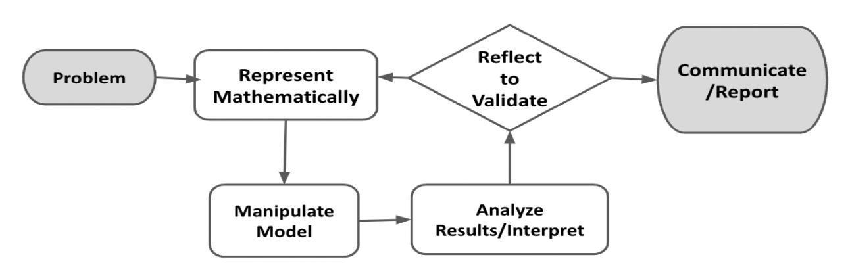
Figure 1. Diagram of Modeling Process. From “Progressions for the Common Core State Standards for Mathematics” [Draft manuscript], by Common Core Standards Writing Team, 2019, p. 6 (http://mathematicalmusings.org/wp-content/uploads/2022/05/modeling_02082019.pdf).

Connections to Learning Principles
Students will:
- design their enclosures in small groups or pairs or with ongoing feedback from peers and/or teacher (LP1 and LP2);
- deepen their understanding of how geometric shapes can be used to model real structures (LP3);
- demonstrate agency as they make decisions about which animal they will design for and what they want to include in their design (LP4);
- see mathematics as relevant and important in a real-world application, positioning them in the context of a career field that uses mathematics and providing the opportunity to design a humane space for animals in captivity (LP6); and
- have the opportunity to use Google Draw, which is a chance to use technology as a tool for better visualization and understanding (LP7).

The following pages provide teacher versions of this task with guidance, suggestions, and comments in red and sample student responses in blue italics.

There are two versions of this task. Students can choose whether to design a zoo enclosure for orangutans or one for elephants. Once they have made their selections, provide them with a student copy of the task for the animal they have chosen. Teacher versions are available for both tasks. Total time students will need for this task will vary, but in trials this took an average of three traditional-length class periods to complete.
[The Introduction, Launch, and Problem sections are the same for both versions of the task.]

Student Task

The Modeling Cycle
Designing a zoo requires creating a space that meets the needs of the animals as well as the needs of the visitors. For example, a space must be created that replicates the key features of an animal’s natural habitat while simultaneously ensuring the safety of visitors and giving visitors the ability to observe the animals in that space. In this task, you will design an enclosure for an animal and produce a scale drawing of the enclosure you’ve designed.
Mathematical models are used to make sense of ideas and phenomena in our world. As illustrated in the image below, the modeling cycle is a process of identifying a problem, creating models, analyzing the story told by those models, and reporting the results to the appropriate audience. In this task, you will be engaging with the mathematical modeling cycle to design an animal enclosure for a zoo given several real-world constraints.
Figure 1. Diagram of Modeling Process. From “Progressions for the Common Core State Standards for Mathematics” [Draft manuscript], by Common Core Standards Writing Team, 2019, p. 6 (http://mathematicalmusings.org/wp-content/uploads/2022/05/modeling_02082019.pdf).

Designing a Zoo Enclosure
Launch
You are a zoo architect, and you and your team have been commissioned to design some of the zoo enclosures for the new San Diego Zoo satellite location. This is a huge project, and several animals need homes!
In this task, you will explore zoo enclosures and design your own while taking into account important design guidelines to ensure the animal will be healthy and the enclosure will stay within the spatial constraints and budget. You will use graph paper or Google Draw to model what you think is the best enclosure for your chosen animal and report on the enclosure’s specifications. Have fun!

QUESTION 1
 | What are some of the things you need to consider when designing your enclosure? Brainstorm with your group.
Answers will vary. Possible student responses:
- Size of animals, number of animals, cost constraints.
- What is the natural habitat of the animal, and can you simulate it?
- Protection from weather and visitors.
- Visibility for visitors; visitor and animal safety.
- How to feed the animals safely?
After sharing the Launch statement with students, consider giving students a few minutes of individual think time to generate responses.
Consider offering students various ways to share their thoughts with the class: pair-share, chart, or whole group.

QUESTION 2
How do architects use math and geometry to design enclosures, buildings, and other structures?
Answers will vary. Possible student responses:
- Determining how much space to use and what the space will look like.
- Building the enclosure.
- Determining the costs.
- Deciding how to make it easy to see the animals and how to keep the animals inside.
- Drawing plans to scale.
The rationale for this question is to give students an opportunity to make connections between the work of zoo designers and mathematics.
Ideas that surface here can help set the stage for the work students will do in designing an enclosure to meet given conditions. Math concepts and skills students will engage in are as follows: area, ratios, estimating, and strategically partitioning.
Students new to the concept/practice may find an introduction to/preliminary practice with drawing to scale beneficial in helping them with this task.

Designing a Zoo Enclosure - Orangutan Version
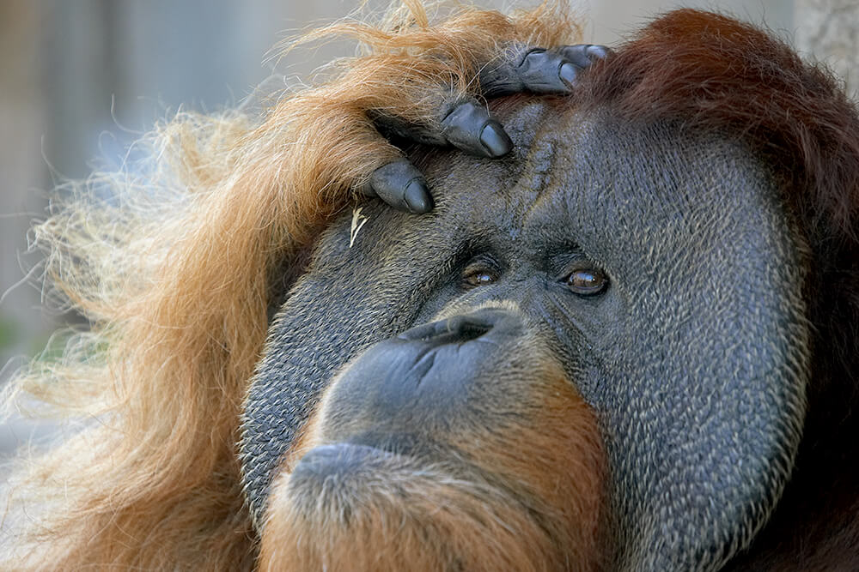
Orangutan Background Details → Jump to Elephant Version
Orangutans are clever animals who live most of their lives in trees. In the San Diego Zoo, Ken Allen was a Bronean orangutan who escaped multiple times during his long life there by unscrewing bolts, reaching around to unlatch locks, and climbing over walls. So your design has to account for some orangutans’ wiley escape tactics!
Your Task: There are two types of animals the San Diego Zoo needs to build enclosures for: orangutans and elephants. You have chosen to design enclosures for orangutans. In this task, you will create a scale drawing of an enclosure for the animal you selected.

In Part 1, the Formulate and Represent Mathematically sections, you will develop a scaled drawing of an enclosure to meet the constraints for designing a space for orangutans. The Formulate and Represent Mathematically (Part 1) Checklist can be used to ensure you have the necessary components before moving on to the remaining parts of the task.

Formulate (Part 1)
ACTION 1
Determine the outer perimeter boundary walls for your enclosure. Consider drafting a sketch of what this might look like before creating a scaled drawing.
What are boundary walls?
These are walls that separate the animal from the rest of the zoo and the visitors.
These are walls that establish the total amount of living space the animal has.
These are walls that are secured into the ground.
Note: You are welcome to use additional paper or digital forms to document your work. Be sure to include all of your work in your final submission.

Represent Mathematically (Part 1)
ACTION 2
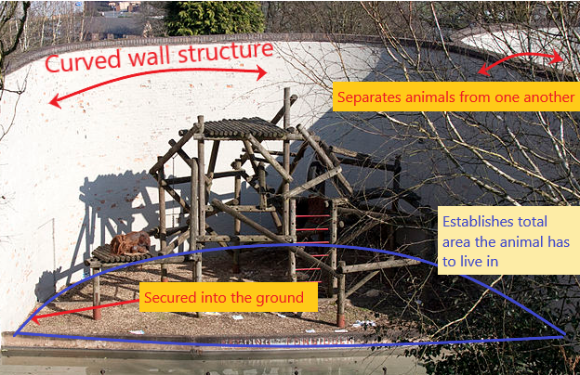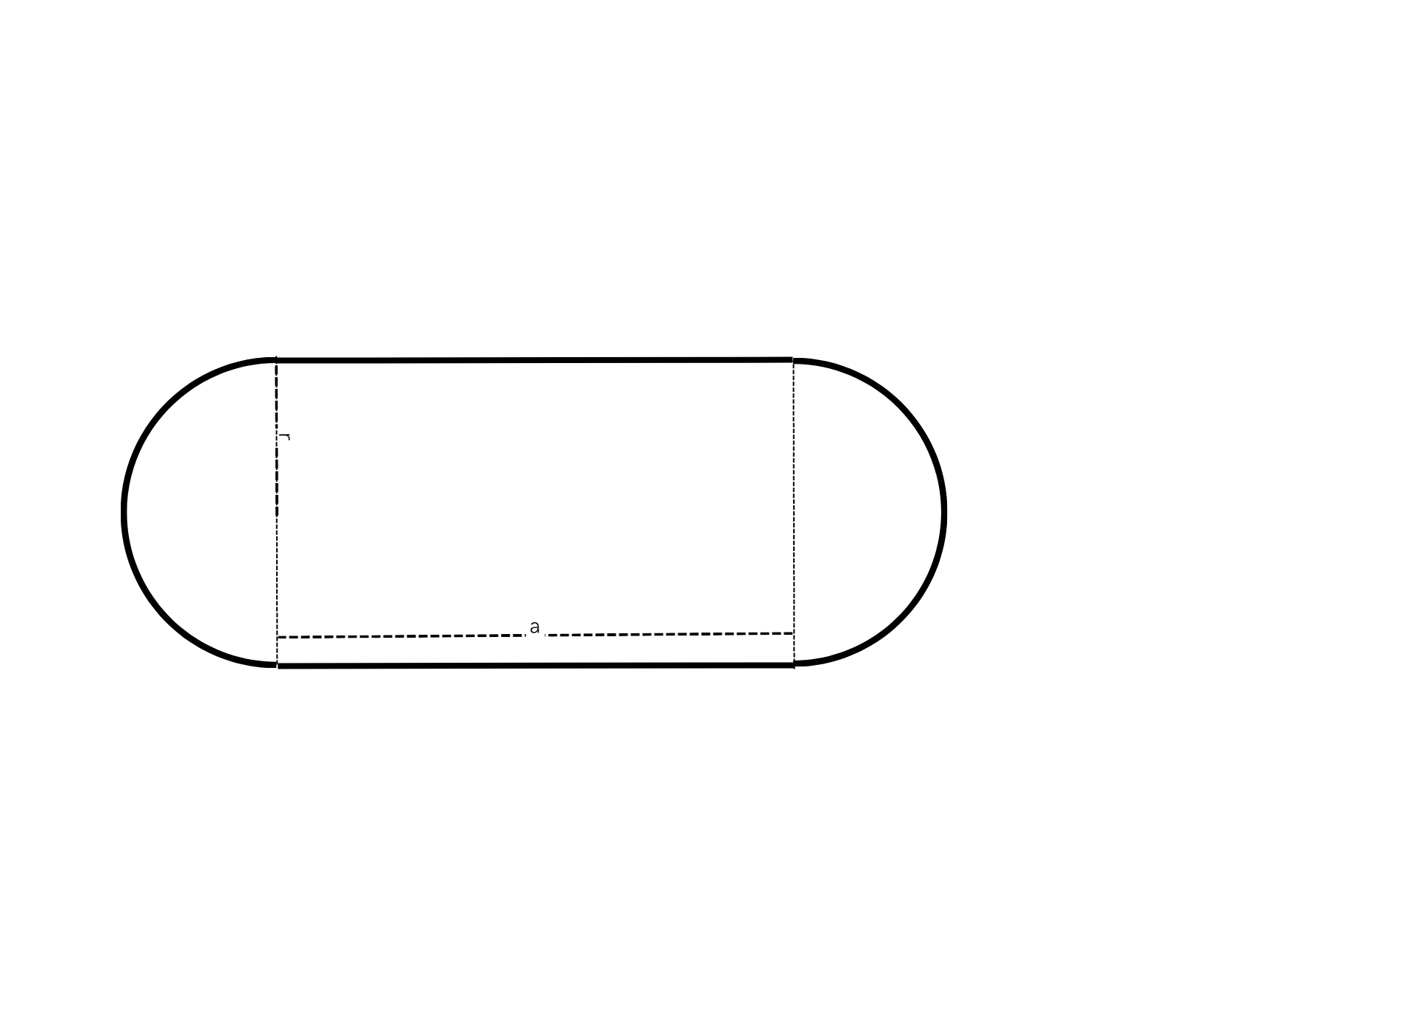
Design Constraints
We are going to model after the Chester Zoo in the UK and give the orangutans at least 3200 but no more than 4500 square meters of space (budget constraints). Assume a flat, level ground for the build.

Perimeter boundary walls need to avoid 90-degree angles with all other perimeter boundary walls to lower the chance of escape. As you draw your perimeter boundary, avoid creating right angles. Consider using ellipses, circles, and composite shapes which are two or more shapes together (like the shape of a track or pill, which is a rectangle and two semicircles). Internal boundaries can be any angle—just the perimeter boundary walls need to have NO 90-degree angles.
Use a piece of graph paper or Google Draw to create a two-dimensional scale drawing of the boundary of your enclosure.
- Include:
  - a key that shows the scale for your drawing; and
  - calculations showing that the area is within the guidelines (3200-4500 m²).
- When you finish Part 1 of your design, use the checklist below to ensure you have all the requirements.

Formulate and Represent Mathematically (Part 1) Checklist
Requirement | Teacher Notes
Perimeter boundary walls are curved and avoid right angles. | (Teachers, please add your notes here.)
A key showing the scale is included. | (Teachers, please add your notes here.)
Calculations are included to show that the design is between 3200-4500 square meters of area. | (Teachers, please add your notes here.)
(Teachers, please add your notes here.)

Formulate (Part 2)
ACTION 3
There must be at least four separate units within the enclosure because females and the young orangutans need to be separated from adult males. Discuss or provide a draft of your design that meets this need.

Note: You are welcome to use additional paper or digital forms to document your work. Be sure to include all of your work in your final submission.

Represent Mathematically (Part 2)
ACTION 4
Additional Design Constraints

Each adult male needs to be completely isolated from any other adult male, and they should never interact. There will be two adult male orangutans. Each male adult should have at least 700 square meters of outdoor space. Label each of these spaces “Single Male Unit.”
Females and young need at least 1000 square meters for their group (they all live together). Label that unit “Females and Young Unit.”
There needs to be an indoor space. The indoor space needs to have an area of 400-450 square meters. This is where orangutans can avoid bad weather and get relief from the sun and human visitors coming to see them. Add at least one indoor space within the boundary and label it “Indoor Unit” on your drawing.
With these design constraints in mind, add to your graph paper or Google drawing and create at least four units in the enclosure boundaries. Include calculations showing that each unit area is within the guidelines above.
When you finish Part 2 of your design, use the checklist below to ensure you have all the requirements.

Formulate and Represent Mathematically (Part 2) Checklist
Requirement | Teacher Notes
There are at least four separate units within the perimeter boundary, and each unit has a label. | (Teachers, please add your notes here.)
Each of the two Single Male Units has an area of at least 700 square meters, and calculations of the areas are included. | (Teachers, please add your notes here.)
The outdoor Females and Young Unit has a total area of at least 1000 square meters, and calculations of the area are included. | (Teachers, please add your notes here.)
The indoor unit has a total area of 400-450 square meters, and calculations of the area are included. | (Teachers, please add your notes here.)
(Teachers, please add your notes here.)

Formulate (Part 3)
ACTION 5
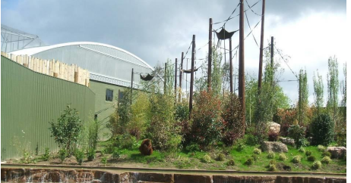
Consider adding environmental elements such as trees, rocks, water sources, climbing structures, or anything else you think of that would provide a good environment for orangutans.
As you add these features, consider how the exhibit enhances the visitor experience.

Represent Mathematically (Part 3)
ACTION 6
Imagine what those environmental elements and features would look like from above as your sketch is two-dimensional.
Add these elements to your blueprint design.
When you finish Part 3 of your design, use the checklist below to ensure you have all the requirements.

Formulate and Represent Mathematically (Part 3) Checklist
Requirement | Teacher Notes
Environmental elements have been intentionally added and placed to enhance the animal experience depicted on the scale drawing. | (Teachers, please add your notes here.)
Environmental elements have been intentionally added and placed to enhance the visitor experience. | (Teachers, please add your notes here.)
(Teachers, please add your notes here.)

Validate and Report
ACTION 7
Create a presentation of your design for the orangutan enclosure for the zoo’s board of directors for approval (using a slideshow, poster, video, and/or report). Use your blueprint and supporting computations to show the estimated space needed in your presentation.
Make sure to address:
- mathematical evidence that orangutans will have at least 3200 square meters but no more than 4500 square meters of living-space area;
- appropriate-sized indoor unit that has between 400-450 square meters of area (back up your claim with mathematical evidence);
- any potential design concerns you have with your model (e.g., escape potential, birth and new offspring accommodations);
- ways in which you have enhanced the environment with water features, ropes, plants, etc., for the animals; and
- ways in which you have enhanced the environment for the visitors (visibility, safety, etc.).

Validate and Report Checklist
Requirement | Teacher Notes
A rationale has been provided showcasing that required constraints have been met and that additional features enhance both the animal and visitor experience. | (Teachers, please add your notes here.)
The results are clearly communicated in a way that is appropriate for the intended audience. | (Teachers, please add your notes here.)
(Teachers, please add your notes here.)

Student Task

Designing a Zoo Enclosure - Elephant Version
Elephant Background Details → Jump to Orangutan Version
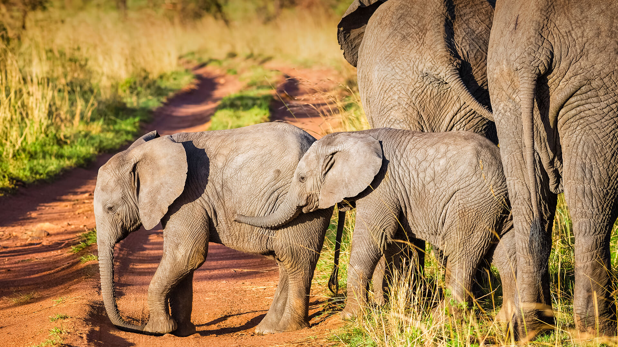
Elephants are massive animals that live in herds with female matriarchs. In the San Diego Zoo, they enjoy swimming pools and mud wallows to help keep them cool, so including water areas is going to be crucial in your design!
Your Task: There are two types of animals the San Diego Zoo needs to build enclosures for: orangutans and elephants. You have chosen to design enclosures for elephants. In this task, you will create a scale drawing of an enclosure for the animal you selected.

In Part 1, the Formulate and Represent Mathematically sections, you will develop a scaled drawing of an enclosure to meet the constraints for designing a space for elephants. The Formulate and Represent Mathematically (Part 1) Checklist can be used to ensure you have the necessary components before moving on to the remaining parts of the task.

Formulate (Part 1)
QUESTION 1
Determine the outer perimeter boundary walls for your enclosure. Consider drafting a sketch of what this might look like before creating a scaled drawing.
What are boundary walls?
These are walls that separate the animal from the rest of the zoo and the visitors.
These are walls that establish the total amount of living space the animal has.
These are walls that are secured into the ground.
Note: You are welcome to use additional paper or digital forms to document your work. Be sure to include all of your work in your final submission.

Represent Mathematically (Part 1)
QUESTION 2
Design Constraints
The zoo is planning for two male and four female elephants. Zoologists have advised you that the elephants must have at least 3000 square meters of space to avoid crowding and conflict.
The zoo architect has notified you that the maximum amount of space they can offer for this enclosure is 6000 square meters.
Use a piece of graph paper or Google Draw to create a two-dimensional scale drawing of the boundary of your enclosure.
- Include:
  - a key that shows the scale for your drawing; and
  - calculations showing that the area is within the guidelines (3000-6000 m²).
- When you finish Part 1 of your design, use the checklist below to ensure you have all the requirements.

Formulate and Represent Mathematically (Part 1) Checklist
Requirement | Teacher Notes
A key showing the scale is included. | (Teachers, please add your notes here.)
Calculations are included to show that the design is between 3000-6000 square meters of area. | (Teachers, please add your notes here.)
(Teachers, please add your notes here.)

Formulate (Part 2)
QUESTION 3
All zoos with a breeding herd of elephants must have at least three separate units as part of their enclosure. Discuss or provide a draft of your design that meets this need.

Note: You are welcome to use additional paper or digital forms to document your work. Be sure to include all of your work in your final submission.

Represent Mathematically (Part 2)
QUESTION 4
Additional Design Constraints

There must be an outdoor unit for all bachelor males that should be at least 500 square meters. Label this unit “Bachelor Pad.”
There must be an outdoor unit for adult females and babies that should be at least 2000 square meters. Label this unit “Mothers and Babies.”
There must be an indoor unit that should be at least 300 square meters for each group of four or fewer elephants. For each additional elephant, increase the space by 80 square meters. Label this unit “Indoor Unit.” As a reminder, the zoo is planning for two male and four female elephants.
With these design constraints in mind, add to your graph paper or Google drawing and create at least three units in the enclosure boundaries. Include calculations showing that each unit area is within the guidelines above.
When you finish Part 2 of your design, use the checklist below to ensure you have all the requirements.

Formulate and Represent Mathematically (Part 2) Checklist
Requirement | Teacher Notes
There are at least three separate units within the perimeter boundary, and each unit has a label. | (Teachers, please add your notes here.)
The Bachelor Pad Unit has a total area of at least 500 square meters, and calculations of the area of the unit are included. | (Teachers, please add your notes here.)
The outdoor Mothers and Babies Unit has a total area of at least 2000 square meters, and calculations of the area of the unit are included. | (Teachers, please add your notes here.)
The indoor unit has an appropriately sized area, and calculations of the area of the unit are included. | (Teachers, please add your notes here.)
(Teachers, please add your notes here.)

Formulate (Part 3)
QUESTION 5
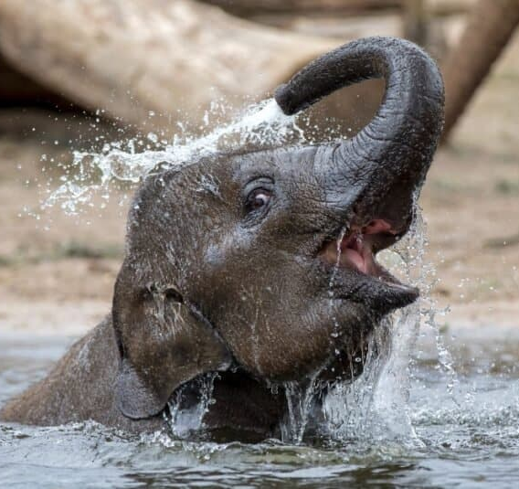
Consider adding environmental elements such as trees, rocks, water sources, or anything else you think of that would provide a good environment for elephants.
As you add these features, consider how the exhibit enhances the visitor experience.

Represent Mathematically (Part 3)
QUESTION 6
Consider what these additional design features would look like from above since your sketch is two-dimensional.
Additional Design Constraints

Enclosures should have multiple water features. Using circles or ellipses, draw a pool in every outdoor area. Make the area of the pool at least 20 square meters.
Include large rocks or trees to help elephants to hide from or get away from other members of the herd when needed.
Add these elements to your blueprint design.
When you finish Part 3 of your design, use the checklist below to ensure you have all the requirements.

Formulate and Represent Mathematically (Part 3) Checklist
Requirement | Teacher Notes
Environmental elements have been intentionally added and placed to enhance the animal experience depicted on the scale drawing. | (Teachers, please add your notes here.)
Environmental elements have been intentionally added and placed to enhance the visitor experience. | (Teachers, please add your notes here.)
(Teachers, please add your notes here.)

Validate and Report
QUESTION 7
Create a presentation of your design for the elephant enclosure for the zoo’s board of directors for approval (using a slideshow, poster, video, and/or report). Use your blueprint and supporting computations to show the estimated space needed in your presentation.
Make sure to address:
- mathematical evidence that the elephants will have at least 3000 square meters but no more than 6000 square meters of living-space area;
- appropriate-sized indoor unit and outdoor units (back up claim with mathematical evidence);
- any potential design concerns you have with your model (e.g., escape potential, birth and new offspring accommodations);
- ways in which you have enhanced the environment with water features, rocks, plants, etc., for the animals; and
- ways in which you have enhanced the environment for the visitors (visibility, safety, etc.).

Validate and Report (Part 3) Checklist
Requirement | Teacher Notes
A rationale has been provided showcasing that required constraints have been met and that additional features enhance both the animal and visitor experience. | (Teachers, please add your notes here.)
The results are clearly communicated in a way that is appropriate for the intended audience. | (Teachers, please add your notes here.)
(Teachers, please add your notes here.)

References
EAZA Elephant Taxon Advisory Group. (2020). EAZA best practice guidelines for elephants. European Association of Zoos and Aquaria. https://www.eaza.net/assets/Uploads/CCC/BPG-2020/Elephant-TAG-BPG-2020.pdf
Great Ape Taxon Advisory Group. (2018, July 31). Orang utan EEP best practice guidelines. European Association of Zoos and Aquaria. https://www.eaza.net/assets/Uploads/CCC/OU-EEP-Best-Practice-Guidelines-final.pdf
Hisgett, T. (2011, March 8). Part of the Orangutan enclosure at Dudley Zoo, West Midlands, England [Photograph]. Wikipedia. https://en.wikipedia.org/wiki/File:Dudley_Zoo,_West_Midlands,_England_-Orangutan_enclosure-8March2011.jpg
San Diego Zoo Wildlife Alliance: Animals & Plants. (n.d.). Elephant. San Diego Zoo. Retrieved February 14, 2023, from https://animals.sandiegozoo.org/animals/elephant
San Diego Zoo Wildlife Alliance: Animals & Plants. (n.d.). Orangutan. San Diego Zoo. Retrieved February 14, 2023, from https://animals.sandiegozoo.org/animals/orangutan
Smithsonian Science Education Center. (2018, July 9). How to design a zoo exhibit in four steps. STEMvisions Blog. https://ssec.si.edu/stemvisions-blog/how-design-zoo-exhibit-four-steps

