Example 1: When Math Gives You Lemons …

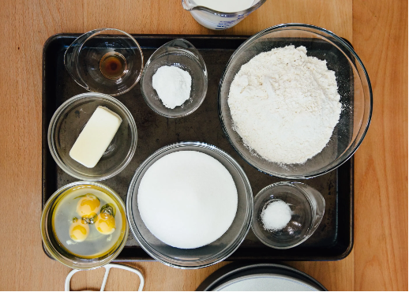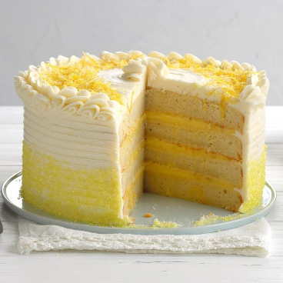

What experience do you have with baking?

Are there recipes you feel a connection to or simply love to make?

What are some things you should consider when preparing to cook or bake?

If needed, feel free to use your digital resources to explore baking tips.

Read the task below and answer the corresponding prompts. Be prepared to explain the meaning of the numbers and any other relevant quantities used in your model.

Ayhan found his great grandmother’s recipe for lemon cake. He mixed all the ingredients together in his 3-quart mixing bowl and noticed the batter almost filled up the bowl.
Now he has to determine which baking pan to use. He has a set of pans that include the following:
● A loaf pan that measures 8.5 inches by 4.5 inches by 2.5 inches
● A square pan that measures 8 inches by 8 inches by 2 inches
● An oblong pan that measures 13 inches by 9 inches by 1.75 inches

Which pan(s) should he use?

Consider the following questions:
● What’s promising about your approach?
● What additional questions does your approach bring up for you?
● Do you think your own approach is reasonable? Why or why not?

Extension
● Engage with a peer. What’s promising about their approach?
● What additional questions does your peer’s approach bring up for you?
● What do you notice about your own thinking and the thinking of your peer?

Example 2: M100 Designing a Fitness App

Your school is sponsoring a walk-a-thon to raise funds for a new computer lab. You have been asked to work with an app developer to create a new fitness app for participants to use before, during, and after the walk-a-thon.

The app developer needs you to complete the following tasks before the actual programming for the app can begin.
- Draft a flowchart^{[1]} which outlines how a fitness app will work for the walk-a-thon.
- Design a table which organizes key quantities of interest for a walk-a-thon participant using your favorite tech tool.
- Finalize a flowchart with all the features the app should include.

Part A: Let’s make sense of the task.
● What things do you think people do to prepare for a walk-a-thon?
● What kinds of questions do you think people will want the app to be able to answer?
● What kinds of information will you need to answer these questions?
● What measurable quantities do you think the app should be able to capture and record?
● What are the mathematical relationships between the various quantities you’ve identified and the questions folks might have?
● What additional factors do you think need to be considered when creating an app that helps folks prepare for this walk-a-thon?

Part B: Explore existing fitness apps and draft the flow of your new app.
● Take some time to learn more about popular fitness apps currently available. Try out free apps [https://www.garagegymreviews.com/best-free-workout-apps ] or interview people you know who use fitness apps to learn more about this product.
○ What new understandings do you have about how these apps function?
○ What quantities do you see displayed for the user?
○ How are relationships between quantities used to provide information that is useful to the user?
○ What new understandings about the relationships between the quantities identified in Part A do you have?

● Based on your current understanding of apps, preparing for physical activity, the quantities you identified, and the relationships between those quantities, what kind of information do you think would be helpful to capture and record?
● Create a draft of a flowchart which shows the steps of how the app you envision would work.

Part C: Design a table and a second draft of your app flowchart.
● Use spreadsheets or other tech tools to design a table or program that could be used within your app to capture information from the user to produce quantities of interest. Describe the mathematical relationships your table is designed to use.
● Test out your table or program with people you know. What new insights do you have?

Part D: Reflect and revise.
● What worked well about the table or program you designed? What did not? How would you modify what you have? Create a sample screenshot of how you envision this aspect of your app to work. Describe the mathematical relationships in play. What are the limitations of the model you designed? What ideas for future development do you recommend?

● Revisit the flowchart you drafted earlier in the process. What modifications would you make? Make a third draft of the flow of your app.

● What surprised you about this process?

Extending the Learning (Optional)
- Explore the work of software engineers, architects, and developers.[Principal Software Engineer vs Architect vs Developer | NCube ]What elements of what you accomplished fit under each of these roles? What new insights do you have about this field?
- One approach to app development is to build apps that have a wide range of applications. Having the ability to reuse core aspects of a program for different functions gives programs the ability to increase their earning potential. Consider the following group of possible participants. What would you add or modify to your app to make this something every person could continue to use beyond the walk-a-thon event?

Name | Age  (years) | Height  (feet) | Weight (lbs.) | Activities | Workout 1 | Workout 2 | Workout 3
Nico | 15 | 5’10” | 120 | Cross country running, track and field | 5k run  18:36 min. | 5k run  20:01 min. | 5k run  17:46 min.
Raj | 44 | 6’0” | 175 | Tennis, swim | Tennis  2 hrs. | Tennis  2 hrs. | Tennis  2 hrs.
Maura | 51 | 5’4” | 140 | Walking, dancing | Walk  30 min. | Dance  1 hr. | Walk  40 min.

^{[1]} A flowchart is a picture of the separate steps of a process in sequential order. It is a generic tool that can be adapted for a wide variety of purposes, and can be used to describe various processes, such as a manufacturing process or a project plan.

Example 3: Care to Compost

The United States Environmental Protection Agency (EPA) “estimates that more food reaches landfills and incinerators than any other single material in our everyday trash, constituting 24 percent of the amount landfilled and 22 percent of the amount combusted with energy recovery.” [source: Regional Resources to Reduce and Divert Wasted Food Across the United States | US EPA ]

A study completed by The Drawdown Review: Climate Solutions for a New Decade shared “composting organic waste versus landfilling can reduce more than 50% of carbon dioxide-equivalent greenhouse gas emissions, for a total of 2.1 gigatons between now (2020) and 2050 if climate change is curbed to a 2 degree Celsius rise in the average global temperature.” [source: The ComPOSTer: How much can composting help in solving the climate challenge? [UPDATED] ]

How do you organize your waste at home? Prepare to share with your classmates.

Watch this video on landfills and waste to understand how our waste accumulates and what challenges exist.
https://thinktv.pbslearningmedia.org/resource/930d15c4-5137-46f3-a9d8-39b8cd8d27f9/930d15c4-5137-46f3-a9d8-39b8cd8d27f9/

We have learned about challenges and solutions with food waste from the New Jersey and Seattle examples. Let’s now consider food waste in your community.

Search for articles and videos on food waste from where you live. Find and record important data about food waste management (or waste management in general) and the resulting costs, monetary and otherwise.

● What resonates with you?
● What questions do you have now?
● What information is helpful to design your Public Service Announcement (PSA)?
● How can you persuade community members to take your advice?

Develop a public service announcement (PSA) in the form of an infographic or advertisement (suitable for radio, social media, or television) to inform your community about ways they can help minimize the amount of food and organic waste that goes into landfills.

Your PSA should include information that informs your community about:
● waste trends in your local area
● the long-term impact of current trends
● ways to change current trends for positive impact

Your PSA should:
● identify relevant quantities
● use appropriate graphical displays of these quantities

Additional Resources

Part 1: Making sense of waste management
- Wasted Food Programs and Resources Across the United States | US EPA
- National Overview: Facts and Figures on Materials, Wastes and Recycling | US EPA
- The ComPOSTer: How much can composting help in solving the climate challenge? [UPDATED]

Part 2: Making sense of infographics
- Food Waste — Information is Beautiful
- Consumers | USDA
Part 3: Making sense of composting efforts
- Composting efforts gain traction across the United States - The Washington Post
- Beginner's Guide to Composting | One Small Step | NowThis
- Composting for Beginners | The Dirt | Better Homes & Gardens
- 6 Different Ways To Compost, No Matter Where You Live
- Why is composting so hard in the United States? | Greenbiz
- https://achievethecore.org/content/upload/Modeling-Task_Landfill_Final_2_6_20.pdf

