Name: Teacher:


M151B Performance Task
Small-Scale Home Design
The Modeling Cycle
Shelter is considered a basic human need. In this task, you will consider the relationship between basic human needs and housing design. You will apply geometric principles to design, evaluate, and report your findings. While you work through this task, keep in mind that your report at the end will be a presentation, article, or short video in which you pitch your findings as a solution to potential investors. Gather ideas as you work to help inform how you decide to present your findings.
Mathematical models are used to make sense of ideas and phenomena in our world. As illustrated in the image below, the modeling cycle is a process of collecting data about an idea or problem, creating models of that data, analyzing the story told by those models, and reporting the results to the appropriate audience.

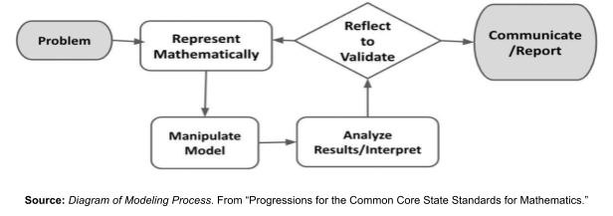
In this task, you will be engaging with this mathematical modeling cycle to help solve issues of housing insecurity. You will use the models and your takeaways from this task to create a presentation, article, short video, or other creative product to persuade city investors of a potential solution for housing insecurity. Your product will provide an explanation that is supported by evidence as well as visual renderings of your ideas and a discussion of their applicability in helping solve the problem.

What does a person need to survive? How much space do they need? What makes a shelter adequate to meet these needs? What happens when resources are not available to help meet these human needs? Consider a person’s physical, psychological, and socio-cultural needs, and then respond to the questions below.

QUESTION 1
 | What items does a home need to be livable for 1 person? Create a list.

What do you think is the smallest space that is livable?
QUESTION 2

Problem and Formulate
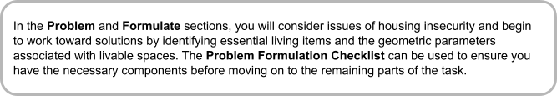
Problem

QUESTION 3
Use online search engines to help you summarize the following information:
- What is housing insecurity?
- What percent of people experience housing insecurity?
- How could small homes provide a potential solution for housing insecurity?

Formulate

QUESTION 4
Refer back to your response to Question 1. Decide whether to add or remove any items from your original list and make those changes in Question 1. Remember you are designing this for 1 person. Then answer these questions:
- Explain why you added and/or removed any items from your list.
- Add your final items, their approximate dimensions (with units), and any notes in the table below.

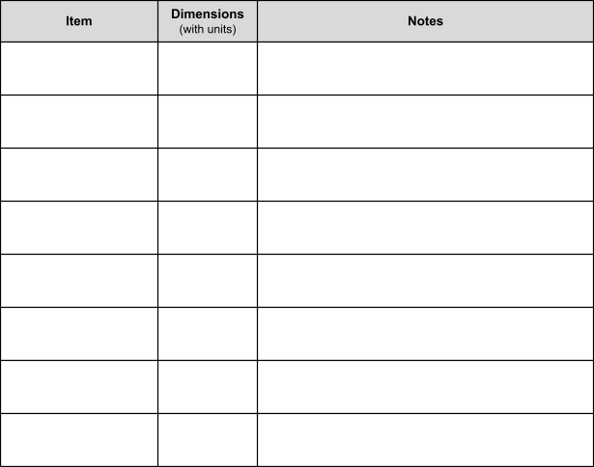

QUESTION 5
What rooms would you require in a house for the items on your final list? What other considerations are there for figuring out how big each room needs to be?

Problem Formulation Checklist
Requirement | Fulfilled?
I can define housing insecurity and identify the percent of people experiencing it. | ▢
I have hypothesized how small homes could provide a potential solution for housing insecurity. | ▢
I have evaluated my original list of housing items and refined it accordingly. | ▢
I have determined the dimensions of essential living items and identified the necessary rooms and required space for a livable area that contains these items. | ▢
Teacher Consultation:

Model
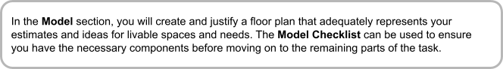

ACTION 1
 | A floor plan is a scale drawing that shows the different rooms in a home.  Using your work from Question 4, create a scale floor plan showing how you would structure the rooms within a small home. Assume 1 person living in the space.  - Show the dimensions of each room in your drawing.  - Show how the items would fit into the space you design.  - Label each item or use drawings that clearly show what the items are.  Here are some ideas to help with this task:  - Use graph paper, pencils, and rulers  - https://www.smartdraw.com/  - GeoGebra  - Any other helpful online floor plan creator platform you can find!  - Creating and manipulating shapes in Google Draw, Google Slides, or Microsoft PowerPoint

QUESTION 6
What is the approximate area (in square feet) of the small home you designed? Show how you determined your answer.

Model Checklist
Requirement | Fulfilled?
I created and labeled a scaled floor plan with room dimensions and item placement for a small home big enough for 1 person. | ▢
I demonstrated how each room’s dimensions are appropriate for the necessary home items and can be considered a livable space. | ▢
I computed an approximate total area of the home. | ▢
Teacher Consultation:

Analyze and Validate
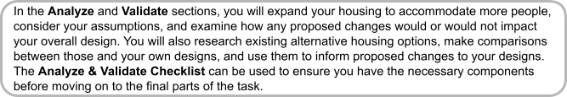
Analyze

QUESTION 7
How would your design change for 4 people living in the space? What would remain the same? How would the area of the space be different than with just one person? State any assumptions.

Validate

ACTION 2
Research some different “small spaces” that are used to house people. Some ideas may include shipping containers, tiny homes, studio apartments, and recreational vehicles (RVs).
- What are the dimensions or square footage of some of these small living spaces?
- How do they compare to the total area of the space you created? Are any smaller?
- Would you change anything about your design based on your research?

Analyze & Validate Checklist
Requirement | Fulfilled?
I described how my design would or would not change after expanding it to 4 people. | ▢
I identified the dimensions and square footage of existing alternative housing options and made comparisons across these and my own designs. | ▢
I evaluated my designs against these parameters and proposed any appropriate changes. | ▢
Teacher Consultation:

Reflect

QUESTION 8
Reflect on what you learned about how professional designers create small spaces for housing. What surprised you from your research? What ideas of yours were affirmed by the research?
Report

QUESTION 9
Create a presentation, article, or short video for city investors to pitch your design as a potential solution for eliminating housing insecurity for its people.

In your product:
- Explain how creating smaller living spaces can help reduce or eliminate housing insecurity.
- Cite any applicable research or resources.
- If your product is primarily visual, include an outline or brief script to accompany it.
- If desired, research a particular city and include city-specific data as available.
- Include your own design as part of your argument.

For this extension, you get to keep thinking like a designer! Ponder the following question, then choose one or more of the bulleted questions below to tackle.
How do professionals use what they know to improve their designs, make production more efficient, and apply equations to inform how big or how small to make their spaces?
Now, use a search engine to research and respond to one or more of the following:
- What is the average family size? Is there a standard tiny home size? Are these two values related in any way?
- Is there an ideal size for tiny homes that are mass-produced? What is the ideal ratio of size to number of people being housed? Is there a constant rate in which each person being housed gets a certain amount of square footage? How do designers efficiently and economically create homes for people they don’t know?
- Write an equation that represents the relationship between the size of the space and the number of people being housed. The number of people should be one of the variables that changes. How can you apply this equation to help refine the solutions you proposed earlier to combat housing insecurity?

