M104 Performance Task
Jellyfish Takeover!
Modeling With Functions of Exponential Type
Teacher Version

Design Notes
This task is set within the context of problems currently affecting the environment and the ecology of Earth. In this task, students will examine data associated with one of those environmental issues and apply the basic mathematical modeling cycle to make predictions, interpret information, and report findings. The learning experience centers around the CCSSM modeling cycle as illustrated below:
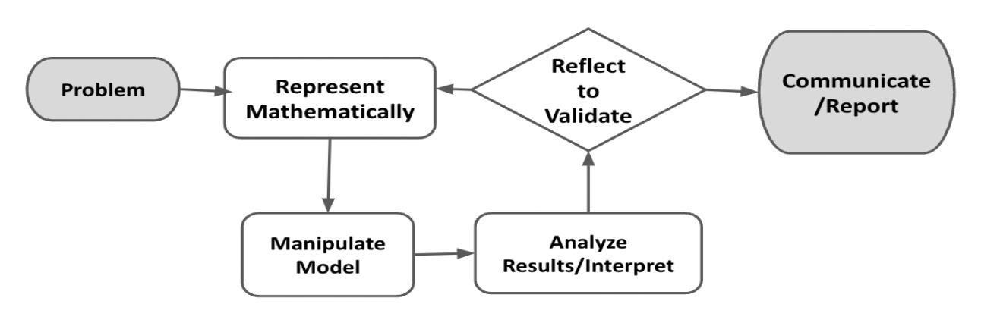
Figure 1. Diagram of Modeling Process. From “Progressions for the Common Core State Standards for Mathematics” [Draft manuscript], by Common Core Standards Writing Team, 2019, p. 6 (http://mathematicalmusings.org/wp-content/uploads/2022/05/modeling_02082019.pdf).

Connections to Learning Principles
Students will:
- examine multiple variables to better understand some of the implications of global climate changes (LP1);
- have agency in their learning as they decide how to present the final information to the intended audience (LP4);
- analyze an issue that impacts the world around them (LP6); and
- use technology to examine relationships between quantities graphically (LP7).

The following pages provide teacher versions of this task with guidance, suggestions, and comments in red and sample student responses in blue italics.

Student Task

The Modeling Cycle
There are many problems affecting the environment and the ecology of Earth. In this task, you will examine data associated with one of those environmental issues and apply the basic mathematical modeling cycle to make predictions, interpret information, and report your findings.
Mathematical models are used to make sense of ideas and phenomena in our world. As illustrated in the image below, the modeling cycle is a process of collecting data about an idea or problem, creating models of that data, analyzing the story told by those models, and reporting the results to the appropriate audience. In this task, you will be engaging with this mathematical modeling cycle to analyze data, evaluate findings, and identify trends in jellyfish populations.
Figure 1. Diagram of Modeling Process. From “Progressions for the Common Core State Standards for Mathematics” [Draft manuscript], by Common Core Standards Writing Team, 2019, p. 6 (http://mathematicalmusings.org/wp-content/uploads/2022/05/modeling_02082019.pdf).

Global Average Surface Temperatures
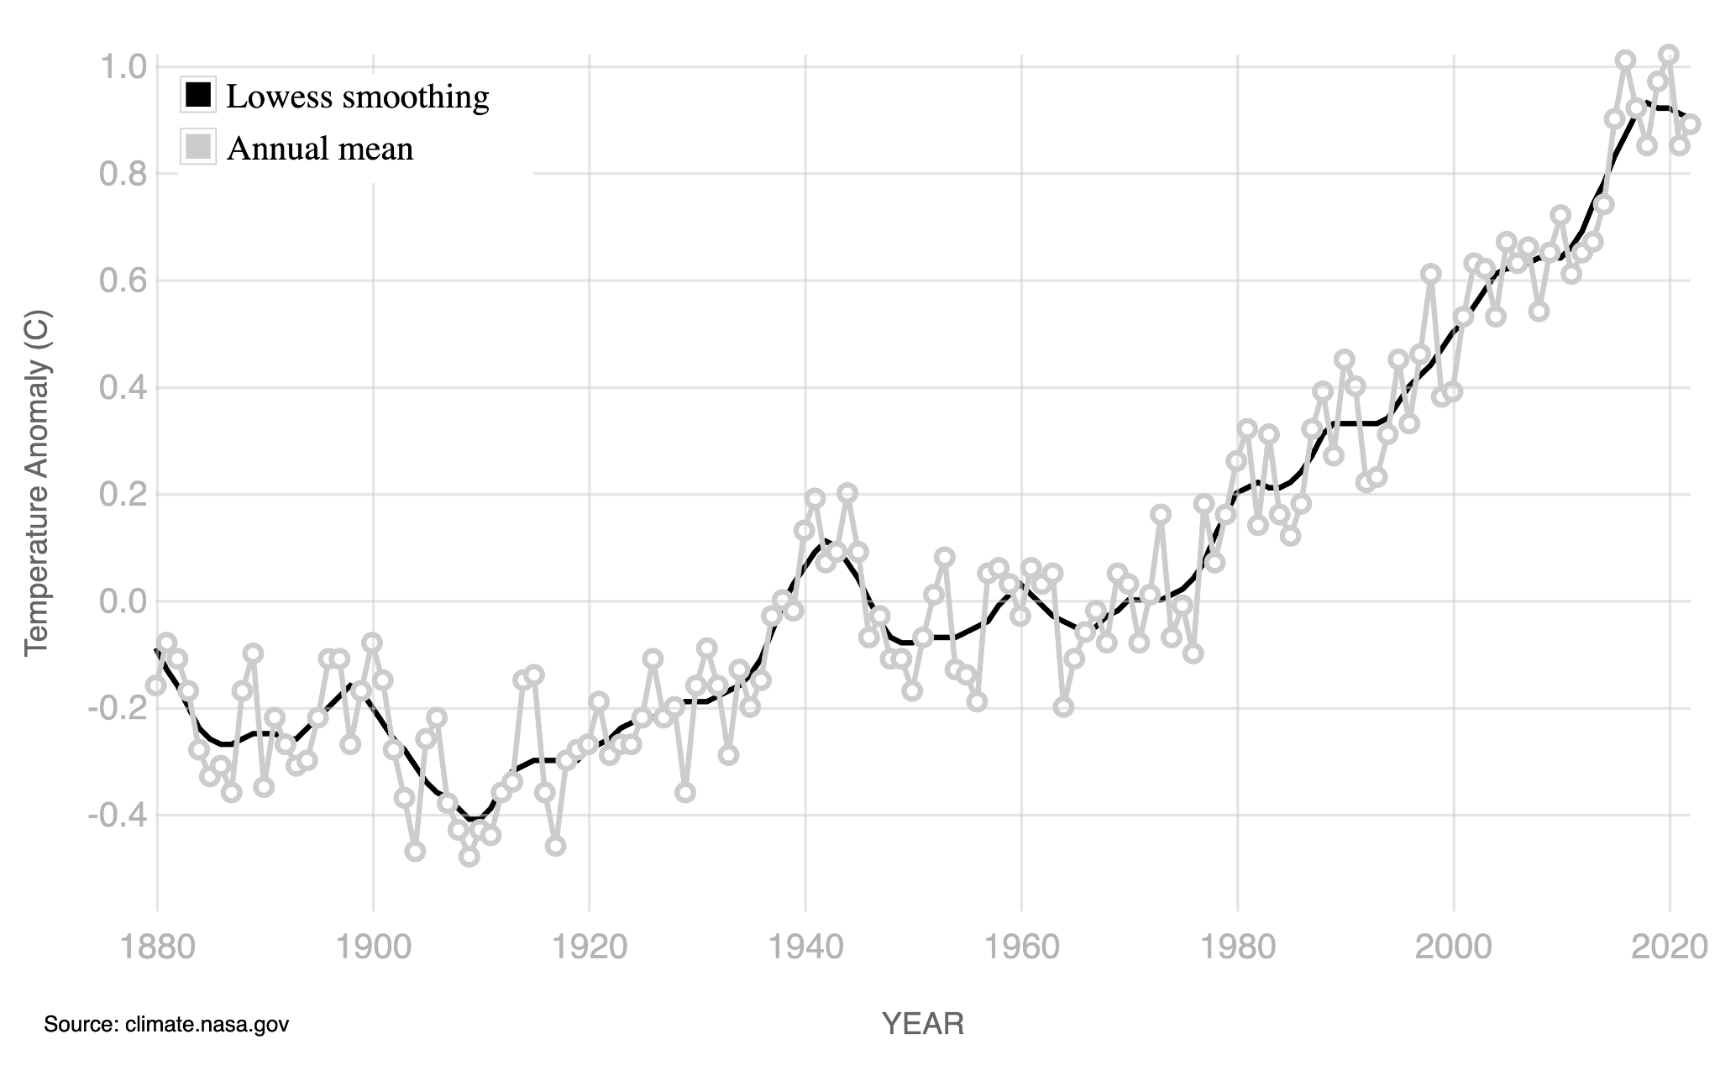
Launch
Figure 1. Difference between expected average surface temperature and actual average surface temperature
GLOBAL LAND-OCEAN TEMPERATURE INDEX
Data source: NASA's Goddard Institute for Space Studies (GISS).
Credit: NASA/GISS
Since 1880, the year of the first global average-surface-temperature measurement, records show a general rising trend in average surface temperature, with 2016 and 2020 being the hottest years on record (NASA). This is alarming, as such rapid temperature changes are devastating ecosystems, destroying homes, and hurting people all over the world. In California, for example, heat waves and droughts are extending wildfire seasons, while in Florida, rising sea levels put people and their property at risk from flooding and storms (National Academies/Inside Climate News). Some South Pacific Islands have already disappeared due to rising sea levels (National Academies/Inside Climate News)!
The graph displayed shows the difference between the expected average surface temperature (57°F/13.9°C) and the actual average surface temperature of the earth since the year 1880. For example, in the year 1900, the actual average surface temperature was colder than the expected average surface temperature, which is why that value appears below the 0.0 line on the y-axis.

QUESTION 1
 | What do you notice about the shape of the above graph? What do you wonder about the graph? How might the global average surface temperature be changing over time?
Answers will vary. Possible student responses:
- It appears to show an increasing trend.
- There is a bump at the year 1940.
- The lowest value is about -0.4 and the highest is near 0.9.
- It crosses zero at about the year 1939.
- It probably means that the global average surface temperature is increasing, getting further above the normal 57 degrees.
 | If needed, help students attend to the expected average surface temperature (57°F/13.9°C) that is described in the text above the graph—ask students to interpret different values on the graph to check for their understanding. For example, what do negative values mean? What do positive values mean? What was the value in the year 1920, and what does it mean in context?

QUESTION 2
If the trend in the data continues on a similar course as it is in the graph, in what year might you expect the temperature anomaly (shown on the y-axis) to rise above 2°C? Justify your answer.
Answers will vary. Possible student response:
- It seems to go up about 0.5 degrees every 20 years for the past 40 years, so it will probably be around 2060 to go up another full degree above where it is in 2020.
If needed, prompt students to extend the graph in a shape that seems reasonable, possibly using tools like graph paper.

Jellyfish Takeover!
Gulf of California—Jellyfish Populations
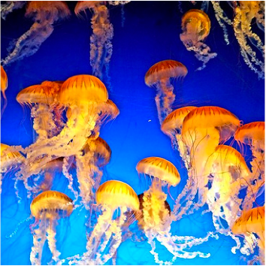
Scientists studying rising ocean temperatures have found something startling: While many species are unable to adapt to sudden changes in ocean temperatures, jellyfish are thriving! With their predators and competitors migrating to colder environments, jellyfish are able to reproduce faster than ever, causing a spike in jellyfish population numbers.
Your Task: Understand how jellyfish populations are changing over time as global surface temperature and ocean temperatures rise. Create a summary demonstrating your findings.
Role: In this scenario, you will take on the role of an oceanographer.
Scientists expect that jellyfish populations will increase as the ocean temperatures rise, but they aren’t sure what the specific rate of increase will be. A team of scientists at the Scripps Institute of Oceanography has gathered data on jellyfish populations in the Gulf of California over the past three years, along with the average ocean temperature during collection times. In this task, you will use these data to predict changes, identify a representative model, and develop an equation for changing jellyfish populations as a function of time.
In the Problem and Formulate sections, you will investigate data to determine how the number of jellyfish in an area is related to the temperature of the ocean over time; then you will evaluate this relationship to identify a model of best fit and create a related equation. The Problem Formulation Checklist can be used to ensure you have the necessary components before moving on to the remaining parts of the task.

Problem
QUESTION 1
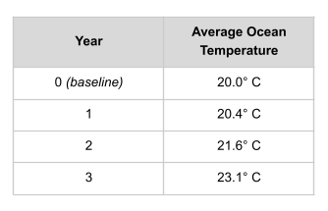
The table shows the average ocean temperature in a particular part of the Pacific Ocean at four different time points, each one year apart.
Based on the changes you see with the temperature over time in this part of the ocean, what might you expect to happen to the number of jellyfish in that same time period? You may use internet search engines to help you think through this question.
Answers will vary. Possible student response:
- I read that jellyfish are very versatile and can adapt to a pretty wide range of temperatures. So as long as they continue to have enough food, it seems like the population will continue to grow.

Formulate
QUESTION 2
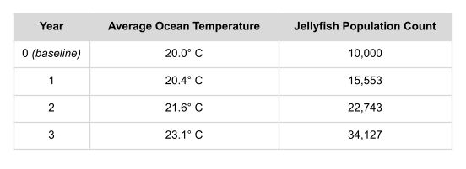
The table below shows the jellyfish population count in the part of the Pacific Ocean where the temperature data was collected. Your task is to determine whether the jellyfish population is increasing linearly or exponentially over time in this location.
Use graphing software or graph paper to plot the data points for the year and the jellyfish population count. What do you notice about the shape of the graph?
Answers will vary. SEE Q3 for data and graph.
Direct students to the graphing calculator at Desmos.com where they can graph the data points and identify the shape of the graph. They may need to look up some functionality, such as creating a data table and adjusting the viewing window, if they don’t have a lot of experience with the technology. Encourage them to use online videos or tutorials to figure out how to do these things.

QUESTION 3
Determine whether a linear or an exponential model fits the data better. What is an equation that you could use to model the relationship between the year and the jellyfish population count?
Answers will vary. Possible student response:
- I graphed both on Desmos, and the exponential model is a better fit for the data for year vs. jellyfish population count. Linear is okay, but the exponential is definitely closer to all of my points.
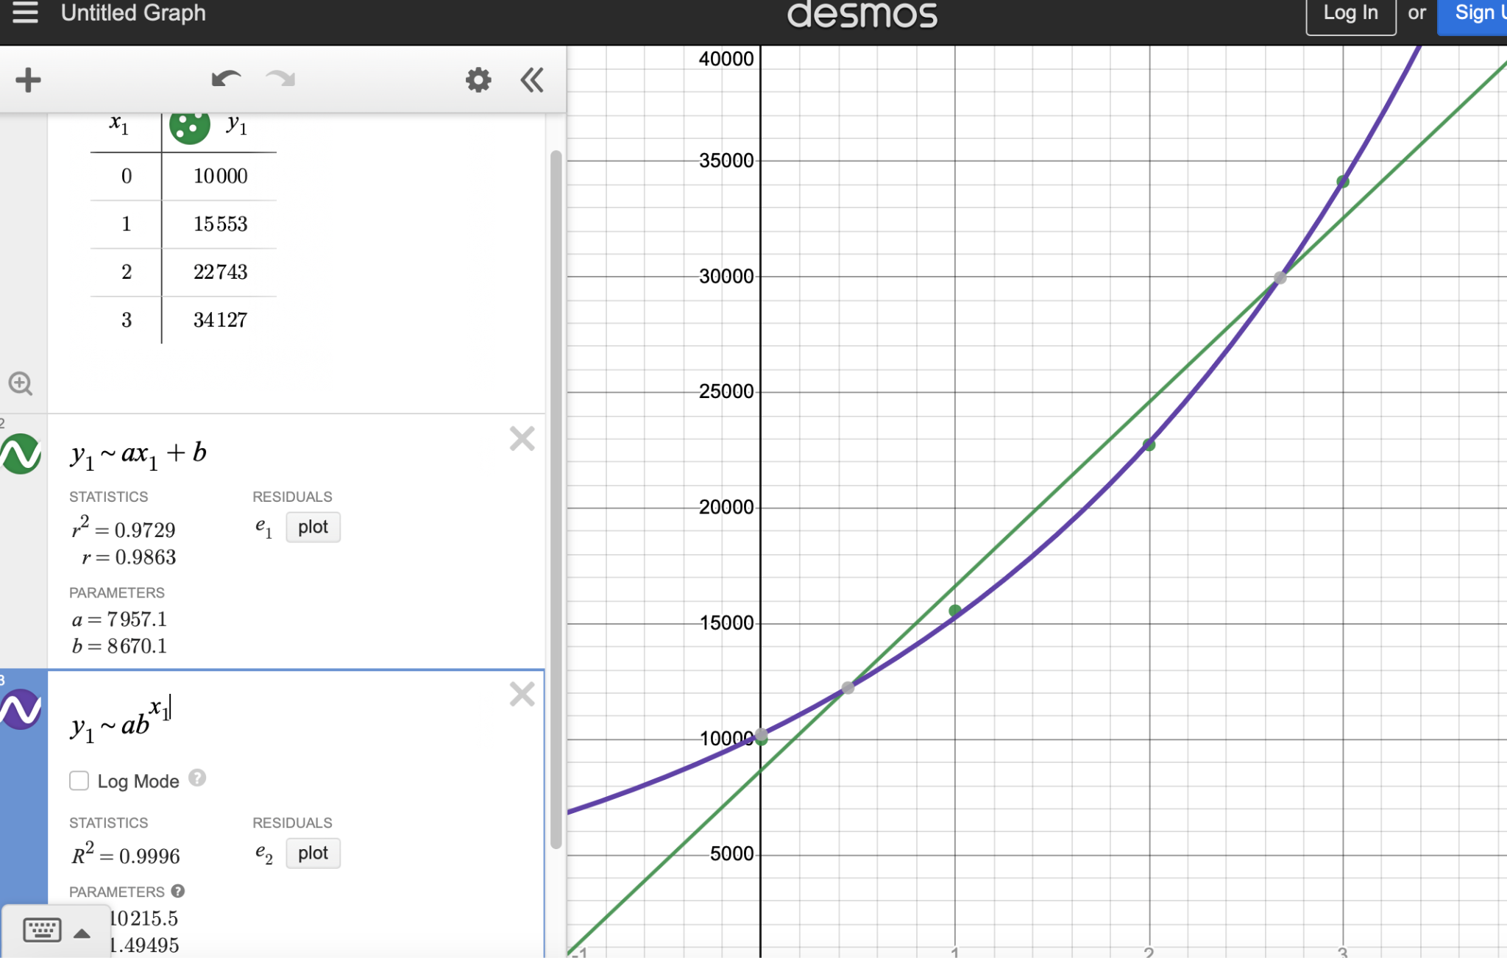
Students can also use the same functionality of Desmos.com to evaluate whether a linear or an exponential model fits the data better (in the above Desmos screenshot, the exponential model fits better than the linear model).

Problem Formulation Checklist
Requirement | Teacher Notes
A prediction about changes in jellyfish population by time period has been made. | (Teachers, please add your notes here.)
The data points for year and jellyfish population count have been accurately plotted, and the shape of the graph has been described. | (Teachers, please add your notes here.)
An accurate model has been identified and an accurate equation has been created for relating the variables of time and number of jellyfish. | (Teachers, please add your notes here.)
(Teachers, please add your notes here.)
In the Compute and Interpret and Analyze sections, you will use your equation to make predictions about future jellyfish populations, evaluate your predictions against other factors, and consider the importance of and relationship among these variables in these kinds of analyses. The Compute, Interpret, and Analyze Checklist can be used to ensure you have the necessary components before moving on to the remaining parts of the task.

Compute
QUESTION 4
Based on your equation, how many jellyfish would you predict will be in that location in five years from the baseline data collection (Year 0)? What about in 10 years?
Answers will vary. Possible student response:
- I used my equation y=10215.5(1.5)^{x} to find that in 5 years, it would be 77,574 and in 10 years it would be 589,077.
Students' equations may vary slightly from the previous section (e.g., if they elected to do a hand drawn graph vs. using technology to determine a curve of best fit). They should have values that are quite high after 10 years, though, if using a valid exponential model.

Interpret and Analyze
QUESTION 5
How confident are you that the predictions you made in Q4 are accurate? What other factors might affect the predictions produced by your equation?
Answers will vary. Possible student response:
- The numbers seem too high. The exponential model fits the data points that we have, but it seems like the jellyfish may run out of food or space, or something else could happen to keep the population from actually reaching over 500,000 in 10 years.
Encourage students to do additional reading if necessary. Use questioning prompts as needed to fully bring them into the context such as: Can a population continue to grow and grow? Why or why not? What do you need to consider besides the mathematical model?

QUESTION 6
Why is it important to examine the variable for ocean temperature in addition to analyzing the change in the jellyfish population? How are the two related?
Answers will vary. Possible student response:
- It said in the beginning that while some animals cannot handle the rising ocean temperatures, the jellyfish are thriving. So we have to look at the rising temperature because it means that the jellyfish will bloom, but other animals will have to move to cooler temperatures or they may die.
Encourage students to do additional reading if necessary. The purpose of this question is to ensure that students are able to connect the context of a growing jellyfish population back to the idea that they are able to survive in conditions that other animals cannot.

Compute, Interpret, and Analyze Checklist
Requirement | Teacher Notes
The equation has been used to make predictions for five and 10 years after the baseline. | (Teachers, please add your notes here.)
Thoughtful, valid reasons have been provided for why the model will or will not be good at predicting five and 10 years out. | (Teachers, please add your notes here.)
A valid reason has been given for needing to study the temperature variable in addition to time and number of jellyfish. | (Teachers, please add your notes here.)
(Teachers, please add your notes here.)
In the Validate and Report sections, you will identify ways to research and improve the accuracy and effectiveness of your equation; you will also create a product that appropriately demonstrates your conclusions. The Validate and Report Checklist can be used to ensure you have the necessary components before moving on to the remaining parts of the task.

Validate
QUESTION 7
What are some methods you might use to determine if the equation you developed is a good one? What additional data might you collect? Why?
Answers will vary. Possible student response:
- I think you could continue to collect data for more time. If the trend continues, then the equation can still be used, but additional data could lead to a slightly different equation, so you would want to refine it over time based on new observations.
The purpose of this question is to get students thinking about how and why models may change over time. Students may suggest collecting data from additional locations or collecting more data over additional years to determine the adequacy of the equation over time.

Report
QUESTION 8
Product: Based on what you know, create a summary (either written, drawn, in a video, or in a PowerPoint, for example) that demonstrates your findings regarding the change in jellyfish populations and its relationship with rising ocean temperatures. Make sure it includes the following information:
- Describes the change in jellyfish populations over time
- Explains the relationship between jellyfish population change and ocean temperatures
- Refers to the equation you created, and identifies what it may mean for the future
- Provides evidence of your research—answering questions like: What are some actions that human beings might take to ensure that the jellyfish do not actually “take over”?

Validate and Report Checklist
Requirement | Teacher Notes
A method has been identified for validating the equation over time. | (Teachers, please add your notes here.)
A clear, comprehensive summary connects all of the variables studied and provides some possible actions to consider in tackling the challenge of a “jellyfish takeover.” | (Teachers, please add your notes here.)
(Teachers, please add your notes here.)

