M113 Performance Task
Is That Your Final Answer?

The Modeling Cycle
Many game shows have some element of probability associated with them. Some game shows ask contestants to choose from several doors or boxes where some have prizes and others have nothing. Other game shows, like the one you will explore in this task, rely on contestants answering questions when given a set of answer choices.
Mathematical models are used to make sense of ideas and phenomena in our world. As illustrated in the image below, the modeling cycle is a process of collecting data about an idea or problem, creating models of that data, analyzing the story told by those models, and reporting the results to the appropriate audience. In this task, you will be engaging with the mathematical modeling cycle to analyze the difference between an individual and a group knowing the correct answer to a particular question.
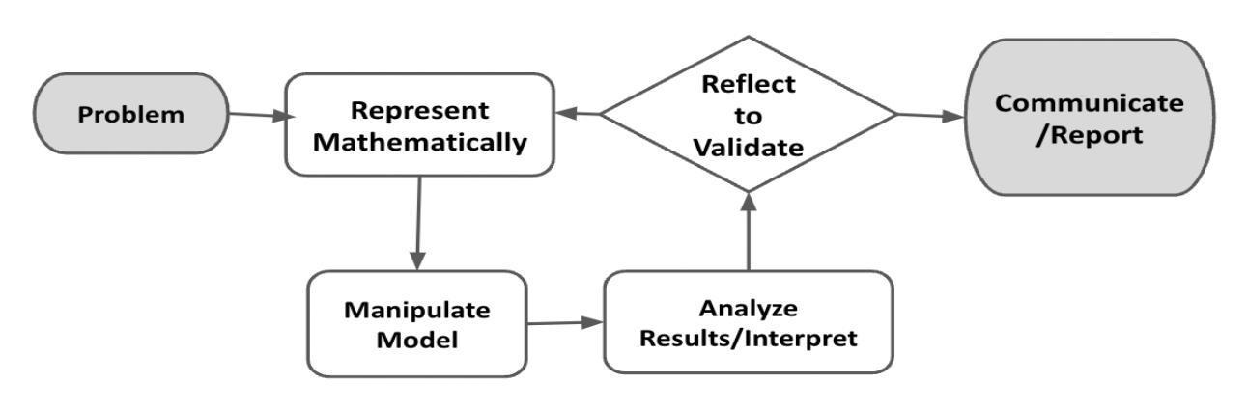
Figure 1. Diagram of Modeling Process. From “Progressions for the Common Core State Standards for Mathematics” [Draft manuscript], by Common Core Standards Writing Team, 2019, p. 6 (http://mathematicalmusings.org/wp-content/uploads/2022/05/modeling_02082019.pdf).

Is That Your Final Answer?
Launch
In the show “Who Wants To Be a Millionaire?,” contestants answer multiple-choice trivia questions to try to win money. They have three Lifelines, which allow them to seek support from other people in cases where they don’t know the answer to a question. The Lifelines are called 50:50, Phone a Friend, and Ask the Audience. If contestants don’t know the answer and don’t have any Lifelines left, they can “walk away” and keep the value of the last question they answered correctly. If contestants answer incorrectly, they lose the game and win no money. In this task, you will examine the probability associated with the Ask the Audience Lifeline using the modeling cycle.

 | In the show, if the contestant doesn’t know the answer, they can poll the audience. The question is read to the audience and each audience member selects the answer they believe is correct. Those results are then shown to the contestant to show the percent of audience members who selected each of the four answer choices.  Without performing any calculations, do you think the contestant should trust the most popular audience response? What is your initial reaction? Why do you feel that way?

In the Problem and Formulate sections, you will develop a multiple-choice trivia quiz that can be administered to a group of people. The Problem Formulation Checklist can be used to ensure you have the necessary components before moving on to the remaining parts of the task.

Problem
Are people really “smarter in numbers”? This task will allow you to analyze the collective wisdom of groups of people versus individuals to better understand a phenomenon called The Wisdom of Crowds Theory.

Formulate
ACTION 1
 | Use Google Forms to create a 10-question, multiple-choice trivia quiz using any questions that you want. Each question should have four answer choices—one that is correct and three that are incorrect.

ACTION 2
Give the quiz to a group of people. Each person needs to respond independently without the help of others and without the help of the internet! Have at least 20 people take the trivia quiz.

Problem Formulation Checklist
Requirement | Fulfilled?
I have developed a 10-question, multiple-choice trivia quiz. | ▢
I have administered a 10-question, multiple-choice trivia quiz to at least 20 people. | ▢
Teacher Consultation: | ______________

In the Represent Mathematically sections, you will organize your data in two spreadsheet tabs to make the data easier to analyze. The Represent Mathematically Checklist can be used to ensure you have the necessary components before moving on to the remaining parts of the task.

Read this entire section before you look at the survey results from your participants. You need to decide the best way to score each person’s survey so that you have the data you need for this section.

Represent Mathematically—Part 1
ACTION 3
Read this entire section before you look at the survey results from your participants. You need to decide the best way to score each person’s survey so that you have the data you need for this section.
Organize your data in two different ways using two separate tabs on a Google Sheet or in an Excel workbook.
Show how many or what percent of people chose each answer choice for each of the 10 questions.
Tab #1
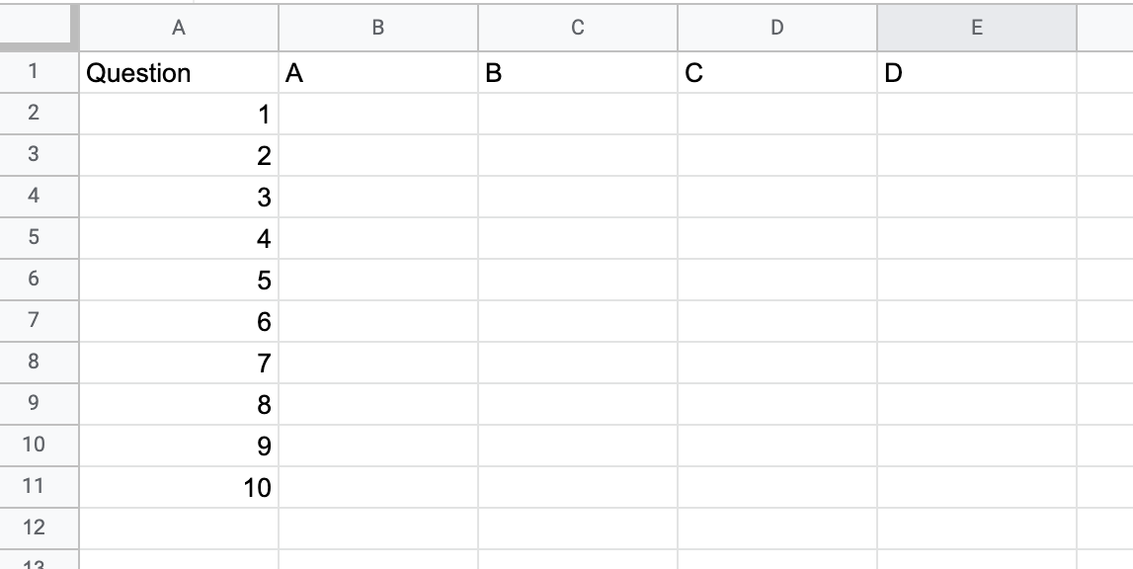
You might organize the data with the question number in the first column and answer choices A, B, C and D across the first row, as shown below.

Show how many people selected each answer choice. Decide whether to display that information as a percent or as a number (or choose a display that allows you to show both). You may change this later if it is helpful to your analysis.
Show how many questions each person answered correctly on their own trivia quiz.
Tab #2
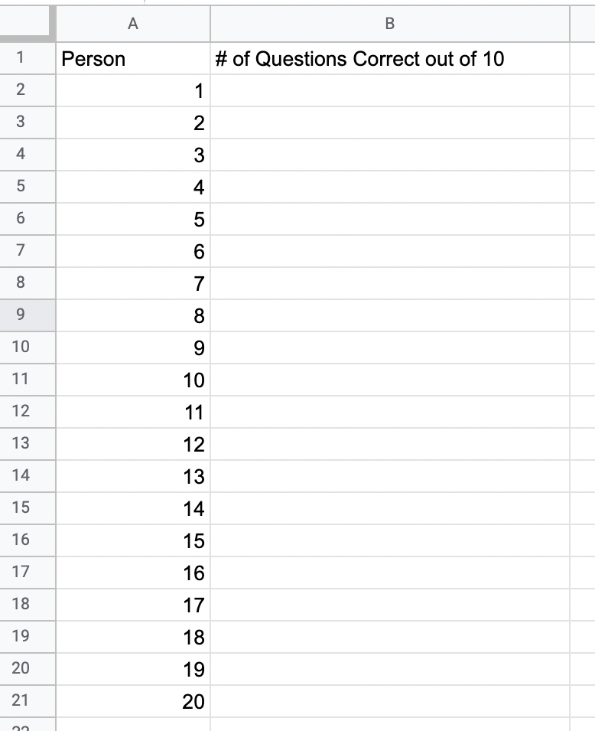
You might organize the data with either names or numbers assigned to people in the first column and the number of questions they answered correctly out of 10 in the second column, as shown below.

Represent Mathematically—Part 2
ACTION 4
Create a distribution of your own data that shows the percentage of people who got each number of questions correct. You may use graph paper or generate the distribution using technology, such as Google Sheets.
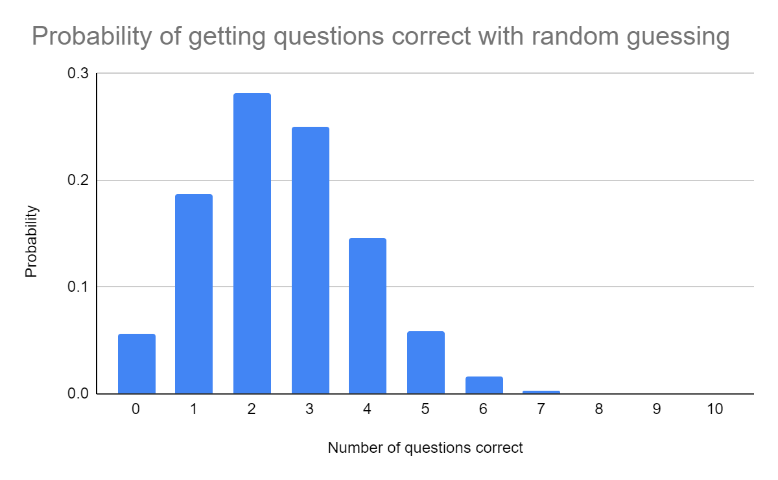
This histogram shows the probability of getting different numbers of questions correct on a 10-question quiz if the person taking the quiz was guessing the answers by randomly selecting A, B, C or D.

QUESTION 2
Think about how your distribution compares to the distribution shown above created by randomly guessing. What do you notice? What do you wonder?

Represent Mathematically—Parts 1 and 2 Checklist
Requirement | Fulfilled?
The data have been compiled in a way that allows for them to be entered into the spreadsheet. | ▢
Two spreadsheet tabs of a workbook accurately reflect the data from the quiz. | ▢
The distribution accurately reflects the data. | ▢
Teacher Consultation: | ______________
In the Compute, Interpret, and Reflect sections, you will use your data to consider how the wisdom of a group of people compares to the wisdom of an individual. You will reflect on some other ways that this type of thinking might be important outside of the context of game shows. Record your responses on paper or in a word processing document for each section. The Compute, Interpret, and Reflect Checklist can be used to ensure you have the necessary components before moving on to the remaining parts of the task.

Compute
QUESTION 3
Examine your data. For how many of the 10 questions on your trivia quiz did the majority of your respondents select the correct answer? How does the number compare to the average score an individual received when taking your quiz? Why do you think that is?

Interpret
QUESTION 4
The audience members of “Who Wants To Be a Millionaire?” select the correct answer about 90% of the time when asked to participate. Compare that to your own data. Did the majority of your sample select the correct answer at a higher or lower rate than the audience of “Who Wants To Be a Millionaire?”

Reflect
QUESTION 5
In this investigation, you have been exploring what is known as The Wisdom of Crowds Theory. This theory assumes that the collective knowledge of large and diverse groups of people leads to better decisions, ideas, and problem-solving than the knowledge of an individual person. In what other situations might The Wisdom of Crowds Theory be relevant?

Compute, Interpret, and Reflect Checklist
Requirement | Fulfilled?
I have made an accurate comparison between the group’s data and that of an individual. | ▢
I have made an accurate comparison ibetween the “Who Wants To Be a Millionaire?” data and the sample data. | ▢
I have offered some appropriate extensions of the idea behind The Wisdom of Crowds Theory. | ▢
Teacher Consultation: | ______________

