Baseline Professional Learning Handout
M102 Modeling with Linear Functions and Equations

Baseline Professional Learning Handout 1
Selected Common Core High School Standards for Mathematics 2
Progressions Excerpt 5
M102 Content and Practice Expectations 6
M102 Content and Practice Expectations and Indicators 7
Let’s Investigate 8
Kimi and Jordan Task 8
Sandia Aerial Tram Task 8
Let’s do some math! Round 1 9
Task 1:Taxi! 9
Learning Principles 10
Task 1: Taxi! Student Work 11
Let’s do some math! Round 2 14
Task 2: Median Monthly Rent Prompt 14
Task 2: Median Monthly Rent Student Work 17
Criteria for Success 24
References 24
Selected Common Core High School Standards for Mathematics

High School - Algebra
Create equations that describe numbers or relationships
- Create equations and inequalities in one variable and use them to solve problems.
- Create equations in two or more variables to represent relationships between quantities; graph equations on coordinate axes with labels and scales.
- Represent constraints by equations or inequalities, and by systems of equations and/or inequalities, and interpret solutions as viable or nonviable options in a modeling context.

Solve linear equations in one variable
- Solve linear equations and inequalities in one variable, including equations with coefficients represented by letters.

Solve systems of equations
- Solve systems of linear equations exactly and approximately (e.g., with graphs), focusing on pairs of linear equations in two variables.

High School - Functions
Understand the concept of a function and use function notation
- Understand that a function from one set (called the domain) to another set (called the range) assigns to each element of the domain exactly one element of the range. If f is a function and x is an element of its domain, then f(x) denotes the output of f corresponding to the input x. The graph of f is the graph of the equation y = f(x).
- Use function notation, evaluate functions for inputs in their domains, and interpret statements that use function notation in terms of a context.

Interpret functions that arise in applications in terms of the context
- For a function that models a relationship between two quantities, interpret key features of graphs and tables in terms of the quantities, and sketch graphs showing key features given a verbal description of the relationship. Key features include: intercepts; intervals where the function is increasing, decreasing, positive, or negative; relative maximums and minimums; symmetries; end behavior; and periodicity.★
- Relate the domain of a function to its graph and, where applicable, to the quantitative relationship it describes. For example, if the function h(n) gives the number of person-hours it takes to assemble n engines in a factory, then the positive integers would be an appropriate domain for the function.★
- Calculate and interpret the average rate of change of a function (presented symbolically or as a table) over a specified interval. Estimate the rate of change from a graph.★

Analyze functions using different representations
- Graph functions expressed symbolically and show key features of the graph, by hand in simple cases and using technology for more complicated cases.★
a. Graph linear and quadratic functions and show intercepts, maxima, and minima.

- Compare properties of two functions each represented in a different way (algebraically, graphically, numerically in tables, or by verbal descriptions). For example, given a graph of one quadratic function and an algebraic expression for another, say which has the larger maximum.

Build a function that models a relationship between two quantities

- Write a function that describes a relationship between two quantities.★
  - Determine an explicit expression, a recursive process, or steps for calculation from a context.

Interpret expressions for functions in terms of the situation they model

- Interpret the parameters in a linear or exponential function in terms of a context.

High School - Modeling
Modeling links classroom mathematics and statistics to everyday life, work, and decision-making. Modeling is the process of choosing and using appropriate mathematics and statistics to analyze empirical situations, to understand them better, and to improve decisions. Quantities and their relationships in physical, economic, public policy, social, and everyday situations can be modeled using mathematical and statistical methods. When making mathematical models, technology is valuable for varying assumptions, exploring consequences, and comparing predictions with data.

A model can be very simple, such as writing total cost as a product of unit price and number bought, or using a geometric shape to describe a physical object like a coin. Even such simple models involve making choices. It is up to us whether to model a coin as a three-dimensional cylinder, or whether a two-dimensional disk works well enough for our purposes. Other situations—modeling a delivery route, a production schedule, or a comparison of loan amortizations—need more elaborate models that use other tools from the mathematical sciences. Real-world situations are not organized and labeled for analysis; formulating tractable models, representing such models, and analyzing them is appropriately a creative process. Like every such process, this depends on acquired expertise as well as creativity. Some examples of such situations might include:
- Estimating how much water and food is needed for emergency relief in a devastated city of 3 million people, and how it might be distributed.
- Planning a table tennis tournament for 7 players at a club with 4 tables, where each player plays against each other player.
- Designing the layout of the stalls in a school fair so as to raise as much money as possible.
- Analyzing stopping distance for a car.
- Modeling savings account balance, bacterial colony growth, or investment growth.
- Engaging in critical path analysis, e.g., applied to turnaround of an aircraft at an airport.
- Analyzing risk in situations such as extreme sports, pandemics, and terrorism.
- Relating population statistics to individual predictions.

In situations like these, the models devised depend on a number of factors: How precise an answer do we want or need? What aspects of the situation do we most need to understand, control, or optimize? What resources of time and tools do we have? The range of models that we can create and analyze is also constrained by the limitations of our mathematical, statistical, and technical skills, and our ability to recognize significant variables and relationships among them. Diagrams of various kinds, spreadsheets and other technology, and algebra are powerful tools for understanding and solving problems drawn from different types of real-world situations. One of the insights provided by mathematical modeling is that essentially the same mathematical or statistical structure can sometimes model seemingly different situations. Models can also shed light on the mathematical structures themselves, for example, as when a model of bacterial growth makes more vivid the explosive growth of the exponential function.

The basic modeling cycle is summarized in the diagram. It involves (1) identifying variables in the situation and selecting those that represent essential features, (2) formulating a model by creating and selecting geometric, graphical, tabular, algebraic, or statistical representations that describe relationships between the variables, (3) analyzing and performing operations on these relationships to draw conclusions, (4) interpreting the results of the mathematics in terms of the original situation, (5) validating the conclusions by comparing them with the situation, and then either improving the model or, if it is acceptable, (6) reporting on the conclusions and the reasoning behind them. Choices, assumptions, and approximations are present throughout this cycle.

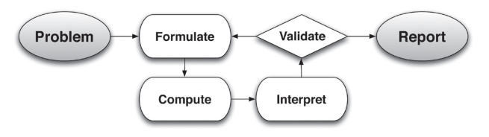

In descriptive modeling, a model simply describes the phenomena or summarizes them in a compact form. Graphs of observations are a familiar descriptive model— for example, graphs of global temperature and atmospheric CO2 over time.

Analytic modeling seeks to explain data on the basis of deeper theoretical ideas, albeit with parameters that are empirically based; for example, exponential growth of bacterial colonies (until cut-off mechanisms such as pollution or starvation intervene) follows from a constant reproduction rate. Functions are an important tool for analyzing such problems. Graphing utilities, spreadsheets, computer algebra systems, and dynamic geometry software are powerful tools that can be used to model purely mathematical phenomena (e.g., the behavior of polynomials) as well as physical phenomena. Modeling Standards Modeling is best interpreted not as a collection of isolated topics but rather in relation to other standards. Making mathematical models is a Standard for Mathematical Practice, and specific modeling standards appear throughout the high school standards indicated by a star symbol (★).

Functions Progression Excerpt
Functions and Modeling In modeling situations, knowledge of the context and statistics are sometimes used together to find a function defined by an algebraic expression that best fits an observed relationship between quantities. (Here “best” is assessed informally, see the Modeling Progression and high school Statistics and Probability Progression for further discussion and examples.) Then the algebraic expressions can be used to interpolate (i.e., approximate or predict function values between and among the collected data
values) and to extrapolate (i.e., to approximate or predict function values beyond the collected data values). One must always ask whether such approximations are reasonable in the context.

In school mathematics, functional relationships are often given by algebraic expressions. For example, f(n) = n² for n ≥ 1 gives the n^{th} square number. But in many modeling situations, such as the temperature at Boston’s Logan Airport as a function of time, algebraic expressions may not be suitable.

M102 Content and Practice Expectations
102.a | Engage in the modeling cycle.
102.b | Interpret linear functions and equations that arise in applications in terms of the context.
102.c | Analyze linear functions using different representations.
102.d | Build linear functions that model relationships between two quantities.
102.e | Analyze and solve linear equations and pairs of simultaneous linear equations to draw conclusions.
102.f | Interpret expressions for linear functions in terms of the situation they model.
102.g | Solve linear equations and inequalities in one variable.
102.h | Create equations that describe linear relationships.
102.i | Understand the relevance of modeling with linear functions.
102.j | Use a linear function model to determine values of interest in a real-world problem.

M102 Content and Practice Expectations and Indicators
Content and Practice Expectations | Indicators  Choose an artifact where you…
102.a: Engage in the modeling cycle (performance assessment). | i. engage with the full modeling cycle (problem, formulate, compute, interpret, validate, revise as necessary, report).
102.b: Interpret linear functions and equations that arise in applications in terms of the context. | i. select two different data points that illustrate something interesting or important about the context you are modeling and describe what these points tell you about the topic.
 | ii. use a model to compute output values and then interpret the values in the context of the problem.
 | iii. describe the domain of the linear function, including anything noticed about values that are not part of the domain given the context.
 | iv. describe the contextual meaning of the rate of change for a linear model.
102.c: Analyze linear functions using different representations. | i. create a linear graph to show a particular context and describe important values that help understand something about the problem you are exploring.
 | ii. explain how the parameters of a linear model relate to its graph.
102.d: Build linear functions that model relationships between two quantities. | i. identify the quantities and variables of interest in a given situation or data set that are interesting and that demonstrate a linear relationship.
 | ii. build a function that models the linear relationship between two quantities in a situation.
102.e: Analyze and solve linear equations and pairs of simultaneous linear equations to draw conclusions. | i. find the solution to a system of two linear equations in two variables.
 | ii. explain whether a system of two linear equations will have one solution, no solution, or an infinite number of solutions.
 | iii. create a system of two linear equations in two variables to model a real-world situation.
 | iv. explain the meaning of a solution to a system of two linear equations in two variables in terms of the context being modeled.
102.f: Interpret expressions for linear functions in terms of the situation they model. | i. describe the meaning of the parameters for a linear function in terms of the context.
102.g: Solve linear equations and inequalities in one variable. | i. find the solution to a linear equation or inequality in one variable.
 | ii. justify a solution to a linear equation or inequality in one variable using logical reasoning or an argument about reasonableness.
102.h: Create equations that describe linear relationships. | i. identify the variables of interest in a given situation or data set that are interesting and that demonstrate a linear relationship.
102.h: Create equations that describe linear relationships. | ii. build an equation that models the linear relationship between two quantities in a situation.
102.i: Understand the relevance of modeling with linear functions. | i. notice something that surprised you or that you learned about the topic through linear modeling of data. Share what surprised you or what you learned.
 | ii. highlight something you are most proud of in your learning about linear modeling.
 | iii. explain how modeling can be used to answer important questions.
102.j: Use a linear function model to determine values of interest in a real-world problem. | i. determine one or more output values for specific inputs to the function.

Let’s Investigate

Kimi and Jordan Task

Kimi and Jordan are each working during the summer to earn money in addition to their weekly allowance. Kimi earns $9 per hour at her job, and her allowance is $8 per week. Jordan earns $7.50 per hour, and his allowance is $16 per week.

- Jordan wonders who will have more income in a week if they both work the same number of hours. Kimi says, "It depends." Explain what she means.

- Is there a number of hours worked for which they will have the same income? If so, find that number of hours. If not, why not?

- What would happen to your answer to part (b) if Kimi were to get a raise in her hourly rate? Explain.

- What would happen to your answer to part (b) if Jordan were no longer to get an allowance? Explain.

Source: Illustrative Mathematics

Sandia Aerial Tram Task

Albuquerque boasts one of the longest aerial trams in the world. The tram transports people up to Sandia Peak. The table shows the elevation of the tram at various times during a particular ride.

Minutes into the Ride | 2 | 5 | 9 | 14
Elevation in Feet | 7069 | 7834 | 8854 | 10,129

- Write an equation for a function (linear, quadratic, or exponential) that models the relationship between the elevation of the tram and the number of minutes into the ride. Justify your choice.

- What was the elevation of the tram at the beginning of the ride?

- If the ride took 15 minutes, what was the elevation of the tram at the end of the ride?

Source: Illustrative Mathematics

Let’s do some math! Round 1

Task 1: Taxi!
Students are given a problem like this to interpret the parameters of a linear function:

Part 1
Lauren records her taxi fare displayed on the computer screen at different points of time during a taxi ride:
Distance, d, in miles | Fare, F, in dollars
3 | 8.25
5 | 12.75
11 | 26.25

How would you describe the relationship between the two quantities?

Part 2
Identify two quantities that have a relationship that you’d like to track and believe is linear in nature.

- What quantities are you tracking?
- What about the relationship between these two quantities leads you to believe it will be linear?
- Develop a model that describes the relationship between the two quantities.
- What surprised you about the relationship you just modeled?

(Adapted from Illustrative Mathematics, Taxi!, 2016)

Sample Learning Experience

Set the stage by asking students, “Why might Lauren keep track of the distances she travels and the amount she pays?”

Ask students if they know of other situations where they might want to keep track of what they are doing and why. Note these ideas for the second prompt to extend the learning.

Monitor students as they work on their description of the relationship between the distance and the fare Lauren paid. Select student work that illustrates different techniques: use of a graph, analysis of rates of change within the table, or the writing of an equation. Consider sequencing the work in a way that builds a coherent mathematical story and allows for connections across representations. Encourage students to ask questions to their peers as mathematical ideas are presented.

Amplify aspects of the conversation that:

- explain the linear nature of this relationship.
- contextualize the slope and y-intercept of the line.
- lead to the equation of this linear function.

Allow students the opportunity to return to their work to revise, as necessary.

Have students work in pairs to complete the task. Allow them the option of using chart paper, Google Slides, or other creative outlets to showcase their work.

Learning Principles
Engage with cognitively demanding tasks in heterogeneous settings (LP 1). Students should be given opportunities to grapple with multistep, non-routine tasks that promote mathematical rigor. These experiences should be differentiated so that all students engage in appropriate challenges—for example, through tasks with multiple entry points and solution pathways. These experiences should continue to integrate knowledge and skills developed in grades 6-8 at the level of sophistication of high school mathematics.

Engage in social activities (LP 2). Students should have opportunities to work independently and to communicate with one another about mathematics by engaging in collective and collaborative learning activities. Explaining and having opportunities to revise one’s thinking has excellent value in solidifying one’s knowledge.

Build conceptual understanding through reasoning (LP 3). Students should be given the opportunity to reason, justify, and problem solve with critical thinking, reading, writing, speaking, and listening. Through reasoning and work with multiple representations, students learn why procedures work and build a conceptual understanding of key mathematical ideas.

Have agency in their learning (LP 4). Students should be able to choose tasks and learning experiences that align with their interests and aspirations. All students have rich and varied experiences and home lives. Learning mathematics should bring students’ identities and interests to the fore and build on the strengths that they bring to the learning space.

View mathematics as a human endeavor across centuries (LP 5). Students should understand that mathematical ideas emanated over time from civilizations around the world and have opportunities to explore these contributions to mathematics. Students should develop an appreciation of mathematics as a human endeavor: one in which they feel a sense of belonging, where they see themselves as mathematicians, and one that offers opportunities to broaden their ideas about what mathematics is, how it is used, and who it is for.

See mathematics as relevant (LP 6). Students should engage with mathematics in ways that authentically involve real-world situations. Problem-solving contexts should allow students to perceive mathematics as a tool for addressing the questions that arise in everyday life, as well as the ways it can model our world and address global economic, social, and environmental challenges. Students should also engage with mathematics in ways that connect to academic disciplines and future careers by doing the mathematics used by artists, designers, engineers, and other professionals.

Employ technology as a tool for problem-solving and understanding (LP 7). Research indicates that technology is a powerful tool for learning deeper mathematics by improving calculation efficiency and enabling more sophisticated analysis. Students should learn to use technology, with emphasis put on widely used tools and software, such as calculators and spreadsheets, to make sense of models. Technology use should not be limited to supporting “doing mathematics,” but should also be used as a tool for displaying and communicating results to appropriate audiences.

Slide Deck for sharing student work

Task 1: Taxi! Student Work

Example 1:
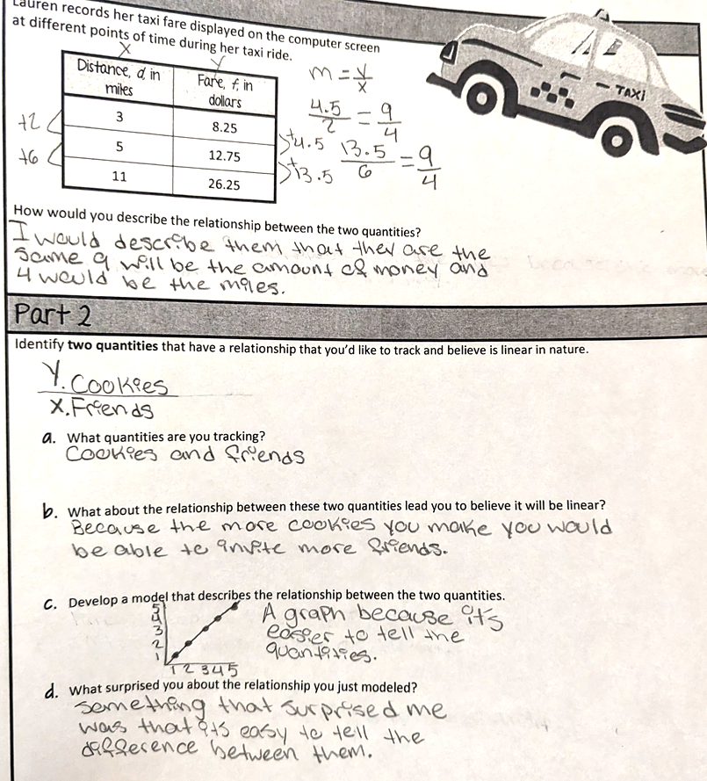

Example 2:
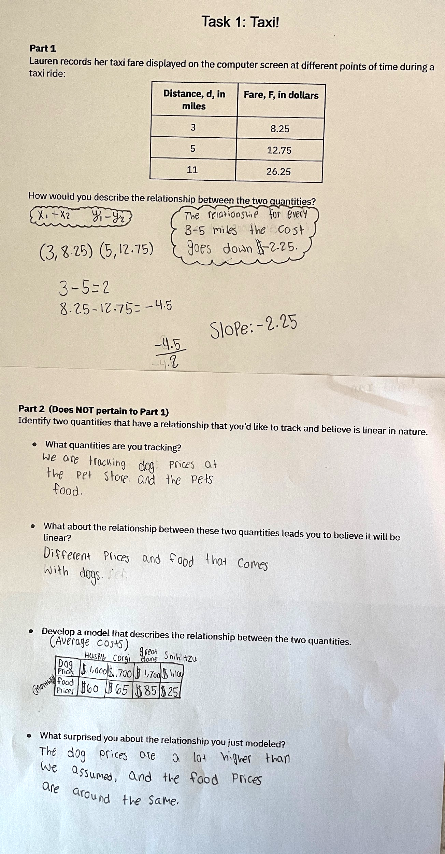

Example 3:
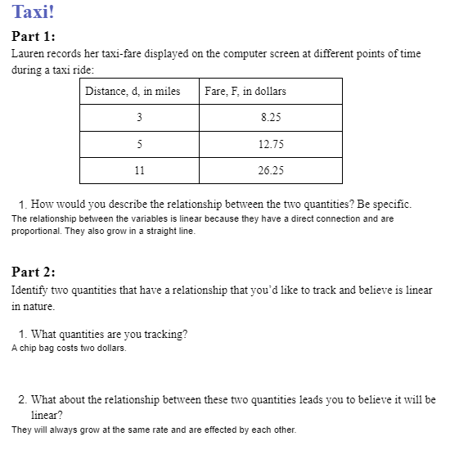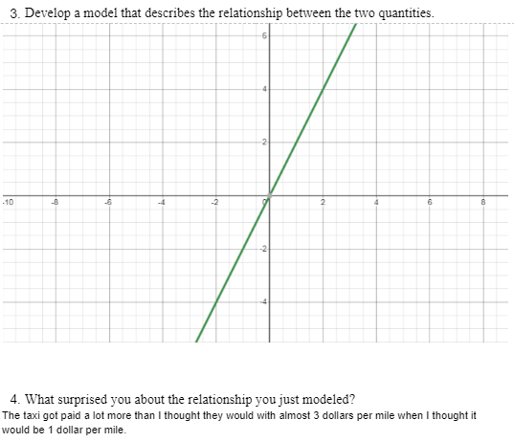

Let’s do some math! Round 2

Task 2: Median Monthly Rent
Share a table that outlines median monthly rent by state, like the one below.

Ask: “What do you notice? What do you wonder?”

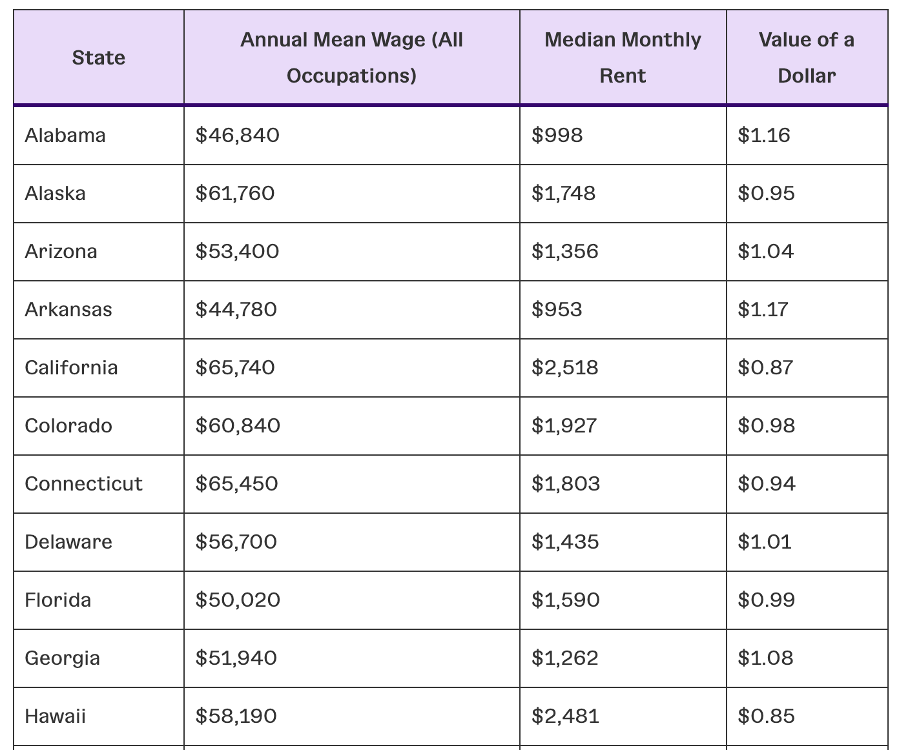
(Source: The Average Cost of Living by State and Why Ignoring It Could Sink Your Business)

Your job is to explore how different income structures impact saving for anmergency fund. Consider the following situation.

Paula works as an electrician and makes about $52,000 a year. Her living expenses are about $2,000 a month. She has saved $12,000, which she estimates is enough for 6 months of expenses in case of emergency.

- Write an equation that represents how much Paula has after $x$ months.
- Graph this equation using Desmos.com or geogebra.org.
- Describe what the graph looks like.
- Why does it make sense that the graph looks like that?

(Source: 25 Jobs That Pay $50K a Year Without a Degree)

Irfan works as a machine assembler for $17 an hour and has about the same cost of living as Paula. He works full-time, which is 40 hours a week. He would like to save for 6 months of expenses.

- Write an equation that represents how much Irfan has after $x$ months.
- Graph this equation using Desmos.com or geogebra.org.
- Describe what the graph looks like.
- Why does it make sense that the graph looks like that?

(Source: Find Jobs: Assembler)
(Additional Resource: Beyond the Farm: Rural Industry Workers in America)

Consider Paula and Irfan’s income structures, living expenses, and their wish to have emergency fund savings. Use features of your graphing software to explore the following:

- Under what conditions will Irfan be able to save $12,000?
- Explore the legal requirements for working overtime. Resource: Overtime Pay
- How many additional hours a week (overtime) will Irfan need to work if he gets paid at a rate of time and a half? Or double his regular rate?
- Prepare to share about the differences you notice between the two workers.

Next, explore income structures for jobs in a field of interest to you. One possible resource is May 2021 National Occupational Employment and Wage Estimates: United States

Develop a plan for saving for 6 months of expenses for an emergency.
- What are the typical living expenses for your area?
- What is an equation that models how much money you’d have after $x$ months?

Sample Learning Experience

Begin by giving students an opportunity to notice and wonder about data found on a median monthly rent table. Build on their wonderings to introduce the idea of monthly living expenses. Ask students to identify a state where $2,000 would be a reasonable estimate of monthly living expenses.

Give students time to begin exploration independently, then invite them to work in pairs to engage in the exploration. As students work, monitor for ways they communicate their reasoning.
Some students may use features of the graphing software to focus on particular points of interest, while others may create a table of values to compare and illustrate the changes they see.

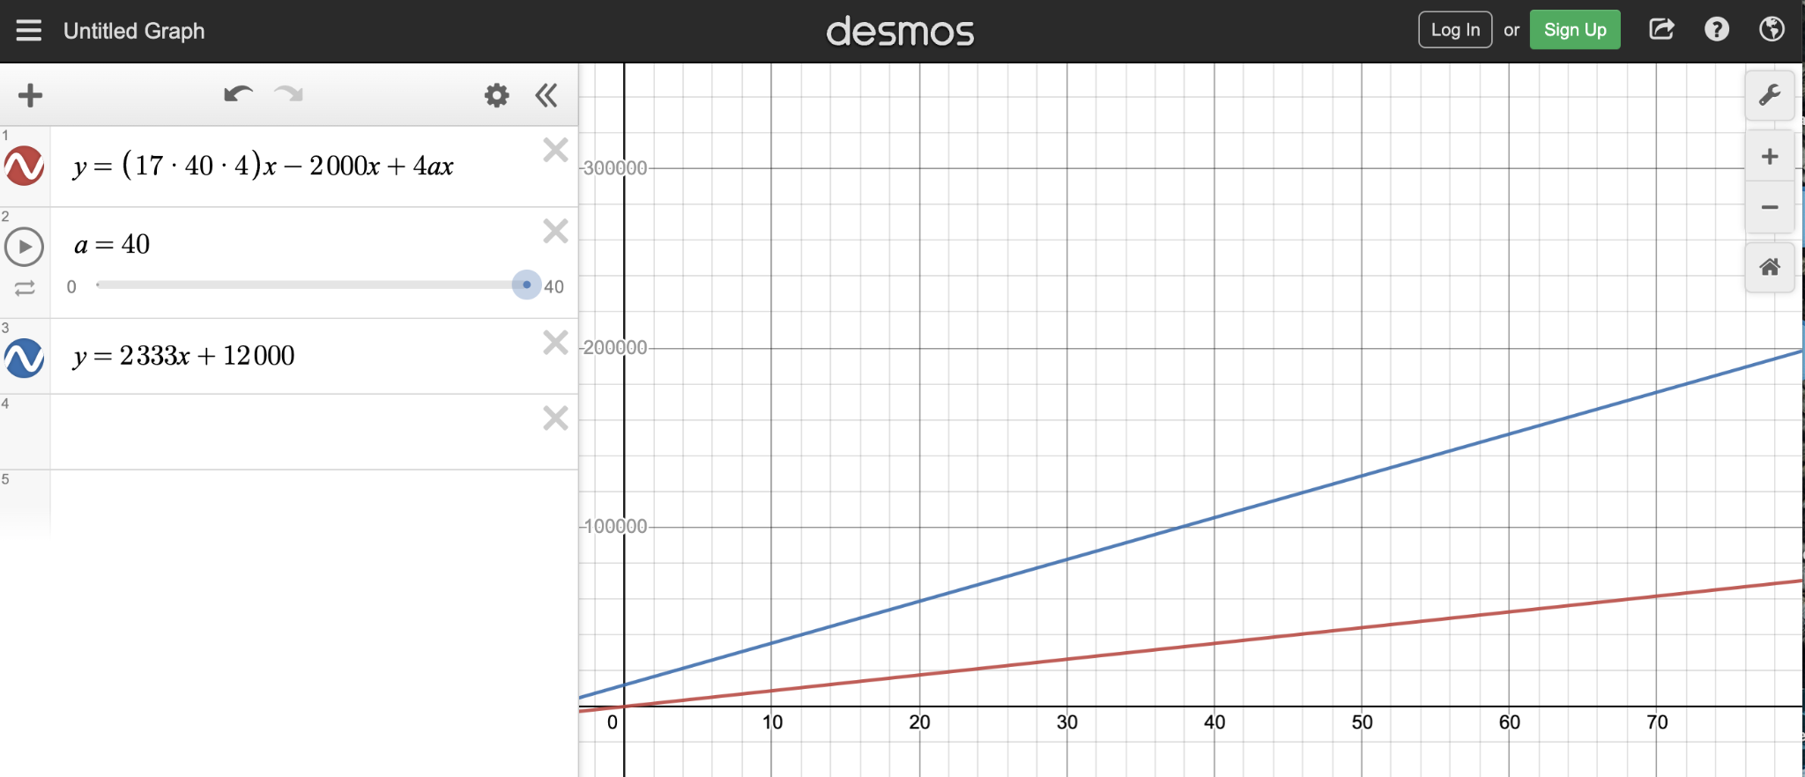

Facilitate the discussion about the exploration. Here are some points to emphasize:

- Connections between the context, features of the graph (slope and y-intercept), and impact on the graph as constraints and assumptions change. For example, if Paula gets a raise, the line has a greater slope and the line is steeper. The rate of change is also greater.
- Encourage students to compare the structure of the resulting equations, when parameters changed, with the structure of the original equation they determined in A.

Give students additional time to revise their work.

Task 2: Median Monthly Rent Student Work

Example 1:
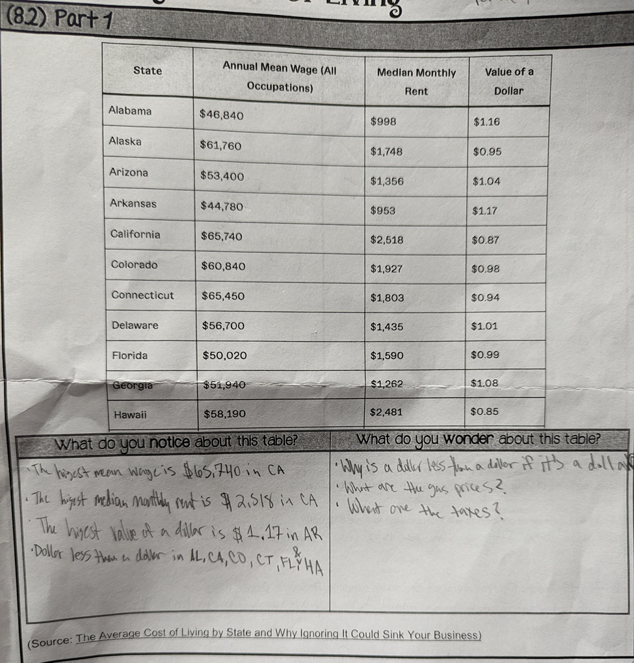
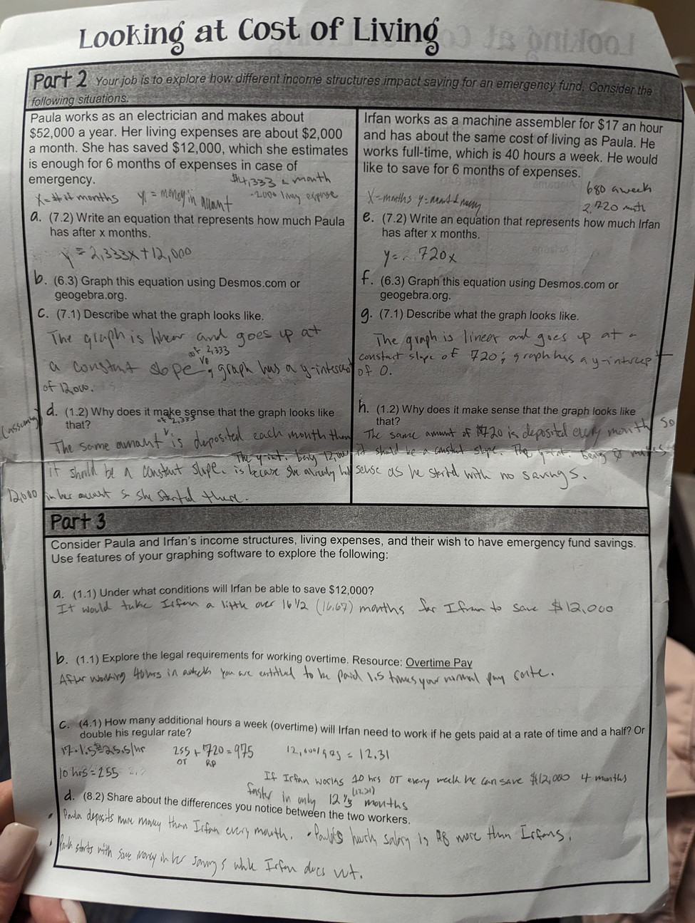
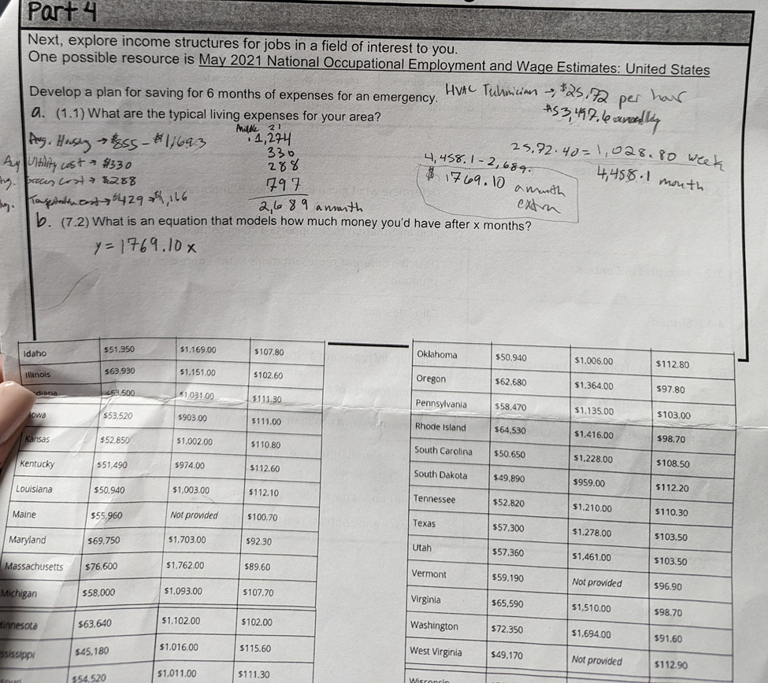

Example 2:

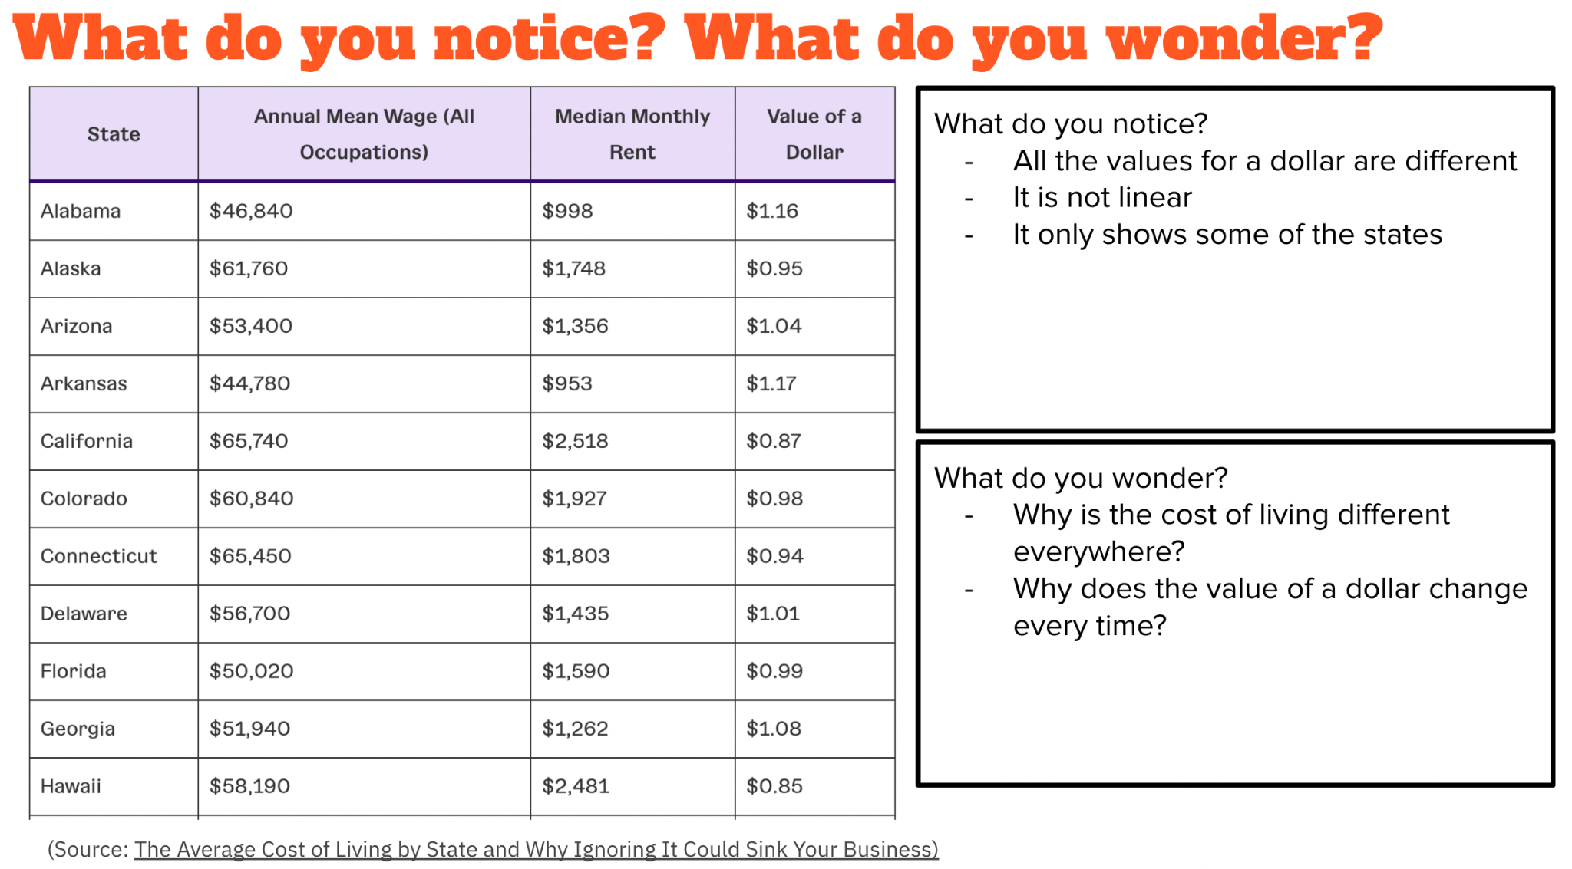
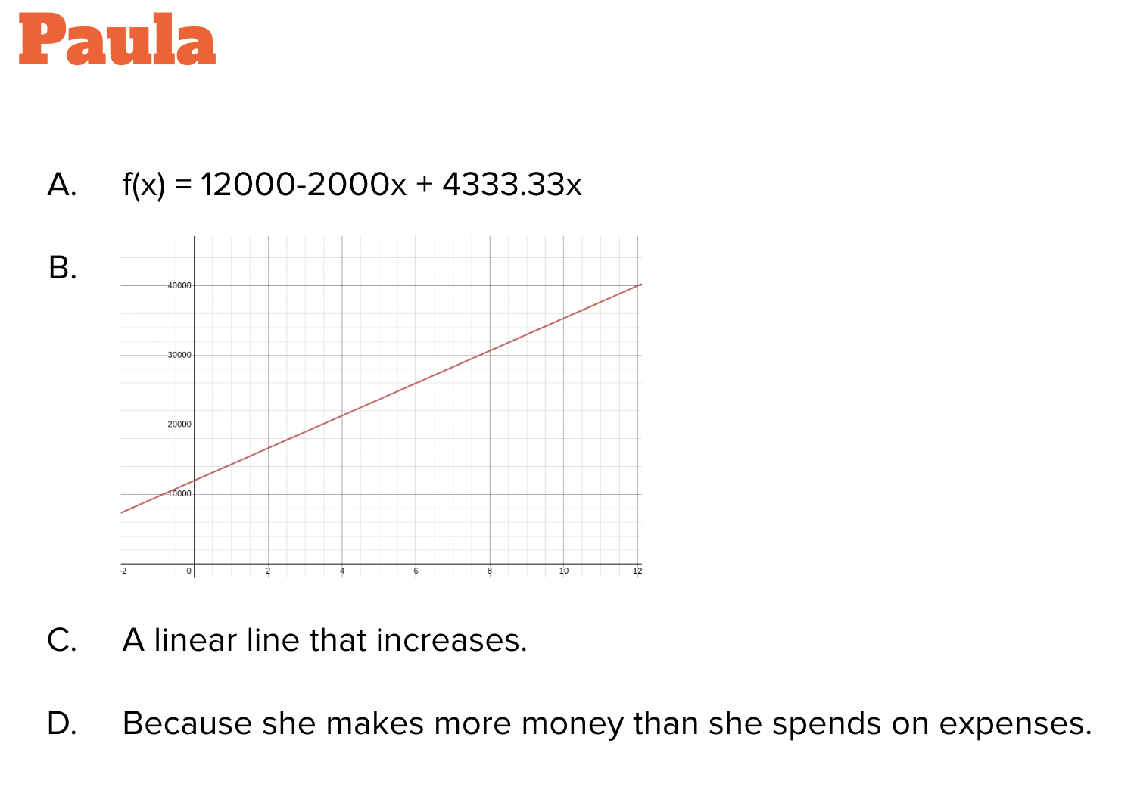
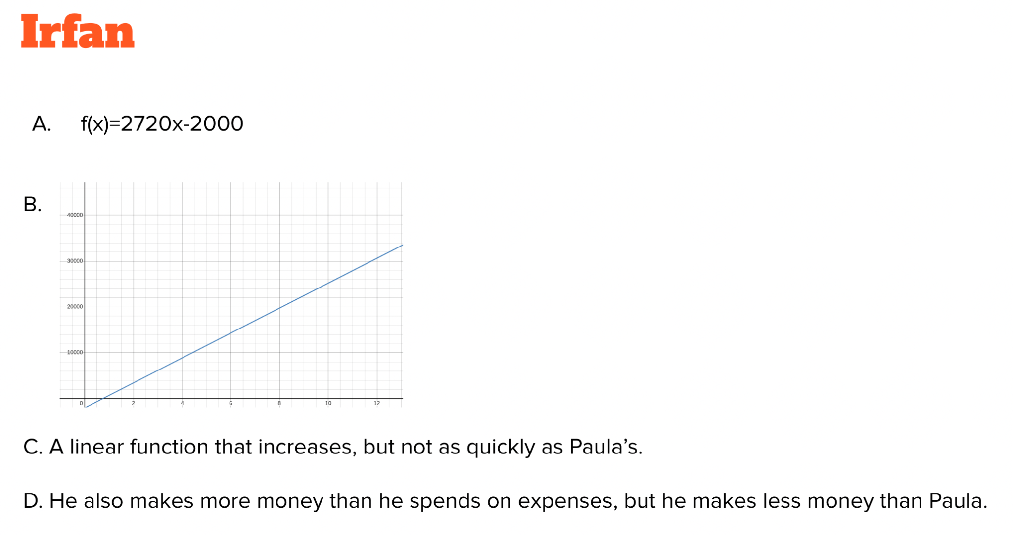
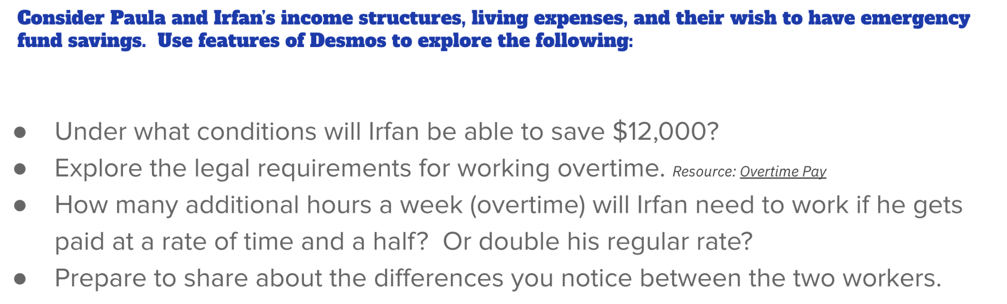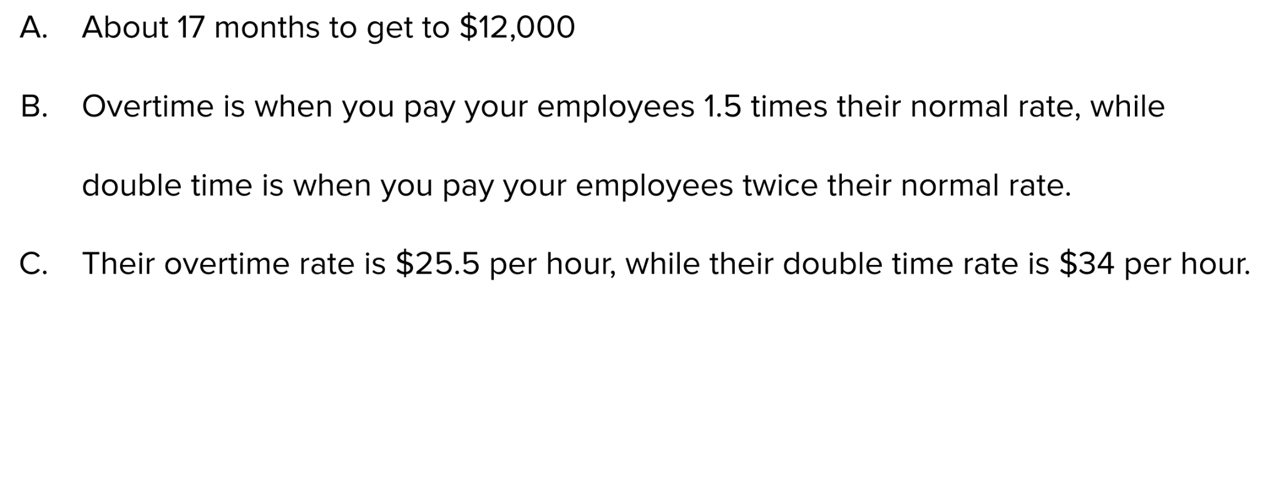

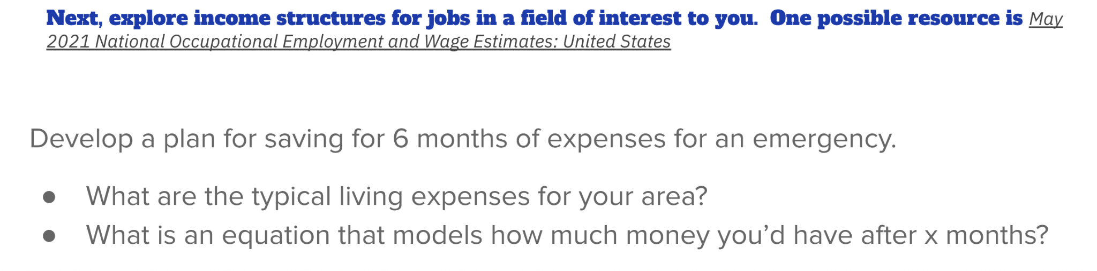
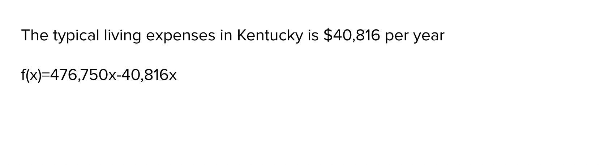

Example 3:
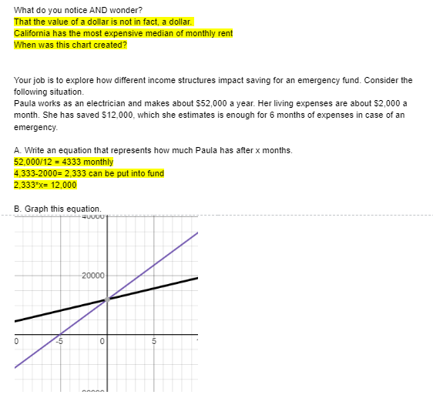
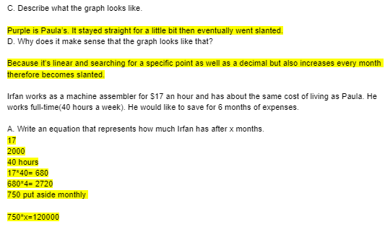
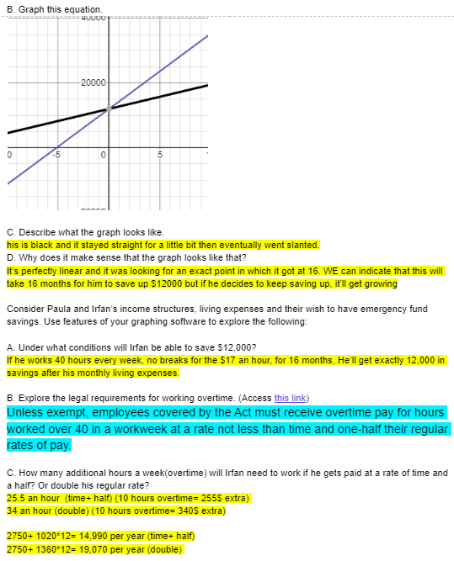
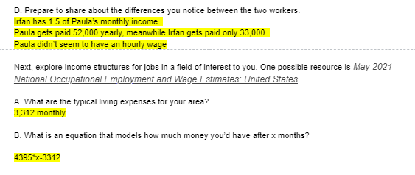

Criteria for Success

Conference and Provide Revision Support | Accept with Revision | Accept
The student’s artifact shows an emerging understanding of the expectations of the indicator(s). After conferencing and additional instruction/learning, the student may provide a revised or different artifact as evidence of the indicator(s). | The student’s artifact is approaching a full understanding of the expectations of the indicator(s). The artifact may contain execution errors that should be corrected in revision. The student may revise the selected artifact or submit a different artifact. | The student’s artifact demonstrates evidence that they have met the expectations of the indicator(s).

References

Blakely-Gray, R. (2021, April 1). The Average Cost of Living by State, and Why Ignoring it Could Sink Your Business. From Patriot: https://www.dchealthmatters.org/indicators/index/view?indicatorId=15&localeTypeId=3

Common Core Standards Writing Team. (2016, August 17). Progressions for the Common Core State Standards in Mathematics (draft). High School, Quantity. Tucson, AZ: Institute for Mathematics and Education, University of Arizona.

Illustrative Mathematics. (2016, May 4). Kimi and Jordan Task. Illustrative Mathematics High School Functions.
https://tasks.illustrativemathematics.org/content-standards/HSF/BF/A/1/tasks/241

Illustrative Mathematics. (2016, May 4). Sandia Aerial Tram. Illustrative Mathematics High School Functions.
https://tasks.illustrativemathematics.org/content-standards/HSF/BF/A/1/tasks/241

Illustrative Mathematics. (2016, May 4). Taxi!. Illustrative Mathematics High School Algebra, Functions.
https://tasks.illustrativemathematics.org/content-standards/tasks/243

Indeed Editorial Team. (2021, June 9). 25 Jobs That Pay $50K a Year Without a Degree. From Indeed Career Guide: https://www.indeed.com/career-advice/finding-a-job/jobs-that-pay-50k-without-a-degree

