Example 1: Micro-mobility: Is it worth it?
Cities have begun to offer micro-mobility options like shared electric scooters and bikes in hopes of meeting the transportation needs of their communities. For this task, you will explore the limits and possibilities of using such devices.
Use Google Maps to locate at least three places of interest. Some options could include your school site, a place you go to often, or a place of work. Use technological tools, like Desmos or GeoGebra, or transparency paper to superimpose a coordinate system over your map. Make sure to turn in this map with your solutions.
- If you were to use an electric scooter that can travel 35 miles on a single charge, would you be able to make the trip from the first place of interest to the second, and return back to the first point of interest? Justify your response using words, numbers, and symbols.

- How long would it normally take to make that round trip using other modes of transportation you have access to (car, bus, or walking)? How long do you estimate it would take to make the trip on a scooter? Support your claim using mathematical evidence.

- What are the advantages and disadvantages of offering micro-mobility options? Explain your reasoning.

Example 3: The Marchetti Constant

Cesare Marchetti, a physicist and systems analyst, proclaimed that people are willing to commute from their homes for about half an hour each way. This idea is known as the Marchetti Constant.

Ancient Rome, around 275 CE, was a “walking city,” meaning that the main mode of transportation was by walking. The map below illustrates an outline of the city during that period.
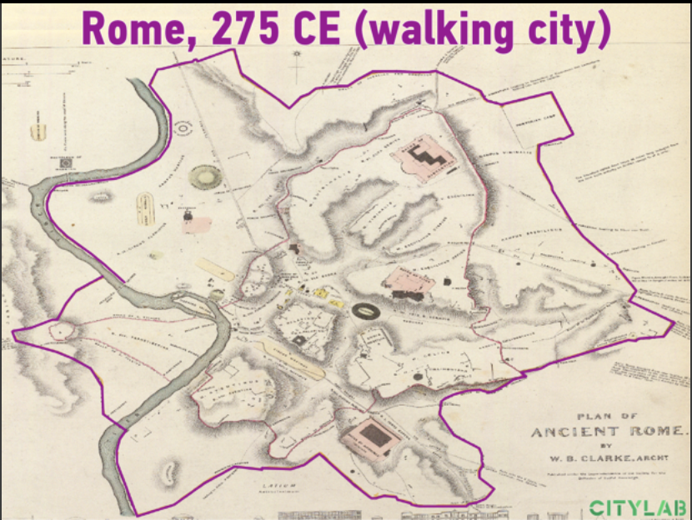
(Source: The Commuting Principle That Shaped Urban History - Bloomberg)

Use geometric concepts and tools to determine the degree of accuracy of the model outlined in purple in the diagram above. Aspects to explore and express in mathematical terms are as follows:

- What is the approximate diameter of the city? Why does that make sense, in terms of what you know about typical walking rates?

- What is the approximate area of ancient Rome? Explain your findings.

Running water into homes was a luxury in ancient Rome. Therefore, Roman citizens were provided potable water by way of strategically placed water fountains throughout the city. It is believed that water fountains were located within a 50-meter radius from each other (Water System of Ancient Rome).

- Based on the work you’ve done so far, about how many water fountains were present in the city at that time?

- Extension: Explore the historical roots of the city you live in. How has the radius of the city changed over time? Does the Marchetti Constant hold?

