Example 1: Eco-Friendly Product

Part 1: Design Phase (Option 1—Game Controller)
You are a small business owner and you will create a new controller (or gaming device) for your favorite gaming system. You plan to sell your product on an online store to reach a greater market.  - Consider the qualities that make a controller effective for gaming and identify design elements that may hinder its usability.  - Create a rough sketch of your controller or gaming device design.  Consider the shapes you’ll use in your redesign: a prism, cone, pyramid, or some combination of these shapes [or any three-dimensional geometric figure you can describe.]  - Determine the size/dimensions of your product. |  | 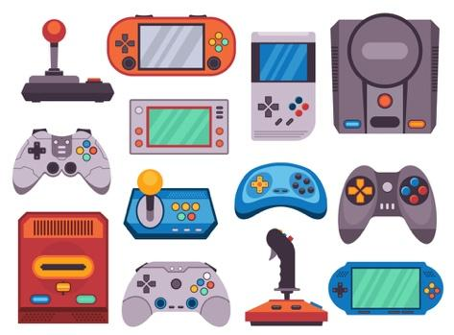  Need inspiration:  Consider old and current gaming controllers and handheld gaming devices
Explain your design:

Part 2: Ecofriendly product
- Investigate the different methods that companies are using to create environmentally sustainable products. What did you learn? Why might this be important?  - What do you want to aspire to as you reflect on the design of your product? If you need to revisit and redesign your product, you may. |   Need inspiration:  - What Does Eco-Friendly Actually Mean?  ● What Does Eco-Friendly Mean?  - Eco-Friendly Building Materials  - Sustainable Materials  - Recycled Materials: Design the controller using recycled materials such as recycled plastic or bioplastics made from renewable resources. This reduces the reliance on virgin materials and minimizes environmental impact.  - Biodegradable Components: Incorporate biodegradable components into the controller's construction. This includes buttons, casing, and other parts made from biodegradable materials that break down naturally at the end of the product's life cycle.  - Solar-Powered: Implement solar panels into the controller's design to harness solar energy for charging. This reduces the need for disposable batteries or electricity from non-renewable sources.  - Energy-Efficient: Design the controller to be energy-efficient, with features such as automatic power-off when not in use or low-power consumption components to extend battery life.  - Modular Design: Create a modular controller with interchangeable parts that allow for easy repair and upgrades. This extends the lifespan of the controller and reduces electronic waste.  - Carbon Offsetting: Offset the carbon footprint of production and shipping processes by investing in carbon offset projects, such as reforestation or renewable energy initiatives.  - Education and Awareness: Include educational materials with the controller to raise awareness about environmental issues and promote sustainable gaming practices among consumers.

Example 2: Roses for Rosa
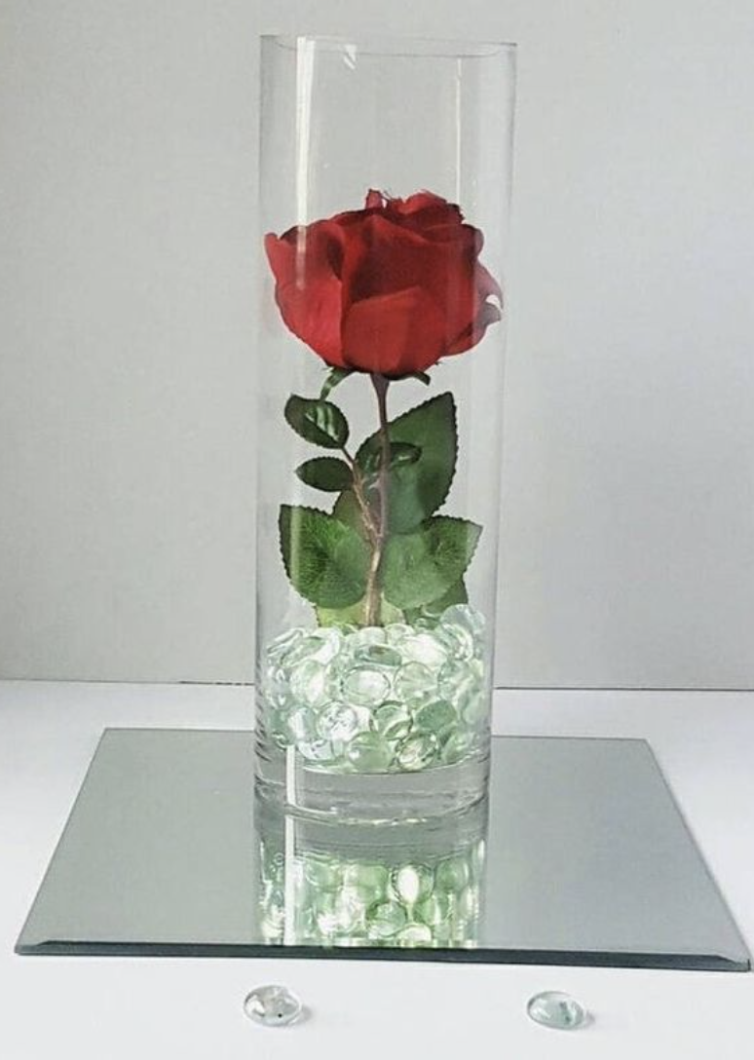

Rosa and her family are planning for her Quinceañera. Each of the 15 tables at Rosa’s reception will have a centerpiece—a cylindrical glass vase filled one-third of the way with glass marbles holding a rose in place.

- The glass vases are 10 inches tall with a 4 inch diameter.
- Rosa can choose between marbles that are 12mm or 16mm in diameter.
- The 12mm marbles cost $11.99 for 340 pieces.
- The 16mm marbles cost $11.99 for 140 pieces.
- Rosa spent $110 on the vases.
- The florist is not charging Rosa for the 15 extra roses for the centerpieces.

- If Rosa chooses 12mm marbles, how many bags will she need? How many bags will she need if she chooses 16mm marbles?
- Rosa’s budget for the centerpieces is $250. Will she be able to stay within her budget?
- The marble company also sells 8mm marbles (1100 pieces for $11.99). Would you recommend Rosa buy these marbles instead?

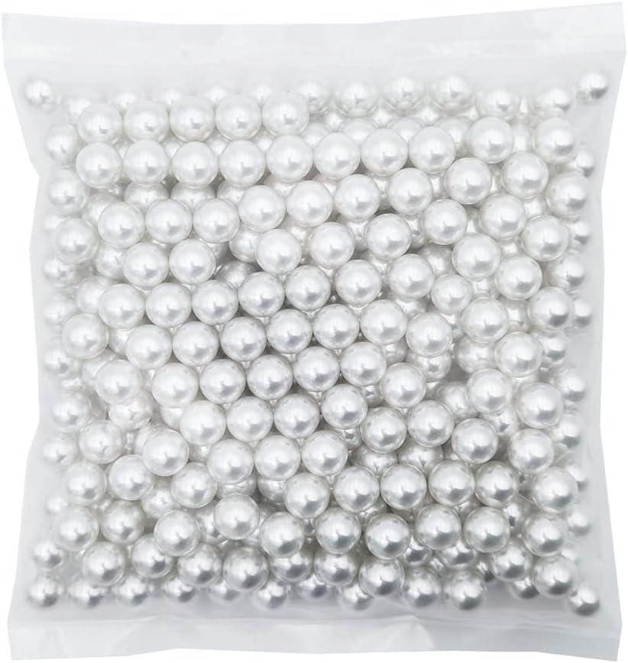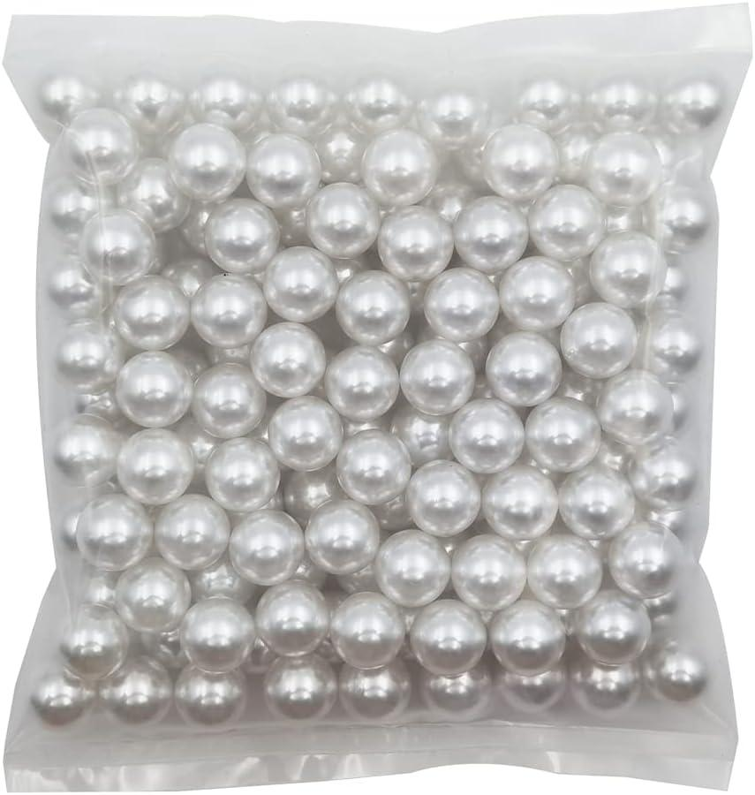

12 mm marbles 16 mm marbles
340 pieces 140 pieces
$11.99 $11.99

Example 3: Similar Solids

Name:
Similar Solids
- What are some ways these two solids are alike?

- What are some ways these two solids are different?

A B

- What information would you need to calculate the volume of each solid?

- What is the same and different about how you would find the volume of each solid?

These images show the same number of coins arranged in different ways:

C D
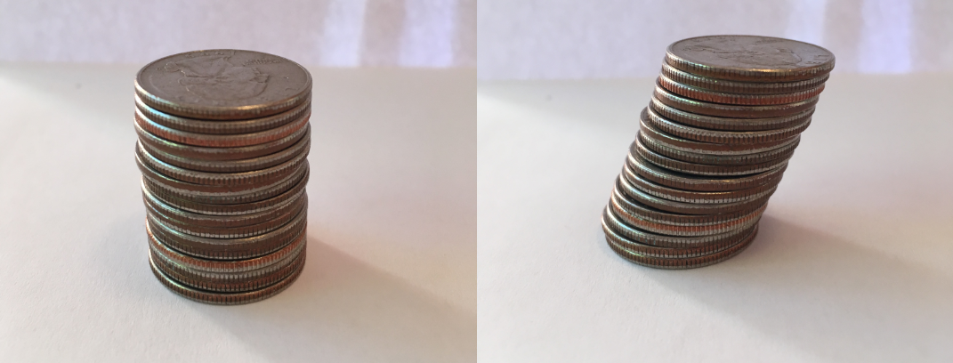

- How are the two coin stacks different from each other?

- Does either stack resemble a geometric solid? If so, which stack and solid?

- How do the heights of the two stacks compare?

- How do the volumes of the two stacks compare? Explain your reasoning.

