Baseline Professional Learning Handout
M202 Rational Exponents and Complex Numbers

Baseline Professional Learning Handout 1
High School, Number Progression Excerpt 2
M202 Content and Practice Expectations 3
M202 Content and Practice Expectations and Indicators 3
Let’s Investigate 4
Evaluating Exponential Expressions Task 4
Powers of a Complex Number Task 5
Let’s do some math! Round 1 6
Task 1: Working with Complex Numbers 6
Learning Principles 8
Task 1: Working with Complex Numbers Student Work 9
Let’s do some math! Round 2 10
Task 2: Fractional Exponents 10
Task 2: Fractional Exponents Student Work 13
Criteria for Success 14
Selected Common Core High School Standards for Mathematics

High School - Number and Quantity
Extend the properties of exponents to rational exponents
- Explain how the definition of the meaning of rational exponents follows from extending the properties of integer exponents to those values, allowing for a notation for radicals in terms of rational exponents. For example, we define $5_{}^{\frac{1}{3}}$ to be the cube root of 5 because we want ${\left(5^{\frac{1}{3}}\right)}^{3}=5^{\left(\frac{1}{3}\right)3}$to hold, so ${\left(5^{\frac{1}{3}}\right)}^{3}$ must equal 5.
- Rewrite expressions involving radicals and rational exponents using the properties of exponents.

Perform arithmetic operations with complex numbers
- Know there is a complex number $i$ such that $i^{2}=–1$, and every complex number has the form $a+bi$ with $a$ and $b$ real.
- Use the relation $i^{2}=–1$ and the commutative, associative, and distributive properties to add, subtract, and multiply complex numbers.

Use complex numbers in polynomial identities and equations
- Solve quadratic equations with real coefficients that have complex solutions.

High School, Number Progression Excerpt
The Real Number System
Use properties of rational and irrational numbers An important difference between rational and irrational numbers is that rational numbers form a number system. If you add, subtract, multiply, or divide two rational numbers, you get another rational number (provided the divisor is not 0 in the last case). The same is not true
of irrational numbers. For example, if you multiply the irrational number 2 by itself, you get the rational number 2. Irrational numbers are defined by not being rational, and this definition can be exploited to generate many examples of irrational numbers from just a few.^{N-RN.3} For example, because $\sqrt{2}$ is irrational it follows that $3+\sqrt{2}$ and $5\sqrt{2}$ are also irrational. Indeed, if $3+\sqrt{2}$ were an irrational number, call it $x$, say, then from $3+\sqrt{2}=x$ we would deduce $\sqrt{2}=x-3$ . This would imply $\sqrt{2}$ is rational, since it is obtained by subtracting the rational number 3 from the rational number $x$. But it is not rational, so neither is $3+\sqrt{2}$.
Although in applications of mathematics the distinction between rational and irrational numbers is irrelevant, since we always deal with finite decimal approximations (and therefore with rational numbers), thinking about the properties of rational and irrational numbers is good practice for mathematical reasoning habits such as constructing viable arguments and attending to precisions (MP.3, MP.6).
Complex Numbers
One remarkable fact about introducing the number i is that it works: the set of numbers of the form $a+bi$, where $i^{2}=–1$ and $a$ and $b$ are real numbers, forms a number system. That is, you can add, subtract, multiply and divide two numbers of this form and get another number of the same form as the result. We call this the system of complex numbers.^{N-CN.1}

M202 Content and Practice Expectations
202.a | Reason about and extend the properties of exponents to rational exponents.
202.b | Reason about and perform operations with complex numbers.
202.c | Analyze and use complex numbers in polynomial equations.

M202 Content and Practice Expectations and Indicators
Content and Practice Expectations | Indicators  Choose an artifact where you…
202.a: Reason about and extend the properties of exponents to rational exponents. | i. explain how the definition of the meaning of rational exponents follows from extending the properties of integer exponents to those values, allowing for a notation for radicals in terms of rational exponents.
 | ii. Rewrite expressions involving radicals and rational exponents using the properties of exponents.
202.b: Reason about and perform operations with complex numbers. | i. Demonstrate understanding that there is a complex number i such that $i^{2}=–1$, and every complex number has the form $a+bi$with a and b real.
 | ii. Use the relation $i^{2}=–1$ and the commutative, associative, and distributive properties to add, subtract, and multiply complex numbers.
202.c: Analyze and use complex numbers in polynomial equations. | i. Solve quadratic equations with real coefficients that have complex solutions.

Let’s Investigate

Evaluating Exponential Expressions Task
Henry explains why $4^{\frac{3}{2}}=8$:
I know that $4^{3}$ is 64 and the square root of 64 is 8.
Here is Henrietta's explanation for why $4^{\frac{3}{2}}=8$:
I know that $\sqrt{4}=2$ and the cube root of 2 is 8.

- Are Henry and Henrietta correct? Explain.

- Calculate $4^{\frac{5}{2}}$ and ${27}^{\frac{2}{3}}$ using Henry's or Henrietta's strategy.

- Use both Henry and Henrietta's reasoning to express $x^{\frac{m}{n}}$ using radicals (here $m$ and $n$ are positive integers and we assume $x>0$).

Source: Illustrative Mathematics

Powers of a Complex Number Task

- Let $z=1+i$ where $i^{2}=–1$. Calculate $z^{2}, z^{3},$ and $z^{4}$.

- Graph $z, z^{2}, z^{3},$ and $z^{4}$ in the complex plane. What do you notice about the positions of these numbers?

- What is $z^{100}$? Explain.

Source: Illustrative Mathematics

Let’s do some math! Round 1

Task 1: Working with Complex Numbers

Students are given a problem like this:
- The diagram represents the sum of two complex numbers: $\left(4+2i\right)+\left(–6-5i\right).$
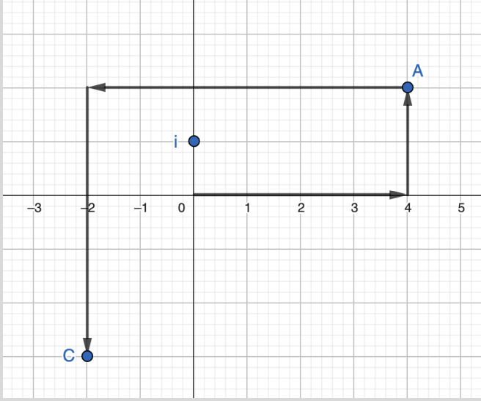
  - Which part of the expression does Point A represent? Explain how you know.
  - What complex number does Point C represent? Explain how you know.
  - Based on the analysis above, describe how to find the sum of two complex numbers.
- Write and record a tutorial for a new classmate that explains how to simplify expressions that involve addition or subtraction of two complex numbers. Be sure to include a diagram that illustrates why your method works.
Sample Learning Experience
Provide time for students to consider Question 1 and independently develop a response. Engage students using the math language routine Stronger and Clearer Each Time, as described below:
- Have students write their response to 1c, including their justification.
- If you have emerging multilingual students in your class, give students a minute to visualize themselves verbalizing their thoughts to a classmate.
- Ask students to meet with a classmate and take turns to share what they wrote (about two minutes each). As one person shares, the other should pose clarifying questions.
- Give students about one minute to reflect on this partner sharing. Encourage students to add new thinking to their original response based on what they heard.
- Have students switch partners and repeat the process of sharing their thinking and refining their response. Repeat this process as much as time permits.

Provide time for students to revise their written justifications using the information gained during their partner-sharing time. While observing student discussions, identify varying solution methods to be presented during the whole group share out. Look for methods that invite connections between the graphical representation and a purely arithmetic approach. Have selected students present their responses—consider using a document camera for students to show actual work—and explain their justification. Focus the discussion on Question 1c. As discussion takes place, invite
classmates to join the discussion. Ask:
- How do you differentiate the real and imaginary axis?
- Why does each axis have a positive and negative side?
- Do you agree with ____ explanation of Point A? What about this explanation is clear to you? How can we strengthen the explanation?
- Is there anything you disagree with in this explanation??

Provide time for students to revise their work.

Use student responses to Question 1c to launch work on Question 2. Pose a question like, “Will the method you described (1c) work for any pair of complex numbers?” Encourage students to explore concrete examples as they prepare their response to Question 2.

Consider inviting select students to share their approach at strategic points in time as they work on Question 2. As students present their ideas, invite classmates to reflect using the following questions:
- What makes sense about the ideas shared?
- What questions surface for you?
- What can you take from this discussion and apply to your own work?

Provide time for students to revise their work. As students continue their work, select additional pairs to share how they structured their investigation to determine a response to the question, “Does this method work for any two complex numbers?” Give students additional time to revise their work.

Learning Principles
Engage with cognitively demanding tasks in heterogeneous settings (LP 1). Students should be given opportunities to grapple with multistep, non-routine tasks that promote mathematical rigor. These experiences should be differentiated so that all students engage in appropriate challenges—for example, through tasks with multiple entry points and solution pathways. These experiences should continue to integrate knowledge and skills developed in grades 6-8 at the level of sophistication of high school mathematics.

Engage in social activities (LP 2). Students should have opportunities to work independently and to communicate with one another about mathematics by engaging in collective and collaborative learning activities. Explaining and having opportunities to revise one’s thinking has excellent value in solidifying one’s knowledge.

Build conceptual understanding through reasoning (LP 3). Students should be given the opportunity to reason, justify, and problem solve with critical thinking, reading, writing, speaking, and listening. Through reasoning and work with multiple representations, students learn why procedures work and build a conceptual understanding of key mathematical ideas.

Have agency in their learning (LP 4). Students should be able to choose tasks and learning experiences that align with their interests and aspirations. All students have rich and varied experiences and home lives. Learning mathematics should bring students’ identities and interests to the fore and build on the strengths that they bring to the learning space.

View mathematics as a human endeavor across centuries (LP 5). Students should understand that mathematical ideas emanated over time from civilizations around the world and have opportunities to explore these contributions to mathematics. Students should develop an appreciation of mathematics as a human endeavor: one in which they feel a sense of belonging, where they see themselves as mathematicians, and one that offers opportunities to broaden their ideas about what mathematics is, how it is used, and who it is for.

See mathematics as relevant (LP 6). Students should engage with mathematics in ways that authentically involve real-world situations. Problem-solving contexts should allow students to perceive mathematics as a tool for addressing the questions that arise in everyday life, as well as the ways it can model our world and address global economic, social, and environmental challenges. Students should also engage with mathematics in ways that connect to academic disciplines and future careers by doing the mathematics used by artists, designers, engineers, and other professionals.

Employ technology as a tool for problem-solving and understanding (LP 7). Research indicates that technology is a powerful tool for learning deeper mathematics by improving calculation efficiency and enabling more sophisticated analysis. Students should learn to use technology, with emphasis put on widely used tools and software, such as calculators and spreadsheets, to make sense of models. Technology use should not be limited to supporting “doing mathematics,” but should also be used as a tool for displaying and communicating results to appropriate audiences.

Task 1: Working with Complex Numbers Student Work

Example 1:

Insert image of student work here

Example 2:

Insert image of student work here

Example 3:

Insert image of student work here

Let’s do some math! Round 2

Task 2: Fractional Exponents
Students are given a problem like this:

Part 1
Let’s think about what $a^{\frac{1}{2}}$ means.

- Select some value for $a$ and develop a table to show that for some values for $a^{x}$ , $x$ is any set of integer values of your choice.

- Based on the values from your table, make an educated guess about the value of $a^{\frac{1}{2}}$. Explain your reasoning.

- Check the actual solution for $a^{\frac{1}{2}}$. Explain why this answer makes sense. If the answer is different from your guess above, write down two-three ideas or questions you can pose to help examine why $a^{\frac{1}{2}}$ has the designated value.

- Based on conclusions you’ve reached, what do you anticipate something like $a^{\frac{1}{2}}$ means?
  - How can you use what you see in your table or what you know about properties of exponents to explain what this means?

Part 2
- Based on the discussion of Part 1, what do you anticipate the values of $a^{\frac{1}{3}}$ and $a^{\frac{1}{4}}$will be?
  - How can you use what you see in your table or what you know about properties of exponents to explain what this means?

- Create a video or animated short explaining what an expression like $d^{\frac{m}{p}}$ means.

Sample Learning Experience
Part 1
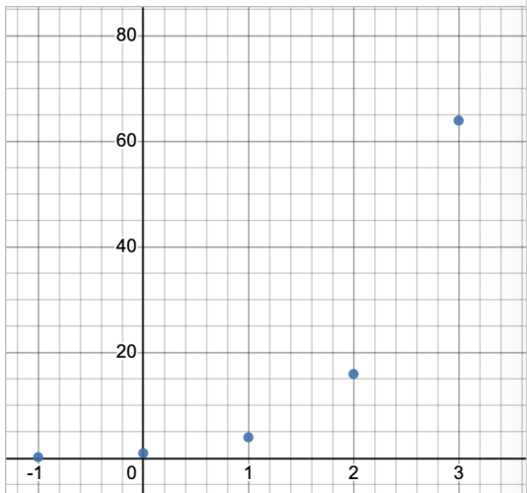
After some individual work time, where students develop an approach to the prompt, encourage them to share and compare approaches. Students should have access to tech tools that facilitate problem solving, like spreadsheets and scientific and graphing calculators. As students share with partners, monitor and select a couple of approaches to highlight and reflect on progress made at this point. Look for student work that offers space to discuss choices students made about values to use as the base and exponents, as well as a variety of ways that students reasoned about this. Some sample approaches are illustrated below.
$4^{1}$ | $4^{\frac{1}{2}}$ | $4^{2}$ | $4^{3}$
4 |  | 16 | 64

$2^{1}$ | $2^{\frac{1}{2}}$ | $2^{2}$ | $2^{3}$
2 |  | 4 | 8

${25}^{1}$ | ${25}^{\frac{1}{2}}$ | ${25}^{2}$ | ${25}^{3}$
25 |  | 625 | 15625
Questions that can be posed to student pairs as they work and/or as students share with classmates:
- How did you decide on a value of 𝑎 to use?
- How are you selecting powers of 𝑎 to use? Which powers of 𝑎 are helpful in reaching a conclusion?
- Did you notice anything interesting about the values? What is happening to your numbers?
- How did you reach a conclusion about the meaning of a fraction as an exponent?
Give selected pairs of students time to share responses and invite classmates to reflect on the following questions:
- What’s promising about this approach?
- What questions does this approach surface for you?
- What can you take from this approach to apply to your own work?
Provide additional time for students to revise their work, as well as to make progress on the additional prompts in Part 1. While they work, select additional pairs to share how they used the structure of the expressions and their understanding of the values, either by way of reasoning through the values in the table and/or graphs, to reach conclusions. Give students additional time to revise their work. Consider the benefits of holding whole class discussions after Question 2 and again after Question 4. Chart key findings that students can build from to transition to Part 2.
Part 2
After some individual work time, where students develop an approach to the prompt, encourage them to share and compare approaches. Consider using similar prompts as listed above to give space for students to develop a strategic approach. After a whole group discussion of Question 5, provide additional time for students to revise their work and to develop their response to Question 6. Showcase student videos and animations. Give students an opportunity to reflect on this experience and revise their work as they see fit. Some questions for reflection are as follows:
- What is something you learned about yourself in conducting this mathematical investigation?
- What is something you’re proud of?
- What is a new insight you have about how mathematics works?

Task 2: Fractional Exponents Student Work

Example 1:

Insert image of student work here

Example 2:

Insert image of student work here

Example 3:

Insert image of student work here

Criteria for Success

Conference and Provide Revision Support | Accept with Revision | Accept
The student’s artifact shows an emerging understanding of the expectations of the indicator(s). After conferencing and additional instruction/learning, the student may provide a revised or different artifact as evidence of the indicator(s). | The student’s artifact is approaching a full understanding of the expectations of the indicator(s). The artifact may contain execution errors that should be corrected in revision. The student may revise the selected artifact or submit a different artifact. | The student’s artifact demonstrates evidence that they have met the expectations of the indicator(s).

