M111B Performance Task
Measuring Up

The Modeling Cycle
In this task, you will examine statistics associated with a sports champion, a sleep study of Americans, or another topic of your choice to compare to your own analysis of a smaller, local population and apply the basic mathematical modeling cycle to make predictions, interpret information, and report your findings.
Mathematical models are used to make sense of ideas and phenomena in our world. As illustrated in the diagram below, the modeling cycle is a process of collecting data about an idea or problem, creating models of that data, analyzing the story told by those models, and reporting the results to the appropriate audience.
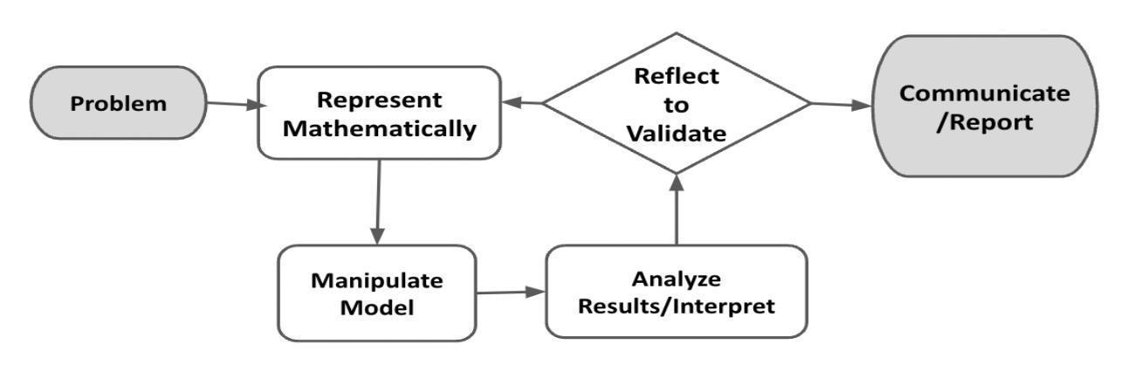
Figure 1. Diagram of Modeling Process. From “Progressions for the Common Core State Standards for Mathematics” [Draft manuscript], by CCSS Writing Team, 2019, p. 6.
In this task, you will be engaging with this mathematical modeling cycle to analyze data, evaluate findings, and identify trends. You will use the models and your takeaways from this task to create a product that reflects your interpretation of your data. You will generate and describe statistics such as standard deviation and median, create and justify a visual to explain your data, and identify an audience who would benefit from your data, among other final questions and tasks.

Introduction: Measuring Up
We compare a lot as a society. Who is the best actor? Which car is the better buy? How much does the typical American spend on toilet paper? It is how we determine the best, worst, and typical of everything in populations of people, places, and things. Any time we collect numerical data for one variable, we are analyzing one-variable statistics.

QUESTION 1
 | Think about yourself. Make a list of things you enjoy and/or interesting things that are happening in your life. Consider facts, interests, and/or talents.

QUESTION 2
Considering what you shared in Question 1, do you think you do more, do less, are better, or are worse? Or are you average, in the middle?

What quantities could be measured to make a comparison? Why would a comparison be important?

Measuring Up
Choose Your Own Adventure
In this performance assessment, you will compare statistics already compiled by a group like the U.S. Census, ESPN, or another source related to the population of your choosing. You will need to gather data from an appropriate sample of your population, compute statistical measures, build models like dot plots, and compare these to pre-prepared statistics.
Your Task: Pick one of the options below:
OPTION A: Compare a famous athlete to yourself or one of the athletes in your school. They will need to play the same sport. You will need to select one variable to compare (e.g., compare the 3-point throws for Stephan Curry and yourself or starting point guard).
OPTION B: Compare the national sleep patterns to the sleep patterns in your class, family, or another group.
OPTION C: Pick another topic for which you will compile a data set about yourself or something of interest to you locally to compare against statistics that have already been compiled for another population.

In the Problem and Formulate sections, you will gather data for your option, then evaluate this relationship to identify a model of best fit and create a related equation. The Problem Formulation Checklist can be used to ensure you have the necessary components before moving on to the remaining parts of the task.

Note: You are welcome to use additional paper or digital forms to document your work. Be sure to include all of your work in your final submission.

Problem
ACTION 1
Use search engines to help you explain why your selected comparison matters. Summarize the following information:
- State your option and what you intend to compare.

- Provide a purpose to your option.

- Describe what you expect to learn.

ACTION 2
Write a one-variable statistical question to collect data based on your response in Action 1.

ACTION 3
Define the variable you will investigate through your statistical question and the population that you will sample.

Formulate
ACTION 4
Describe your data collection plan. Refer to these guiding questions:
- Can you investigate your statistical question? Or do you need to narrow your focus to make your question more specific?
- What data can help you investigate your statistical question?
- How much data should you collect?
- How will you collect your data?
- What type of bias might you encounter?
- How can you minimize bias?
- How frequently do you need to collect data?

Problem Formulation Checklist
Requirement | Fulfilled?
I clearly identified what I will be comparing and its significance. | ▢
I wrote a measurable, one-variable statistical question. | ▢
I defined my variables and sample population. | ▢
I described a clear data collection plan that addresses bias. | ▢
Teacher Consultation: | ______________

In the Represent Mathematically and Interpret & Analyze sections, you will collect your data, compute statistical measures of center and spread, and model the data with an appropriate visual display. Write a statement explaining why you chose this particular display. The Represent Mathematically Checklist can be used to ensure you have the necessary components before moving on to the remaining parts of the task.

Represent Mathematically
ACTION 5
Carry out your data collection plan. Describe any modifications, if any, you needed when carrying out your data collection plan.

ACTION 6
Generate the following statistics for your data set.
- mean
- standard deviation
- median
- interquartile range

Explain the meaning of these statistics in the context of your data set.

ACTION 7
Choose and create an appropriate visual to display your data. Explain why the visual you chose is appropriate for your data.

Represent Mathematically Checklist
Requirement | Fulfilled?
I completed and compiled the data collection to be included in the report. | ▢
I described any modifications that may have been necessary in my data collection. | ▢
I generated the necessary statistics and interpreted each of them. | ▢
I chose a data display that is appropriate for the data set. | ▢
Teacher Consultation: | ______________
In the Analyze and Interpret Results section, you will include an interpretation of your data. Use the measures you calculated above to support your response to the questions posed. The Analyze and Interpret Results Checklist can be used to ensure you have the necessary components before moving on to the remaining parts of the task.

Analyze and Interpret Results
ACTION 8
Choose the measure of central tendency and spread appropriate to your data. Explain your rationale.
ACTION 9
Decide how you will determine and address outliers. Provide a summary of the evidence you considered when addressing outliers.

QUESTION 3
Recall in Action 1 that you shared the purpose of the comparison you selected.
What story did the data tell relative to your purpose?
Who would benefit from these data, and how would they benefit?

Analyze and Interpret Results Checklist
Requirement | Fulfilled?
I selected the measures of central tendency and spread that are accurate and appropriate for the data. | ▢
I explored the possible effects of outliers using the shape, center, spread, and context of data sets. | ▢
I told the story of the data that accurately interprets and uses the results of the analysis to explain how this information can be useful. | ▢
I identified the audience who would benefit from this data. | ▢
Teacher Consultation: | ______________

In the Validate and Report section, you will add on to the document you started above and clarify the voice and audience. In the Validate section, you will explain whether the data were sufficient for addressing your statistical question or how you would improve the process in the future. You will also create an appropriate way to report the findings from your work to the intended audience (e.g., through a short video, pamphlet, or other visual). The Validate and Report Checklist can be used to ensure you have the necessary components for completing the task.

Validate and Report
ACTION 10
Validate your model using these guiding questions.
- Did the data sufficiently address the question you were investigating? Why or why not?
- If you were to try to collect data to answer your statistical question again, how would you adjust your process, your question, and/or how you analyzed the data to provide better information to the audience interacting with your data?

ACTION 11
Communicate your results in a manner and format that are appropriate for the audience and purpose you identified in Questions 2 and 3, in a way that most clearly illustrates your findings.

Validate and Report Checklist
Requirement | Fulfilled?
I provided a rationale showing how the data sufficiently addressed the question at hand or I articulated a clear understanding about how to improve the data collection and analysis in the future. | ▢
I clearly communicated the results in a way that is appropriate for the intended audience. | ▢
Teacher Consultation: | ____________

