M111B Performance Task
Measuring Up
Modeling with Data: One-Variable Measurement Data
Teacher Version

Design Notes
In this task, students will determine and create an appropriate way to report the findings they analyze and visualize using the one-variable data they collect focused on making a comparison between two populations. This performance task is structured to guide students through the process of simultaneously engaging in each component of the modeling cycle and developing a report. Students will be recording information as they go through different sections. This can either be captured in an online word processing document or on standard notebook paper. Student-teacher consultations have been built in to scaffold the process. Consider using those structured check-in points as places where select student(s) share their approach/findings with the class to support the collective learning of the class. This learning experience centers around the CCSSM modeling cycle as illustrated below:
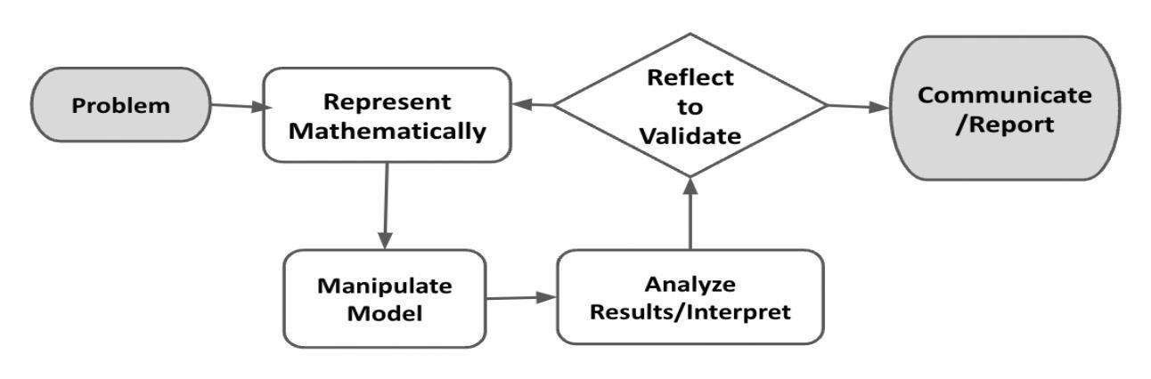
Figure 1. Diagram of Modeling Process. From “Progressions for the Common Core State Standards for Mathematics” [Draft manuscript], by CCSS Writing Team, 2019, p. 6.

Connections to Learning Principles
Students will:
- collect data outside of the classroom and engage in social interactions (LP1 & LP2);
- build conceptual understanding through thinking deeply about the causes of wait-time delays in a given setting and collecting data to inform how to help alleviate this problem (LP3);
- have agency in their learning as they select a question of interest to explore and decide the best way to collect data related to their question (LP4);
- see how data can be used to drive improvements that make our lives better (LP6); and
- have the opportunity to use technology to help organize and understand their collected data (LP7).

The following pages provide teacher versions of this task with guidance, suggestions, and comments in red and sample student responses in blue italics.
Student Task

The Modeling Cycle
In this task, you will examine statistics associated with a sports champion, a sleep study of Americans, or another topic of your choice to compare to your own analysis of a smaller, local population and apply the basic mathematical modeling cycle to make predictions, interpret information, and report your findings.
Mathematical models are used to make sense of ideas and phenomena in our world. As illustrated in the image below, the modeling cycle is a process of collecting data about an idea or problem, creating models of that data, analyzing the story told by those models, and reporting the results to the appropriate audience. In this task, you will be engaging with this mathematical modeling cycle to analyze data, evaluate findings, and identify trends.
Figure 1. Diagram of Modeling Process. From “Progressions for the Common Core State Standards for Mathematics” [Draft manuscript], by Common Core Standards Writing Team, 2019, p. 6 (http://mathematicalmusings.org/wp-content/uploads/2022/05/modeling_02082019.pdf).

Introduction: Measuring Up
We compare a lot as a society. Who is the best actor? Which car is the better buy? How much does the typical American spend on toilet paper? It is how we determine the best, worst, and typical of everything in populations of people, places, and things. Any time we collect numerical data for one variable, we are analyzing one-variable statistics.

QUESTION 1
 | Think about yourself. Make a list of things you enjoy and/or interesting things that are happening in your life. Consider facts, interests, and/or talents.  Answers will vary. Possible student responses:  - I play soccer.  - I love to cook.  - I like to listen to music.  - My family is shopping to buy a house.  - I love sports, games, and all competitions. Track is my favorite sport.
After sharing the Introduction paragraph with students, consider giving students a few minutes of individual think time to generate responses to this question.
Consider offering students various ways to share their thoughts with the class: pair-share, chart, or other spaces.

QUESTION 2
Considering what you shared in Question 1, do you think you do more, do less, are better, or are worse? Or are you average, in the middle?

What quantities could be measured to make a comparison? Why would a comparison be important?

Answers will vary. Possible student responses:
- I’m decent at playing soccer. I get some playing time at every game.
- I make the best Mexican rice! Everyone loves it.
- I have my buds in all day! I definitely listen to music more than anyone in my class!
- I keep hearing my family say that the houses are so much more expensive to buy right now. How much more expensive are they? Is this an effect from the pandemic? Was it cheaper in 2019 (pre-pandemic)? I need to know house prices, and I think that those will show that prices are higher now than before.
- Track and Field has records—there is always “the best” at all levels: youth, middle school, high school, collegiate, and professional. Quantities measured for comparison would be race times and distances/heights for field events.
In answer to the “why a comparison is important”:
- Choosing the better buy
- Deciding whether there is inequality and injustice.
- Comparisons allow us to identify when things are not equal and determine whether that inequality is good or bad to inform our next moves (either fix or reward).
- Comparisons are a big part of sports—the goal is to win, to be the best; you are literally comparing you or your team to the competitor. It’s how you determine the winner or analyze the athlete or team to know where you stand and to improve. Especially when considering track, results are listed in comparison: who crossed the line first, who threw/jumped the furthest/highest, etc.
The rationale for this question is to give a space to surface how students attend to comparison: what qualities or quantities they base their comparisons on, and why comparisons can be important.
Ideas that surface here can help set the stage for statistical questions students will generate for this performance task.
Students might focus on qualitative aspects of comparison; look for ways to coach students through the process of identifying quantitative measures, especially if they elect Option C.

Measuring Up
Choose Your Own Adventure
In this performance assessment, you will compare statistics compiled already by a group like the U.S. Census, ESPN, or another source related to the population of your choosing. You will need to gather data from an appropriate sample of your population, compute statistical measures, build models like dot plots, and compare these to pre-prepared statistics.
Your Task: Pick one of the options below:
OPTION A: Compare a famous athlete to yourself or one of the athletes in your school. They will need to play the same sport. You will need to select one variable to compare (e.g., compare the 3-point throws for Stephan Curry and yourself or starting point guard).
OPTION B: Compare the national sleep patterns to the sleep patterns in your class, family, or another group.
OPTION C: Pick another topic for which you will compile a data set about yourself or something of interest to you locally to compare against statistics that have already been compiled for another population.
Here are sample answers for Option A: track runners, free throw percentage, saves (goalie); Option B: average sleep each night; and Option C: a student-selected topic of housing prices, how many miles walked during a hunt, how far can you punt a football. Allow students the freedom to select what interests them. This will get them more involved.
In the Problem and Formulate sections, you will gather data for your option, then evaluate this relationship to identify a model of best fit and create a related equation. The Problem Formulation Checklist can be used to ensure you have the necessary components before moving on to the remaining parts of the task.

Note: You are welcome to use additional paper or digital forms to document your work. Be sure to include all of your work in your final submission.

Problem
ACTION 1
Use search engines to help you explain why your selected comparison matters. Summarize the following information:
- State your option and what you intend to compare.
- Provide a purpose to your option.
- Describe what you expect to learn.
Sample Answer for Option A:
- I chose Option A, to compare a famous athlete to an athlete in my school. Molly is currently the fastest female at my high school in the 400m and 800m; she made it to finals at state (placed 7th) as a sophomore. She is good for our classification, but she is not the best. Sanya Richards-Ross is. So, how does my high school’s current fastest female 400m runner, Molly, compare to the female American record holder, Sanya Richards-Ross, (48.70) in the women’s 400m? The purpose of this is to compare times of an accomplished high school athlete (who should be very proud of her talents) to the best. How much of a time difference exists between their race times? How consistent are the athletes? Is Molly as reliable as Sanya—can Molly be trusted to run the 400 leg in a relay and make the time expected of her relay team, or do Molly’s times vary too much, and she just ran well at a critical time in the season to place at the state championships? Sanya is the American record holder and is a professional, so I would expect her times to be very consistent and for her to be reliable in a relay. How similar in spread will Molly be to Sanya? These are answers I expect to learn.

Sample Answer for Option B:
- When I looked at sleep data, I learned that it is recommended we get between 7 and 9 hours of sleep. People who sleep less than 7 hours have more health issues. I also learned that young people need more sleep, like 9 hours a night. I know I like to stay up late, and I don’t usually get 9 hours of sleep. I want to learn how much sleep people in my class are getting to see if we are getting the recommended amount of sleep.
Sample Answer for Option C:
- I choose Option C and want to compare house prices near me right now to the national average of house prices in 2022.
- How far can I punt a football, throw a baseball, throw a lacrosse ball, dribble a basketball down the court.
- How many pictures you have in your photo gallery on your phone
- How many TV shows or anime series you have watched from a given list
- What books you have read
- Social media usage on smartphones
- How fast you can text
- How many text messages you send a day
Students might also be interested in gathering more localized data; encourage student agency here and allow students to adjust their focus accordingly, within reason.

ACTION 2
Write a one-variable statistical question to collect data based on your response in Action 1.

Sample Answer for Option A:
- What are Molly’s and Sanya’s typical times in the 400-meter dash?
Sample Answer for Option B:
- I’ve selected Option B and plan to ask my classmates. The statistical question I will ask is: How much sleep do you get in a night?
Sample Answer for Option C:
- How much do houses in my neighborhood currently cost?
- After X punt attempts, what is the average distant?
The statistical question is the question that students will ask their population in order to elicit a numeric response.
Students may need assistance in narrowing these questions. Consider inviting students to examine the questions generated by the class.
For example, take a question like How well do you sleep? and work with the class to turn it into a quantitative, one-variable question. You may pose a question like: What about sleep is quantifiable?
Students need to be mindful of what units they will be using. Make sure they are consistent through their task.

ACTION 3
Define the variable you will investigate through your statistical question and the population that you will sample.

Sample Answer for Option A:
- Time, in seconds, to the nearest hundredth. I will be comparing Molly’s last 20 (and fastest 20 because she only raced 20) times to Sanya Richards-Ross’s average time in her last 20 races.

Sample Answer for Option B:
- The variable is the number of hours of sleep my friends got last night. The population I will sample is the people in my class.

Sample Answer for Option C:
- The price of 30 different houses in my neighborhood to the nearest $10k
Students might also be interested in gathering more localized data; encourage student agency here and allow students to adjust their focus accordingly, within reason.
When defining their variable, students should include their unit measures.
This is a good opportunity to talk about magnitude and appropriate rounding to help students be able to generate models.
Consider selecting a variety of students’ variables and ask students to share how they dealt with their quantities. Examples:
- To what place value should you round your numbers?
- What did you take into consideration?
- What degree of accuracy is reasonable for the data set you are working with?
- Why does that make sense?
If students are still struggling to make decisions related to magnitude and rounding, consider facilitating a class discussion by asking: What is reasonable to round to when measuring things with the same units, like:
- When little kids are handling money versus the financial management of large corporations;
- When timing your mile run versus measuring your time streaming TV/movies; or
- Any other examples of which you can think.

Formulate
ACTION 4
Describe your data collection plan. Refer to these guiding questions:
- Can you investigate your statistical question? Or do you need to narrow your focus to make your question more specific?
- What data can help you investigate your statistical question?
- How much data should you collect?
- How will you collect your data?
- What type of bias might you encounter?
- How can you minimize bias?
- How frequently do you need to collect data?

Sample Answer for Option A:
- Molly is a sophomore, so she has raced 20 races in high school. I will collect those times and collect the last 20 times for Sanya Richards-Ross. Molly’s times are listed on athletic.net and Sanya’s are listed on Sanya RICHARDS-ROSS | Profile | World Athletics. There is slight bias in the collection because Molly only has 20 races, while Sanya Richards-Ross has hundreds (49 of her races have broken the 50-second barrier), and I am collecting Sanya’s LAST 20 race times, not her 20 fastest (her record is in 2006 and her last times are in 2016). Molly’s data points are her fastest and last 20 race times. I could recollect the data after Molly’s junior and/or senior season, but Sanya Richards-Ross is retired and her collection is final unless I collected a different set of times, like her 20 fastest, not final 20.

Sample Answer for Option B:
- I will ask everyone in my class “How much sleep did you get last night?” and record their answers. There are 16 of us in this class. I’m not sure what bias I might encounter. Maybe someone will be too shy to say how much sleep they got last night because they might think it’s too much or too little. Maybe I can ask folks to write how much they slept last night on a piece of paper and turn it into a box, so it is anonymous.

Sample Answer for Option C:
- I will ask 30 of my classmates to look their house up on Zillow and record its estimated value. I am just going to ask them in person, help them use Zillow in case they have not used it before, and record the data in my notebook right away. This way, I will have a variety of locations in the neighborhood and more similar families to mine. I want to avoid only gathering data from one street or one small section since our house buying requirements are within the boundaries of my district, so I do not have to change schools. This will also eliminate the bias since certain places in my neighborhood are substantially more affluent and others are much less well off. House prices are relatively stable in short time frames, so I only need to collect the data once per person within about a month. I am rounding to the nearest $10K because I think the prices will be within 100K, so $10K intervals will mean that the domain will have about 10 steps which seems like a reasonable amount of space to see the spread appropriately.
Students may choose to collect raw data in a variety of ways, including asking people in person, asking people online, gathering existing data from online platforms, etc. Remind students to consider what is reasonable within their time constraints. Some raw data may be difficult to find, and students may need to reconsider their statistical question.

This is also a learning opportunity for students to consider sample size: How big is big enough for a representative sample? Give students time to reflect on this question. Consider selecting a variety of the student’s identified population and ask them to share how many values they plan to have in their data set; then ask:

- How did you decide the sample size?
- How is your sample a good representation of the population?
- What did you take into consideration?

If students are still having a hard time making decisions related to sample size, consider having the students use color tiles, marbles, or another manipulative to represent a diverse population and asking them to form reasonable and unreasonable samples.

- For example, if your population is about 50% yellow hexagons, 40% green triangles, and 10% blue rhombi, then is a sample with 10 yellow hexagons and 1 green triangle a representative sample?

Problem Formulation Checklist
Requirement | Teacher Notes: For each Requirement, what are some specific things that came up in that part of the task?
Two populations have been identified and a reasonable explanation of the significance of comparison is given. | (Teachers, please add your notes here.)
An investigable, sound statistical question appropriate for a one-variable statistical model has been chosen/identified. | (Teachers, please add your notes here.)
Appropriate variables and sample population have been identified. | (Teachers, please add your notes here.)
A reasonable, detailed, early data collection plan with controls for bias has been created. | (Teachers, please add your notes here.)
General Teacher Notes: | (Teachers, please add your notes here.)
In the Represent Mathematically and Interpret & Analyze sections, you will collect your data, compute statistical measures of center and spread, and model the data with an appropriate visual display. Write a statement explaining why you chose this particular display. The Represent Mathematically Checklist can be used to ensure you have the necessary components before moving on to the remaining parts of the task.

Represent Mathematically
ACTION 5
Carry out your data collection plan. Describe any modifications, if any, you needed when carrying out your data collection plan.
Answers will vary. Possible student responses:
- Yes, everything went as planned, and I did not make modifications.
- I surveyed everyone who came to school today—that was 14 of us. I did not have to modify my data collection plan.
- I noticed that a lot of the people I asked at first all lived in the same area of the district boundaries, so I started mapping the locations as well in order to only keep people who were more spread out, representing each small part of town.
ACTION 6
Generate the following statistics for your data set.
- mean
- standard deviation
- median
- interquartile range

Explain the meaning of these statistics in the context of your data set.

Sample Answer for Option A:
- Molly: 64.73, 65.4, 64.54, 65.33, 63.14, 62.31, 63.99, 62.37, 62.74, 63.85, 63.94, 62.82, 63.12, 62.47, 65.23, 64.94, 64.69, 65.2, 66.48, 68.94
- Mean: 64.31
- Median: 64.27
- Standard Deviation: 1.58
- IQR: 2.25
  - 62.31, 62.97, 64.27, 65.22, 68.94
- Sanya Richards-Ross: 52.16, 51.49, 51.09, 49.95, 50.79, 50.29, 51.93, 50.95, 51.12, 50.47, 51.62, 51.19, 52.39, 50.03, 49.66, 50.10, 51.12, 50.39, 50.27, 49.98
- Mean: 50.85
- Median: 50.87
- Standard Deviation: 0.77
- IQR: 1.15
  - 49.66, 50.19, 50.87, 51.34, 52.39

Sample Answer for Option B:
- The mean for the data set I collected is 6.8 and the standard deviation is 1.0. This means that the average amount of sleep our class got last night is about 6.8 hours of sleep.
- The median is 6.975 and the interquartile range is 1. This means 50% of our class slept less than 7 hours of sleep. It also means that 50% of our class slept between 6 and 8 hours last night.

Sample Answer for Option C:
- Mean: $390K; Standard Deviation: $70K; Median: $390K; IQR: $100K.
- The mean and median are both $390K, meaning that houses in my neighborhood cost on average about $390K. The standard deviation tells us that 68% of the houses in my neighborhood are between $320K and $460K, while the IQR tells me that 50% of the houses in my neighborhood are between $330K and $430K.

ACTION 7
Choose and create an appropriate visual to display your data. Explain why the visual you chose is appropriate for your data.
Sample Answer for Option A:
Molly’s boxplot:
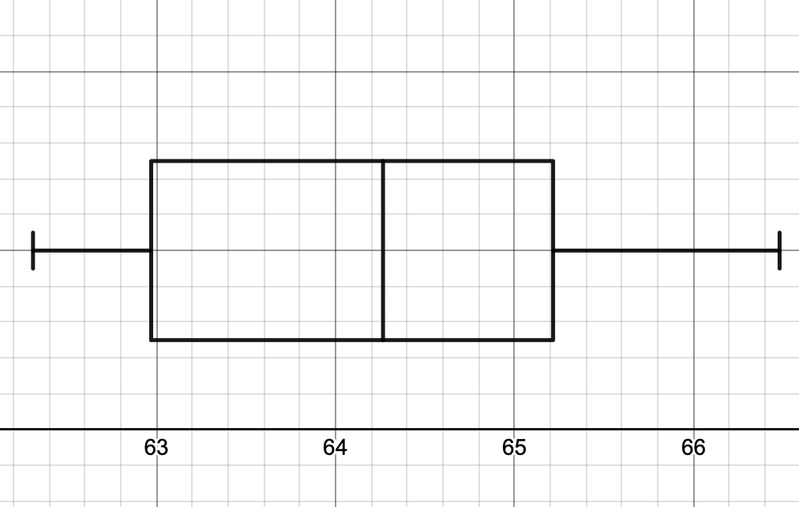
Molly’s dot plot:
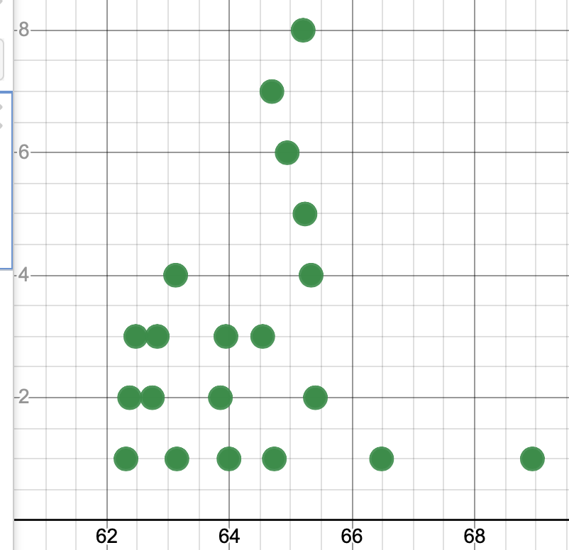
Molly’s histogram:
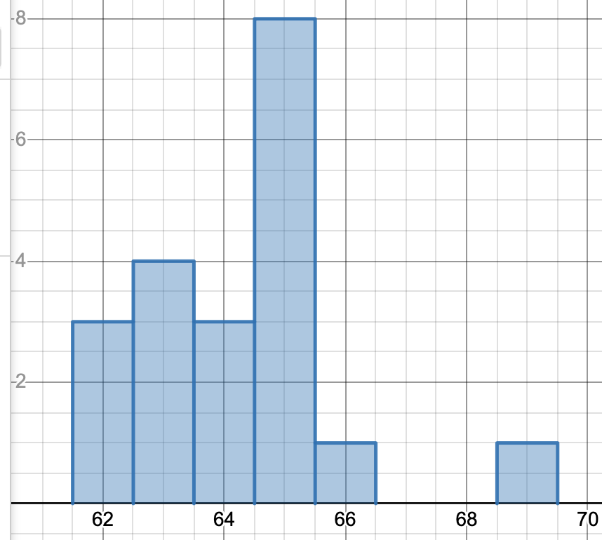

Sanya’s boxplot:
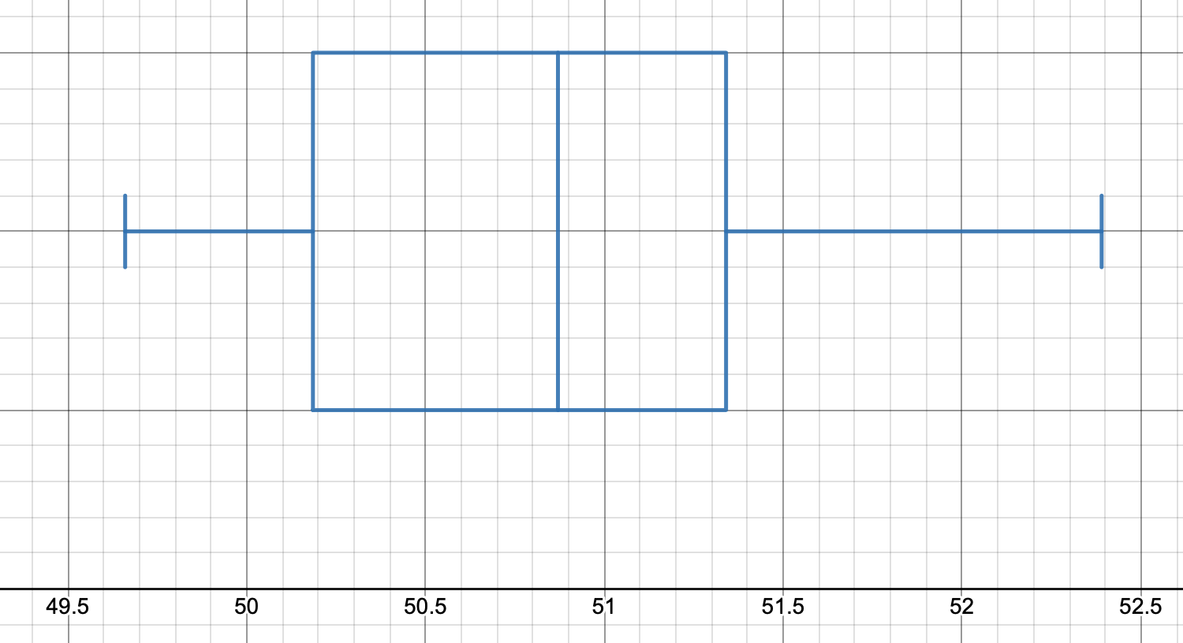
Sanya’s dot plot:
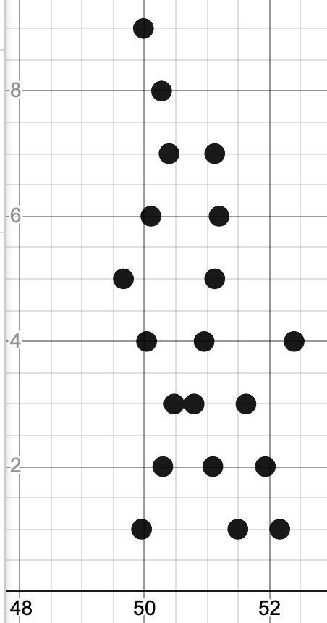
Sanya’s histogram:
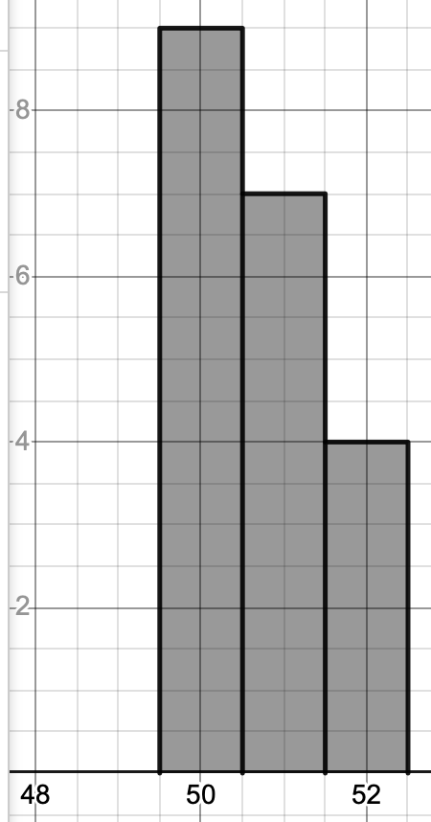

Sample Answer for Option B:
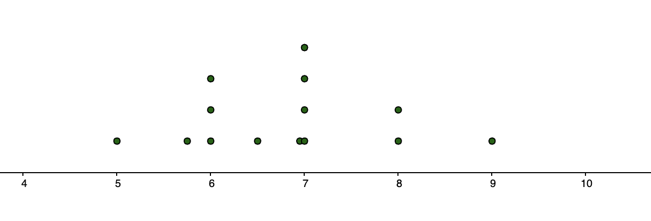
- I decided to use a dot plot for this data set because it shows each one of us. Each dot represents the number of hours one of my classmates slept last night.

Sample Answer for Option C:
- I chose a histogram because it provided a clear visual to show the symmetry of about three-fourths of the graph and the obvious skew to the right. The dot plot was not as clear to see as the intervals were too small to notice clear trends, and the box-and-whisker plot did not help us see the symmetry of the lower three-fourths. The histogram used a bin size of $50K instead of the initial $10K plan which helped show trends because it was too spread out over the $10K bin size.
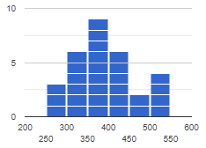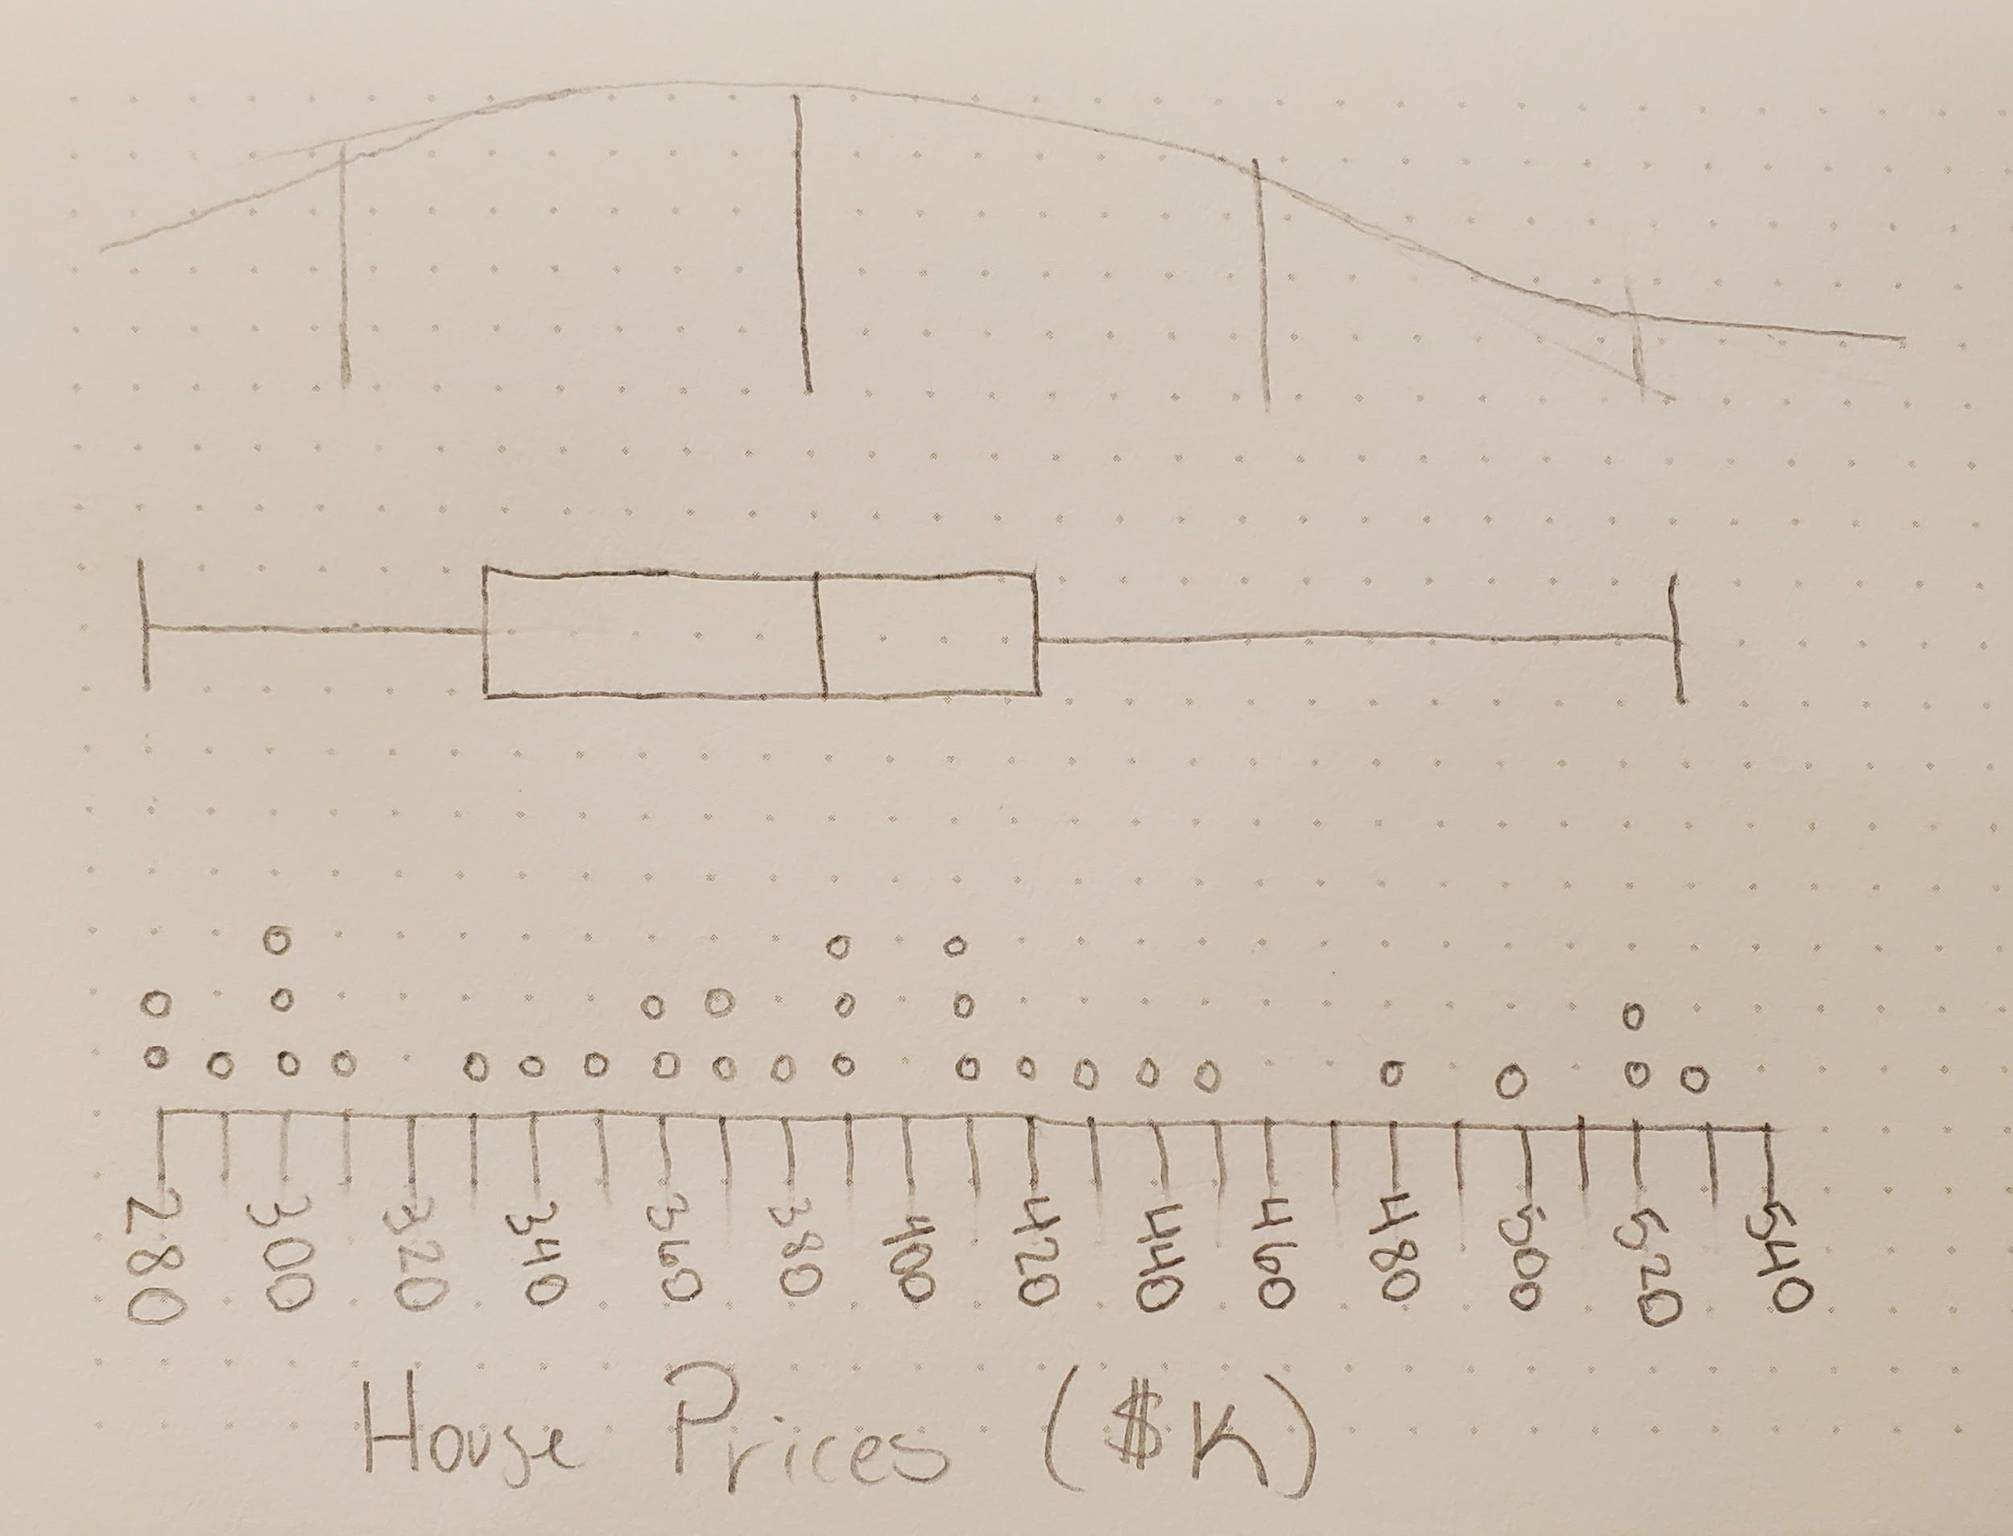

House Prices ($k)
Consider the time you have available and whether you would like students to show you all of the representations they considered or only their final choice with an explanation.

Students may use paper and pencil or any digital tool to create their visuals. Below are some options for online modeling tools:
- GeoGebra Applet: Dot Plot Maker
- GeoGebra Applet: Box and Whisker Plot Generator
- Desmos Graphing Calculator
- Apple Numbers
- Google Sheets
- Microsoft Excel

Represent Mathematically Checklist
Requirement | Teacher Notes: For each Requirement, what are some specific things that came up in that part of the task?
Data collection has been completed and compiled to include in the report. | (Teachers, please add your notes here.)
The student described reasonable modifications to their data collection process. | (Teachers, please add your notes here.)
The student generated the necessary statistics and interpreted each of them appropriately. | (Teachers, please add your notes here.)
The student’s chosen data display is appropriate for these data. | (Teachers, please add your notes here.)
General Teacher Notes: | (Teachers, please add your notes here.)

In the Analyze and Interpret Results section, you will include an interpretation of your data. Use the measures you calculated above to support your response to the questions posed. The Analyze and Interpret Results Checklist can be used to ensure you have the necessary components before moving on to the remaining parts of the task.

Analyze and Interpret Results
ACTION 8
Choose the measure of central tendency and spread appropriate to your data. Explain your rationale.
Sample Answer for Option A:
- Molly’s data set is somewhat skewed; she will show a lot greater variation and growth, so median and IQR are the better measures of center and spread, respectively.

Sample Answer for Option B:
- I plan to use the mean and standard deviation in my comparison since the information I have about the national average refers to the average amount of sleep adults get. In looking at the data visually, in dot plot and box plot form, I see that the data are kind of normally distributed, so that tells me to use mean and standard deviation.
Sample Answer for Option C:
- Due to the skew of the four houses over $500K (which are not outliers), the median and IQR are the better measures of central tendency and spread. The mean is the same as the median, so I chose to compare the measures of spread and outliers. I learned that according to each measure of spread there are no outliers, so I prefer the median and IQR since they are less affected by the skew.
Students should refer to the distribution of their data using vocabulary like skew and symmetry.
When possible, use technology to help focus students on the Interpretation of their data.

ACTION 9
Decide how you will determine and address outliers. Provide a summary of the evidence you considered when addressing outliers.
Sample Answer for Option A:
- Desmos included an outlier for Molly in the box plot. The time was her first race in high school—probably terrible weather and 4.63 seconds slower than her average time (that is a lot for the 400m). In terms of understanding the context and explaining it mathematically, 68.94 is an outlier. Sanya had no outliers in her last 20 races.
Sample Answer for Option B:
- To identify outliers, I can use the rule of thumb—that outliers are found 2 standard deviations from the mean. Based on the 68-95-99.7 breakdown, approximately 68% of the population slept between 5.8 and 7.8 hours, 95% slept between 4.8 and 8.8 hours, and 99.7% slept between 3.8 and 9.8 hours. Based on this, there is one outlier — 9. There is one person who slept 9 hours.
Sample Answer for Option C:
- There are no outliers. I calculated the upper and lower fences for the data set and found that all of the data lie within the boundaries set.
QUESTION 3
Recall in Action 1 that you shared the purpose of the comparison you selected.
What story did the data tell relative to your purpose?
Who would benefit from these data, and how would they benefit?
Sample Answer for Option A:
- To no surprise, Sanya is way more consistent than Molly in the race. Molly is still fairly consistent —I’m looking at the SD and IQR for this specifically because Molly’s slowest time is an outlier, so I would not want to look at the range of the data. This tells me that Molly would be a reliable 400m leg in a relay and she did not just “peak” at the state championships—she ran well the entire two seasons. It also told me that there is a huge difference between Sanya and Molly’s average race time. If they raced, Sanya would probably finish the race as Molly is nearing the 300m mark (assuming this from the 13.46 second difference; for reference, this time difference is a decent time for a high school girl’s 100m dash). This emphasizes how amazing Sanya Richards-Ross is because Molly’s accomplishment (that she placed at the high school state championships as a sophomore) is impressive and not common for a high school athlete. The track coach, the team, Molly, and college recruiters would benefit from this data. Molly’s high school coach could use this information to include her in the 400 relay race.
Sample Answer for Option B:
- The purpose of this work was to learn how much sleep people in my class are getting and to see if we are getting the recommended amount of sleep. From the article given, I know that the average amount of sleep people get is 5.5 hrs. Our class average is 6.8, a bit higher than the 2019 average. Yet, our average is a little lower than the recommended amount of sleep, 7 hours or 9 hours for our age group. Only one person in our class is getting the amount of recommended sleep. This is not good. From Healthline.com’s online article, I see that not getting enough sleep leads to memory issues, mood changes, weakened immunity, risk for diabetes, trouble with concentration, accidents, high blood pressure, weight gain, risk of heart disease, and balance. I think everyone at our school would benefit from hearing this information. It will help us make informed decisions about what each of us can do to make sure we get enough sleep.
Sample Answer for Option C:
- The median housing price according to the U.S. Census for 2017–2021 is $240K, which is significantly lower (houses in my neighborhood right now are $150K more expensive, which is 62.5% more). That tells me that my neighborhood is much more expensive compared to other places in America. I think that people who are looking into buying a house and do not care if they leave the school district would benefit from this information because they would learn that this area is more expensive than typical and may be the incentive they need to look elsewhere.

Analyze and Interpret Results Checklist
Requirement | Teacher Notes: For each Requirement, what are some specific things that came up in that part of the task?
The measures of central tendency and spread selected are accurate and appropriate for the data. | (Teachers, please add your notes here.)
The possible effects of outliers are explored using the shape, center, spread, and context of data sets. | (Teachers, please add your notes here.)
The story of the data accurately interprets and uses the results of the analysis to explain how this information can be useful. | (Teachers, please add your notes here.)
A reasonable audience who would benefit from this data has been identified. | (Teachers, please add your notes here.)
General Teacher Notes: | (Teachers, please add your notes here.)

In the Validate and Report section, you will add on to the document you started above and clarify the voice and audience. In the Validate section, you will explain whether the data were sufficient for addressing your statistical question or how you would improve the process in the future. You will also create an appropriate way to report the findings from your work to the intended audience (e.g., through a short video, pamphlet, or other visual). The Validate and Report Checklist can be used to ensure you have the necessary components for completing the task.

Validate and Report
ACTION 10
Validate your model using these guiding questions.
- Did the data sufficiently address the question you were investigating? Why or why not?
- If you were to try to collect data to answer your statistical question again, how would you adjust your process, your question, and/or how you analyzed the data to provide better information to the audience interacting with your data?
Sample Answer for Option A:
- Yes, it sufficiently addressed the question and everything I was looking for, so I wouldn’t change my processes.
Sample Answer for Option B:
- In looking at the impact of lack of sleep and seeing that only 1 person in our class gets enough sleep, I think I’d like to survey more students in our school. I also want to ask more questions, because I like to stay up late and maybe others do, too. Some questions I could ask are: How late do you go to sleep? When do you wake up? Maybe these data can help influence the start and end of our school days.
Sample Answer for Option B:
- My question about whether COVID-19 impacted housing was not able to be answered because the Census data I gathered included 2020 and 2021. However, it did give me the information I needed to compare my neighborhood to America as a whole and help me understand that we are living in an area that is more expensive. I would also start my data collection with a map and create regions and limit responses within a random set of 5 from each region (or something similar).
This is a checkpoint for reflection and revision. Students only need to say yes/no if they could answer their original question and share any deviations that had been necessary. This allows them to share their process to create their final product. Students do not need to state what they learned (this was done in Question 3).

ACTION 11
Communicate your results in a manner and format that are appropriate for the audience and purpose you identified in Questions 2 and 3, in a way that most clearly illustrates your findings.
*Submission is separate and not included in the example.

Sample Responses:
- I would present my results through a document or email, in what would be an appropriate way to communicate with a coach or college recruiter. When I communicate these results, I will use more common terms, such as average race time.
- I’m going to make a short video that we can show to the school board.
- I chose to create an infographic that can be shared with people digitally to let them know that this area is more expensive than America as a whole.

Validate and Report Checklist
Requirement | Teacher Notes: For each Requirement, what are some specific things that came up in that part of the task?
A rationale has been provided showing how the data sufficiently addressed the question at hand or there is a clear understanding articulated about how to improve the data collection and analysis in the future. | (Teachers, please add your notes here.)
The results are clearly communicated in a way that is appropriate for the intended audience. | (Teachers, please add your notes here.)
General Teacher Notes: | (Teachers, please add your notes here.)

References

GeoGebra. “Box and Whisker Plot Generator.” GeoGebra Applet: Box and Whisker Plot Generator, GeoGebra, https://www.geogebra.org/m/gQkXhAvd. Accessed 29 July 2023.
GeoGebra. “Dot Plot Maker.” GeoGebra: Dot Plot Maker, GeoGebra, https://www.geogebra.org/m/BxqJ4Vag. Accessed 29 July 2023.
MaxPreps. “Division A Boys Baseball (Spring 2023) Batting Average Stat Leaders.” MaxPreps, CBSSports.com, https://docs.google.com/document/d/1oPiEObE-Lrrgn40cn5aBBjSvj0r7jYeEfjrDtIOC-PI/edit. Accessed 29 July 2023.
National Safety Council. “Average night’s sleep now less than six hours, survey shows.” Family Safety and Health, National Safety Council, 20 March 2020, https://www.safetyandhealthmagazine.com/articles/19519-average-nights-sleep-now-less-than-six-hours-survey-shows#:~:text=Results%20of%20the%20annual%20survey,to%20nine%20hours%20a%20night.
StatMuse. “StatMuse.” StatMuse, StatMuse, https://docs.google.com/document/d/1oPiEObE-Lrrgn40cn5aBBjSvj0r7jYeEfjrDtIOC-PI/edit. Accessed 29 July 2023.
World Athletics. “Sanya RICHARDS-ROSS.” World Athletics Profiles, World Athletics, https://worldathletics.org/athletes/united-states/sanya-richards-ross-14319838. Accessed 29 July 2023.

