Baseline Professional Learning Handout
M213: Bayesian Reasoning and Probability Theory

Baseline Professional Learning Handout 1
Selected Common Core High School Standards for Mathematics 2
Data Science Big Ideas 2
M213 Content and Practice Expectations 3
M213 Content and Practice Expectations and Indicators 4
Let’s Investigate 6
Cards and Independence 6
False Positive Test Results 7
Let’s do some math! Round 1 8
Task 1: Class Playlist 8
Learning Principles 10
Let’s do some math! Round 2 11
Task 2: The Story of Weights 11
Criteria for Success 13

Selected Common Core High School Standards for Mathematics
Understand independence and conditional probability and use them to interpret data
- Describe events as subsets of a sample space (the set of outcomes) using characteristics (or categories) of the outcomes, or as unions, intersections, or complements of other events (“or,” “and,” “not”).

- Understand that two events A and B are independent if the probability of A and B occurring together is the product of their probabilities, and use this characterization to determine if they are independent.

- Understand the conditional probability of A given B as P(A and B)/P(B), and interpret independence of A and B as saying that the conditional probability of A given B is the same as the probability of A, and the conditional probability of B given A is the same as the probability of B.

- Construct and interpret two-way frequency tables of data when two categories are associated with each object being classified. Use the two-way table as a sample space to decide if events are independent and to approximate conditional probabilities. For example, collect data from a random sample of students in your school on their favorite subject among math, science, and English. Estimate the probability that a randomly selected student from your school will favor science given that the student is in tenth grade. Do the same for other subjects and compare the results.

- Recognize and explain the concepts of conditional probability and independence in everyday language and everyday situations. For example, compare the chance of having lung cancer if you are a smoker with the chance of being a smoker if you have lung cancer.

Use the rules of probability to compute probabilities of compound events in a uniform probability model
- Find the conditional probability of A given B as the fraction of B’s outcomes that also belong to A, and interpret the answer in terms of the model.

- Apply the Addition Rule, P(A or B) = P(A) + P(B) – P(A and B), and interpret the answer in terms of the model.

Data Science Big Ideas

M213 Content and Practice Expectations
213.a | Understand that probability is a long run relative frequency.
213.b | Determine probabilities of single and multiple events using Bayesian reasoning.
213.c | Reason about the mathematical consequences of certain prior events.
213.d | Make likelihood predictions for discrete and continuous probability distributions.
213.e | Understand how sampling distributions, developed through simulation, are used to make likelihood predictions.

M213 Content and Practice Expectations and Indicators

Content and Practice Expectations | Indicators  Choose an artifact where you…
213.a: Understand that probability is a long run relative frequency. | i. describe probability contextually as a long run relative frequency and understand probabilistic implications for individual trials.
 | ii. demonstrate understanding that probability is needed in the field of Data Science in order to provide guiding principles for obtaining information from data.
213.b: Determine probabilities of single and multiple events using Bayesian reasoning. | i. determine intersection probabilities using the conditional probability formula.
 | ii. show and explain the correspondences across representations of compound probabilities (e.g., tree diagrams, two-way tables).
213.c: Reason about the mathematical consequences of certain prior events. | i. use Bayesian reasoning to compare the compound probabilities of independent and dependent events.
 | ii. use understanding of the conditional probability formula, Bayes’ Theorem, to describe the implications of prior events when making predictions.
 | iii. demonstrate understanding that an association that exists between variables may disappear or reverse when observing subgroups.
 | iv. describe a situation where independence may be assumed, even when drawing without replacement.
213.d: Make likelihood predictions for discrete and continuous probability distributions. | i. make likelihood predictions for at least one type of discrete probability distribution.
 | ii. make likelihood predictions for a normal distribution.
 | iii. check and describe conditions to approximate a distribution to a normal curve in order to make likelihood predictions.
213.e: Understand how sampling distributions, developed through simulation, are used to make likelihood predictions. | i. develop simulations to determine approximate sampling distributions.
 | ii. explain how sampling distributions, developed through simulation, are used to describe the sample-to-sample variability of sample statistics.
 | iii. make likelihood predictions using sampling distributions.

Let’s Investigate

Cards and Independence
One card is selected at random from the following set of 6 cards, each of which has a number and a black or white symbol: {2△,4◻,8◼,8⧫,5◻,5◼}
- Let B be the event that the selected card has a black symbol, and F be the event that the selected card has a 5. Are the events B and F independent? Justify your answer with appropriate calculations.
- Let B be the event that the selected card has a black symbol, and E be the event that the selected card has an 8. Are the events B and E independent? Justify your answer with appropriate calculations.
Source: Illustrative Mathematics

False Positive Test Results
A certain test for mononucleosis has a 99% chance of correctly diagnosing a patient with mononucleosis and a 5% chance of misdiagnosing a patient who does not have the infection. Suppose the test is given to a group where 1% of the people have mononucleosis. If a randomly selected patient's test result is positive, what is the probability that she has mononucleosis? Explain.

Source: Illustrative Mathematics

Let’s do some math! Round 1

Task 1: Class Playlist

Explain to students that they are going to create a class playlist and identify the genre categories they are in. The goal is to represent four-six different genres in the class playlist in order to make the probabilities more meaningful and to create a program that isn’t too unruly. Have students and a partner write a list of 10 of their favorite songs, including the title and artist, then identify the genre category for each song.

Once pairs have their lists of songs and genres, bring the class together. Ask them to share the genres in their list. Consider organizing this like a whip around with new ideas only: after the first pair shares their genres, have each pair share only new genres to add to the list. If there are more or less than four-six genres generated by the class, start a conversation with them about needing to consolidate or expand the list. Have pairs input their final 10 song choices into a Google Form (it can look like this). Generate the spreadsheet from the form and share a copy with the students.

Students should clean the data by checking for typos or duplicates, then download the file as a .csv file. Provide this EduBlocks program for them to run their file in. Explain that this is a simulation to model listening to a playlist on shuffle, and that they are going to take some time now to analyze how realistic the model might be. Invite students to share how they think the simulation could more accurately model listening to a playlist on shuffle.

Building on what students share, emphasize that the programs they built had some limitations because they assumed replacement of songs back into the playlist. Share what this means about how songs are played when listening to the playlist. Point out that most playlist shuffles don’t work in this way. Invite students for a short brainstorm about the question:
- How would we need to change the program to model the way most people listen to playlists with each song playing once?

Continuing the discussion, invite students to share what they think about how the related probabilities in the simulation would change or not without replacement. Ask questions about the probabilities like:
- Now that you have talked about how the code would change, are there changes in the theoretical probability?
- Will the experimental probability be different without replacement? What if you play exactly the number of songs in the playlist?
- How does the variability of the simulation with replacement compare to that of the simulation without replacement?
- What questions are you interested in exploring with a simulation without replacement? Record three-five questions students brainstorm.

Share with students that they will be exploring conditional probability questions about their model without replacement. For example: What is the probability of a rock song playing second if the first song was a rock song? Ask the students:
- Are any of the questions the class generated conditional probability questions?

Allow students time to revise the provided program in groups in order to reflect the questions generated and outcomes of the class discussion. Have groups swap programs and test them to see what similarities and differences they have in code. Then, have students revise their code one last time after exploring another group’s.
Adapted from YouCubed

Note: Lessons from the YouCubed.org website may require setting up a free account and logging in to access the whole lesson.

Learning Principles
Engage with cognitively demanding tasks in heterogeneous settings (LP 1). Students should be given opportunities to grapple with multistep, non-routine tasks that promote mathematical rigor. These experiences should be differentiated so that all students engage in appropriate challenges—for example, through tasks with multiple entry points and solution pathways. These experiences should continue to integrate knowledge and skills developed in grades 6-8 at the level of sophistication of high school mathematics.

Engage in social activities (LP 2). Students should have opportunities to work independently and to communicate with one another about mathematics by engaging in collective and collaborative learning activities. Explaining and having opportunities to revise one’s thinking has excellent value in solidifying one’s knowledge.

Build conceptual understanding through reasoning (LP 3). Students should be given the opportunity to reason, justify, and problem solve with critical thinking, reading, writing, speaking, and listening. Through reasoning and work with multiple representations, students learn why procedures work and build a conceptual understanding of key mathematical ideas.

Have agency in their learning (LP 4). Students should be able to choose tasks and learning experiences that align with their interests and aspirations. All students have rich and varied experiences and home lives. Learning mathematics should bring students’ identities and interests to the fore and build on the strengths that they bring to the learning space.

View mathematics as a human endeavor across centuries (LP 5). Students should understand that mathematical ideas emanated over time from civilizations around the world and have opportunities to explore these contributions to mathematics. Students should develop an appreciation of mathematics as a human endeavor: one in which they feel a sense of belonging, where they see themselves as mathematicians, and one that offers opportunities to broaden their ideas about what mathematics is, how it is used, and who it is for.

See mathematics as relevant (LP 6). Students should engage with mathematics in ways that authentically involve real-world situations. Problem-solving contexts should allow students to perceive mathematics as a tool for addressing the questions that arise in everyday life, as well as the ways it can model our world and address global economic, social, and environmental challenges. Students should also engage with mathematics in ways that connect to academic disciplines and future careers by doing the mathematics used by artists, designers, engineers, and other professionals.

Employ technology as a tool for problem-solving and understanding (LP 7). Research indicates that technology is a powerful tool for learning deeper mathematics by improving calculation efficiency and enabling more sophisticated analysis. Students should learn to use technology, with emphasis put on widely used tools and software, such as calculators and spreadsheets, to make sense of models. Technology use should not be limited to supporting “doing mathematics,” but should also be used as a tool for displaying and communicating results to appropriate audiences.

Task 1: Class Playlist

Example 1:
Student work goes here

Example 2:
Student work goes here

Let’s do some math! Round 2

Task 2: The Story of Weights
Students are shown the following photo and prompt:
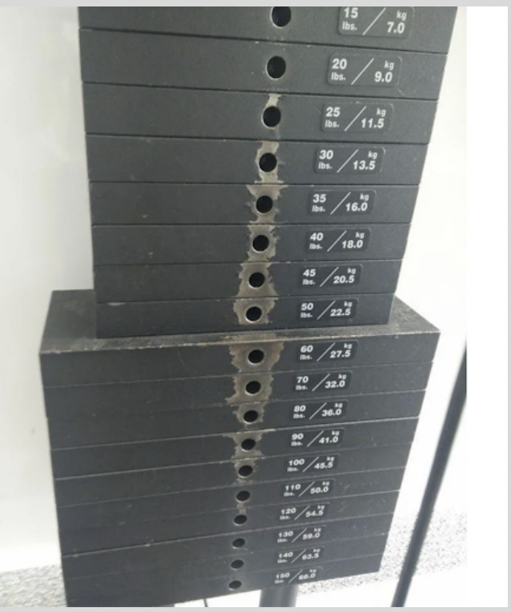

- What do you notice about the usage of the weights based on the wear of the weights (where the pin has been placed)?
- What do you wonder?
- What story does this visual tell?

Sample Learning Experience

Invite students to share their noticings, wonderings, and questions. As a class, discuss:
- What do the marks on the weights tell us about gym goers’ use of weights?
- If we were to make a histogram of the use of different weights, what do you think it would look like?

This data talk depicts how weight usage (as marked by the wear on the weights created by users missing inserting the pin, indicating higher usage) falls along a normal distribution. It is interesting to note that by looking at the wear and tear based on the number of pin misses, we are able to see a normal distribution curve.

In groups, ask students to sketch a histogram that represents weights usage by gym goers. Students should then discuss the following questions with each other and take notes on their findings:
- What do you notice about the shape of the histogram?
- What are the characteristics of this histogram?
- What would you label the y-axis of this histogram? Why?
- What do our histograms tell us about the likelihood of the use of different weight amounts?
After some time, have groups share their findings and revise their own findings using other groups’ reasonings.

Adapted from YouCubed

Note: Lessons from the YouCubed.org website may require setting up a free account and logging in to access the whole lesson.

Task 2: The Story of Weights

Example 1:
Student work goes here

Example 2:
Student work goes here

Criteria for Success

Conference and Provide Revision Support | Accept with Revision | Accept
The student’s artifact shows an emerging understanding of the expectations of the indicator(s). After conferencing and additional instruction/learning, the student may provide a revised or different artifact as evidence of the indicator(s). | The student’s artifact is approaching a full understanding of the expectations of the indicator(s). The artifact may contain execution errors that should be corrected in revision. The student may revise the selected artifact or submit a different artifact. | The student’s artifact demonstrates evidence that they have met the expectations of the indicator(s).

