M151 Performance Task
Designing a Zoo Enclosure
Elephant Version

The Modeling Cycle
Designing a zoo requires creating a space that meets the needs of the animals as well as the needs of the visitors. For example, a space must be created that replicates the key features of an animal’s natural habitat while simultaneously ensuring the safety of visitors and giving visitors the ability to observe the animals in that space. In this task, you will design an enclosure for an animal and produce a scale drawing of the enclosure you’ve designed.
Mathematical models are used to make sense of ideas and phenomena in our world. As illustrated in the image below, the modeling cycle is a process of identifying a problem, creating models, analyzing the story told by those models, and reporting the results to the appropriate audience. In this task, you will be engaging with the mathematical modeling cycle to design an animal enclosure for a zoo given several real-world constraints.
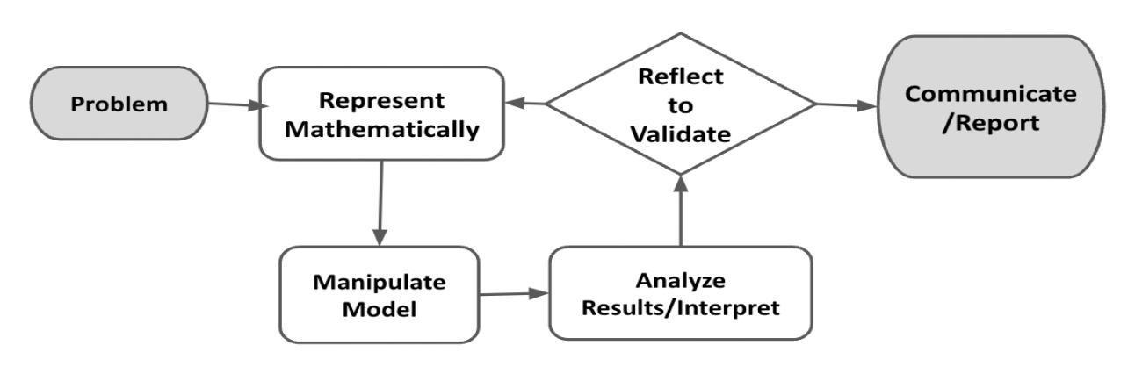
Figure 1. Diagram of Modeling Process. From “Progressions for the Common Core State Standards for Mathematics” [Draft manuscript], by Common Core Standards Writing Team, 2019, p. 6 (http://mathematicalmusings.org/wp-content/uploads/2022/05/modeling_02082019.pdf).

Designing a Zoo Enclosure
Launch
You are a zoo architect, and you and your team have been commissioned to design some of the zoo enclosures for the new San Diego Zoo satellite location. This is a huge project, and several animals need homes!
In this task, you will explore zoo enclosures and design your own while taking into account important design guidelines to ensure the animal will be healthy and the enclosure will stay within the spatial constraints and budget. You will use graph paper or Google Draw to model what you think is the best enclosure for your chosen animal and report on the enclosure’s specifications. Have fun!

QUESTION 1
 | What are some of the things you need to consider when designing your enclosure? Brainstorm with your group.

QUESTION 2
How do architects use math and geometry to design enclosures, buildings, and other structures?

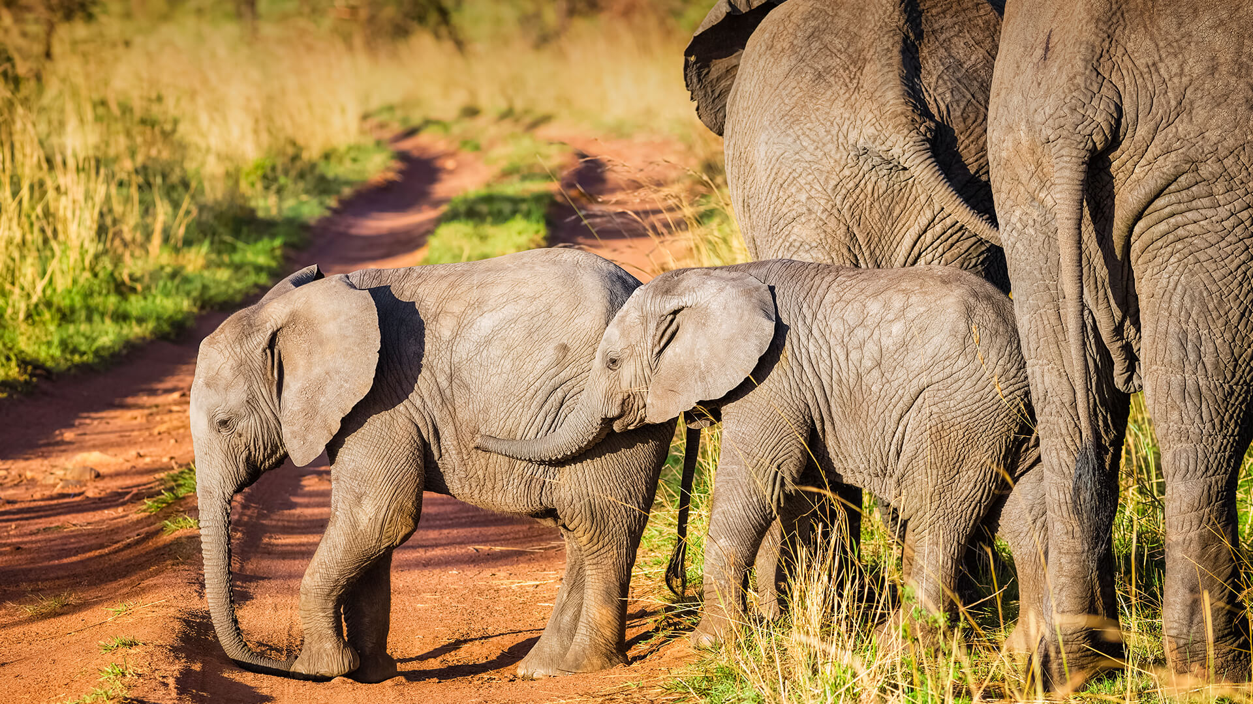
Designing a Zoo Enclosure - Elephant Version
Elephant Background Details
Elephants are massive animals that live in herds with female matriarchs. In the San Diego Zoo, they enjoy swimming pools and mud wallows to help keep them cool, so including water areas is going to be crucial in your design!

Your Task: There are two types of animals the San Diego Zoo needs to build enclosures for: orangutans and elephants. You have chosen to design enclosures for elephants. In this task, you will create a scale drawing of an enclosure for the animal you selected.

In Part 1, the Formulate and Represent Mathematically sections, you will develop a scaled drawing of an enclosure to meet the constraints for designing a space for elephants. The Formulate and Represent Mathematically (Part 1) Checklist can be used to ensure you have the necessary components before moving on to the remaining parts of the task.

Formulate (Part 1)
ACTION 1
Determine the outer perimeter boundary walls for your enclosure. Consider drafting a sketch of what this might look like before creating a scaled drawing.
What are boundary walls?
These are walls that separate the animal from the rest of the zoo and the visitors.
These are walls that establish the total amount of living space the animal has.
These are walls that are secured into the ground.

Note: You are welcome to use additional paper or digital forms to document your work. Be sure to include all of your work in your final submission.

Represent Mathematically (Part 1)
ACTION 2
Design Constraints
The zoo is planning for two male and four female elephants. Zoologists have advised you that the elephants must have at least 3000 square meters of space to avoid crowding and conflict.
The zoo architect has notified you that the maximum amount of space they can offer for this enclosure is 6000 square meters.
Use a piece of graph paper or Google Draw to create a two-dimensional scale drawing of the boundary of your enclosure.
- Include:
  - a key that shows the scale for your drawing; and
  - calculations showing that the area is within the guidelines (3000-6000 m²).
- When you finish Part 1 of your design, use the checklist below to ensure you have all the requirements.

Formulate and Represent Mathematically (Part 1) Checklist
Requirement | Fulfilled?
I have drawn perimeter boundary walls that are curved and avoid right angles. | ▢
I have included a key showing the scale. | ▢
I have included calculations to show that the design is between 3000-6000 square meters of area. | ▢
Teacher Consultation: | ______________

Formulate (Part 2)
ACTION 3
Design the enclosure with the required units. All zoos with a breeding herd of elephants must have at least three separate units as part of their enclosure. Discuss or provide a draft of your design that meets this need.

Note: You are welcome to use additional paper or digital forms to document your work. Be sure to include all of your work in your final submission.

Represent Mathematically (Part 2)
ACTION 4
With these design constraints in mind, add to your graph paper or Google drawing and create at least three units in the enclosure boundaries. Include calculations showing that each unit area is within the guidelines above.
Additional Design Constraints

There must be an outdoor unit for all bachelor males that should be at least 500 square meters. Label this unit “Bachelor Pad.”
There must be an outdoor unit for adult females and babies that should be at least 2000 square meters. Label this unit “Mothers and Babies.”
There must be an indoor unit that should be at least 300 square meters for each group of four or fewer elephants. For each additional elephant, increase the space by 80 square meters. Label this unit “Indoor Unit.” As a reminder, the zoo is planning for two male and four female elephants.
When you finish Part 2 of your design, use the checklist below to ensure you have all the requirements.

Formulate and Represent Mathematically (Part 2) Checklist
Requirement | Fulfilled?
I have at least three separate units within the perimeter boundary, and each unit has a label. | ▢
I have planned the Bachelor Pad Unit to have a total area of at least 500 square meters, and calculations of the area of the unit are included. | ▢
I have planned the outdoor Mothers and Babies Unit to have a total area of at least 2000 square meters, and calculations of the area of the unit are included. | ▢
I have planned the indoor unit to have an appropriately sized area, and calculations of the area of the unit are included.
Teacher Consultation: | ______________

Formulate (Part 3)
ACTION 5
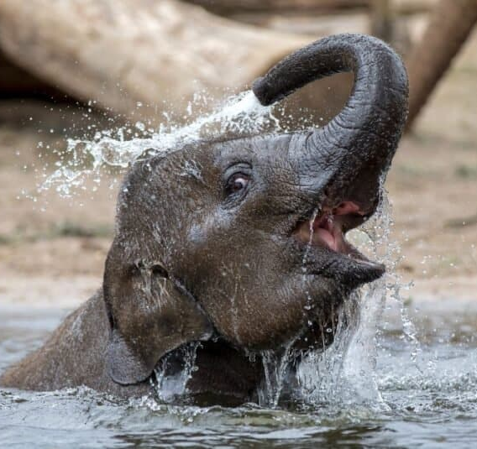
Consider adding environmental elements such as trees, rocks, water sources, or anything else you think of that would provide a good environment for elephants.
As you add these features, consider how the exhibit enhances the visitor experience.

Represent Mathematically (Part 3)
ACTION 6
Consider what these additional design features would look like from above since your sketch is two-dimensional.
Additional Design Constraints

Enclosures should have multiple water features. Using circles or ellipses, draw a pool in every outdoor area. Make the area of the pool at least 20 square meters.
Include large rocks or trees to help elephants to hide from or get away from other members of the herd when needed.
Add these elements to your blueprint design.
When you finish Part 3 of your design, use the checklist below to ensure you have all the requirements.

Formulate and Represent Mathematically (Part 3) Checklist
Requirement | Fulfilled?
I have intentionally added and placed environmental elements to enhance the animal experience depicted on the scale drawing. | ▢
I have intentionally added and placed environmental elements to enhance the visitor experience. | ▢
Teacher Consultation: | ______________

Validate and Report
ACTION 7
Create a presentation of your design for the elephant enclosure for the zoo’s board of directors for approval (using a slideshow, poster, video, and/or report). Use your blueprint and supporting computations to show the estimated space needed in your presentation.
Make sure to address:
- mathematical evidence that the elephants will have at least 3000 square meters but no more than 6000 square meters of living-space area;
- appropriate-sized indoor unit and outdoor units (back up claim with mathematical evidence);
- any potential design concerns you have with your model (e.g., escape potential, birth and new offspring accommodations);
- ways in which you have enhanced the environment with water features, rocks, plants, etc., for the animals; and
- ways in which you have enhanced the environment for the visitors (visibility, safety, etc.).

Validate and Report Checklist
Requirement | Fulfilled?
I have provided a rationale showing that required constraints have been met and that additional features enhance both the animal and visitor experience. | ▢
I have clearly communicated the results in a way that is appropriate for the intended audience. | ▢
Teacher Consultation: | ______________

