Baseline Professional Learning Handout
M154 Coordinate Geometry

Baseline Professional Learning Handout 1
Selected Common Core High School Standards for Mathematics 2
Progressions Excerpt 2
M154 Content and Practice Expectations 3
M154 Content and Practice Expectations and Indicators 4
Let’s Investigate 5
Explaining the Equation for a Circle Task 5
A Midpoint Miracle Task 6
Let’s do some math! Round 1 7
Task 1: Micro-Mobility Prompt 7
Learning Principles 9
Task 1: Micro-Mobility Student Work 10
Let’s do some math! Round 2 11
Task 2: Ancient Rome Prompt 11
Task 2: Ancient Rome Student Work 13
Criteria for Success 14
Selected Common Core High School Standards for Mathematics

High School - Geometry
Translate between the geometric description and the equation for a conic section.
- Derive the equation of a circle of given center and radius using the Pythagorean Theorem; complete the square to find the center and radius of a circle given by an equation.
- Derive the equation of a parabola given a focus and directrix.

Use coordinates to prove simple geometric theorems algebraically.

- Use coordinates to prove simple geometric theorems algebraically. For example, prove or disprove that a figure defined by four given points in the coordinate plane is a rectangle; prove or disprove that the point (1, √3) lies on the circle centered at the origin and containing the point (0, 2).
- Prove the slope criteria for parallel and perpendicular lines and use them to solve geometric problems (e.g., find the equation of a line parallel or perpendicular to a given line that passes through a given point).
- Find the point on a directed line segment between two given points that partitions the segment in a given ratio.
- Use coordinates to compute perimeters of polygons and areas of triangles and rectangles, e.g., using the distance formula.★

Geometry Progression Excerpt
Analytic Geometry
The introduction of coordinates into geometry connects geometry and algebra, allowing algebraic proofs of geometric theorems. This area of geometry is called analytic geometry. The coordinate plane consists of a grid of horizontal and vertical lines; each point in the plane is labeled by its displacement (positive or negative) from two reference lines, one horizontal and one vertical, called coordinate axes. Note that it is the displacement from the axes, rather than the displacement along these axes, that is usually the most useful concept in proving theorems. This point is sometimes obscured for students by the mathematical convention of putting a
scale on the axes themselves and labeling them x-axis and y-axis. A different convention, of putting the scale within a quadrant (e.g., as can be done with dynamic geometry software), is sometimes used, and might be more useful pedagogically. From their work in Grade 8, students are familiar with the idea that two points $(x_{1},y_{1})$and $(x_{2},y_{2})$in the coordinate plane determine a right triangle whose hypotenuse is the line segment between the two points and whose legs are parallel to the axes. Two important geometric facts about these triangles lead to foundational formulas in analytic geometry.

First, for all the pairs of distinct points on a given line, the corresponding triangles are similar. This can be shown using the AA criterion for similarity. Because the horizontal (or vertical) grid lines are all parallel to each other, and the line is transversal to those parallel lines, the ratio of the vertical side to the horizontal side does
not depend on which two points are chosen, and so is a characteristic of the line itself, called its slope, m. The algebraic manifestation of this is the slope formula:

$m=\frac{y_{2}-y_{1}}{x_{2}-x_{1}}$,
The relationship between the slopes of parallel and perpendicular lines is a nice example of the interplay between geometry and algebra.

Second, the Pythagorean Theorem applies: the length of the hypotenuse is the distance between the two points, and the lengths of the legs can be calculated as differences between the coordinates. The algebraic manifestation of the Pythagorean Theorem is the formula for the distance, d, between the two points:

$d=\sqrt{{(x_{2}-x_{1})}^{2}+{(y_{2}-y_{1})}^{2}}$

Students can use the distance formula to prove simple facts about configurations of points in the plane.

However, the power of analytic geometry to reduce geometric relationships to algebraic ones is a danger in teaching it because students can lose sight of the geometric meaning of the formulas. Thus the equation for a circle with center $(a,b)$ and radius r,
${(x-a)}^{2}+{(y-b)}^{2}=r^{2}$

can become disconnected from the Pythagorean theorem, even though it is nothing more than a direct statement of that theorem for any right triangle with radius of the circle as its hypotenuse. As another example, students sometimes get the impression that the word “parabola” is the name for the graph of a quadratic function, whereas a parabola is a geometric object with a geometric definition. It is a beautiful and simple exercise in the interplay between geometry and algebra to derive the equation from this definition.

M154 Content and Practice Expectations
154.a | Translate between the geometric description and the equation for a conic section, specifically of a circle and parabola.
154.b | Use coordinates to prove simple geometric theorems algebraically.
154.c | Prove the slope criteria for parallel and perpendicular lines and use them to solve geometric problems.
154.d | Find the point on a directed line segment between two given points that partitions the segment in a given ratio.
154.e | Use coordinates to compute perimeters of polygons and areas of triangles and rectangles, e.g., using the distance formula.

M154 Content and Practice Expectations and Indicators
Content and Practice Expectations | Indicators  Choose an artifact where you…
154.a: Translate between the geometric description and the equation for a conic section, specifically of a circle and parabola. | i. explain how the Pythagorean Theorem can be used to derive the equation of a circle.
 | ii. write the equation for a parabola using the focus and directrix.
154.b: Use coordinates to prove simple geometric theorems algebraically. | i. use the distance formula to find the distance between two points on a coordinate plane.
 | ii. use coordinates along with the slope formula, distance formula, and/or midpoint formula to prove simple geometric theorems algebraically.
 | iii. use coordinates to prove that a quadrilateral is, or is not, a specific quadrilateral
154.c: Prove the slope criteria for parallel and perpendicular lines and use them to solve geometric problems. | i. classify lines or segments as parallel, perpendicular, or neither.
 | ii. write the equation of a line parallel or perpendicular to a given line and passing through a given point.
 | iii. solve problems involving equations of parallel and perpendicular lines.
154.d: Find the point on a directed line segment between two given points that partitions the segment in a given ratio. | i. use the midpoint formula, the section formula, and the distance formula to find the partition point of a given directed line segment.
 | ii. use dilations to find the coordinates of a point that divides a directed line segment in a given ratio.
154.e: Use coordinates to compute perimeters of polygons and areas of triangles and rectangles (e.g., using the distance formula). | i. use coordinates to compute perimeters of polygons and the areas of triangles and quadrilaterals.
 | ii. decompose complex figures whose vertices can be located on a coordinate plane into simple shapes to determine perimeter and/or area.

Let’s Investigate

Explaining the Equation for a Circle Task
This problem examines equations defining different circles in the x-y plane.

- Use the Pythagorean theorem to find an equation in x and y whose solutions are the points on the circle of radius 2 with center (1,1) and explain why it works.

- Suppose r is a positive number and (a,b) a point in the plane. Use the Pythagorean theorem to find an equation in x and y whose solutions are the points on the circle of radius r with center (a,b) and explain why it works.

Source: Illustrative Mathematics

A Midpoint Miracle Task

Draw a quadrilateral ABCD. Try to draw your quadrilateral so that no two sides are congruent, no two angles are congruent, and no two sides are parallel.

- Let P, Q, R, and S be the midpoints of sides AB, BC, CD, and DA, respectively. Use a ruler to locate these points as precisely as you can, and join them to form a new quadrilateral PQRS. What do you notice about the quadrilateral PQRS?

- Suppose your quadrilateral ABCD lies in the coordinate plane. Let $(x_{1},y_{1})$ be the coordinates of vertex A, $(x_{2},y_{2})$ the coordinates of B, $(x_{3},y_{3})$ the coordinates of C, and $(x_{4},y_{4})$ the coordinates of D. Use coordinates to prove the observation you made in part (a).

Source: Illustrative Mathematics

Let’s do some math! Round 1

Task 1: Micro-Mobility

Students are given a problem like this:
Cities have begun to offer micro-mobility options like shared electric scooters and bikes in hopes of meeting the transportation needs of their communities. For this task, you will explore the limits and possibilities of using such devices.
Use Google Maps to locate at least three places of interest. Some options could include your school site, a place you go to often, or a place of work. Use technological tools, like Desmos or GeoGebra, or transparency paper to superimpose a coordinate system over your map.
- If you were to use an electric scooter that can travel 35 miles on a single charge, would you be able to make the trip from the first place of interest to the second, and return back to the first point of interest? Justify your response using words, numbers, and symbols.
- How long would it normally take to make that round trip using other modes of transportation you have access to (car, bus, or walking)? How long do you estimate it would take to make the trip on a scooter?
- What are the advantages and disadvantages of offering micro-mobility options?
Sample Learning Experience
Give students an opportunity to begin the task independently, then invite them to work in pairs to share ideas and discuss strategies for completing the task. As students are working, monitor and identify solution paths to share with the whole class. Note some students may superimpose a coordinate system using tracing paper or web-based applications like Desmos or GeoGebra. Some students may center their map, as illustrated below, while others may position it in the first quadrant.
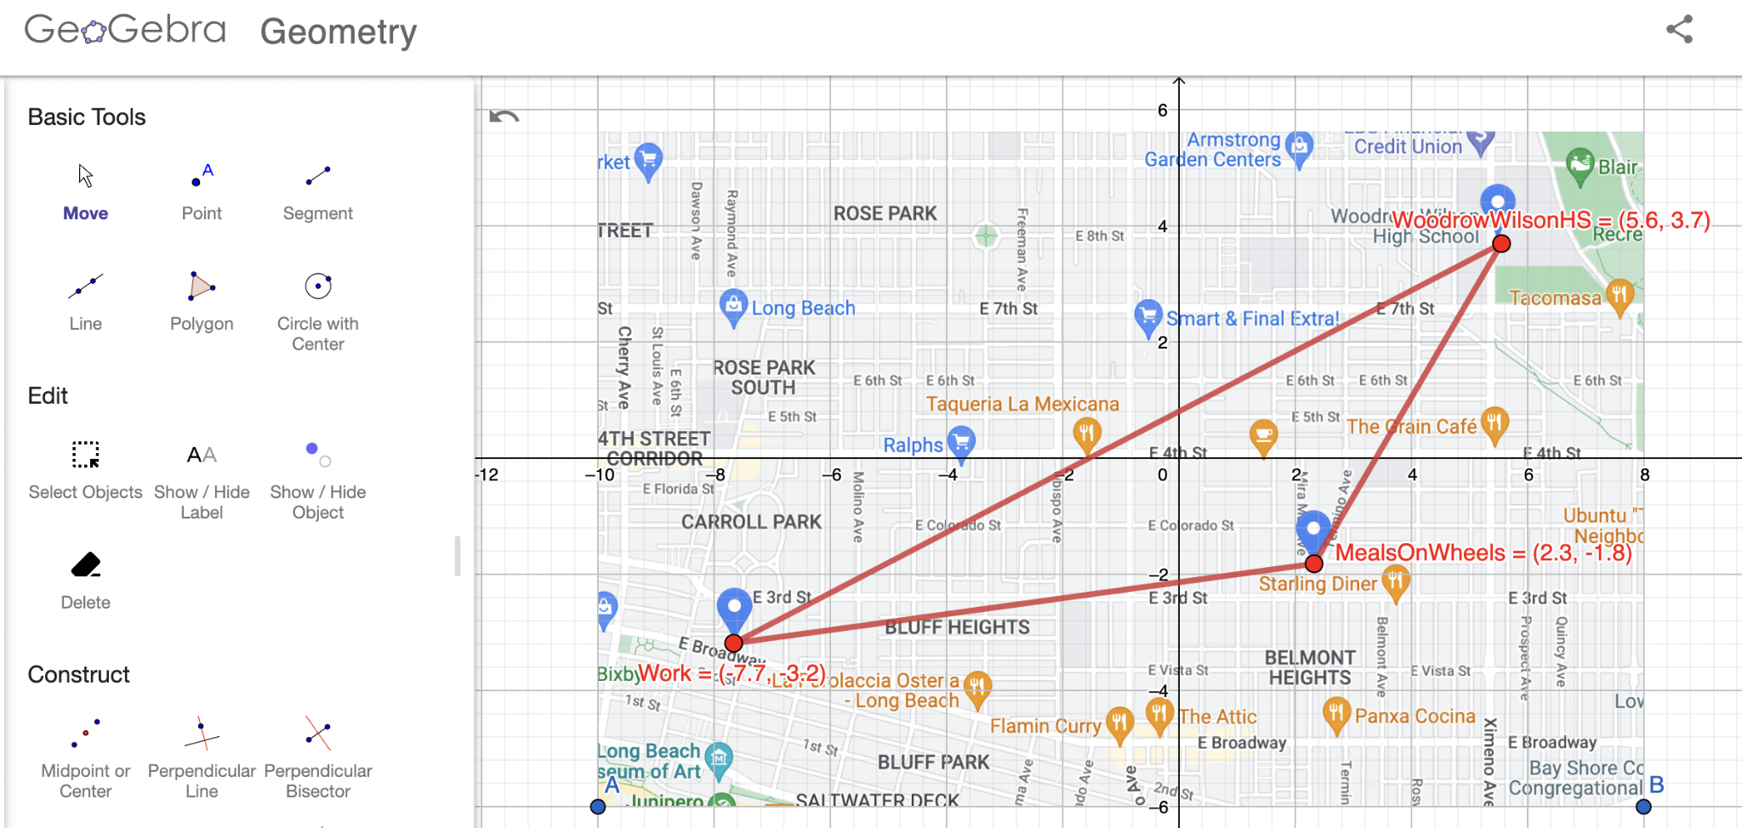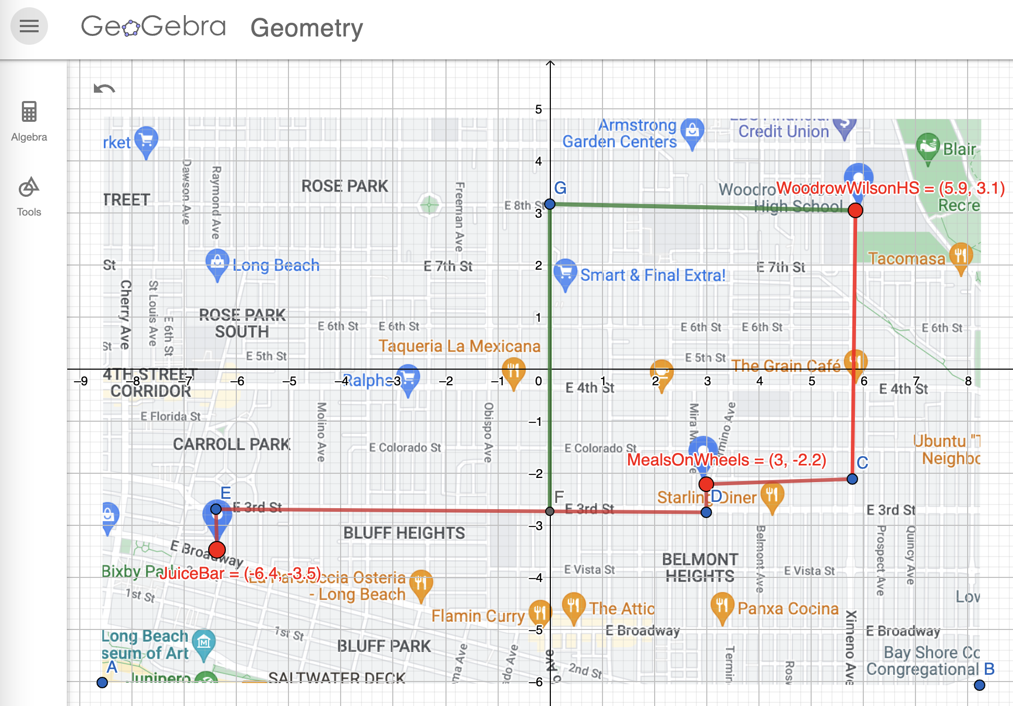
Here are some questions to facilitate the discussion of Question 1:
- What do you appreciate about this approach?
- What questions does this approach surface for you?
- What are some commonalities and differences among the various approaches shared?
- How might you determine if there’s enough charge to make the round trip? What information do you need to figure out in order to be confident about your answer?
- What can you take from this approach to apply to your own work?
Provide additional time for pairs to revise their work and/or continue with completing the task using the ideas that surfaced.
As students start Question 3, consider offering tools for them to conduct research. Here are a few websites where they can learn more about micro-mobility:
- Micro mobility: A Travel Mode Innovation | FHWA
- The Environmental Impacts of E-Scooters
- Micro mobility: moving cities into a sustainable future | EY
Offer students the opportunity to work in pairs or small groups to complete the task. Give the option of using chart paper, Google Slides, or other creative outlets to showcase their work. Give students the opportunity to return to their work to revise, as necessary.

Learning Principles
Engage with cognitively demanding tasks in heterogeneous settings (LP 1). Students should be given opportunities to grapple with multistep, non-routine tasks that promote mathematical rigor. These experiences should be differentiated so that all students engage in appropriate challenges—for example, through tasks with multiple entry points and solution pathways. These experiences should continue to integrate knowledge and skills developed in grades 6-8 at the level of sophistication of high school mathematics.

Engage in social activities (LP 2). Students should have opportunities to work independently and to communicate with one another about mathematics by engaging in collective and collaborative learning activities. Explaining and having opportunities to revise one’s thinking has excellent value in solidifying one’s knowledge.

Build conceptual understanding through reasoning (LP 3). Students should be given the opportunity to reason, justify, and problem solve with critical thinking, reading, writing, speaking, and listening. Through reasoning and work with multiple representations, students learn why procedures work and build a conceptual understanding of key mathematical ideas.

Have agency in their learning (LP 4). Students should be able to choose tasks and learning experiences that align with their interests and aspirations. All students have rich and varied experiences and home lives. Learning mathematics should bring students’ identities and interests to the fore and build on the strengths that they bring to the learning space.

View mathematics as a human endeavor across centuries (LP 5). Students should understand that mathematical ideas emanated over time from civilizations around the world and have opportunities to explore these contributions to mathematics. Students should develop an appreciation of mathematics as a human endeavor: one in which they feel a sense of belonging, where they see themselves as mathematicians, and one that offers opportunities to broaden their ideas about what mathematics is, how it is used, and who it is for.

See mathematics as relevant (LP 6). Students should engage with mathematics in ways that authentically involve real-world situations. Problem-solving contexts should allow students to perceive mathematics as a tool for addressing the questions that arise in everyday life, as well as the ways it can model our world and address global economic, social, and environmental challenges. Students should also engage with mathematics in ways that connect to academic disciplines and future careers by doing the mathematics used by artists, designers, engineers, and other professionals.

Employ technology as a tool for problem-solving and understanding (LP 7). Research indicates that technology is a powerful tool for learning deeper mathematics by improving calculation efficiency and enabling more sophisticated analysis. Students should learn to use technology, with emphasis put on widely used tools and software, such as calculators and spreadsheets, to make sense of models. Technology use should not be limited to supporting “doing mathematics,” but should also be used as a tool for displaying and communicating results to appropriate audiences.

Task 1: Micro-Mobility Student Work

Example 1:

Insert image of student work here

Example 2:

Insert image of student work here

Example 3:

Insert image of student work here

Let’s do some math! Round 2

Task 2: Ancient Rome Prompt
Students are given a problem like this.

Cesare Marchetti, a physicist and systems analyst, proclaimed that people are willing to commute from their homes for about half an hour each way. This idea is known as the Marchetti Constant.

Ancient Rome, around 275 CE, was a “walking city,” meaning that the main mode of transportation was by walking. The map below illustrates an outline of the city during that period.
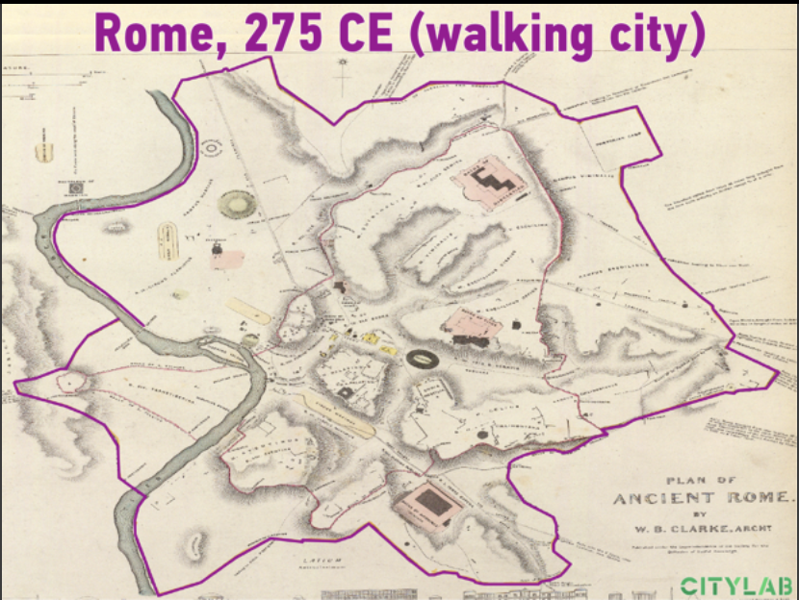
(Source: The Commuting Principle That Shaped Urban History - Bloomberg)

Use geometric concepts and tools to determine the degree of accuracy of the model outlined in purple in the diagram above. Aspects to explore and express in mathematical terms are as follows:

- What is the approximate diameter of the city? Why does that make sense, in terms of what you know about typical walking rates?
- What is the approximate area of ancient Rome?

Running water into homes was a luxury in ancient Rome. Therefore, Roman citizens were provided potable water by way of strategically placed water fountains throughout the city. It is believed that water fountains were located within a 50-meter radius from each other (Water System of Ancient Rome).

- Based on the work you’ve done so far, about how many water fountains were present in the city at that time?

Extension

Explore the historical roots of the city you live in. How has the radius of the city changed over time? Does the Marchetti Constant hold?

Sample Learning Experience
Give students an opportunity to begin the task independently, then invite them to work in pairs to share ideas and discuss strategies for completing the task. As student pairs work, monitor and make note of solution paths to share with the whole class. Note that some students may superimpose a coordinate system using tracing paper or web-based applications like Desmos or GeoGebra.
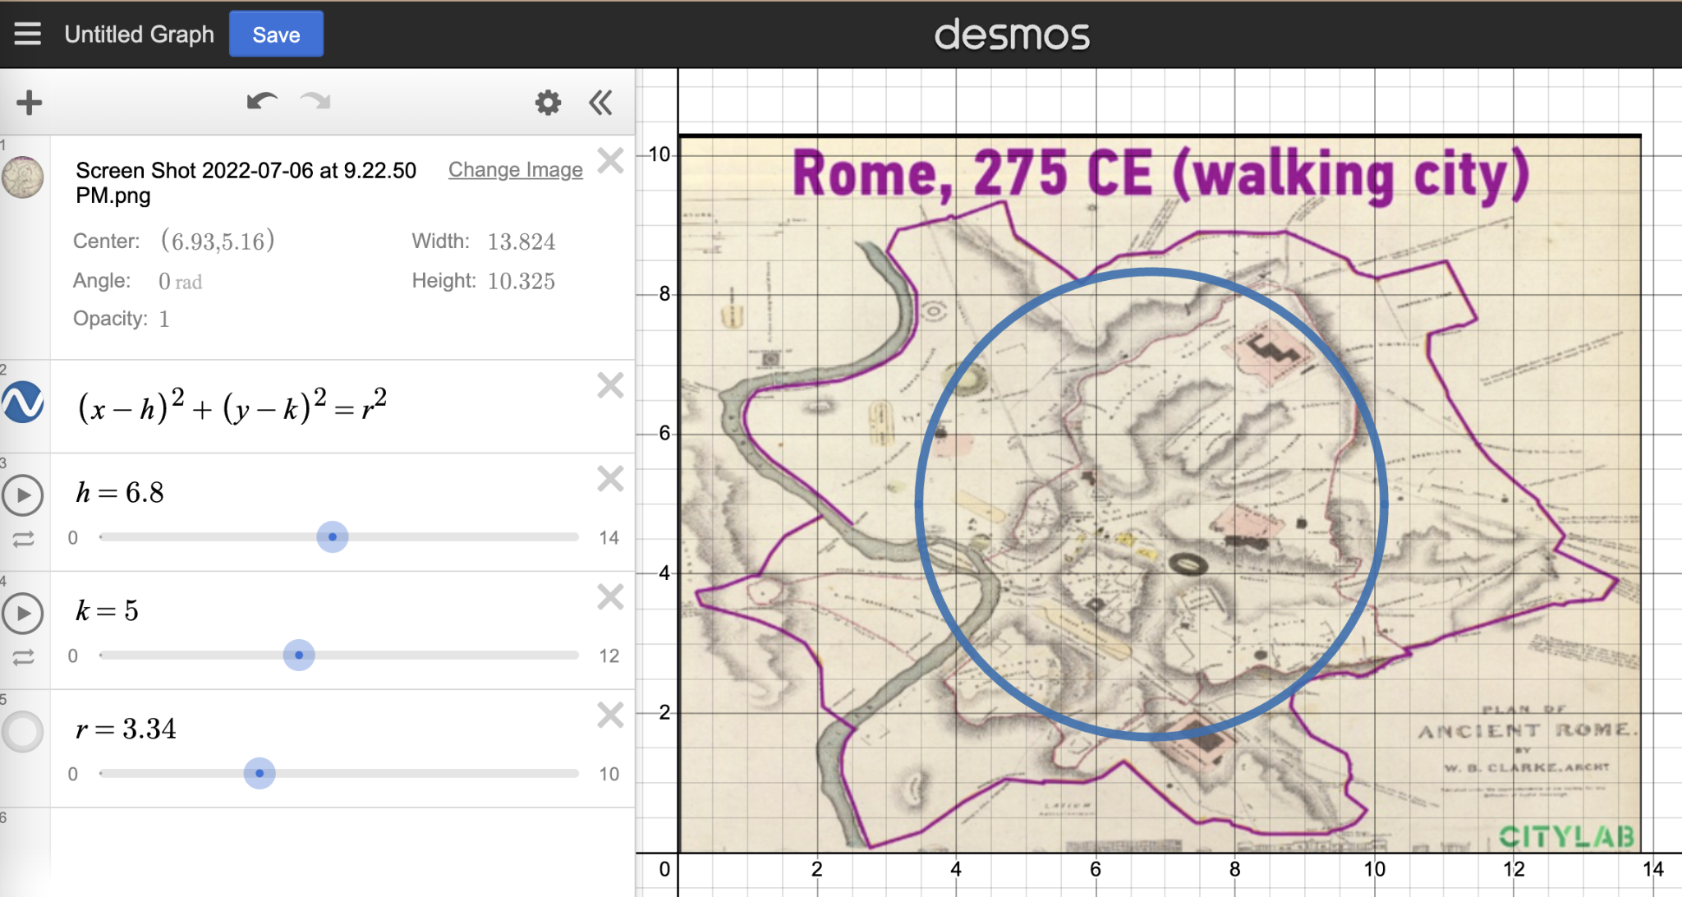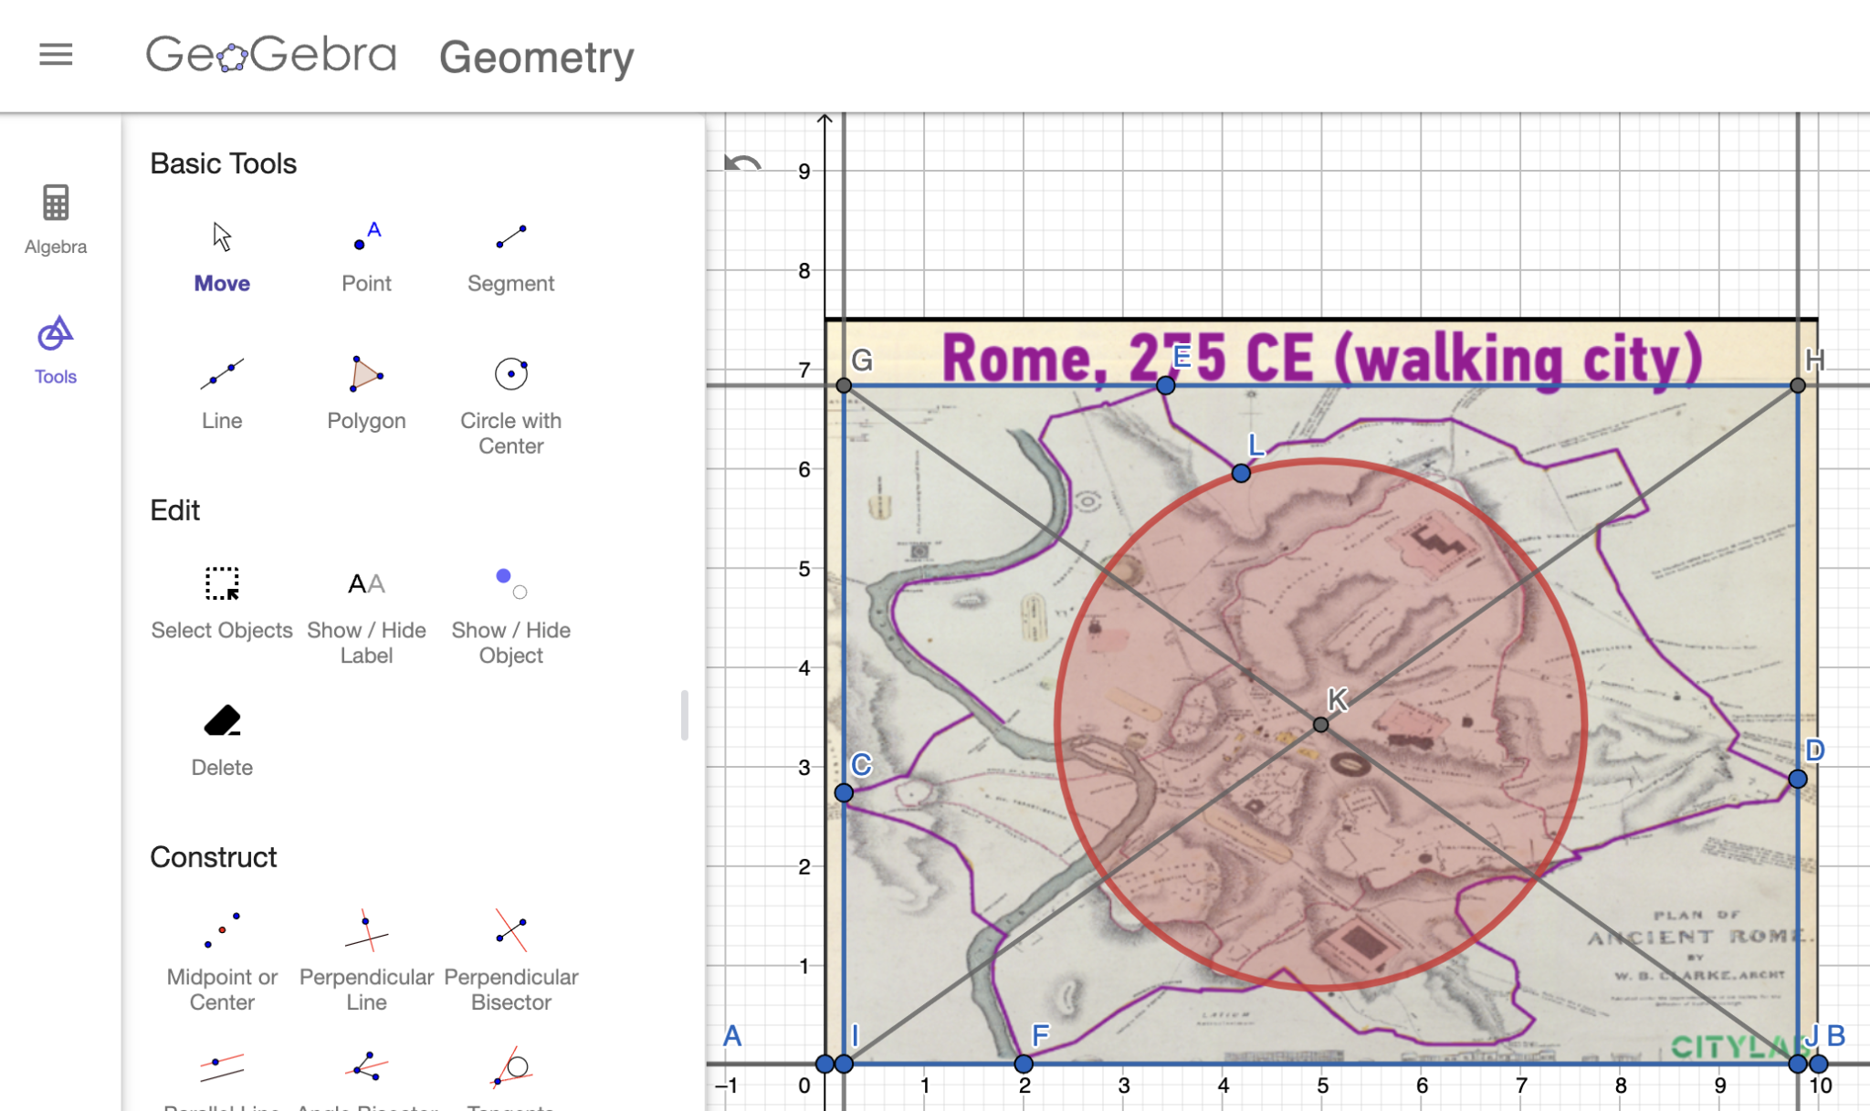
Here are some questions to facilitate the discussion of Questions 1 and 2:
- What do you appreciate about this approach?
- What questions does this approach surface for you?
- What are some commonalities and differences among the various approaches shared?
- How might you determine the approximate area of the city?
- What information do you need in order to reach some conclusions?
- What can you take from this approach to apply to your own work?
Provide additional time for pairs to revise their work and/or continue with completing the task using the ideas that surface.
As students start Question 3, monitor and select approaches they take to make sense of this. One sample approach is illustrated below. Encourage students to share and challenge approaches.
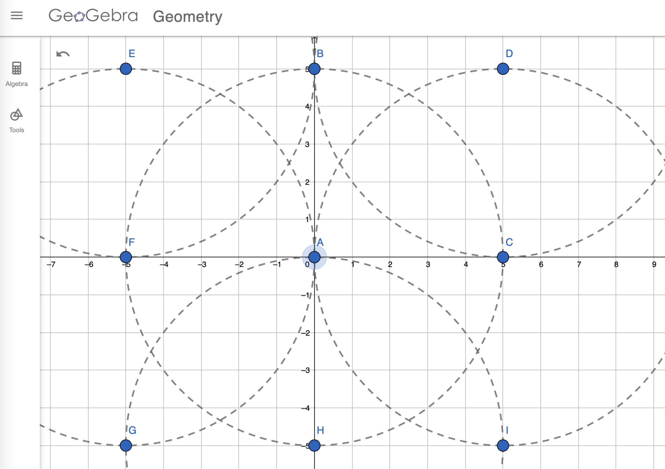
Provide additional time for pairs to revise their work and/or continue with completing the task using the ideas that surface.

Task 2: Ancient Rome Student Work

Example 1:

Insert image of student work here

Example 2:

Insert image of student work here

Example 3:

Insert image of student work here

Criteria for Success

Conference and Provide Revision Support | Accept with Revision | Accept
The student’s artifact shows an emerging understanding of the expectations of the indicator(s). After conferencing and additional instruction/learning, the student may provide a revised or different artifact as evidence of the indicator(s). | The student’s artifact is approaching a full understanding of the expectations of the indicator(s). The artifact may contain execution errors that should be corrected in revision. The student may revise the selected artifact or submit a different artifact. | The student’s artifact demonstrates evidence that they have met the expectations of the indicator(s).

