M212B Scoring Guide – Predictive Modeling UFOs
M212B Performance Task
Predictive Modeling - UFOs

The Modeling Cycle
Since the beginning of recorded human history, people have reported seeing flying objects unlike any familiar animals or aircraft. Popularly known as Unidentified Flying Objects, UFOs could be secret military or civilian technology, a trick of the light, an outright fabrication…or perhaps evidence that alien life has arrived at Earth. In this task, you will take on the role of a data scientist to investigate a dataset with multiple variables describing UFO sightings over the past 100 years. As a data scientist, you will conduct an exploratory analysis of the data, look for emergent patterns in the data, and interpret what story about UFOs the data may be hiding.
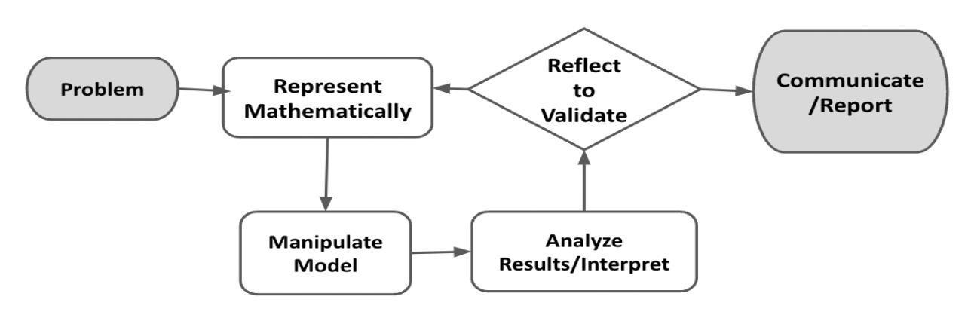
Mathematical models are used to make sense of ideas and phenomena in our world. As illustrated in the image below, the modeling cycle is a process of collecting data about an idea or problem, creating models of that data, analyzing the story told by those models, and reporting the results to the appropriate audience. In this task, you will be engaging with this mathematical modeling cycle to identify patterns in how, where, and when people report seeing UFOs.
Figure 1. Diagram of Modeling Process. From “Progressions for the Common Core State Standards for Mathematics” [Draft manuscript], by Common Core Standards Writing Team, 2019, p. 6 (http://mathematicalmusings.org/wp-content/uploads/2022/05/modeling_02082019.pdf).

Introduction: What makes a UFO sighting, anyways?
By definition, an Unidentified Flying Object (UFO) must be in the air, and we must not have enough information to definitely identify it as a known aircraft, animal, or natural phenomena. This includes all sorts of mundane occurrences: if someone throws a tomato past your head and you don’t get a clear look at it, that tomato would be a UFO. In popular usage, a UFO is generally an object seen in the sky that looks or moves like a piloted vessel. Most sightings are of faraway objects, but people have also reported seeing alien spacecraft up close, perhaps even being taken on board!
Read some of the text descriptions of sightings in the UFO dataset, then answer the questions below.

QUESTION 1
 | Imagine receiving a UFO report with a grainy photo of a faraway circular object. The reporter says they saw the object hovering in the sky for 30 seconds before it disappeared behind a cloud, and swears the photo is conclusive proof that we are not alone in the universe. Brainstorm as many possible explanations for this sighting as you can. Which explanations might you think are more likely than others, and why?  [This question is not meant to be scored. Look for reasonable responses (see teacher-facing guide for ideas). Expect students to answer individually on their own forms, as well as participate in a small group or class discussion.]  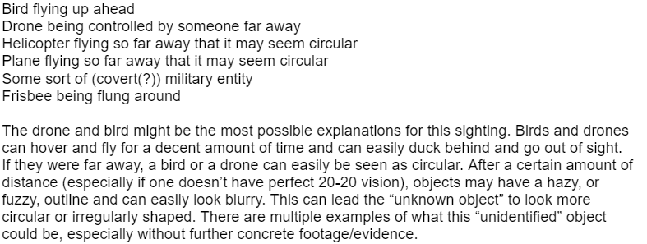  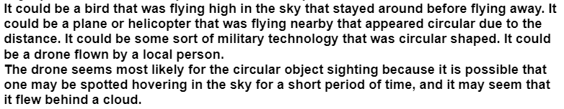  The student’s response shows some logical explanations for the sighting. It would be good to have students share their thoughts with classmates after independently responding.  Student B  Student A

The student obviously put a lot of through into this response. While it is tempting to judge this student’s response as “above average,” that is not the point of this question. Again, use a student’s response to this question as a way to increase engagement with the task amongst all students via a class or small group discussion.

Student C
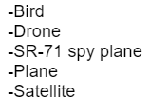
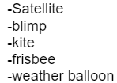

This student did give a list of possible explanations for the sighting but didn’t state which they thought was the most likely explanation. That is okay as long as during the discussion students talk about which ideas they think are most likely at this point.
QUESTION 2
Student A | What features or evidence from a UFO sighting would make you more inclined to believe that it was an artificial aircraft of some sort? What features or evidence would convince you more that it was an alien aircraft?  [This question is not meant to be scored. Look for reasonable responses (see teacher-facing guide for ideas). Expect students to answer individually on their own forms, as well as participate in a small group or class discussion.]  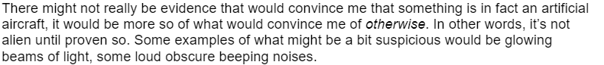  This student’s response illustrates what many students thought at this point “It’s not alien until proven so.” Again, these first two questions are just meant to generate and increase student engagement.
Student B
This student gave some real thought into differentiating between artificial reasons vs possible alien reasons for the UFO sightings. A class discussion following the first two questions of this task would likely spark a lot of lively discussions amongst students.

Student C
The response only addresses the second part of Question 2, but this is okay. At this point, you are just looking for students to continue engaging with the task and thinking about the possible explanations.

Initial Data Exploration
QUESTION 3
Plot separate distributions of responses to three variables from the UFO dataset. You might consider histograms, violin plots, or box plots. What do you notice about the distribution of these variables?
[Students are likely to spend quite a bit of time trying to digest the UFO dataset. Remember that the purpose of this question is to reinforce concepts of visualizing data from M211 as well as take part in a necessary step before conducting a formal analysis of the dataset. Examining the variables is of particular importance when the dataset could be biased or contain incorrect responses, which could skew our models considerably.]

This student took a sample of the data, but the sample was not clearly notated. For each graph, the student should be prompted to “Clearly indicate what portion of the data this visual is representing.”
Student A
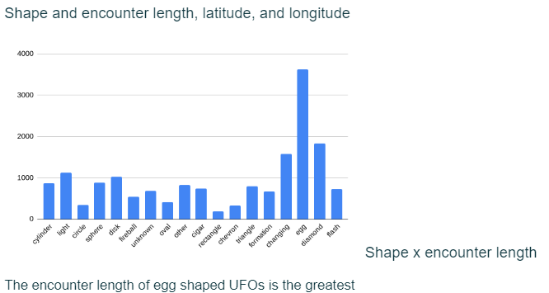

This student has created an accurately labeled bar chart, with shape on the x-axis and encounter length on the y-axis. The student analyzed the visual representation and identified the column with the largest count. The student could be prompted with questions, “How do we refer to the greatest category count in statistics?” or “What was your sample size? How does that affect your representation?”

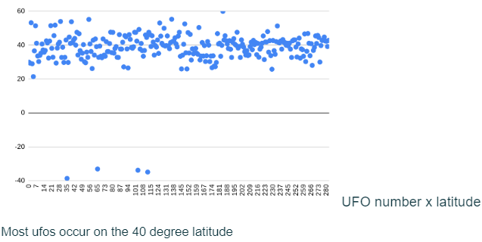
For both of these scatterplots, it is assumed that this student created a separate column, and numbered the data 1 to 300, labeling it UFO Number. The first scatter plot provides a visualization of UFO number and latitude. The second scatterplot provides a visualization of UFO number and longitude.

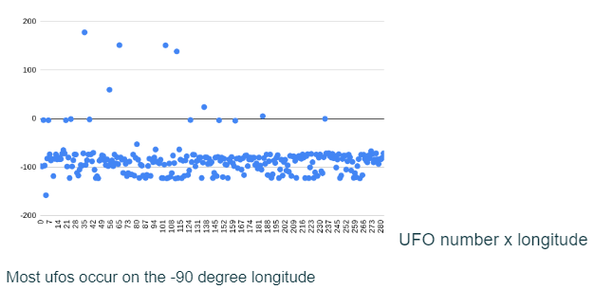
A scatter plot, in this case, does not relate the necessary information most clearly. The student could be prompted with questions, “How can you reimagine this visual, only using categories of data originally in the data set?” or “If you are looking for the highest occurrence, what is a different graphical representation you can use?”

This is an overall thorough response. For the first two graphs, the student took a sample of the data, clearly notating the sample size. The student failed to clearly note the sample size of the data om the last graph but that is easily remedied during the consultation.
Student B
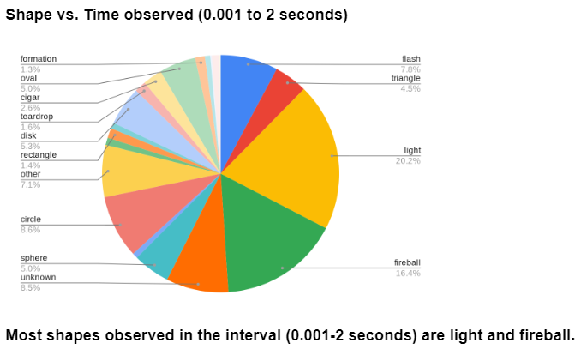
The student’s pie chart shows the shapes of UFOs observed between 0.001 to 2 seconds, grouped into percentages. The student analyzed the visual representation and identified light and fireball as the largest percentages in the pie chart. You can prompt the student to further consider their data display by asking “How does the portion of light and fireball compare to the rest of the 7+pie chart?”

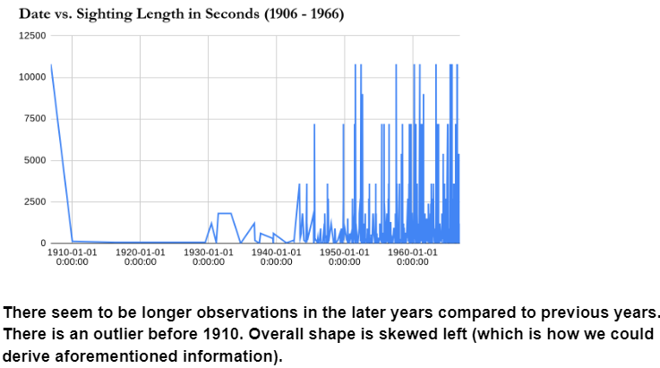
For this display, the student first had to transform sighting lengths from minutes and hours, into seconds, before creating a visual. Once the data was transformed, the student represented the relationship with a time series graph. The student analyzed the visual, notating an increase in sightings, the overall shape of the data, and an outlier.

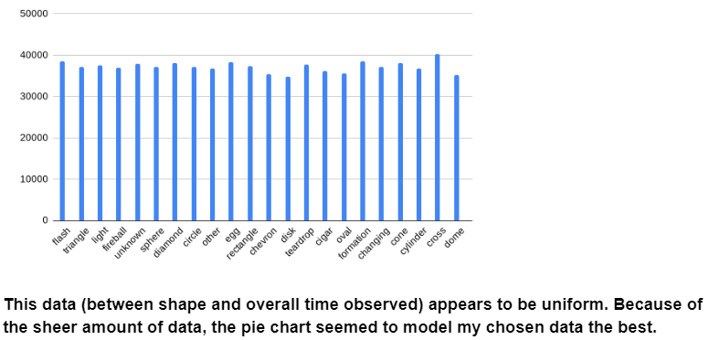
As stated above, the student failed to clearly note the sample size of the data here. The student did create a bar graph for third 3rd visual display, comparing shape and overall time observed. They analyzed and described the data as being uniform. During the consultation, consider asking “How can you label or indicate this for readers to easily understand your chosen data display?”

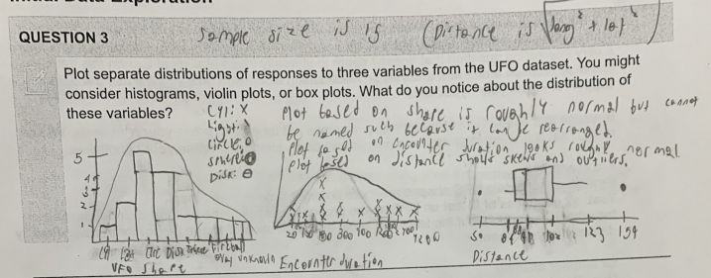
Student C

Transcription of student writing: “Plot based on shape is roughly normal but cannot be named such because it can be rearranged. Plot based on encounter duration looks roughly normal. Plot based on distance shows skews and outliers.”
The student created 3 visuals to represent the data (bar chart, dot plot, and box plot).They described the shape of all 3 graphs but left out information about the data represented on the y-axis in each of their graphs. The visuals have also been hand drawn and are hard to read. This student can be prompted with, “How can we use graph paper to represent our data in a clearer way?” or “What information is on the y-axis, what does this tell us about the data?”

Planning your analysis
Student A
This UFO dataset contains several variables, which may or may not be related to each other. We also lack ground truth data; since these are self-reported UFO sightings, we don’t know for sure what each respondent actually saw or even if their report is accurate.

Of course, that doesn’t mean we are helpless. Researchers work with imperfect datasets all the time. We will begin by brainstorming some hypotheses that you think this dataset could help you answer.

QUESTION 4
Brainstorm two testable hypotheses that you could analyze with this dataset. For each hypothesis, include:
- Your hypothesis written in plain English
- How the data might show your hypothesis is false
- What you think could be interesting if your hypothesis is true

For example,
Hypothesis: Certain UFO shapes are more commonly seen than others.
Evidence of falsity: The reported proportions for each UFO shape are similar (i.e., all ~10%).
Potential interesting findings: If there are one or two shapes that are much more common, and those shapes happen to be the same shapes we see on popular media (generally ovals or circles), that could show the media affect our perception and attention in the wider world to the point of causing people to see aliens where they might not exist.
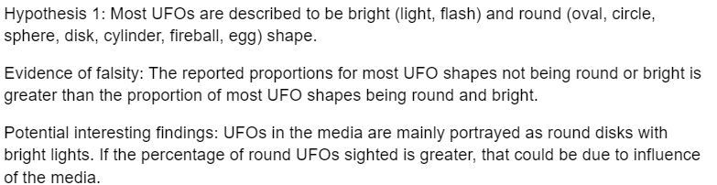

The student’s first hypothesis is clearly stated and can be tested using the data provided. The evidence of falsity does not quite make sense, as the student used the phrase “proportions for most UFO shapes” for both bright and round shapes. It’s worth asking the student what they meant, as both of these proportions can’t possibly be “most” at the same time, to help them realize that the word “most” should be omitted here for it to be a reasonable answer. This student’s potential interesting findings response is very insightful–they are thinking about the bigger picture and why the data could have provided the results that it did.

Student A
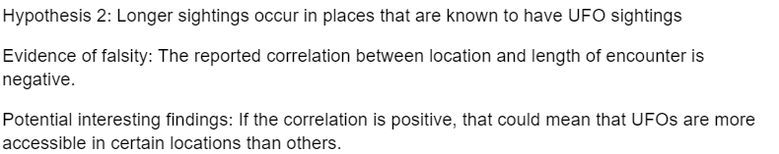

The 2nd hypothesis is clearly stated and can be tested using the data provided, potentially requiring the creation of a new variable (number of sightings in each location). However, there is a slight error in the evidence of falsity response. Correlation can only occur between two quantitative variables. The student should be asked about the “location” variable mentioned–for example, “How do you measure location?” This should hopefully help the student realize that the variable should actually be “number of sightings at location.” Lastly, it may be worth asking for more information about the potential interesting findings–why would it be important that UFOs are more accessible in certain locations than others?

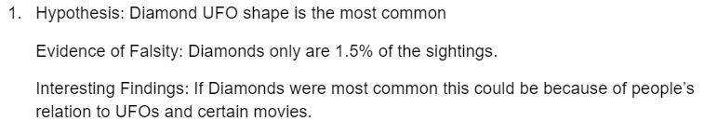
Student B
This student’s first hypothesis can be tested using the data provided. However, this example is very similar to the example provided in the question, so it may be worth asking the student for a more novel hypothesis. For their evidence of falsity, the word “only” is not explicit enough of a comparison word to analyze how rare diamond-shaped UFOs are compared to the other shapes. Perhaps ask the student for more information here, in hopes that they provide a comparison. The student could also be asked to further explain what they mean by “people’s relation to UFOs and certain movies.” Are there movies that show diamond-shaped UFOs? Is there a general pre-conceived notion that UFOs should/shouldn’t be diamond-shaped?

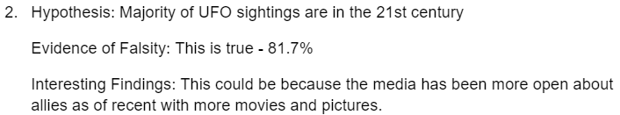
Student B continued

This hypothesis can be tested using the data provided and is more novel than the previous hypothesis provided. The hypothesis could potentially be falsifiable, and the student should provide how the hypothesis would be falsified, even though the hypothesis appears to be true in this instance. Ask, “What would the scenario look like where this hypothesis is not true?” in order to test their understanding of how to reject a false hypothesis. While the student’s response for the potential interesting findings is adequate, it could be expanded on slightly. Perhaps ask questions such as “What do you mean by ‘allies?’ How does this mean there are more UFO sightings in the 21st century than prior?”

Student C
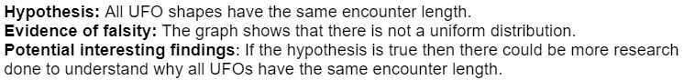

This student provided a hypothesis that can be tested using the data provided and provides a valid piece of evidence that would prove this hypothesis to be false. It may be worth asking the student what would be important/interesting about UFOs having the same encounter length to ensure the student is thinking genuinely about the implications of their findings.

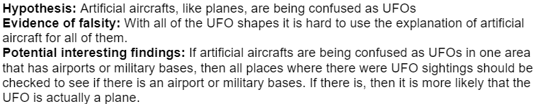

The hypothesis provided here would be difficult to test using the given data without modification. Perhaps ask the student, “How can we make this hypothesis measurable?” An additional question could be “What shapes in the data are comparable to artificial aircrafts?” to help the student find a specific measure for the proportion of UFO sightings that could potentially be aircrafts instead. The student’s evidence of falsity hints at the idea of it being unlikely for all UFO sightings to be artificial aircrafts; the measurable quantity the student decides on in the hypothesis will help strengthen this argument further. For the student’s potential interesting findings, the student shows evidence of genuine thought by indicating why artificial aircrafts might be confused as UFOs.

QUESTION 5
Choose one of your hypotheses from the previous question and explain how you would test the dataset to see if your hypothesis is false. This is likely to be a statistical test of some kind. However, if you have a very interesting question that doesn’t seem to fit neatly into a statistical test on this dataset, you may propose a different analysis or visualization along with how you will use the data to support or refute your hypothesis.

Because this dataset is relatively messy, you may not be able to prove your hypothesis true or false. That is fine, as long as your analysis can partly support or refute your hypothesis.

For example,
Hypothesis: Certain UFO shapes are more commonly seen than others.
Test: χ2 goodness of fit test on UFO shape proportions against the uniform distribution. Our hypothesis is supported if the test shows that the distribution of shape proportions is significantly different from uniform.

Or another example,
Hypothesis: People are mistaking man-made objects for UFOs.
Test: Create a heatmap of sightings based on the geolocated data and compare it to an online map of major world airports. Even better, compare it against an online map of the average number of man-made objects in the sky, if such a map exists. Our hypothesis is supported if our UFO heatmap shows sightings are significantly concentrated around major airports or places where many man-made objects are in the sky.
Student A

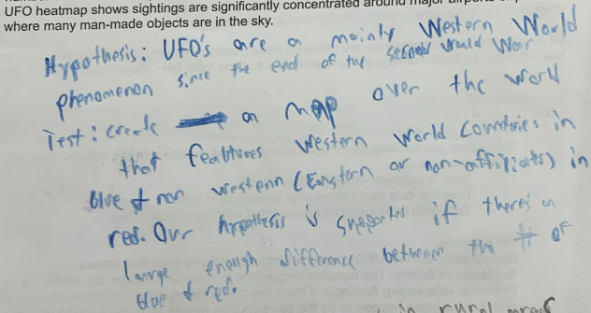

This student indicates a method to test their hypothesis, by distinguishing information of UFO sightings between western world countries and non-western countries. Their test can be made stronger through a more thorough explanation of their process. Possible prompts for this student might be, “How are you distinguishing western and non-western countries,” or “What indicates a ‘large enough difference’ to prove your test true?”

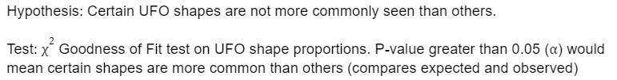
Student B

This student indicates a correct method to test their hypothesis and a correct test that will analyze their hypothesis. One error the student made was stating that a P-value greater than 0.05 would mean certain shapes are more common than others, when they should have said “less than.” Prompt the student by asking “What does a P-value mean? What is your null hypothesis?” When the student remembers that a P-value is the likelihood of the shape proportions being the same by random chance, they will hopefully recognize their mistake.

Student C
This student indicates a method to test their hypothesis, by comparing UFO sightings to flight routes. Their test can be made stronger by incorporating a statistical test, such as a T-test or $x^{2}$ Goodness of Fit test, or z test. Perhaps ask this student during the consultation, “What statistical test can you use to justify or refute your hypothesis?”

Initial Data Exploration and Planning Your Analysis Checklist
Requirement | Fulfilled?
I plotted separate distributions of responses to three variables from the UFO dataset described what I noticed about the distribution of those variables. | ▢
I proposed two testable hypotheses for the dataset and reported on evidence of falsity and potential interesting findings. | ▢
I chose one of my hypotheses and tested the data to either support or refute that hypothesis. | ▢
Teacher Consultation: | ______________

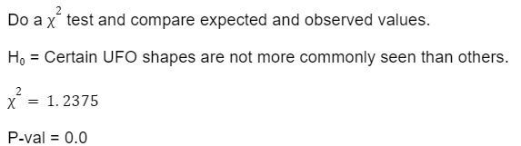
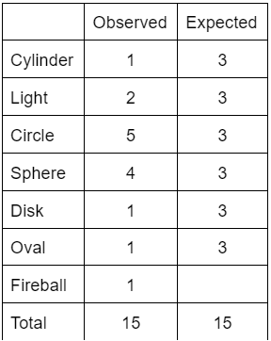
Open Modeling Challenge
Student B
While the student decided on the correct test to use to analyze their hypothesis from the previous question, this $x^{2}$ test was done incorrectly. In particular, the student recognized that the expected column should add to the same amount as the observed column, but every box needs to be filled in. To help the student recognize this, perhaps ask, “Since every box needs to be filled in and have the same value, how can I find what that value should be?” Doing this will yield a correct calculation of 2, as well as a correct P-value. Additionally, to strengthen the response, the student should provide a brief explanation of what this P-value means in context.
QUESTION 6
Student A | Attempt to support or refute your hypothesis using your suggested analysis from the previous section. Make sure to include a table, graph, or some other visualization that would help a reader interpret your results.  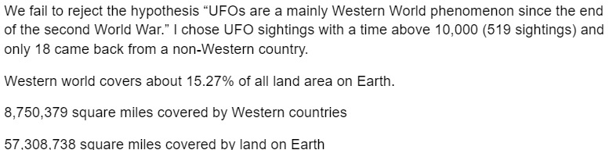  The student provided evidence for failing to reject their hypothesis. They cite information from the data, and outside information, to strengthen their claim. Their claim can be made stronger through a more thorough analysis of the data. Possible questions to ask this student might be: “What measurement are you using for time?” “How can you use statistical analysis to further strengthen your claim?” “What is the purpose of the last three statements about earth and western countries?” “How can you make this purpose stronger?”

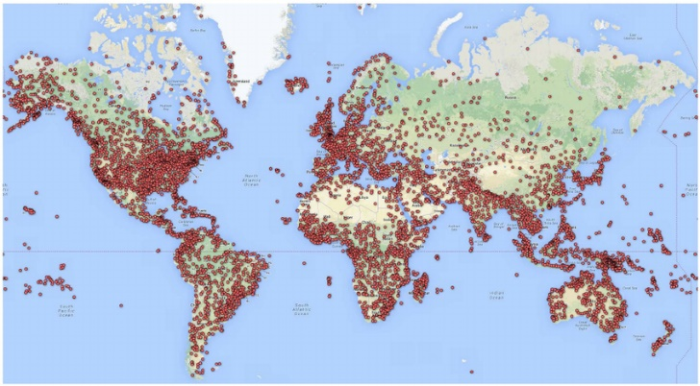
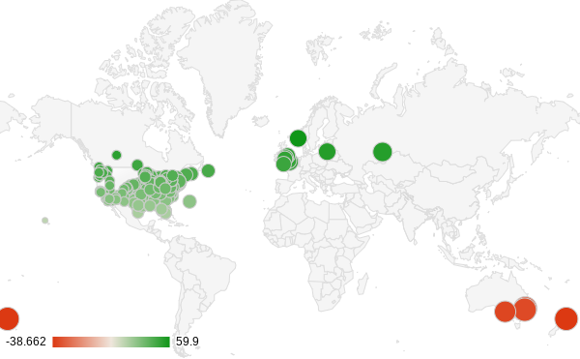
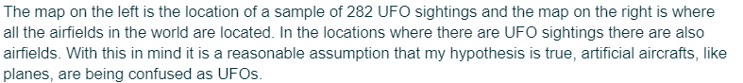
Student C

This student provided a visual representation to support the test of their hypothesis. However, this response lacks a mathematical comparison of the images above. The student’s claim can be made stronger by analyzing the data in each photo and drawing conclusions from their analysis. Perhaps ask this student during the consultation, “How can you use statistics to help support your reasonable assumption?”

Interpretation and Evaluation
QUESTION 7
Explain whether or not your analysis supported or refuted your hypothesis. If you feel the result was ambiguous or inconclusive, explain why and what you could have done differently to get a more conclusive result. Explain your reasoning as if you were giving a presentation to a government official who only knows a little statistics.
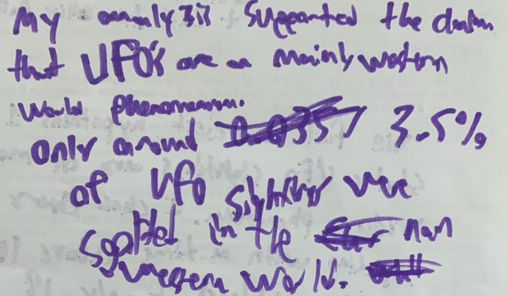
This student defends their claim by stating a statistic from their findings, “Only around 3.5% of UFO sightings were sighted in the non-Western world.” However, the question asks students to, “explain your reasoning as if you were giving a presentation to a government official who only knows a little statistics.” This student should be prompted to provide more detail around their findings, through a deeper analysis.
Student A
Student B

This student made a correct conclusion based on their P-value but did not explicitly state why they could make this conclusion. Prompt the student as to why the analysis supports the hypothesis to make the student’s thinking visible, as well as to strengthen the argument.

This student clearly names the ambiguity in their analysis but does not expand beyond that. This response can be made stronger through additional detail, satisfying a presentation to a government official.
Student C

QUESTION 8
One of the marks of a principled approach to scientific analysis is to consider counterarguments. For your analyses, present at least one counterargument to your findings and what you would need to do to evaluate the counterargument.

For example, let’s say we discovered that the proportion of UFO shapes are not significantly different from the uniform distribution. In other words, in this dataset each shape is reported a similar amount of the time. A counterargument to this finding could be that in fact some shapes are more common, but the dataset is polluted by random and false reports because it was drawn from online surveys with minimal verification. To check whether this is true, we could do a similar analysis but only on sightings with a “description” field containing more than 5 words and written in relatively coherent English, because random reporters would likely not take the time to fully describe what they saw.

Student A
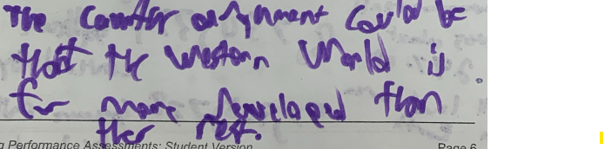

Transcription: “The counter argument could be that the Western World is far more developed than the rest.”
This student provides a counterargument for their hypothesis. The counterargument could be made stronger through further explanation and detail. Additionally, consider asking the student how the Western World being more developed is an explanation for more or less UFO sightings to help them recognize any holes in their reasoning.

Student B

This student provides a counterargument for their hypothesis. The counterargument could be made stronger through further explanation and detail. Consider pushing students to write more about the effect lies and bias can have on data.

Student C



This student provides a counterargument for their hypothesis, but the wording of “artificial aircrafts,” is confusing. The detail of their counterargument, using the absence planes to justify UFOs is reasonable. This response could be made stronger by stating how many times this would need to occur to be a strong counterargument. Consider posing that idea to the student as a question.

Reflection
This student has responded to parts of the prompts. They have stated their opinion on the data not being convincing. They name specific components that would be more convincing. The response from this student could be strengthened by greater detail, supported by mathematical justification. Potential questions to ask this student during the consultation might be, “What was unconvincing about the data,” or “What additional data would be helpful? How would you use the data?”
QUESTION 9
Student A | Congratulations on completing an open-ended data analysis task!  - Say you were on a mission to figure out once and for all whether UFO sightings are glimpses of top-secret military aircraft or even alien spaceships, rather than people misinterpreting a cloud or normal aircraft for a UFO or even making up reports. Did your analysis help you decide whether people are truly seeing something “secret?”  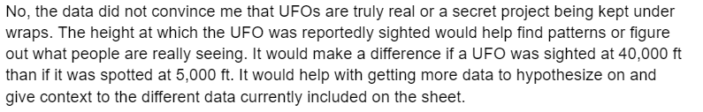  - If you could access more data than the dataset provides, what other existing data would you like to include in your analysis to help you find patterns or even figure out what people are really seeing? Why do you think this new data could help you?
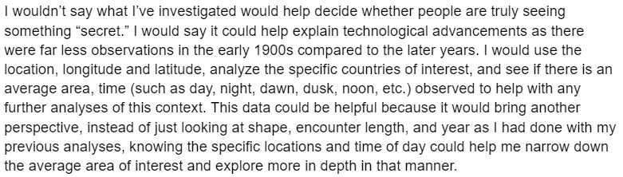
This student provided a thorough response to all parts of the prompt. The student shows genuine thought surrounding the idea of seeing something “secret,” and they explain what additional variables would help strengthen their research.
Student B


Student C
This student has stated their final opinion around UFOs. Several parts of the prompt were left unanswered. This student would benefit from revisiting all parts of the question and making sure their response satisfies each component. A potential question to pose to this student is, “What parts of the question can you expand upon?”

Open Modeling Challenge Checklist
Requirement | Fulfilled?
I included a visualization to help support or refute my analysis. | ▢
I explained my reasoning as if I were giving a presentation to a government official who only knows a little statistics. | ▢
I presented a counterargument to my findings as well as what I would need to do to evaluate the counterargument. | ▢
I suggested additional data I would like to include in my analysis to help find patterns or figure out what people are really seeing. | ▢
Teacher Consultation: | ______________

