Example 1: Ball Throwing

Work with your group to develop a model that describes the height of a ball thrown at a given time during the throw. Have one person in the group throw a ball while another records a video of the event. Make sure that the video includes the entire path of the ball from the throw to when it hits the ground. Prepare your findings to share with the class.

- Record someone tossing a ball from start until it stops moving.
  - It might be a good idea to use a slow-motion setting.

- Watch a selected group’s video. Describe and record what you notice while watching the video.
  - Describe key elements, such as the height of the ball upon release, the highest point the ball reached, and when and where the ball lands.
  - Think about how the group has organized and is presenting their data. What quantities did they include?

- How high was the ball above the ground at its highest point? What makes finding this difficult and how can you persevere in finding it?

As students present, think about these questions:

● What do you appreciate about this approach?
● What questions does this approach surface for you?
● Do you think the model is reasonable? Why or why not?
● What can you take from this approach to apply to your own work?

Reflect on and revise your work.

Example 2: 3, 2, 1 ….. Liftoff

Part 1: Making Sense of Rocket Launches

- Watch the video “Grasshopper 744m Test| Single Camera (Hexacopter).”

- Reflect: What questions does this clip bring to mind?

- Visualize: Sketch a diagram that illustrates the rocket’s flight. Use the diagram you developed to sketch a graph.

- Read the article “Why SpaceX wants to land a rocket on a platform in the ocean” by Joseph Stromberg.

- Inquire: What questions do the article and the video answer? What new questions does this surface for you?

Part 2: Modeling with Quadratics

After some trials, SpaceX learned to control the flight of reusable rockets used to launch spaceships into space.

- Watch and gather data from SpaceX’ April 2022 launch of Ax-1 [watch from about 3:26 to 3:36]

- Vizualize: Create a model for the flight of the Phase 1 rocket used in that mission. Prepare to share your findings.

- Inquire: What new questions surface for you?

Example 3: I See a Rainbow!

The appearance of a rainbow is a phenomenon that has captured the imaginations of people since prehistoric times. At one point, the Greek philosopher Aristotle described the rainbow in Book III of his treatise Meteorology: “The rainbow never forms a full circle, nor any segment greater than a semicircle. At sunset and sunrise the circle is smallest and the segment largest: as the sun rises higher the circle is larger and the segment smaller” (as quoted in Corradi’s A short history of the rainbow).

Notice that Aristotle proclaims, “the rainbow never forms a full circle.” In this assignment, you will explore this phenomenon and use tools, including Desmos.com or Geogebra.org, to construct an argument that either supports or refutes Aristotle’s statement.

Some materials to explore:
● Kamal Al-Din Al-Farisi's Explanation of the Rainbow
● Corradi history of the rainbow.pdf
● Chasing Rainbows in the Hudson Valley

Consider using sliders on Desmos or GeoGebra to explore the graph of a quadratic function and the graph of a circle.

One form of a quadratic function you can use is $y=a{\left(x-h\right)}^{2}+k$. One form for the equation of a circle you can use is ${\left(x-d\right)}^{2}+{\left(y-f\right)}^{2}=r^{2}$.
.

To fit these curves to an image of a rainbow, begin by adding an image of a rainbow onto your Desmos or GeoGebra graph.

Prepare to share your findings in a presentation, including:

- New understandings you have about rainbows from your research.
- Highlights from your exploration in fitting the graph of a quadratic function and fitting the graph of the equation of a circle to the image you used.
- How you decided which was a better fit.
- The equation of the curve of best fit and your best explanation as to what each parameter could possibly represent.

Here is one sample image you may choose to use.
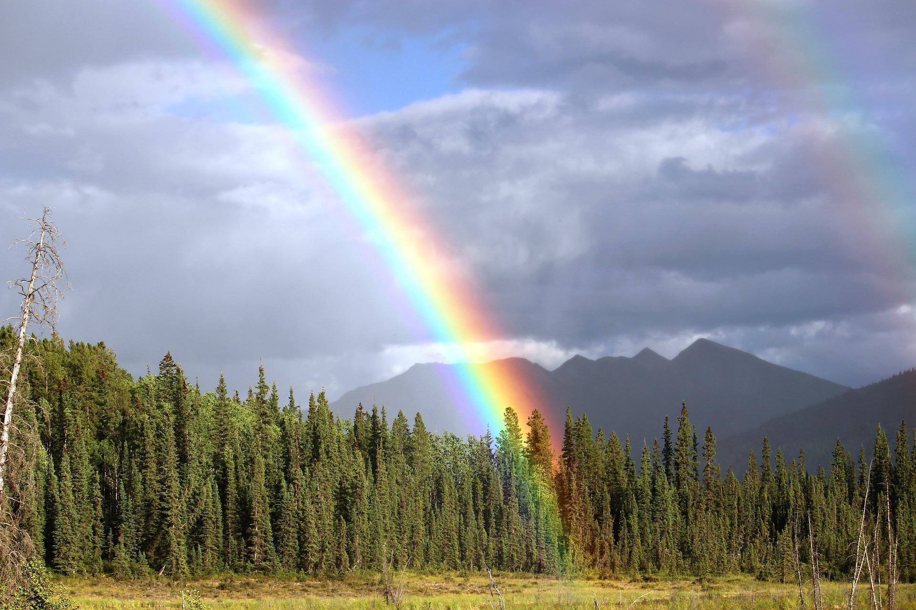

(Source: Pixabay picture: Rainbow Bow Colors Double - Free photo on Pixabay)

Explain Your Thinking:
- How did you choose to place the image on the grid?
- How did you verify the focus of the work: did you select key points, color, or some other feature(s) to guide you as they explored best fit?
- How did you determine which was a better fit?
- How did the research influence your approach?

Additional questions for reflection:
- What’s promising about this approach?
- What questions does this approach surface for you?
- Do you think the model is reasonable? Why or why not?
- What can you take from this approach to apply to your own work?

