Baseline Professional Learning Handout
M101 Linear Equations: Concepts and Skills

Baseline Professional Learning Handout 1
Selected Common Core High School Standards for Mathematics 2
Progressions Excerpt 2
M101 Content and Practice Expectations 3
M101 Content and Practice Expectations and Indicators 4
Let’s Investigate 5
Writing Constraints Task 5
Solution Sets Task 6
Let’s do some math! Round 1 7
Task 1: Solutions 7
Learning Principles 8
Task 1: Solutions Student Work 9
Let’s do some math! Round 2 12
Task 2: Finding a Context Prompt 12
Task 2: Finding a Context Student Work 14
Criteria for Success 17
References 17
Selected Common Core High School Standards for Mathematics

High School - Algebra
Create equations that describe numbers or relationships
- Create equations and inequalities in one variable and use them to solve problems.
- Create equations in two or more variables to represent relationships between quantities; graph equations on coordinate axes with labels and scales.
- Represent constraints by equations or inequalities, and by systems of equations and/or inequalities, and interpret solutions as viable or nonviable options in a modeling context.

Understand solving equations as a process of reasoning and explain the reasoning
- Explain each step in solving a simple equation as following from the equality of numbers asserted at the previous step, starting from the assumption that the original equation has a solution. Construct a viable argument to justify a solution method.

Solve linear equations in one variable
- Solve linear equations and inequalities in one variable, including equations with coefficients represented by letters.

Solve systems of equations
- Solve systems of linear equations exactly and approximately (e.g., with graphs), focusing on pairs of linear equations in two variables.

Represent and solve equations and inequalities graphically

- Understand that the graph of an equation in two variables is the set of all its solutions plotted in the coordinate plane, often forming a curve (which could be a line).
- Graph the solutions to a linear inequality in two variables as a halfplane (excluding the boundary in the case of a strict inequality), and graph the solution set to a system of linear inequalities in two variables as the intersection of the corresponding half-planes.

Algebra Progression Excerpt
.
Equations in one variable A naked equation, such as $x^{2}=4$, without any surrounding text, is merely a sentence fragment, neither true nor false, since it contains a variable x about which nothing is said. A written sequence of steps to solve an equation, such as in the margin, is code for a narrative line of reasoning using words like “if,” “then,” “for all,” and “there exists.” In the process of learning to solve equations, students learn certain standard “if–then” moves, for example “if $x=y$ then $x+2=y+2$.” The danger in learning algebra is that students emerge with nothing but the moves, which may make it difficult to detect incorrect or made-up moves later on. Thus the first requirement in the standards in this domain is that students understand that solving equations is a process of reasoning. This does not necessarily mean that they always write out the full
text; part of the advantage of algebraic notation is its compactness. Once students know what the code stands for, they can start writing in code. Thus, eventually students might go from $x^{2}=4$ to $x=±2$ without intermediate steps.

M101 Content and Practice Expectations
101.a | Reason about and solve one-variable linear equations and inequalities.
101.b | Solve real-life mathematical problems using linear expressions, equations, and inequalities.
101.c | Analyze and solve two-variable linear equations and pairs of simultaneous linear equations.
101.d | Represent and solve linear equations and inequalities graphically.

M101 Content and Practice Expectations and Indicators
Content and Practice Expectations | Indicators  Choose an artifact where you…
101.a: Reason about and solve one-variable linear equations and inequalities. | i. use variables to represent numbers and write equations when solving a real-world or mathematical problem.
 | ii. demonstrate understanding that a variable can represent an unknown number or, depending on the purpose at hand, any number in a specified set.
101.b: Solve real-life and mathematical problems using linear expressions, equations, and inequalities. | i. solve multi-step real-life and mathematical problems posed with positive and negative rational numbers in any form while using tools strategically.
 | ii. construct simple equations and inequalities to solve problems by reasoning about quantities.
101.c: Analyze and solve two-variable linear equations and pairs of simultaneous linear equations. | i. solve linear equations in two-variables.
 | ii. give examples of linear equations in two-variables with one solution, an infinity of solutions, or no solutions.
 | iii. analyze and solve pairs of simultaneous linear equations.
101.d: Represent and solve linear equations and inequalities graphically. | i. explain why the x-coordinates of the points where the graphs of the linear equations y=f(x) and y=g(x) intersect are the solutions to the equation f(x)=g(x).
 | ii. find solutions to a system of linear equations in the form y=f(x) and y=g(x) approximately by using their graphs.
 | iii. graph the solutions to a linear inequality in two variables as a half plane (excluding the boundary in the case of a strict inequality), and graph the solution set to a system of linear inequalities in two variables as the intersection of the corresponding half-planes.

Let’s Investigate

Writing Constraints Task

In (a)–(d), (i) write a constraint equation, (ii) determine two solutions, and (iii) graph the equation and mark your solutions.

- The relation between quantity of chicken and quantity of steak if chicken costs $1.29/lb and steak costs $3.49/lb, and you have $100 to spend on a barbecue.

- The relation between the time spent walking and driving if you walk at 3 mph then hitch a ride in a car traveling at 75 mph, covering a total distance of 60 miles.

- The relation between the volume of titanium and iron in a bicycle weighing 5 kg, if titanium has a density of 4.5g/cm3 and iron has a density of 7.87 g/cm3 (ignore other materials).

- The relation between the time spent walking and the time spent canoeing on a 30 mile trip if you walk at 4 mph and canoe at 7 mph.

Source: Illustrative Mathematics

Solution Sets Task

Given below are the graphs of two lines, y = −0.5x + 5 and y = −1.25x + 8, and several regions and points are shown. Note that C is the region that appears completely white in the graph.
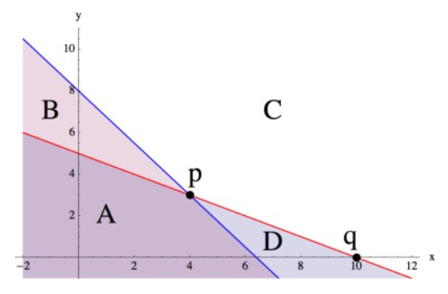
For each region and each point, write a system of equations or inequalities, using the given two lines, that has the region or point as its solution set and explain the choice of ≤,≥, or = in each case. (You may assume that the line is part of each region.)

Source: Illustrative Mathematics

Let’s do some math! Round 1

Task 1: Solutions

Students are given a problem like this:

Which of the following equations have the same solution as $x+3=5x-4$?

- $x-3=5x+4$
- $2x+8=5x-3$
- $10x+6=2x-8$
- $10x-8=2x+6$
- $0.3+\frac{x}{10}=\frac{1}{2}x-0.4$
Prepare to share your response.
- Explain how you could tell which equations have the same solution as the given equation without solving each one (and without substituting a value).
- Are there other equations on the list that share a common solution? Without solving, how could you tell?

(Adapted from Illustrative Mathematics, Same Solutions?, 2016)

Sample Learning Experience

After some individual work time where students develop an approach to the prompt, encourage students to share and compare approaches in pairs. Monitor and select a couple of approaches to highlight and reflect on progress made at this point. Look for student work that indicates students are beginning to attend to the structure of the equation.

Questions that can be posed to student pairs as they work:

- What do you notice about the structure of the equations? In what ways are they the same? In what ways are they different?
- What relationships do you notice in the parts that look similar?

Give selected pairs of students time to share responses and invite classmates to reflect on the following questions:

- What’s promising about this approach?
- What questions does this approach surface for you?
- What can you take from this approach to apply to your own work?

Provide time for students to revise their work. While they work, select additional pairs to share how they used the structure and relationship between the equations to determine which sets of equations have the same solution. Give students additional time to revise their work.

Learning Principles
Engage with cognitively demanding tasks in heterogeneous settings (LP 1). Students should be given opportunities to grapple with multistep, non-routine tasks that promote mathematical rigor. These experiences should be differentiated so that all students engage in appropriate challenges—for example, through tasks with multiple entry points and solution pathways. These experiences should continue to integrate knowledge and skills developed in grades 6-8 at the level of sophistication of high school mathematics.

Engage in social activities (LP 2). Students should have opportunities to work independently and to communicate with one another about mathematics by engaging in collective and collaborative learning activities. Explaining and having opportunities to revise one’s thinking has excellent value in solidifying one’s knowledge.

Build conceptual understanding through reasoning (LP 3). Students should be given the opportunity to reason, justify, and problem solve with critical thinking, reading, writing, speaking, and listening. Through reasoning and work with multiple representations, students learn why procedures work and build a conceptual understanding of key mathematical ideas.

Have agency in their learning (LP 4). Students should be able to choose tasks and learning experiences that align with their interests and aspirations. All students have rich and varied experiences and home lives. Learning mathematics should bring students’ identities and interests to the fore and build on the strengths that they bring to the learning space.

View mathematics as a human endeavor across centuries (LP 5). Students should understand that mathematical ideas emanated over time from civilizations around the world and have opportunities to explore these contributions to mathematics. Students should develop an appreciation of mathematics as a human endeavor: one in which they feel a sense of belonging, where they see themselves as mathematicians, and one that offers opportunities to broaden their ideas about what mathematics is, how it is used, and who it is for.

See mathematics as relevant (LP 6). Students should engage with mathematics in ways that authentically involve real-world situations. Problem-solving contexts should allow students to perceive mathematics as a tool for addressing the questions that arise in everyday life, as well as the ways it can model our world and address global economic, social, and environmental challenges. Students should also engage with mathematics in ways that connect to academic disciplines and future careers by doing the mathematics used by artists, designers, engineers, and other professionals.

Employ technology as a tool for problem-solving and understanding (LP 7). Research indicates that technology is a powerful tool for learning deeper mathematics by improving calculation efficiency and enabling more sophisticated analysis. Students should learn to use technology, with emphasis put on widely used tools and software, such as calculators and spreadsheets, to make sense of models. Technology use should not be limited to supporting “doing mathematics,” but should also be used as a tool for displaying and communicating results to appropriate audiences.

Task 1: Solutions Student Work

Example 1:
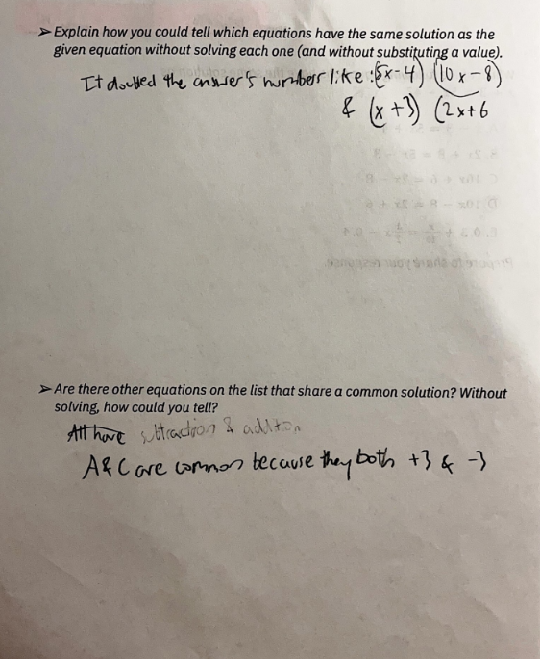
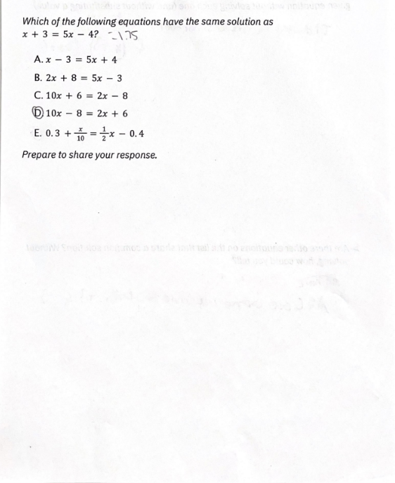

Example 2:

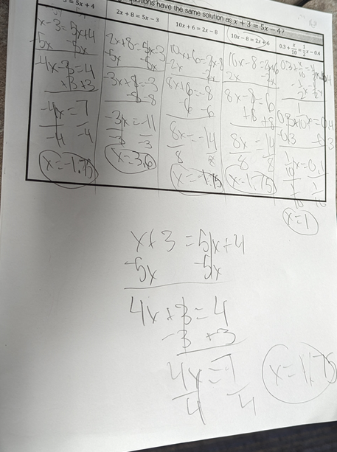

Example 3:
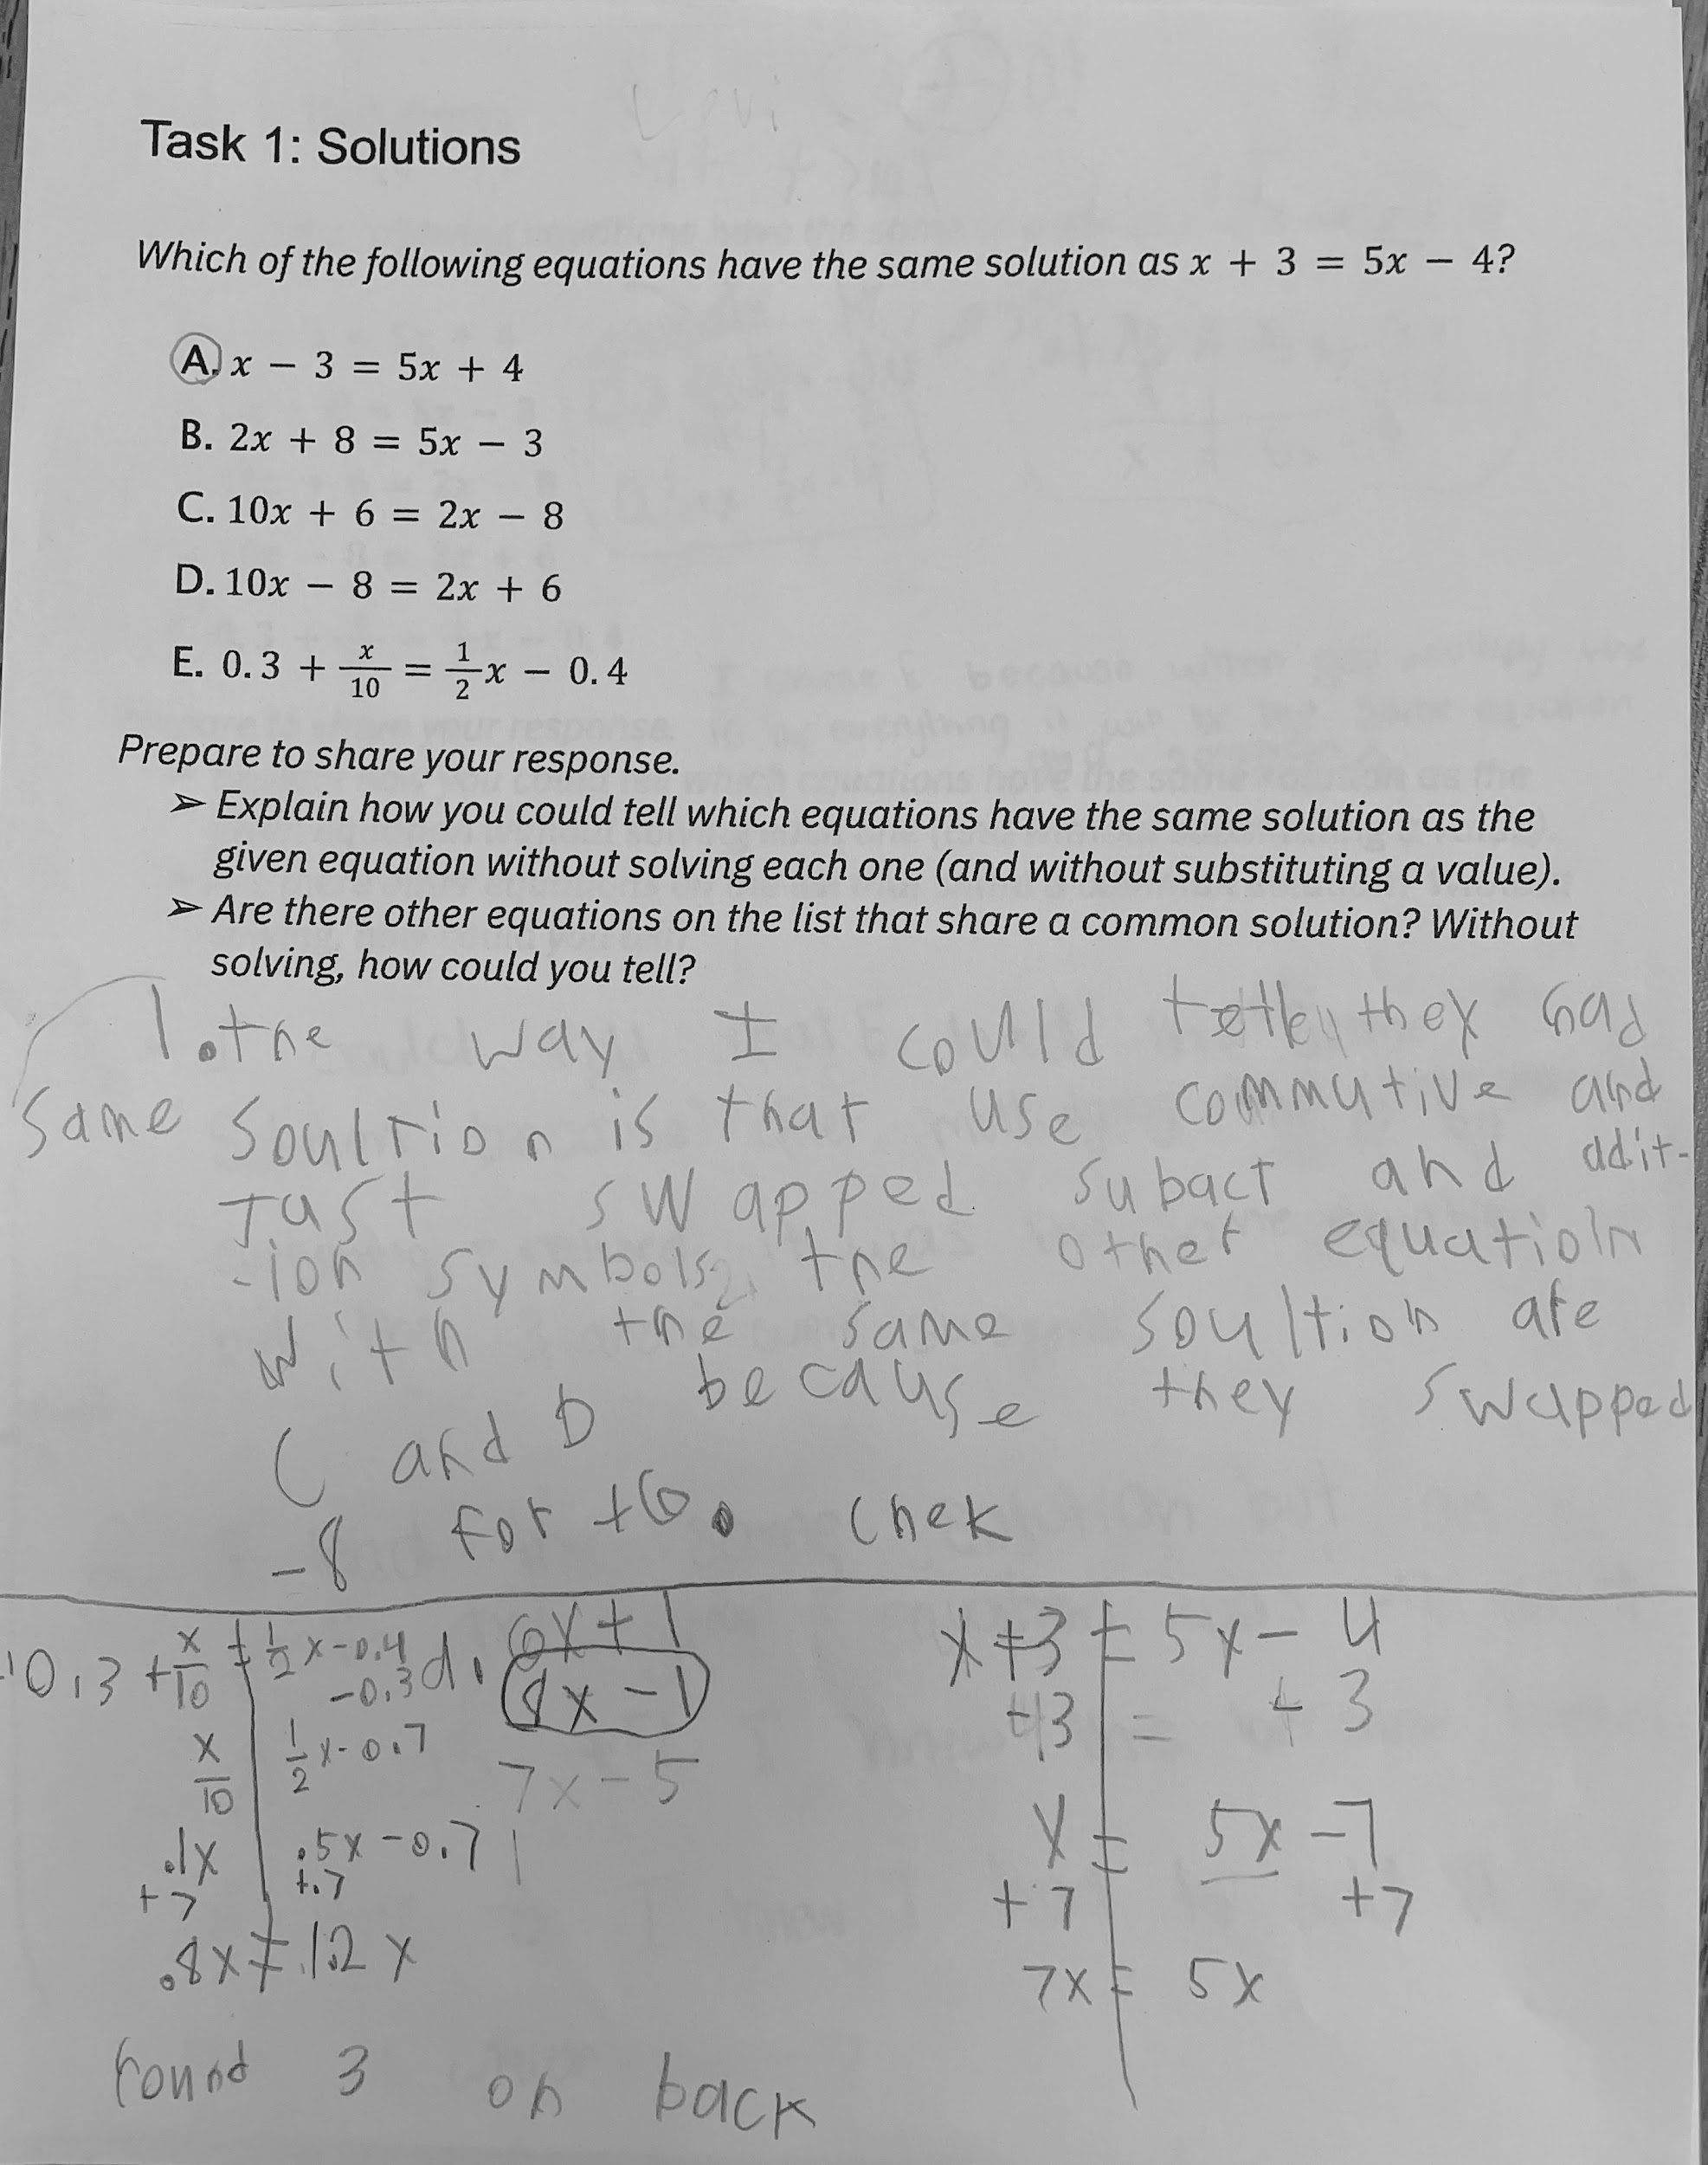

Let’s do some math! Round 2

Task 2: Finding a Context
Students are given an equation like this:

Consider the equation
$0.75x=0.25x+1$

- Think about the expressions “$0.75x$” and “$0.25x+1$.” Create a real-world situation that could be represented by these expressions.
- Based on this, what could x represent?
- Why would it make sense to have these two expressions be equal to one another based on the context?
- How could you use technology to create a graphical representation that shows the solution to the equation $0.75x=0.25x+1$?

Sample graph using technology:
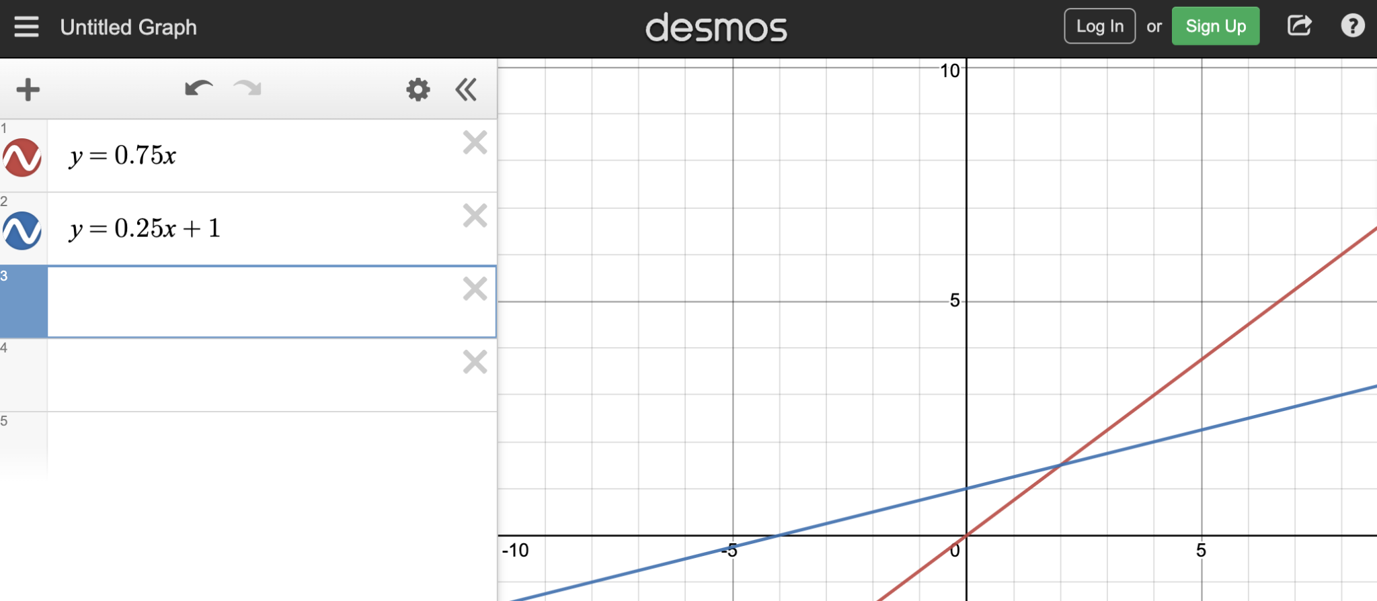

- What is the solution to $0.75x=0.25x+1$? What does the solution to the equation mean relative to the context you created?
- What is another way you could have found the solution to $0.75x=0.25x+1$?

Sample Learning Experience

The goal of this task is to invite students to make sense of an alternate way of thinking about solutions to an equation in order to build towards a flexible way of working with equations. In this case, students consider what each expression of an equation could represent in terms of a system of equations. This builds conceptual understanding (LP3).
In the first prompt, we are inviting students to give light context to the problem to help them personalize it and make concrete some of the conceptual ideas they are asked to explore.
Rephrase the prompt as necessary: What quantity/situation could 0.75x represent? What quantity/situation could 0.25x + 1 represent?
Consider selecting a context or two for reflection. Questions worth exploring are:

- What about this context makes sense to have two expressions that are equal to each other?
- What about the context you developed makes sense? What, if anything, needs to be modified so that it makes sense?

After this discussion, students should be given time to refine the context they developed.

Later, in the exploration, we want students to notice that this equation ($0.75x=0.25x+1$) is in terms of x and its solution is the x-coordinate of the point of intersection of the graphs of $y=0.75x$ and $y=0.25x+1$. This conversation can be expanded to examine the nuanced difference between the solution to $0.75x=0.25x+1$ and the solution to the system of equations defined by $y=0.75x$ and $y=0.25x+1$.
This work can be expanded by asking students to also represent equations with one solution, no solution, or many solutions graphically, as well as extend their exploration to include inequalities.
During the discussion of their work, ask students to reflect and share on these questions:
- What does it mean to solve an equation? How about a real-life problem?
- What is helpful about considering the graph of the system of equations?
- How might you use what you learned through this experience in other settings?

Task 2: Finding a Context Student Work

Example 1:

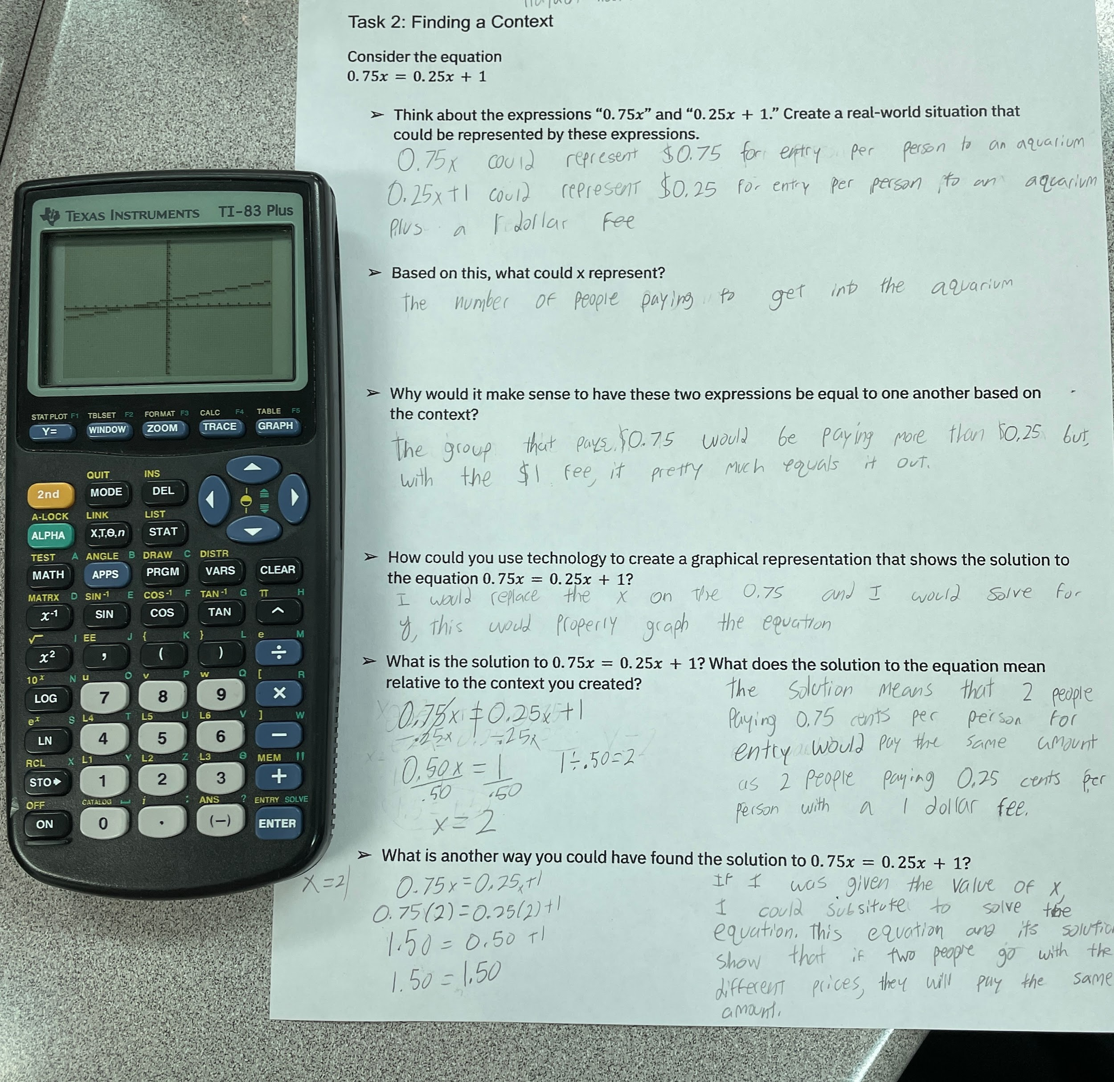

Example 2:

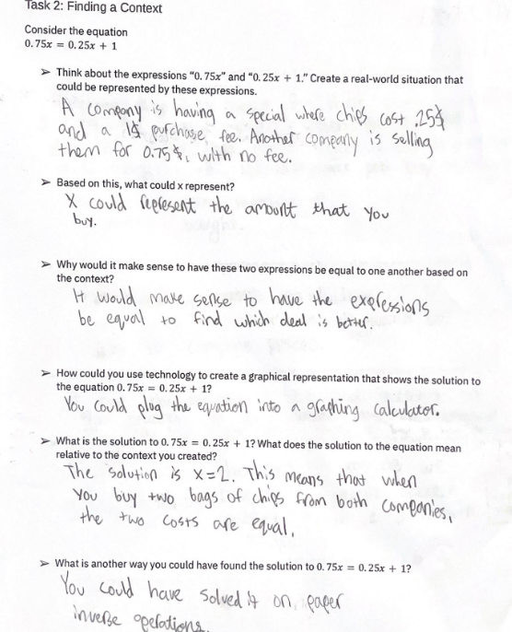

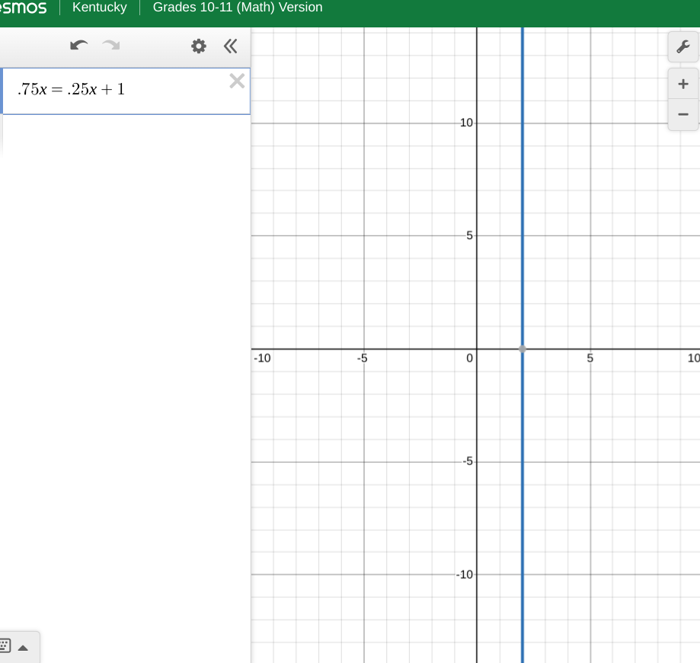

Example 3:

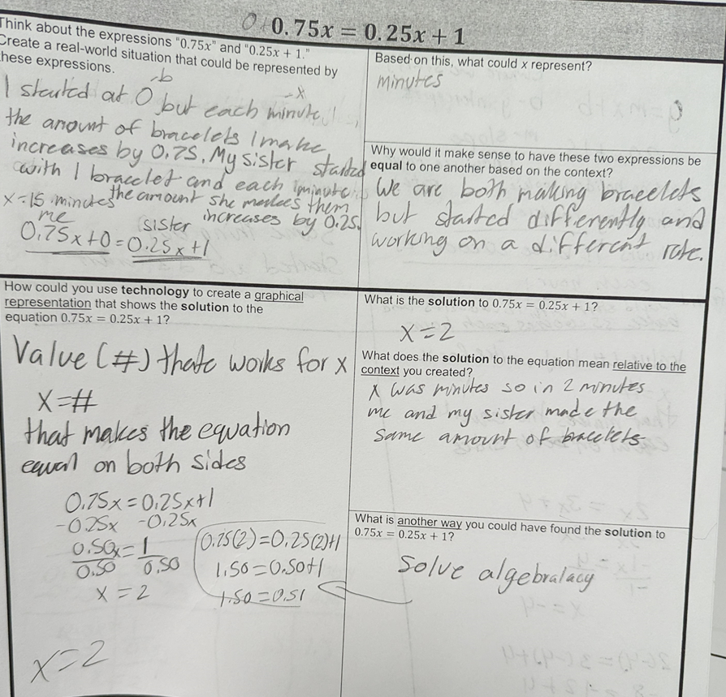

Criteria for Success

Conference and Provide Revision Support | Accept with Revision | Accept
The student’s artifact shows an emerging understanding of the expectations of the indicator(s). After conferencing and additional instruction/learning, the student may provide a revised or different artifact as evidence of the indicator(s). | The student’s artifact is approaching a full understanding of the expectations of the indicator(s). The artifact may contain execution errors that should be corrected in revision. The student may revise the selected artifact or submit a different artifact. | The student’s artifact demonstrates evidence that they have met the expectations of the indicator(s).

References
Common Core Standards Writing Team. (2016, August 17). Progressions for the Common Core State Standards in Mathematics (draft). High School, Quantity. Tucson, AZ: Institute for Mathematics and Education, University of Arizona.

