M102 Performance Task
The Cost of Driving Fast

The Modeling Cycle
If you want to get somewhere faster in an automobile, you simply drive faster. Right? But how much time do people really save by putting the “pedal to the metal”? In this task, you will contribute to a safe driving campaign by analyzing and reporting on the actual amount of time that people save by driving faster.
Mathematical models are used to make sense of ideas and phenomena in our world. As illustrated in the image below, the modeling cycle is a process of collecting data about an idea or problem, creating models of that data, analyzing the story told by those models, and reporting the results to the appropriate audience. In this task, you will be engaging with this mathematical modeling cycle to understand and communicate whether speeding actually saves as much time as people may believe.

.
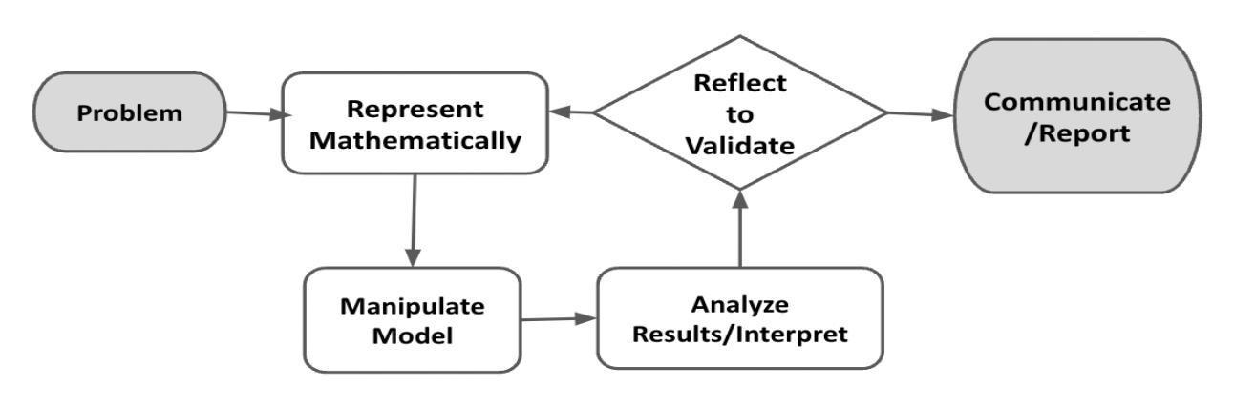
Figure 1. Diagram of Modeling Process. From “Progressions for the Common Core State Standards for Mathematics” [Draft manuscript], by Common Core Standards Writing Team, 2019, p. 6 (http://mathematicalmusings.org/wp-content/uploads/2022/05/modeling_02082019.pdf).

The Cost of Driving Fast
Launch
Imagine you or somebody you know gets a speeding ticket for driving faster than the posted speed limit. The speeding ticket requires a payment of $200. Was it worth driving faster than the posted speed limit, knowing that you have to pay $200?

QUESTION 1
 | What are some reasons why people might drive faster than the posted speed limit?

QUESTION 2
Let’s think about different distances. What is a place that might be less than one mile from your current location? What is a place that might be about 20 miles from your current location? What is a place that is definitely more than 100 miles from your current location?

Problem
You have been asked to create one portion of a safe-driving campaign. The primary focus of your portion of the campaign is to help drivers understand whether the potential financial cost of a speeding ticket is worth the amount of time saved by getting to a destination faster.

In the Formulate and Represent Mathematically section, you will examine the relationship between how fast a person is driving and how long it will take them to travel different distances.
You will create one or more data displays that illuminate the relationships. The Formulate and Represent Mathematically Checklist can be used to ensure you have the necessary components before moving on to the remaining parts of the task.

Formulate and Represent Mathematically
QUESTION 3
 | How long would it take a driver traveling at 40 miles per hour (mph) to travel 10 miles? What about 100 miles?
QUESTION 4
 | How long would it take a driver traveling at 60 mph to travel 10 miles? What about 100 miles?

ACTION 1
The questions presented above provide some insight into how driving at different speeds affects the amount of time it takes to get to a destination.
Create a set of graphs to show the relationship between distance traveled and time for at least three different driving speeds.
Note: You are welcome to use additional paper or digital forms to document your work. Be sure to include all of your work in your final submission.
The graphs you create should answer the question:
How long does it take drivers traveling at different speeds to go different distances?

ACTION 2
For each graph, write the equation for that graph. Clearly define any variables used or quantities represented.

Formulate and Represent Mathematically Checklist
Requirement | Fulfilled?
I have created at least three graphs to accurately communicate the relationship between driving speed, distance traveled, and time. Graphs are on the same set of coordinate axes. | ▢
I have clearly defined any variables used relative to the context of the problem. | ▢
I have associated each graph with an accurate equation. | ▢
Teacher Consultation: | ______________
In the Manipulate Model, Interpret, Reflect, and Report sections, you will relate driving speed, distance, and time to inform your campaign data; you will research costs associated with speeding tickets; you will consider other information pertinent to your campaign; and you will present your findings and your final campaign. The Manipulate Model, Interpret, Reflect, and Report Checklist can be used to ensure you have the necessary components before finalizing your work on this task.

Manipulate Model
ACTION 3
Use the information from the previous section. Complete the tables below to highlight specific quantities of interest that you might use to build your final campaign.

Interpret
ACTION 4
Research the cost of speeding tickets locally. Decide how to integrate this information with your findings so far to make a compelling argument that the amount of time people typically save by speeding is not worth the financial burden of possibly getting a speeding ticket.

Reflect
QUESTION 5
As you get ready to synthesize your information, here are a couple of other pieces of information that might help you:
- On average, people drive about 20 miles one way to work.
- Most people who drive faster than the posted speed limit only exceed that posted speed limit by 1-20 miles per hour.
Why is this information important to know as you develop your communication?
Are there any additional data displays or other speeds that would be valuable to examine and communicate? What other factors contribute to the speed at which a person travels?
What other costs or risks are associated with speeding? Can you find and use any other data to support your argument that speeding does not pay?

Report
QUESTION 6
Think of different ways you can share this information with others within the context of a public service announcement. Specifically, aim to be as creative as possible. Divergent thinking will help you here: What unique idea can you generate that nobody else in your class is likely to produce? These types of products will not only grab your audience’s attention more quickly, but they will also be more memorable in the long run, which, with what you now know about the costs of speeding, could help save lives!
Note: You are welcome to use additional paper or digital forms to document your work. Be sure to include all of your work in your final submission.
Don’t let format limit you—you can think of ANYTHING from creating/parodying music lyrics, making an informational video or commercial, writing a children’s book or creating a children’s rhyme they can recite when playing hopscotch or jumping rope (we’re talking REALLY divergent, here!), making a speech, creating an interpretive dance, painting an abstract representative picture, assembling a collage of original related photography, or anything unique and memorable you can use to communicate your message.

ACTION 5
In addition to your product, you need to create an accompanying one-pager with at least one data display (table, graph, etc.), one paragraph explaining the data and making the argument that speeding does not save that much time, and one paragraph explaining your product (this will be especially essential for products that do not use words or that convey their message implicitly/interpretively).

Manipulate Model, Interpret, Reflect, and Report Checklist
Requirement | Fulfilled?
I have presented a product that is unique/creative, well-executed, memorable, and succinct. | ▢
I have accompanied the product with a one-pager that includes at least one data display, one argumentative paragraph, and one product-explanatory paragraph. | ▢
I have effectively integrated information from the task and any additional research into the product and/or one-pager to convince the audience that driving over the speed limit is not worth the financial cost (and/or other risks) of a speeding ticket. | ▢
Teacher Consultation: | ______________

