Baseline Professional Learning Handout
M104 Modeling with Exponential Functions

Baseline Professional Learning Handout 1
Functions Progression Excerpt 5
M104 Content and Practice Expectations 5
M104 Content and Practice Expectations and Indicators 6
Let’s Investigate 7
Lake Algae Task 7
Interesting Interest Rates Task 8
Let’s do some math! Round 1 9
Task 1: Superman Prompt 9
Learning Principles 10
Task 1: Superman Student Work 11
Let’s do some math! Round 2 16
Task 2: COVID-19 Prompt 16
Task 2: COVID-19 Student Work 17
Criteria for Success 24
Selected Common Core High School Standards for Mathematics

High School - Functions
Understand the concept of a function and use function notation
- Understand that a function from one set (called the domain) to another set (called the range) assigns to each element of the domain exactly one element of the range. If f is a function and x is an element of its domain, then f(x) denotes the output of f corresponding to the input x. The graph of f is the graph of the equation y = f(x).
- Use function notation, evaluate functions for inputs in their domains, and interpret statements that use function notation in terms of a context.

Interpret functions that arise in applications in terms of the context
- For a function that models a relationship between two quantities, interpret key features of graphs and tables in terms of the quantities, and sketch graphs showing key features given a verbal description of the relationship. Key features include: intercepts; intervals where the function is increasing, decreasing, positive, or negative; relative maximums and minimums; symmetries; end behavior; and periodicity.★
- Relate the domain of a function to its graph and, where applicable, to the quantitative relationship it describes. For example, if the function h(n) gives the number of person-hours it takes to assemble n engines in a factory, then the positive integers would be an appropriate domain for the function.★
- Calculate and interpret the average rate of change of a function (presented symbolically or as a table) over a specified interval. Estimate the rate of change from a graph.★

Analyze functions using different representations
- Graph functions expressed symbolically and show key features of the graph, by hand in simple cases and using technology for more complicated cases.★
e. Graph exponential and logarithmic functions, showing intercepts and end behavior, and trigonometric functions, showing period, midline, and amplitude.

- Write a function defined by an expression in different but equivalent forms to reveal and explain different properties of the function.
  - Use the properties of exponents to interpret expressions for exponential functions. For example, identify percent rate of change in functions such as y = (1.02)t, y = (0.97)t, y = (1.01)12t, y = (1.2)t/10, and classify them as representing exponential growth or decay.
- Compare properties of two functions each represented in a different way (algebraically, graphically, numerically in tables, or by verbal descriptions). For example, given a graph of one quadratic function and an algebraic expression for another, say which has the larger maximum.

Build a function that models a relationship between two quantities

- Write a function that describes a relationship between two quantities.★
  - Determine an explicit expression, a recursive process, or steps for calculation from a context.
  - Combine standard function types using arithmetic operations. For example, build a function that models the temperature of a cooling body by adding a constant function to a decaying exponential, and relate these functions to the model.

Construct and compare linear, quadratic, and exponential models and solve problems

- Distinguish between situations that can be modeled with linear functions and with exponential functions.
  - Prove that linear functions grow by equal differences over equal intervals, and that exponential functions grow by equal factors over equal intervals.
  - Recognize situations in which one quantity changes at a constant rate per unit interval relative to another.
  - Recognize situations in which a quantity grows or decays by a constant percent rate per unit interval relative to another.
- Construct linear and exponential functions, including arithmetic and geometric sequences, given a graph, a description of a relationship, or two input-output pairs (include reading these from a table).
- Observe using graphs and tables that a quantity increasing exponentially eventually exceeds a quantity increasing linearly, quadratically, or (more generally) as a polynomial function.

Interpret expressions for functions in terms of the situation they model

- Interpret the parameters in a linear or exponential function in terms of a context.

High School - Modeling
Modeling links classroom mathematics and statistics to everyday life, work, and decision-making. Modeling is the process of choosing and using appropriate mathematics and statistics to analyze empirical situations, to understand them better, and to improve decisions. Quantities and their relationships in physical, economic, public policy, social, and everyday situations can be modeled using mathematical and statistical methods. When making mathematical models, technology is valuable for varying assumptions, exploring consequences, and comparing predictions with data.

A model can be very simple, such as writing total cost as a product of unit price and number bought, or using a geometric shape to describe a physical object like a coin. Even such simple models involve making choices. It is up to us whether to model a coin as a three-dimensional cylinder, or whether a two-dimensional disk works well enough for our purposes. Other situations—modeling a delivery route, a production schedule, or a comparison of loan amortizations—need more elaborate models that use other tools from the mathematical sciences. Real-world situations are not organized and labeled for analysis; formulating tractable models, representing such models, and analyzing them is appropriately a creative process. Like every such process, this depends on acquired expertise as well as creativity. Some examples of such situations might include:
- Estimating how much water and food is needed for emergency relief in a devastated city of 3 million people, and how it might be distributed.
- Planning a table tennis tournament for 7 players at a club with 4 tables, where each player plays against each other player.
- Designing the layout of the stalls in a school fair so as to raise as much money as possible.
- Analyzing stopping distance for a car.
- Modeling savings account balance, bacterial colony growth, or investment growth.
- Engaging in critical path analysis, e.g., applied to turnaround of an aircraft at an airport.
- Analyzing risk in situations such as extreme sports, pandemics, and terrorism.
- Relating population statistics to individual predictions.

In situations like these, the models devised depend on a number of factors: How precise an answer do we want or need? What aspects of the situation do we most need to understand, control, or optimize? What resources of time and tools do we have? The range of models that we can create and analyze is also constrained by the limitations of our mathematical, statistical, and technical skills, and our ability to recognize significant variables and relationships among them. Diagrams of various kinds, spreadsheets and other technology, and algebra are powerful tools for understanding and solving problems drawn from different types of real-world situations. One of the insights provided by mathematical modeling is that essentially the same mathematical or statistical structure can sometimes model seemingly different situations. Models can also shed light on the mathematical structures themselves, for example, as when a model of bacterial growth makes more vivid the explosive growth of the exponential function.

The basic modeling cycle is summarized in the diagram. It involves (1) identifying variables in the situation and selecting those that represent essential features, (2) formulating a model by creating and selecting geometric, graphical, tabular, algebraic, or statistical representations that describe relationships between the variables, (3) analyzing and performing operations on these relationships to draw conclusions, (4) interpreting the results of the mathematics in terms of the original situation, (5) validating the conclusions by comparing them with the situation, and then either improving the model or, if it is acceptable, (6) reporting on the conclusions and the reasoning behind them. Choices, assumptions, and approximations are present throughout this cycle.

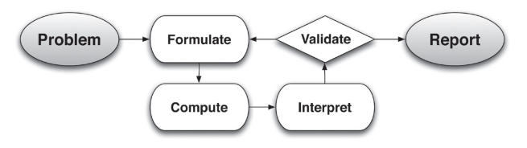

In descriptive modeling, a model simply describes the phenomena or summarizes them in a compact form. Graphs of observations are a familiar descriptive model— for example, graphs of global temperature and atmospheric CO2 over time.

Analytic modeling seeks to explain data on the basis of deeper theoretical ideas, albeit with parameters that are empirically based; for example, exponential growth of bacterial colonies (until cut-off mechanisms such as pollution or starvation intervene) follows from a constant reproduction rate. Functions are an important tool for analyzing such problems. Graphing utilities, spreadsheets, computer algebra systems, and dynamic geometry software are powerful tools that can be used to model purely mathematical phenomena (e.g., the behavior of polynomials) as well as physical phenomena. Modeling Standards Modeling is best interpreted not as a collection of isolated topics but rather in relation to other standards. Making mathematical models is a Standard for Mathematical Practice, and specific modeling standards appear throughout the high school standards indicated by a star symbol (★).

High School - Statistics and Probability
- Represent data on two quantitative variables on a scatter plot, and describe how the variables are related.
- Fit a function to the data; use functions fitted to data to solve problems in the context of the data. Use given functions or choose a function suggested by the context. Emphasize linear, quadratic, and exponential models.

Functions Progression Excerpt
.
Functions and Modeling In modeling situations, knowledge of the context and statistics are sometimes used together to find a function defined by an algebraic expression that best fits an observed relationship between quantities. (Here “best” is assessed informally, see the Modeling Progression and high school Statistics and Probability Progression for further discussion and examples.) Then the algebraic expressions can be used to interpolate (i.e., approximate or predict function values between and among the collected data
values) and to extrapolate (i.e., to approximate or predict function values beyond the collected data values). One must always ask whether such approximations are reasonable in the context.

In school mathematics, functional relationships are often given by algebraic expressions. For example, f(n) = n² for n ≥ 1 gives the n^{th} square number. But in many modeling situations, such as the temperature at Boston’s Logan Airport as a function of time, algebraic expressions may not be suitable.

M104 Content and Practice Expectations
104.a | Engage in the modeling cycle.
104.b | Interpret exponential functions that arise in applications in terms of the context.
104.c | Analyze exponential functions using different representations.
104.d | Build an exponential function that models a relationship between two quantities.
104.e | Construct and compare linear and exponential models and solve problems to draw conclusions.
104.f | Interpret expressions for exponential functions in terms of the situation they model.
104.g | Summarize, represent, and interpret data on two quantitative variables for linear and exponential model fits. In this badge, students are encouraged to investigate patterns of association in bivariate data, which includes the informal description of the fit of the curve and addresses the usefulness of the model for the particular context.
104.h | Understand the relevance of modeling with exponential functions.
104.i | Use a function of exponential type to determine values of interest in a real-world problem.

M104 Content and Practice Expectations and Indicators
Content and Practice Expectations | Indicators  Choose an artifact where you…
104.a: Engage in the modeling cycle (performance assessment). | i. engage with the full modeling cycle (problem, formulate, compute, interpret, validate, revise as necessary, report).
104.b: Interpret exponential functions that arise in applications in terms of the context. | i. select two different data points that illustrate something interesting or important about the context you are modeling and describe what these points tell you about the topic.
 | ii. use a model to compute output values and then interpret the values in the context of the problem.
 | iii. describe the domain of the exponential function, including anything noticed about values that are not part of the domain or why the shape of the model might change for particular values of the domain.
 | iv. describe the contextual meaning of the average rate of change between two points for an exponential function.
104.c: Analyze exponential functions using different representations. | i. create an exponential graph to show a particular context and describe important values that help to understand something about the problem you are exploring.
 | ii. explain how the parameters of an exponential model relate to its graph.
104.d: Build an exponential function that models a relationship between two quantities. | i. identify the variables of interest in a given situation or data set that are interesting and that demonstrate an exponential relationship.
 | ii. build a function that models the exponential relationship between two quantities in a situation.
104. e: Construct and compare linear and exponential models, solve problems, and draw conclusions. | i. distinguish between situations that can be modeled with linear functions and those that can be modeled with exponential functions.
 | ii. provide insight into why some relationships are linear and others are exponential or explain why, in terms of a situation being modeled, an exponential function is a better model than a linear function.
104.f: Interpret expressions for exponential functions in terms of the situation they model. | i. describe the meaning of the parameters for an exponential function in terms of the context.
104.g: Summarize, represent, and interpret data on two quantitative variables for linear and exponential model fits. | i. choose a particular representation of your data to communicate something important to a particular person or audience and explain why you made that choice. In this badge, students are encouraged to investigate patterns of association in bivariate data, which includes the informal description of the fit of the curve and addresses the usefulness of the model for the particular context.
104.h: Understand the relevance of modeling with exponential functions. | i. recognize something that surprised you or that you learned about the topic through exponential modeling of data. Share what surprised you or what you learned.
 | ii. highlight something you are most proud of in your learning about exponential modeling.
 | iii. explain how modeling can be used to answer important questions.
104.i. Use functions of exponential type to determine values of interest in a real-world problem. | i. determine one or more output values for specific inputs to the function.

Let’s Investigate

Lake Algae Task
On June 1, a fast growing species of algae is accidentally introduced into a lake in a city park. It starts to grow and cover the surface of the lake in such a way that the area covered by the algae doubles every day. If it continues to grow unabated, the lake will be totally covered and the fish in the lake will suffocate. At the rate it is growing, this will happen on June 30.

- When will the lake be covered half-way?

- On June 26, a pedestrian who walks by the lake every day warns that the lake will be completely covered soon. Her friend just laughs. Why might her friend be skeptical of the warning?

- On June 29, a clean-up crew arrives at the lake and removes almost all of the algae. When they are done, only 1% of the surface is covered with algae. How well does this solve the problem of the algae in the lake?

- Write an equation that represents the percentage of the surface area of the lake that is covered in algae as a function of time (in days) that passes since the algae was introduced into the lake if the cleanup crew does not come on June 29.

Source: Illustrative Mathematics

Interesting Interest Rates Task

City Bank pays a simple interest rate of 3% per year, meaning that each year the balance increases by 3% of the initial deposit. National Bank pays an compound interest rate of 2.6% per year, compounded monthly, meaning that each month the balance increases by one twelfth of 2.6% of the previous month's balance.

- Which bank will provide the largest balance if you plan to invest $10,000 for 10 years? For 15 years?

- Write an expression for C(y), the City Bank balance, y years after a deposit is left in the account. Write an expression for N(m), the National Bank balance, m months after a deposit is left in the account.

- Create a table of values indicating the balances in the two bank accounts from year 1 to year 15. For which years is City Bank a better investment, and for which years is National Bank a better investment?

Source: Illustrative Mathematics

Let’s do some math! Round 1

Task 1: Superman Prompt
Students are given a problem like this:

The original Superman movie came out in 1978 and made about $300 million at the box office. If the yearly inflation rate is about 4%, how much money would this be equivalent to in 2022?

Sample Learning Experience

Students are given time to consider the question and develop an answer independently, before having an opportunity to share their response with others. Eventually, responses—some of which could be partially complete—that highlight multiple entry points and solution pathways are selected for sharing with the whole class. As you monitor students, look for approaches where students:
- generate a table and use differences to test for a linear fit.
- generate a table or expression where students use a two-step process to model exponential growth, such as
- $300+300(.04)$.
- generate a table or expression where students use the growth rate to model exponential growth.

One sample table is illustrated below:

Year | Revenue (millions of dollars)
1978 | 300
1979 | 312
1980 | 324.48

One sample expression is illustrated below:

$300⋅{1.04}^{t}$

Instead of quickly asking students to identify an answer or approach, give students time to share responses to questions such as:

- What’s promising about this approach?
- What questions does this approach surface for you?
- Do you think the model is reasonable? Why or why not?
- What can you take from this approach to apply to your own work?
- What additional questions could be answered about this context using some of the models we’ve seen? Are some models more helpful than others in answering these additional questions?

Following the discussion, students are given an opportunity to reflect on and revise their work. Finally, one or more reasonable models are revealed explicitly, and students have an opportunity to reflect on the reasonable models and revise their work.

Learning Principles
Engage with cognitively demanding tasks in heterogeneous settings (LP 1). Students should be given opportunities to grapple with multistep, non-routine tasks that promote mathematical rigor. These experiences should be differentiated so that all students engage in appropriate challenges—for example, through tasks with multiple entry points and solution pathways. These experiences should continue to integrate knowledge and skills developed in grades 6-8 at the level of sophistication of high school mathematics.

Engage in social activities (LP 2). Students should have opportunities to work independently and to communicate with one another about mathematics by engaging in collective and collaborative learning activities. Explaining and having opportunities to revise one’s thinking has excellent value in solidifying one’s knowledge.

Build conceptual understanding through reasoning (LP 3). Students should be given the opportunity to reason, justify, and problem solve with critical thinking, reading, writing, speaking, and listening. Through reasoning and work with multiple representations, students learn why procedures work and build a conceptual understanding of key mathematical ideas.

Have agency in their learning (LP 4). Students should be able to choose tasks and learning experiences that align with their interests and aspirations. All students have rich and varied experiences and home lives. Learning mathematics should bring students’ identities and interests to the fore and build on the strengths that they bring to the learning space.

View mathematics as a human endeavor across centuries (LP 5). Students should understand that mathematical ideas emanated over time from civilizations around the world and have opportunities to explore these contributions to mathematics. Students should develop an appreciation of mathematics as a human endeavor: one in which they feel a sense of belonging, where they see themselves as mathematicians, and one that offers opportunities to broaden their ideas about what mathematics is, how it is used, and who it is for.

See mathematics as relevant (LP 6). Students should engage with mathematics in ways that authentically involve real-world situations. Problem-solving contexts should allow students to perceive mathematics as a tool for addressing the questions that arise in everyday life, as well as the ways it can model our world and address global economic, social, and environmental challenges. Students should also engage with mathematics in ways that connect to academic disciplines and future careers by doing the mathematics used by artists, designers, engineers, and other professionals.

Employ technology as a tool for problem-solving and understanding (LP 7). Research indicates that technology is a powerful tool for learning deeper mathematics by improving calculation efficiency and enabling more sophisticated analysis. Students should learn to use technology, with emphasis put on widely used tools and software, such as calculators and spreadsheets, to make sense of models. Technology use should not be limited to supporting “doing mathematics,” but should also be used as a tool for displaying and communicating results to appropriate audiences.

Task 1: Superman Student Work

Example 1:
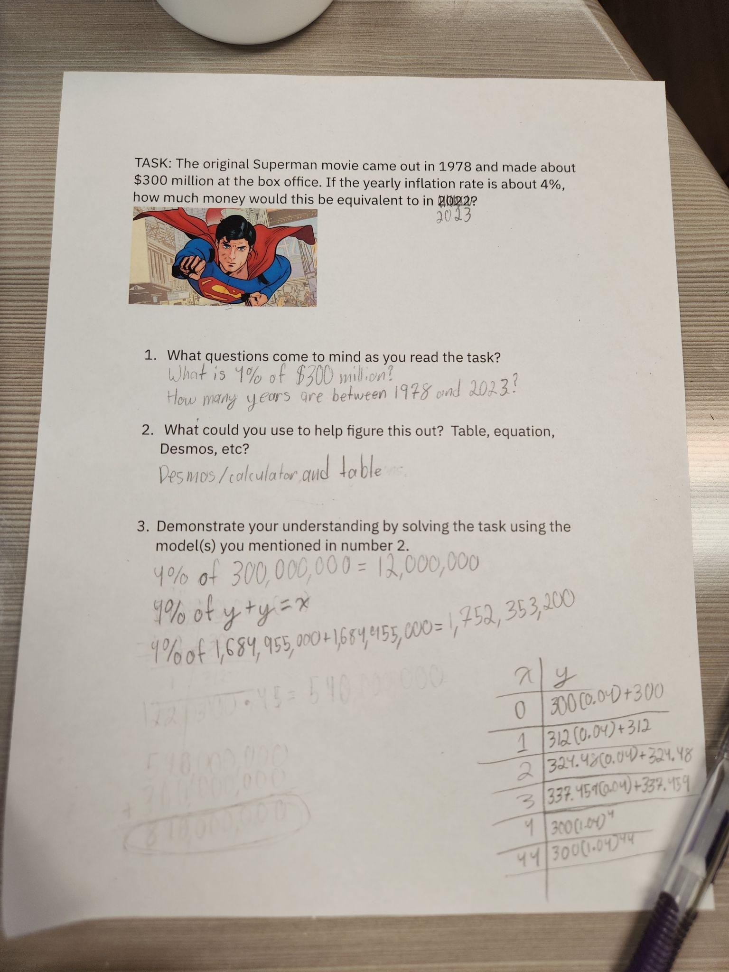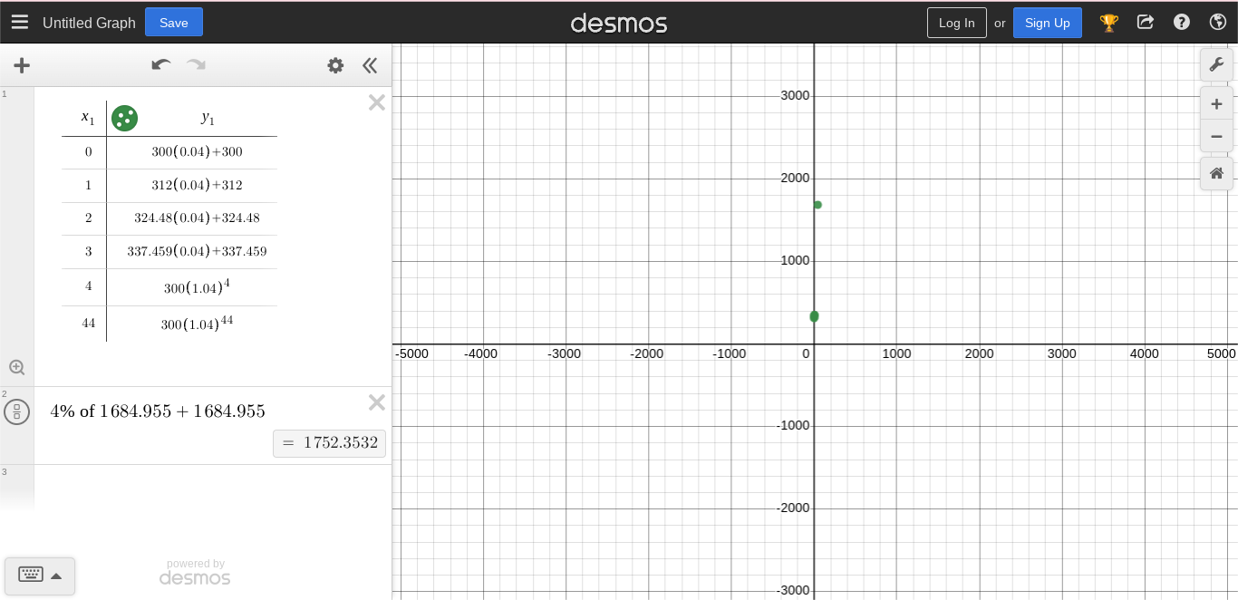

Example 2:

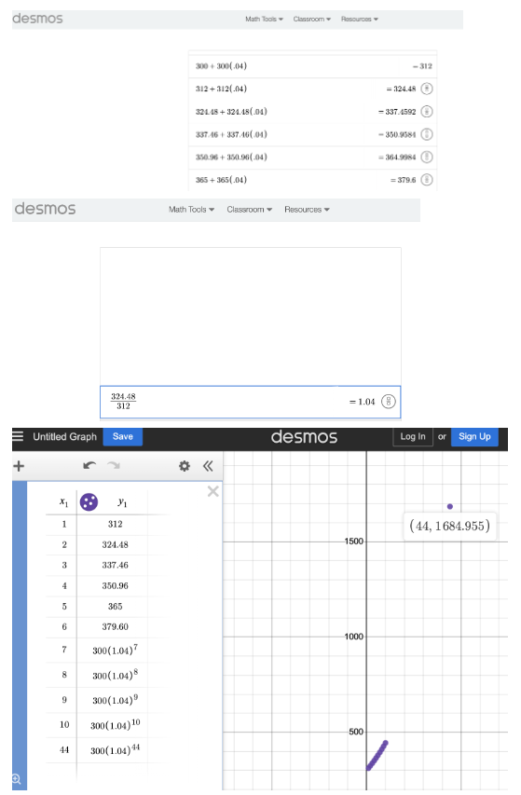
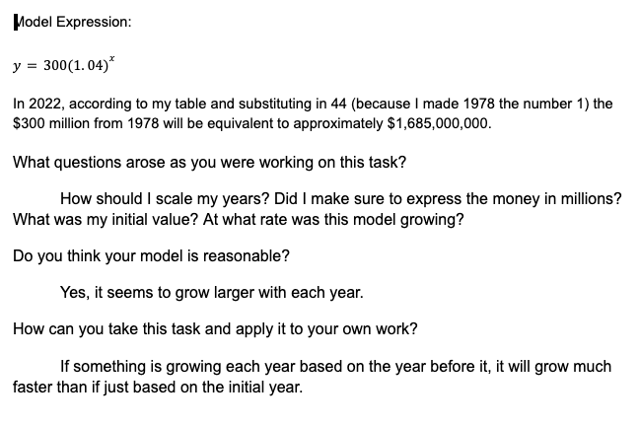

Example 3:
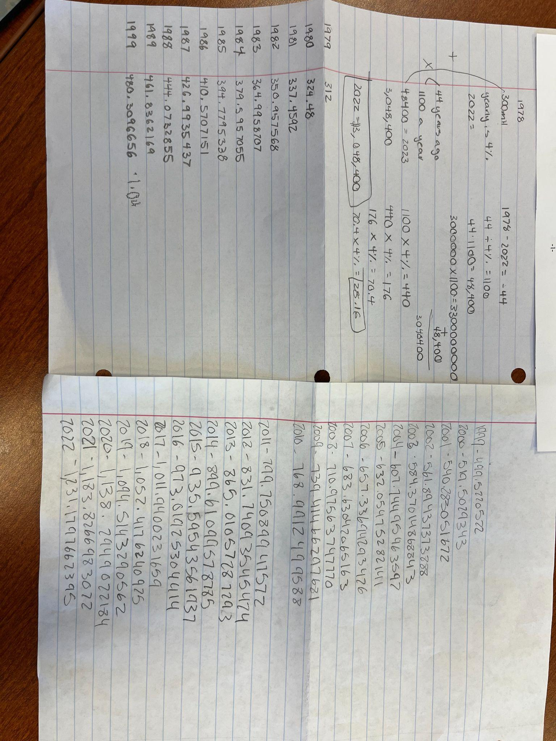

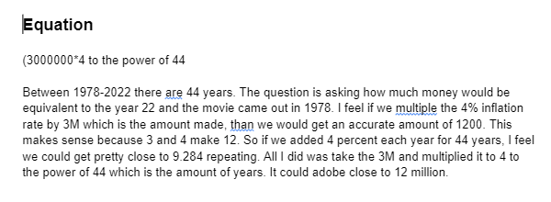

Let’s do some math! Round 2

Task 2: COVID-19 Prompt
Students are given a table that shows the number of positive COVID-19 cases and the weekly rate of increase of infections for different US ZIP codes in April 2020:

ZIP Code | Number of Infections | Rate of Increase (4/2/20 - 4/9/20)
10025 | 343 | 5.6%
10029 | 462 | 26.4%
10035 | 56 | 3.2%

Sample Learning Experience

Students are asked to work in triads to use a Google Sheet (or other spreadsheet software) to model what the number of infections will be on July 1, 2020.

As students work, they respond to questions such as:

- What formulas are you using in your Google Sheet? Write them as Google Sheet formulas and algebraic equations.
- What assumptions are you making as you develop these formulas?
- Use online search tools to locate census data to learn more about these ZIP codes. What do you notice? What do you wonder?
- Look up the actual rate of infection in each ZIP code on July 1, 2020. How accurate was your model? How would you change it? What additional assumptions or parameters might have caused the model to change?
- What does the work you have done suggest about the need to have people who are constantly studying data and refining models as part of their work?
- What additional questions surface for you as a result of the work above?
- How could the work you have done be used to inform policymakers, such as health or government officials?

Following the discussion, students are given an opportunity to reflect on and revise their work. Finally, one or more reasonable models are revealed explicitly, and students have an opportunity to reflect on the reasonable models and revise their work.

Task 2: COVID-19 Student Work

Example 1:
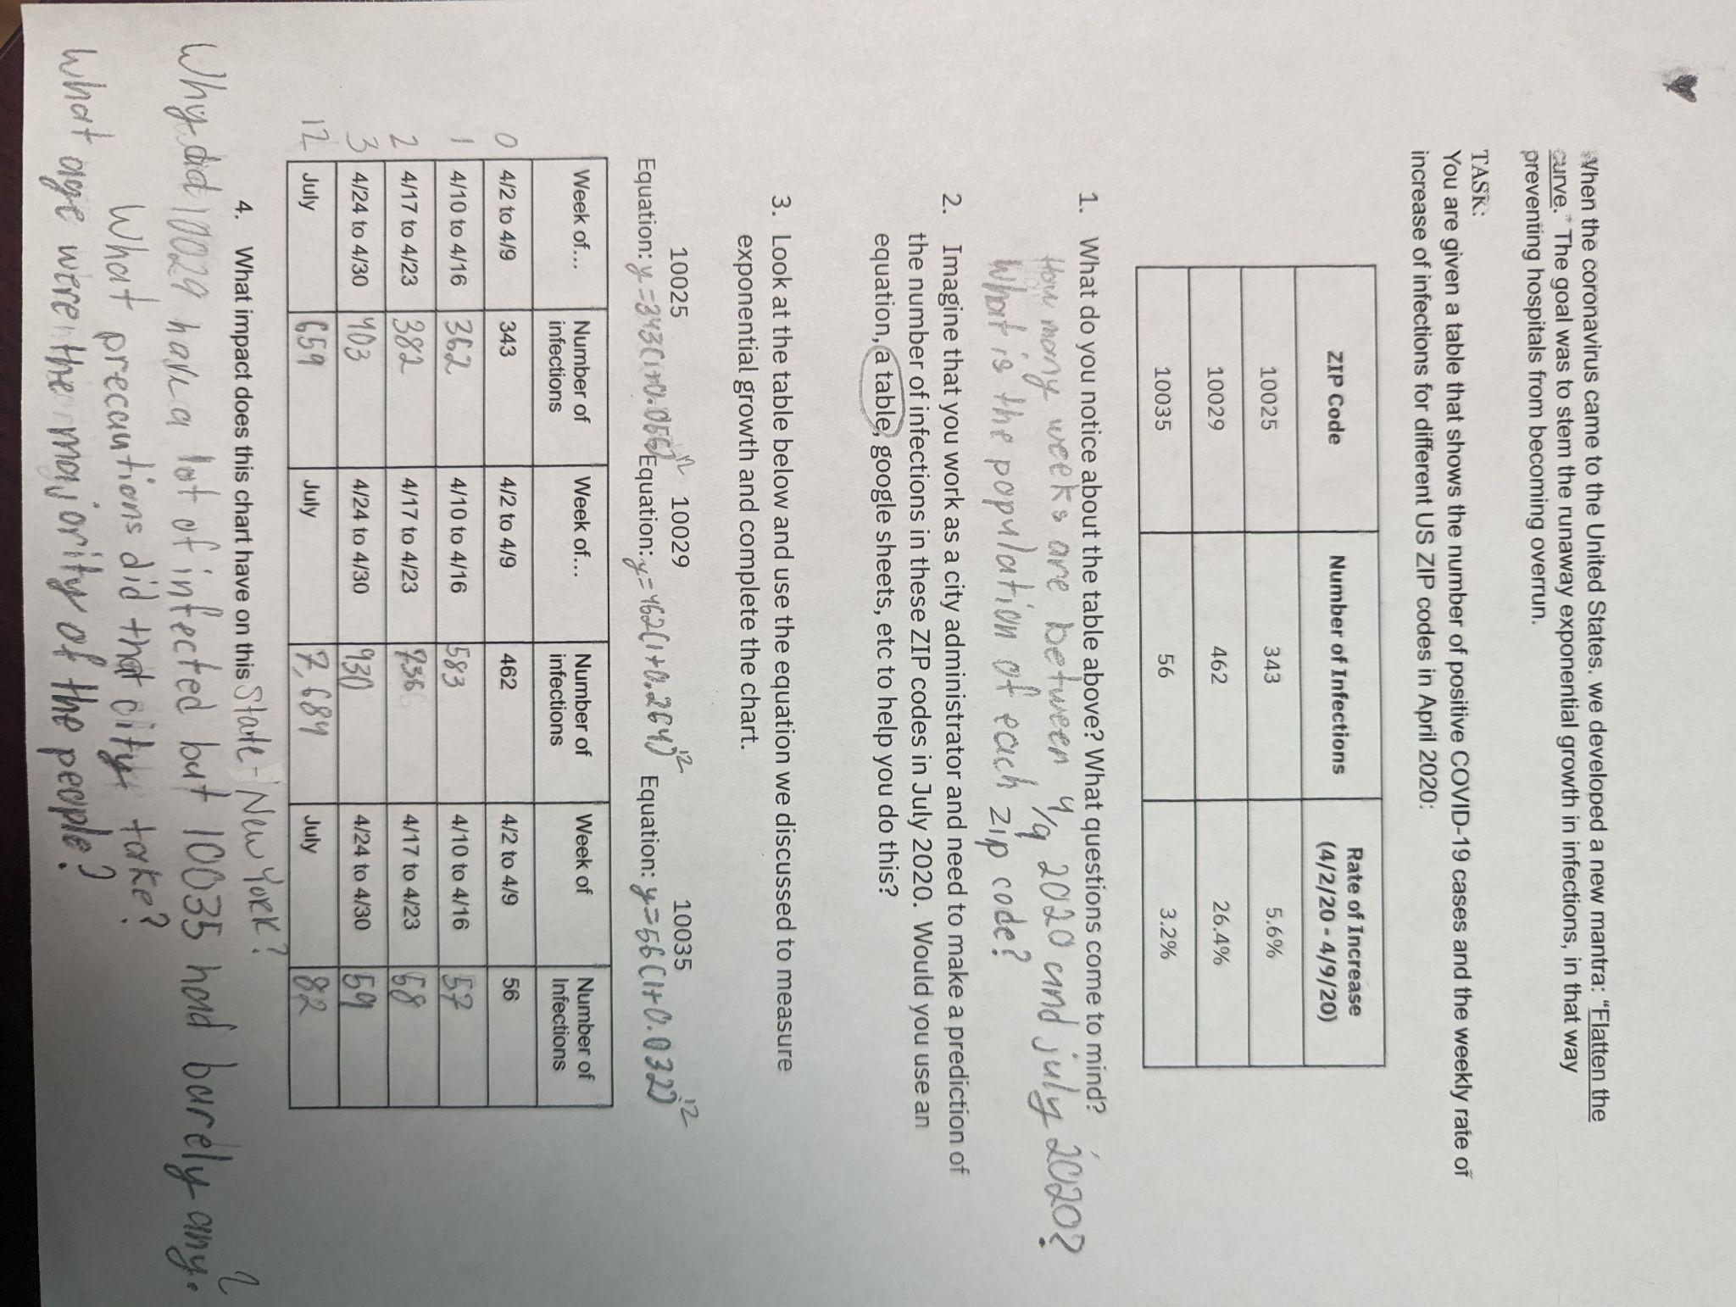

Example 2:
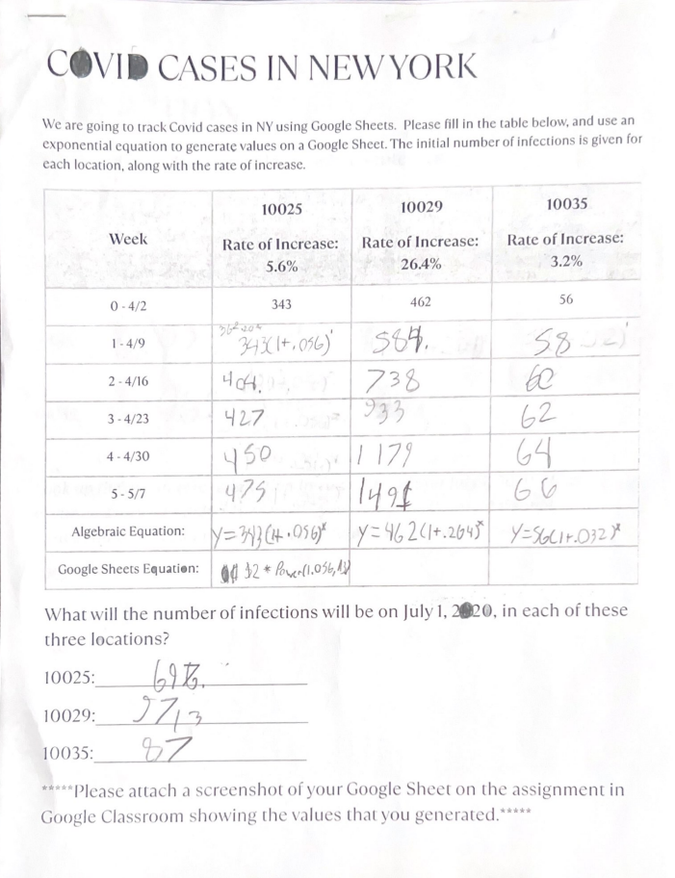
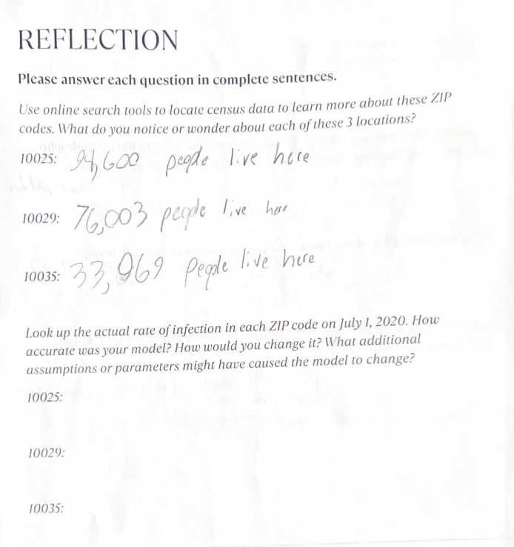
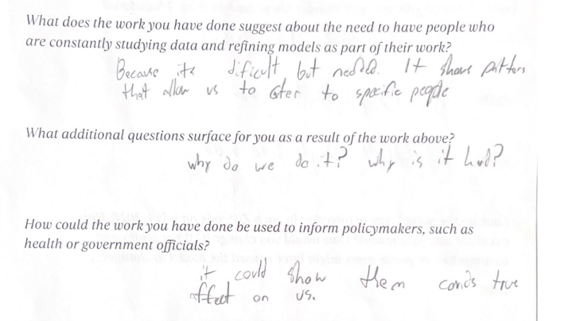

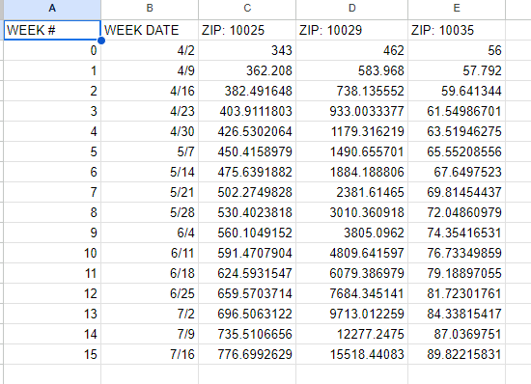

Example 3:
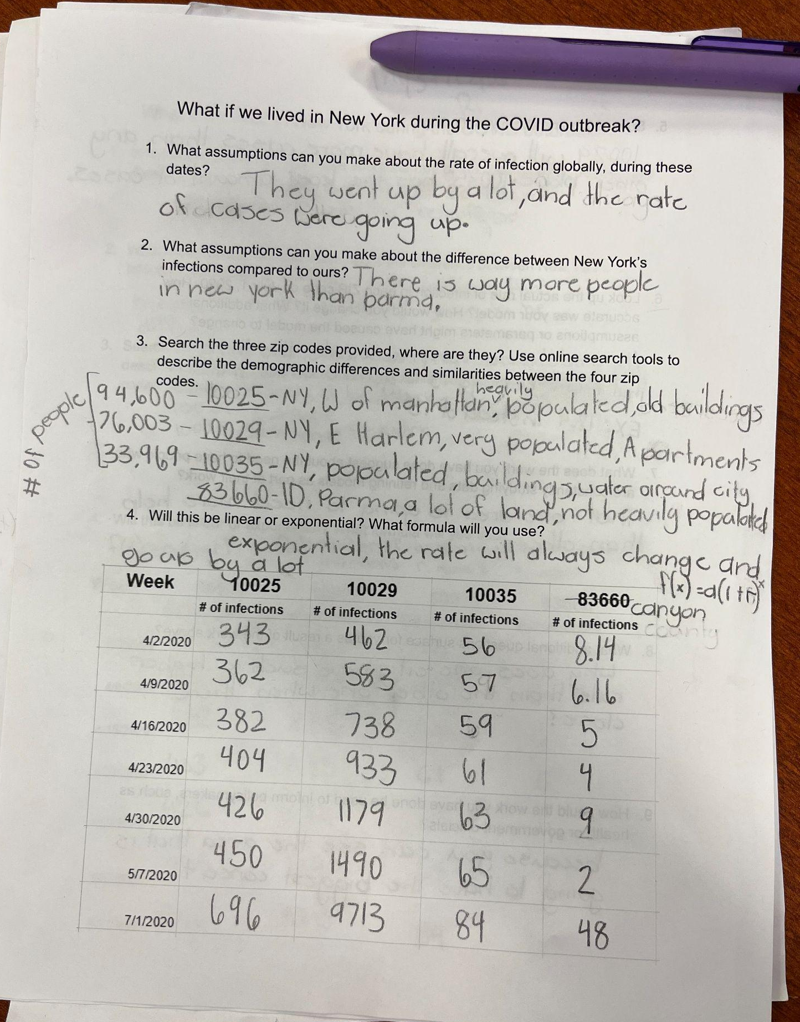
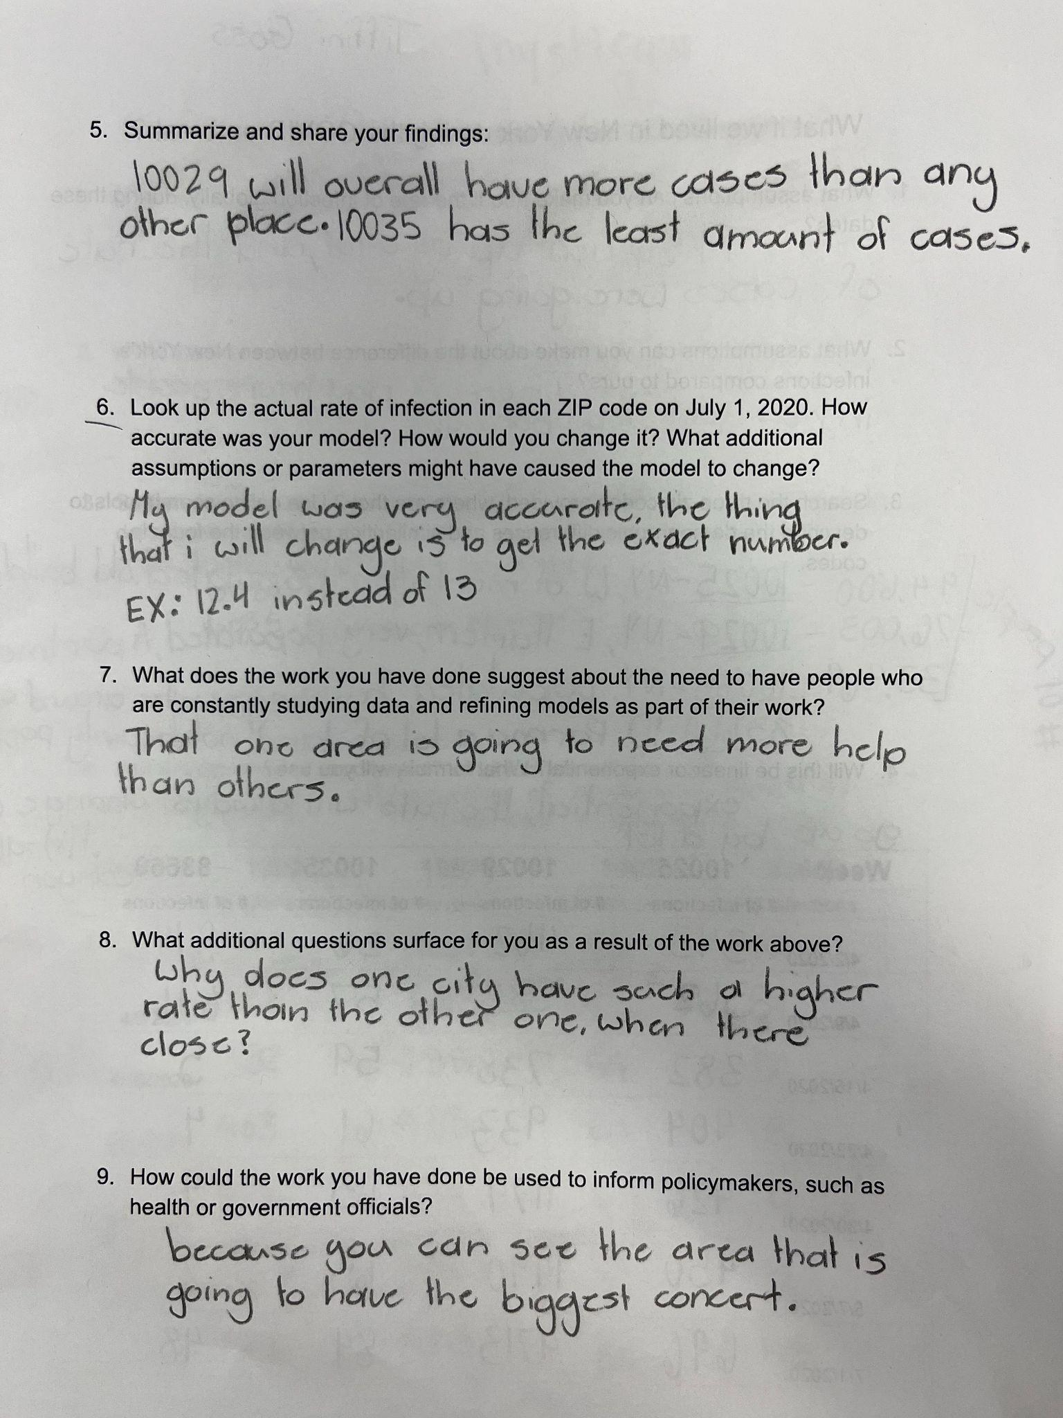
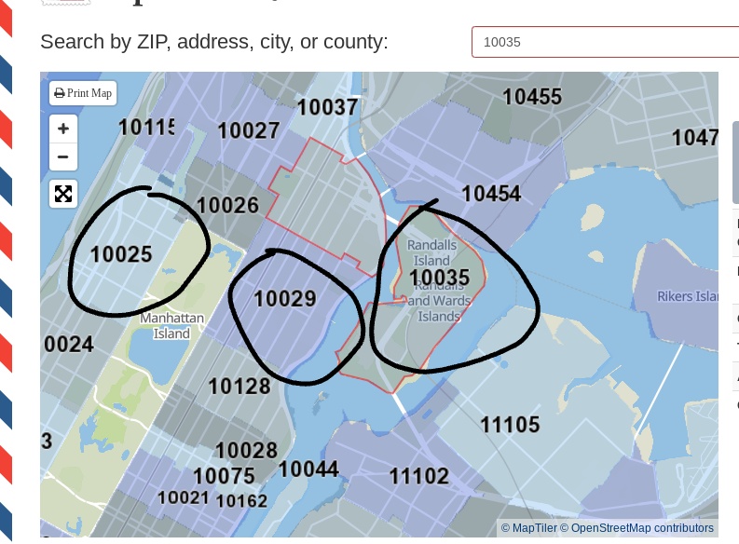

Criteria for Success

Conference and Provide Revision Support | Accept with Revision | Accept
The student’s artifact shows an emerging understanding of the expectations of the indicator(s). After conferencing and additional instruction/learning, the student may provide a revised or different artifact as evidence of the indicator(s). | The student’s artifact is approaching a full understanding of the expectations of the indicator(s). The artifact may contain execution errors that should be corrected in revision. The student may revise the selected artifact or submit a different artifact. | The student’s artifact demonstrates evidence that they have met the expectations of the indicator(s).

