Example 1: Understanding Graduation Rates

E

Understanding Graduation Rates
Before we begin, let’s discuss graduation rates.
- What do you think a state’s “graduation rate” is?

- What factors might cause a state’s graduation rate to be higher or lower?

Exploring the data.
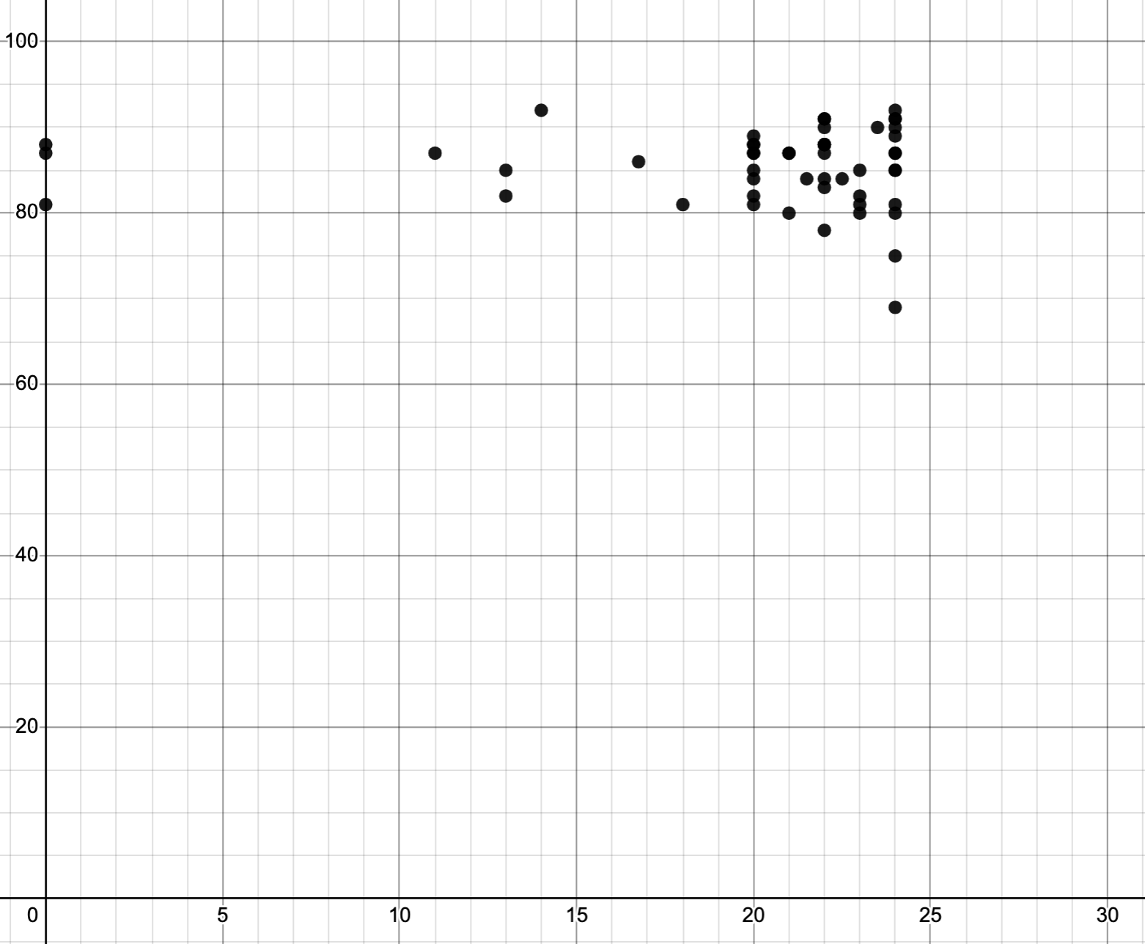
- What could the x-axis represent? This can be referred to as the explanatory or independent variable.

- What type of association is represented by this data? (linear, exponential, quadratic, something else)?

- What does the y-axis represent? This can be called the response variable or the dependent variable.

- Do you think the number or required courses is a good predictor for high school graduation rate?

- There are three points on the y-axis. Now that you know what the explanatory and response variables are, what do you think those three points represent? Label your axes with the correct variables.

A Closer Look.
Explore the information found in the National Center for Education Statistics’ comparison of each state’s high school graduation requirements (https://nces.ed.gov/programs/coe/indicator/coi/high-school-graduation-rates) and the National Center for Education Statistics’ comparison of state graduation rates (https://reports.ecs.org/comparisons/high-school-graduation-requirements-01). Respond to the following questions:

- What are the coordinates for a state like Alabama? What do the coordinates represent?

- What are the coordinates of Pennsylvania? What do the coordinates represent?

- How does the meaning of the coordinates of these points compare? Are they tracking the same things?

- When creating a mathematical model, it is important that the quantities being used are tracking the same things. Why would it make sense to exclude data from Pennsylvania, Colorado, and Massachusetts?

Wrap up.
To close, consider and respond to the following questions:

Where would your high school fit on the graph as a coordinate point?

What recommendations would you offer or new questions surface for you?

Example 2: Risk Ratio

Part 1: Develop a Statistical Question
According to a Harvard Health Publishing web article, “Heart Health”:
“a healthy heart “beats about 2.5 billion times over the average lifetime, pushing millions of gallons of blood to every part of the body. This steady flow carries with it oxygen, fuel, hormones, other compounds, and a host of essential cells. It also whisks away the waste products of metabolism.”

When the heart can’t perform at optimal health, it is said that a person has developed some form of cardiovascular disease or heart disease. Doctors have developed a way to quantify a person’s risk for developing heart disease; it is called relative risk ratio.

- Research heart disease. What are some factors that might lead to heart disease?

Some individuals aspire to prevent heart disease by engaging in daily walks. A statistical question to explore in that group is looking at the relationships between heart disease and walking speed. One such statistical question could be: Is a higher average walking speed associated with a lower rate of heart disease?
- A relative risk ratio is a number that compares the possibility of getting heart disease among one group with the possibility of getting that disease in another group.
If the risk ratio is 1, that means both groups have the same possibility of getting heart disease.

Based on your current understanding, answer the following questions using a factor you found in your answer to Question 1:
  - What do you believe are the two groups involved?

  - What do you anticipate the relative risk ratio will be: about 1, greater than 1, or less than 1? How did you arrive at this conclusion?

  - What are some statistical questions you can ask about heart disease?

Part 2: Understanding a Mathematical Representation
In one study, researchers set out to quantify the specific amounts of physical activity required for lower risks of heart disease.

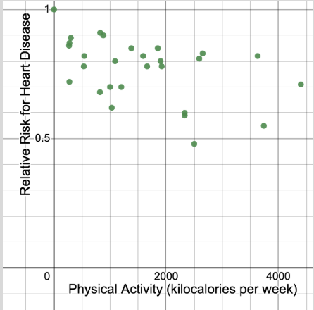

Based on: Dose response between physical activity and risk of coronary heart disease: a meta-analysis

- What do you notice? What do you wonder?

- How might you use this graph to answer the statistical question, “Do higher levels of physical activity lower the risk of heart disease?”

Part 3: Manipulate the Model
- Work with this representation of the data on Desmos Calculator: Physical Activity and Relative Risk for Heart Disease to determine the line of best fit.

Line of best fit: ____________________________

- Find and interpret the value of the coefficient of determination, $r^{2}$.

$r^{2}$=_____

- Based on the value of $r^{2}$ and the data, do you believe the claim that a higher level of physical activity lowers the risk of heart disease is valid?

Part 4: Interpret the Model
- Do you think that a level of physical activity, quantified by kilocalories per week, is a good predictor of a relative risk for heart disease? Use evidence to explain your reasoning.

Part 5: Reflection
- Consider your list of variables. Which ones does your group believe could be a better predictor of a shortened lifespan due to heart disease? Explain your reasoning.

