Baseline Professional Learning Handout
M201 Modeling with Exponential Functions

Baseline Professional Learning Handout 1
M201 Content and Practice Expectations 3
M201 Content and Practice Expectations and Indicators 4
Let’s Investigate 5
Graphs of Power Functions 5
Transforming the Graph of a Function 6
Let’s do some math! Round 1 7
Task 1: Speeding Tickets Prompt 7
Learning Principles 10
Task 1: Speeding Tickets Student Work 11
Let’s do some math! Round 2 16
Task 2: School Heating Prompt 16
Task 2: School Heating Student Work 19
Criteria for Success 24
References 24
Selected Common Core High School Standards for Mathematics

High School - Functions
Understand the concept of a function and use function notation
- Understand that a function from one set (called the domain) to another set (called the range) assigns to each element of the domain exactly one element of the range. If f is a function and x is an element of its domain, then f(x) denotes the output of f corresponding to the input x. The graph of f is the graph of the equation y = f(x).
- Use function notation, evaluate functions for inputs in their domains, and interpret statements that use function notation in terms of a context.
- Recognize that sequences are functions, sometimes defined recursively, whose domain is a subset of the integers. For example, the Fibonacci sequence is defined recursively by f(0) = f(1) = 1, f(n +1) = f(n) + f(n - 1) for n ≥ 1.

Analyze functions using different representations
- Graph functions expressed symbolically and show key features of the graph, by hand in simple cases and using technology for more complicated cases.★
  - Graph linear and quadratic functions and show intercepts, maxima, and minima.
  - Graph square root, cube root, and piecewise-defined functions, including step functions and absolute value functions.
  - Graph polynomial functions, identifying zeros when suitable factorizations are available, and showing end behavior.
  - (+) Graph rational functions, identifying zeros and asymptotes when suitable factorizations are available, and showing end behavior.
  - Graph exponential and logarithmic functions, showing intercepts and end behavior, and trigonometric functions, showing period, midline, and amplitude.
- Write a function defined by an expression in different but equivalent forms to reveal and explain different properties of the function.
  - Use the process of factoring and completing the square in a quadratic function to show zeros, extreme values, and symmetry of the graph, and interpret these in terms of a context.
  - Use the properties of exponents to interpret expressions for exponential functions. For example, identify percent rate of change in functions such as y = (1.02)t, y = (0.97)t, y = (1.01)12t, y = (1.2)t/10, and classify them as representing exponential growth or decay.
- Compare properties of two functions each represented in a different way (algebraically, graphically, numerically in tables, or by verbal descriptions). For example, given a graph of one quadratic function and an algebraic expression for another, say which has the larger maximum.

Build a function that models a relationship between two quantities

- Identify the effect on the graph of replacing f(x) by f(x) + k, k f(x), f(kx), and f(x + k) for specific values of k (both positive and negative); find the value of k given the graphs. Experiment with cases and illustrate an explanation of the effects on the graph using technology. Include recognizing even and odd functions from their graphs and algebraic expressions for them.

M201 Content and Practice Expectations
201.a | Understand the concept of a function and use function notation.
201.b | Graph functions expressed symbolically and show key features of the graph, by hand in simple cases and using technology for more complicated cases.
201.c | Write a function defined by an expression in different but equivalent forms to reveal and explain different properties of the function.
201.d | Build new functions from existing functions.
201.e | Compare properties of two functions each represented in a different way (algebraically, graphically, numerically in tables, or by verbal descriptions).
201.f | Build a function that models a relationship between two quantities.

M201 Content and Practice Expectations and Indicators
Content and Practice Expectations | Indicators  Choose an artifact where you…
201.a: Understand the concept of a function and use function notation. | i. demonstrate understanding of the following language of functions: If f is a function and x is an element of its domain, then f(x) denotes the output of f corresponding to the input x. The graph of f is the graph of the equation y = f(x).
 | ii. recognize that sequences are functions, sometimes defined recursively, and their domain is a subset of the integers.
201.b: Graph functions expressed symbolically and show key features of the graph, by hand in simple cases and using technology for more complicated cases. | i. graph linear and quadratic functions and show intercepts, maxima, and minima.
 | ii. graph square root, cube root, and piecewise-defined functions, including step functions and absolute value functions.
 | iii. graph polynomial functions, identifying zeros when suitable factorizations are available, and showing end behavior.
 | iv. graph exponential functions showing intercepts and end behavior.
201.c: Write a function defined by an expression in different but equivalent forms to reveal and explain different properties of the function. | i. rewrite expressions, using processes such as factoring and completing the square in a quadratic function, to show zeros, extreme values, and symmetry of graphs.
 | ii. use the properties of exponents to interpret expressions for exponential functions.
201.d: Build new functions from existing functions. | i. identify the effect on the graph of replacing f(x) by f(x) + k, k f(x), f(kx), and f(x + k) for specific values of k (both positive and negative); find the value of k given the graphs. Experiment with cases and illustrate an explanation of the effects on the graph using technology.
201.e: Compare properties of two functions each represented in a different way (algebraically, graphically, numerically in tables, or by verbal descriptions). | i. compare properties of two functions that highlight two quantities or features of interest.
201.f: Build a function that models a relationship between two quantities. | i. identify and/or define the variables of interest in a given situation or data set that demonstrate a functional relationship.
 | ii. build a function that models the relationship between two quantities in a situation.

Let’s Investigate

Graphs of Power Functions
- Sketch the graphs of the functions described by $f(x)=x^{2}$ and $g(x)=x^{4}$ on the same axes, being careful to label any points of intersection. Also, find and label $(\frac{1}{2},f(\frac{1}{2}))$ and $(\frac{1}{2},g(\frac{1}{2}))$.

- Sketch the graphs of the functions described by $f(x)=x^{3}$ and $g(x)=x^{5}$ on the same axes, being careful to label any points of intersection. Also, find and label $(\frac{1}{2},f(\frac{1}{2}))$ and $(\frac{1}{2},g(\frac{1}{2}))$.

- Sketch the graphs of the functions described by $f(x)=x^{2}$ and $g(x)=x^{3}$ on the same axes, being careful to label any points of intersection. Also, find and label $(\frac{1}{2},f(\frac{1}{2}))$ and $(\frac{1}{2},g(\frac{1}{2}))$.

Source: Illustrative Mathematics

Transforming the Graph of a Function

The figure shows the graph of a function f whose domain is the interval −2 ≤ x ≤ 2.

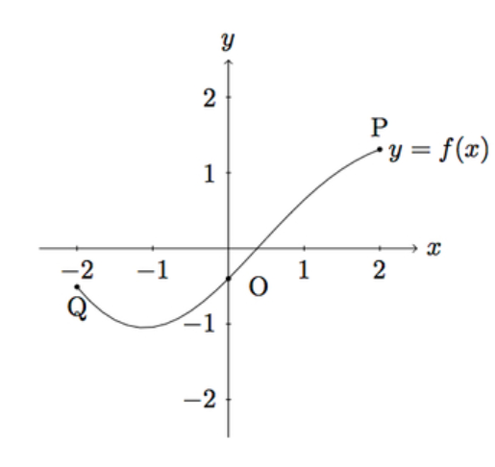

- In (i)–(iii), sketch the graph of the given function and compare with the graph of f. Explain what you see.
  - $g(x)=f(x)+2$
  - $h(x)=-f(x)$
  - $p(x)=f(x+2)$

- The points labelled Q, O, P on the graph of f have coordinates

Q = (−2,−0.509), O = (0,−0.4), P = (2,1.309).

What are the coordinates of the points corresponding to P,O,Q on the graphs of g, h, and p?

Source: Illustrative Mathematics

Let’s do some math! Round 1

Task 1: Speeding Tickets Prompt
Student are presented with a scenario like this:

Part A: Speeding in Massachusetts

A speeding ticket fine in Massachusetts is $100 for any speed up to 10 miles above the posted speed limit. The fine increases by $10 for each additional mile an hour after the first 10.
[Source: Speeding Ticket FAQs | Massachusetts Speeding Ticket Lawyer]

- Create a graph of this situation where the number of miles over the posted speed limit is on the horizontal axis and the cost of the ticket is on the vertical axis.
  - Does this graph represent a function?
  - What domain and range are reasonable for this function? How do you see these in the graph?
- Suppose the posted speed limit is 65 miles per hour. Create a “formula” that takes the driver’s speed at the time of incident in that zone and generates the cost of the driver’s speeding ticket.
  - Explain how the formula you created works. What is the input? What is the output?
  - Define any variables you use and illustrate how the formula(s) work.
Part B: Speeding in New York
Fines for speeding vary from state to state. In New York, speeding penalties are determined as follows:
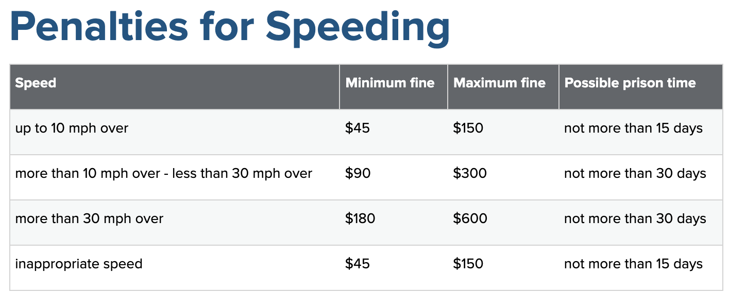
Source: Penalties for Speeding | Governor's Traffic Safety Committee

- Create a graph of this situation that illustrates the relationship between quantities.
  - What is interesting about your graph?
  - What do some of the interesting features of the graph mean relative to the context?

- How does New York’s Speeding Penalty system compare to Massachusetts’ system?
  - What are your thoughts about this?

Part C: Extending the learning:
Learn about your state’s or another state’s or another state’s system for determining speeding penalties.
  - Is it possible to represent the system graphically? Using a formula of some sort? Why or why not?
  - How does your state’s system compare to the systems in New York and Massachusetts?
  - What are your thoughts on this?

Sample Learning Experience

Launch this task by engaging students in a conversation to make sense of driving laws, speed limits, and penalties for going over the speed limit. Some questions you can pose are as follows:
- How does a driver determine how fast to go at any point in time?
- How does a driver know the maximum speed for any road they’re on?
- What are some consequences for going over the speed limit?

Introduce the prompt and provide time for students to consider the questions posed. Give students time to work independently and develop a response. Ensure students have access to multiple tools they can use to develop a response.

Invite students to partner with classmates and share their responses. Provide time for students to revise their justifications using the information gained during these discussions.

Some possible approaches are as follows:
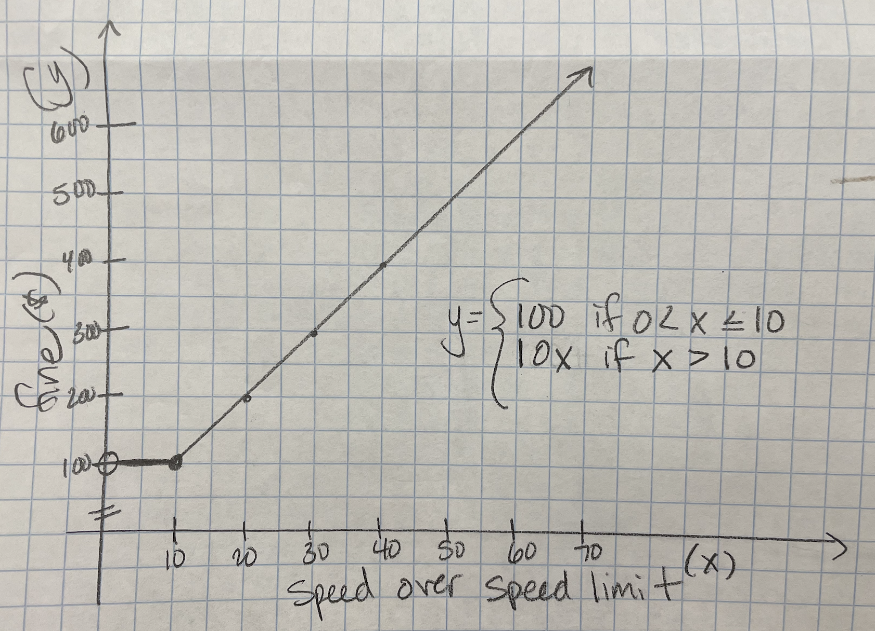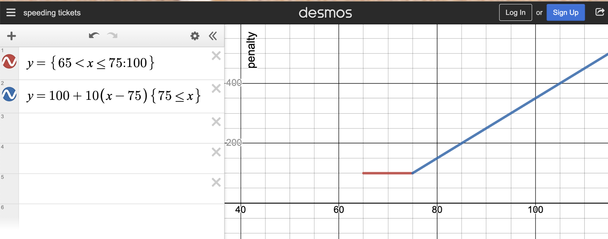

Monitor and select various solution methods to share with the class as students work with classmates. Have selected students present their responses—consider using a document camera for students to show actual work—and explain their justification. As discussion takes place, invite classmates to make sense of and build on each other’s responses, allowing for students to clarify and defend their response as the conversation ensues. Ask:

- What about this reasoning makes sense?
- In what ways is using a function helpful to communicate speeding penalties?
- What questions surface for you?
- Is there anything you have as an alternate explanation or point of view?
- What can you take from this approach to apply to your own work?

Following the discussion, provide students an opportunity to reflect on and revise their work. Additionally, offer students tools to explore any of the questions that surface from examining the speeding penalty practices of these states. Follow a similar structure for Parts B and C.

Learning Principles
Engage with cognitively demanding tasks in heterogeneous settings (LP 1). Students should be given opportunities to grapple with multistep, non-routine tasks that promote mathematical rigor. These experiences should be differentiated so that all students engage in appropriate challenges—for example, through tasks with multiple entry points and solution pathways. These experiences should continue to integrate knowledge and skills developed in grades 6-8 at the level of sophistication of high school mathematics.

Engage in social activities (LP 2). Students should have opportunities to work independently and to communicate with one another about mathematics by engaging in collective and collaborative learning activities. Explaining and having opportunities to revise one’s thinking has excellent value in solidifying one’s knowledge.

Build conceptual understanding through reasoning (LP 3). Students should be given the opportunity to reason, justify, and problem solve with critical thinking, reading, writing, speaking, and listening. Through reasoning and work with multiple representations, students learn why procedures work and build a conceptual understanding of key mathematical ideas.

Have agency in their learning (LP 4). Students should be able to choose tasks and learning experiences that align with their interests and aspirations. All students have rich and varied experiences and home lives. Learning mathematics should bring students’ identities and interests to the fore and build on the strengths that they bring to the learning space.

View mathematics as a human endeavor across centuries (LP 5). Students should understand that mathematical ideas emanated over time from civilizations around the world and have opportunities to explore these contributions to mathematics. Students should develop an appreciation of mathematics as a human endeavor: one in which they feel a sense of belonging, where they see themselves as mathematicians, and one that offers opportunities to broaden their ideas about what mathematics is, how it is used, and who it is for.

See mathematics as relevant (LP 6). Students should engage with mathematics in ways that authentically involve real-world situations. Problem-solving contexts should allow students to perceive mathematics as a tool for addressing the questions that arise in everyday life, as well as the ways it can model our world and address global economic, social, and environmental challenges. Students should also engage with mathematics in ways that connect to academic disciplines and future careers by doing the mathematics used by artists, designers, engineers, and other professionals.

Employ technology as a tool for problem-solving and understanding (LP 7). Research indicates that technology is a powerful tool for learning deeper mathematics by improving calculation efficiency and enabling more sophisticated analysis. Students should learn to use technology, with emphasis put on widely used tools and software, such as calculators and spreadsheets, to make sense of models. Technology use should not be limited to supporting “doing mathematics,” but should also be used as a tool for displaying and communicating results to appropriate audiences.

Task 1: Speeding Tickets Student Work

Example 1:
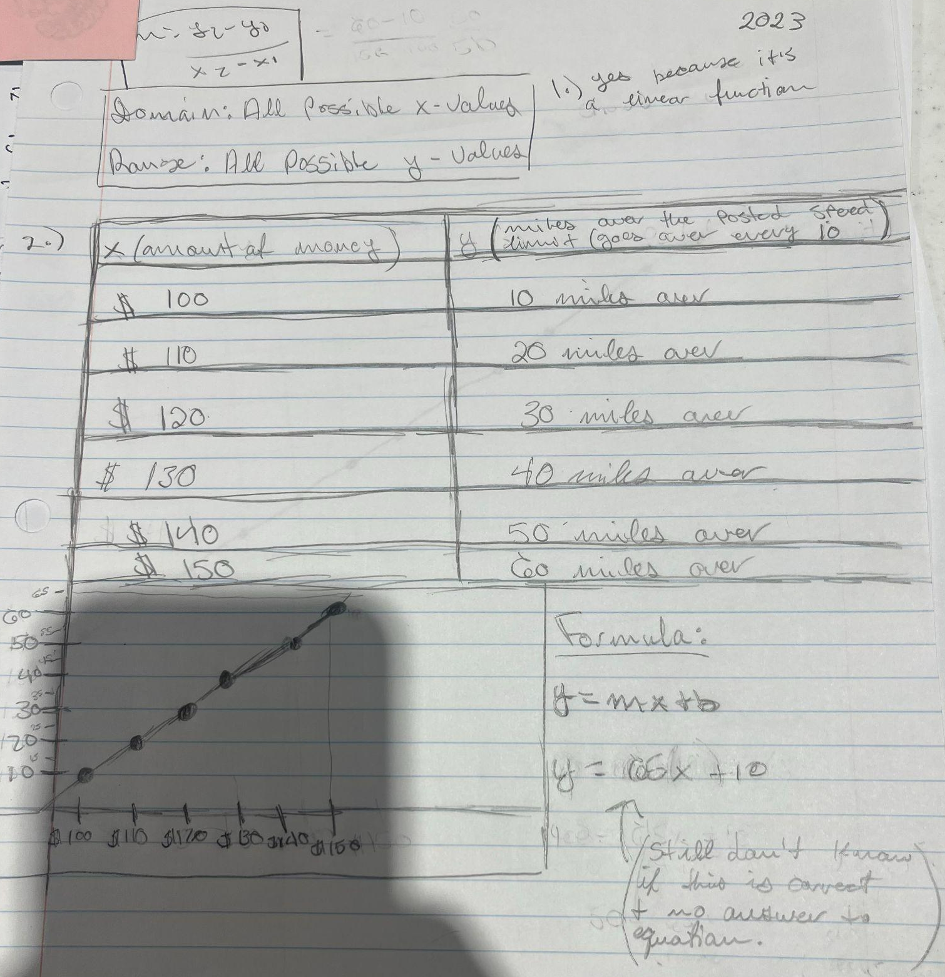

Example 2:
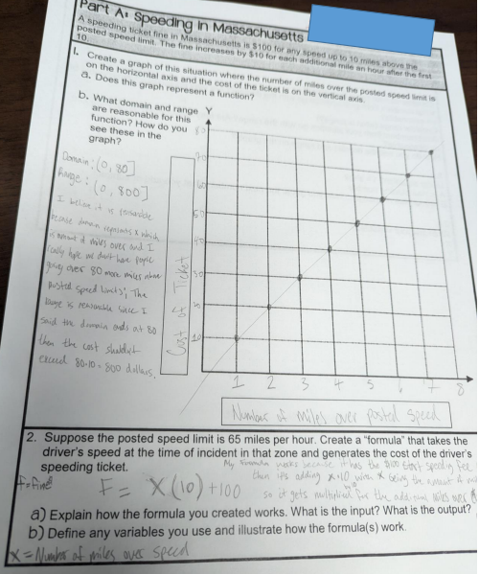
Example 3:
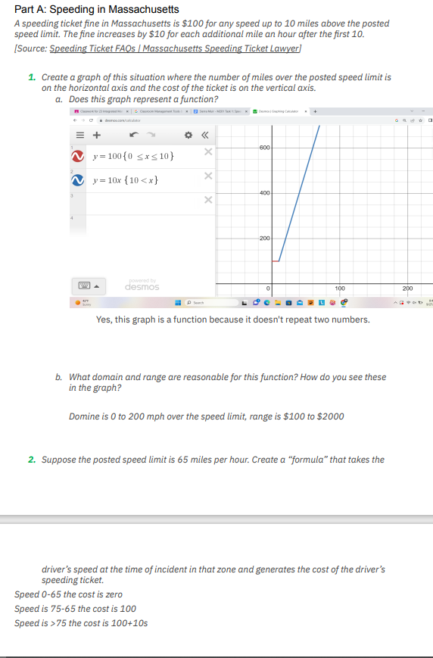
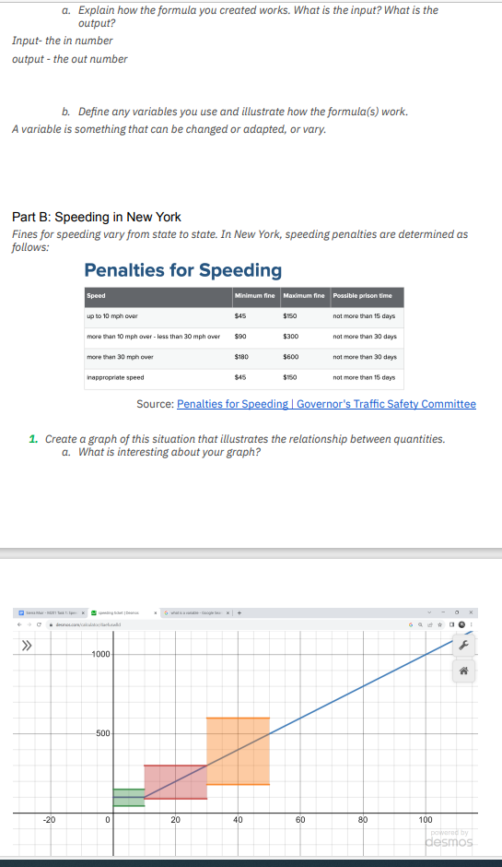
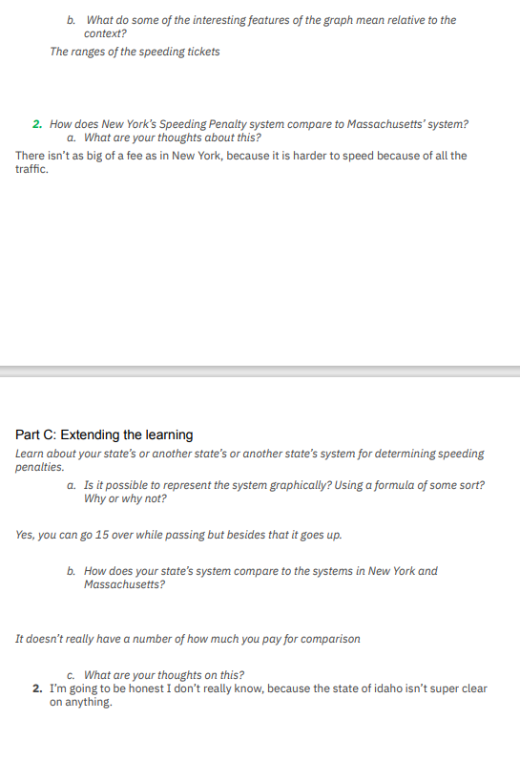

Let’s do some math! Round 2

Task 2: School Heating Prompt
Students are given a problem like this:

During the winter months, some schools shut down due to extreme cold conditions and the schools’ inability to adequately heat their buildings. According to the Capital Gazette and Bloomberg, the Baltimore City Public School System experienced this over the course of two winters in 2017 and 2018. In an effort to help, one college student started a GoFundMe campaign to purchase space heaters, raising about $84,000. One high school student reported near freezing temperatures of
${ 50}^{∘}F$ at the start of the day. With the use of a space heater, the classroom temperatures increased to ${65}^{∘}F$. In Maryland, the estimated cost to run a heater is about $0.20 per hour.

- Examine the image below or explore the actual graph at https://www.desmos.com/calculator/nts1vbqygf
  - How would you describe the relationship between the input and the output?
  - What does this relationship tell you about the costs of heating a room? How do the variables, slope of the line, and the equation of the function capture that relationship?
  - If a school has set up 40 classrooms each with a space heater, how would the function between the number of days and the cost of heating change? How does this impact the graph of the function? How does it impact the equation?
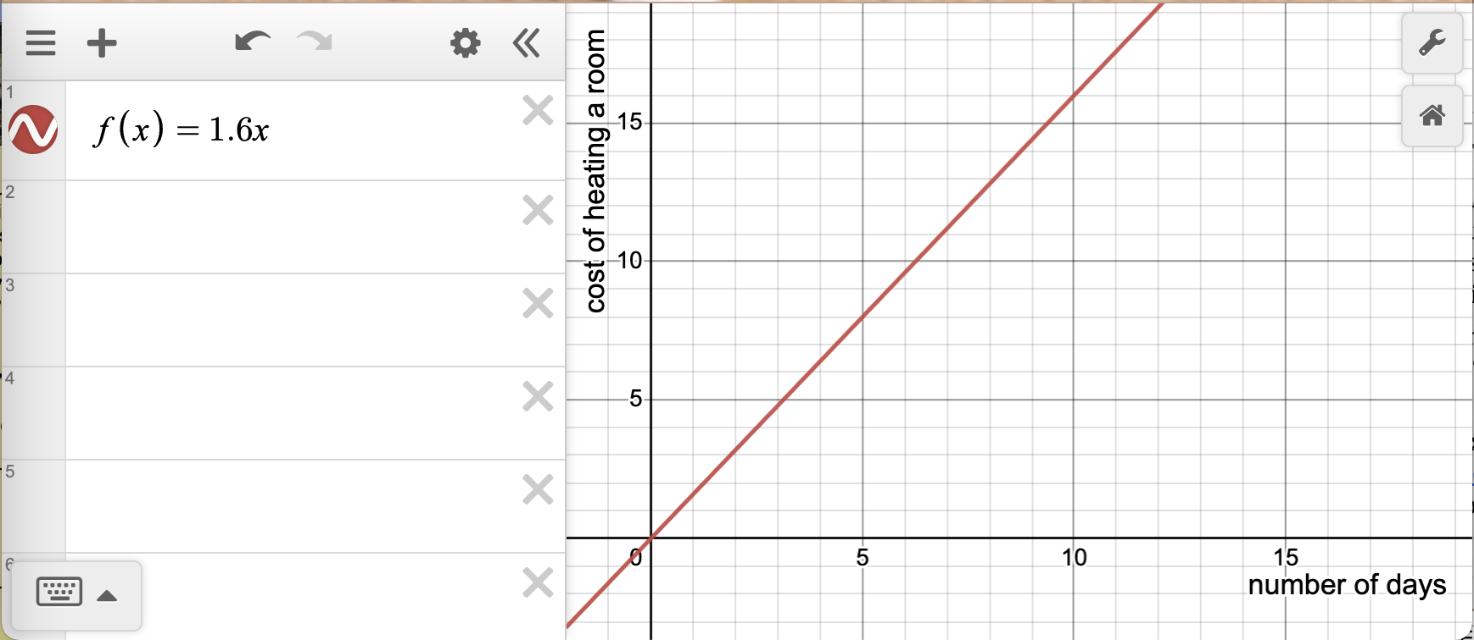

- Consider the following graph of $y=g(x)$.
  - How would you describe the relationship between the input and the output?
  - What values of the input are part of the domain of this function? Why does that make sense?
  - What does the relationship represented below tell us about how a space heater works to warm a room?
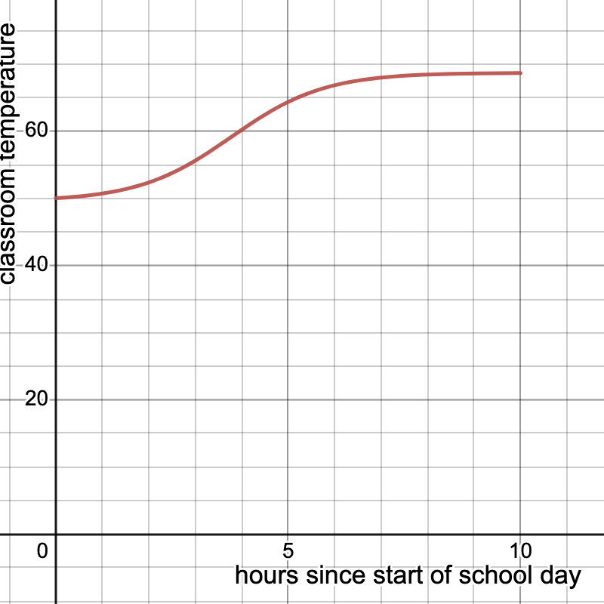
  - Given the conditions, the school leadership team decides to have administrators who are already in the building two hours before the start time preheat all the classrooms and keep the heaters running until the end of the school day.
    - Sketch a graph of the new function $h$, which gives the temperature in the school as a function of time.
    - Write an equation for $h$ in terms of $g$. Explain why your equation makes sense.
    - How will the school leadership team’s decision to start heating rooms earlier impact their cost for heating the school?

Sample Learning Experience

Have students examine the following articles to set context to the situation. Lead a class discussion based on thoughts, reflections, surprises, etc. from the articles.
- Ericson Jr., E. (2018, January 7). How Baltimore Students Got Left in the Cold. Bloomberg. How Baltimore's Public Schools Got Left In the Cold - Bloomberg
- McNamara, J. (2017, January 10). Cold classrooms a hot issue in Bowie. Retrieved from Capital Gazette: Cold classrooms a hot issue in Bowie – Capital Gazette

Lead into the activity with some individual work time, where students develop an approach to the prompt, encouraging them to share and compare approaches. Monitor and select a couple of approaches to highlight and reflect on progress made at this point.

Questions that can be posed to student pairs as they work:

- What is this context about? What connections can you make to your own experience?
- What are the quantities, things that can be counted or measured, involved in this context?
- What do you anticipate is the relationship between these quantities? Why does that make sense?
- What connections can you make between these ideas you shared and the first graph?
- What connections can you make between these ideas you shared and the first equation?
- Press for details by asking can you say more about…?

Give selected pairs of students time to share responses and invite classmates to reflect on the following questions:

- What makes sense about the ideas shared?
- What questions surface for you?
- What can you take from this discussion and apply to your own work?

Provide time for students to revise their work. While they work, select additional pairs to share how they used the structure and relationship between the equations to determine which sets of equations have the same answer. Give students additional time to revise their work.

Additionally, offer students tools to explore any of the questions that surface from examining the case of Baltimore Public Schools.

Task 2: School Heating Student Work

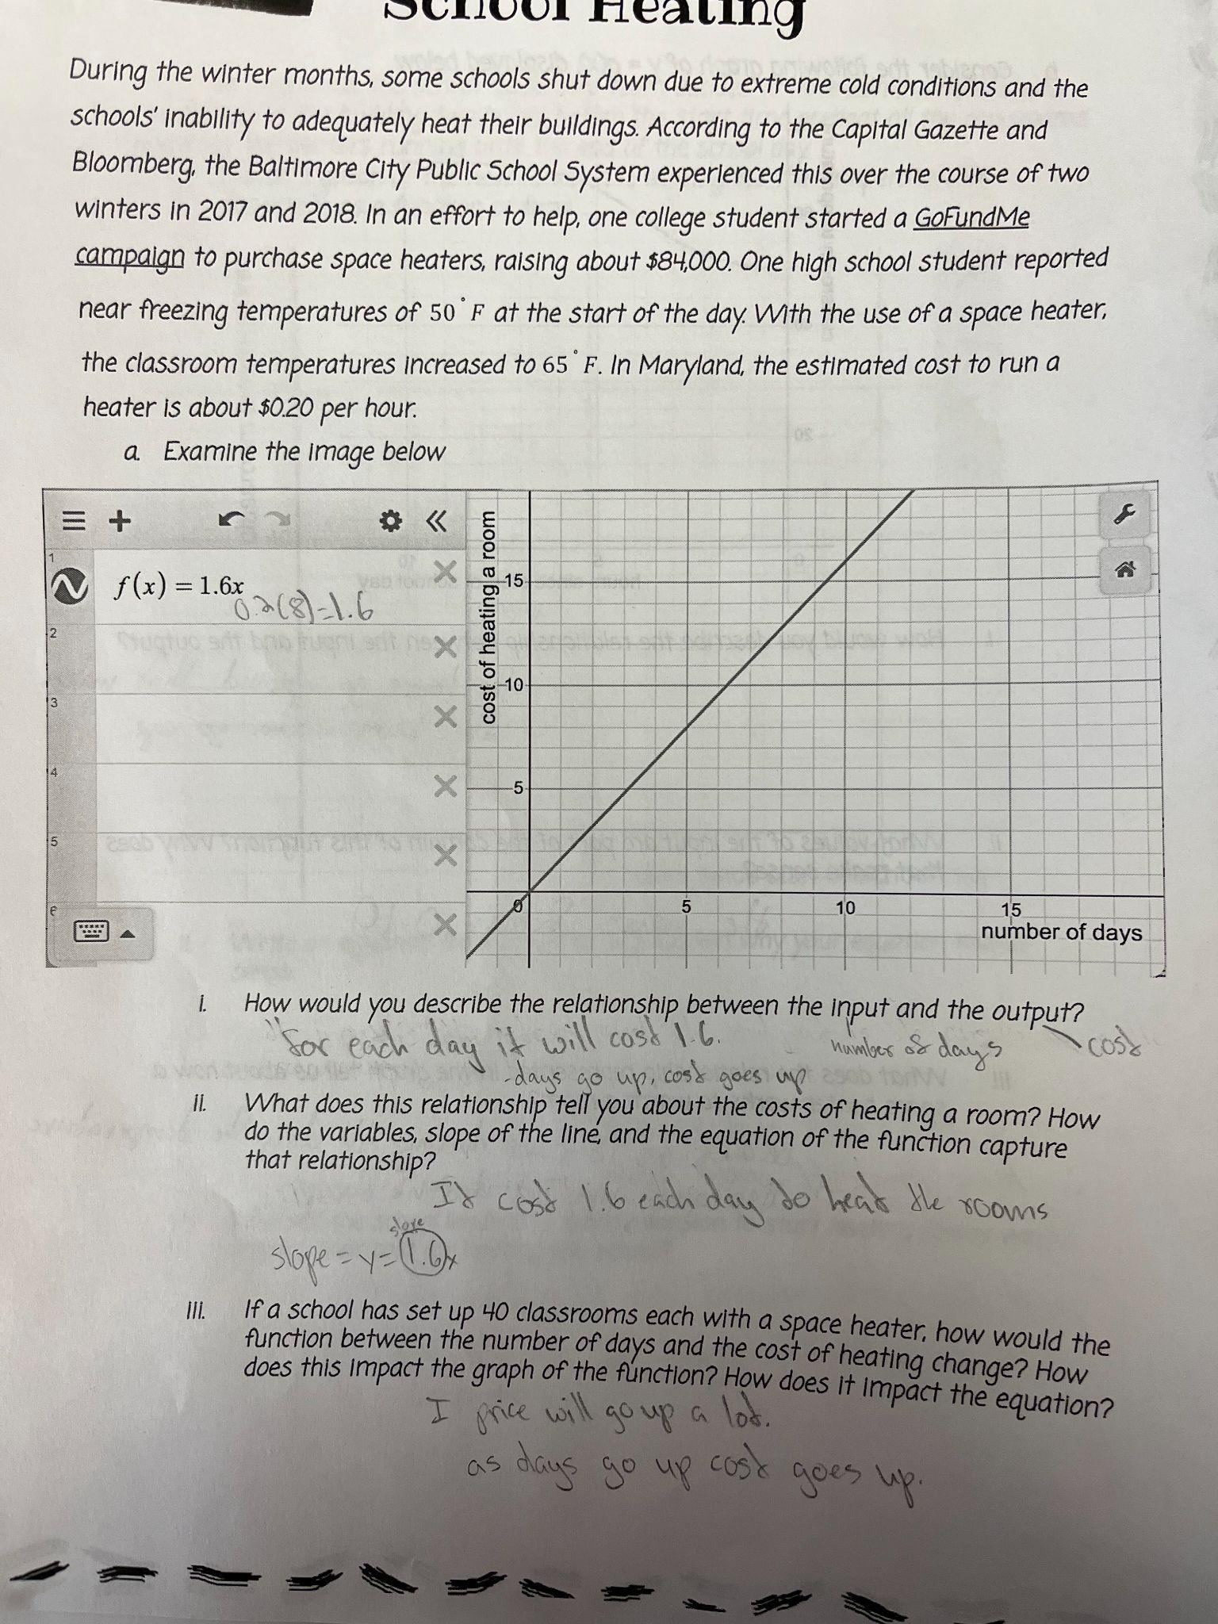
Example 1:

Example 2:
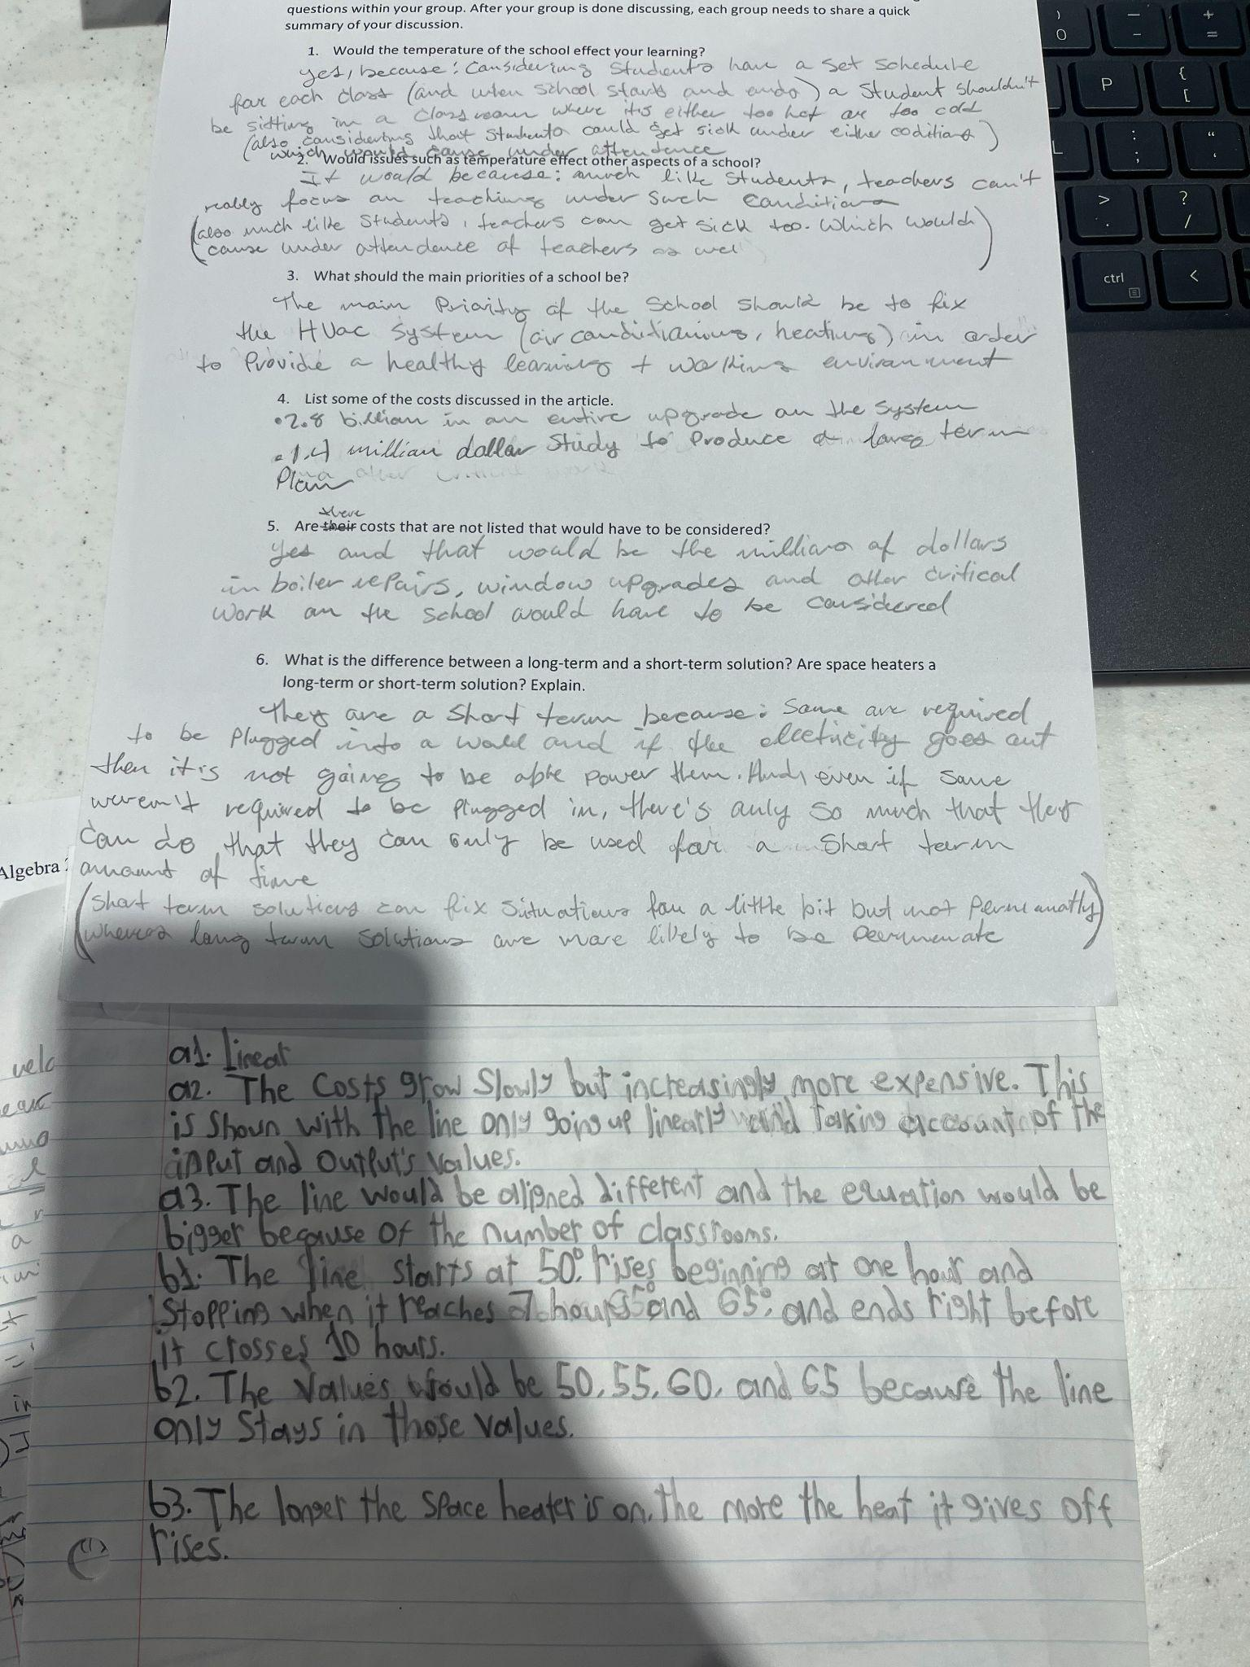

Example 3: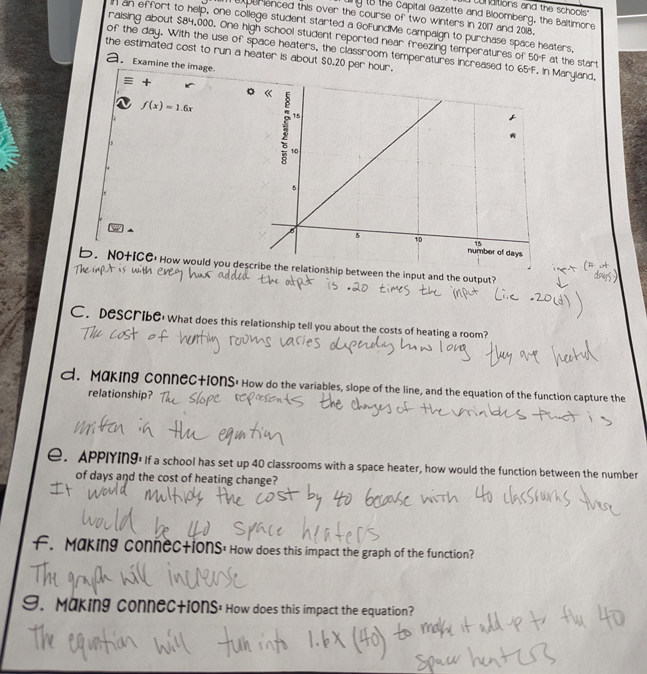
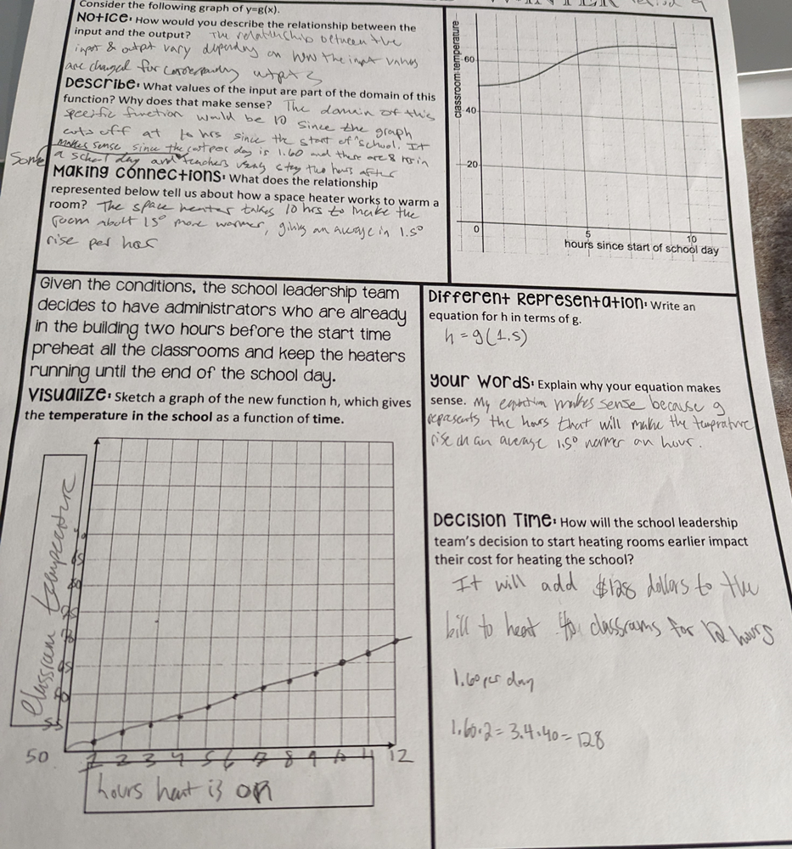

Criteria for Success

Conference and Provide Revision Support | Accept with Revision | Accept
The student’s artifact shows an emerging understanding of the expectations of the indicator(s). After conferencing and additional instruction/learning, the student may provide a revised or different artifact as evidence of the indicator(s). | The student’s artifact is approaching a full understanding of the expectations of the indicator(s). The artifact may contain execution errors that should be corrected in revision. The student may revise the selected artifact or submit a different artifact. | The student’s artifact demonstrates evidence that they have met the expectations of the indicator(s).

References

Illustrative Mathematics. (2016, May 4). Graphs of Power Functions. Illustrative Mathematics High School Functions. http://tasks.illustrativemathematics.org/content-standards/HSF/IF/C/7/tasks/627

Illustrative Mathematics. (2016, May 4). Interesting Interest Rates. IIlustrative Mathematics. https://tasks.illustrativemathematics.org/content-standards/tasks/302

