Baseline Professional Learning Handout
M112 Modeling with Data: Two-Variable Measurement Data

Baseline Professional Learning Handout 1
Selected Common Core High School Standards for Mathematics 2
Statistics and Probability Excerpt 3
M112 Content and Practice Expectations 4
M112 Content and Practice Expectations and Indicators 5
Let’s Investigate 7
Restaurant Bill and Party Size Task 8
Best Phone Charger Task 10
Let’s do some math! Round 1 11
Task 1: Graduation Rates 12
Learning Principles 15
Task 1: Graduation Rates Student Work 16
Let’s do some math! Round 2 17
Task 2: Heart Disease 18
Task 2: Heart Disease Student Work 20
Criteria for Success 21
References 21

Selected Common Core High School Standards for Mathematics

High School - Statistics and Probability
Summarize, represent, and interpret data on two categorical and quantitative variables
- Summarize categorical data for two categories in two-way frequency tables. Interpret relative frequencies in the context of the data (including joint, marginal, and conditional relative frequencies). Recognize possible associations and trends in the data.
- Represent data on two quantitative variables on a scatter plot, and describe how the variables are related.
  - Fit a function to the data; use functions fitted to data to solve problems in the context of the data. Use given functions or choose a function suggested by the context. Emphasize linear, quadratic, and exponential models.
  - Informally assess the fit of a function by plotting and analyzing residuals.
  - Fit a linear function for a scatter plot that suggests a linear association.

Interpret linear models
- Interpret the slope (rate of change) and the intercept (constant term) of a linear model in the context of the data.
- Compute (using technology) and interpret the correlation coefficient of a linear fit.
- Distinguish between correlation and causation.

Statistics and Probability Excerpt

Students have seen scatter plots in Grade 8 and now extend that knowledge to fit mathematical models that capture key elements of the relationship between two variables and to explain what the model tells us about that relationship. Some of the data should come from science, as in the examples about cricket chirps and temperature, and tree growth and age, and some from other aspects of their everyday life, e.g., cost of pizza and calories per slice.  If you have a keen ear and some crickets, can the cricket chirps help you predict the temperature? The margin shows data modeled in a scientific investigation of that phenomenon. In this situation, the variables have been identified as chirps per second and temperature in degrees Fahrenheit. The cloud of points in the scatter plot is essentially linear with a moderately strong positive relationship. It looks like there must be something other than random behavior in this association. A model has been formulated: The least squares regression line has been fit by technology.^{S-ID.6} The model is used to draw conclusions: The line estimates that, on average, each added chirp predicts an increase of about 3.29 degrees Fahrenheit. (Common Core Standards Writing Team, 2012) | 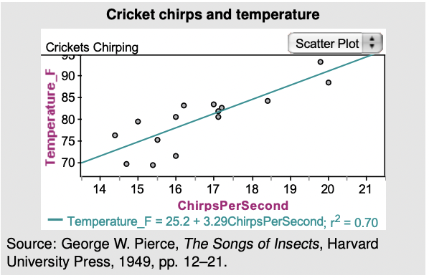

M112 Content and Practice Expectations
112.a | Engage in the modeling cycle.
112.b | Use scatter plots to represent two-variable measurement data.
112.c | Describe visible patterns between two data sets in a scatter plot.
112.d | Informally fit a straight line for scatter plots that suggest a linear association.
112.e | Fit a linear, quadratic, or exponential function to two-variable measurement data.
112.f | Use functions that have been fitted to two-variable measurement data to answer questions about the relationship being modeled.
112.g | Assess the fit of a function using the correlation coefficient, residuals, and other tools.
112.h | Explain insights gained from analyzing two-variable measurement data and limitations of curves fitted to data.

M112 Content and Practice Expectations and Indicators
Content and Practice Expectations | Indicators  Choose an artifact where you…
112.a: Engage in the modeling cycle. | i. engage with the full modeling cycle (problem, formulate, compute, interpret, validate, revise as necessary, report).
112.b: Use scatter plots to represent two-variable measurement data. | i. construct a scatter plot from collected data
 | ii. explain the meaning of a data point plotted on a scatter plot
112.c: Describe visible patterns between two data sets in a scatter plot. | i. identify the type of association visible in a scatter plot
 | ii. give a hypothesis that might explain the association identified in a scatter plot
112.d: Informally fit a straight line for scatter plots that suggest a linear association. | i. sketch a line that follows a pattern of linear association
 | ii. justify location and direction of a line fitted to data
112.e: Fit a linear, quadratic, or exponential function to two-variable measurement data. | i. graph a linear, quadratic, or exponential function that models two-variable measurement data
 | ii. find the equation for a linear, quadratic, or exponential function that models two-variable measurement data
 | iii. justify the choice of linear, quadratic, or exponential function
112.f: Use functions that have been fitted to two-variable measurement data to answer questions about the relationship being modeled. | i. explain the meaning of parameters for a function fitted to two-variable measurement data
 | ii. use a function fitted to two-variable measurement data to predict values
112.g: Assess the fit of a function using the correlation coefficient, residuals, and other tools. | i. find the correlation coefficient for a function fitted to two-variable measurement data
 | ii. explain the meaning of a correlation coefficient
 | iii. plot residuals for a function fitted to two-variable measurement data
 | iv. interpret a residual plot in terms of a function’s goodness of fit
112.h: Explain insights gained from analyzing two-variable measurement data and limitations of curves fitted to data. | i. use statistical tools to justify a conclusion about two-variable measurement data
 | ii. explain a limitation of a curve fitted to data
 | iii. distinguish between correlation and causation

Let’s Investigate

Restaurant Bill and Party Size Task
The owner of a local restaurant selected a random sample of dinner tables at his restaurant. For each table, the owner recorded the total amount of the dinner bill and the number of people at the table. The data are given in the table below. A scatterplot of the data is also shown.

People | Bill
1 | $8.50
2 | $36.00
2 | $32.55
3 | $29.30
3 | $50.65
4 | $48.75
5 | $63.75
5 | $60.00
8 | $82.50
10 | $125.75

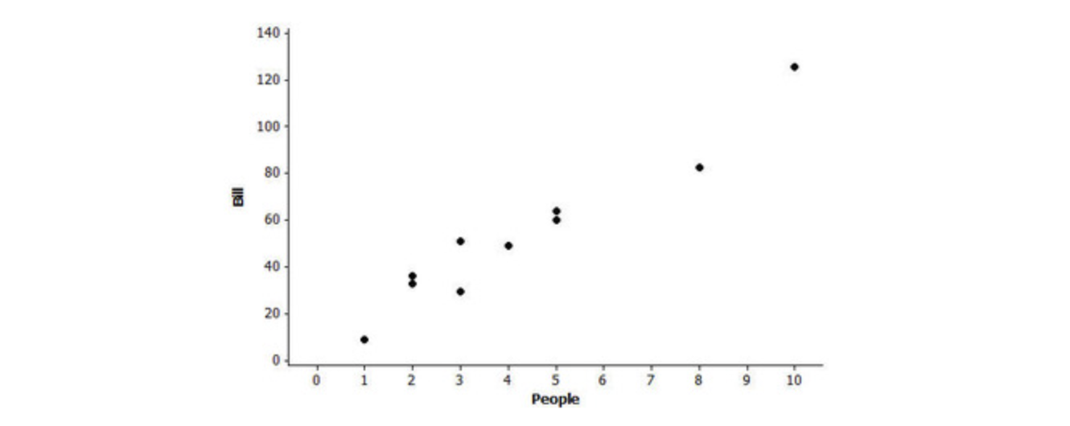

- Does the relationship between the number of people and the bill appear to be weak, moderate or strong?
- Does the relationship between the number of people and the bill appear to be linear?
- The equation of the line of best fit is Bill = 5.80 + 11.15 · People. Sketch this line on the scatterplot.
- Interpret the slope of the line of best fit in the context of this problem.
- Note that the points in the scatterplot do not all lie on the line. What could explain this variability?
- Use the equation of the line of best fit to estimate how much would you predict the bill to be for a party of 8?
- There was one party of 8 whose bill was $82.50. Did they pay more than or less than the predicted amount? How much more or how much less did they pay?
- The difference calculated in part (g) is called a residual. When each residual is calculated and plotted against the corresponding number of people, the resulting plot is called a residual plot. The residual plot for this data set is shown below.
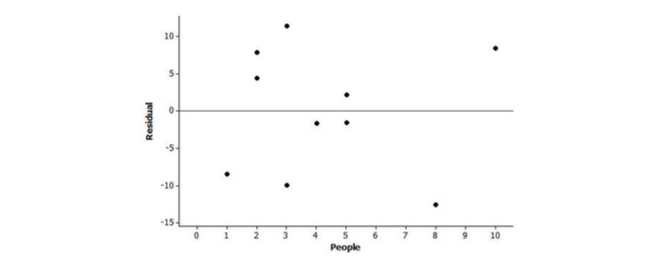
Explain how one could use the residual plot in order to determine if a linear model is an appropriate way to describe the relationship between number of people and the amount of the bill.
- A random sample of several pizza restaurants in the area was selected. Data was collected on the diameter and the price of the smallest cheese pizza sold at the restaurant. The line of best fit was fit to the data and the corresponding residual plot is given below.
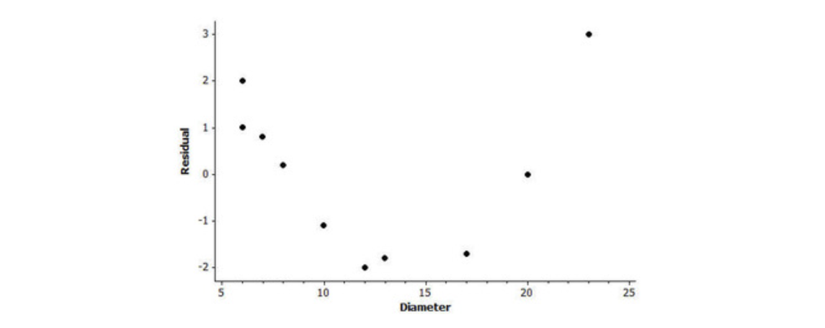
Does there appear to be a linear relationship between the diameter and the price of a cheese pizza in this area? Use the residual plot to explain your answer.

Source: Illustrative Mathematics

Best Phone Charger Task

Consider the following statement from The New York Times’ Wirecutter post The Best USB Phone Charger by Nick Guy:
“If you’ve ever scrambled out the door with your phone’s battery in the red, you know that power is precious, and the faster you can get it, the better. Anker’s PowerPort III Nano is the best option for charging any phone fast: It's tiny and inexpensive, and it can get a fully drained phone battery to more than 50% full in half an hour.”
In this task your job is to determine which charger is the best charger in your class.
- Select at least two chargers to compare how quickly they can increase a phone’s battery power. What data will you need to collect?
- Gather enough data from each charger to create a scatter plot for each one. What labels did you use for each axis?
- Use technology to compute the best fit line for each charger’s scatter plot.
- What are the values for the slope and $y$-intercept for each best fit line? What do these values mean in this situation?
  - Describe the relationship you see between the two quantities you used in this analysis.
  - Do you believe there is a causal relationship between these two quantities?
- Based on your work, which of the chargers is the best?
  - What are the limitations of your mathematical analysis?

Source: Student Achievement Partners XQ HS Badging Team

Let’s do some math! Round 1

Task 1: Graduation Rates

Sample Learning Experience

Part 1: Making Sense of a Scatter Plot
Students are invited to consider graduation rates and the factors that might impact them, using discussion questions such as these:
- What do you think a state’s “graduation rate” is?
- What factors might cause a state’s graduation rate to be higher or lower?

After discussing, students are provided this scatterplot and told that each point represents a state; the response variable is the state’s graduation rate.

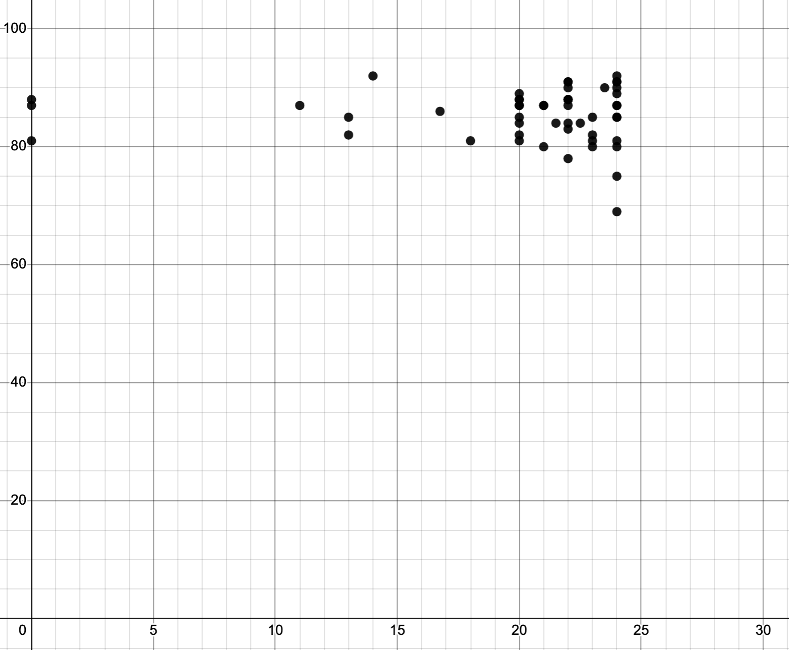

Students are then asked to brainstorm, first individually, then with a peer group, the answers to these questions:
- What could be the context of the explanatory variable?
- What type of association is represented by this data (linear, quadratic, power, etc.)?
- There are three data points on the y axis. What could these points represent?

After sharing, students are told that the explanatory variable for the data above is the number of courses required by U.S. states in order to graduate high school.

Students are then asked to brainstorm, first individually, then with a peer group, the answers to these questions:
- Do you think the number of required courses is a good predictor for high school graduation rate?
- Now that you know that the response variable is high school graduation rate, what could the three data points on the y-axis represent?

To deepen understanding of the context being modeled, students investigate the information found in the Education Commission of the States’ comparison of each state's high school graduation requirements and the National Center for Education Statistics’ comparison of state graduation rates. They respond to questions such as these:
- What are the coordinates for a state like Alabama? What do the coordinates represent?
- What are the coordinates of Pennsylvania? What do the coordinates represent?
- How does the meaning of the coordinates of these points compare? Are they tracking the same things?
- When creating a mathematical model, it is important that the quantities being used are tracking the same things. Why would it make sense to exclude data from Pennsylvania, Colorado, and Massachusetts?

Part 2: Using a Line of Best Fit

Using technology, students are asked to estimate and draw in a line of fit for the data set. (See, for example, this Desmos calculator link.) Students discuss and respond to these questions:
- What does the y-intercept and slope of your line of best fit mean for the given context?
- Use technology to fit a regression model to the data. Find the value of the correlation coefficient, r. What does this value mean for the given context? (See for example, this Desmos calculator link.)
- Is a linear model a good fit for this set of data?
- Using technology find the value of the coefficient of determination,
- $r^{2}.$ The coefficient of determination shows the amount of variability accounted for in the model. Does the value of $r^{2}$ you calculated validate or dispute the claim that a higher number of required courses in high school lead to higher graduation rates?
- Here is the residual plot of data given above based on the linear regression model shown below:
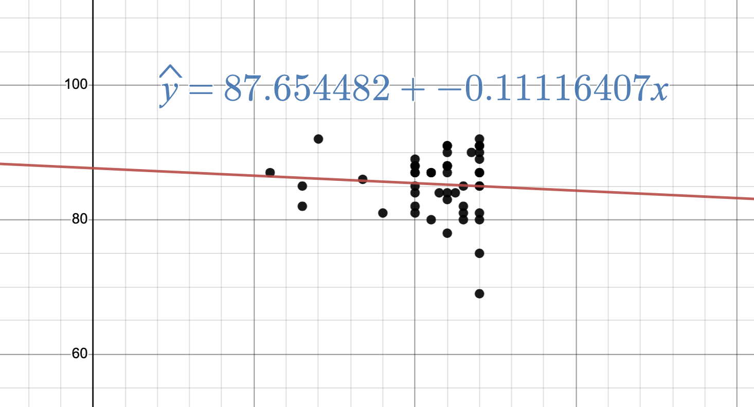
Residual plot:
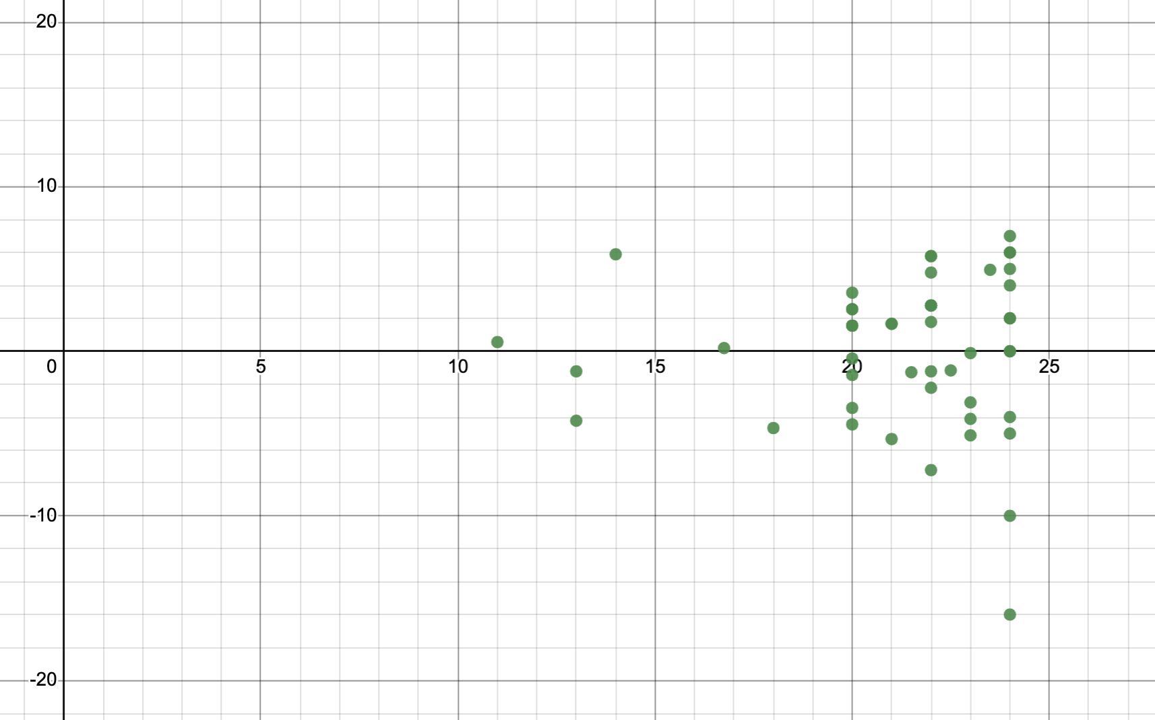
Is a linear model appropriate for the given data?

Students are then asked to consider the other potential factors influencing graduation rates brainstormed initially in Part 1. Students find state level data and repeat the process to examine the effect of their chosen explanatory variable is a better predictor

In closing, students are asked to consider and respond to these questions:
- Which explanatory variable that you have examined impacts high school graduation rates more? Support your answer with appropriate statistics.
- What new insights have you gained about the number of course requirements and graduation rates?

Learning Principles
Engage with cognitively demanding tasks in heterogeneous settings (LP 1). Students should be given opportunities to grapple with multistep, non-routine tasks that promote mathematical rigor. These experiences should be differentiated so that all students engage in appropriate challenges—for example, through tasks with multiple entry points and solution pathways. These experiences should continue to integrate knowledge and skills developed in grades 6-8 at the level of sophistication of high school mathematics.

Engage in social activities (LP 2). Students should have opportunities to work independently and to communicate with one another about mathematics by engaging in collective and collaborative learning activities. Explaining and having opportunities to revise one’s thinking has excellent value in solidifying one’s knowledge.

Build conceptual understanding through reasoning (LP 3). Students should be given the opportunity to reason, justify, and problem solve with critical thinking, reading, writing, speaking, and listening. Through reasoning and work with multiple representations, students learn why procedures work and build a conceptual understanding of key mathematical ideas.

Have agency in their learning (LP 4). Students should be able to choose tasks and learning experiences that align with their interests and aspirations. All students have rich and varied experiences and home lives. Learning mathematics should bring students’ identities and interests to the fore and build on the strengths that they bring to the learning space.

View mathematics as a human endeavor across centuries (LP 5). Students should understand that mathematical ideas emanated over time from civilizations around the world and have opportunities to explore these contributions to mathematics. Students should develop an appreciation of mathematics as a human endeavor: one in which they feel a sense of belonging, where they see themselves as mathematicians, and one that offers opportunities to broaden their ideas about what mathematics is, how it is used, and who it is for.

See mathematics as relevant (LP 6). Students should engage with mathematics in ways that authentically involve real-world situations. Problem-solving contexts should allow students to perceive mathematics as a tool for addressing the questions that arise in everyday life, as well as the ways it can model our world and address global economic, social, and environmental challenges. Students should also engage with mathematics in ways that connect to academic disciplines and future careers by doing the mathematics used by artists, designers, engineers, and other professionals.

Employ technology as a tool for problem-solving and understanding (LP 7). Research indicates that technology is a powerful tool for learning deeper mathematics by improving calculation efficiency and enabling more sophisticated analysis. Students should learn to use technology, with emphasis put on widely used tools and software, such as calculators and spreadsheets, to make sense of models. Technology use should not be limited to supporting “doing mathematics,” but should also be used as a tool for displaying and communicating results to appropriate audiences.

Task 1: Graduation Rates Student Work

Example 1:

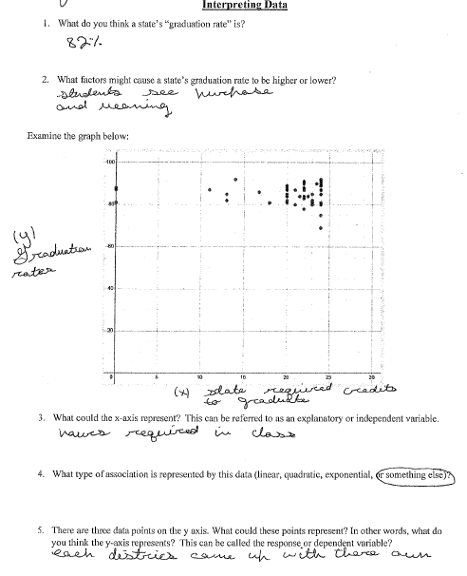

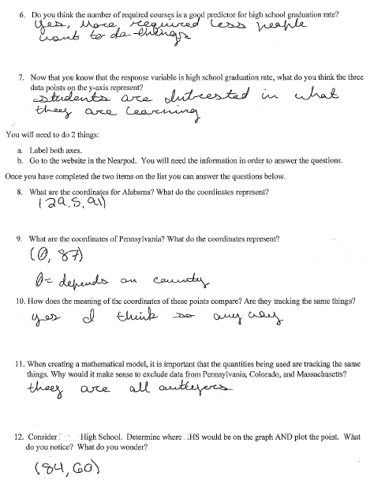

Example 2:
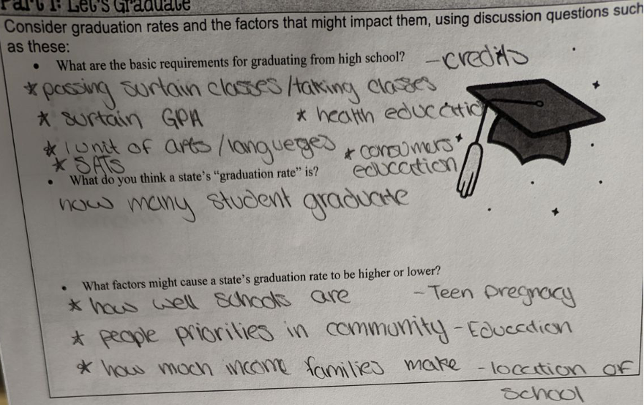

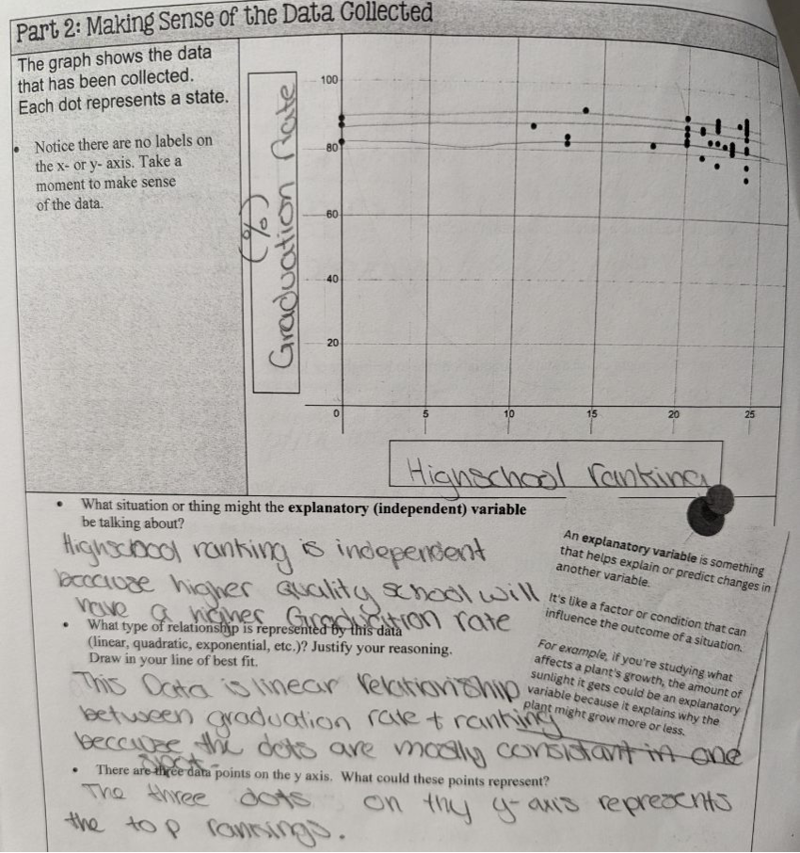

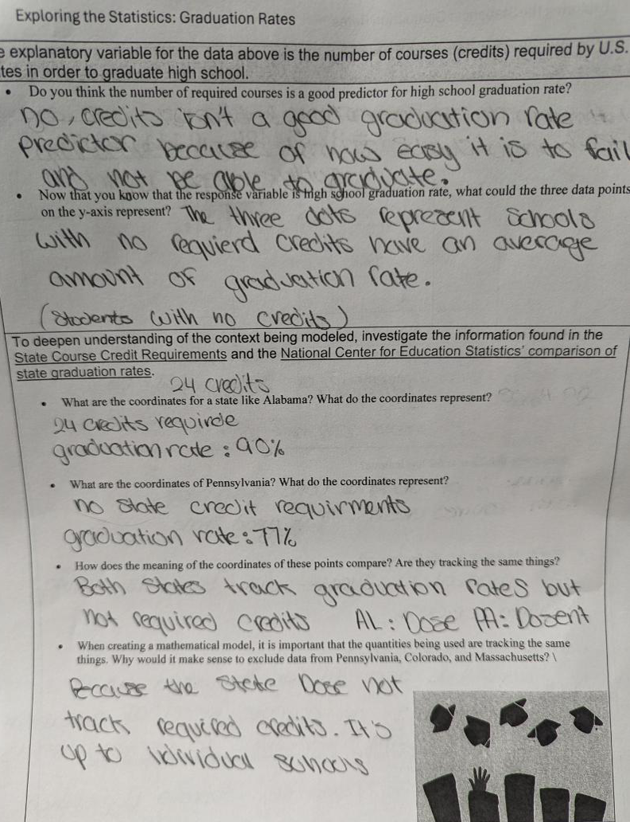
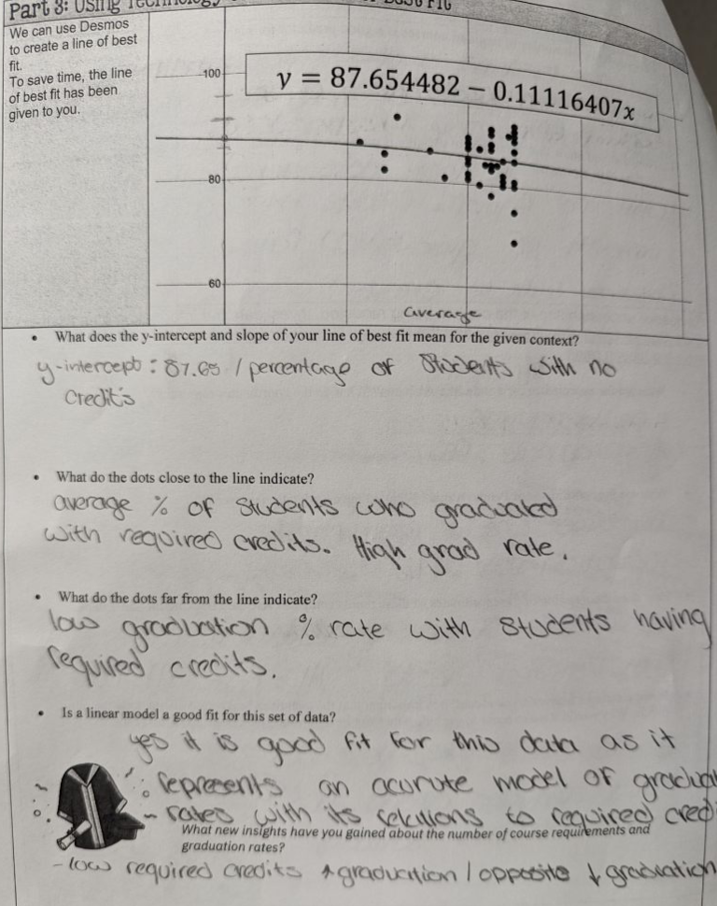
Example 3:

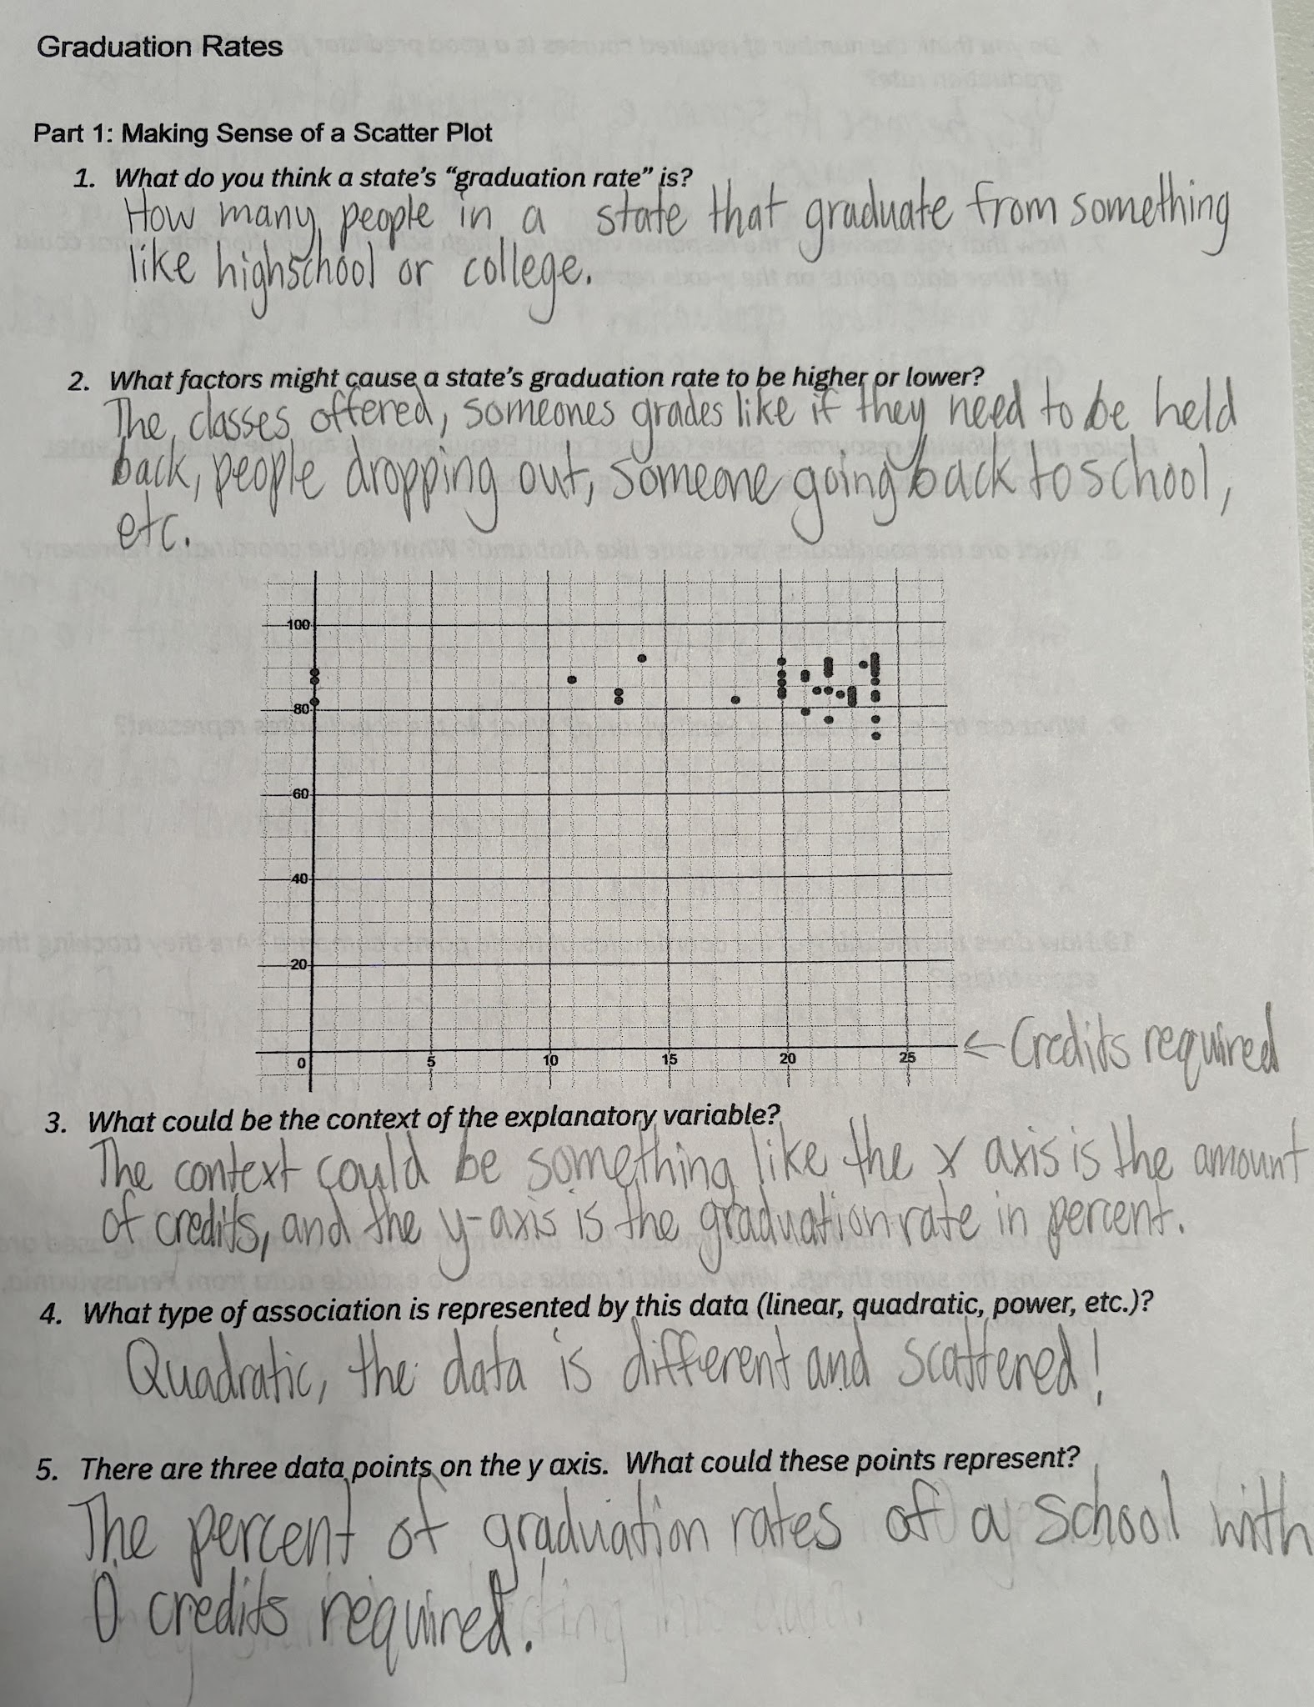
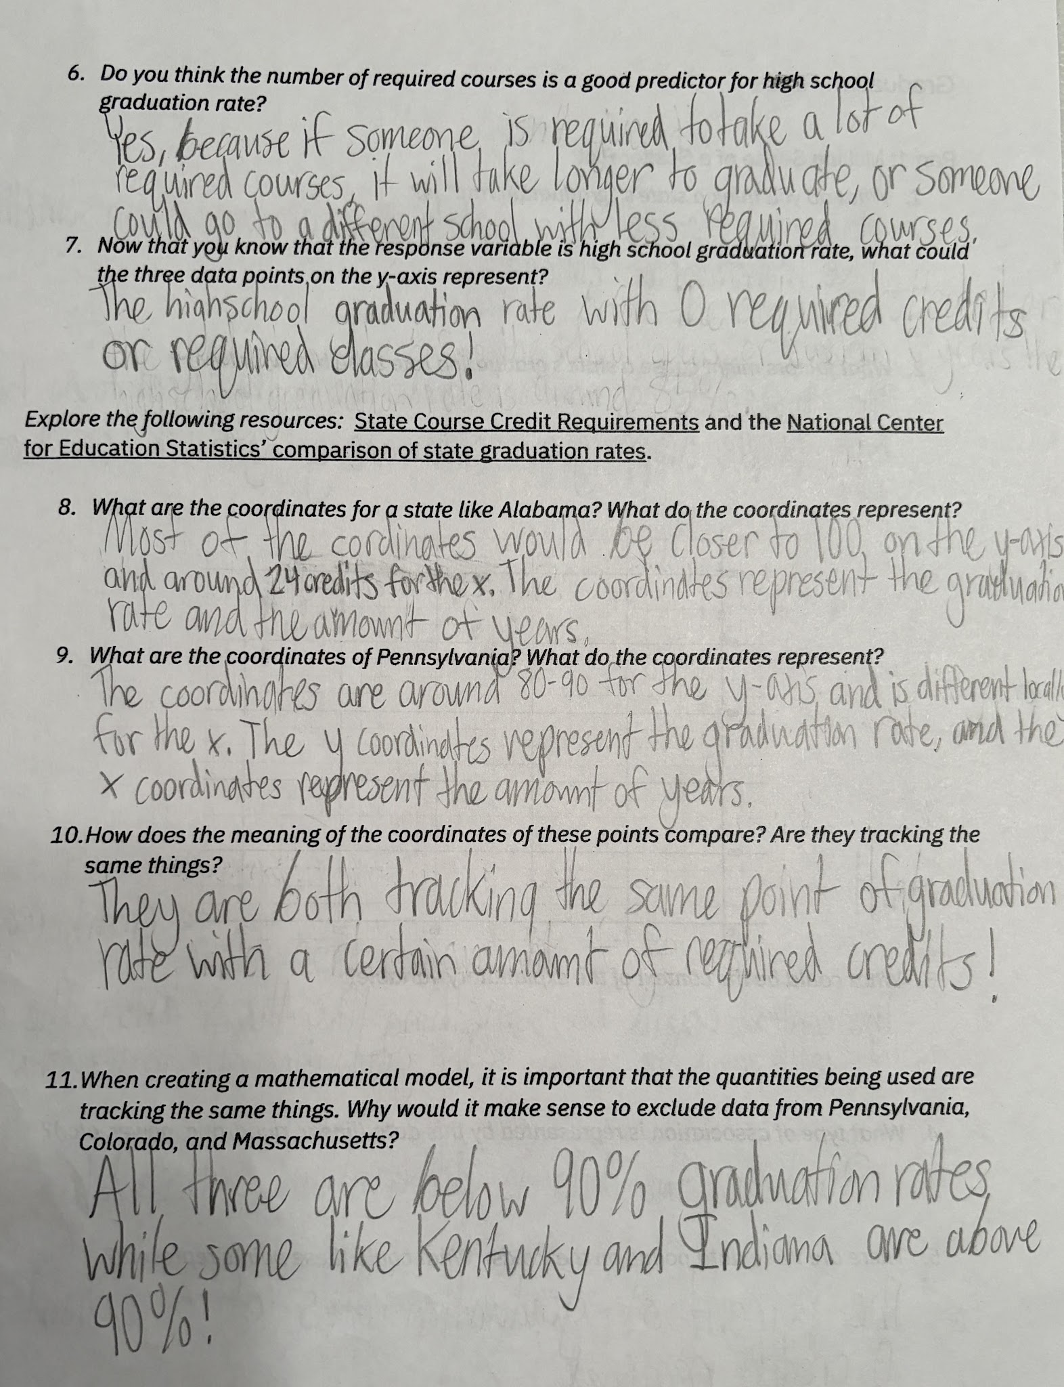

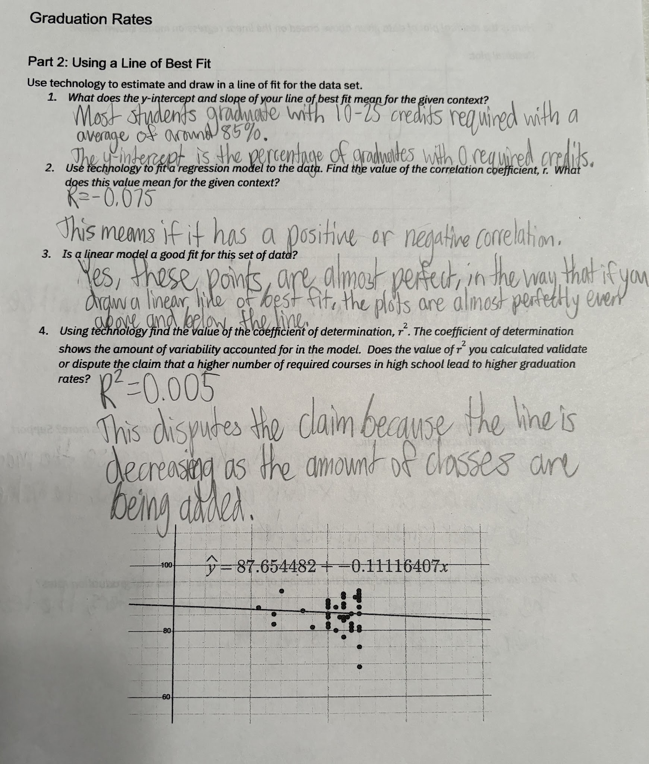

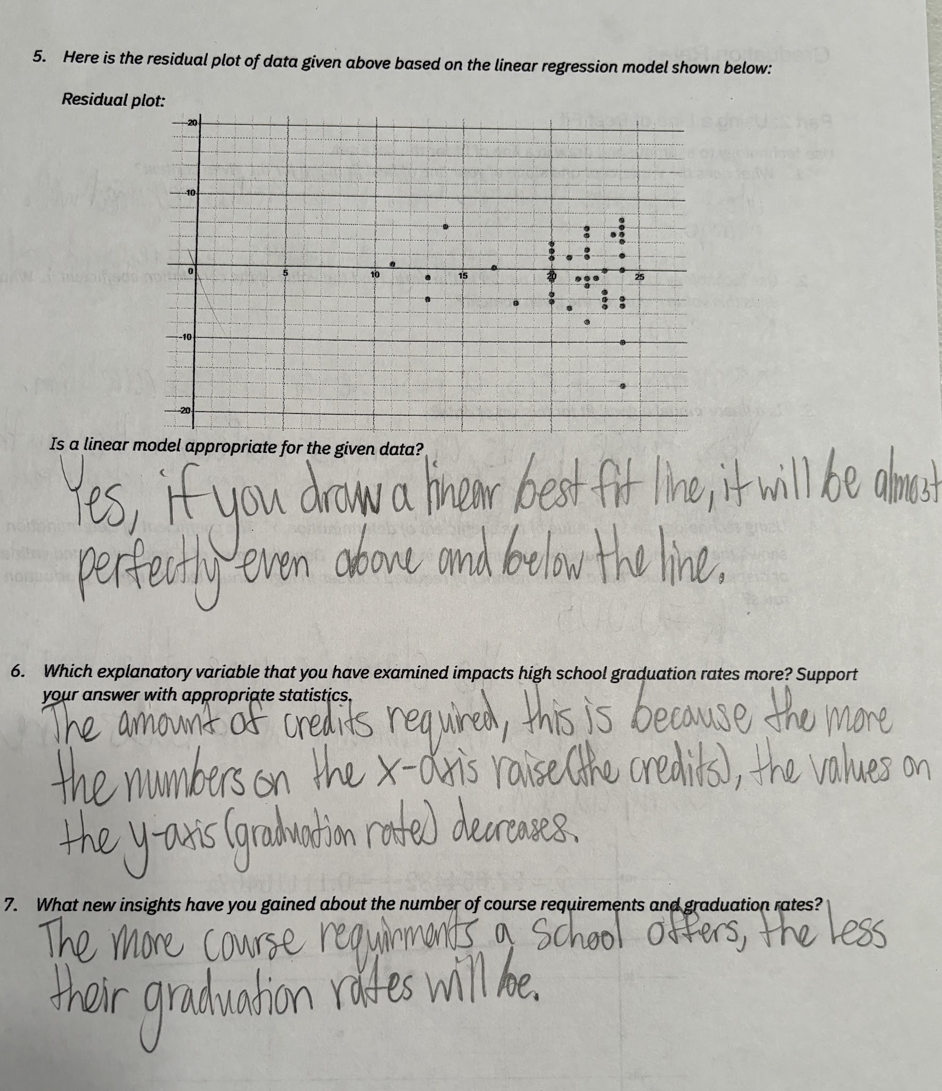

Let’s do some math! Round 2

Task 2: Heart Disease
Students are given a problem similar to this.

Step 1: Developing a Statistical Question

Students are primed with information about heart disease, including what it is and possible contributing factors. Students are asked to brainstorm factors that might decrease a person’s risk for heart disease.

Students learn that some believe that individuals with a constant sense of time urgency (often called type-A behavior) are more susceptible to heart disease than are more relaxed individuals. Some psychologists have investigated geographical areas and their relationship to the pace of life. They considered the relationship of city-wide heart disease rates and general measures of the pace of life in the city. Students then collaboratively develop a statistical question to explore involving heart disease and walking speed, such as: Is a higher average walking speed associated with a lower rate of heart disease?

Step 2: Mathematical Representation

Students are asked to consider how they could use a scatter plot to explore their statistical question. First, let them think individually for 2-3 minutes. Next, have them turn and talk or speak within small groups. Continued individually, partners, or small groups have students generate a scatter plot from data such as the one shown below, using technology as an aid. In this scatter plot, the explanatory (independent) variable for the data above is the average walking speed of pedestrians in different cities. The response (dependent) variable in the data set above is the age adjusted (how many months subtracted from life expectancy) of death from heart disease.

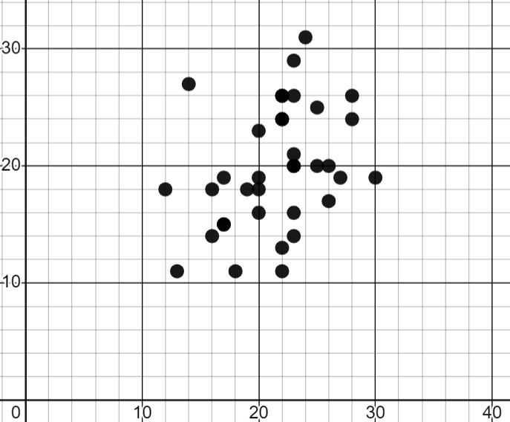
Source: Census At School

Students discuss:
- What is the context of the explanatory (independent) variable?
- What is the context of the response (dependent) variable?
- What type of association is represented by this data (linear, quadratic, power, etc.)?
- There are multiple data points in the set. Choose one and explain what it means.

Step 3: Manipulate the Model

Students use technology to draw a line of best fit for the scatter plot. Have students navigate independently to the Demos Calculator: Average Walking Speed and Heart Disease. Students respond to and discuss questions such as these:
- How did you decide your line of best fit?
- What do the y-intercept and slope mean in the context of this problem?
- What type of model is best for this data set?
- Using technology, find the value of the coefficient of determination, r². Does the value of r² you calculated validate or dispute the claim that a higher average speed of walking causes a decrease in lifespan due to heart disease?

Part 4: Interpreting the Model

Students consider and discuss this question, using their modeling to support their responses:
- Do you think that average speed of walking is a good predictor of a shortened lifespan due to heart disease?

Part 5: Reflecting

Students consider further variables to explore, by discussing there the
- What other variables do you think contribute to heart disease related death?
- Consider your list of variables. Which ones does your group believe could be a better predictor of a shortened lifespan due to heart disease?

Task 2: Heart Disease Student Work

Example 1:

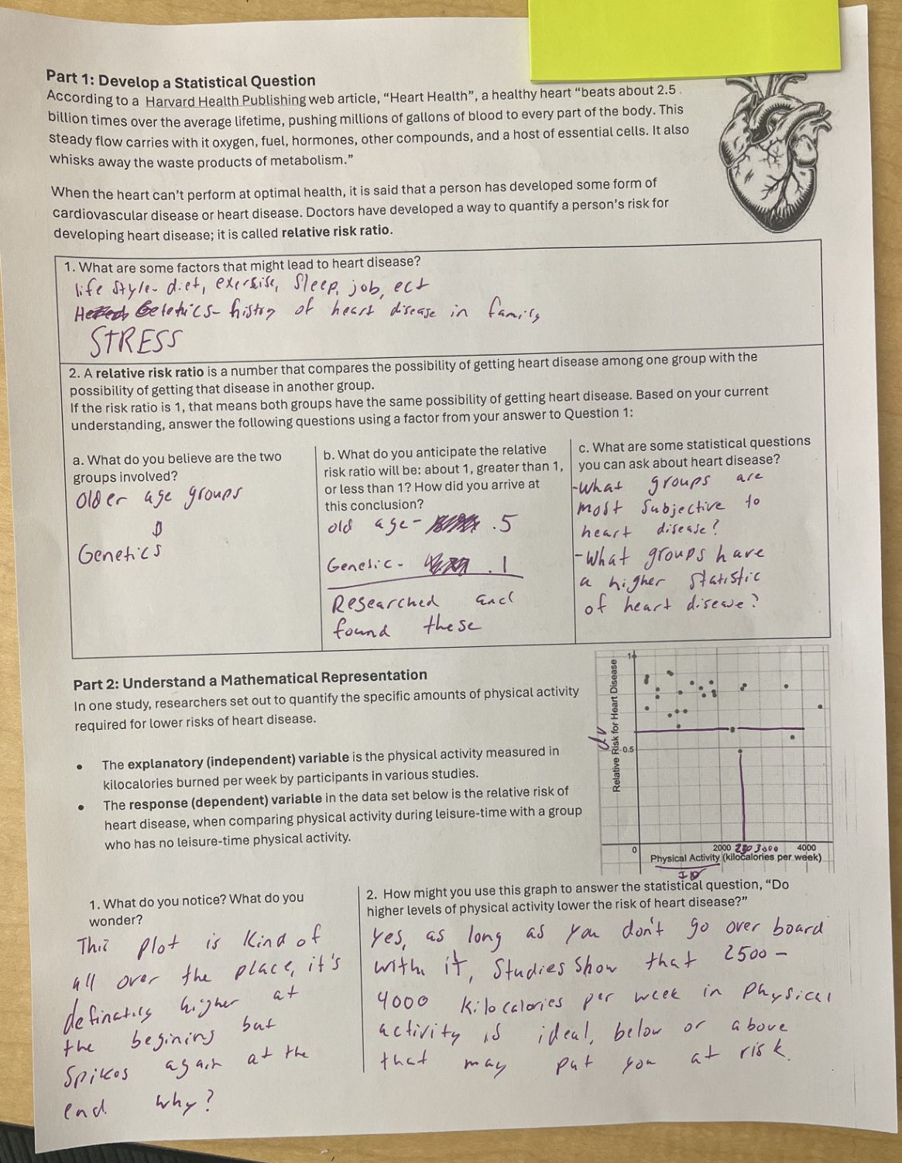

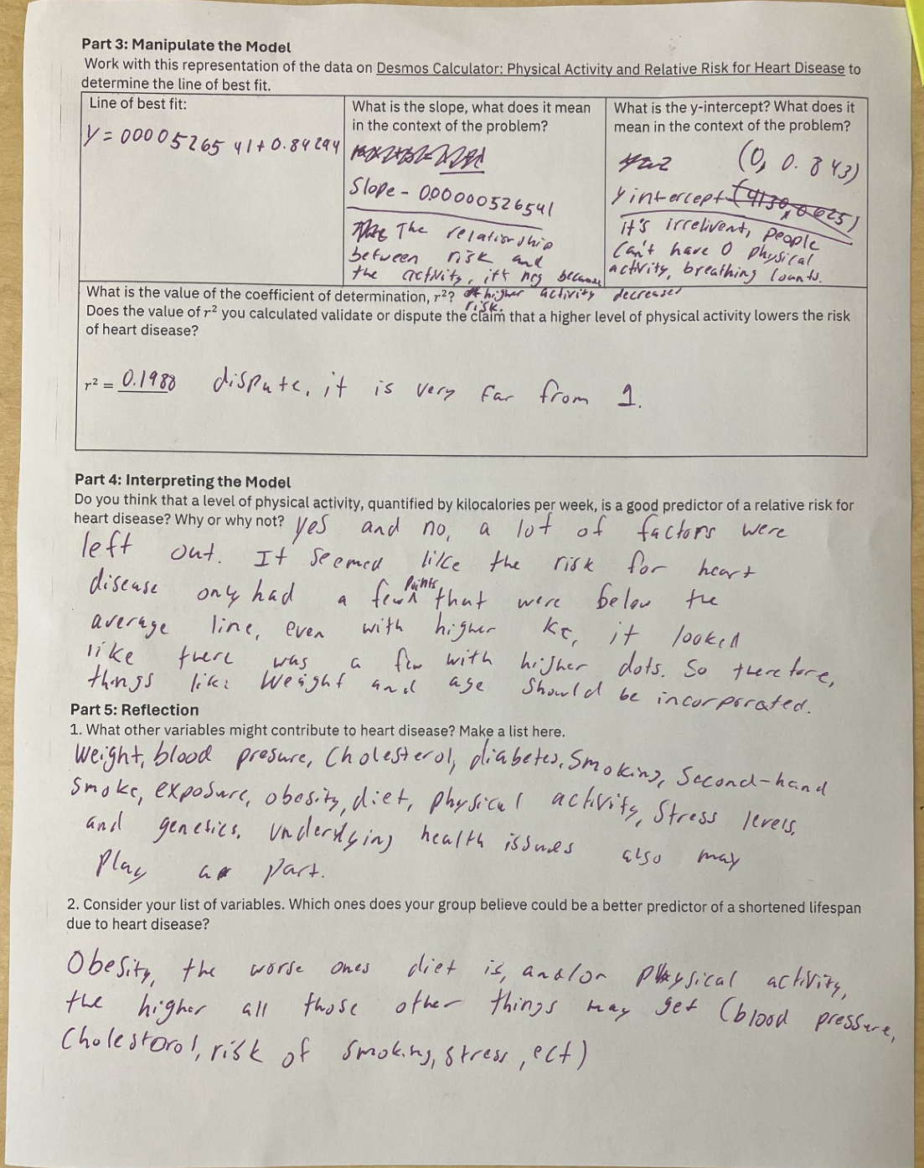

Example 2:
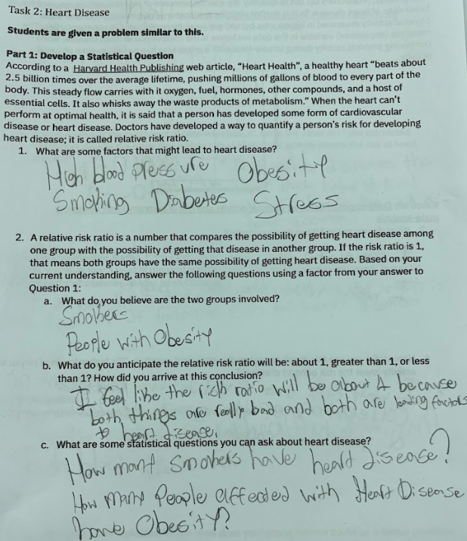
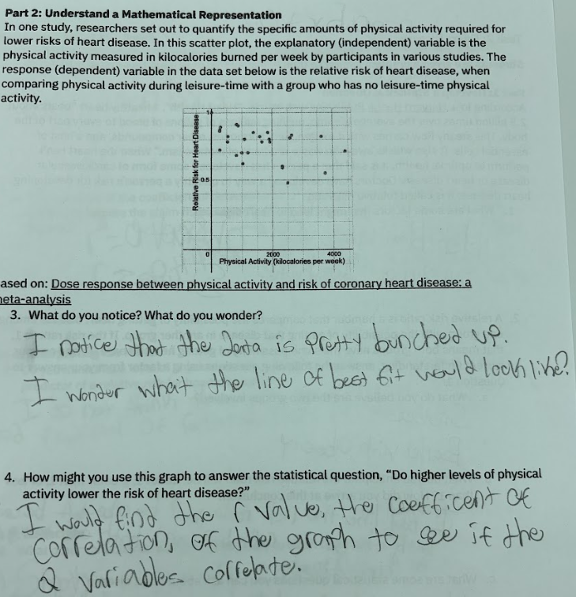
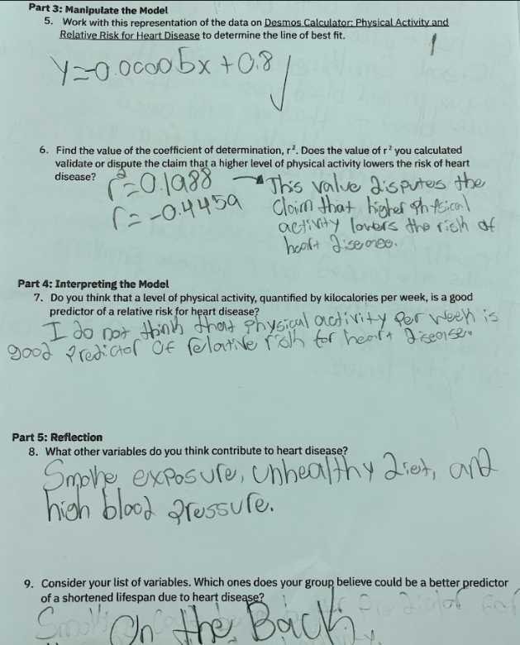

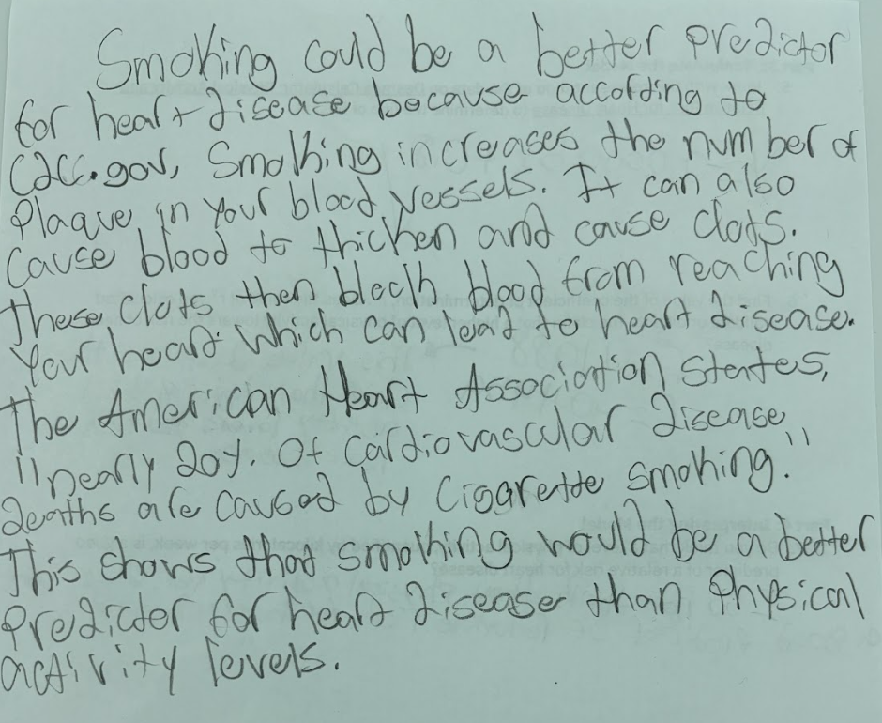

Example 3:

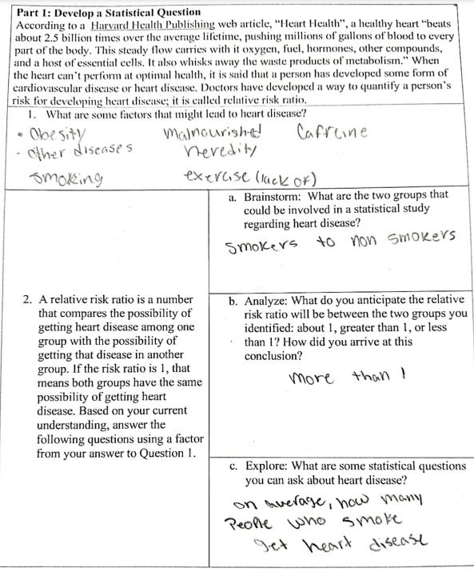
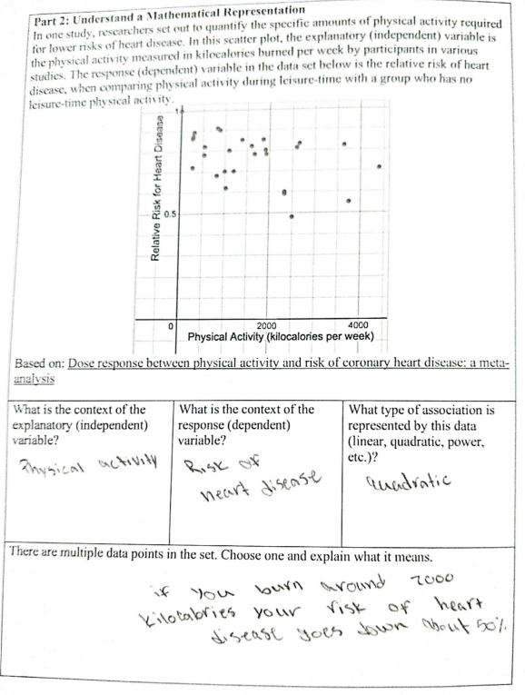
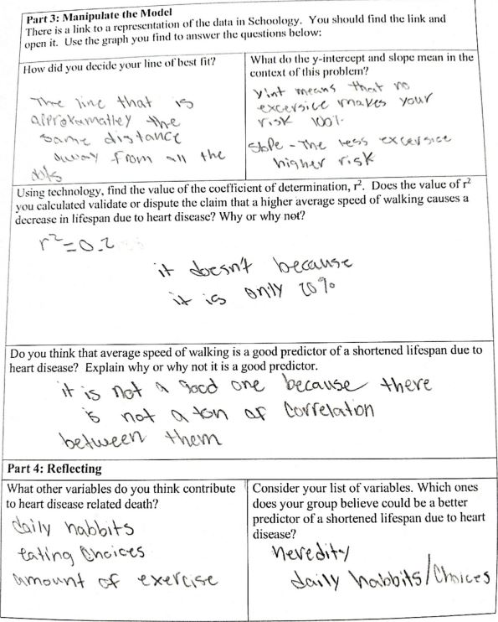

Criteria for Success

Conference and Provide Revision Support | Accept with Revision | Accept
The student’s artifact shows an emerging understanding of the expectations of the indicator(s). After conferencing and additional instruction/learning, the student may provide a revised or different artifact as evidence of the indicator(s). | The student’s artifact is approaching a full understanding of the expectations of the indicator(s). The artifact may contain execution errors that should be corrected in revision. The student may revise the selected artifact or submit a different artifact. | The student’s artifact demonstrates evidence that they have met the expectations of the indicator(s).

References

Common Core Standards Writing Team. (2012, A;pril 21). High School Statistics and Probability. Progressions for the Common Core State Standards in Mathematics (draft). https://achievethecore.org/content/upload/Draft%20High%20School%20Progression%20on%20Statistics%20and%20Probability.pdf

Guy, N. (2023, January 20). The Best USB Phone Charger. Wirecutter New York Times. https://www.nytimes.com/wirecutter/reviews/best-multiport-usb-wall-charger/

Illustrative Mathematics. (2016, May 4). Restaurant Bill and Party Size. Illustrative Mathematics. https://tasks.illustrativemathematics.org/content-standards/HSS/ID/B/6/tasks/2046

