M111 Performance Task
Imagining a Better Meal Experience

The Modeling Cycle
Restaurants and other retail operations often collect feedback or other data to improve their operations. For example, when you enter a food court or cafeteria, several things work well to accomplish the goal of getting the food you want to eat. Sometimes, you might notice or wonder what could be done differently to make the experience better. In this task, you will design a proposal for improving services in such a place.
Mathematical models are used to make sense of ideas and phenomena in our world. As illustrated in the image below, the modeling cycle is a process of collecting data about an idea or problem, creating models of that data, analyzing the story told by those models, and reporting the results to the appropriate audience. In this task, you will be engaging with the mathematical modeling cycle to prepare and design a proposal for improving services.
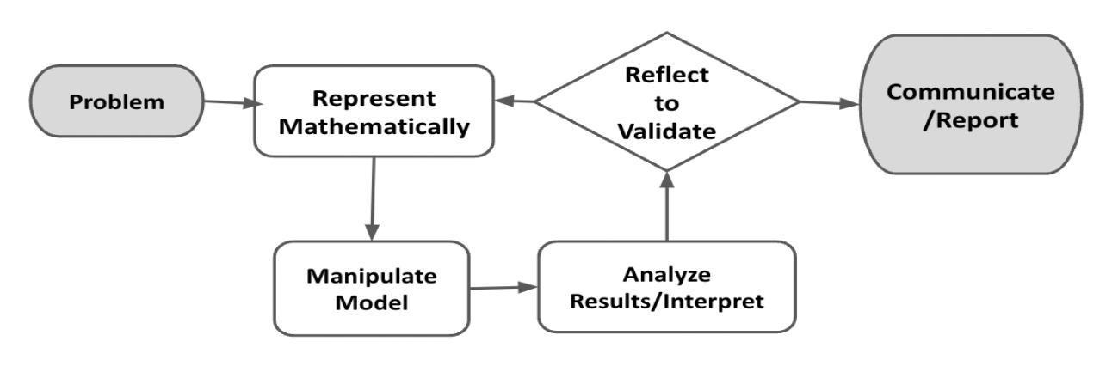
Figure 1. Diagram of Modeling Process. From “Progressions for the Common Core State Standards for Mathematics” [Draft manuscript], by Common Core Standards Writing Team, 2019, p. 6 (http://mathematicalmusings.org/wp-content/uploads/2022/05/modeling_02082019.pdf).

Imagining a Better Meal Experience
Launch
Imagine you are in class and the bell rings for lunch. As you walk into the cafeteria, there are already a lot of people there getting in line, claiming seats, throwing away trash. You can smell the food, hear the chatter, and see the buzz of activity. There is so much going on around you! As you get in the long line to get a meal, you start thinking about how a cafeteria works.

QUESTION 1
 | What do you wonder about a school cafeteria? Come up with some questions!

QUESTION 2
What are things that work well in your cafeteria, and what are things that are inconvenient or that could be improved in some way?

QUESTION 3
Using the ideas and observations you made in the previous questions, what statistical questions can you create about the cafeteria?

In the Problem and Formulate sections, you will develop a written plan that contains one of your statistical questions and a detailed data collection plan using the questions from the sections below as a guide. Create a document that will include this written plan and other parts of this task. The Problem Formulation Checklist can be used to ensure you have the necessary components before moving on to the remaining parts of the task.

Problem
ACTION 1
Select a one-variable statistical question from the questions you generated above.
Guiding Questions
Choose one of the statistical questions you created that you are interested in investigating further and that is appropriate for a one-variable statistical model.
Who would benefit from the data collected from your statistical question? And why?

Note: You are welcome to use additional paper or digital forms to document your work. Be sure to include all of your work in your final submission.

Formulate
ACTION 2
Describe your data collection plan.
Guiding Questions
Can you investigate your statistical question? Or do you need to narrow your focus to make your question more specific?
What data can help you investigate your statistical question?
How much data should you collect?
How will you collect your data?
What type of bias might you encounter?
How can you minimize bias?
How frequently do you need to collect data?

Problem Formulation Checklist
Requirement | Fulfilled?
I have selected a one-variable statistical question. | ▢
I have a data collection plan that shows promise for investigating the statistical question. | ▢
I have attended to ways of reducing bias in the data collection plan. | ▢
Teacher Consultation: | _____________
In the Represent Mathematically section, you will add on to the document you started above. You will show a summary of the data you collected and the visual you chose for this data. Write a statement explaining why you chose this particular display. The Represent Mathematically Checklist can be used to ensure you have the necessary components before moving on to the remaining parts of the task.

Represent Mathematically
ACTION 3
Carry out your data collection plan. Were you able to carry out your plan as designed? What worked well with your plan? Describe any modifications, if any, you needed when carrying out your data collection plan.

ACTION 4
Choose and create an appropriate visual to display your data. Explain why the visual you chose is appropriate for your data.

Represent Mathematically Checklist
Requirement | Fulfilled?
I have completed and compiled the data collection to be included in the report. | ▢
I have chosen a data display that is appropriate for these data. | ▢
Teacher Consultation: | ______________

In the Analyze and Interpret Results section, you will include an interpretation of your data. Use the measures you calculated above to support your response to the questions posed. The Analyze and Interpret Results Checklist can be used to ensure you have the necessary components before moving on to the remaining parts of the task.

Analyze and Interpret Results
ACTION 5
Choose a measure of central tendency and a measure of spread appropriate to your data. Calculate these measures and explain how you chose and calculated them.

ACTION 6
Decide how you will determine and address outliers. Provide a summary of the evidence you considered when addressing outliers.

QUESTION 4
What story did the data tell relative to your question?
How can a cafeteria or restaurant use these data?

Analyze and Interpret Results Checklist
Requirement | Fulfilled?
I have selected the measures of central tendency and spread that are accurate and appropriate for the data. | ▢
I have explored the possible effects of outliers using the shape, center, spread, and context of data sets. | ▢
I have told the story of the data that accurately interprets and uses the results of the analysis to explain how this information can be useful. | ▢
Teacher Consultation: | ______________

In the Validate and Report section, you will add on to the document you started above and clarify the voice and audience. In the Validate section, you will explain whether the data were sufficient for addressing your statistical question or how you would improve the process in the future. You will also create an appropriate way to report the findings from your work to the intended audience (e.g., through a short video, pamphlet, or other visual). The Validate and Report Checklist can be used to ensure you have the necessary components for completing the task.

Validate and Report
QUESTION 5
Validate your model using the Guiding Questions provided and record your responses.
- Did the data sufficiently address the question you were investigating? Why or why not?
- If you were to try to collect data to answer your statistical question again, how would you adjust your process, your question, or how you analyzed the data to provide better information to the audience interacting with your data?

ACTION 7
Communicate your results in a manner and format that are appropriate for your audience and purpose, in a way that most clearly illustrates your findings.

Validate and Report Checklist
Requirement | Fulfilled?
I have provided a rationale showing how the data sufficiently addressed the question at hand or I have articulated a clear understanding about how to improve the data collection and analysis in the future. | ▢
I have clearly communicated the results in a way that is appropriate for the intended audience. | ▢
Teacher Consultation: | ______________

