Example 1: Exploring Complex Numbers

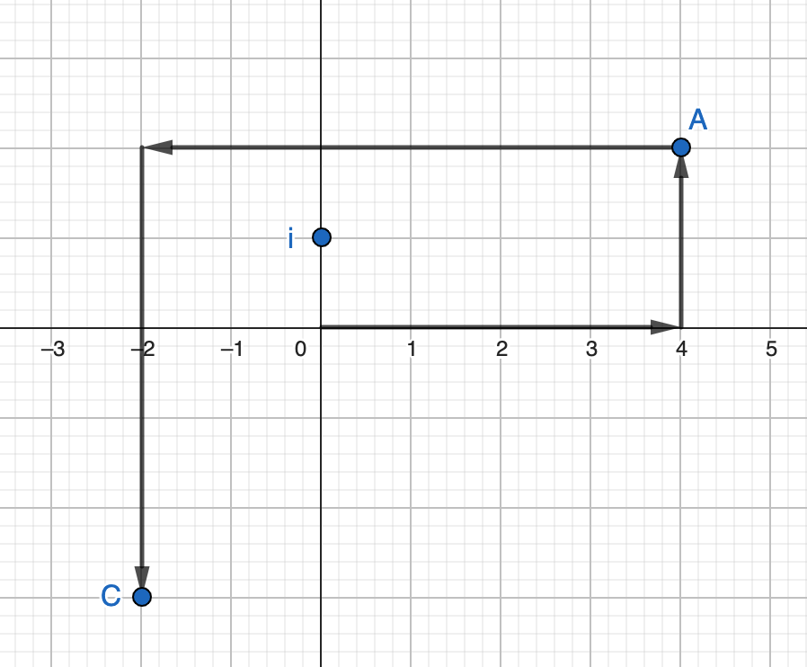
- The diagram represents the sum of two complex numbers: $(4+2i)+(-6−5i).$

  - Which part of the expression does Point A represent? Explain how you know.

  - What complex number does Point C represent? Explain how you know.

  - Based on the analysis above, describe how to find the sum of two complex numbers.

- Write and record a tutorial for a new classmate that explains how to simplify expressions that involve addition or subtraction of two complex numbers. Be sure to include a diagram that illustrates why your method works.

Example 2: Exploring Rational Numbers

Part 1: Let’s think about what $a^{\frac{1}{2}}$ means.

- Select some value for $a$ and develop a table to show some values for $a^{x}$.

$a$
$a^{x}$

- Based on the values from your table, make an educated guess about the value of $a^{\frac{1}{2}}$. Explain your reasoning.

- Check the actual solution for $a^{\frac{1}{2}}$. Explain why this answer makes sense. If the answer is different from your guess above, write down two-three ideas or questions you can pose to help examine why $a^{\frac{1}{2}}$ has the designated value.

- Based on conclusions you’ve reached, what do you anticipate something like $a^{\frac{3}{2}}$means?
  - How can you use what you see in your table or what you know about properties of exponents to explain what this means?

Part 2:
Based on the discussion of Part 1, what do you anticipate the values of $a^{\frac{1}{3}}$and $a^{\frac{1}{4}}$ will be?

- How can you use what you see in your table or what you know about properties of exponents to explain what this means?

- Create a video or animated short explaining what an expression like ${ d}^{\frac{m}{p}}$means.

