Example 1: Unit Circle

Part 1: Drawing the Unit Circle
On your own: Draw a circle on a coordinate plane centered at (0,0) with a radius of 1. This is called a unit circle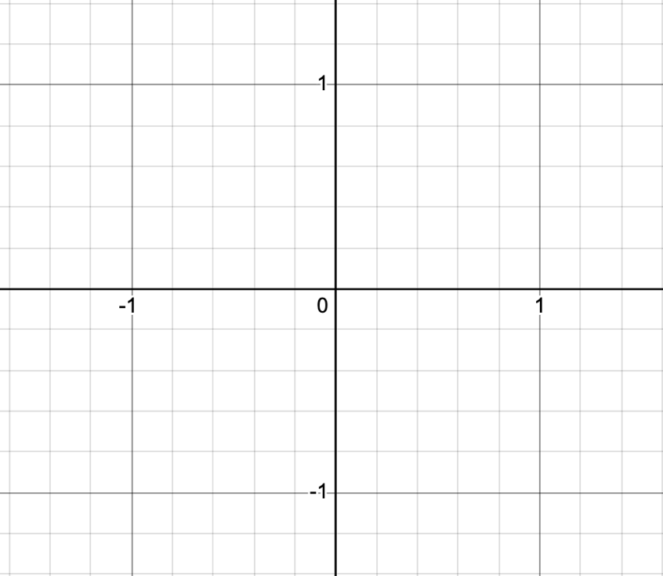 |  | What is the circumference of the circle?
 |  | What is the length of the arc from point (1,0) to the point (-1,0)? How do you know?
Part 2: Exploring the Unit Circle
With a partner: Use the following steps to find additional arc lengths, angles, and coordinates on the unit circle.
- Find the arc length from point (1,0) to a different point on the unit circle.  - Mark and label the point J.  - Record the arc length in the table.  - Draw ray AJ.  - Determine the measure of the angle formed by ray AB and ray AJ. Record this in the table.  - What are the coordinates of point J? Record the coordinates in the table.  - Repeat steps 1-5 for 3 more points. Label them K, L and M.
  Point | Arc Length from (1,0) | Angle Measure | Coordinates
  J
  K
  L
  M
Part 3: Radians
Definition of 1 radian: An angle of 1 radian is defined to be the angle, in the counterclockwise direction, at the center of a unit circle which spans an arc of length 1.

Given the definition of 1 radian, approximately where would 1 radian be on your circle? Mark a point there and label it point P.

Explore the relationship between the sine and cosine of the angle measures from your table and the coordinates of the associated points. What do you notice? How can you explain the relationship that exists, if any?

Example 2: Sine and Cosine

Have you ever gone to the beach on a summer day and seen a yellow flag on the shore? This flag is an indication of moderate surf signaling that the tides may be high and swimmers should be cautious when entering the water. Oceanographers are people who research and study the different conditions of the ocean. One important job of oceanographers is to study the waves, currents, and tides. These reports on ocean activity help us to know when the ocean is safe and allowed to be open to the public for activities such as fishing, boating, and swimming.

The image given shows the water level in Bridgeport, Connecticut, over a 50 hour period in September. Using what you know about trigonometric functions, you will make sense of this information and do the job of an oceanographer for the day!
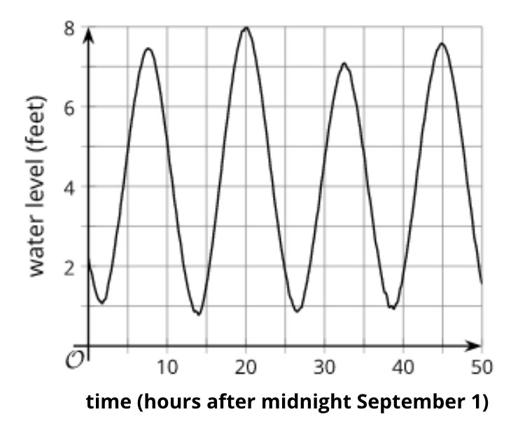
- Notice and Wonder: What initial observations do you have about the water levels shown by the graph?

- Based on the image, what is the period for this graph? Explain how you know.

- Use Desmos to create an equation to model the relationship between the water level in feet and the number of hours after midnight on September 1st.

What equation did you come up with? Explain how you created and refined your equation to get a close fit to the graph shown in this problem.

- Making connections: How might swimmers, boaters, or fishers use the information in your graph to make informed decisions about their activities? Is there anybody else who might be interested in the information shown by the graph? If so, who?

