

**Registration** **2025-2026**

Dear Parents,

Attached is the enrollment form for the 2025-2026 school year. Please review the age requirements below and mark the appropriate age group on the registration form.

**Toddlers/Fall and Spring:** Children must be 17 months old by the start of class.

**Twos:**  Children must be two by August 31, 2025

**Threes:** Children must be three by August 31, 2025

**Pre-K:** Children must be four by August 31, 2025

**Transitional:**  Children must be five by August 31, 2025

**Kindergarten:**  Children must be five by August 31, 2025

**January 2026 Twos:** Children must be two by December 31, 2025

Completed registration forms for current Day School students, accompanied with the non-refundable $85.00 fee (payable by check or cash) will be accepted in the Day School office immediately.

**PLEASE REGISTER PROMPTLY - SOME OF OUR CLASSES FILL QUICKLY!!**

Forms for children not presently enrolled in the school will be accepted beginning **January 2, 2025,** with the $85.00 fee (payable by check or cash).

The Toddler Program is held on Wednesdays, with the option to add a Thursday class should the Wednesday programs fill. Registrations are for the Fall **OR** Spring session - please check the session and circle the preferred class time on the registration form. If a preferred time is not indicated, your child will be placed where there is an opening.

If you are registering a child for both the 2025 Fall Toddler and 2026 Spring Toddler or January 2’s, a separate form and the $85 registration fee is required for each.

Our Private Academic School License requires children enrolled in our Three Year Old through Kindergarten programs be toilet trained. Our Two Year Old program does not fall under this license; toilet training is not a requirement for these children.

Please feel free to contact me if I can be of any assistance answering questions about placement.

Sincerely,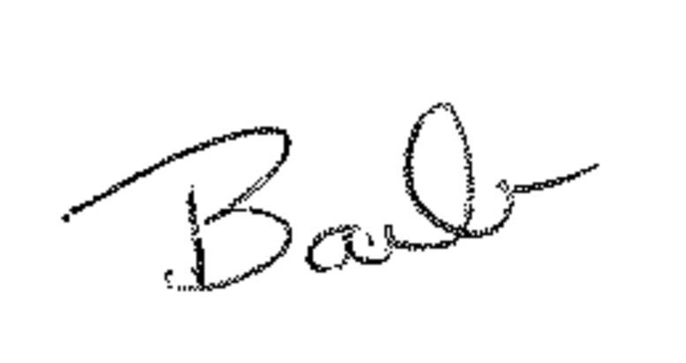

Barbara G. Condit

Director, Good Samaritan Day School

610-644-6181

barb.condit@good-samaritan.org

10/21/24