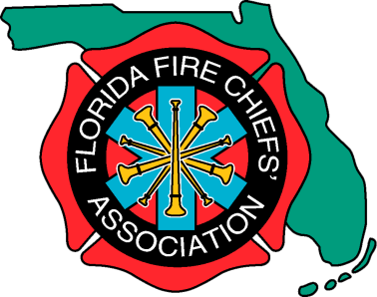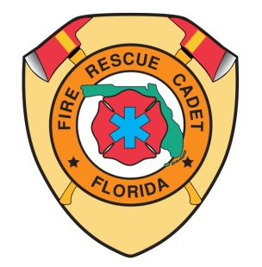
Florida Association of
Fire Rescue Cadets

Florida Winter Fire Games Checklist

___ Book hotel rooms

___ Register for Event

___ Build any necessary props for events.

___ Review any updates for events.

___ Print Consent Form and Code of Conduct.

___ Order lunches for Cadets and Advisors

___ Submit t-shirts sizes if required.

___ Order Additional Items if needed.

___ Costumes needed for Awards Dinner?

___ Compete and have fun!

