Quentin Blake Centre for Illustration
Brief: Freelance Fundraiser (Trusts and Foundations)

Quentin Blake Centre for Illustration (formerly known as House of Illustration) is transforming derelict 18th- and 19th-century industrial buildings into new galleries, learning spaces, a shop and a café. While the £12mn project is underway, we’re continuing to tour exhibitions and deliver projects with illustrators, schools and community groups.

We are looking for a freelance fundraiser who will support grant-writing (£10k-£1mn) for our exciting capital project and for our current exhibitions and participation programmes. We are seeking someone who can commit 40 days over 3-4 months (though this is flexible) in the first instance, with the potential for extension.

We are looking for someone with experience making applications to trusts and foundations and successfully securing six- and seven-figure grants for cultural projects (ideally including museum and gallery projects).

Submit your expression of interest by 12:00 noon BST on Monday 10 October by emailing harry.hickmore@qbcentre.org.uk with the subject ‘Freelance Fundraiser’ with a short cover letter and company profile/CV, outlining your interest in this role and the relevant experience you would bring.

You are welcome to include examples of previous applications or work that demonstrates your grant writing skills. Please include your daily rate and availability with your expression of interest. Shortlisted candidates will be invited for an initial informal interview.

Please let us know if you have any access requirements that need to be met to enable you to submit an expression of interest or attend interview by emailing us access@qbcentre.org.uk.

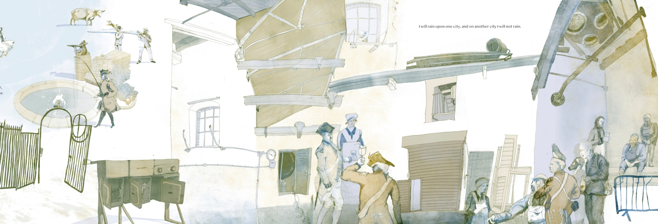
If you have any queries, please email harry.hickmore@qbcentre.org.uk

If you have any queries, please email harry.hickmore@qbcentre.org.uk

About the Quentin Blake Centre for Illustration

Illustration is fundamental to human communication, progress and understanding. It tells stories, propels activism and conveys life-saving information.

The Quentin Blake Centre is the UK’s first and only cultural organisation dedicated to illustration. We believe in a world in which everyone can communicate, explore and examine the world through visual imagery; a more curious, equal and compassionate world.

We were founded twenty years ago by one of the UK’s best-loved illustrators, Sir Quentin Blake. We grew into a thriving public exhibitions and learning offer, operating from rented galleries – ‘House of Illustration’ - in Kings Cross.

Now, we have the opportunity to establish a permanent home: a place where generations of curious visitors, art-lovers, illustrators, families and schoolchildren will come to explore and be inspired. Due to open in 2024, the £12mn Centre will repurpose the New River Head industrial heritage site after seventy years hidden to the public, creating new galleries, learning spaces, a café, shop and public gardens.
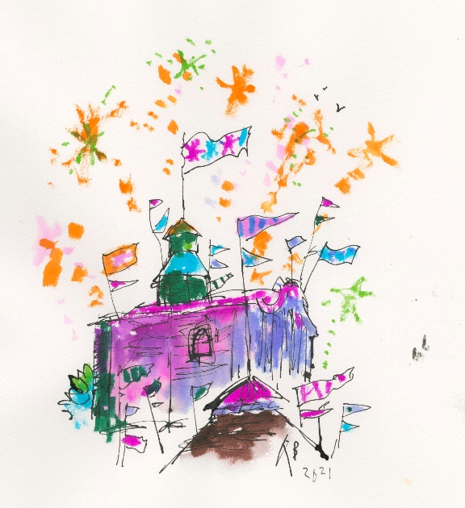
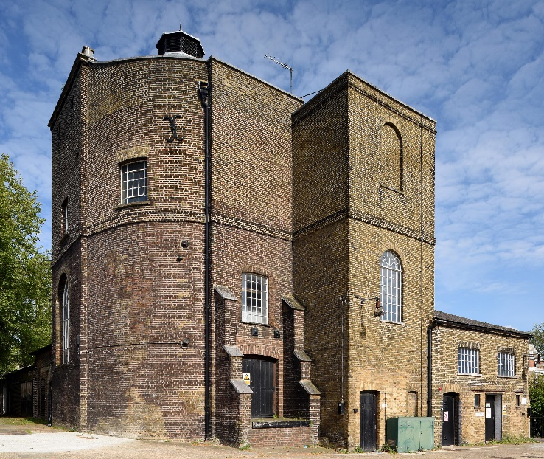

Although we don’t currently have a physical home, we are continuing to tour exhibitions around the UK, support illustrators to develop their practice, and deliver projects with schools and community groups. We will are also establishing an online home for collections and related re-search; the first of its kind in the world.

Find out more about our work www.qbcentre.org.uk

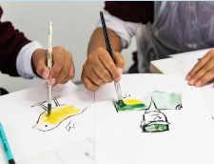
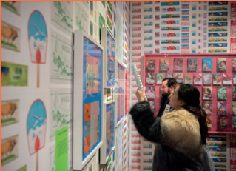

Image credits:
Lost Springs, Coming Spring © Sharpay Chenyué)Yuàn; New River Head Engine House © Justin Piperger; Quentin Blake Centre for Illustration; Primary school workshop © Rob Harris; Made in North Korea exhibition © Paul Grover

