SITE Santa Fe and the Santa Fe Community Educators Network
Collaborate to Bring Distance Learning Materials to Santa Fe Public Schools
Amidst Coronavirus Closures

June 12, 2020 (Santa Fe, NM) - Since the Santa Fe school closures in mid-March due to the Covid-19 Pandemic, nonprofits, teachers, and volunteers in our community have banded together to support students, families, and the Santa Fe Public School system through the Santa Fe Community Educators Network (SFCEN). The Community Educators Network is a group of educators from nonprofits in Santa Fe who have met monthly for more than six years to share resources and address community needs through collective impact initiatives.

Supported by the Santa Fe Community Foundation and the City of Santa Fe Children and Youth Commission, the Community Educators Network mobilized quickly to provide distance learning materials to students at the food pick up locations, handing out over 1000 learning packets filled with workbooks and art and science supplies to families every week. These materials are also been made available for free on the SFCEN website (sfcommunityeducators.org).

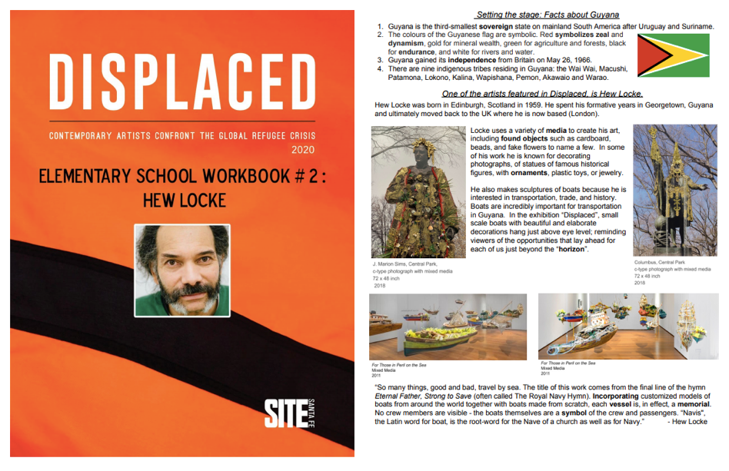
Hew Locke: Distance Learning Workbook (Elementary/English)

SFCEN members connected regularly with Cristina Gonzales, the SFPS Arts Education Coordinator; Sabra Romero, SFPS Volunteer and Event Coordinator; Mary Massey, SFPS Extended Learning Coordinator; and Grace Mayer, art teacher and NEA representative. Leaders from SFCEN surveyed teachers and provided these materials through The National Education Association (NEA) distribution at Aspen, Capital, Chaparral, Kearny, Ramirez Thomas, Sweeney, and Santa Fe High Schools, organized by Grace Mayer. In addition, the Community Educators Network expanded their distribution to include Communities in Schools families, CYFD, and Santa Fe Indian Center.

Over the past month and a half, families received distance learning materials from Santa Fe Botanical Garden, New Mexico Office of Archaeology, SITE Santa Fe, The Randall Davey Audubon Center, Math Amigos, the Georgia O'Keeffe Museum, and Art Smart. This mobilized effort shows how cultural institutions and the Santa Fe Public Schools can work together to improve education for all students in Santa Fe. Over 15,000 sets of materials have been distributed thus far. SFCEN will continue to distribute materials over the summer, partnering with the City Summer Program. More information is available at summersantafe.com.

Contact:
Joanne Lefrak
lefrak@sitesantafe.org
505.989.1199 x 19
Sitesantafe.org Distance Learning

###

