

Angel Islington Business Improvement District
Mid-term review
November 2024

The Angel Islington Business Improvement District has completed its fourth term min-term review. This report and recommendations are for the BID board’s information and will be published on the BID’s website.

- Purpose of the review

Mid-term reviews are best practice for all Business Improvement Districts.
The Angel Islington mid-term review was run in the summer of 2024 to help the BID advise the Board on the following issues as we approach the fifth ballot:

- The BID area
- Financial rules, including multiplier, threshold and cap
- The fifth-term summary prospectus
- Ballot strategy

- Summary of delivery in current BID term

The focus of the BID in the fourth term was on professionalising governance and delivery processes and achieving industry compliance standards. In addition to exiting initiatives and services, the following projects were delivered in the first half of the fourth term, accumulating across the period.

YEAR | Governance
2021/2 | Governance review  Delivery strategy  Staff away day  Creation of Finance and Exec Committee
2022/3 | Delivery plan  High Streets Data Service  AGM  Business breakfasts  Responsible Business Network  Marketing and Culture Group  Business Crime Reduction Partnership
2023/4 | Delivery plan  High Streets Data Service  AGM and business breakfast  Responsible Business Network  Marketing and Culture Group  Business Crime Reduction Partnership  Hospitality Network  Mid-term Review

YEAR | Environment
2021/2 | Place manager post creation  Environmental services review
2022/3 | Becoming a BCorp course  Spring cleaning  Net Zero Neighbourhoods strategy  Christmas lighting renewal  Programme Manager post creation
2023/4 | Spring cleaning II  Becoming a BCorp course II  Parkguard wardens contract

YEAR | Promotion
2021/2 | Angel Loves Summer  Summer Social  Newsletter  London Design Festival
2022/3 | Angel Loves Summer  Summer Social  Glow in the Angel  Winter guide  Angel area brand  E-newsletter
2023/4 | Angel Loves Summer  Summer Social  Summer Guide  People of Camden Passage art exhibition  Glow in the Angel  Winter guide  Angel Crackers campaign  Area brand roll-out  B2B newsletter  What’s On Newsletter and Angel tickets  Use of Angel poster sites for promotion  Website

- Findings

Of the 43 responses, 32 were from levy paying businesses, with the remaining responses from local residents or partners connected with the BID.

Awareness
The questionnaire sought to understand the BID services that respondents most recognised and had engaged with. This is useful in order that we can focus on raising awareness of those services that have not reached our levy payers’ consciousness. The five services respondents were most and least aware of were:
Five services levy payers most aware of: |  | Five services levy payers least aware of:
 | Paper and plastic recycling |  | Spring-cleaning
 | Responsible Business Network |  | Glow in the Angel xmas event
 | Networking events |  | Bulky waste collection
 | Christmas lighting |  | Paper and plastic recycling
 | Crime reduction initiatives |  | Marketing and Culture Group

Awareness ranges between 41% of respondents being aware of a BID service – in this case ‘paper and plastic recycling’, and 58% being unaware of our spring-cleaning initiative. Both spring cleaning and the Glow in the Angel Christmas event are new initiatives and more public than business-facing, gaining some of the BID’s highest social media engagement.

In terms of the services that respondents regularly engaged with, used or noticed, the list was different again, the top five being:

 | BID member e-newsletter
 | Marketing and Culture Group
 | Paper and plastic recycling
 | Winter Guide
 | Christmas lighting

The BID member e-newsletter, which contains a range of BID and local economy news, new openings, events and advice has a growing readership of over 1,100 with low numbers unsubscribing. The Marketing and Culture Group has quickly assumed an important role in the coordination of the neighbourhood’s activation and promotion.

Paper and plastic recycling has for many years been one of the BIDs most valued services, with tangible savings for members, and remains popular. The news that almost 30% of respondents were unaware of the service suggests however that there is more potential to increase take-up.

The Winter Guide, published for the first time in 2023, and which has been followed in 2024 with a Summer Guide has become an important part of the BIDs B2C offer, which of course includes the promotion of the Angel to local employees as well as residents and visitors. This guide is widely available in shops over the festive season, reflecting the 24% of our respondents that have picked one up.

Finally, Angel’s Christmas lighting scheme, which is being renewed in part over the current BID term, is an important promotional presence in the run-up to Christmas. 24% of respondents recognised this lighting as part of the BIDs service package and while reasonably high in the list, there is work to do to ensure levy payers understand this lighting is arranged by the BID as opposed to, say, the local authority.

The BID stresses to levy payers that it’s services, including initiatives like Christmas lighting, public events and promotion, often focus on providing general economic uplift, increasing footfall and spend rather than those services that deliver direct savings to levy payers, such as recycling. The BID’s delivery aims to strike a balance between these two approaches and remind levy payers at ballot stage that general initiatives that they value would not be delivered if the BID was not in existence.

Collective contracting
One of the opportunities of BID mechanisms is collective contracting, which provides businesses with the opportunity to sign up to contracts that provide savings and may have additional benefits to the area, such as reducing road miles, improving general sustainability and encouraging sign-up of important services.

The questionnaire sought to understand the potential support for services that could be provided in this way to levy payers:

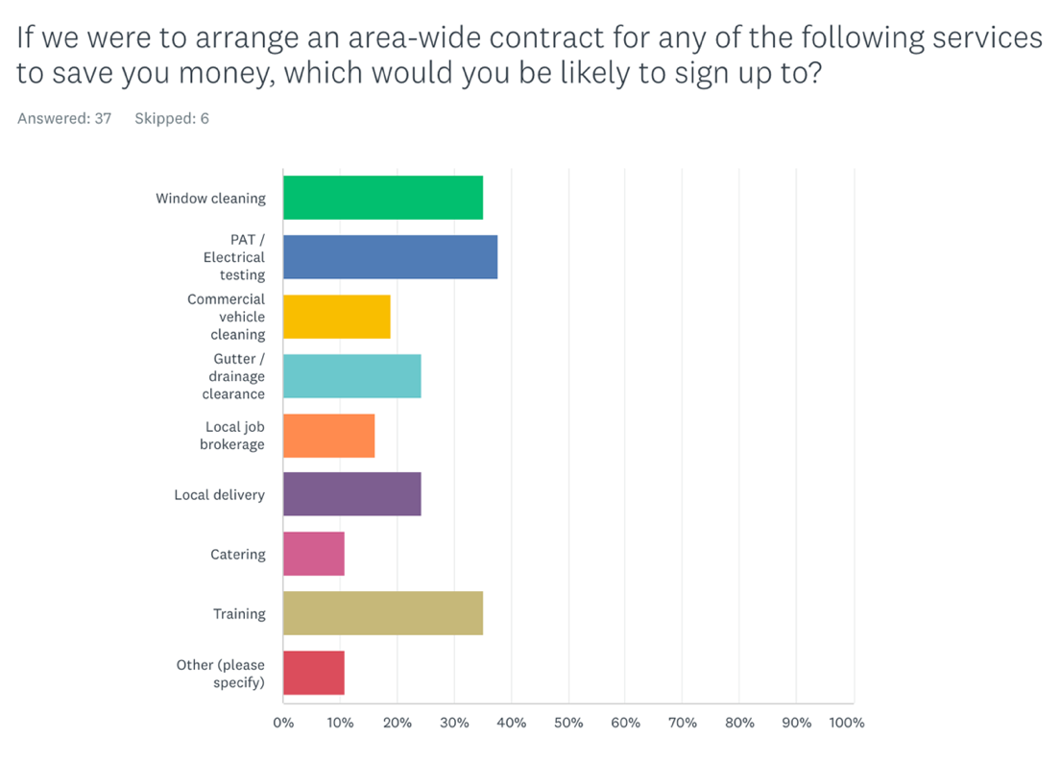

These responses provide important insights that could help the BID establish a fifth term offer of value to Angel’s businesses. In addition, the BID’s ongoing partnership with the local authority could facilitate a local employability element, fulfilling contracts using local labour and not-for-profit companies where feasible. We will explore this further.

Voting intention

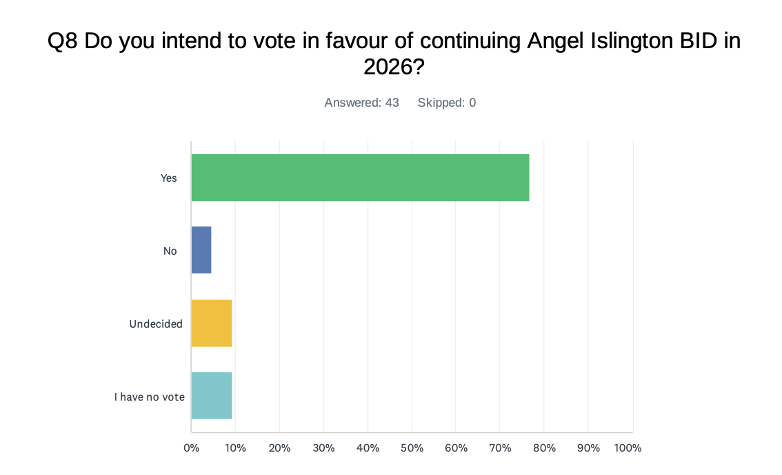

When asked whether they intended to vote in favour of continuing the BID into a fifth term, 77% of respondents said they would. Although the number of respondents is not significant, this is a good early indication that the BID continues to enjoy local support, particularly as the survey overlapped with the BID levy bills being sent out.

The package of member support for the majority of the BID’s levy payers is satisfactory. However, the BID should focus on delivering benefits to office occupiers and levy payers that pay a service charge in addition to the BID levy, and do not therefore benefit from all the BID’s services.

- Modelling alternative BID arrangements

A number of BID models have been considered by the F&A, and their recommendation to the Board is below.

BID model | Income p.a. | Pros | Cons
Current. 1% levy,  Threshold: 25.5k RV  Cap: £25k RV per hereditament  550 levy payers | £580,000 | BID has been successful at ballot with these arrangements in the past | Increasing costs means decreasing income and diminishing service levels
Increased Levy  1.5% levy Threshold: 25.5k RV. Cap: £25k RV per hereditament. 550 levy payers | £870,000 | Simpler renewal ballot campaign with existing members | 50% increase in levy to businesses may be unpalatable
Expanded A. 1% levy  Boundary expanded to include Upper St to Highbury Corner, St John’s St to Skinner St  Goswell Rd to Percival St  City Rd to Bath Street, Essex Rd to New North Rd and Pentonville Road to King’s Cross Rd, Threshold: 25.5k RV, No Cap. 793 levy payers | £876,780 | Justifiable boundary increase, to reflect larger BID areas in London and opportunity to expand services to greater numbers of businesses | Would need to expand team to deliver services and this may necessitate an office move and a rent liability.  1% is the lower end of average levy multipliers.
Expanded B. 1.5% levy  Boundary expanded to include Upper St to Highbury Corner, St John’s St to Skinner St  Goswell Rd to Percival St  City Rd to Bath Street, Essex Rd to New North Rd and Pentonville Road to King’s Cross Road. Threshold: 25.5k RV. No Cap .793 levy payers | £1,025,181 | Average multiplier nationally is 1.5% - 2% so this level appropriate given rising costs | As above, though mitigated by higher income.
Expanded C. 1.8% levy  Boundary expanded to include Upper St to Highbury Corner, St John’s St to Skinner St  Goswell Rd to Percival St  City Rd to Bath Street, Essex Rd to New North Rd and Pentonville Road to King’s Cross Road. Threshold: 25.5k RV. No Cap. 793 levy payers | £1,114,204 | Average multiplier nationally is 1.5% - 2% so this level appropriate given rising costs | As above, though mitigated by higher income.

All figures are approximate and likely to fluctuate due to changing valuations, new development etc. An additional consideration is the potential of a new BID being created at Old Street, which may include a section of City Road incorporated into this model. There is no information as yet on the proposed boundaries. There may be an additional consideration in the next business plan around the offer or rate for businesses that pay a service charge.

- Recommendations

- More concerted and targeted promotion of the recycling service as a key money-saver for levy payers
- Continue to build the recognition and strategic purpose of the BIDs networks – The Responsible Business Network, Marketing and Culture Group and Hospitality Network as they mature
- Grow the BIDs business-to-consumer activity, including social media, printed communications and public-facing events
- Work up proposals for new services in the form of collective contracting (e.g. training, electrical testing and window cleaning contracts for levy payers)
- Deliver as many elements of the BIDs Net Zero Strategy as possible
- Develop annual marketing and public realm delivery plans
- Consult with office occupiers and members that pay a service charge to develop bespoke package of member benefits
- Work up a business plan for the BID’s fifth term – Board to agree model.

APPENDIX – Delivery and KPIs for Mid-term review

Mid-term review engagement methods

The BID engaged the membership and other stakeholders using the following methods:

- Board and sub-groups
The BID encouraged engagement with the review across a number of groups, including the BID’s Board, Angel Responsible Business Network, Pubwatch, and Marketing & Culture Group. This exercise asked stakeholders to provide their thoughts on issues such as the boundary of the Angel commercial area, the issues coming up that the BID should tackle and the design of our existing services.

- Consultation activities at events
Attendees at BID events, such as the Summer Social, collab events, business breakfasts and the AGM were asked to fill in the survey.

- Survey linked to QR code
A survey linked to via a QR code was provided and widely publicised through the following:

  - Newsletters
  - Website
  - Events

- Meetings with levy payers
Following a letter to every BID levy payer, the BID offered a face-to-face interview at their premises covering the survey questions and a broader discussion of their objectives in the area, their concerns about the area and the BID and their aims for a fifth term. In practice engagement with this offer was low.

- Finance and Administration sub-group led review
Covering BID levy rules and boundaries, commencing April 2024

Key performance indicators

Due to resource constraints, the BID did not meet all of the key performance
indicators, as illustrated overleaf:

KPI | Achieved?
Contact 100% of the levy paying membership, plus a range of other stakeholders including:  - Council officers  - Ward Councillors and Executive Members  - Local residents (including young people)  - Landlords  - Voluntary levy payers  - Businesses that operate below the levy threshold  - Education institutions  - Public sector bodies including emergency services  - Non-local relevant bodies including GLA, TfL and relevant levy payer head offices. | 100% of the levy payers for whom the BID holds up to date contact details were contacted and we used the exercise to update contact details for those levy payers that are no longer in date.  The BID asked non-levy payers that attended events to fill in the questionnaire, including some of the groups on the left. It was not possible to contact all of them however in the time available.
Obtain survey responses from 50% of the BID’s levy payers | No. The survey received 43 responses – 8% of levy payers, although many more conversations with levy payers took place during the review period.
Arrange face-to-face interviews with 25% of levy payers. | During the review period, the BID met with more than 25% (137) of its levy payers to inform them of the review. It is easier to speak to street facing businesses than offices however.

Meeting notes of all conversations and survey responses were recorded on the BID’s CRM system. Non-levy payer contacts were added to the system, with the permission of the interviewee.

The minimum rateable value under which a BID levy is not charged
The maximum amount any single business can pay in levy
https://www.placemanagement.org/the-bid-foundation/industry-standards/
Crime reduction initiatives include the Business Crime Team, Pub Watch, Business Watch, and Business Crime Reduction Partnership.

