Best Sellers to Help You Do Business.
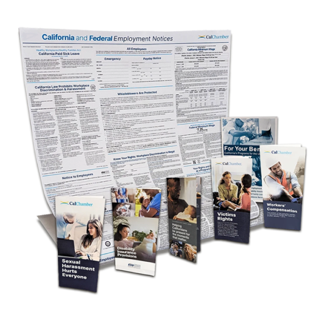
2027 California and Federal Employment Poster
You must post a compliant Employment Poster in a conspicuous place in the workplace where all employees and applicants can see it. The poster also must include information about your workers’ compensation benefits, payday schedule and emergency contacts. You may need to order several to ensure that your business, branches and satellite offices are displaying the poster according to the law. Failure to comply can result in severe penalties and fines by the state of California. If any of your company’s workers are Spanish-speaking, you will need to order the Spanish version.

California Wage Order Posters

Employers of non-exempt employees are required to post industry-specific Wage Order(s) in each workplace. There are 17 different Wage Orders offered laminated in English & Spanish.

City and County Labor Law Posters
Which mandatory City or County posters apply to your business? It depends on which city your employees work – whether at your facilities, remotely from their homes or while traveling.

2027 HR Quick Guide for California Employers (HR Handbook)

Includes color-coded easy reference sections. Required and recommended forms for California businesses available to download using a special URL provided in the book.

Required Pamphlets Kit
Contains 20 copies of each of six pamphlets that employers must distribute to employees.

California Labor Law Digest 2027 Edition
This comprehensive, California-specific Digest puts answers to labor law questions right at your fingertips, updated with new case law and regulations. (Print or Digital Download)

Remote Employees Kit
For each employee who works remotely 100% of the time, this kit includes our all-in-one California and Federal Employment poster plus each of the six required pamphlets your employee must receive.
These products are produced by the California Chamber of Commerce, a publisher of top-quality human resource products and services with more than 125 years of experience helping California business do business.
Order Today and SAVE!  Business Name  Contact Person  Address  Telephone  E-mail  Wage Order Poster @ [your price] $______  1 Manufacturing, 2 Personal Service, 3 Canning, Freezing & Preserving, 4 Professional Technical, Clerical, Mechanical and Similar, 5 Public Housekeeping, 6 Laundry, Linen Supply, Dry Cleaning and Dyeing, 7 Mercantile, 8 Industries Handling Product After Harvest, 9 Transportation, 10 Amusement & Rec., 11 Broadcasting, 12 Motion Picture Industry, 13 Preparing Agricultural Products for Market, on the Farm, 14 Agricultural Occupations, 15 Household Occupations, 16 On-Site Construction, Drilling, Logging and Mining, 17 Miscellaneous Employees  _____ Version # _____ English _____ Spanish  _____ Version # _____ English _____ Spanish  _____ Version # _____ English _____ Spanish  _____ Version # _____ English _____ Spanish  _____ Version # _____ English _____ Spanish | _____California and Federal Employment Poster $_____  All required notices on one poster @ [your price]  _____ English _____ Spanish  _____Laminated California and Federal Employment Poster $_____  All required notices on one poster @ [your price]  _____ English _____ Spanish  _____Local City/County Minimum Wage Posters @ [your price] $______  Specific City or County__________________________  _____HR Quick Guide for California Employers  @ [your price] $______  _____California Labor Law Digest Book @ [your price] $______  _____California Labor Law Digest Download @ [your price] $______  _____Required Pamphlets Kit @ [your price] $______  _____ English _____ Spanish  _____Remote Employee Kit @ [your price] $______  _____ English _____ Spanish  Subtotal $_______  Tax $_______  Total $_______

Substantial discount when you purchase through your local chamber of commerce.

Another business solution brought to you

by the California Chamber of Commerce

