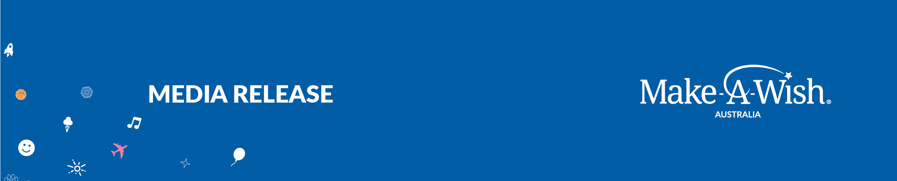

WISH KID ZETH ‘SAVES THE DAY’ WITH SPIDER-MAN

Monday 1 August 2022 is Spider-Man’s 60th Anniversary and to mark this amazing milestone Make-A-Wish® Australia and The Walt Disney Company in Australia & New Zealand celebrate with a video of the incredible wish kid Zeth working with Spider-Man to save the city of Perth from mayhem!

11-year-old Zeth, who was diagnosed with a Wilms Tumour at the age of seven, decided four years ago that his wish was to have an ultimate day with his favourite superhero, Spider-Man.

To make Zeth’s wish happen, Make-A-Wish teamed up with Disney to align the stars and create a special day for the two to finally meet in March this year.

And what better way to start a day saving the city than by taking part in rigorous superhero training? Zeth picked up some flying skills at iFLY then ziplined across the Swan River – where he overcame his fear of heights and was extra brave for Spider-Man.

Zeth followed the clues to Perth’s SciTech Museum where he and Spider-Man worked to stop Doctor Octopus and crack the code of the ‘Quantum configurator’ before it shut down Perth’s power grid.

Thankfully they made it within seconds, and the WA Police congratulated Zeth and awarded him a medal for his valour.

Zeth’s big sister Kayla was there for the adventure, and said the day was filled with “so many wow moments.”

“Zeth is one of the most beautiful kids you’ll ever meet, and he’s had such a tough journey, but for us, the wish day was an end to Zeth’s journey,” Kayla said.

“I admire everything Make-A-Wish does, helping so many kids just like Zeth,” she said. “And for Disney to collaborate on the wish was amazing as we are all such big fans of Disney!”

Since 1980, Disney has helped Make-A-Wish to grant more than 145,000 wishes around the world – bringing hope and joy to wish children and their families.

Kylie Watson-Wheeler, Senior Vice President and Managing Director for The Walt Disney Company in Australia and New Zealand, said: “We’re proud partners of Make-A-Wish and support all the organisation does to uplift, inspire, and bring comfort to kids and families when it’s most needed. It’s incredible seeing Zeth’s smile as he teams up with his favourite superhero, Spidey, and they bring some amazing imagination and storytelling to life.”

Chief Executive Officer of Make-A-Wish Australia, Sally Bateman said: “Our wish program receives no government funding, so we’re incredibly fortunate to be in partnership with the amazing team at Disney who help make unforgettable wishes like Zeth’s happen.

“Due to COVID delays, Make-A-Wish currently has more than 800 children waiting for a wish. We’re very grateful to Disney, local partners Scitech and WA Police, and our Wish Force of volunteers who all played an important role in making Zeth’s wish come true.

“Our aim is for the Wish Journey to leave a profound and lasting impact on wish kids like Zeth, and help inspire them to dream bigger, and to believe that anything is possible.”

To find out more about Make-A-Wish and how you can support wishes, please visit www.makeawish.org.au

-ENDS-

Media enquiries: Wrights PR, Nicolette Stathopoulos, +61 405 270 910, nstathopoulos@wrights.com.au

About Make-A-Wish® Australia
Make-A-Wish is one of Australia's most trusted charities and is part of the world’s largest wish-granting organisation. It exists to bring the local community together to grant life-changing wishes for children and teens with critical illnesses. Since 1985 it has delivered more than 10,000 inspirational wishes to children across the country. From the humble to the seemingly impossible – the Wish Force has made unicorns fly, sent kids to the moon and even brought dinosaurs back from extinction. Make-A-Wish Australia led the world in adopting the Wish Journey, a carefully curated program which focuses on wish capture and design, building anticipation for each child ahead of their wish being realised. In 2022, Make-A-Wish Australia was proud to place in YouGov Australia’s Top 10 Charity Rankings.

About The Walt Disney Company
The Walt Disney Company, together with its subsidiaries and affiliates, is a leading diversified international family entertainment and media enterprise with the following business segments: Media Networks; Parks, Experiences and Products; Studio Entertainment; and Direct-to-Consumer and International. For more than nine decades, The Walt Disney Company has created entertainment of the highest quality. From humble beginnings as a cartoon studio in the 1920s, to its distinguished name in the entertainment industry today – which includes Pixar, Marvel, Lucasfilm, ESPN, National Geographic, and 20th Century Studios – Disney proudly continues its legacy of creating world-class stories and experiences for every member of the family. Its mission has and always will be to entertain, inform and inspire people around the globe through the power of storytelling.

