
Bridging Units: Resource Pocket 7

Direct and inverse proportion

Direct and inverse proportion is new to the Foundation tier at GCSE level. With a whole new strand on ‘Ratio, Proportion and Rates of Change’ there is an expectation that students will have a very good understanding of proportional reasoning and be able to apply their knowledge to a variety of problems. This resource pocket builds upon the skills developed in resource pocket 1 ‘Fractions and Ratio’ and aims to further help students deepen their understanding of proportional reasoning to enable them to access this content on the new GCSE. All content is suitable for Foundation students except question 4 on Skills Builder 3 which is content from the higher tier only.
This resource pocket progresses through three sections: developing understanding, skills builders and problem solving activities. As with all 9 resource pockets there are a number of different learning styles and approaches used to cater for a variety of learners.
- Developing Understanding
These are class based, teacher led questions with suggested commentary to get the most from a class or small group discussion. The boxed text can either be copied onto the whiteboard for class discussion, or printed onto cards and handed out to students to be used for paired or small group work.
- Skills Builders
These are standard progressive worksheets that can be used to drill core skills in a particular area.
- Problem Solving Activities
Extension activities for paired work or small group work to develop problem solving skills whilst focussing on a particular area of mathematics that students can learn to apply.

Developing Understanding 1

1 part cordial with 4 parts water Perfect
To make the perfect blackcurrant drink, mix:
What will the drink taste like if:
(a) 1.5 parts cordial is mixed with 4 parts water
(b) 1 part cordial is mixed with 3 parts water
(c) 1 part cordial is mixed with 5 parts water
(d) 1 part cordial is mixed with 4 parts water and served over crushed ice
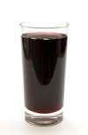
Emphasise the use of consistent language to describe the taste such as strong and weak.
Some questions that would develop a discussion around proportional reasoning could be:
- Can you describe the taste if one extra part cordial and one extra part water is added?
- Can you explain why?
- What about if an extra two parts of both cordial and water is added?
Answers
(a) strong
(b) strong
(c) weak
(d) weaker as the ice melts
- strong
- because 4 parts water need adding for every 1 part cordial
- this would be even stronger

Student’s key misconception here is to believe that as the same amount is being added to (or subtracted from) the cordial and the water, then the ratios are equivalent. Visually demonstrating can help students overcome this:
What is being represented in the diagrams above?
Can you create some more?
Create two smiley and two sad diagrams
Cordial Water
1 : 4
2 : 5
1.5 : 6


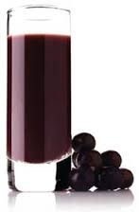

Cordial | Water | Taste
1 | 4 | Perfect
2 | 5
2 | 8
3 | 15
3 | 10
4 | 16
4 | 20

Using only the words
Strong, Weak or Perfect
And comparing to the ‘perfect blackcurrant drink’ describe what the drink will taste like if cordial and water is mixed in each ratio
When students have completed the table, use the values to reinforce the links between ratios and fractions. Some possible questions to develop a discussion around this could be:
- In the perfect blackcurrant, what fraction of the drink is cordial?
- Is this the same fraction for all ‘perfect blackcurrant’ drinks in the table?
- Using equivalent fractions, can you write some more ratios for ‘perfect blackcurrant’?
Answers

Cordial | Water | Taste
1 | 4 | Perfect
2 | 5 | Strong
2 | 8 | Prefect
3 | 15 | Weak
3 | 10 | Strong
4 | 16 | Perfect
4 | 20 | Weak

- Yes the faction is the same
- Some correct fractions and ratios
could be 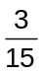 (3 : 12), 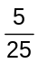 (5: 20)
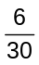 (6 : 24)

Ella is having a party, she wants to make perfect blackcurrant drink for the guests.
  - What fraction of the drink will be water?
  - If Ella wants to make 10 litres of perfect blackcurrant drink, how much cordial does
she need to use?
Answers
- 2 litres
Discuss the different ways of calculating the amount.
Ensure students have considered sharing in ratio 1 : 4 and are clear that this is the same as
calculating of 2 litres.
- If Ella has 5 litres of water, how much cordial does she need to mix it with?
- How much perfect blackcurrant drink can she make with litre of cordial?
- What about if Ella has 400 ml of cordial?
Answers
- 1.25 litres of cordial for 5 litres of water
- 2.5 litres of blackcurrant with litre of cordial
- 2000 ml or 2 litres blackcurrant with 400 ml of cordial

Developing Understanding 2


SHOP AND CO.
2 BOTTLES OF WATER £0.90
4 TUBES OF SWEETS £2.40
TOTAL CHARGE £3.30
CASH £10.00
CHANGE £6.70

Ensure that students understand what the till receipt is showing.
Then discuss what information can be taken from the receipt.
Ask:
- How much would 6 tubes of sweets cost?
Answers
- £3.60
Discuss the different methods of calculating the cost of 6 tubes.
- What would be the cost of 10 tubes?
- What would be the total charge for 4 bottles of water and 8 tubes of sweets?
- How did you calculate it? Is there a quick way?
- What would be the total charge for 1 bottle of water and 2 tubes of sweets?
- What would be the total charge for 4 bottles of water and 2 tubes of sweets?
- As one quantity has doubled and the other has halved, should the cost stay the same?
- If not why not?
Answers
- 10 tubes = £6
- 4 water + 8 sweets = £6.60
- A quick way is to double the total charge
- 1 water + 2 sweets = £1.65
- 4 water + 2 sweets = £3
- No it shouldn’t be the same
- Because the water and the sweets are different prices

Introduce the fact that the number of tubes and the cost of the tubes are directly proportional and ask students to explain what they think this means.
- Using only the information on the till receipt, can you identify anything else that is directly
proportional?
- Are the quantity and cost of buying everything directly proportional?
Discuss bulk buying items and that often if you buy a large quantity of one item you can get a discounted price. Emphasise that in this case the quantity and cost are not directly proportional.
Answers
- The number of bottles of water and the cost of the water
- No, not everything
Julie’s shop charges £1.30 for 5 rubber ducks
Kieron sells 8 rubber ducks for £2.24

Use the information to discuss who is offering the best value for money:
- How much does Julie charge for 1 duck?
- How much does Kieron charge for 1 duck?
- Who is offering the best deal?
- How much would it cost to buy 10 ducks from Kieron?
- If Julie decided to match Kieron’s price, how much would she charge for 5 ducks?
Answers
- Julie charges 26p for 1 duck
- Kieron charges 28p for 1 duck
- Julie has the best deal
- 10 ducks = £2.80
- 5 ducks at Kieron’s price = £1.40

70
0.01462
- What could these signs be showing?
Students should quickly realise that the first sign is showing a speed limit of 70 mph.
Ask students:
- If it is ok to travel 70 miles in 1 hour, how many hours would it take to travel 1 mile?
The second sign shows 0.014286 hours per mile. (This is 0.857 minutes or 51.429 seconds per mile)
Discuss with students which is the better sign to display on the roads.

Julie’s shop charges £1.30 for 5 rubber ducks
Kieron sells 8 rubber ducks for £2.24
Ask students to calculate:
- How many pounds does Julie charge for 1 duck?
- How many ducks (exactly) does Julie sell for 1 pound?
- Which is the most sensible value to calculate and why?
Explain to students that when working with values that are proportional, it helps to work out a constant. Here both the number of pounds per duck and the number of ducks per pound provide us with a constant, but the unit price is the easiest to use.
Answers
- £0.26 for 1 duck
- 3.8 ducks for £1
- The number of pounds per duck

Sally works in a café.
To earn £60 she must work 8 hours.
Kamran works in the same café.
After a 5 hour shift, he earns £39.




Ask students to think of different ways that they could compare the earnings of Sally and Kamran.
- What are the two unit values that can be compared?
- Which is the most sensible to use?
- Can you explain why?
- Calculate this for Sally’s earnings
- Calculate this for Kamran’s earnings?
- What do your findings show?
- Make comparisons using the number of hours work to earn £1.
- Does this confirm or contradict your findings?
Answers
- The two unit values are pounds per hour and hours per pound
- The most sensible is pounds per hour
- Because we normally work a whole number of hours, or any other valid reason
- Sally’s rate per hour is £7.50
- Kamran’s rate per hour is £7.80
- Kamran earns a higher rate than Sally
- Sally must work 0.13333.. hours per pound, Kamran must work 0.128 hours per pound, so
Kamran has the better rate as he has to work less per pound
- This confirms that Kamran earns a higher rate

Developing Understanding 3

Freddie is building an extension on his house.
It will take him 40 days to complete if he works alone.
He would like the extension completed in 7 days.
Is it possible?
If so, how?

Encourage students to think about how long it would take if Freddie had somebody to help him.
Some questions to ask:
- How long would it take if two people were building the extension?
- What about more than two people?
- What assumptions are being made?
Explain that if certain assumptions are made, then the number of workers and the number of days to complete the job are inversely proportional.
Here the constant is the number of days for ONE worker, 40 days.

Answers:
workers
days
40
Answers
- 2 people = 20 days
- eg 4 people = 10 days
- Assuming that all workers work at the same speed

Claire wants to arrange a minibus to take a group of friends to a party.
The minibus can hold 25 passengers.
The cost for hiring the minibus is £125.
This will be shared equally between the passengers.
(a) If there are 20 passengers, what fraction must they each pay?
(b) If there are 20 passengers going to the party, how much do they each
have to pay for the minibus?
(c) If each passenger must pay 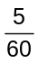 of £125
How many passengers are going to the party?

Explain that the number of passengers and the cost per person are inversely proportional. Ask students if they can explain what this means to their partner.
- What affect does the fact that the minibus can hold 25 passengers have?
As the number of passengers increases, the cost per person decreases.
Here the constant is the cost if there is ONE passenger, £125.
passengers
cost
125
Answers
- 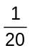
- £6.25
- 12

US Dollars ($)
British
Pounds
(£)
An amount of British pounds is related to the same amount in US dollars.
The graph shows this relationship.
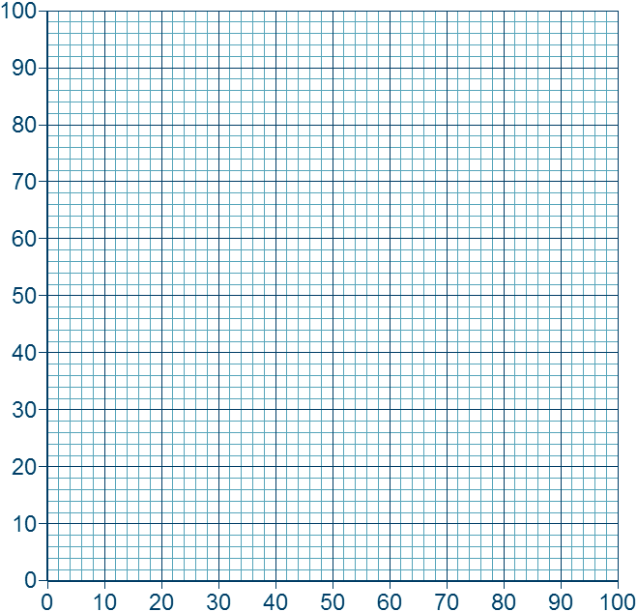
Ask students what they can see from the graph.
- Can you see from the graph how many US Dollars have the same value as £60?
- How many pounds could you get for $50?
- Is the graph any use if I want to convert £100 into US Dollars?
Ask the students if they think British pounds and US Dollars are proportional? If so, are they directly or inversely proportional? And why?
From the previous examples, students should understand that the two are directly proportional because as one increases, the other increases by the same proportion.
Answers
- £60 = $90
- $50 = £34
- Yes £50 = $75 so £100 = $150

Skills Builder 1: Direct proprtion

Section A
For each statement calculate each unit value, then circle which is the most sensible to use.
The first one has been done for you.
 | 1 | 8 books cost £9.60  8 books = £9.60  ÷ 8 ÷ 8  = £1  8 books = £9.60  ÷ 8 ÷ 8  1 book =
 |  |  | £1.20 per book |  | 0.833 books per £1

12 hrs = 1500 bricks  ÷ 12 ÷12  1 hr | 2 | In 12 hours a bricklayer laid 1500 bricks  12 hrs = 1500 bricks  ÷ 12 ÷12  = 1 brick
 |  |  |  | bricks per hr |  | hrs per brick

 | 3 | A heart beats 280 times in 4 minutes
 |  |  | minutes per beat |  | beats per minutes

 | 4 | Bernie can type 150 words in 5 minutes

 | 5 | £8 is equal to €10.50

 | Section B
 | 1 | Sam pays £1 for 4 chocolate bars.  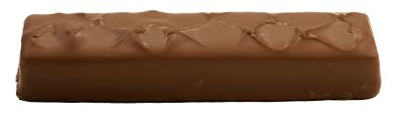  How much would 7 chocolate bars cost?

 | 2 | Lucy earns £24.50 for 3.5 hours work.  How much will she earn for 10 hours work?

 | 3 | Elsa takes 2 days to paint 3 rooms.  How long will it take to paint 5 rooms of the same size?

 | 4 | Aliyah makes 5 loom bracelets in 15 minutes.    How many bracelets can she make in an hour?
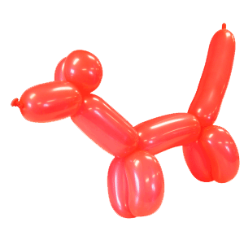
 | 5 | Terry the Clown can make 12 balloon animals in 2 minutes.  He needs to make balloon animals for 30 children.  How long will it take him?

 | Section c
 | 1 | Four students took IQ tests.  Each student was asked a different number of questions.  Their results are as follows:  Simon answered 8 questions correctly out of 10  Selina answered 9 questions correctly out of 12  Jimmy answered 6 questions correctly out of 9  Fran answered 4 questions correctly out of 6  Which student performed the best in their IQ test?

 | 2 | Which is the best value:    500 g of sweets for £3.75 or  800 g of sweets for £5.50 ?



 | 3 | Ani drove 400 miles on 80 litres of petrol.  Xavier drove 360 miles on 60 litres of petrol.  Who drives the most fuel efficient car?

 | 4 | A shop has 2 offers:    12  toilet rolls for £6    18  toilet rolls for £8  Which is the better value?

 | 5 | Band A and Band B are both playing at the AQA Arena.  The Arena has a capacity of 40,000 people.  Band A sold out in 9 days.  After 5 days of ticket sales, Band B has sold 26,000 tickets.  Assuming that Band B will continue to sell tickets at the same rate, will they sell out quicker than Band A?  Justify your answer.

Sills Builder 2 : Direct and Inverse Proportion

 | 1 | Using the information in the centre, complete each diagram.  Use the two empty boxes to make up your own statements.
(a)
There are 1640 calories
in _________
chocolate bars
3 chocolate bars contain 615 calories
10 chocolate bars
contain _________
calories

5 chocolate bars
contain _________
calories

In _________
chocolate bars there
are 410 calories

(b)
2 farmers can plough
a field in 6 days
It takes 3 days
for _________
farmers to plough
the field
18 farmers can
plough the field
in _________ days

1 farmer can plough
the field in
_________ days
contain _________
calories

It will take _________
farmers 4 days
to plough the field

 | 2 | If 6 magazines cost £7.20.  How many magazines can you buy for £12?
 | 3 | 4 builders can build a house in 20 days.  How long would it take 1 builder?

 | 4 | 3 painters can paint a fence in 5 hours.  How long would it take 2 painters?

 | 5 | 350 parcels are sent into 3 vans for delivery.  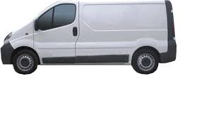  The first van contains twice as many parcels as the second van.  The third van contains twice as many parcels as the first van.  How many parcels are in each van?

 | 6 | Richard is organising his DVDs into three categories.  The comedy category has 10 more DVDs than the Action category.  The Animated category has twice as many DVDs as the Comedy category.  If Richard has 110 DVDs altogether, how many of each category does he have?

 | 7 | Eamon buys two bottles of shampoo and a bottle of conditioner.  - 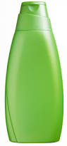  He pays at the till and receives 80 pence change from £5.  If the conditioner was 1.5 times the cost of the shampoo,  how much was the conditioner?

Skills Builder 3 : Graphs

 | 1 | The number of bottles of shampoo is directly proportional to the cost.  3 bottles of shampoo cost £5.40.  (a) How much would 5 bottles of shampoo cost?  (b) On the grid below, draw a graph to represent the relationship between the number of  bottles and the cost.
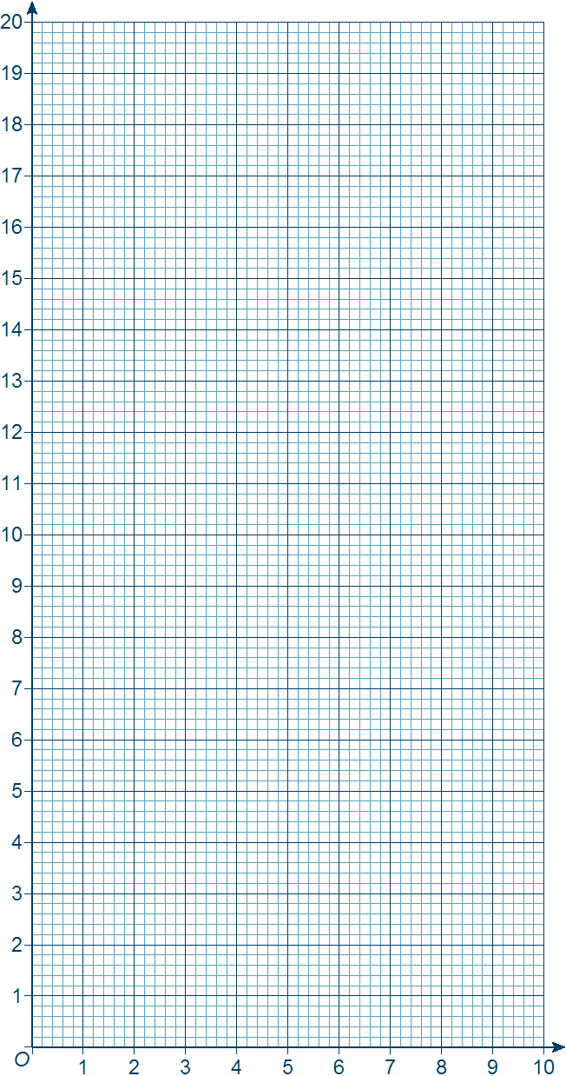
Number of bottles
Cost (£)

 | 2 | The wage Jess earns is directly proportional to the number of hours she works.  Her wage is £108 when she works 12 hours.  (a) Draw a graph to represent the relationship between Jess’s wage and the number of hours  she works.
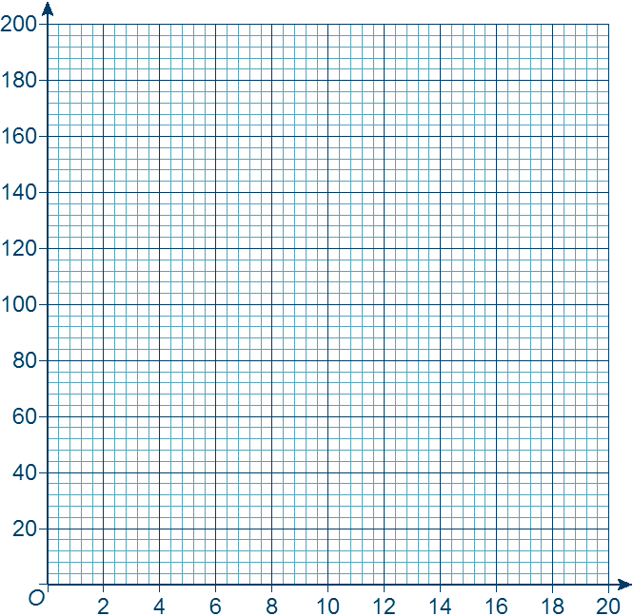
Number of hours worked
Wage
(£)
(b) Use the graph to work out how much Jess’ wages will be if she works 4 hours.
(c) Use the graph to work out how many hours Jess has worked if her wage is £144.
(d) Read some more values from the graph and use them to write two sentences.

 | 3 | The graph shows the relationship between pounds and euros.
 |  | 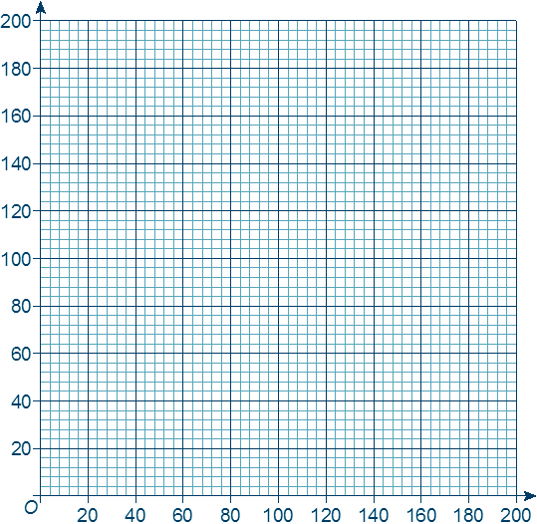  £  € | (a) Explain why the graph shows  that pounds and euros are  directly proportional.  (b) Use the graph to work out  how many euros is  equivalent to £40  (c) Use the graph to work out  how many pounds is  equivalent to €180  (d) Explain how you could use  the graph to work out how  many euros is equivalent to  £1000.

 | 4 | The points plotted on the grid below represent the number of people at a Christmas lunch and the cost per person.
 | Cost  per  person  (£) | 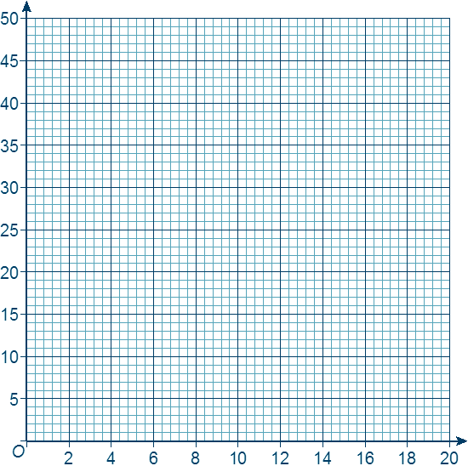  ×  ×  ×  ×  ×  Number of people | (a) Join the points with a smooth  curve to create the graph.  (b) Does this graph show direct  proportion or inverse  proportion?  (c) Use the graph to calculate  the cost per person when  14 people attend.

Problem solving 1 : Ratios and Fractions

Print and cut out the cards
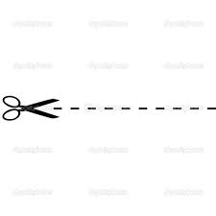
Give one set to each pair or group of students.
The instructions are contained within one of the cards, so no teacher guidance is required.

 |  | How much change will  James get from £20? | The ratio of the cost of an  apple to the cost of a melon is  1:8
 |  | 100g of grapes cost  of  the cost of a melon | James buys 6 apples, 1 melon  50g of grapes and  2 bottles of water
 |  | 4 apples cost  84p | 8 bottles of water cost  £3.60
 |  | At the checkout, James  hands in a voucher giving  him 15% off the total | James goes shopping at  his local farm shop

Print and cut out the cards
Give one set to each pair or group of students.
The instructions are contained within one of the cards, so no teacher guidance is required.
A community hall needs painting.
Two local decorating companies are available to do the work.
Using the information on the cards, work out which company each painter works for, and decide which company can paint the hall the quickest.
 | Painters R Us is a decorating company that has 4 painters.  Each painter works at the same speed. | Décor and Co is a decorating company that has 4 painters. Each painter works at the same speed, this speed is faster than the painters at Painters R Us
 | Alfie and Cal work for the same company. Together they could paint the hall in exactly 3 hours | Evan can paint the hall in exactly 8 hours
 | Billy and Hans work for the same company, together they could paint the hall in exactly 4 hours | Dev and Frank do not work for the same company. Together they would take more than 3 hours but less than 4 hours to paint the hall
 | Evan and Ged work for different companies. Together they would take less than 4 hours to paint the hall | Frank works for the same company as Ged
 | How long would it take all painters from Painters R Us to paint the hall together? | How long would it take all painters from Decor and Co to paint the hall together?

Answers

 | Skills builder 1
 | Section A
 | 1 | £120 per book 0.8.33 books per £1

 | 2 | 125 bricks per hour 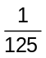 hours per brick

 | 3 | 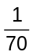 minutes per beat 70 beats per minute

 | 4 | 30 words per minute 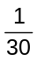 minutes per word
 | 5 | €1.3125 per £1 £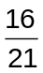 per €1 (either circled)
 | Section B
 | 1 | £1.75
 | 2 | £70
 | 3 | 3 days
 | 4 | 20
 | 5 | 5 minutes

 | Section C
 | 1 | Simon = 80%, Selina = 75%, Jimmy = 67%, Fran = 67%  Simon performed the best.
 | 2 | 500g = 75p per 100 g, 800 g = 69p per 100 g  800g for £5.50 is the better value.
 | 3 | Ani = 50 miles per 10 litres, Xavier = 60 miles per 10 litres  Xavier has the most fuel efficient car.
 | 4 | 18 rolls = £2.67 for 6, 12 rolls = £3 for 6.  18 for £8 is the better value.
 | 5 | Band B will sell out in 8 days.  Yes they will sell out quicker.

 | Skills builder 2: Direct and Inverse Proportion
 | 1 | 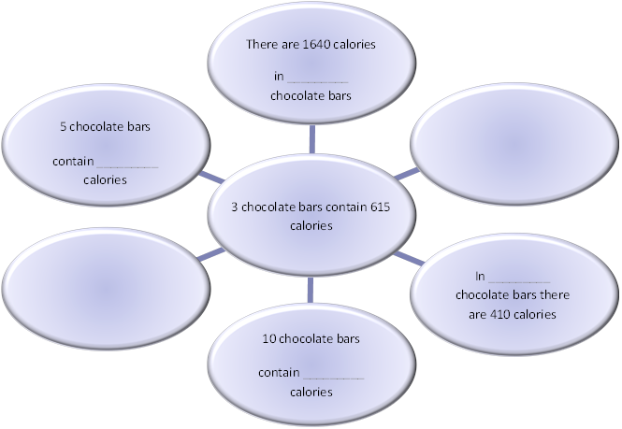  2  2050  1025  8

 | 2 | 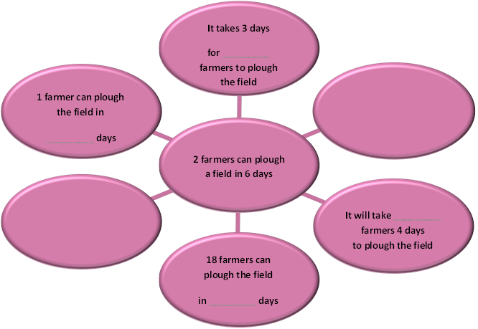  3  4  1.5  12
 | 2 | 10
 | 3 | 80 days
 | 4 | 7.5 hours
 | 5 | Van 1 = 100, Van 2 = 50, Van 3 = 200
 | 6 | Comedy = 30, Action = 20, Animated = 60
 | 7 | £1.80

 | Skills builder 3: Graphs
 | 1 | (a) £9  (b) straight line through (0, 0) and (3, 5.4)

 | 2 | (a) straight line through (0, 0) and (12, 108)  (b) £36  (c) 16 hours

 | 3 | (a) straight line through the origin  (b) €60  (c) £120  (d) convert £100 then multiply by 10

 | 4 | (a) smooth curve through the points  (b) inverse proportion  (c) accept between £6 and £8

Problem solving 1: Ratios and Fractions
1 apple = 21p
1 melon = £1.68
50 g grapes = 56p
1 water = 45p
James’ total bill = £3.74 after the discount.
His change will be £16.26

Problem Solving 2: Ratios and Fractions
Alfie = 6 hours Billy = 8 hours Cal = 6 hours Dev = 8 hours
Evan = 8 hours Frank = 6 hours Ged = 6 hours Hans = 8 hours
Painters R Us staff are: Billy, Dev, Evan and Hans
Décor and Co staff are: Alfie, Cal, Frank and Ged
Painters R Us would take 2 hours to paint the hall
Décor and Co would take 1.5 hours to paint the hall.
Décor and Co could paint it quicker.

